Para Archery Visually Impaired
Classification Request and Medical Intake Form
- The first part is a request form that needs to be completed and signed by the national archery federation representative.
- The second part is the consent form that must be signed by the athlete to allow the classifiers to collect their personal data.
- The third part is the medical intake form that provides evidence of the relative health condition which must be completed in English by a certified ophthalmologist licensed in the jurisdiction where the athlete resides and who must sign the completed document and provide national medical society or board of practice information for verification purposes.
All parts must be completed electronically in English and submitted by the national federation on behalf of the archer. The requested classification venue must be identified. The request must be received by World Archery (classification@archery.sport) no later than 30 days prior to the classification dates. If the form has been translated into English by an official translator, the translation must be signed by the physician confirming accuracy of translation.
As this represents the first step in the classification process, the information provided must be honest, accurate, and verifiable. Successful completion of this form does not indicate that a classification will be performed. It provides a concise basis of discussion between the applicant and classification team regarding the applicant’s potential for being successfully classified as a para archery competitor. If the form has not been completed in all three parts, it will be returned to the national organisation.
Electronic portrait picture (passport type, JPG) is required as a separate attachment.
Event Requested (must be identified)
Athlete Information (as passport data)
LAST NAME:
FIRST NAME:
Gender ☐ Female ☐ Male Date of birth: ___/___/____
Nationality

National federation
The national archery federation certifies that there are no health risks and contra indication for the athlete to compete at competitive level in para archery. The national federation keeps all the relevant medical and legal documents about it.
Federation’s stamp | Signature | Date: ___/___/____
Consent Form

The archer agrees to cooperate fully with the classification by:
- Fully answering all questions truthfully.
- Attempting all physical tests to the best of their ability.
Note: Athletes who do not cooperate fully as stated above may be disqualified from the competition.
In agreeing to be classified, the archer must understand that some of the tests may unfortunately cause pain. We are sorry for this, but it is unavoidable.

Consent and Athlete Declaration
I have no health problems which would stop me undertaking the tests ask of me.
I agree that if I sustain an injury during the classification procedure, I hold para archery blameless.
My participation in the classification procedure is voluntary and I have the right to withdraw at any time. If I withdraw, I understand that classification cannot take place and I will not be able to compete in para archery competitions.
To assist World Archery in developing the classification system, I also give my consent to allow data collected during my classification to be used for research and educational purposes. This includes any photographs or videos taken during the field evaluation component of classification and/or training and competition. I understand that I may withdraw this consent at any time.

Place and data: ____________________________________________________________
Archer’s signature: _________________________________________________________

Para Archery Visually Impaired
Classification Medical Information Intake Form
Applicant Information
This form needs to be completed electronically (handwritten forms are not accepted).
To be filled by the national archery federation.
PREVIOUS CLASSIFICATION
Last National Classification: Year: ______ Class: ☐ B1 ☐ B2 ☐ B3 ☐ Other: ______
First International Classification: ☐ New or ☐ Year:______ Class: ☐ B1 ☐ B2 ☐ B3 ☒ NE
Last International Classification: Place: ________________________ Year: ______
Actual International Class and Status: ☐ New or ☐ Protest/reclassification accepted;
Or Class: ☐ B1 ☐ B2 ☐ B3 ☐
Status: ☐ Review (next time) or ☐ review Year ______; ☐ NE. 1st panel; ☐ CNC
To be filled by the National Federation a registered ophthalmologist or optometrist.
MEDICAL INFORMATION
A: Relevant systemic pathology and medical information
Age of onset: ______________ At present: ☐ Stable for the last _____ years
Progressive: ☐ No ☐ Yes
Anticipated future procedure(s): ☐ No ☐ Yes: ______________________________
when: _____________
Details:

Ophthalmic medication used by the athlete: ☐ No ☐ Yes: ________________________________
_________________________________________________________________________________
Allergic reactions to ocular drugs: ☐ No ☐ Yes: ____________________________________
Is the eye condition is obvious and visible and explains the loss of vision:
☐ No ☐ Yes: _______________________________________________
B: Visual, ophthalmic and associated diagnosis (short)

C: Ophthalmic medical data

D: Eye medication and allergies

OPTICAL CORRECTION AND PROSTHESIS
Athlete wears glasses: ☐ No ☐ Yes:
Right eye: Sph. _______ Cyl. ________ Axis ( º)
Left eye: Sph. _______ Cyl. ________ Axis ( º)
Athlete wears contact lenses: ☐ No ☐ Yes:
Right eye: Sph. _______ Cyl. ________ Axis ( º)
Left eye: Sph. _______ Cyl. ________ Axis ( º)
Athlete wears eye prosthesis: ☐ No ☐ Yes: ☐ Right ☐ Left

VISUAL ACUITY
Visual Acuity | Right eye | Left eye | Binocular
With correction
Without Correction
Measurement Method: ☐ LogMar ☐ Snellen ☐ Other: __________________________
Correction used: ☐ Glasses  ☐ Contact lenses  ☐ Trial lenses |  | Right eye: Sph. ________ Cyl._________  Axis....................... (For visual acuity test)  Right eye: Sph. ________ Cyl._________  Axis....................... ( for visual acuity test)

EQUIPMENT
Equipment used: ______________________________________Pupil diameter: ______ mm
Date: _______/_______/_________

Periphery isopter | Right eye | Left eye | Binocular
Amplitude in degrees (diameter) | Right eye | Left eye | Binocular

- I confirm that the above information is accurate.
- I certify that there is no ophthalmologic contra-indication for this athlete to compete in the sport of archery.
Attachments added to this Medical Diagnostic Form: ☐ No ☐ Yes: see and check in page 3
Name: ____________________________________________________________________________
Medical Specialty: Ophthalmology,
National Registration Number: _________________________
Address: _____________________________________________________________________
City: _________________________ Country: ______________________ Phone: _______________________
E-mail: ______________________________________

Signature: ___________________________ Date: _______ /_____ / _________

Office Stamp

Notes for Ophthalmologists/ Optometrist:
Thank you for testing this athlete’s visual acuities so that she / he can be classified for Visually Impaired Archery. LogMAR is the preferred test using the LogMAR chart for distance visual acuity testing with Illiterate “E” and/or the Berkeley Rudimentary Vision Test.
On the form, please complete the appropriate uncorrected and corrected visual acuities. Please also attach copies of the visual fields and record any comments.
All Athlete Evaluation and Sport Class allocation will be based on the assessment of visual acuity in the eye with better visual acuity when wearing the best optical correction.
It is important that the acuities are accurate, especially for VAs <6/60, Counting Fingers, therefore please state the distance, Hand Movements and Perception of Light.
It is very important not to exaggerate visual impairment as athletes can be re-tested at sports events and may be re-classified or disqualified.
Athletes who compete using any corrective devices (e.g. glasses, lenses) must attend the Evaluation Session with these devices and their prescription.
Any person accompanying an Athlete during an examination must remain out of sight of the visual acuity charts during the assessment.
The chart is here included for clarity.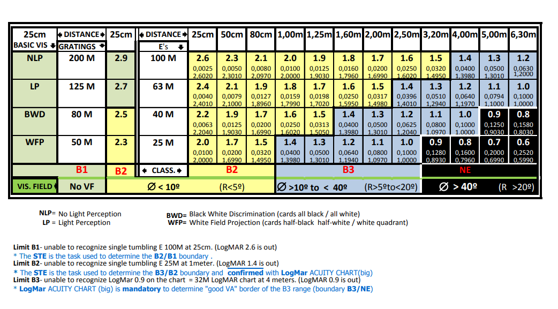
ADDITIONAL MEDICAL DOCUMENTATION:
Specify which eye conditions the athlete is affected and what additional documentation is added to the Medical Diagnostic Form.
The ocular signs must correspond to the diagnosis and to the degree of vision loss. If the eye condition is obvious and visible and explains the loss of vision, no additional medical documentation is required. Otherwise, the additional medical documentation indicated in the following table must be attached. All additional medical documentation needs a short medical report, in English. When the medical documentation is incomplete or the report missing, the classification may not be concluded, and the athlete cannot compete.

Eye condition | Additional medical documentation required
☐ Anterior disease | None
☐ Macular disease | ☐ Macular OCT *  ☐ Multifocal and/or pattern ERG*  ☐ VEP*  ☐ Pattern appearance VEP* | ☐ Right eye ☐ Left eye  ☐ Right eye ☐ Left eye  ☐ Right eye ☐ Left eye  ☐ Right eye ☐ Left eye
☐ Peripheral retina disease | ☐ Full field ERG  ☐ Pattern ERG* | ☐ Right eye ☐ Left eye  ☐ Right eye ☐ Left eye
☐ Optic Nerve disease | ☐ OCT  ☐ Pattern ERG*  ☐ Pattern VEP* ☐ Pattern appearance VEP* | ☐ Right eye ☐ Left eye  ☐ Right eye ☐ Left eye  ☐ Right eye ☐ Left eye  ☐ Right eye ☐ Left eye
☐ Cortical / Neurological disease | ☐ Pattern VEP*  ☐ Pattern ERG*  ☐ Pattern appearance VEP | ☐ Right eye ☐ Left eye  ☐ Right eye ☐ Left eye  ☐ Right eye ☐ Left eye  ☐ Right eye ☐ Left eye
☐ Other relevant medical documentation added | ☐ ________________________________________  ☐ ________________________________________  ☐ ________________________________________

*Notes for electrophysiological assessments (ERGs and VEPs):
Where there is discrepancy or a possible discrepancy between the degree of visual loss and the visible evidence of the ocular disease, the use of visual electrophysiology can be helpful in demonstrating the degree of impairment.
- Submitted electrophysiology tests should include: 1- Copies of the original graphics; 2- The report in English from the laboratory performing the tests, the normative data range for that laboratory, a statement specifying the equipment used and its calibration status. The tests should be performed according to the standards laid down by the International Society for Electrophysiology of Vision (ISCEV) (http://www.iscev.org/standards/).
- A Full Field Electroretinogram (ERG) tests the function of the whole retina in response to brief flashes of light, and can separate function from either the rod or the cone mediated systems. However, it does not give any indication of macular function.
- A Pattern ERG tests the central retinal function, driven by the macular cones but largely originating in the retinal ganglion cells.
- A Multifocal ERG tests the central area (approx. 50 degrees diameter) and produces a topographical representation of central retinal activity.
- A Visual evoked cortical potential (VEP) records the signal produced in the primary visual cortex, (V1), in response to either a pattern stimulus or pulse of light. An absent or abnormal VEP is not in itself evidence of specific optic nerve or visual cortex problems unless normal central retinal function has been demonstrated.
- A Pattern appearance VEP is a specialised version of the VEP used to establish visual threshold which can be used to objectively demonstrate visual ability to the level of the primary visual cortex.

