ALL WORLD MEMBER ARCHERY ASSOCIATIONS
Dear Presidents:
As president of the Argentinean Archery Federation (FATARCO), and on behalf of the Local Organizing Committee (LOC) of the 1st Pan American Indoor Archery Championship, to be held in Buenos Aires, Republic of Argentina from August 29 to September 3, 2023, I would like to invite you all to be part of one of the most important archery events to take place in the Americas in 2023.
The tournament will be held at the Microestadio Cubierto del Parque Tecnópolis, located at J.B. de la Salle 4500, Villa Martelli, Province of Buenos Aires, Argentina (34.560110, -58.505570).
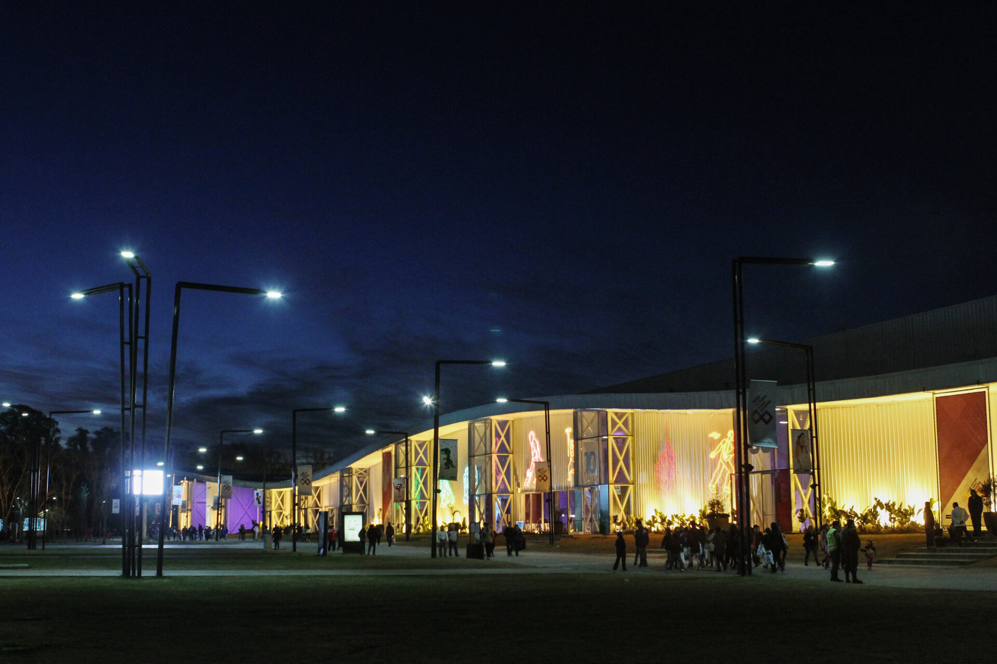

With the support of the National Sports Secretariat (SDN) and the National Ministry of Tourism and Sports, we are working hard to provide your archers with a great sporting experience, as well as an opportunity to get to know our rich culture.
Attached is all the information necessary to register for the 1st Pan American Indoor Archery Championship, official fees, hotel reservations, tournament schedule, etc.
You can also contact us at: panam-indoor@fatarco.com for more information or further questions.

Kind regards

Diego Martín Adrover
President of Federation
Argentina de Tiro con Arco
KEY DATES
Attached you will find information on the details of this event and how to complete the registration.
To register your participation, complete all the necessary sections in WAREOS (https://extranet.worldarchery.sport) within the deadlines listed below:
Deadline summary:
- Start date WAREOS online registration May 1st, 2023
- Deadline preliminary registrations May 31, 2023
- Deadline final registration August 9, 2023
- Late registration fees July 31, 2023
- Hotel reservation and payment of 50%. July 1st, 2023
- Flights schedule August 10, 2023
- Visa Support June 30, 2023
- Final payment hotel and transportation AEP-HOT July 31, 2023
- Deadline for cancellation of full refund July 31, 2023
* After this deadline, the LOC may withhold all amounts owed by the Member Association.

We look forward to welcoming you in Buenos Aires!

PRELIMINARY PROGRAM
Monday, August 28 | From 4:00 p.m.: Arrival of delegations
Tuesday, August 29 | Arrival of delegations  Unofficial practice
Wednesday, August 30 | Official Practice  Team Captains’ meeting  Teams’ inspection
Wednesday, August 30 | Qualifying Round  Opening Ceremony
Friday, September 1st | Single elimination matches up to the semifinals
Saturday, September 2nd | Team Matches up to semifinals
Sunday, September 3rd | Individual and Team Medal Matches  Awards and closing ceremony
Monday, September 4 | Departure of delegations
NOTE: This preliminary program is subject to change in accordance with participation and television requirements. All changes will be published and distributed in due course.

CATEGORIES
The following categories will compete in this Pan American Indoor Archery Championship:
- Recurve Mem
- Recurve Women
- Compound Men
- Compound Women
- Barebow Men
- Barebow Women
All categories include the following divisions:
- U18
- U21
- Senior
- 50+
PRELIMINARY AND FINAL REGISTRATION
All registrations, lodging reservations, transportation needs, flight arrival/departure information and invitation letter requests must be completed using the World Archery Registration Online System (WAREOS)) https://extranet.worldarchery.sport. This system manages the entire registration process for this event. No other registration forms, hotel or transportation reservations will be accepted.

Member associations can log in to WAREOS at http://extranet.worldarchery.sport with the username and password assigned by World Archery. After logging into WAREOS, they must select the event from the list which will allow the association to register their athletes.
Select the "Entries" button to see the list of categories in the event. Then click on the "Category" to enter the athlete and official numbers participating in that event. A WAREOS user manual can be downloaded in PDF format (English) by logging in..
Please contact ( wareos@archery.sport ) for any questions related to technical problems in WAREOS.
For any questions related to the organization of the event (transportation, accommodation, meals, etc.), please contact the LOC directly.
For a category to be officially contested, it must have athletes from a minimum of 4 different member associations. Entries must be completed using WAREOS.
There is no limit to the number of athletes a country can register in each category. Archers registered by their national federations on WAREOS will be required to pay their World Archery Licenses (100 CHF).
To make changes or amendments to entries Member Associations may only use WAREOS and may do so at any time. An email will automatically notify the Organizing Committee and the Member Association of any changes made in WAREOS.
CLUB ARCHERS’ PARTICIPATION
Other athletes (not competing as a country but only as a club) can register for Open WAREOS at https://extranet.worldarchery.sport/ with their username and password if they have registered in the past or register for login details if this is the first time.
After creating your profile, follow the instructions to register at the event.
Please contact World Archery (wareos@archery.sport) if you have technical problems at WAREOS. For any questions related to the organization of the event (transportation, accommodation, meals, etc.), please contact the LOC directly.
Archers who register using Open WAREOS may compete only in the individual events. They will not be able to take part in the team competition.

REGISTRATION FEES (all fees are expressed in € Euros)
REGISTRATION (staying at official hotels)  Athletes: |  | 140 € per athlete
Officials:  REGISTRATION (staying at NON official hotels)  Athletes:  Officials:  Airport transfer *: |  | 90 € per person  280 € per athlete  180 € per person  30 € per person per trip
* Registration fees DO NOT INCLUDE the transfer between the airport and the hotels.
Registration fees INCLUDE daily local transportation between the official hotels and the stadium (round trip) for unofficial and official practice days, qualifying, match-play and final rounds (on 08/29, 08/30, 08/31, 09/01, 09/02 and 09/03 with schedules TBC.
Teams not booking their accommodation with the Organizing Committee will not be entitled to internal and/or airport transfers coordinated by the LOC.
Any changes made after the specified deadlines or if entries differ by more than 4 athletes from the preliminary entries, the following penalties will automatically be applied:
Penalty payable to the Organizing Committee: | Cost in € (euros):
Penalty for late entries (after the final deadline) | 50 € per registration
If the final entries differ from the preliminary entries by more than 4 athletes/officials. | 150 € per registration
Not submitting preliminary entries prior to the deadline, but then submitting final entries. | 150 € per registration

ACCOMMODATION AND GENERAL INFORMATION
Hotel Ramada by Wyndham Buenos Aires – 4 Star hotel
- Price per night for single room 220 €
- Price per night for double room 290 €
- Price per night for triple room 410 €
- Check-in from: August 28, 2023. 4pm
- Hotel website: http://www.nh-hoteles.es/
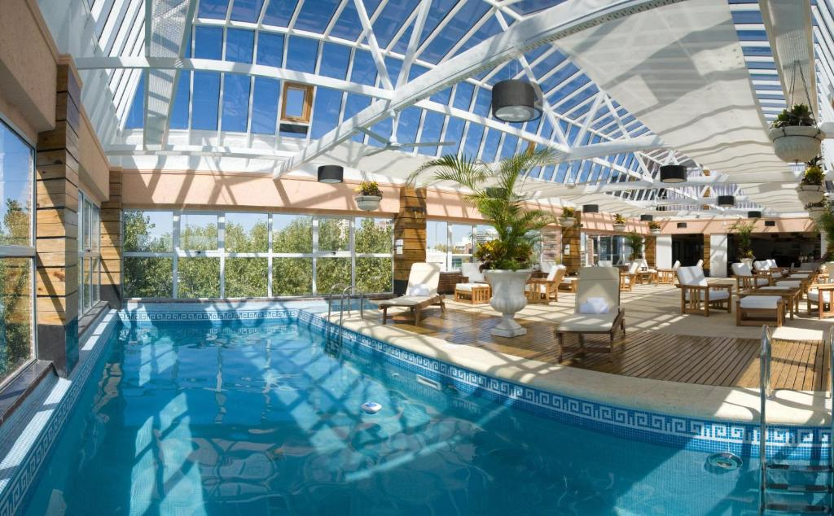
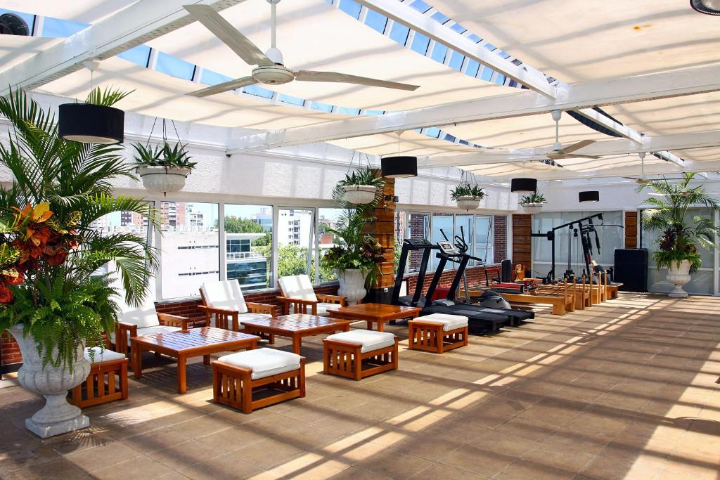
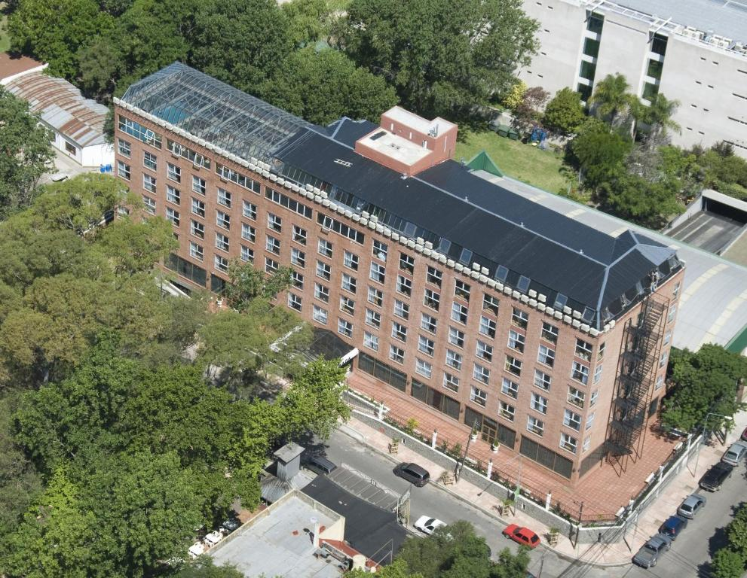

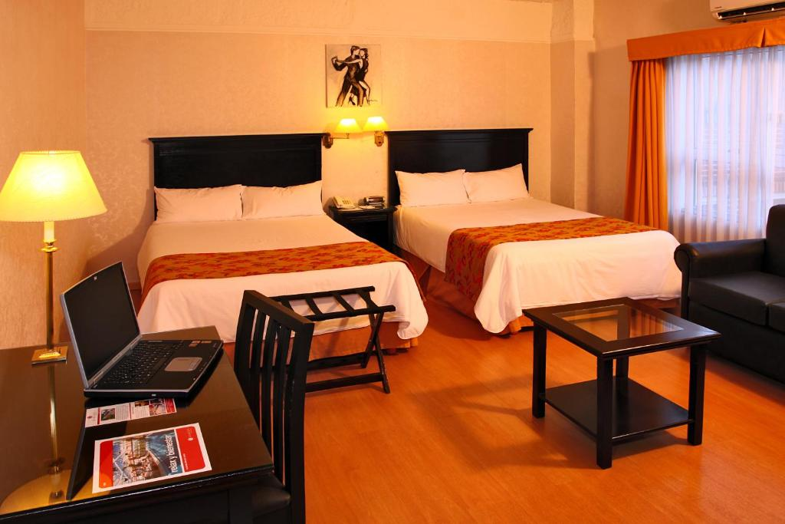
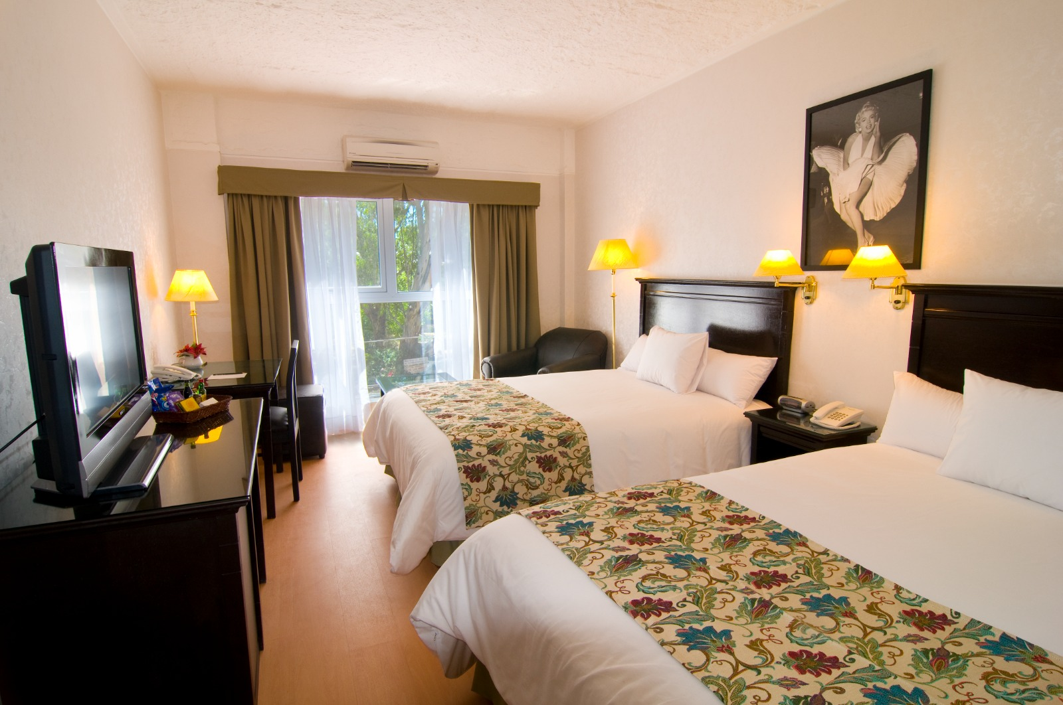
-

- Rooms will be assigned on a first-come, first-served basis.
- Breakfast, lunch, dinner and daily transfer to and from the stadium are included in the accommodation price.
- Lunch will be served at the competition arena.

Important note: See the accommodation page for detailed hotel information. Complete all required sections in WAREOS and make full payment for tickets and accommodations by the specified deadlines. Bank transfers only, no credit cards will be accepted. In addition, the LOC will be responsible for providing any event information at this hotel and providing transportation to official competition and training venues, as well as official meetings.
TRANSPORTATION
Transportation will be provided from Ministro Pistarini International Airport (Ezeiza), Aeroparque Jorge Newbery or the Fluvial Terminal in Buenos Aires City, to the official hotel, if booked through WAREOS, according to the established deadlines.
A pick-up/drop-off fee of 30 € per person per trip will be charged.
Shuttle service to the event will be available between the official hotel and the competition venue from August 29th. Transportation schedules to be confirmed.
Visa

All participants requiring a visa to enter the Republic of Argentina must complete the Visa Support sections of WAREOS no later than June 30, 2023.
It is the responsibility of applicants to provide the necessary information, ensuring that all details are up to date, correct and submitted by the specified deadlines. All participants requiring a visa are requested to submit a copy of their most recent or valid passport. Copies of each application can be uploaded to WAREOS.
All copies of passports and personal data entered/uploaded into WAREOS will be kept securely and in strictest confidence and will not be shared with other parties.
PAYMENT TERMS AND CONDITIONS
All fees paid by bank transfer will be in EUROS (€).
Complete all the necessary sections in WAREOS and make full payment within the specified deadlines. Bank transfers only. Credit cards will not be accepted. All bank charges will be paid by the participants.
Registration fees must be paid in full prior to arrival.
To confirm hotel reservations, a minimum deposit of 50% of the total amount is required to be transferred to the LOC before July 1th, 2023. Reservations after this date will be considered only according to availability. The final outstanding balance will be made by bank transfer before July 31, 2023.
Accommodation is not guaranteed after this period. An invoice prepared by WAREOS will be provided.

BANK INFORMATION FOR ACCOMMODATION, TRANSPORTATION AND REGISTRATION:
- A/C Name: Francesca Baruzzi FARRIOL
- Bank: Deutsche Bank
- Account number: 0019 0511 4149 3001 2992
- SWIFT/BIC: DEUTESBBXXX
- IBAN code: ES31 0019 0511 4149 3001 2992
- City: Barcelona, España

NOTE: ALL PAYMENTS MADE BY BANK TRANSFER WILL BE IN EUROS (€).
All bank charges will be paid by the participants. CREDIT CARDS ARE NOT ACCEPTED.
CANCELLATIONS AND CHANGES
All cancellations and changes must be made through WAREOS / Open WAREOS:
- For cancellations received before July 31, 2023, a full refund of the deposit payment will be made.
- For cancellations received after July 31, 2023, no refund will be issued.
- Refunds will be processed after the event.
- Name changes to team officials or athletes (same category) will be accepted up to two (2) days prior to the official practice without any additional charge or penalty, after this, there will be a surcharge (see page 5).
- If the flight arrival details change at the last minute, please contact the Organizing Committee using the e-mail indicated in the Team Manager's brochure.
- If a participant's arrival is later than the originally scheduled arrival date, the room will be charged from the date of the original booking in WAREOS.
- An e-mail will automatically notify the Organizing Committee and the Member Association of any changes made in WAREOS.
PRACTICE
Practice facilities will be available beginning August 29, 2023 at the official competition stadium located approximately 20 minutes from the official hotel. Transportation to the practice field will be available beginning August 29, 2023 at no additional cost. Available times for unofficial practice will be announced once all registrations and flight plans have been received.

WEATHER
Temperatures at this time are expected to range between 11 and 18 degrees Celsius. On average there are 6 days of precipitation in the month of September.
ACCREDITATIONS:
In order to carry out an orderly accreditation process, each registrant is requested to send to the LOC e-mail address, a 6cmX6cm photo, color, front view, with the face visible.
• E-mail: panam-indoor@fatarco.com
The file should be .jpeg and should be named as follows:
COUNTRY_LASTNAME_PASSPORT
For example: ARG_ROMERO_AAA2540001
Photo files for accreditation will be received until July 31, 2023.

MEDIA REGISTRATION
Media representatives can apply for registration by sending an e-mail to info@archery.sport
Internet

It will be available at the official hotel free of charge (in hotel rooms and in the lobby). Wi-Fi will also be available to access the results in the stadium.
hydration
Each participant will receive 1 reusable bottle and will be able to obtain mineral water from the dispensers that will be available in the different areas of the stadium.
ADDITIONAL INFORMATION
LOC CONTACT
- Name: Paula GERGO
- E-mail: panam-indoor@fatarco.com
- Language: Spanish/ English
- Phone number with international extension: +54 9 11 4174-0452

