TO ALL World Archery Member Associations

Dear Association President,

We invite you to the ‘Gwangju 2022 Hyundai Archery World Cup Stage 2’ to be held in Gwangju, Korea from May 16 to May 22, 2022.

After successfully hosting the 2015 FISU Summer Universiade and the 2019 FINA World Aquatics Championships, Gwangju Metropolitan City is growing one step further as an international sports city. In December 2021, Gwangju was chosen to host the Gwangju 2022 Hyundai Archery World Cup Stage 2 and 2025 World Archery Championships.

Gwangju Metropolitan City is an archery city that has produced a total of six Olympic gold medalists, including Hyang-soon Seo of the 1984 Los Angeles Olympics, Bo-bae Ki of the 2012 London and 2016 Rio de Janeiro Olympics, and San An of the 2020 Tokyo Olympics.

In particular, ‘Gwangju International Archery Center’ which will be the main stadium of the world cup, is an excellent archery facility built in 2015 with international standards. We are making our utmost efforts to prepare for the optimal condition for all participants, so they will be able to show their best performances at the ‘Gwangju International Archery Center’.

Gwangju is an economically and culturally well-balanced city.
The city is Korea's base for automobiles and premium home appliances production and also a developing Korea's Silicon Valley with cutting-edge artificial intelligence (AI) industry.
At the same time, Gwangju is a modern art city represented by the 'Gwangju Biennale’ while inheriting and developing traditional arts.

We wish to meet you in Gwangju this May, under its spring sun that Koreans love the most.

The Gwangju 2022 Hyundai Archery World Cup stage 2 in Gwangju will provide a special and attractive experience for archers.

Thank you.

Yong-seop Lee
Chairman of LOC

Important Dates:

Please find enclosed detailed information regarding this event. To register participation, please complete all the necessary sections in WAREOS(http://extranet.worldarchery.sport) within the deadlines listed below.

Summary of deadlines:

Registration Opening date on WAREOS | 7 February 2022
Preliminary Entries | 16 February 2022
Final Entries | 25 April 2022
Hotel reservation down-payment (50%) | 16 March 2022
Hotel reservation and payment | 25 April 2022
Transportation | 25 April 2022
Visa support | 15 April 2022
Full refund cancellation deadline  *After this deadline, the LOC is allowed to retain all amounts due by the Member Association. | 12 April 2022

Please respect the stated deadlines.

PRELIMINARY PROGRAMME

14 May 2022  Saturday | Arrival of participants  Practice field and local transport available
15 May 2022  Sunday | Arrival of participants  Practice field and local transport available
16 May 2022  Monday | Arrival of participants  Practice field and local transport available
17 May 2022  Tuesday | Official Practice & Qualification Round  Official Practice  Compound 50m Round
18 May 2022  Wednesday | Team Eliminations & Qualification  Compound Team Matches & Recurve Qualifications
19 May 2022  Thursday | Individual Eliminations  Team Eliminations  (Recurve Team Matches and Compound Individual Matches)
20 May 2022  Friday | Mixed Team Eliminations & Individual Eliminations  (Mix Team Matches and Recurve Individual Matches)
21 May 2022  Saturday | Finals – Compound
22 May 2022  Sunday | Finals – Recurve
23 May 2022  Monday | Departure of teams

NOTE: This preliminary programme is subject to change according to participation and TV requirements. All changes will be published and distributed in good time.

PRELIMINARY & FINAL REGISTRATION
All entries, accommodation reservations, transport needs, flight arrival/departure information and visa invitation letter requests are to be completed using the World Archery Online Registration System WAREOS https://extranet.worldarchery.sport. This system handles the entire registration process for this event. No entry forms, hotel reservations or transportation forms will be accepted; all information must be entered into WAREOS.

Member associations can login to WAREOS at https://extranet.worldarchery.sport with the username and password assigned by World Archery. After entering WAREOS, selecting the event from the list will allow a member association to register their athletes. Select/press the “Entries” button to see the list of categories in the event. Select/press the “category” to enter the athlete and official numbers/details participating for that event. A WAREOS User Manual can be downloaded in PDF format (English) upon login.

Contact wareos@archery.sport with any questions regarding technical problems on WAREOS. For any question regarding the organisation of the event (transport, accommodation, meals, invoices, visa etc.) please contact directly the LOC.

A maximum number of 4 athletes per country can be registered into each category of the event. Preliminary entries should be completed using WAREOS.

Member Associations can only use WAREOS to make any changes or amendments to entries and will be able to do so at any time. An email will automatically notify the Organising Committee and Member Association of any changes made in WAREOS.

NOTE: Guideline on Quarantine Exemption: Pre-departure and Day1 test

▪ Eligibility: Delegations of foreign athletes and officials for international sporting events held in Republic of Korea(as of January 28, 2022) are subject to exemption from quarantine on following conditions.
- Applicants must submit proof of two negative COVID-19 PCR tests taken prior to their
departure(Pre-departure) and within 24 hours of their entry(Day1).
(PCR test in Korea will be arranged by LOC or Korean government by free of charge)
※ Conditions for Quarantine Exemption are subject to change according to Korean government’s response to COVID-19
ENTRY FEES

Individual 250 USD per athlete
Official 125 USD per person
Guest 250 USD per person
VIP guest 300 USD per person

Archers and team officials who only stay in the official hotels can participate in the competition due to the COVID-19 countermeasures.

Entry fees for individual/Official include daily local transport to and from the practice field to/from official hotels during the qualification, elimination and finals venues (timetable to be confirmed on site).

Entry fee for guest includes daily local transport to and from the practice field to/from official hotels during the qualification, elimination and finals venues. They have no field of play access.

Entry fee for VIP guest includes daily local transport to and from the practice field to/from official hotels during the qualification, elimination and finals venues. They have no field of play access.

Any changes that are made after the deadlines specified or if entries differ by more than 4 athletes from the preliminary entries, the following penalty fees will automatically be applied.

PENALTY FEES TO BE PAID TO ORGANISING COMMITTEE (USD)

Penalty fees for Late Entries (after final deadline): | 50 per entry
Penalty fees for not filling Preliminary entries | 150 per entry
Penalty fee for differences between preliminary and final entries:  *If the difference between final and preliminary entries number is more than 4 athletes/officials | 150 per entry

PENALTY FEES TO BE PAID TO WORLD ARCHERY (CHF)
Lost / Damaged accreditation | 30.- each
Lost classification card | 30 .-each
Any change to the final country entry list, such as (but not limited to):  - Athlete or official name change  - Date of birth change  - Official position change  - Absence or incomplete on-site contact person | 50.- each  change

NOTE: CHF currency exchange rates will be those on the date of the event.

Member Associations that have penalty fees outstanding from 2021 will need to have paid these penalty fees before being eligible to enter and compete.

Any entries received less than 3days before the team managers meeting for a Hyundai Archery World Cup or World Championships will be refused if no preliminary entry and/or final entry are made prior. This decision cannot be appealed by the teams and is fully compliant with the current World Archery rules, article 3.7.1.2. Entries received after the deadlines, are subject to penalties as clearly stated in the rule book and the invitation documents of World Cups and World championships. A Member Association that has made final entries in WAREOS and does not participate will be invoiced for the number of entries entered in the system, unless they have informed World Archery and the Organising Committee in writing at least one week prior to the event that they are unable to attend.

ACCOMMODATION
UTOP Boutique Hotel & Residence
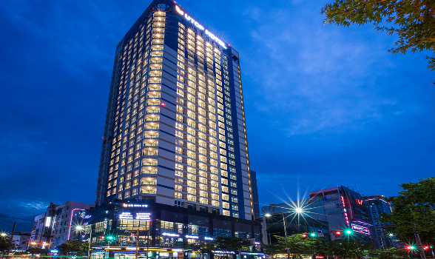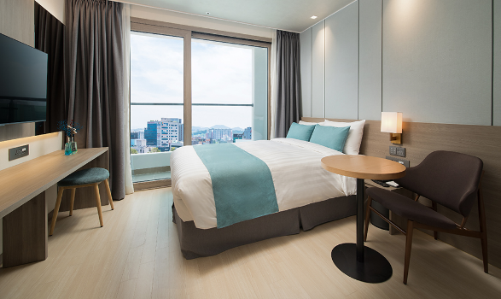
- Single Room price: USD 125.00 per room
- Number of rooms: 250
- Double/Twin Room price: USD 175.00 per room
- Number of rooms: 20
- Board plan: full board
- Check-in from 14.05.2022, 15:00
- Check-out 24.05.2022, 11:00
- Hotel website: https://www.utopboutique.com
Dubai Hotel
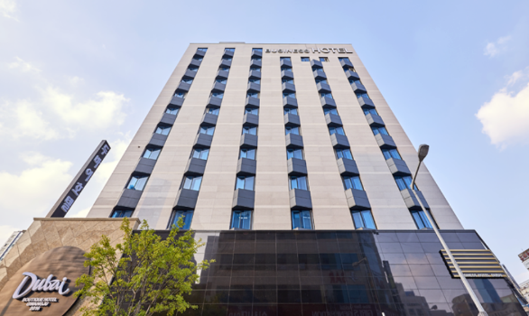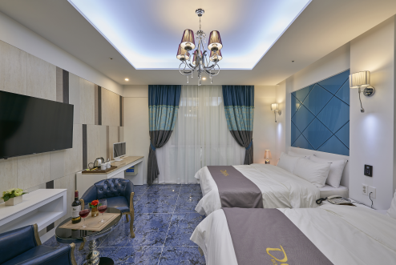
- Single Room price: USD 140.00 per room
- Number of rooms: 20
- Double/Twin Room price: USD 205.00 per room
- Number of rooms: 36
- Board plan: full board
- Check-in from 14.05.2022, 15:00
- Check-out 24.05.2022, 11:00
- Hotel website: http://dubaihotel.kr

Holiday Inn Gwangju Hotel
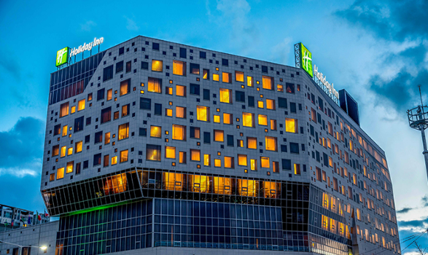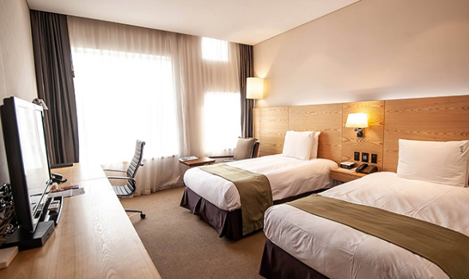
- Single Room price: USD 210.00 per room
- Number of rooms: 10
- Double/Twin Room price: USD 310.00 per room
- Number of rooms: 29
- Board plan: full board
- Check-in from 14.05.2022, 15:00
- Check-out 24.05.2022, 12:00
- Hotel website: https://higwangju.com

Rooms are allocated on a first come, first serve basis. Accommodation includes breakfast, lunch and dinner with non-alcoholic drinks.

TRANSPORTATION
Transportation will be provided from Incheon international airport to the official hotel, from two days before the official practice day until two days after the closing day at 20 USD price for one way. Local transport will be available between the official hotel, practice and competition venues for free. Transport timetables will be confirmed.

VISA
All participants who need an entry visa to Republic of Korea, will be required to complete the Visa Support sections in WAREOS by no later than 15 April 2022.

It is the applicants’ responsibility for supplying the necessary information, ensuring all details are up to date, correct and submitted by the deadlines specified.

In addition, all participants that require a visa are kindly requested to supply a copy of their latest/valid passport. Copies of each application can be uploaded on WAREOS. All passport copies and personal details entered/uploaded to WAREOS will be held securely and in the strictest of confidence and not shared with other parties.

PAYMENT CONDITIONS
Complete all necessary sections in WAREOS and make full payment by the specified deadlines. Bank transfers only, no credit cards will be accepted. All bank charges will be paid by the participants.

The entry fees should be paid in full before arrival.

To confirm hotels reservations, a minimum 50% deposit of the total amount is required to be bank transferred to the LOC before 16 March 2022. Reservations after this date will be considered only according to availability. The final outstanding balance shall be made via bank transfer before arrival. Accommodation cannot be guaranteed after this deadline. A cost summary will be available through WAREOS.

BANK INFORMATION FOR ACCOMMODATION, TRANSPORTATION AND ENTRY FEES
BANK ACCOUNT: GWANGJU ARCHERY ASSOCIATION
BANK: KWANGJU BANK
ACCOUNT NO: 1307-020-162461
SWIFT CODE: KWABKRSE

NOTE: ALL PAYMENTS SHALL BE MADE IN USD.

CANCELLATIONS & CHANGES
All cancellations and changes must be made through WAREOS :

- Should flight arrival details change last minute, please contact the Organising Committee using the details indicated in the team managers’ booklet.
- If a participant’s arrival is later than the original scheduled arrival date, the room will be charged from the date of the original booking in WAREOS.
- An email will automatically notify the Organising Committee and Member Association of any changes made in WAREOS.

HEALTH REGULATIONS (COVID-19)
INFORMATION
- Everybody should follow the Government/public health authorities measures
(national and sport-specific regulations) and be aware of the travel restrictions
- For your information, Medical infrastructure/Hospital with proper care will be reachable within 15 minutes from the venue.

Medical emergency contact and location
HANIL HOSPITAL
Kijoong Joo. 137, Bongseonjungang-ro, Nam-gu, Gwnagju, 61688, Republic of Korea
+82-62-600-1012

- The COVID-19 test center is within 15 minutes from the venue.

COVID-19 test contact and location
NAMGU Public Health Center (COVID-19 TEST)
20-1, Bongseon-ro, Nam-gu, Gwnagju, 61697, Republic of Korea
+82-62-607-2264

ADDITIONAL INFORMATION

Training
A training field will be available starting on 14 May 2022 at the Football Center located approximately 20 minutes from the official hotels.

Weather
Temperatures in May are expected to range between 13 and 24 degrees Celsius. The average in the last few years has been 18 degrees Celsius.

Media Registration
Media representatives can apply for emailing at csb9330@gmail.com (LOC media contact) or at info@archery.sport.

Internet
Will be available in the official hotels for free (in hotel rooms and in the lobby). There will also be Wi-Fi available for access to results on venue.

Water
Each participant with receive clean bottles of water.
Bottled water will be available at the qualification and practice venues.

LOC CONTACT

Name: Su-bin Choi
Address: 111, Naebang-ro, Seo-gu, Gwangju, 61945, Republic of Korea
Email: csb9330@gmail.com
Language: English
Phone number with international extension: +82 62 613 1263

Looking forward to welcoming you in Gwangju, Republic of Korea.

