TO ALL WORLD ARCHERY MEMBER ASSOCIATIONS,

Dear presidents,

As president of the Ecuadorian Archery Federation (FETA), and in representation of the Local Organizing Committee (LOC) of the South American, Open Archery Championship 2023, to be held in Guayaquil, Ecuador from October 10 to 14, 2023, I wish to invite you to be part of one of the most important archery events to take place in the Americas in 2023.

This event is open to all World Archery member associations, and we will have separate awards in the open and South American events in the sub18, sub21, senior, and 50+ categories. The tournament will take place at the Alberto Spencer Stadium.

With the support of governmental, sports and city entities, we are working hard to provide your archers with an extraordinary experience within the field of competition, as well as a cultural opportunity to learn about our city, its hospitality, and traditions. It should be noted that the dates of the Championship coincide with the October festivities in honor of the independence of Guayaquil and different recreational activities, concerts, festivals and civic events are carried out.

Enclosed you will find all the necessary information to register for the 2023 South American Archery Championship, rates and fees, hotel reservations, tournament calendar, and other relevant information.

You can also contact us at: fetasudamericano2023@gmail.com for information or further questions. We hope to see you all in October!
Sincerely,

Guillermo Quiroga Neururen President
Ecuadorian Archery Federation

IMPORTANT DATES

Please find enclosed information regarding the details of this event and how to complete registration. To register the participation, please complete all the necessary sections in WAREOS (https://extranet.worldarchery.sport) within the deadlines listed below:

Summary of deadlines:

Start date for registration | Monday April 24th, 2023
Preliminary entries | Monday, July 10th, 2023
Final entries | Tuesday, September 19th, 2023
Late entry fees | Tuesday, September 19th, 2023
Hotel reservation and 50% payment | Monday, August 7th, 2023
Transfer request Airport-Hotel-Airport | Saturday September 23rd, 2023
Visa support | Monday August 7th, 2023
Final hotel reservation and payment | Sunday September 10th, 2023
Full refund cancellation deadline | Sunday September 17th, 2023

PRELIMINARY SCHEDULE

Date | Activity
Sat 7 and Sun 8 Oct | Arrivals
Mon, Oct 9th | Unofficial practice
Tue, Oct 10th | Official practice, Team Manager´s meeting and equipment inspection
Wed Oct 11th | Qualification round (all categories)
Thu, Oct 12th | Open Team and Mixed Team elimination and finals
Fri, Oct 13th | Open individual eliminations and Bronze matches
Sat, Oct 14th | Open individual finals
Sun, Oct 15th | Departure of teams

NOTE: This preliminary schedule is subject to change according to participation. All changes will be published and distributed in due time.

PRELIMINARY AND FINAL REGISTRATION

All entries, accommodation reservations, transportation needs, flight arrival/departure information and visa invitation letter requests must be completed using the World Archery Online Registration System WAREOS https://extranet.worldarchery.sport. This system handles the entire registration process for this event. Registration forms, hotel reservations or transportation forms will not be accepted; all information must be entered in WAREOS.

Member associations can log in to WAREOS at http://extranet.worldarchery.sport with the username and password assigned by World Archery. After logging into WAREOS, select the event from the list which will allow you to register your athletes. Select/press the “Entries” button to view the list of categories in the event. Select/press the “category” to enter the numbers/details of athletes and officials who will participate in that event. A WAREOS User Manual can be downloaded in PDF format (English) at login.

Please contact (wareos@archery.sport) if you have any questions about technical issues in WAREOS. For any question related to the organization of the event (transport, accommodation, meals, etc.) please contact the LOC directly.

There is no limit in the number of athletes a country can register in each category.

Member Associations can only use WAREOS to make any changes or amendments to entries and will be able to do so at any times. An email will automatically notify the Organising Committee and Member Association of any changes made in WAREOS.
Archers registered by their national associations on WAREOS will be expected to pay an international license to World Archery. The cost of the license is 100 CHF.

Other athletes (not competing as country but only as club) can register on Open WAREOS at https://extranet.worldarchery.sport/ with their username and password if already registered in the past or register to get the log in details if it’s the first time. After the creation of the profile, follow the instructions to register to the event. Contact (wareos@archery.sport) in the World Archery Office with any questions regarding technical problems on WAREOS. For any question regarding the organization of the event (transport, accommodation, meals etc.) please contact directly the LOC.

EVENTS

The South American Open Championship will include individual, team and mixed team events, in the categories:

  - Recurve Men and Women – RM y RW
  - Recurve Under 21 Men and Women – RU21M y RU21W
  - Recurve Under 18 Men and Women – RU18M y RU18W
  - Recurve 50+ Men and Women – R50M y R50W
  - Compound Men and Women – CM y CW
  - Compound Under 21 Men and Women – CU21M y CU21W
  - Compound Under 18 Men and Women – CU18M y CU18W
  - Compound 50+ Men and Women – C50M y C50W Each archer may participate in one category only. Two awards will be made:
- South American Competition: Only athletes from World Archery member associations from South America. Prizes will be awarded for the results of the qualifying round.
- Open competition: All registered World Archery member associations.

ENTRY FEES

Individual: | US$100 per athlete
Officials: | US$90 per person
ENTRY FEES in NON-OFFICIAL HOTELS
Individual: | US$200 per athlete
Officials: | US$180 per person

Any changes that are made after the deadlines specified or if entries differ by more than 4 athletes from the preliminary entries, the following penalty fees will automatically be applied:
Penalty fees to be paid to Organizing Committee: | Cost (USD):
Entries made after the preliminary and/or final entry deadline date. | 50 per entry
If final entries differ from the preliminary entries by more than 4 athletes/officials. | 150 per entry
Failure to have made preliminary entries before the deadline date but then have submitted final entries. | 150 per entry

ACCOMODATION & GENERAL INFORMATION

Rooms are allocated on a first-come, first-served basis. All lodging rates include breakfast, lunch, dinner, and airport-hotel-airport transfers. Breakfast and dinner will be served at the hotel. Lunch will be served at the sports complex where the competition will take place from October 10th to 14th.

Accommodation rates INCLUDE daily local transportation to/from the competition field to/from the official hotels during the events of, official practice, qualification, elimination, and finals (times to be confirmed).

Teams that do not arrange their accommodation with the Organizing Committee will not have the right to:

  - Transfers to and from the airport
  - Transfers to and from the competition field.
  - Lunch provided on the field.
  - Breakfasts and dinners provided at the official hotels.

Important note: Please refer to the accommodation pages for detailed hotel information. Complete all required sections in WAREOS and make full payment for entries and accommodation by the specified deadlines. Bank transfers only. Credit cards will not be accepted.

In addition, the LOC will not be expected to provide any event information at any self-arranged hotels nor to provide transportation to the venue.

SHERATON GUAYAQUIL HOTEL

Single room full board: | US$ 150.00 per room per day
Number of single rooms: | 8
Double room full board: | US$ 240.00 per room per day
Number of doble rooms: | 28
Check-in from: | October 7th, 15:00
Check-out until: | October 15th, 11:00
Hotel website:
https://www.espanol.marriott.com/hotels/travel/gyesi-sheraton-guayaquil-hotel/

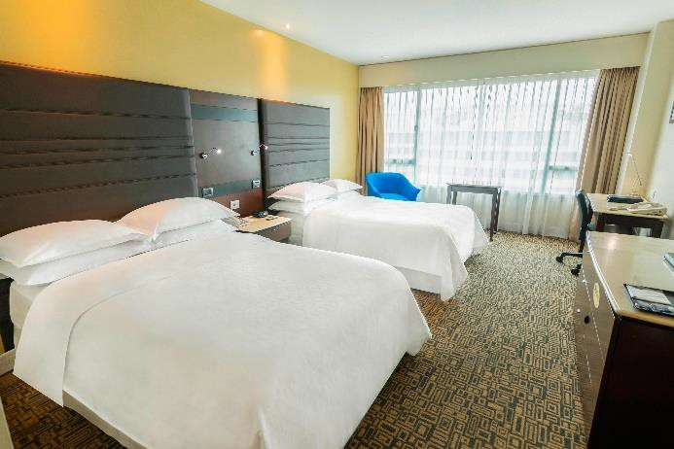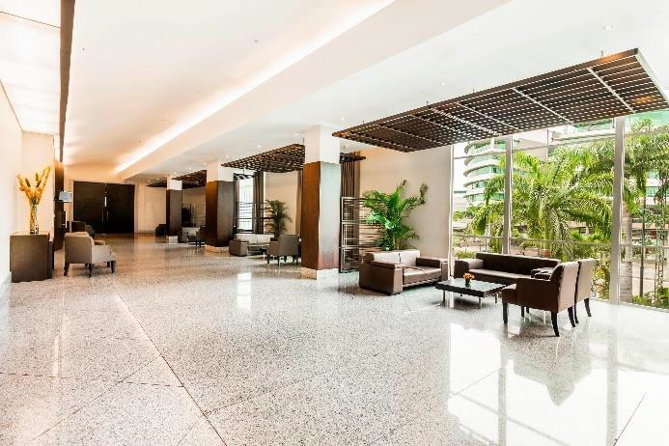

WYNDHAM GARDEN GUAYAQUIL HOTEL

Single room full board: | US$ 150.00 per room per day
Number of single rooms: | 8
Double room full board: | US$ 240.00 per room per day
Number of doble rooms: | 30
Check-in from: | October 7th, 15:00
Check-out until: | October 15th, 11:00
Hotel website:
https://www.wyndhamhotels.com/wyndham-garden/guayaquil-ecuador/wyndham-garden- guayaquil/overview?hotel_id=15935

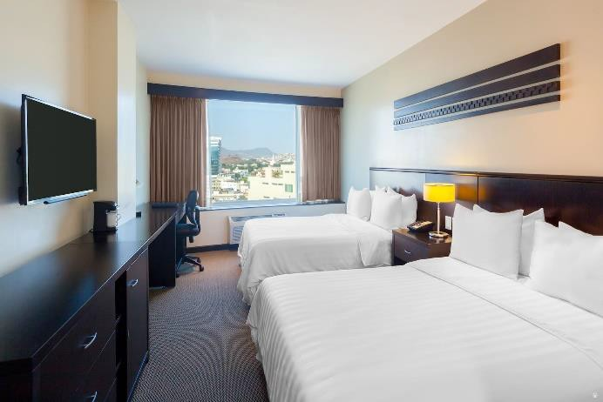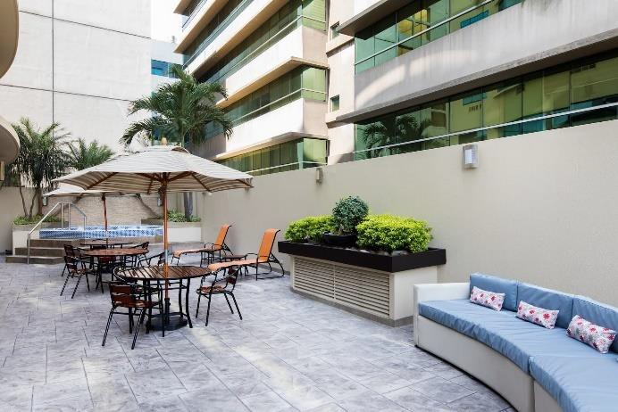

COURTYARD GUAYAQUIL HOTEL

Single room full board: US$ 130.00 per room per day

Number of single rooms: | 10
Double room full board: | US$ 200.00 per room per day
Number of doble rooms: | 29
Check-in from: | October 7th, 15:00
Check-out until: | October 15th, 11:00
Hotel website:
https://www.marriott.com/es/hotels/gyecy-courtyard-guayaquil/overview/

TRANSPORTATION

Transportation will be provided from José Joaquín de Olmedo International Airport of Guayaquil to the official hotels, if booked through WAREOS, within the specified dates.

Event transportation will be available between the official hotels and the competition venue starting October 9th. Transportation schedules will be confirmed.

VISA

All participants who need an entry visa to Ecuador will be required to complete the Visa Support sections in WAREOS by no later than August 7th, 2023. It is the responsibility of the applicants to provide the necessary information, ensuring that all details are up to date, correct and submitted by the deadlines specified.

All participants that require a visa are kindly requested to supply a copy of their latest/valid passport. Copies of each application can be uploaded on WAREOS. All passport copies and personal details

entered/uploaded to WAREOS will be held securely and in the strictest of confidence and not shared with other parties.

PAYMENT CONDITIONS

Complete all necessary sections in WAREOS and make full payment by the specified deadlines. Bank transfers only. No credit cards will be accepted. All bank charges will be paid by the participants.

The entry fees should be paid in full before arrival.

To confirm hotels reservations, a minimum 50% deposit of the total amount is required to be bank transferred to the OC before August 7th, 2023. Reservations after this date will be considered only according to availability. The final outstanding balance shall be made via bank transfer by September 10th, 2023. Accommodation cannot be guaranteed after this deadline. A balanced invoice will be provided via WAREOS.

BANK INFORMATION FOR ACCOMMODATION, TRANSPORTATION AND ENTRY FEES

The bank details for the transfer are in the name of:

A/C name: | FEDERACION ECUATORIANA DE TIRO CON ARCO
Bank: | Banco Bolivariano
Account number: | 0855053013
Swift code: | BBOLECEGXXX
Bank’s Address: | Banco Bolivariano Junín 200 y Panamá Guayaquil, EC090306 Ecuador
Bank’s phone: | +593 4 230 5000 / +593 4 550 5050

NOTE: ALL PAYMENTS SHALL BE MADE IN USD BY BANK TRANSFER.

All bank charges will be paid by the participants. CREDIT CARD are not accepted.

CANCELLATIONS & CHANGES

All cancellations and changes must be made through WAREOS:

  - Cancellations received before September 17th, 2023, a full refund of the deposit payment will be made, discounting administrative and bank costs.
  - Cancellations received after September 17th, 2023, no refund will be given.
  - Refunds will be processed after the event.
  - Name changes to team officials or athletes (same category) will be accepted up to two (2) days before the official practice without any additional charge or penalty, if it is after this, they will have a cost of 50 USD.
  - Should flight arrival details change last minute, please contact the Organizing Committee using the details indicated in the team managers’ booklet.
  - If a participant’s arrival is later than the original scheduled arrival date, the room will be charged from the date of the original booking in WAREOS.
  - An email will automatically notify the Organising Committee and Member Association of any changes made in WAREOS.

HEALTH REGULATIONS

Participants are understood to be athletes, coaches, officials, judges, volunteers and all personnel who are present during the event.

All participants must follow the health regulations established by local and national authorities, as well as those specific to the sport, and be aware of travel restrictions.

For more information or updated requirements visit the websites:

  - http://www.tagsa.aero
  - https://www.gestionderiesgos.gob.ec/coe-nacional/
  - https://www.salud.gob.ec/

PERSONAL HYGIENE AND HEALTH

  - Anyone due to participate in the event who is feeling ill should not attend.
  - Participants should proactively and regularly monitor their health status (including taking their temperature and monitoring for any symptoms).

  - Stay home and self-isolate even with minor symptoms for 10 days or more depending on national protocols, when showing any symptoms (fever, tiredness, dry cough, headache, nasal congestion, runny nose, sore throat, difficulty breathing).
  - Contact a healthcare provider immediately if any respiratory illness is noted.
  - As of February 28, 2023, according to the sanitary regulations in Ecuador, the use of a mask in closed spaces will be mandatory in the case of health centers, hospitals, and health establishments. Check the official sites for updated information.
  - Regularly and thoroughly clean your hands with an alcohol-based hand rub or wash them with soap and water.
  - Avoid touching your eyes, nose and mouth.
  - Cover your mouth and nose with your bent elbow or tissue when you cough or sneeze. Then dispose of the used tissue immediately and wash your hands.
  - Avoid touching high-contact surfaces such as door handles, walls, windows, etc.
  - Avoid crowded places.
  - Avoid steam rooms or saunas.
  - No spitting, as the main mode of transmission of the virus is in respiratory secretions.
  - Athletes should not share clothing, bar soap, sports equipment, water bottles or other personal items.

ADDITIONAL INFORMATION

TRAINING

The competition field will be available for training on October 9, 2023. There will be transportation to and from the official hotels. Schedules will be announced in due course.

WEATHER

Due to its location, Guayaquil's climate is warm almost all year round. For the month of October, the temperature oscillates between 21 and 30 degrees Celsius, with a relative humidity of 57% and there are no rains.

INTERNET

The hotels have WiFi internet in rooms and in public areas of the hotel. Internet service will not be provided at the shooting range.

WATER

Each participant will receive clean bottles of water. Bottled water will be available.

LOC CONTACT

  - Correo: fetasudamericano2023@gmail.com
  - Guillermo Quiroga: +593 997002916
  - Juan Sánchez Rugel: +593 993300270
  - Web: www.feta.org.ec
  - Facebook, Instagram y Twiteer: fetaecuador

Federación Ecuatoriana de Tiro con Arco
Av. De Las Américas s//n
Edif. Comité Olímpico Ecuatoriano Guayaquil, EC090510
Ecuador

