TO ALL World Archery Member Associations

Dear President,

As Chairman of the Local Organizing Committee (LOC) for the 2023 Kahraman Bagatir Spring Arrows Archery Tournament (World Ranking Event) which will be held on 27 – 31 March 2023 in Antalya-TURKEY, I would like to invite and welcome your Association to participate in our event.

This competition will be organized following the World Archery rules for, in both divisions: Recurve and Compound.

Sincerely yours,

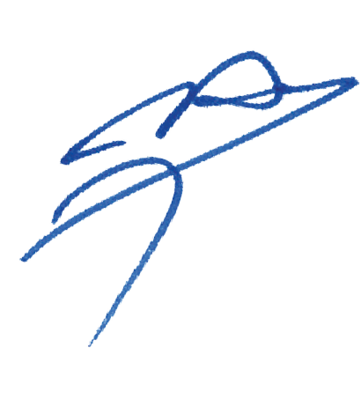

Husnu KOCAOGLU
Chairman of LOC

Important Dates:
Please find enclosed information regarding the details of this event and how to complete registration. To register participation, please complete all the necessary sections in WAREOS within the deadlines listed below:

Summary of deadlines:

Registration Opening date on WAREOS | 20 December 2022
Preliminary Entries | 07 January 2023
Final Entries | 06 March 2023
Hotel reservation down-payment (50%) | 07 January 2023
Hotel reservation and payment | 06 March 2023
Transportation | 06 March 2023
Visa support | 01 March 2023
Full refund cancellation deadline  *After this deadline, the LOC is allowed to retain all amounts due by the Member Association. | 25 March 2023

Looking forward to welcoming you in Antalya, TURKEY.

PRELIMINARY PROGRAMME

25 March 2023  Saturday | Arrival of participants  Practice field and local transport available
26 March 2023  Sunday | Arrival of participants  Practice field and local transport available
27 March 2023  Monday | Official Practice & Equipment Inspection  Recurve & Compound
28 March 2023  Tuesday | Qualification Round  Recurve 70m Round  Compound 50m Round
29 March 2023  Wednesday | Individual Eliminations  Recurve & Compound
30 March 2023  Thursday | Team & Mix Team Eliminations  (Team & Mix Team Matches)
31 March 2023  Friday | Finals – Recurve & Compound
01 April 2023  Saturday | Departure of Teams

NOTE: This preliminary programme is subject to change according to participation and TV requirements. All changes will be published and distributed in good time.
PRELIMINARY & FINAL REGISTRATION

All entries, accommodation reservations, transport needs, flight arrival/departure information and visa invitation letter requests are to be completed using the World Archery Online Registration System WAREOS https://extranet.worldarchery.sport. This system handles the entire registration process for this event. No entry forms, hotel reservations or transportation forms will be accepted; all information must be entered into WAREOS.

Member associations can login to WAREOS at http://extranet.worldarchery.sport with the username and password assigned by World Archery. After entering WAREOS, selecting the event from the list will allow a member association to register their athletes. Select/press the “Entries” button to see the list of categories in the event. Select/press the “category” to enter the athlete and official numbers/details participating for that event. A WAREOS User Manual can be downloaded in PDF format (English) upon login.

Contact wareos@archery.sport with any questions regarding technical problems on WAREOS. For any question regarding the organisation of the event (transport, accommodation, meals, invoices, visa etc.) please directly contact the LOC.

Athletes from a minimum of 4 different Member Associations shall be registered and participate in the event.

A maximum number of six (6) athletes per country can be registered into each category and divisions of the event.

Member Associations can only use WAREOS to make any changes or amendments to entries and will be able to do so at any time. An email will automatically notify the Organising Committee and Member Association of any changes made in WAREOS.

Regulations for Club Archers participating

Club archers (i.e. athletes not competing as country) can register on Open WAREOS with their
username and password if already registered in the past or register to get the log in details if it’s
the first time. After the creation of the profile, follow the instructions to register to the event.

This does not guarantee his/her participation. The process of registration and inclusion must
respect the Club Archers’ regulations and procedures to be able to participate to this event.
Club Archers participating in WRE event must be members of a WA Member Association (therefore official members of the Archery Federation of his/her country). The athlete’s national federation will be able to veto the entry if required.

DRESS REGULATIONS: Club Archers must respect WA rules (Book 1, point 3.22) in terms of uniform for the WA events. Club Archers cannot use any National Team uniform (neither of his country nor any other).

Club Archer must be present in the Official Practice Day when he will pick up his/her accreditation, confirm name and data given and pass the equipment inspection. The Club Archer is not allowed to miss the official practice and arrive directly to the qualification day. Travel plan should be arranged according to the schedule.

ENTRY FEES

Individual 200 EUR per athlete
Official 100 EUR per person
Teams 100 EUR per team (Mixed Team free of charge)

ENTRY FEES IN NON-OFFICIAL HOTELS

Individual 400 EUR per athlete
Official 200 EUR per person
Teams 200 EUR per team (Mixed Team free of charge)

Entry fees for individual/Official/Teams include daily local transport to and from the practice field to/from official hotels during the qualification, elimination, and finals venues (timetable to be confirmed on site).

Any changes made after the deadlines specified or if entries differ by more than 4 athletes from the preliminary entries, the following penalty fees to will automatically be applied:
PENALTY FEES TO BE PAID TO ORGANISING COMMITTEE
Penalty fees for Late Entries (after final deadline): | 50 per entry
Penalty fees for not filling Preliminary entries | 150 per entry
Penalty fee for differences between preliminary and final entries:  *If the difference between final and preliminary entries number is more than 4 athletes/officials  NOTE: CHF currency exchange rates will be those on the date of the event. | 150 per entry

Member Associations that have penalty fees outstanding from 2022 will need to have paid these penalty fees before being eligible to enter and compete.

Any entries received less than 3 days before the team managers meeting for a Hyundai Archery World Cup or World Championships will be refused if no preliminary entry and/or final entry are made prior. This decision cannot be appealed by the teams and is fully compliant with the current World Archery rules, article 3.7.1.2. Entries received after the deadlines, are subject to penalties as clearly stated in the rule book and the invitation documents of World Cups and World Championships. A Member Association that has made final entries in WAREOS and does not participate will be invoiced for the number of entries entered in the system, unless they have informed World Archery and the Organising Committee in writing at least one week prior to the event that they are unable to attend.

ACCOMMODATION & GENERAL INFORMATION
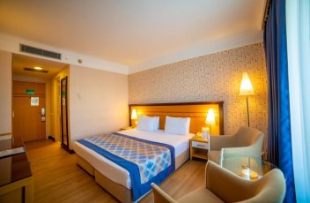
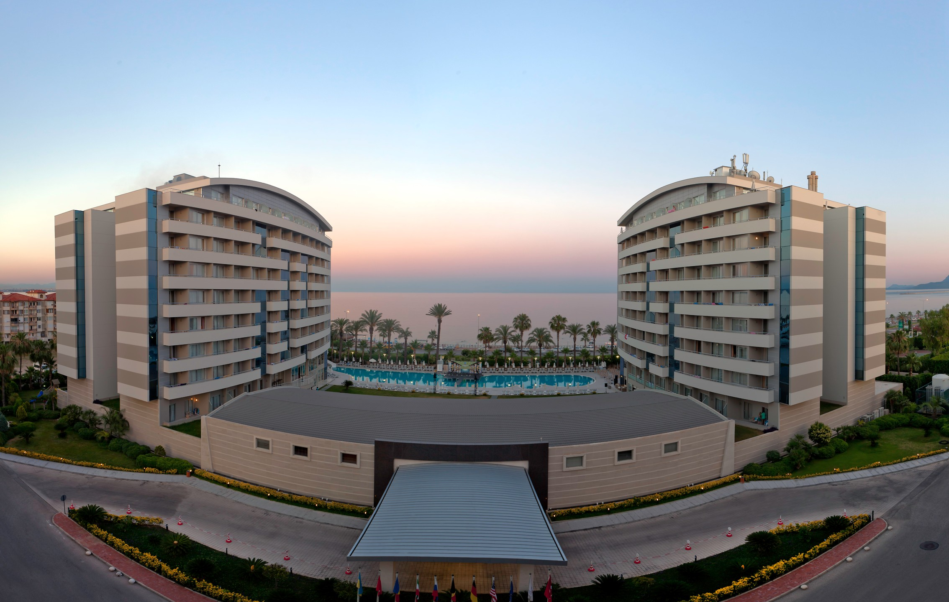
Porto Bello Hotel & Spa – Five Star Hotel
- Single Room price: EUR 200 per room
- Number of rooms: 50
- Double/Twin Room price: EUR 280 per room
- Number of rooms: 100
- Board plan: full board
- Check-in from 25.03.2023
- Hotel website: http://www.portobello.com.tr
Rooms are allocated on a first come, first serve basis. Accommodation includes breakfast, lunch, and dinner with non-alcoholic drinks.
Teams who do not reserve their accommodation through the organising committee will be charged a double entry fee.

In addition, the LOC will be responsible to provide any event information at this hotel and provide transportation to the venues. Private vehicles can be used too.

TRANSPORTATION
Transportation will be provided from Antalya airport to the official hotel, from two days before the official practice day and until two days after the closing day at 45 EUR price (one way). Local transport will be available between the official hotel, practice, competition venues for free. Transport timetables will be confirmed.

VISA
All participants who need an entry visa to Country, will be required to complete the Visa Support sections in WAREOS by no later than 01 March 2023.

It is the applicants’ responsibility for supplying the necessary information, ensuring all details are up to date, correct and submitted by the deadlines specified.

In addition, all participants that require a visa are kindly requested to supply a copy of their latest/valid passport. Copies of each application can be uploaded on WAREOS. All passport copies and personal details entered/uploaded to WAREOS will be held securely and in the strictest of confidence and not shared with other parties.

PAYMENT CONDITIONS
Complete all necessary sections in WAREOS/OPEN WAREOS and make full payment by the specified deadlines. Bank transfers only, no credit cards will be accepted. All bank charges will be paid by the participants. The entry fees should be paid in full before arrival.

To confirm hotels reservations, a minimum 50% deposit of the total amount is required to be bank transferred to the OC before 07 January 2023. Reservations after this date will be considered only according to availability. The final outstanding balance shall be made via bank transfer before arrival. Accommodation cannot be guaranteed after this deadline. A balanced invoice will be provided via WAREOS.

BANK INFORMATION for ACCOMMODATION, TRANSPORTATION and ENTRY FEES:

BANK ACCOUNT: | ANTALYA OKCULUK IHTISAS SPOR KULÜBÜ
BANK: | YAPI KREDI BANKASI
ACCOUNT NO: | 25086669
SWIFT CODE: | YAPITRIS
IBAN: | TR 03 0006 7010 0000 0025 0866 69

NOTE: ALL PAYMENTS SHALL BE MADE IN EUR BY BANK TRANSFER. CREDIT CARDS are not accepted.

CANCELLATIONS & CHANGES
All cancellations and changes must be made through WAREOS / Open WAREOS:
- Should flight arrival details change last minute, please contact the Organising Committee using the details indicated in the team managers’ booklet.
- If a participant’s arrival is later than the original scheduled arrival date, the room will be charged from the date of the original booking in WAREOS.
- An email will automatically notify the Organising Committee and Member Association of any changes made in WAREOS.

HEALTH REGULATIONS (COVID-19)
INFORMATION
- Everybody should follow the Government/public health authorities measures (national and sport-specific regulations) and be aware of the travel restrictions

Medical emergency contact and location
AKDENIZ SIFA HOSPITAL
Kuskavagi Mah. Ataturk Bulvari No 81 Konyaalti / ANTALYA – TURKEY
+ 90 444 7 606

ADDITIONAL INFORMATION
Training
A training field will be available starting on 25 March 2023 at the Konyaalti Ataturk Stadium approximately 10 minutes from the official hotels.

Weather
Temperatures in April are expected to range between 20 and 25 degrees Celsius. The average in the last few years has been 23 degrees Celsius.

Media Registration
Media representatives can apply for registration by emailing info@archery.sport

Internet
Will be available in the official hotels for free (in hotel rooms and in the lobby). There will also be Wi-Fi available for access to results on venue.

Water
Each participant with receive clean bottles of water.
Bottled water will be available at the qualification and practice venues.

LOC CONTACT
Name: Sirer AYDIN
Email: sireraydin@tof.gov.tr
Language: English
Phone number with international extension: + 90 533 515 25 33

