1) World Archery Introduction 4

2) World Archery Objectives 4

3) Event Description 4

4) Typical event schedule for Hyundai Archery World Cup Stage 5

5) Host City Opportunities 6

6) Host City Requirements 6

7) Venue requirements 6

8) Support and services from World Archery 7

9) Bid process (what is required) 7

10) Submission dates and timelines (4 years before the event) 7

11) Bid Evaluation 7

12) Contact Details 8

Appendix A - Venue requirements – Technical drawings 8

Appendix B - Application form 15

CANDIDATE DETAILS 16

ECONOMIC 16

EVENT DATES 17

MOTIVATION FOR HOSTING EVENT 17

ACCOMMODATION 17

TRANSPORT 19

CATERING 19

COMPETITION VENUE LAYOUT 20

VENUE SPACES AND SERVICES AVAILABLE 21

JUDGES 22

ANTI DOPING 22

SPECTATOR SERVICES 22

CEREMONY AND EVENTS 22

SPORTS EQUIPMENT 22

STAFF AND VOLUNTEER REQUIREMENT 23

MEDICAL 23

WEATHER CONDITIONS 23

ENVIRONMENTAL SUSTAINABILITY AND CORPORATE SOCIAL RESPONSIBILITY 23

MEDIA, TV BROADCASTING AND STREAMING 24

MARKETING & PROMOTIONAL PLAN 25

FINANCES 26

LEGAL 27

SUPPORT DOCUMENTS AND LETTERS 28

Document

* Please find enclosed bidding application for the Hyundai Archery World Cup Stage
* This application is for the World Archery member associations (national federations), host cities or local organising committees that are interested in bidding for this World Archery event.
* The bidding organisation understands that the information included within this application is a statement of commitment in what the host organiser is to deliver and to what level, should this application be awarded the event.
* World Archery will not allow any changes in relation to fees, costs, services or locations unless they can be justified. Furthermore, this application will become an integral part of the organisers agreement. All amounts should be expressed in local currency or as an alternative in EUR or USD.

# 1) World Archery Introduction

World Archery is the world governing body for the sport of archery, recognised by and a core sport of the International Olympic Committee (IOC) and International Paralympic Committee (IPC).

World Archery currently consists of 164+ Member Associations (national federations and associations), that are the governing bodies for archery in each country covering the continents of Africa, The Americas, Asia, Europe and Oceania.

World Archery serves to promote and regulate archery world-wide through its member associations and in conformity with the Olympic principles. Aims at initiating interpreting the World Archery rules in the organisation of World Championships, World Cups and other international multi sporting events incorporating Archery. World Archery promotes archery through various media channels and sponsors.

Archery, a true sport for all, has been part of the Olympic movement since 1900 and has been permanently present in the Olympic Games since 1972. World Archery has staged World Championships since 1931 and has progressively developed to eight disciplines since 1991. There is over 460,000 archers associated with the federation in the world. In 2006, World Archery launched the Archery World Cup circuit consisting of four stages and a final that will host the top 8 men and women in the world that qualify.

Although archery is considered a historical/traditional sport, the culture and vision of the World Plan is very much modern and open minded to new ventures.  World Archery is staging its collection of international events at iconic venues and new developing cities around the world, in an effort, to promote both the location and sport, while also providing education and entertainment for spectators.

Should your city or organisation wish to be involved with a dynamic, exciting and growing sport, please contact us to discuss further.

# 2) World Archery Objectives

* To ensure the Host City and Organising Committee have a positive experience and achieve their goals from hosting an archery event
* Create strong partnerships between the Host City, Organising Committee, National Federation and World Archery
* Present and deliver an archery event that is attractive to sponsors and other investors
* Engage the media and public support
* Generate a positive spectator experience
* To have an event with fair play and that is safe
* Assist the National Federation to grow an ongoing legacy of archery participation at all levels, recreational through to elite level

# 3) Event Description

The Hyundai Archery World Cup is the lead up to the Final of the Hyundai Archery World Cup competition and is the most important series of events on the World Archery Calendar.

The Hyundai Archery World Cup is a yearlong tour, consisting of four stages geographically located over currently 3 continents. Athletes, representing their national federations, compete in each stage to accrue world ranking points and qualify one of 7 places available.

World Archery contracts an event organiser to conduct each World Cup Stage. Within the framework established in this document, Hyundai Archery World Cup Stage bidders are also encouraged to develop visionary proposals that can enhance the scope, presentation, and marketing of the Hyundai Archery World Cup. It is a fundamental requirement that any Hyundai Archery World Cup organiser is fully aware of the concept, format and scope of the Hyundai Archery World Cup envisioned by World Archery.

World Archery’s objectives for the Hyundai Archery World Cup are:

* Involve top-level archers all year long comprising of four competition stages leading to the grand final (3 stages in Olympic Games’ year)
* Host finals separately at each stage in spectacular locations (downtown or tourist attractions that showcase the city). Two days of finals are required for compound finals on Saturday and recurve finals on Sunday.
* Develop a strong sponsorship platform.
* Showcase the cities location, engage target markets
* Give archery more media exposure worldwide.
* Have a ticketing policy integrated in the promotion.
* Engage, educate and entertain audiences at the event.
* Promote, and develop all to participate in archery from grassroots to elite level for future national legacy.

Based on these objectives, the Hyundai Archery World Cup has been designed to be the marquee series of events for World Archery.

Unfolding over a week, the Hyundai Archery World Cup stage will not only be a sporting competition, but also a visual spectacle and celebration for the city.

**Key figures:**

* Athletes: 180 - 380 (m 60%/f 40%)
* Athlete officials: 85 - 150
* Participating countries: 35 - 50 from all continents
* Event duration: 7 days
* Approximate dates: April – September
* Disciplines: 2, compound bow and recurve bow as used in the Olympic Games
* Medal events: 10
* Distances shot: 50m and 70m

Matches are shot one after the other from the semi-finals at the finals venue for individual rounds, all matches are fully televised and made available for international broadcast.

# 4) Typical event schedule for Hyundai Archery World Cup Stage

|  |  |
| --- | --- |
| **Days** | **Activity** |
| Monday | Arrival of athletes and judges. Practice facilities should be available. Inspection of the practice, warm up and finals venue ranges. |
| Tuesday | Official practice and qualification rounds |
| Wednesday | Eliminations and qualification rounds |
| Thursday | Elimination rounds |
| Friday | Elimination rounds |
| Saturday | **Compound Final** matches for individuals and mixed teams |
| Sunday | **Recurve Final** matches individual and mixed team |

The programme for the finals section of the competition consists of **two compact 2-hour sessions held on Saturday and Sunday morning and afternoons**, to keep the competition short and intense for maximum spectator and viewer experience.

# 5) Host City Opportunities

* Instant economic impact
* Opportunity to show iconic venues of the city / tourism impact
* Host international and national tourists
* Tickets and merchandise sales
* Advertising rights as agreed with World Archery
* Media and social media coverage (EuroSport, NBC, Claro, Sony pictures networks, KBS Korea, Facebook, Twitter, Instagram, YouTube, World Archery website)
* Unique sporting experience for the local community
* Development of an alternative sport for all that can be done at recreational and elite level
* Non-tangible benefits: Public involvement

# 6) Host City Requirements

* Staging fee (CHF 30,000)
* Venue capacity (min. 800)
* Local transportation for athletes, officials and World Archery staff
* Accommodation and travel costs for World Archery staff, officials and athletes
* Inspection visit costs, if required
* Event marketing and promotion
* Anti-Doping testing

# 7) Venue requirements

**Requirements for the practice venue:**

* A secure flat/level 32-target range is ideal. This range is in operation from the Monday of the event week. The practice range should be located at a walking distance from the main competition venue.
* Regular bus schedule between practice venue, competition venue and hotels shall be organised
* Both spaces to be oriented to the North-South direction (lengthwise when above the equator) with a tolerance of 20 degrees to avoid shooting into the sun.

**Requirements for the competition venue:**

* A secure flat/level 64-target range is the minimum. This range is in operation from the Tuesday of the event week, and shall be ready for inspection on the Monday before official practice.
* Regular bus schedule between practice venue, competition venue and hotels shall be organised
* Venue shall be oriented to the North-South direction (lengthwise when above the equator) with a tolerance of 20 degrees to avoid shooting into the sun.
* Temperature controlled offices shall be set for Accreditation, results and technology, World Archery staff and a dedicated office for media shall be set.
* Screens to follow results, DoS position and enough shelter space with table and chairs shall be placed in the accredited Field of Play area.

**Requirements for Final venue:**

* A secure flat/level primary space measuring a minimum of 100m x 40m for the main competition area.
* A flat secondary space measuring a minimum of 80m x 30m as warm-up area, which should not be more than 50m away from primary space
* Both spaces to be ideally oriented to the North-South direction (lengthwise) with a tolerance of 20 degrees. This is to avoid athlete shooting into the direction of the sun. If an iconic venue cannot satisfy a northerly shooting direction within tolerance, please consult with World Archery.
* Calm weather conditions at venue location

To gain a better understanding of how the typical setup of a Hyundai Archery World Cup venue should appear, please refer to Appendix B for the technical drawings. This appendix also includes an example of the setup for several venue finals organized in previous years. Illustrations showing examples of what is considered a “flat” space defined in the above requirements can also be found. This will further demonstrate how flexible the Hyundai Archery World Cup Stage is in allowing creativity and innovation for the venue.

# 8) Support and services from World Archery

* Deliver a fast and accurate on venue and live results services
* Accreditation system for participating teams and organising committee personnel
* Online entry system to manage the entries of elite athletes and their support staff
* Provide an organisers’ event manual and branding guidelines
* Full technical advice and guidance for archery
* Promote the event within the 164+ member associations
* Dedicated media team to develop written and photographic content and news distribution
* Social media activities, Facebook, Instagram, Twitter and YouTube
* TV graphics, sport introduction videos, athlete bios and archived data

# 9) Bid process (what is required)

* Complete all sections in the event bid application and submit electronically in PDF format with any relevant documents.
* Technical visits, if necessary.
* Bidders are allowed to bid for multiple archery events in the same or different years.

# 10) Submission dates and timelines (4 years before the event)

|  |  |
| --- | --- |
| January | Opening of the bid process |
| 15 November | Bids should be submitted for initial review by the World Archery Secretary General and Head of Events |
| 30 November | Reviewed bids will be submitted to the World Archery Executive Board for review and evaluation |
| Mid-December | All bidders are notified on the outcome on their bid and announcement of the host city |

# 11) Bid Evaluation

The bid evaluation committee consists of the World Archery Secretary General, World Archery Head of Events and the World Archery Executive Board Members.

The World Archery Evaluation Committee will evaluate each bid with the following criteria:

1. Creativity and location of the event
2. Facilities, sports equipment and services that satisfy the World Archery Rules and Organiser Event Manual
3. Accommodation facilities and operations such as catering, transportation and practice
4. Realistic budgeting and financial resources
5. Experience of Organising Committee
6. Marketing, communications and promotional plan
7. Evidence of engagement and support of the national federation, host city Ministry/Council/Mayor or Government
8. Sustainable legacy plan to introduce and develop archery nationally

# 12) Contact Details

Mr Thomas Aubert

Email: [taubert@archery.sport](mailto:taubert@archery.sport)

Tel: +41 21 614 30 50

World Archery: Avenue de Rhodanie 54, 1007 Lausanne, Switzerland

# Appendix A - Venue requirements – Technical drawings

This document shows the technical drawings related to the finals venue requirements for a Hyundai Archery World Cup stage

The following are the technical drawings that may be found here:

1. Typical setup of Archery World Cup Stage Finals venue (3D-view)
2. Typical setup of Archery World Cup Stage Finals venue (plan-view)
3. Setup of Archery World Cup Final 2007 in Dubai (3D-view)
4. Illustrations of what is considered a “flat” space

**Appendix A1: Typical setup of Archery World Cup Stage Finals venue (3D-view)**

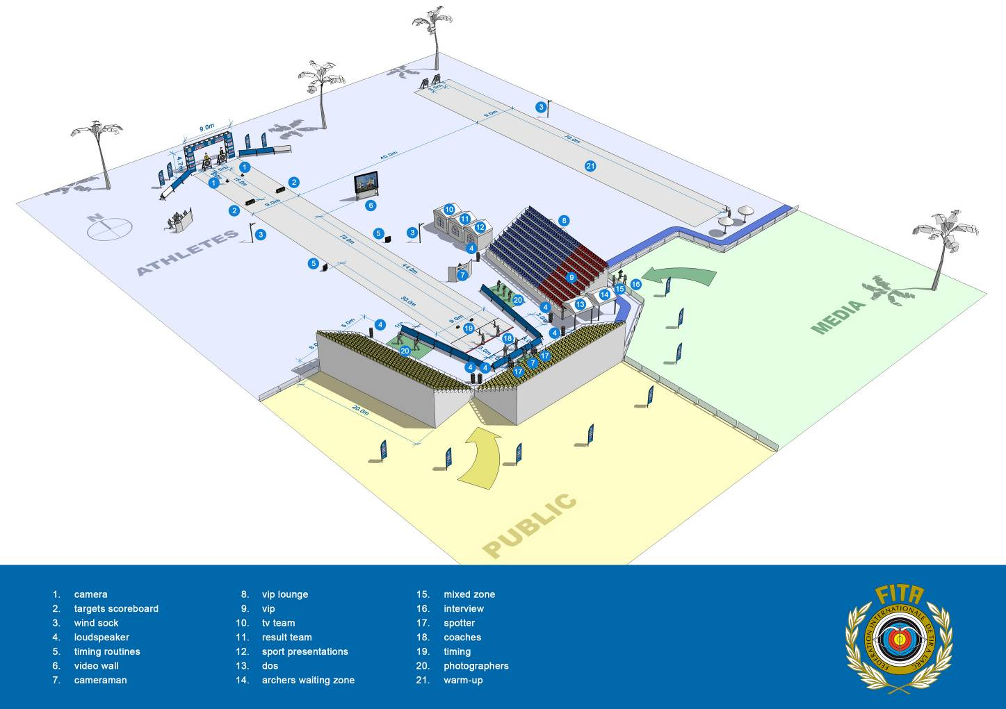

**Appendix A2: Typical setup of Archery World Cup Stage Finals venue (plan-view)**

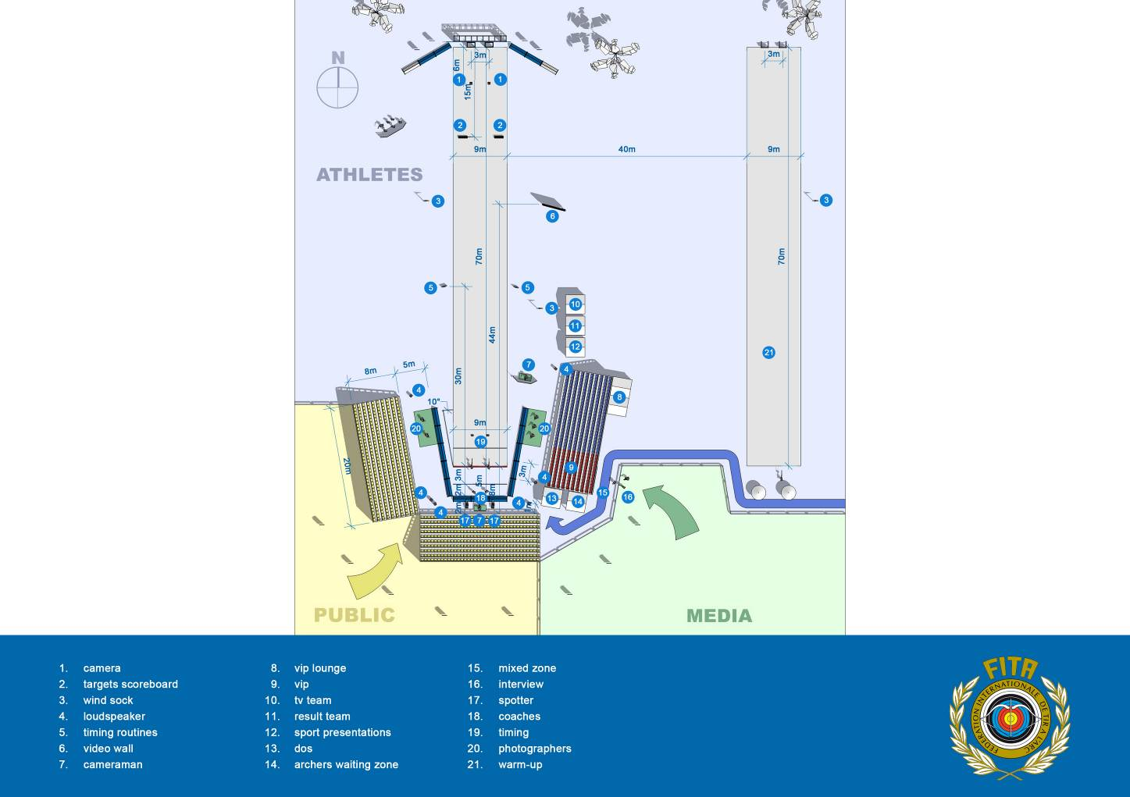

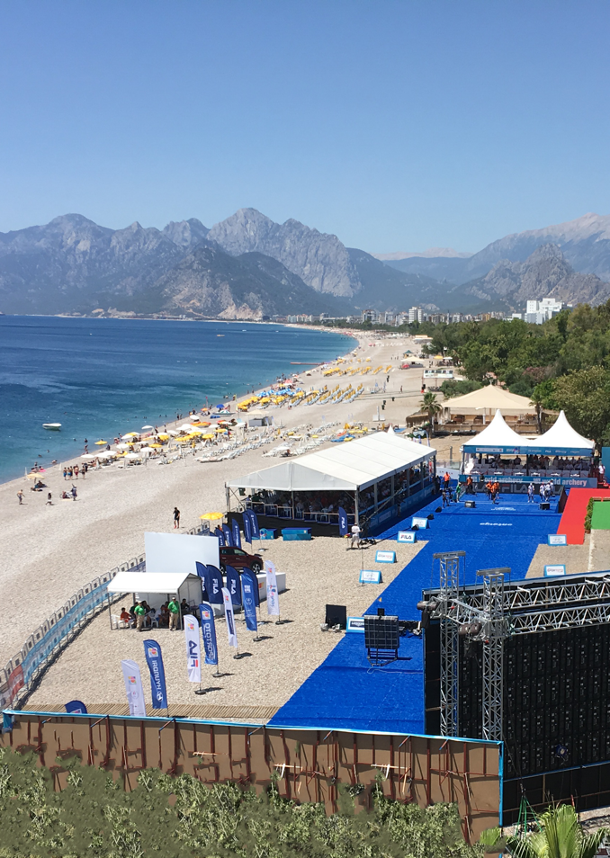

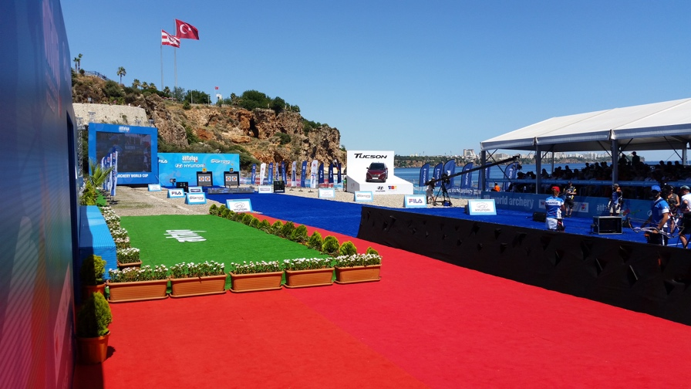

**Appendix A3: Setup of Archery World Cup Final 2007 in Dubai (3D-view)**

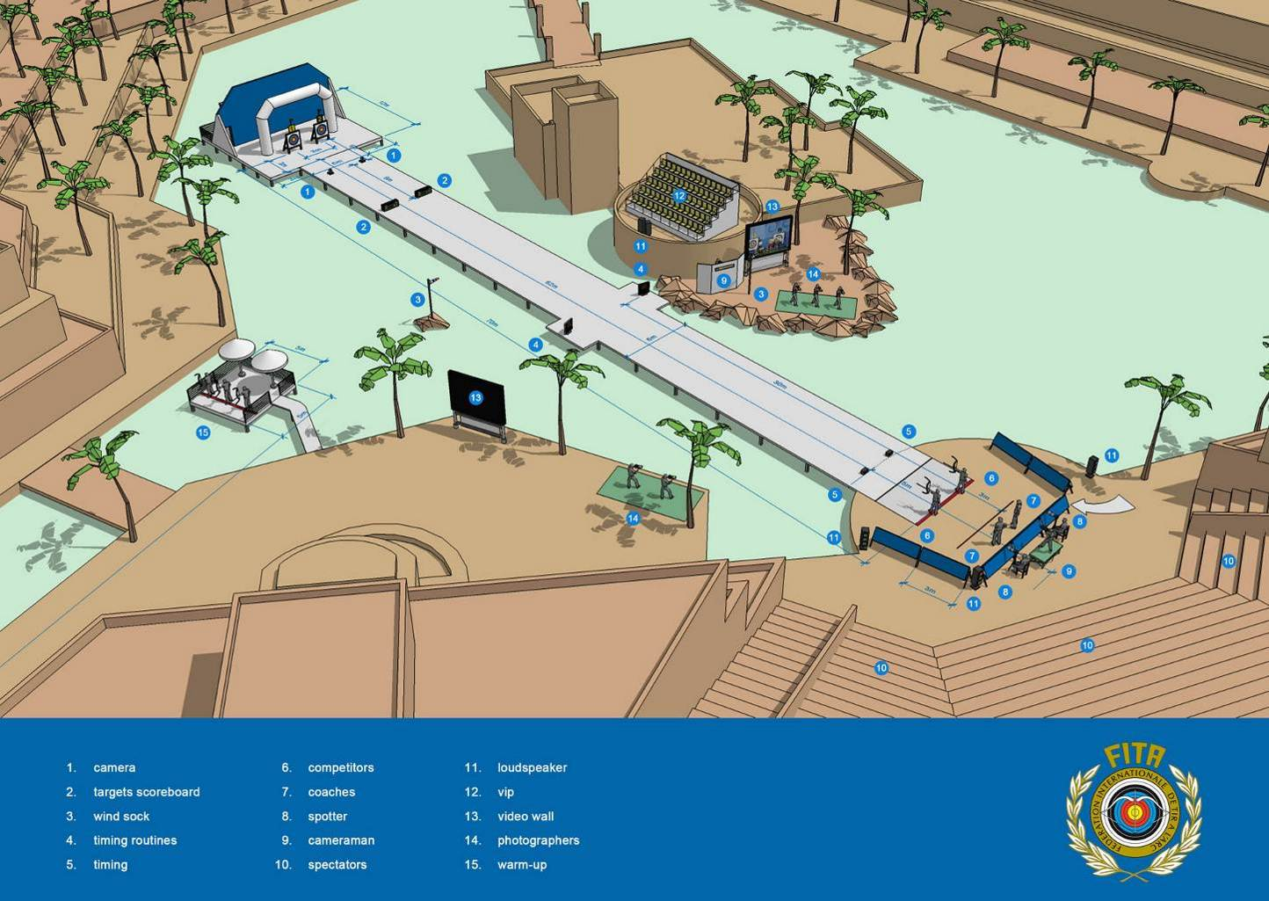

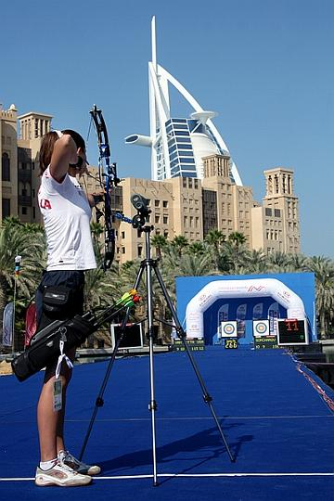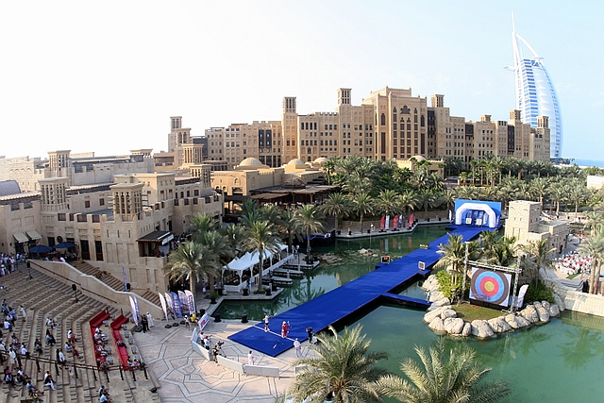

**Appendix A4: Illustrations what is considered a “flat” space**

The following are illustrations of examples of what World Archery considers a “flat” space according to the venue requirements stipulated in section 2.5, in addition to conventional flat spaces such as an open grass field or an outdoor sports arena.

If anything, these illustrations give Organisers an idea of the numerous possibilities that the Archery World Cup venue can take shape in and demonstrate the flexibility as well as innovative potential that this event has in showcasing an extraordinary location as a competition venue.

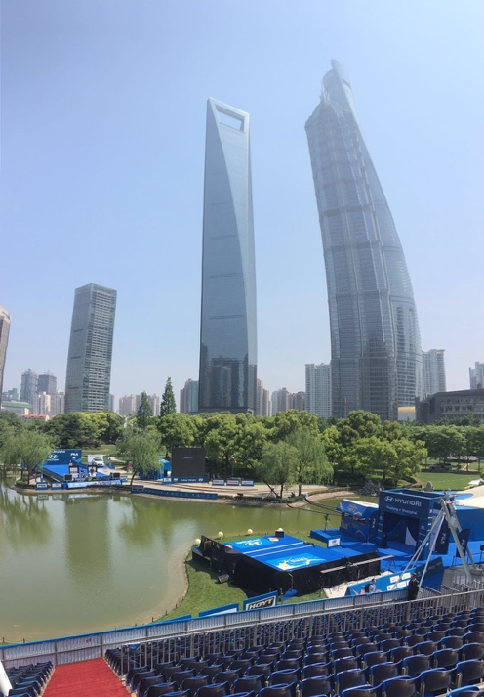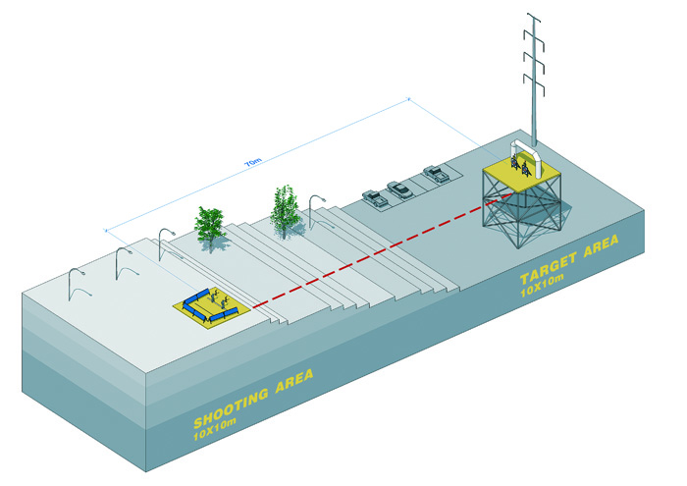

Illustration 1: Differing heights compensated by a platform

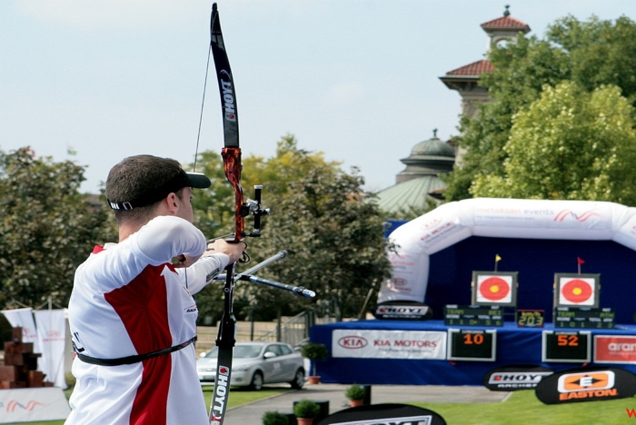

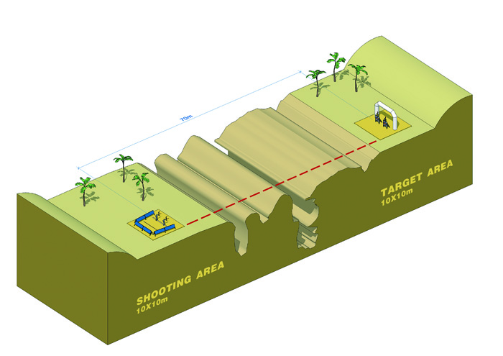

Illustration 2: Undulating ground with unobstructed line-of-sight

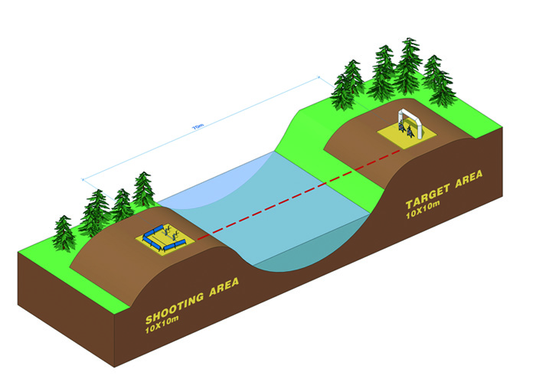

Illustration 3: Water body separating archer and target

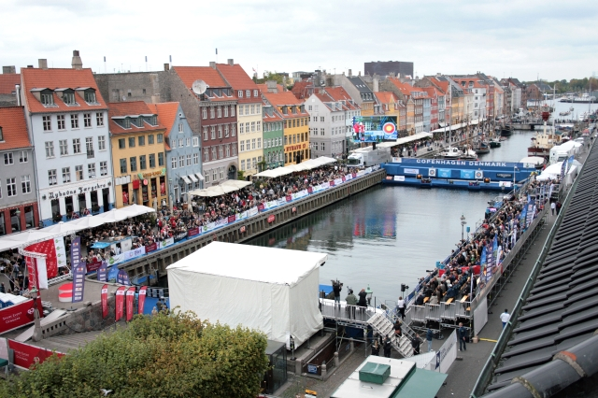**Copenhagen (DEN)**

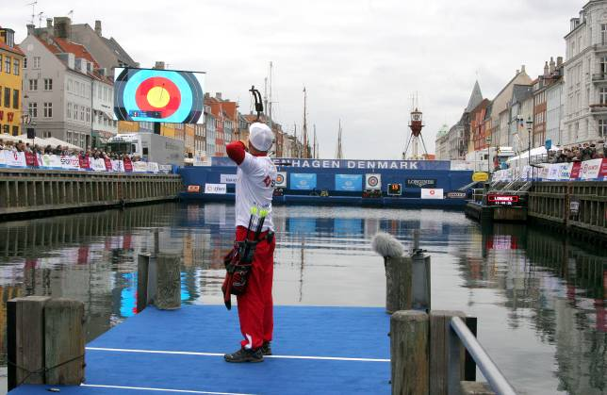

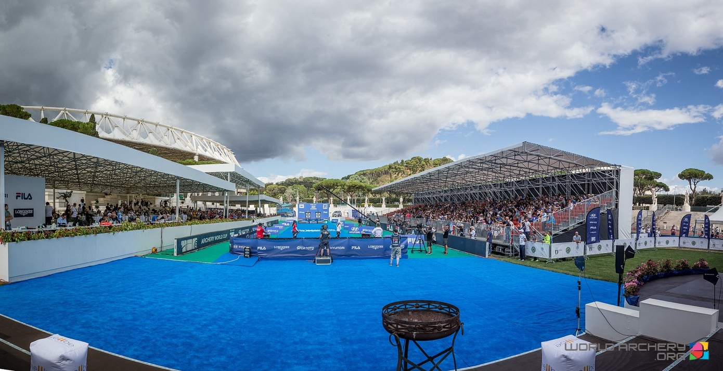**Rome (ITA)**

**Paris (FRA)** 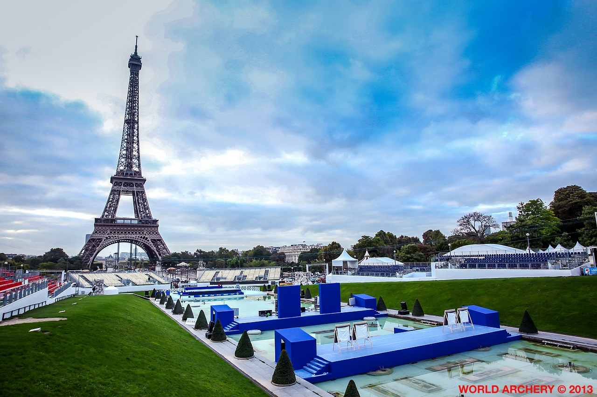

# Appendix B - Application form

Please complete all the information requested below:

|  |  |  |
| --- | --- | --- |
| Name of bidding organisation | |  |
| Type of bidding organisation  (i.e. Member Association, Event Company etc.) | |  |
| Function of bidding organisation  (i.e. event organizer etc.) | |  |
| Mailing  Address | Street Number |  |
| City |  |
| Postal/zip code |  |
| Country |  |
| Telephone Number | |  |
| E-Mail address | |  |
| Website address | |  |
| Any other relevant information | |  |

|  |  |  |
| --- | --- | --- |
| Will the bidding association/ organisation be the organising committee? | Yes | No |
| If no, who will be the organising committee? | | |
| Is the organizing committee a current and valid World Archery Member Association? | Yes | No |
| Please list previous tournaments organized by the tournament organization/director. | | |
| Who will be the Active Director or President of the Organising Committee? | | |

|  |  |
| --- | --- |
| Telephone Number: |  |
| E-Mail address: |  |

CANDIDATE DETAILS

|  |  |
| --- | --- |
| Proposed City for the World Cup Stage |  |
| Official language |  |
| Time Zone |  |
| Population of the city |  |
| Political system and structure or major political issues |  |
| Main holidays in the host country |  |

ECONOMIC

|  |  |
| --- | --- |
| Currency |  |
| GDP |  |
| Annual rate of inflation for the past 5 years |  |
| Forecast for each year up to the event |  |
| Fluctuation in the currency exchange rates compared to USD, CHF in the past 5 years |  |
| Currency used in this bid for pricing (EUR/USD) |  |

EVENT DATES

Hyundai Archery World Cup stages will be organised monthly between April and July. The weeks and months of events will be proposed to the organising committees once all events are allocated. Organisers shall make sure that they can stage event.

MOTIVATION FOR HOSTING EVENT

What is the principal motivation for hosting the Hyundai Archery World Cup Stage?

|  |
| --- |
|  |

Explain the reasons why this event will be successful in your nation

|  |
| --- |
|  |

What would be the impact and legacy for your City/Region in hosting the Hyundai Archery World Cup Stage?

|  |
| --- |
|  |

What other major archery and other sporting events has the host city staged in the last 2 years?

|  |
| --- |
|  |

ACCOMMODATION

Able to cover up to 250 room nights with full board for the World Archery team, athletes and officials. Distribution shall be single rooms for World Archery Staff, Judges and a junior suite for the World Archery President. Athletes may have the choice between single or double rooms.

**Accommodation facilities:**

For each hotel to be used please provide full details on the hotel. Transportation from the hotel to the competition/practice area should be provided free of charge.

|  |  |  |  |  |  |  |  |  |  |  |  |  |  |  |
| --- | --- | --- | --- | --- | --- | --- | --- | --- | --- | --- | --- | --- | --- | --- |
|  | **Headquarter Hotel** | | | | **Alternate Hotel** | | | | | | **Low Cost Rooms** | | | |
| Name of Hotel |  | | | |  | | | | | |  | | | |
| Star rating of the hotel  (e.g. 5, 4, 3 stars) |  | | | |  | | | | | |  | | | |
| Distance from airport to hotel (miles/kilo in metres) |  | | | |  | | | | | |  | | | |
| Average journey time from airport to hotel |  | | | |  | | | | | |  | | | |
| Distance to competition field (miles/kilometres) |  | | | |  | | | | | |  | | | |
| Average journey time to the venue |  | | | |  | | | | | |  | | | |
| How close can event transportation get to the hotel entrance for pick up/drop off? (metres) |  | | | |  | | | | | |  | | | |
| Surrounded area (city, country, quiet) |  | | | |  | | | | | |  | | | |
| **Room Rates** |  | | | |  | | | | | |  | | | |
| Single room rate per day |  | | | |  | | | | | |  | | | |
| Double room rate per day |  | | | |  | | | | | |  | | | |
| Triple room rate per day |  | | | |  | | | | | |  | | | |
| Dormitory (indicate price per person and number of persons) |  | | | |  | | | | | |  | | | |
| **Meals** |  | | | |  | | | | | |  | | | |
| Is the cost of meals included | Breakfast | | **Y** | **N** | Breakfast | | **Y** | | **N** | | Breakfast | | **Y** | **N** |
| Lunch | | **Y** | **N** | Lunch | | **Y** | | **N** | | Lunch | | **Y** | **N** |
| Dinner | | **Y** | **N** | Dinner | | **Y** | | **N** | | Dinner | | **Y** | **N** |
| If no what is the cost |  | | | |  | | | | | |  | | | |
| Breakfast |  | | | |  | | | | | |  | | | |
| Lunch |  | | | |  | | | | | |  | | | |
| Dinner |  | | | |  | | | | | |  | | | |
| **Services and Facilities** |  | | | |  | | | | | |  | | | |
| What other services are available in hotel? |  | | | |  | | | | | |  | | | |
| Car Parking Available | Yes |  | No |  | Yes |  | | No | |  | Yes |  | No |  |
| Cost of car parking |  | | | |  | | | | | |  | | | |
| Internet | Yes |  | No |  | Yes |  | | No | |  | Yes |  | No |  |
| Internet cost |  | | | |  | | | | | |  | | | |
| Laundry | Yes |  | No |  | Yes |  | | No | |  | Yes |  | No |  |
| Laundry costs |  | | | |  | | | | | |  | | | |

|  |  |  |
| --- | --- | --- |
| Has an initial agreement been signed with the hotels or the tourist board having a fixed price for the year of the event? | Yes | No |
| If no, when will the agreement be signed? | DD/MM/YYYY | |

TRANSPORT

**Airport**

|  |  |
| --- | --- |
| Name of the closest airport |  |
| Is this an international airport |  |
| If yes, please provide the number of countries this airport operates to |  |
| If no, please provide the details on the closest international airport to the venue and how transportation will operate between this airport and the host city. |  |
| Flight times from major global hubs |  |
| Is the airport transfer fee included in the entry |  |
| If no, what is the estimated cost for an airport transfer (including both ways) |  |
| What type of transportation will be provided from the airport to hotels? |  |
| Is there any visa entry required / for which country |  |

**Transport to venues**

|  |  |
| --- | --- |
| Is there a dedicated free shuttle bus for spectators and from where (city, train station) |  |
| Is there a parking for spectators on venues |  |

**Public transports to venue**

|  |  |  |  |
| --- | --- | --- | --- |
| **Transport from city to venues** | **Price** | **Frequency/Operating hours** | **Journey time** |
| Taxi |  |  |  |
| Train |  |  |  |
| Metro |  |  |  |
| Bus |  |  |  |
| Other |  |  |  |

CATERING

|  |  |  |  |  |  |  |
| --- | --- | --- | --- | --- | --- | --- |
| Where will lunch be provided? | | Yes: | | | No: | |
| Qualification venue | |  | | |  | |
| Finals venue | |  | | |  | |
| Event Hotel | |  | | |  | |
| Please describe what lunch will be, i.e. hot/cold buffet and how will the various diets be catered for such as allergies, gluten free and religious diets (no pork/halal) etc. | | | | | | |
| Is there a closing party/banquet foreseen? | | Yes: | | | No: | |
| What is the location? |  | | | | | | |
| What evening is proposed? | | |  |  | |  | |
| **DD** | **MM** | | **YYYY** | |
| What is the concept of the party/banquet?  **Note:** World Archery has not expectation for an opening ceremony | | | | | | | |

COMPETITION VENUE LAYOUT

**Practice Field:**

|  |  |  |  |
| --- | --- | --- | --- |
| Is the practice field separate from the competition field? | | Yes | No |
| Please indicate the measurements of the practice field | | | |
| Width (in metres): | Length (in metres): | | |
| Orientation of the practice field, is it a northern direction? | | Yes | No |
| How much, in degrees, is the practice fields direction from the north (+ or –°) | | | |
| How many days prior to official practice will the competition the practice field will be available? | | | |
| What other practice ranges exist in the local area? | | | |

**Finals Field of Play:**

|  |  |  |  |  |  |
| --- | --- | --- | --- | --- | --- |
| Please indicate the measurements of the final venue | | | | | |
| Width (in metres): | | Length (in metres): | | | |
| Orientation of Field, is it a northern direction? | | | | Yes | No |
| How much, in degrees, is the direction from north (+ or -°) | | | | | |
| How many seats will there be in the stands at the finals venue? | | | | | |
| Public seating: | VIP seating: | | Athlete seating: | | |
| How many days prior to the finals will the venue be available? | | | | | |
| Describe concept of the final venue:  *The Finals venue is outlined in the World Archery Organisers Event Manual:*  [*https://extranet.worldarchery.sport/documents/index.php/Events/Bidding/WA_Organising_Manual_Rev2.pdf*](https://extranet.worldarchery.sport/documents/index.php/Events/Bidding/WA_Organising_Manual_Rev2.pdf)  *Please refer to section: 2.1 and 2.1.2* | | | | | |
| What makes the finals venue iconic, recognizable, and memorable? | | | | | |

VENUE SPACES AND SERVICES AVAILABLE

|  |  |  |  |  |
| --- | --- | --- | --- | --- |
|  | **Finals Field** | | **Practice field** | |
| YES | NO | YES | NO |
| Accreditation |  |  |  |  |
| Access for wheelchair users |  |  |  |  |
| Access control (fencing and personnel) |  |  |  |  |
| Anti-doping |  |  |  |  |
| Athlete sheltered area |  |  |  |  |
| Athlete practice range |  |  |  |  |
| Athlete call room |  |  |  |  |
| Athlete bow storage area |  |  |  |  |
| Athlete equipment repair booth |  |  |  |  |
| Catering area |  |  |  |  |
| DOS (Director of Shooting) |  |  |  |  |
| Exhibition, trade and fan zone area |  |  |  |  |
| First aid and medical services/area |  |  |  |  |
| Free bottled water |  |  |  |  |
| Food and beverages to purchase |  |  |  |  |
| General Secretary office |  |  |  |  |
| Judges meeting/rest area |  |  |  |  |
| Judges scoring area |  |  |  |  |
| Jury of appeal room |  |  |  |  |
| Media registration and workroom |  |  |  |  |
| Mixed zone |  |  |  |  |
| World Archery results team |  |  |  |  |
| Security 24hrs (venue and asset protection) |  |  |  |  |
| Spectator stands area |  |  |  |  |
| Sports presentation and DOS stand |  |  |  |  |
| Try archery area for spectators |  |  |  |  |
| Toilets for available on the field for athletes, LOC/World Archery staff, judges and coaches |  |  |  |  |
| Toilets for spectators |  |  |  |  |
| World Archery office |  |  |  |  |
| World Archery storage |  |  |  |  |
| World Archery technical area incorporating DOS, results and sports presentation |  |  |  |  |
| VIP area/hospitality |  |  |  |  |
| Victory ceremony preparation area |  |  |  |  |
| Volunteer/workforce rest area |  |  |  |  |
| Will the athletes’ rest area be large enough for all the athletes and officials in case of inclement weather? |  |  |  |  |

|  |
| --- |
| Please describe the athletes’ rest area: |

JUDGES

|  |  |  |
| --- | --- | --- |
| Engage and provide qualified national or continental judges to assist or perform Director of Shooting role, as well as control on practice field. In addition, provide timing and control signals for the practice and warm up ranges. | Yes | No |

ANTI DOPING

|  |
| --- |
| Who will arrange and conduct the anti-doping operations for this Hyundai Archery World Cup Stage? |
| Please list the name of the WADA accredited doping control lab and its location: |

SPECTATOR SERVICES

|  |  |  |
| --- | --- | --- |
| Will there be a spectator try archery experience? | Yes | No |
| If yes, please explain the concept, when and where: | | |
| What other spectator experience is foreseen at the venues? | | |

CEREMONY AND EVENTS

|  |  |  |
| --- | --- | --- |
| Is there a plan to stage an opening ceremony? | Yes | No |
| If yes, please explain the concept, when and where:  **Note:** World Archery has not expectation for an opening ceremony | | |

SPORTS EQUIPMENT

|  |
| --- |
| What target matts will be used for the event?  **Note:** Foam targets must be used to prevent injuries and damage to arrows. |
| What World Archery licensed approved target faces will be used?  **Note:** World Archery approved manufactures: <https://worldarchery.sport/about-us/sponsors> |
| To provide the necessary sports equipment as outline in the World Archery Organisers Event Manual:  <https://extranet.worldarchery.sport/documents/index.php/Events/Bidding/WA_Organising_Manual_Rev2.pdf>  Please refer to section: 2.2 and 2.2.1 |

STAFF AND VOLUNTEER REQUIREMENT

Where will volunteers and staff be recruited from?

|  |
| --- |
|  |

How many archers are in the 100km radius of the location of the Hyundai Archery World Cup Stage?

|  |
| --- |
|  |

How many local clubs are there to the location of the Hyundai Archery World Cup Stage?

|  |
| --- |
|  |

MEDICAL

Are there any vaccines required or any health-related issue?

|  |
| --- |
|  |

Name of the hospitals in the city, the distance and typical travel time by car from the venues

|  |
| --- |
|  |

WEATHER CONDITIONS

What is the climate during the time of the Hyundai Archery World Cup Stage (Temperature in C°)?

|  |
| --- |
|  |

What are the normal weather conditions during the time of the Hyundai Archery World Cup Stage (windy, rain)?

|  |
| --- |
|  |

ENVIRONMENTAL SUSTAINABILITY AND CORPORATE SOCIAL RESPONSIBILITY

#### Are there any reduction, reuse and recycling of waste?

|  |
| --- |
|  |

What will be considered in terms of impact of transport, water usage and energy on the environment?

|  |
| --- |
|  |

Are you ensuring a tobacco-free competition?

|  |
| --- |
|  |

MEDIA, TV BROADCASTING AND STREAMING

**TV Production and Distribution**

World Archery is responsible for producing a high-definition world feed broadcast signal, completed with graphics and English guide commentary, from the World Archery World Cup and distributing this internationally via satellite and fibre connections. This is complemented by multi-platform live streaming in rights-free territories, news releases, highlights and social clipping.

Independent reports of World Archery’s 14 key territories have broadcasts reaching over 120 million people annually. Coverage is seen in over 150 territories worldwide.

**Digital coverage**

World Archery leverages live and feature video, images and articles through its key digital platforms, which include YouTube, Facebook, Instagram, Twitter and the official website of the federation: [www.worldarchery.sport](http://www.worldarchery.sport). World Archery also maintains a presence on Tumblr, Pinterest and WeChat.

World Archery’s digital platforms reach over 150 million people every year.

What is the organising committee’s media plan?

|  |
| --- |
|  |

**Social Media**

|  |  |  |  |  |  |
| --- | --- | --- | --- | --- | --- |
| What social platforms do you use? | Facebook | Twitter | Instagram | YouTube | Own website |
| How many followers do you have? |  |  |  |  |  |
| What is the average impression* on your social media platforms?  *\*number of times your content is displayed* |  |  |  |  |  |
| What is the average engagement* on your social media platforms?  *\* it measures the public shares, likes and comments* |  |  |  |  |  |

Describe your target audience on social media. Who are they?

|  |
| --- |
|  |

What is your strategy on social media? How many posts per week do you create?

|  |
| --- |
|  |

What type of content do you create for your audience on social media (images, video, quotes, blog posts, etc.)?

|  |
| --- |
|  |

**Television**

What current relations have been created with the national television companies and what events have they produced for you previously. Whenever possible World Archery tries to coproduce with the national television station and share resources:

|  |
| --- |
|  |

Please provide details of archery on local TV in the last 4 years:

|  |
| --- |
|  |

**Note:** Television rights are owned by World Archery and are assigned to a production company. All television arrangements should be coordinated with the World Archery assigned producer. All will be outlined in the organiser’s agreement.

MARKETING & PROMOTIONAL PLAN

What is your marketing plan:

|  |
| --- |
|  |

What is the overall concept of the event (theme, attractions around the event etc):

|  |
| --- |
|  |

#### How will you promote the event:

|  |
| --- |
|  |

FINANCES

|  |  |  |  |
| --- | --- | --- | --- |
| **Budget Sections:** | | | |
| **INCOME/REVENUE** | **VIK (Value In Kind)** | **CASH** | **Total (indicate currency)** |
| Government Funding |  |  |  |
| City/Local Authority Funding |  |  |  |
| Sponsorship |  |  |  |
| Participant Entry Fees |  |  |  |
| Hotel/Catering Revenues |  |  |  |
| Exhibitor Trading Stand Fees |  |  |  |
| Donations |  |  |  |
| Ticket Sales |  |  |  |
| Merchandise |  |  |  |
| Other |  |  |  |
| **INCOME/REVENUE TOTAL** |  |  |  |

|  |  |  |  |
| --- | --- | --- | --- |
| **OUTGOINGS/EXPENDITURE** | **VIK**  **(Value In Kind)** | **CASH** | **Total (indicate currency)** |
| Event Staging Fees |  |  |  |
| Venue hire |  |  |  |
| Overlay building (temporary structures) |  |  |  |
| Accommodation |  |  |  |
| Transport |  |  |  |
| Catering |  |  |  |
| Staff and Volunteer Requirements |  |  |  |
| Sports Equipment |  |  |  |
| Office Administration and IT |  |  |  |
| Event Marketing and Promotion |  |  |  |
| Event Branding/Look and Feel |  |  |  |
| Event Functions/Entertainment and Ceremonies |  |  |  |
| Media, Social Media and Broadcasting |  |  |  |
| Sponsorship |  |  |  |
| Anti-Doping |  |  |  |
| Security and Access Control |  |  |  |
| Medical |  |  |  |
| Logistics |  |  |  |
| Event Insurances |  |  |  |
| Evaluation and Legacy |  |  |  |
| Contingency |  |  |  |
| **OUTGOINGS/EXPENDITURE TOTAL** |  |  |  |

LEGAL

|  |  |  |
| --- | --- | --- |
| Are there any laws or regulations that could cause issues with the importation and exportation of bows and arrows? | Yes | No |
| If yes, please provide details: | | |

|  |  |  |
| --- | --- | --- |
| Will the necessary license be provided by the organising committee to be able to play music at the venues? | Yes | No |
| If no, please explain: | | |

|  |  |  |
| --- | --- | --- |
| Will the Hyundai Archery World Cup Stage be fully covered with liability insurance supplied by the organiser? | Yes | No |
| If yes, please explain the coverage: | | |

**Note:** Liability insurance is to be provided by the organising committee. World Archery will have a general policy that could be at less costs than a separate policy.

|  |
| --- |
| What is the procedure to care for athletes or coaches who arrive to the host nation without adequate insurance or have insufficient finances to pay for any medical expenses? |
|  |

|  |  |  |
| --- | --- | --- |
| Are there any specific World Archery Member Associations that are restricted to enter the host country? | Yes | No |
| If yes, please list the countries excluded: | | |

**Note:** Organisers must permit athletes and officials from all World Archery Member Associations to enter the host nation on equal terms. All World Archery Member Associations mush have the right to use their national or World Archery approved flag and anthem.

|  |  |  |
| --- | --- | --- |
| Will all World Archery member associations be able to march with their country (or World Archery approved) flag, carry a placard with their country (or World Archery approved) name, wear their country uniform with country name, and play their anthem if they win a gold medal? | Yes | No |
| If no, please list explain and list exceptions: | | |

**Note:** Please furnish a signed letter from your appropriate government official to confirm the answers to the above two questions.

SUPPORT DOCUMENTS AND LETTERS

|  |  |  |  |
| --- | --- | --- | --- |
| **Please submit the following with the bid application:** | **Yes** | **No** | **Comment** |
| National Olympic Committee |  |  |  |
| National Archery Federation that is a Member Association of World Archery, if it is, the bidding organising committee not a member |  |  |  |
| National Sports Minister |  |  |  |
| The host city of the Hyundai Archery World Cup Stage |  |  |  |
| A letter from the appropriate government official stating all World Archery Member Associations may enter the country on an equal basis. Also, that their national or World Archery approved flag, country name (or World Archery approved association name and anthem may be used at the Hyundai Archery World Cup Stage |  |  |  |
| Preliminary budget to stage the Hyundai Archery World Cup Stage according to the enclosed format |  |  |  |
| Local Organising Committee Structure chart attached |  |  |  |
| Anti-Doping Agency to use for the Hyundai Archery World Cup Stage |  |  |  |

|  |
| --- |
| I ________________________________________________ hereby warrant on behalf of the  _________________________________________________________ Association / Organization that the statements made and the information provided in this Bid Application are accurate.  I acknowledge that this Bid Application and the information given herein will be fundamental to the decision by World Archery regarding the award of the Hyundai Archery World Cup Stage.  Furthermore, I agree that should the Hyundai Archery World Cup Stage be awarded to the __________________________________________________________ Association / Organization, this Bid Application shall form part of the Organizer Agreement to be concluded between World Archery and the _______________________________________ Association and that the __________________________ Association will be bound by this warranty and the organizer agreement.  As part of the organisers agreement, I accept the staging fee of 30’000 CHF, and the performance guarantee of 25% which may be reimbursed after the event, to be paid to World Archery before the event. The performance guarantee will be evaluated on reports and requests eventually made to the LOC during their event, and their ability to provide the service agreed upon at signature of Organisers’ agreement.  World Archery will require a World Archery approved Technical Delegate to visit the organizing committee to view and approve the site, technical equipment, accommodation, transportation and the organization. The organizer will be responsible for these expenses, up to a total not to exceed 2’500 CHF.  The candidate/LOC agrees that under the World Anti-Doping Code, World Archery reserves the right to cancel any agreement with a LOC if the NADO of the country concerned is declared non-compliant by WADA. World Archery can cancel the agreement without penalty where the relevant country has been ruled ineligible to host the Event. Any amount already paid by the event will be kept by World Archery to cover the costs by World Archery related to the event. |

**Name of President of Bidding Association/ Organization:**

|  |  |  |
| --- | --- | --- |
| Name of the President from the bidding organisation | |  |
| Mailing  Address | Street Number |  |
| City |  |
| Postal/zip code |  |
| Country |  |
| Telephone Number | |  |
| E-Mail address | |  |
| Website address | |  |
| Any other relevant information | |  |

**Signature of Bidding Association/Organization President:**

|  |  |  |  |  |  |  |
| --- | --- | --- | --- | --- | --- | --- |
| Name of the President from the National Archery Federation that is a World Archery Member Association | | | |  | | |
| Signature of the President | | | |  | | |
| Date: | DD | MM | YYYY |
| President’s Term of office expiry date | | | | DD | MM | YYYY |
| Name of the Secretary General | | | |  | | |
| Signature of the Secretary General | | | |  | | |
| Name of the Treasure | | | |  | | |
| Signature of the Treasure | | | |  | | |

**Note:** Bid applications do not always need to be submitted by a World Archery Member. Host Cities and other organisations can submit a bid application independently, but confirmation would be required of the bid application by the World Archery Member Association.