world archery europe

congress 2020

19th MAy 2020

antalya

## ınvıtatıon package



Dear World Archery Europe Member Associations, Dear Delegates;

On behalf of the Organizing Committee (OC) of the World Archery Europe Congress 2020 and European Outdoor Championships 2020, Antalya, we would like to invite you to participate to the WA Congress 2020 which will be held in Antalya at 19 May 2020.

To register participation, please complete all the necessary sections in WAREOS within the deadlines listed below:

* Preliminary Hotel Reservation and %50 Deposit 19 March 2020
* Preliminary Transportation 19 March 2020
* Visa Support Letter Form 19 March 2020
* Final Hotel & Transportation with remaining Balance 01 May 2020

Please find the necessary information concerning organization, registration and participation to the WAE Congress 2020.

We look forward to welcoming you Antalya.

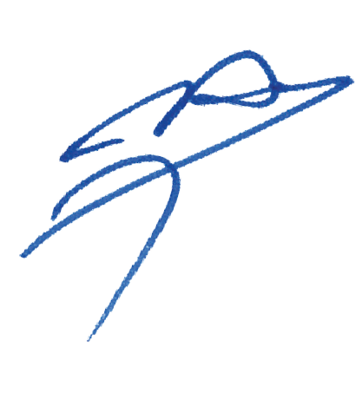Best Regards.

Husnu KOCAOGLU

President of LOC

To All World Archery Europe Member Associations and Delegates;

This document has been created for those who will participate in the World Archery Europe Congress. Congress delegates will need the register their participation for congress and book their accommodation for congress using WAREOS.

**SCHEDULE of the CONGRESS**

Monday, 18 May 2020 World Archery Europe Executive Board Meeting.

Tuesday, 19 May 2020 08:00 – 09:00 Registration at Congress Hall

09:00 – 13:00 WAE Congress 2020

13:00 – 14:00 Buffet Lunch

14:30 – 17:00 Aspendos Tour (Guided)

19:30 – 21:00 Dinner

**Congress Location;**

WAE Congress 2020 will take place at 1st Floor Bale Hall on official Congress Hotel Rixos Downtown Hotel Antalya.

**Congress Registration;**

Congress registration, accommodation reservations, transport needs, flight arrival/departure information and visa invitation letter requests are to be completed fully using WAREOS.

To register please follow this link: <https://extranet.worldarchery.org/> Then, using your current WAREOS account login, you will see a form to fill in with all your information.

**Note:**

For those congress delegates that will also be attending the European Outdoor Championship & CQT as a coach or team manager etc, will need to register and reserve their accommodation separately for those event in WAREOS.

**Official Congress Hotel;**

|  |  |  |
| --- | --- | --- |
| **Congress Hotel** | **Single Room** | **Double Room** |
| Rixos Downtown Hotel Antalya | 210,00€ | 300,00€ |

Accommodation rates included full board (Breakfast, Lunch and Dinner) accommodation per room per day and transportation from/to airport.

gök, açık hava, ağaç içeren bir resim

Açıklama otomatik olarak oluşturulduiç mekan, pencere, yer, duvar içeren bir resim

Açıklama otomatik olarak oluşturuldu**Rixos Downtown Hotel Antalya;**

Hotel has a pool area, Wi-Fi, continental breakfast, lunch and dinner restaurant.

**Payment Conditions;**

To confirm your hotel reservations, %50 deposit of the total amount has to be paid by a bank transfer to the Organizing Committee before **19 March 2020**. Reservations received after this date will be considered according to availability.

**Bank Information for Accommodation and Transportation:**

|  |  |
| --- | --- |
| BANK ACCOUNT: | ANTALYA OKCULUK IHTISAS SPORKULÜBÜ |
| BANK: | YAPI KREDI BANKASI |
| ACCOUNT NO: | 25086669 |
| SWIFT CODE: | YAPITRIS |
| IBAN: | **TR 03 0006 7010 0000 0025 0866 69** |

**NOTE**:

* Please indicate in the reference/notes section the team or reservation name that corresponds to the payment
* All payment shall be made in EUR by BANK TRANSFER.
* All bank wire charges will be paid by the participant
* CREDIT CARDS or TRAVEL CHECKS will not be accepted as payment.

**Cancellations & Changes:**

Cancellation must be made by WAREOS and be received before 19 March 2020 for a complete refund of the deposit paid, less any bank charges incurred.

Any entries received after this date will be as per the cancellation policy.

All rates for payments after deadlines are subject to additional changes without prior notice. Refunds will be processed after the event.

**Transportation;**

Transportation from/to Antalya International Airport will be only provided for delegates accommodated at the official Congress Hotel and booked in advance.

Antalya International airport is 18km (approximately 25mins) from city center.

**Weather;**

According the weather information, the average daily temperature is 20 – 25 C. Please note that temperature will drop in the evening and rain is possible.

**Contacts;**

**General Information on the Congress**

Name: Sirer AYDIN

Email: [sireraydin@gmail.com](mailto:sireraydin@gmail.com)

Phone: 00 90 533 515 25 33

**WAREOS registration system**

Name: Ms Cécile TOSETTI

Email: ctosetti@archery.sport

**Deadline for Congress Registration**

**01 MAY 2020**