world archery europe

congress 2021

30th MAy 2021

antalya

## ınvıtatıon package



Dear World Archery Europe Member Associations, Dear Delegates;

On behalf of the Organizing Committee (OC), we would like to invite you to participate in the WAE Congress 2021 which will be held on 30th of May 2021 in Antalya, Turkey.

To register participation, please complete all the necessary sections in WAREOS within the deadlines listed below:

* Preliminary Hotel Reservation and 50% Deposit 20 April 2021
* Preliminary Transportation 20 April 2021
* Visa Support Letter Form 30 April 2021
* Final Hotel & Transportation with remaining payment 10 May 2021

Please find the necessary information concerning organization, registration, and participation to the WAE Congress 2021.

We look forward to welcome you Antalya.

Best Regards.

Hakan ÇAKIROGLU

President of LOC

To All World Archery Europe Member Associations and Delegates;

This document has been created for those who will participate in the World Archery Europe Congress. Congress delegates will need the register their participation for congress and book their accommodation for congress using WAREOS.

**SCHEDULE of the CONGRESS**

Saturday, 29 May 2021 World Archery Europe Executive Board Meeting.

Sunday, 30 May 2021 08:00 – 09:00 Registration at Congress Hall

09:00 – 13:00 WAE Congress 2021

13:00 – 14:30 Buffet Lunch

14:30 - 19:30 Free Time

19:30 – 21:00 Dinner

**Congress Location.**

WAE Congress 2021 will take place at Porto Bello Hotel Resort & Spa

Address: Liman, Akdeniz Blv., 07070 Konyaaltı-Antalya

**Congress Registration.**

Congress registration, accommodation reservations, transport needs, flight arrival/departure information and visa invitation letter requests are to be completed fully using WAREOS.

To register please follow this link: <http://register.worldarchery.sport> Then, using your current WAREOS account login, you will see a form to fill in with all your information.

**Note:**

For those congress delegates that will also be attending the European Outdoor Championship & CQT as a coach or team manager etc, will need to register and reserve their accommodation separately for those events in WAREOS.

**Official Congress Hotel;**

|  |  |  |
| --- | --- | --- |
| **Congress Hotel** | **Single Room** | **Double Room** |
| Porto Bello Hotel Resort & Spa | 148,00€ | 196,00€ |

Accommodation rates included full board (Breakfast, Lunch and Dinner) accommodation per room per day and transportation from/to airport.

**Porto Bello Hotel Resort & Spa;**

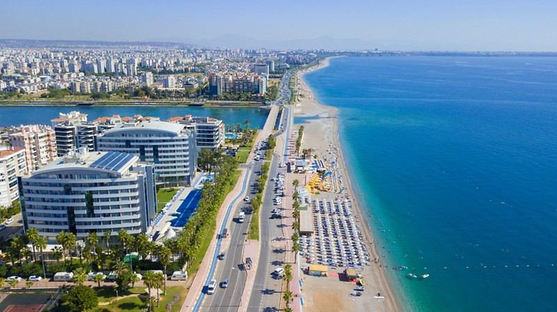

Hotel has a pool area, Wi-Fi, continental breakfast, lunch and dinner restaurant.

**Payment Conditions.**

To confirm your hotel reservations, %50 deposit of the total amount has to be paid by a bank transfer to the Organizing Committee before **20 April 2021**. Reservations received after this date will be considered according to availability.

**Bank Information for Accommodation and Transportation:**

BANK INFORMATION for ACCOMMODATION, TRANSPORTATION and ENTRY FEES:

|  |  |
| --- | --- |
| BANK ACCOUNT: | ANTALYA OKCULUK IHTISAS SPOR KULÜBÜ |
| BANK: | YAPI KREDI BANKASI |
| ACCOUNT NO: | 25086669 |
| SWIFT CODE: | YAPITRIS |

**NOTE**:

* Please indicate in the reference/notes section the team or reservation name that corresponds to the payment
* All payment shall be made in EUR by BANK TRANSFER.
* All bank wire charges will be paid by the participant
* CREDIT CARDS or TRAVEL CHECKS will not be accepted as payment.

**Cancellations & Changes:**

Cancellation must be made by WAREOS and be received before 10 May 2021 for a complete refund of the deposit paid, less any bank charges incurred.

Any entries received after this date will be as per the cancellation policy.

All rates for payments after deadlines are subject to additional changes without prior notice. Refunds will be processed after the event.

**Transportation.**

Transportation from/to Antalya International Airport will be only provided for delegates accommodated at the official Congress Hotel and booked in advance.

Transfer fee is 30 Euro (round trip).

Antalya International airport is 25km (approximately 30mins) from Congress Hotel.

**Weather.**

According the weather information, the average daily temperature is 25 – 30 C. Please note that temperature will drop in the evening and rain is possible.

**Contacts;**

**General Information on the Congress**

Name: Sirer AYDIN

Email: [sireraydin@gmail.com](mailto:sireraydin@gmail.com)

Phone: 00 90 533 515 25 33

**WAREOS registration system**

Name: Cecile TOSETTI

Email: [ctosetti@archery.sport](mailto:ctosetti@archery.sport)

**Deadline for Congress Registration**

**10 MAY 2021**