CONGRESS

Motion for Law Form
According to World Archery Constitution and Rules, Book 1, Articles 1.7.7, 1.7.13, 1.7.14, Appendix 1, Article 6.4. To be submitted to the World Archery Office congress@archery.sport latest by 20 April 2021.

1. Submitted by: | Target Archery Committee
2. In Quality of:  Please mark one with “X” | World Archery President   Executive Board   Permanent Committee x  Member Association   Continental Association 
3. Date of submission | 21 March 2021
4. Book, Chapter,  Article | Book 2, Chapter 7, Article 7.2.2  Book 3, Chapter 14, Article 14.4, 14.5.1, 14.5.2  This motion includes also some by-laws (marked in italic):  Book 2, Chapter 7, Article 7.2.2.1  Book 3, Chapter 14, Article 14.4.1  Book 3, Appendix 1, Image 3  These are not yet adopted but added for the clarity reasons. EB will adopt those after Congress if the motion is approved.
5. Interpretations potentially affected

6. Text of the motion (*) | Book 2:  7.2.2 Target Faces  …  There are 10 eight indoor target faces:  - The 60cm diameter face;  - The 60cm triangular triple face;  - The 60cm vertical triple face;  - The 40cm diameter face;  - The 40cm triangular triple face;  - The 40cm vertical triple face  - The 40cm-R triangular triple face;  - The 40cm-C triangular triple face;  - The 40cm-R vertical triple face;  - The 40cm-C vertical triple face .  Only target faces produced by a manufacturer licensed by World Archery shall be used at World Archery competitions.  (bylaw) 7.2.2.1 Description:  … An inner 10 ring, (which is marked as an X on the score cards for recurve and barebow) of 6.1cm in diameter for the 122cm target face and 4cm in diameter for the 80cm target face, is required to help determine ties in ranking. This inner 10 ring shall be scored as 11 for compound.  Book 3:  14.4 Scorecards shall be signed by the scorer and the athlete, indicating that the athlete agrees with the value of each arrow, the sum total and the number of: the number of 10’s and the number of X’s (or 9's for indoors).  - Compound: 11’s and 10’s  - Recurve and barebow outdoor: X’s and 10’s (including X’s)  - Recurve and barebow outdoor: 10’s  If the scorer is participating in the shooting, his scorecard shall be signed by another athlete on the same target butt.  14.5 In the event of a tied score, the ranking of the results shall be determined in the following order.  14.5.1 Except for those ties as set out in Article 14.5.2 , tied scores in all rounds are ranked using:  - Individuals and Teams:  - Recurve and Barebow:  - Greatest number of 10’s (including inner 10’s);  - Greatest number of X’s (inner 10’s) – for Outdoor Rounds only;  - Compound:  - Greatest number of 11’s;  - Greatest number of 10’s;  14.5.2 For ties deciding the entrance to the Elimination Rounds, in Matches, or in the top 8 (in case of using Match play chart 1A and 1B, or Match Play Chart 5 - Appendix 3-Match Play Charts, 1. Match Play Chart 1A (104 athletes, byes are permitted) in Book 2 or Book 2-Events in Book 2) there shall be shoot-offs to break the ties (the system of the number of 11’s, 10’s and/or X’s (9's for indoors recurve/barebow) shall not be used):  (bylaw) 14.4.1 Each target will have two scorecards one of which may be electronic. If there is a discrepancy in the arrow values between an electronic and a paper score card, the paper card will take precedence.  The organisers are not required to accept or record scorecards that have not been signed, do not contain the sum total, and/or the number of 11’s, 10's and/or the number of X's (only for outdoors) and/or which contain mathematical errors.  The organisers or officials are not required to verify the accuracy of any submitted scorecard, however if the organisers or the officials note an error or a missing signature at the time of submission, they will ask the athletes concerned to correct such error and the result as corrected will stand. Organizers may, but are not required to, have a process when the scorecards are submitted by the athletes to attempt to note an error or a missing signature. However, athletes are ultimately responsible for their portion of the scorecards and, if a paper scorecard is not submitted or is submitted without the athlete signature and not corrected at the time of submission, the athlete shall be disqualified (individual/team and mixed team where applicable) by the chair of the tournament judge commission. Any such corrections shall occur before the next stage of competition. Should a discrepancy be found in the sum total where:  - two paper scorecards are used, the sum total of the lower arrow scores will be used for the final result; if the score on a single scorecard (and in the case of double scoring, the score is the same on each scorecard), is lower than the actual score, the lower score on the scorecard will be used;  - one paper scorecard and one electronic scorecard are used, the total of the electronic scorecard will be used for total score, 11s, 10s and/or Xs on the following conditions:  - a total score has been entered on the manual scorecard so verification is possible;  - in case no 11s, 10s and/or Xs are entered on the manual scorecard, no 11s, 10s and/or Xs are registered;  - in case no total score is entered on the manual scorecard when it is submitted to the results team, then the athlete shall be disqualified (individual/team and mixed team where applicable).  Appendix 1  Target Faces and Equipments  1-10 11 Scoring Zones Target Face  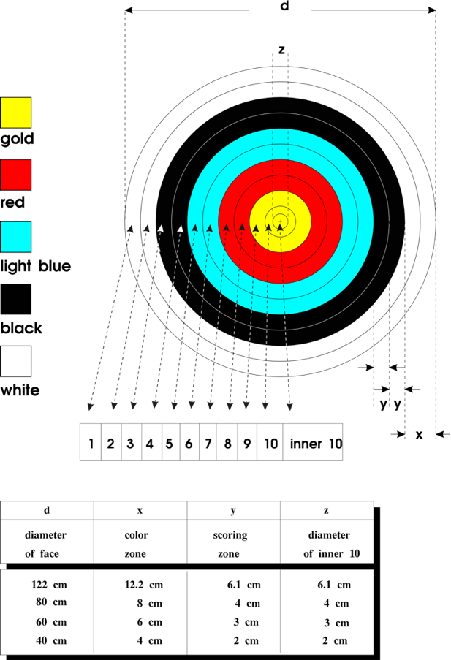  Appendix 1 –Should reflect the 11 points to Compound
7. Reason | Indoor Compound Scoring – Change to 11 Ring Scoring  The Goal is to decrease the number of ties in qualification and match play, while keeping the present target face(s).  By scoring the 2cm ‘x’ ring (inner 10) on the conventional ‘recurve’ 40cm indoor target faces, as 11 the number of ties and would be significantly reduced.  The new ‘perfect round’ total would be 660 vs 600.  To reduce ties in qualification and match play rounds.  The Target Archery Committee undertook data analysis on 11 ring scoring using existing data to underscore the need for a change to the indoor compound scoring.  For practical implication on World Records: if this motion is approved, the World Records of Compound Rounds are going to be reset (specific process to be determined and published). The current World Records would become Historical Records.  Performance Awards scores (bylaw) will still need to be adapted.

(*) Please state the wording to be used precisely with the new requested version/addition/amendment in full words.

