WORLD ARCHERY EUROPE
CONGRESS 2022

5th JUNE 2022
MUNICH

Invitation Package

Dear World Archery Europe Member Associations, dear Delegates,

on behalf of the Organizing Committee (OC), we would like to invite you to participate in the WAE Congress 2022 which will be held 5th of June 2022 in Munich, Germany.

To register participation, please complete all the necessary sections in WAREOS within the deadlines listed below:

Summary of deadlines:

- Preliminary Hotel Reservation 06/04/2022
- Final Hotel Reservation 20/04/2022
- Final Transportation 06/05/2022
- 80% Deposit Hotel Payment 06/05/2022
- Visa Support 17/05/2022
- Remaining Payments 17/05/2022

Please find all the necessary information concerning organization, registration and participation to the WAE Congress 2022.

We are looking forward to welcoming you in Munich.

Sincerely yours,

Hans-Heinrich von Schönfels
President of the
Organizing Committee

This document has been created for those who will participate in the World Archery Europe Congress. Congress delegates will need the register their participation for congress and book their accommodation for congress using WAREOS.

SCHEDULE of the CONGRESS

Saturday, 4th June 2022 World Archery Europe Executive Board Meeting

Sunday, 5th June

08:00 – 09:00 Registration at Congress Hall
09:00 – 13:00 WAE Congress 2022
13:30 – 15:00 Buffet Lunch
After Lunch: Cultural Activity in Munich

Congress Location

WAE Congress 2022 will take place at the Old Town Hall in Munich.
Adress: Marienplatz 15, 80331 München

Congress Registration.
Congress registration, accommodation reservations, transport needs, flight
arrival/departure information and visa invitation letter requests are to be
completed fully using WAREOS.

To register please follow this link: https://extranet.worldarchery.sport
Then, using your current WAREOS account login, you will see a form to fill in with all your information.

Note:
For those congress delegates that will also be attending the European Outdoor
Championship as a coach or team manager etc, will need to register and reserve their accommodation separately for those events in WAREOS.

ACCOMMODATION

All room rates are calculated per night including full board (Breakfast, lunch and dinner). All room rates include the current German VAT. Please note that in case of an increase, we must increase the room rates as well.

It is mandatory to choose the official hotel listed by the Local Organizing Committee. A delegation choosing a non-official hotel will not be allowed to participate in the Congress.

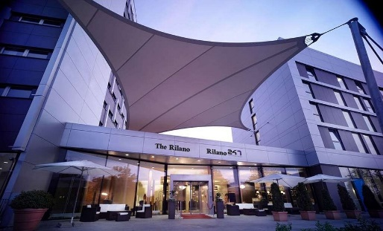
The Rilano Hotel Munich ****

https://www.rilano-hotel-muenchen.de/

EUR 167 / single incl. breakfast
EUR 252 / double incl. breakfast

This preferred hotel in Munich Schwabing is a 4-star hotel that is combined with many facilities for shopping, dining and relaxing. The hotel offers 150 modern rooms, all well equipped with direct dial telephone, mini bar, TV and internet access. Most are air conditioned. A subway station is about 5 minutes away from the hotel. From there you can reach the city center in about 15 minutes. The hotel restaurant offers international and regional dishes.
Distances: 15 minutes' drive from the qualification venue and 20 minutes' drive from the final’s venue, 16 minutes’ drive from the congress location

Rilano 24/7 Hotel Munich ***
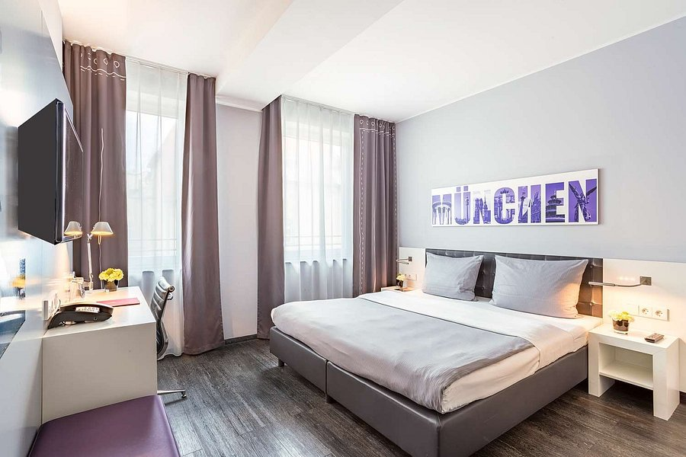
https://www.rilano-247-hotel-muenchen-schwabing.de/

EUR 147 / single incl. breakfast
EUR 238/ double incl. breakfast

Tourist class hotel in Munich-Schwabing in a central location, with a total of 230 rooms, all of them with bath/shower, toilet, SAT- TV, telephone and analog or DSL high-speed internet-access. The hotel offers a bar and a restaurant with international and regional dishes. A subway station is about 5 minutes away from the hotel. From here you can reach the city center in about 15 minutes. Buffet breakfast is included.
Distances: 15 minutes' drive from the qualification venue and 20 minutes' drive from the final’s venue, 16 minutes’ drive from the congress location

Holiday Inn City Centre ****
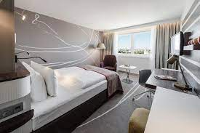
https://holiday-inn-city-centre-munich.hotel-ds.com/de/

EUR 179 / single incl. breakfast
EUR 266 / double incl. breakfast

The hotel has 580 rooms that are equipped with bath tub, hair dryer, minibar, radio, TV, self-dial telephone including voicemail and fax modem for internet access. For dinner the hotel offers three different restaurants. There is direct access within the same building complex to Munich's underground system at the "Rosenheimer Platz" station that guarantees rapid and direct transit to the Central Station, the Munich International Airport and the new Trade Fair Grounds. Buffet breakfast is included.
Distances: 20 minutes' drive from the qualification venue and 12 minutes' drive from the final’s venue, 12 minutes’ drive from the congress location

Leonardo Munich City Olympiapark ****
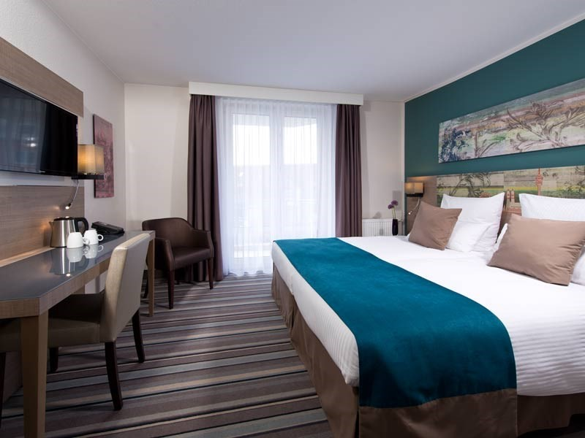
https://www.leonardo-hotels.de/leonardo-hotel-munich-city-olympiapark

EUR 174 / single incl. breakfast
EUR 252 / double incl. breakfast

Its unique location at the Olympic Park makes this hotel an ideal starting point for the city center, the BMW World, the Olympic Park and the other sightseeing highlights of Munich. It is perfectly connected by public transport to the city center. The hotel offers a restaurant and a bar. Feel at home in its new 196 spacious and modern designed rooms that feature facilities like air-conditioning, free Wi-Fi and flat screen TV. Buffet breakfast is included.
Distances: 20 minutes' drive from the qualification venue and 12 minutes' drive from the final’s venue, 15 minutes’ drive from the congress location

PAYMENT CONDITIONS HOTELS:

To confirm hotel reservations, an 80% deposit, of the total amount, is required to be transferred, to the HK Travel Plus GmbH before 06 May 2022 via a bank transfer, using the details below. The remaining payment for accommodation should be paid by 17th May 2022.

Accommodation cannot be guaranteed after this deadline. In case of cancellation after 06 May 2022 and/or a no-show, the travel agency will charge a cancellation fee of 100% of the costs for all nights and rooms you have booked.

BANK INFORMATION for ACCOMMODATION ONLY

Account holder:
HK Travel Plus GmbH
Frauenlobstraße 97,
D-55118 Mainz

Account:
Volksbank Alzey-Worms eG
Marktplatz 19
D-67547 Worms, Germany

IBAN DE 15 5509 1200 0080 518307
BIC GENODE61AZY

PLEASE DO NOT MAKE HOTEL PAYMENTS TO THE ORGANIZING COMMITTEE

Contact to Travel Agency
hk travel plus GmbH Phone: +49-6131-217098-0
Mrs. Birgit Huhn Fax: +49-6131-217098-20
Frauenlobstraße 97 E-mail: birgit.huhn@hktravelplus.de 55118 Mainz, Germany Web: www.hktravelplus.de

Transportation
Transport from/to Munich Airport will only be provided for delegates accommodated at the official hotels. Transportation fee (round trip) is 30 Euros per person.

On June 5th a shuttle service will be provided to the congress venue (timetable to be confirmed).

Airport Transportation Fee:
Roundtrip 30 Euro per person

Transportation fees must be made to the Organizing Committee by the set deadline. The payment must be transferred to the following bank account:

German Shooting Sport and Archery Federation / Deutscher Schützenbund e.V.
Lahnstr. 120
65195 Wiesbaden, Germany

Account:
Wiesbadener Volksbank
Schillerplatz 4
65185 Wiesbaden, Germany
IBAN DE16 5109 0000 0008 8088 80
BIC WIBADE5W

Weather
Temperatures in May are expected to range between 18 and 25 degrees Celsius. The average in the last few years has been 25 degrees Celsius.

Visa
It is your responsibility to establish with your respective foreign office if you requires a visa for Germany. You can find additional information on https://www.auswaertiges-amt.de/en/visa-service. All participants who need an entry visa to Germany, will be required to complete the Visa Support Form in WAREOS by no later than 06 May 2022.

It is the applicants’ responsibility for supplying the necessary information, ensuring all details are up to date, correct and submitted by the deadlines specified.

In addition, all participants that require a visa are kindly requested to supply a copy of their latest/valid passport. Copies of each application can be uploaded on WAREOS. All passport copies and personal details entered/uploaded to WAREOS will be held securely and in the strictest of confidence and not shared with other parties.

Please ensure your passport is valid for at least six months from the date you enter Germany, or you may not be admitted.

Contacts:

General Information on the Congress
Name: Julia Matheis
Email: matheis@dsb.de
Phone: +49 611 46807 415

WAREOS registration system
Email: wareos@archery.sport

