**WORLD ARCHERY CONGRESS**

**INVITATION PACKAGE**



**WORLD ARCHERY CONGRESS**

**INVITATION AND INFORMATION PACKAGE**

Dear Member Associations, Dear Congress Delegates,

This document has been created for those who will participate in the World Archery Congress. Congress delegates will need to register their participation for congress and book their accommodation for congress using WAREOS.

**SCHEDULE OF THE CONGRESS**

(As of 1 March 2023)

Wednesday, 26 July All day Arrival of delegates

Thursday, 27 July 8.00 am to 9.00 am Registration

9.00 am Official Opening of the Congress

6.00 pm End of work session (day 1)

*Followed by* Dinner at Congress hotel

Friday, 28 July 8.00 am to 9.00 am Registration

9.00 am Start of the work session (day 2)

5.00 pm Official Closing of the Congress

Departure of delegates OR transfer to World Championships hotel reservation

Saturday, 29 July All day Departure of delegates

**CONGRESS LOCATION**

Titanic Chaussee Berlin

Chausseestraße 30

10115 Berlin

[www.titanic-hotels.com](http://www.titanic-hotels.com)

**DEADLINES**

Congress

Motions for rule changes 27 February 2023

Nominations for elections 28 April 2023

Proxy form 27 June 2023

Congress delegates registration 6 July 2023

*There will be no exceptions made to these deadlines. All* [*Congress related documents and deadlines are available here*](https://www.worldarchery.sport/about-us/organisation/congress)*.*

Hotel and transportation

Pre Entry Hotel reservation 25 March 2023

50% payment Hotel 25 March 2023

Final Hotel Reservation 25 April 2023

Final Transportation 25 June 2023

100% payment Hotel and Transportation 25 June 2023

Payment deadline for those not using official hotel 6 July 2023

*Hotel reservation requests are possible according to availability. No reservation is guaranteed without the payment.*

*Please also consult the cancellation policy for refund dates.*

Visa

Visa support letter application 25 June 2023

*Be aware that you might need to start the process earlier depending on the process times in your embassy.*

**CONGRESS REGISTRATION**

According to World Archery constitution article 1.7.2 following maximum number of delegates is allowed:

* Member Association (national federation) – voting delegate and two other delegates. If there are three delegates in total, both genders must be presented.
* Continental Associations - two delegates
* Associate International Federations - two delegates

Each delegation could also bring interpreter, at their own cost. Interpreters, if any, have to be registered through WAREOS as well.

Congress registration, accommodation reservations, transport needs, flight arrival/departure information and visa invitation letter requests are to be completed fully using WAREOS.

To register please follow this link: https://extranet.worldarchery.org/

Then, using your current Extranet account login, you will see a form to fill in with all your information.

In case there is registration done by **6 July** and no show at Congress, then federation will be charged according to registration. See cancellation policy for further details.

**NOTE:**

*For those congress delegates that will also be attending the World Archery Championship as a coach or team manager etc, will need to register and reserve their accommodation separately for those events in WAREOS. However, for the time of Congress – the hotel must be booked under Congress, otherwise registration fee will apply.*

**REGISTRATION FEE**

There is **no registration fee** for delegates who book their hotel for two nights in official congress hotel. This must be booked in WAREOS under Congress, not under World Championships.

**360 €** **is the Congress registration fee** for delegates who do not stay at least two nights in Congress hotel. It includes buffet lunches and coffee breaks on both day of Congress and dinner on first evening. This fee does not include any transportation.

**OFFICIAL CONGRESS HOTEL**

**Titanic Chaussee Berlin**

The hotel has free Wifi. The hotel room rates for Congress are **per person,** per night and include all coffee breaks during the Congress.

|  |  |  |  |
| --- | --- | --- | --- |
| **Titanic Chaussee Berlin** | **Meals included** | **Price for single room** | **Price for double room per person** |
| 26-27 July | 26 July - dinner,  27 July - full board,  28 July - breakfast, lunch | 294 EUR | 227 EUR |
| 28 July | 28 July - dinner  29 July - breakfast | 264 EUR | 197 EUR |

Spa, swimming pool, and gym with additional fee, that can be booked directly at the hotel at own expenses.Additional purchases in the hotel bar, café and minibar are at own expense.

Ein Bild, das drinnen, Bett, Boden, Raum enthält.
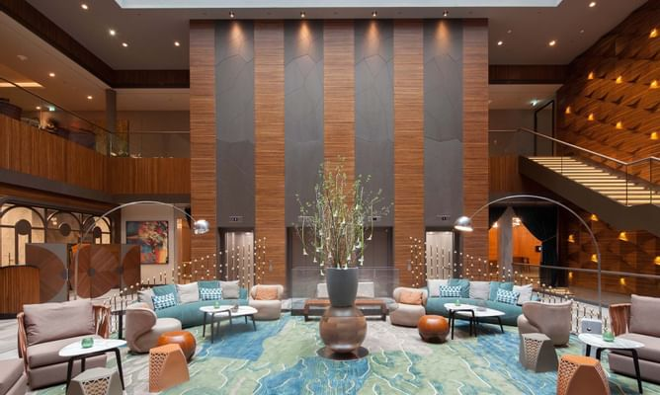Ein Bild, das Decke, drinnen, Boden, Gebäude enthält.

The check-in date for Congress is 26 July and the check-out 28-29 July. If you need early arrivals, please let us know by email [birgit.huhn@hktravelplus.de](mailto:birgit.huhn@hktravelplus.de), so we can confirm if the rate and availability.

Check-in at the hotel is at 3:00 pm, rooms will not be available until this time. Check-out time is at 12:00 am, please make sure to do the check-out at the front desk before this hour, otherwise an extra night will be charged.

*NOTE: In case you do not reserve the Congress hotel through Congress WAREOS, registration fee will apply.*

**TRANSPORT**

Airport transfer

You can reserve pick up and drop off (round trip) from and to the airport via WAREOS. Transport is offered only from Berlin Brandenburg Airport (BER) to the Titanic hotel and back.

Each way: **35 EUR / person**

**Public transport**

There is a metro station near by the official Congress hotel. The main train station is 2km from the hotel and connected with metro. The taxi from train station is around 15-20€.

**Transport to World Championships hotels after Congress**

The delegates who will stay in Berlin, can arrange their transfer to World Championships hotel either by foot, by metro or by ordering taxi from the Titanic hotel. This will be the fastest and most convenient solution as the end time of the Congress may slightly vary.

**CANCELLATION POLICY**

In case of registration and no show at Congress, federation will be charged according to details in WAREOS as of 6 July 2023.

Refund of payments for registration fee, transport and/or hotel:

100% refund in case of cancellation 25 March 2023

50% refund in case of cancellation 25 April 2023

**PAYMENT CONDITIONS**

To confirm your hotel reservations and transport, a 50% deposit of the total amount, is to be paid by a bank transfer to the travel agency before 25 March 2023**.** Remaining payments (100%) **before 25 June 2023.** Reservations received after this date will be considered according to availability.

* Hotel and transportation prices are including VAT.
* All payments shall be made in EUR by bank transfer.
* Credit cards and travel checks cannot be accepted.

Bank information – hotel and airport transportation

BANK: Volksbank Alzey-Worms eG

ADDRESS: Marktplatz 19,D-67547 Worms

BANK ACCOUNT HOLDER NAME: hk travel plus GmbH

ACCOUNT NO/IBAN: DE15 5509 1200 0080 5183 07

BIC/SWIFT CODE: GENODE61AZY

Bank transfer fees are the responsibility of the sender.

Bank information – registration fee (if no hotel reservation in Congress WAREOS)

BANK: Wiesbadener Volksbank

ADDRESS: Schillerstraße 4, 65185 Wiesbaden

BANK ACCOUNT HOLDER NAME: German Shooting Sport and Archery Federation

ACCOUNT NO/IBAN: DE16 5109 0000 0008 8088 80

BIC/SWIFT CODE: WIBADE5W

Bank transfer fees are the responsibility of the sender.

CONTACTS

General information on the congress organisation and visa:

Name: Ms. Julia Matheis

E-mail: [matheis@dsb.de](mailto:matheis@dsb.de)

Phone: +49 611 46807-415

Accommodation and transport:

Name: Ms. Birgit Huhn

E-mail: [birgit.huhn@hktravelplus.de](mailto:birgit.huhn@hktravelplus.de)

Phone: +49 6131-217098-0

WAREOS registration system, access to Extranet:

E-mail: [support@archery.sport](mailto:support@archery.sport)

Congress documents and procedures:

[Info link here](https://www.worldarchery.sport/about-us/organisation/congress)

E-mail: [congress@archery.sport](mailto:congress@archery.sport)