WORLD ARCHERY EUROPE
CONGRESS 2024

04th MAY 2024
ESSEN

Invitation Package

Dear World Archery Europe Member Associations, dear Delegates,

on behalf of the Organizing Committee (OC), we would like to invite you to participate in the WAE Congress 2024 which will be held 4th of May 2024 in Essen, Germany.

To register participation, please complete all the necessary sections in WAREOS within the deadlines listed below:

Summary of deadlines:

- Preliminary Hotel Reservation 05/02/2024
- Final Hotel Reservation 05/03/2024
- Final Transportation 01/04/2024
- 80% Deposit Hotel Payment 05/03/2024
- Visa Support 01/04/2024
- Remaining Payments 01/04/2024

Please find all the necessary information concerning organization, registration and participation to the WAE Congress 2024.

We are looking forward to welcoming you in Essen.

Sincerely yours,
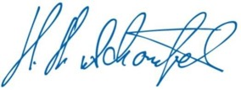
Hans-Heinrich von Schönfels
President of the
Organizing Committee

This document has been created for those who will participate in the World Archery Europe Congress. Congress delegates will need the register their participation for congress and book their accommodation for congress using WAREOS.

SCHEDULE of the CONGRESS

Friday, 3rd May 2024 World Archery Europe Executive Board Meeting

Saturday, 4th May

08:00 – 09:00 Registration at Congress Hall
09:00 – 13:00 WAE Congress 2024
13:30 – 15:00 Buffet Lunch
After Lunch: Cultural Activity in Essen

Congress Location

WAE Congress 2024 will take place at the Erich-Brost-Pavillon in Essen.
Adress: Fritz-Schupp-Allee 14, 45141 Essen

Congress Registration.
Congress registration, accommodation reservations, transport needs, flight
arrival/departure information and visa invitation letter requests are to be
completed fully using WAREOS.

To register please follow this link: https://extranet.worldarchery.sport
Then, using your current WAREOS account login, you will see a form to fill in with all your information.

Note:
For those congress delegates that will also be attending the CQT and the European Outdoor Championship as a coach or team manager etc, will need to register and reserve their accommodation separately for those events in WAREOS.

ACCOMMODATION

All room rates are calculated per night including full board (Breakfast, lunch and dinner). All room rates include the current German VAT. Please note that in case of an increase, we must increase the room rates as well.

It is mandatory to choose the official congress hotels listed by the Local Organizing Committee. A delegation choosing a non-official hotel will not be allowed to participate in the Congress.

NH Hotel Essen****
https://www.nh-hotels.com/en/hotel/nh-essen

EUR 210 / single incl. full board
EUR 320 / double incl. full board
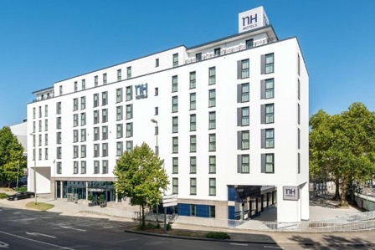
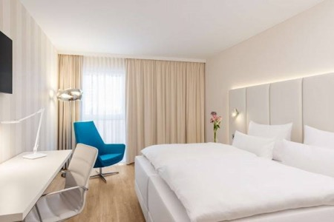

The 4*superior NH Hotel in Essen is a modern and stylish hotel located in the heart of Essen with popular attractions such as the Essen Cathedral, Zeche Zollverein (a UNESCO World Heritage Site) and the city's vibrant shopping and dining districts nearby. Additionally, excellent public transportation links make it easy to explore the wider region. The hotel offers 182 comfortable and elegantly designed rooms and suites. Each room is tastefully furnished with modern amenities, including flat-screen TVs, minibar and free Wi-Fi, to make your stay enjoyable and convenient. On-site parking around.

Intercity Hotel Essen****
https://hrewards.com/de/intercityhotel-essen

EUR 193 / single incl. full board
EUR 310 / double incl. full board
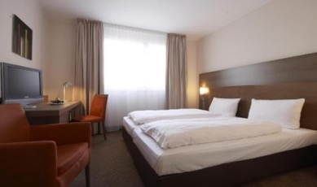
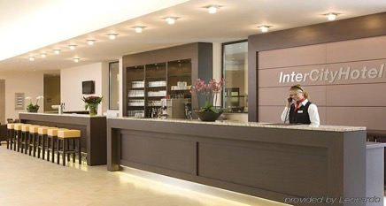
The 4* Hotel Essen is centrally located in the city of Essen. The hotel offers 167 comfortable and modernly furnished rooms. It is situated near Essen's main train station, providing excellent access to public transportation and making it convenient for guests to explore the city's attractions and shops in the downtown area. Rooms typically come equipped with amenities such as a flat-screen TV, a desk, complimentary Wi-Fi. There is a parking garage directly at the hotel.

PAYMENT CONDITIONS HOTELS:

To confirm hotel reservations, an 80% deposit of the total amount is required to be transferred to the HK Travel Plus GmbH before 05 March 2024 via a bank transfer using the details below. The remaining payment for accommodation should be paid by 01 April 2024.

Accommodation cannot be guaranteed after this deadline. In case of cancellation after 05 March and/or a no-show, the travel agency will charge a cancellation fee of 100% of the costs for all nights and rooms you have booked.

BANK INFORMATION for ACCOMMODATION ONLY

Account holder:
HK Travel Plus GmbH
Frauenlobstraße 97,
D-55118 Mainz

Account:
Volksbank Alzey-Worms eG
Marktplatz 19
D-67547 Worms, Germany
IBAN DE 15 5509 1200 0080 518307
BIC GENODE61AZY

PLEASE DO NOT MAKE HOTEL PAYMENTS TO THE ORGANIZING COMMITTEE

Contact to Travel Agency
hk travel plus GmbH Phone: +49-6131-217098-0
Mrs. Birgit Huhn Fax: +49-6131-217098-20
Frauenlobstraße 97 E-mail: birgit.huhn@hktravelplus.de 55118 Mainz, Germany Web: www.hktravelplus.de

Transportation

Airport Transfer will be provided to/from the official hotels from two airports:
- Cologne/Bonn Airport (CGN)
- Dusseldorf Airport (DUS)
Transport from/to the airports will only be provided for delegates accommodated at the official hotel. Transportation fee (round trip) is 90 Euros per person.

On May 4th a shuttle service will be provided to the congress venue (timetable to be confirmed).

Airport Transportation Fee:
Roundtrip 90 Euro per person

Transportation fees must be made to the Organizing Committee by the set deadline. The payment must be transferred to the following bank account:

German Shooting Sport and Archery Federation / Deutscher Schützenbund e.V.
Lahnstr. 120, 65195 Wiesbaden, Germany

Account:
Wiesbadener Volksbank
Schillerplatz 4
65185 Wiesbaden, Germany
IBAN DE16 5109 0000 0008 8088 80
BIC WIBADE5W

Weather
Temperatures in May are expected to range between 12 and 20 degrees Celsius. The average in the last few years has been 18 degrees Celsius.

Visa
It is your responsibility to establish with your respective foreign office if you requires a visa for Germany. You can find additional information on https://www.auswaertiges-amt.de/en/visa-service. All participants who need an entry visa to Germany, will be required to complete the Visa Support Form in WAREOS by no later than 01 April 2024.

It is the applicants’ responsibility for supplying the necessary information, ensuring all details are up to date, correct and submitted by the deadlines specified.

In addition, all participants that require a visa are kindly requested to supply a copy of their latest/valid passport. Copies of each application can be uploaded on WAREOS. All passport copies and personal details entered/uploaded to WAREOS will be held securely and in the strictest of confidence and not shared with other parties.

Please ensure your passport is valid for at least six months from the date you enter Germany, or you may not be admitted.

Contacts:
General Information on the Congress
Name: Julia Matheis
Email: matheis@dsb.de
Phone: +49 611 46807 415

WAREOS registration system
Email: wareos@archery.sport

