TO ALL World Archery Africa Member Associations

Dear President / Secretary General,

As Chair of the Local Organising Committee (LOC) of the 12th African Archery Championships to be held in Pretoria, South Africa from 5 to 10 November 2022 I would like to invite you all to be part of this prestigious archery event to take place in the southern part of Africa in 2022.

Pretoria is one of South Africa’s three capital cities, serving as the seat of the executive branch of government, and as is the host to all foreign embassies to South Africa. Pretoria is located around 50km north of Johannesburg in the northeast of South Africa. It lies in a transitional belt running between the Highveld plateau to the south and the lower-lying Bushveld to the north. Because of an altitude of about 1,350m above sea level, the city enjoys a warm climate.

Pretoria is well-planned and famous for its streets lined with jacaranda trees. Church Street stretches east-west for 12 miles (20 km). It is the seat of the universities, Correspondence Schools, Technical and teacher-training colleges, Veterinary Institute and the Council for Scientific and Industrial Research, the country’s largest research organization.

Pretoria’s High Performance Centre was launched in 2002 and is the training ground for tomorrow’s sporting champions and the venue of choice for sports professionals and enthusiasts alike.

South Africa and its people have soul
We wish you an excellent stay and a good competition.
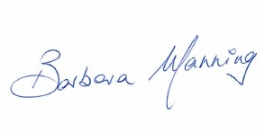
Sincerely yours,

Contact (Phone): +27829014900 (WhatsApp)
Email: barbara@sanaa.org.za
Barbara MANNING
LOC President

COMPETITION VENUE
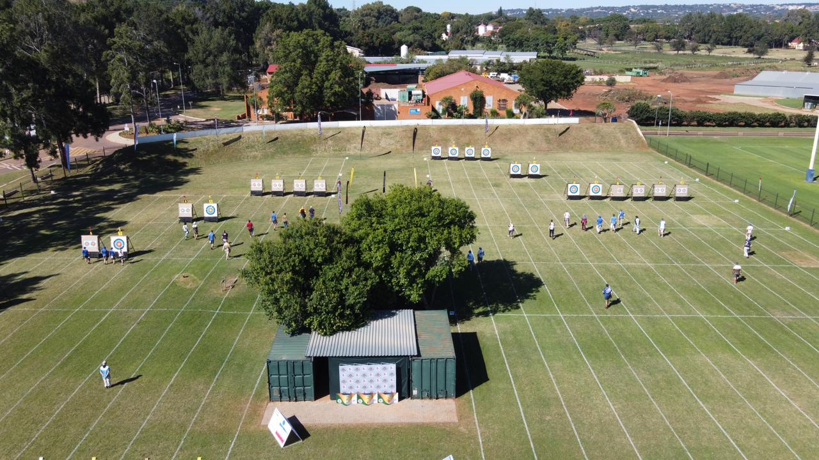
The event will take place at the Tuks Archery club in Pretoria which is located a short walking distance from the official hotels.

IMPORTANT DATES
Please find enclosed detailed information regarding this event. To register participation, please complete all the necessary sections in WAREOS (https://extranet.worldarchery.sport) within the deadlines listed below.
Summary of deadlines:
- Registration Opening date on WAREOS | 29 July 2022
- Preliminary Entries | 5 August 2022
- Final Entries | 15 October 2022
- Hotel reservation down-payment (50%) | 1 October 2022
- Final payment, hotel, transport & entry fees | 25 October 2022
- Transportation | 15 October 2022
- Visa Support Request | 5 September 2022
- Full refund cancellation deadline | 15 October 2022
*After this deadline, the LOC is allowed to retain all amounts due by the Member Association
* Please respect the stated deadlines.
PRELIMINARY PROGRAMME
2 - 4 November 2022  Wednesday - Friday | Arrival of participants  Practice field will be available from 4 November 2022
5 November 2022  Saturday | Official Practice (Equipment Inspection)  Team Managers Meeting  Opening Ceremony (TBC)
6 November 2022  Sunday | Qualification Round  (Recurve 70m Round, Compound 50m Round and Barebow 50m Round)  + Para Archery
7 November 2022  Monday | Team / Mixed Team Eliminations & Finals (Till Semi-Finals 1/2)  (Recurve , Compound and Barebow)
8 November 2022  Tuesday | Individual Eliminations & Finals (Till Semi-Finals 1/2)  (Compound, Recurve and Barebow)
9 November 2022  Wednesday | Finals Compound – Individual and Team  - Compound (Women and Men)  - Barebow (Women and Men)  - Award Ceremonies
10 November 2022  Thursday | Finals Recurve – Individual and Team  - Recurve (Women and Men)  - WA Live Streaming  - Award Ceremonies  Closing Party (TBC)
11 November 2022  Friday | Departure of teams

- This preliminary program is subject to change according to participation and T.V. requirements. All changes will be published and distributed in good time.
- This is the first time to include Barebow division and Para categories in the African Archery Championships, so there will be no minimum number of athletes for any category.

PRELIMINARY & FINAL REGISTRATION
All entries, accommodation reservations, transport needs, flight arrival/departure information and visa invitation letter requests are to be completed using the World Archery Online Registration System WAREOS https://extranet.worldarchery.sport. This system handles the entire registration process for this event. No entry forms, hotel reservations or transportation forms will be accepted; all information must be entered into WAREOS.
Member associations can login to WAREOS at http://extranet.worldarchery.sport with the username and password assigned by World Archery. After entering WAREOS, selecting the event from the list will allow a member association to register their athletes. Select/press the “Entries” button to see the list of categories in the event. Select/press the “category” to enter the athlete and official numbers/details participating for that event. A WAREOS User Manual can be downloaded in PDF format (English) upon login.
Contact wareos@archery.sport with any questions regarding technical problems on WAREOS. For any question regarding the organisation of the event (transport, accommodation, meals, invoices, visa etc.) please contact directly the LOC (barbara@sanaa.org.za ).
A maximum number of Four (4) athletes per country can be registered into each category and division of the event. Preliminary entries should be completed using WAREOS.
Member Associations can only use WAREOS to make any changes or amendments to entries and will be able to do so at any time. An email will automatically notify the Organising Committee and Member Association of any changes made in WAREOS.

ENTRY FEES
Individual 150 USD per athlete
Official 100 USD per person
Guest 100 USD per person
- No Entry Fees for Teams and/or Mixed Teams
The entry fees for individual/Official include the accreditation card and the access to practice and competition fields, but DO NOT include airport transfer to hotels, daily local transport to and from the practice and competition field to/from official hotels during the qualification, elimination and finals (if needed).
The entry fee for guest includes the accreditation card without access to field of play.
Any changes that are made after the deadlines specified or if entries differ by more than (4) athletes from the preliminary entries, the following penalty fees will automatically be applied.

PENALTY FEES TO BE PAID TO ORGANISING COMMITTEE
Penalty fees for Late Entries (after final deadline): | 50 USD per entry
Penalty fees for not filling Preliminary entries : | 50 USD per entry
Penalty fee for differences between preliminary and final entries:  *If the difference between final and preliminary entries number is more than (4) athletes/officials | 50 USD per entry
Member Associations that have penalty fees outstanding to World Archery from 2021 will need to pay these penalty fees before being eligible to enter and compete.
Any entries received less than (3) days before the team managers meeting will be refused if no preliminary entry and/or final entry are made prior. This decision cannot be appealed by the teams and is fully compliant with the current World Archery rules, article 3.7.1.2. Entries received after the deadlines are subject to penalties as clearly stated in the rulebook and the invitation document of this Championship. A Member Association that has made final entries in WAREOS and does not participate will be invoiced for the number of entries entered in the system, unless they have informed World Archery Africa and the Organising Committee in writing at least one week prior to the event that they are unable to attend.

ACCOMMODATION
All participants are requested to stay only at the official hotels for logistic, management, security and COVID control purposes.
Future Africa Accommodation (No T.V. / Air conditionner in room)
Single |  | Double/Twin
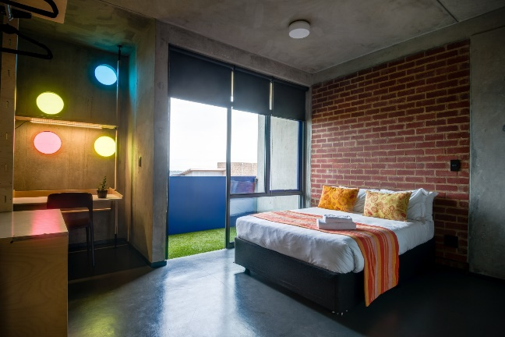 |  | 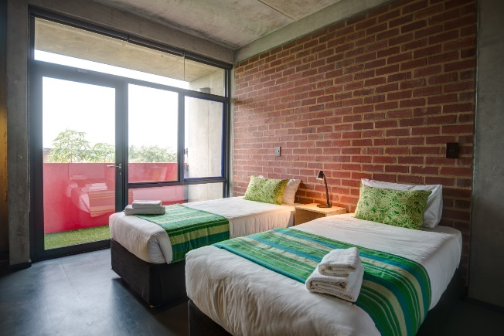
- Single Room price | 130 USD per room |  | Number of rooms : 10
- Double / Twin Room | 200 USD per room |  | Number of rooms : 13
- Board plan: Full Board: Breakfast & Dinner at the Future Africa – Lunch at the venue (included in the price)
- Check-in from: 14:00
- Check-out: 12:00

High Performance Centre (HPC) – Locker 1 & 2
Single | Double/Twin |  | Triple/Quad
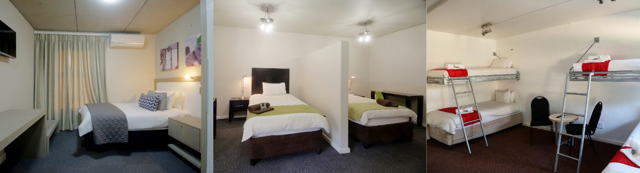
- Single Room price |  | 120 USD per room |  | Number of rooms : 10
- Double / Twin Room |  | 180 USD per room |  | Number of rooms : 16
- Triple Room (3 persons) |  | 225 USD per room |  | Number of rooms : 8
- Quad Room (4 persons) |  | 260 USD per room |  | Number of rooms : 4
- Board plan: Full Board: Breakfast & Dinner at HPC – Locker 1 & 2 – Lunch at the venue (included in the price)
- Check-in from: 14:00
- Check-out: 12:00
Both accommodation options are located inside the University of Pretoria, their unique location is only 10 minutes walking away from the practice and competition venues, and they are around 45 minutes driving away from the Johannesburg O.R. Tambo International Airport (JNB).
Rooms will be allocated on a first come, first serve basis. Accommodation rates include breakfast, lunch and dinner. Lunch will be served at the archery venue. Laundry service will be available for extra charges.
Early arrivals and late departures of the teams will need to be arranged with LOC case by case.

Closing Party: LOC will organize a Closing Party on 10 November 2022 for only 20 USD per person.
TRANSPORTATION
Local transportation will be provided from the Johannesburg O.R. Tambo International Airport (JNB) to the official hotels (around 45 minutes between airport and official hotels). This airport has daily flights with many different airlines. Transport timetables will be confirmed.
- The local transportation fee is 80 USD per person (Flat rate for a return journey)

VISA
All participants who need an entry visa to South Africa, will be required to complete the Visa Support sections in WAREOS by no later than 5 September 2022.

It is the applicants’ responsibility to supply the necessary information, ensuring all details are up to date, correct and submitted by the deadlines specified.

In addition, all participants that require a visa are kindly requested to supply a copy of their latest/valid passport. Copies of each application can be uploaded on WAREOS. All passport copies and personal details entered/uploaded to WAREOS will be held securely and in the strictest of confidence and not shared with other parties.

PAYMENT CONDITIONS
Complete all necessary sections in WAREOS and make full payment by the specified deadlines. Bank transfers only, no credit cards will be accepted. All bank charges will be paid by the participants.

ALL the fees should be paid in full before arrival.
To confirm hotel reservations, a minimum 50% deposit of the total amount is required to be bank transferred to the LOC before 1 October 2022. Reservations after this date will be considered only according to availability. The final outstanding balance shall be made via bank transfer before 25 October 2022. Accommodation cannot be guaranteed after this deadline. A balanced invoice will be provided via WAREOS and LOC.
Important:
- All payment is to be made to The South African National Archery Association, after receiving the corresponding proforma invoice.
- Please email LOC to make sure you receive the proforma invoice on the correct mailbox
- After 01 October 2022 reservations will be considered only according to availability.
BANK INFORMATION FOR ACCOMMODATION, TRANSPORTATION AND ENTRY FEES
Account Holder name | S A National Archery Association (SANAA)
Federation address | 41 – 17th Street, Parkhurst,
City, Post code & Country | Johannesburg, 2193 , Republic of South Africa
Telephone number | +27114472706 / +27829014900
Bank | Nedbank Limited
Account number | 1345012217
Swift Code | NEDSZAJJ
Bank address | 81 Main Road, Hermanus, Western Cape 7200
Email address | barbara@sanaa.org.za
NOTE: ALL PAYMENTS SHALL BE MADE IN USD BY BANK TRANSFER

CANCELLATIONS & CHANGES
All cancellations and changes must be made through WAREOS:
- Should flight arrival details change in the last minute, please contact the Organising Committee using the details indicated in the team managers’ booklet.
- If a participant’s arrival is later than the original scheduled arrival date, the room will be charged from the date of the original booking in WAREOS.
- An email will automatically notify the Organising Committee and Member Association of any changes made in WAREOS.
HEALTH REGULATIONS (COVID-19)
INFORMATION
- Everybody should follow the Government/public health authorities measures (national and sport-specific regulations) and be aware of travel restrictions
- For your information, Medical infrastructure/Hospital with proper care will be reachable within 15 minutes from the venue, where COVID-19 tests can be done.
- Please inform LOC if you need a COVID-19 test before your departure.
- The cost of COVID-19 test will be 50 USD and will be paid to LOC in advance.
Medical EMERGENCY
For Emergency, there are (2) Hospitals close to the HPC (Accommodation / Venue):
- Groenkloof Life Hospital, Address: 50 Kruin Street, Muckleneuk, Pretoria, 0181, (3.2 km) Phone: +27 12 424 3600. Mediclinic Muelmed, Address: 577 Pretorius St, Arcadia, (3.6 km from the HPC) Phone: +27 12 440 0600
- There are also Sports Medicine professionals based at HPC.
ADDITIONAL INFORMATION
Training
The training field will be available starting on 4 November 2022 from 14:00 at the Tuks University Sports Grounds located approximately 10 minutes walking from the official hotels.
The delegations will have to reserve sessions to access to the training field, to limit the number of archers shooting on the field.

Weather – November (Average)
- The maximum day temperature in Pretoria is 27° degrees Celsius
- The minimum day temperature in Pretoria is 14° degrees Celsius
- 13 hours of daylight per day
- 9 hours of sunshine per day
- Low heat and humidity
- 12 days of rain
- 11+ UV index

Media Registration
Media representatives can apply for registration by emailing LOC: barbara@sanaa.org.za

Internet
Will be available in the official hotels for free (in hotel rooms and in the lobby). There will also be Wi-Fi available for access to results on venue.

Water
Drinking water in South Africa is safe to drink and cook with when taken from taps in urban areas like Pretoria. A water fountain system will be used at the venue.

CURRENCY
- South African Banks are regulated by FICA (Financial Intelligence Centre Act 38 of 2001.
South Africa introduced FICA in 2001 to help fight financial crimes such as money laundering, the financing of terrorist activities, and to protect banking customers from such crimes.
- Currency brought into or taken from South Africa is therefore monitored by law.
- At present the customs law in South Africa states that you can bring up to 25,000 Rand (local currency)in cash or combinations of cash in other currencies, the limit is 10,000 USD (or equivalent) without having to declare this upon arrival at any customs points when arriving by air, land or sea.
- Banks also charge a 3% levy for depositing cash.
- Exchange rates fluctuate – so there would be a need to charge a levy for cash being deposited.
- Average exchange rate in the bank is:
1 United States Dollar (USD) = 16.32 South African Rand (ZAR) + exchange commission

Electricity
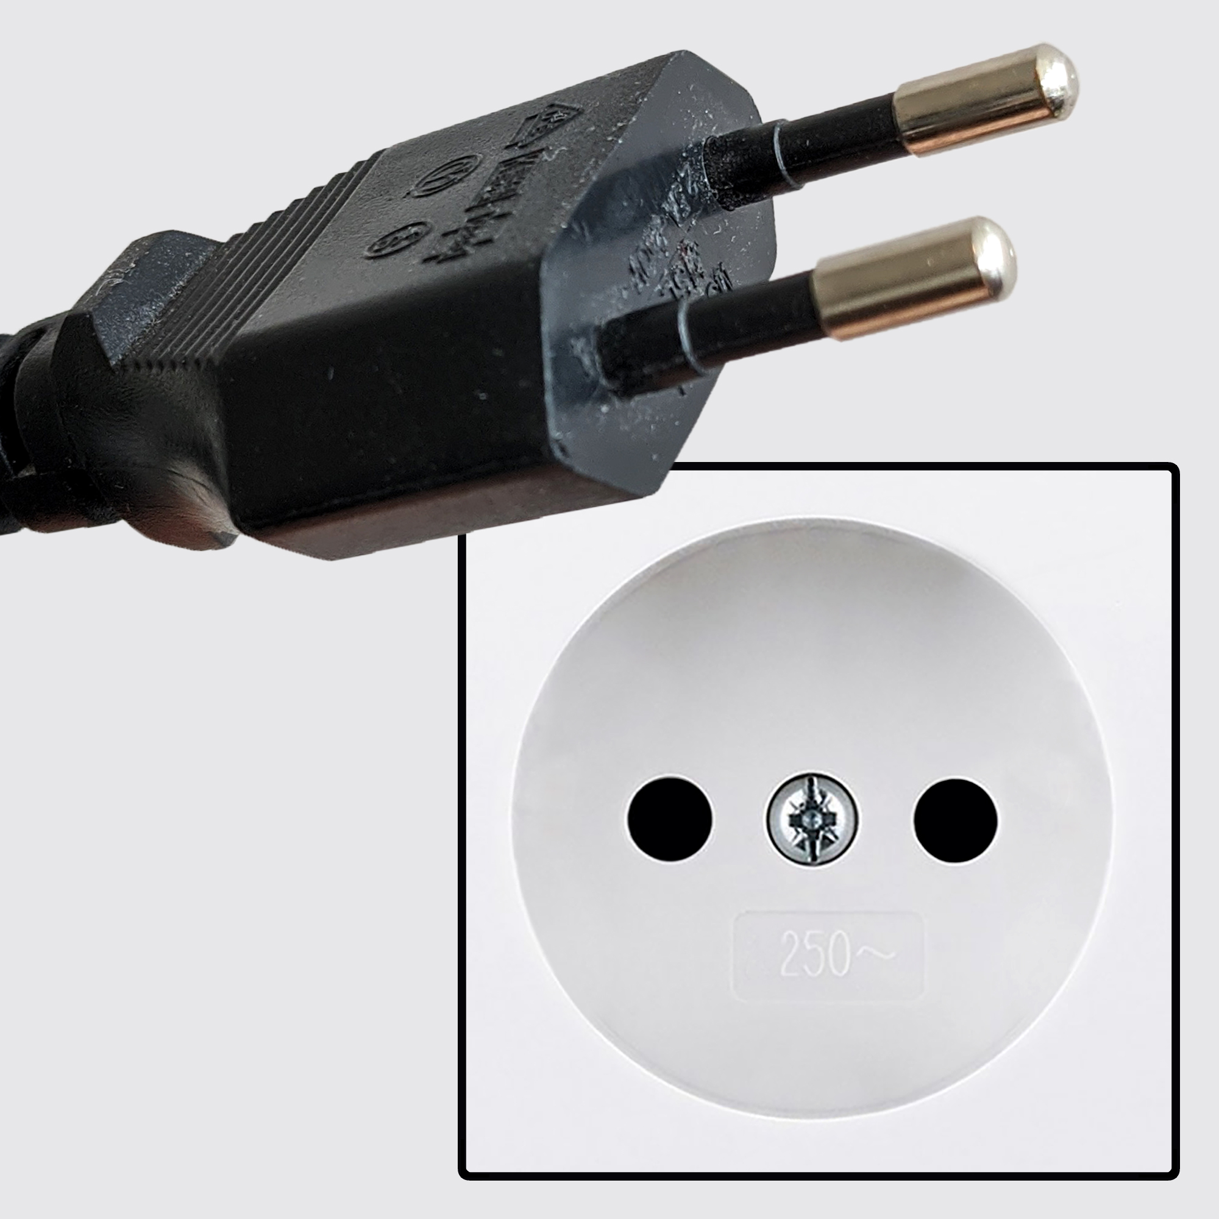
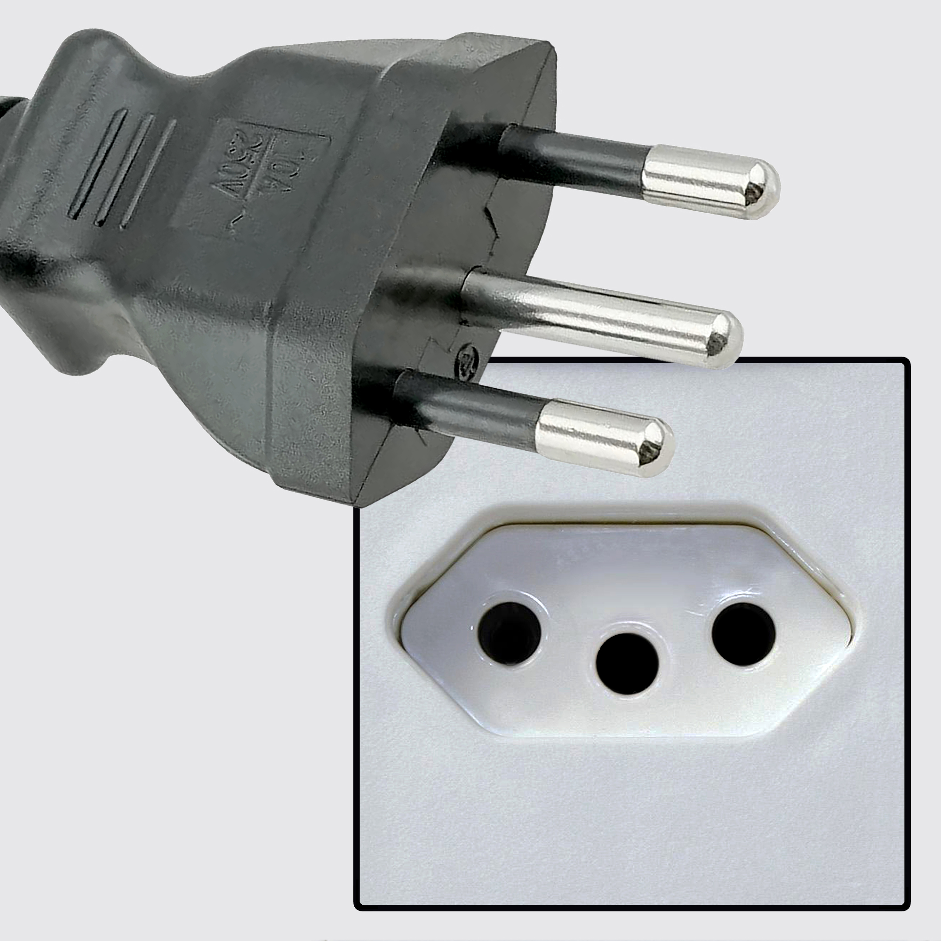
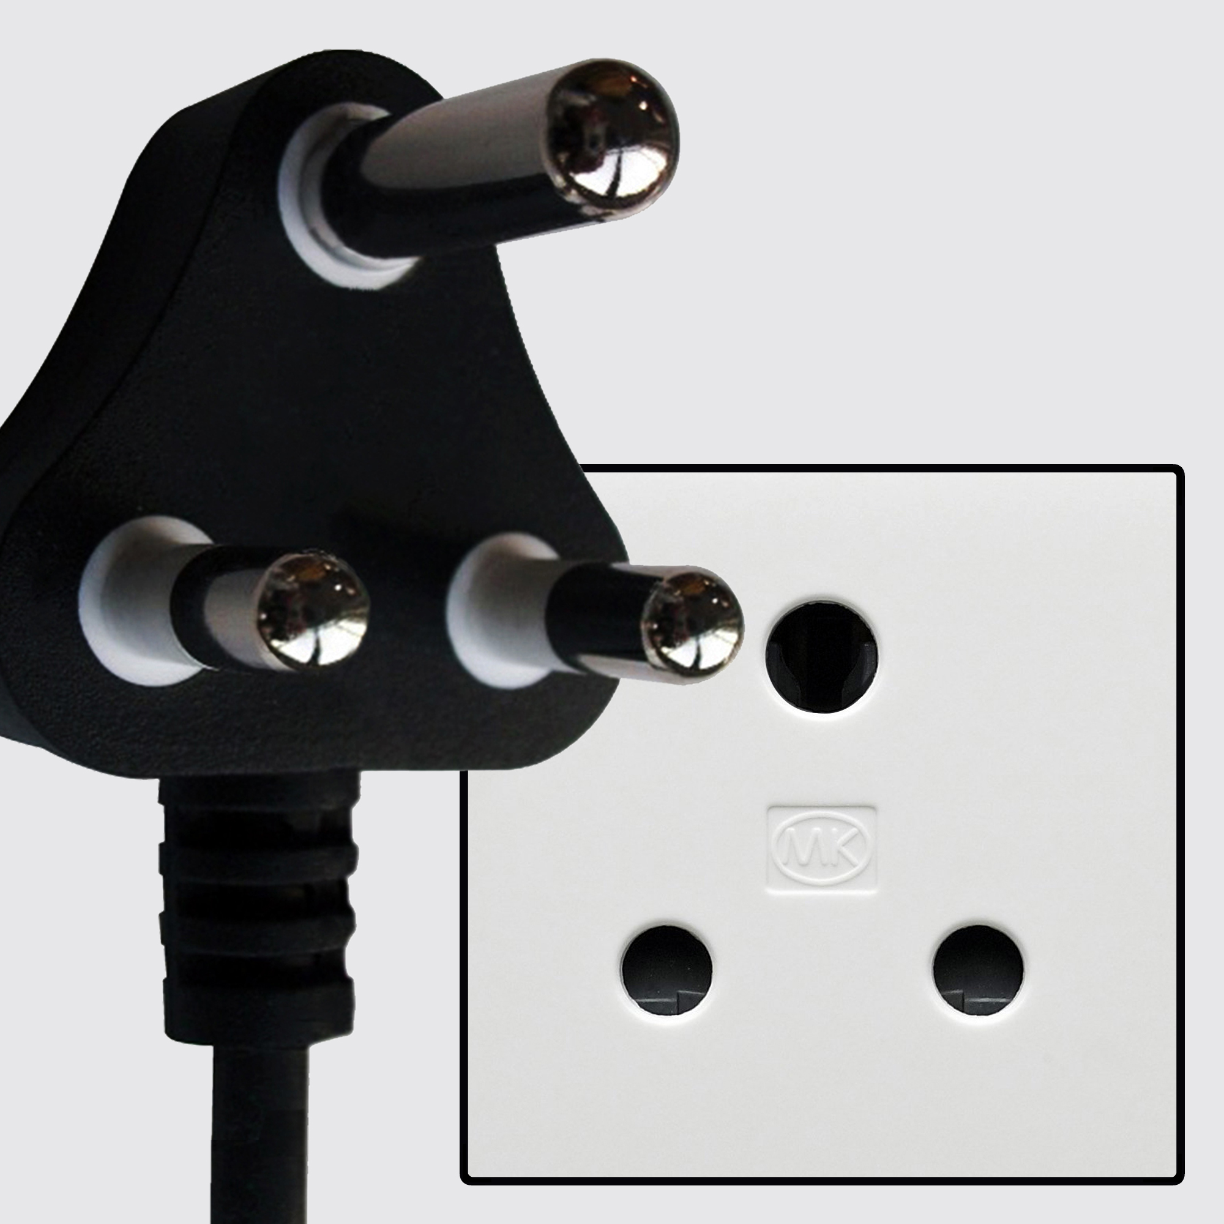
These are the most common power plugs used in South Africa: Type M – Type N – Type C

PRETORIA CITY
There are many good places to visit in Pretoria city and around it such as the following:
LION PARK LANSERIA
Situated only 13km from Lanseria Airport and only 40min from Johannesburg, the must-see tourist destination; Lion & Safari Park is nestled in the beautiful Magaliesberg mountain range and also within the Cradle of Humankind, a world UNESCO heritage site.  The 600 hectare property is home to a vast selection of indigenous species such as Lion, Cheetah, Hyena, Leopard, Wild Dog, Sable antelope, Kudu, Nyala (to mention only a few), the Lion & Safari Park offers a wealth of exciting activities for all ages, guests are guaranteed to get super-close to some of Africa’s favourite animals whether you go on an informative guided tour or self-drive. | 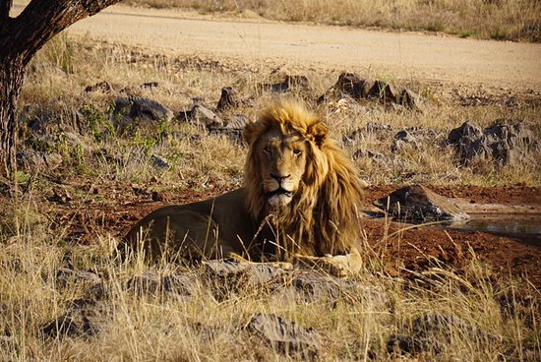
MENLYN PARK SHOPPING CENTRE (6.5 km from the High Performance Centre)
Menlyn offers a wide range of shopping stores, from H n M to Zara, cotton on and many more. The mall is a little hard to navigate around but it’s very convenient especially if you just want to buy everything from one place. There is also a Casino at Menlyn Square. | 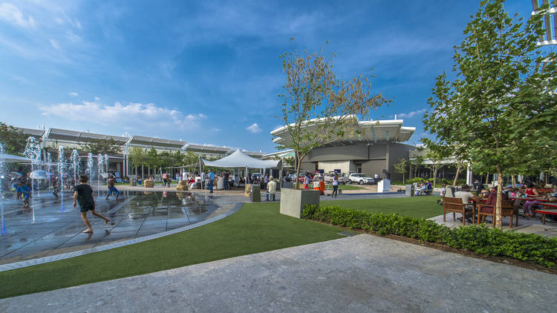
BROOKLYN MALL (± 5 km from the High Performance Centre)
Situated in the heart of Pretoria's cosmopolitan Embassy suburbs, Brooklyn Mall and Brooklyn Square combine all the components to create a vibrant hub of activity for the Capital's most prestigious neighborhood. Brooklyn Mall offer customers the convenience of one-stop-shopping catering to the requirements of the most discerning shopper. | 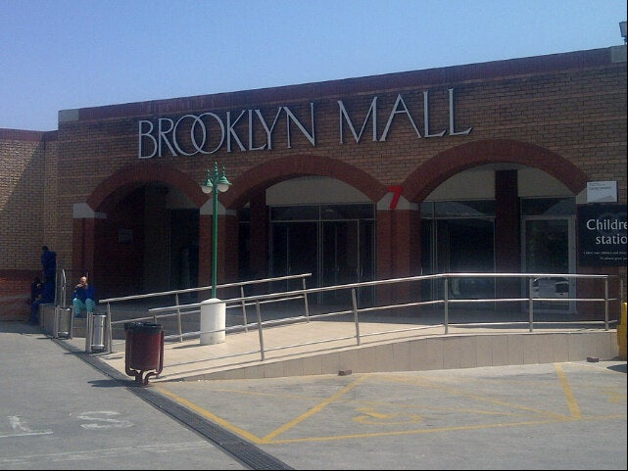
SANDTON CITY (43.9 km from Hatfield Gautrain Station – Trip Duration: 36 min)
Sandton City is Africa’s most iconic shopping centre. Defining the Sandton skyline, this prestigious setting is home to over 300 of the world’s most coveted retail brands, and embodies all the glamour of world-class shopping, dining, and leisure | 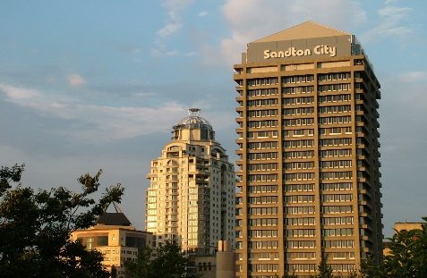
PILANSBERG SAFARI
Experience a full day Pilanesberg safari from Johannesburg. The Pilanesberg National Park is South Africa’s 4th largest national park. It covers an area of 55,000 hectares. | 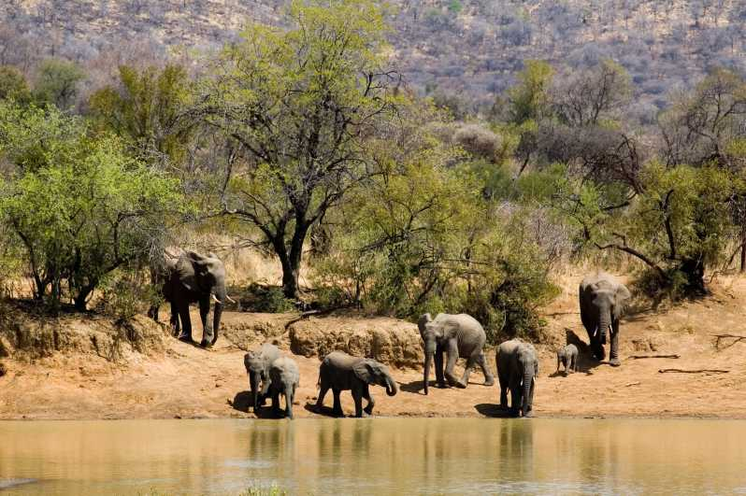
UNION BUILDINGS
The Union Buildings are considered South Africa's Architectural masterpiece. Designed and built by Herbert Baker and completed in 1913, the Union Buildings houses the Administrative offices of the Union of South Africa. Today it is still the official seat of government and houses the offices of the President of South Africa. It is situated on Meintjieskop and overlooks the City. | 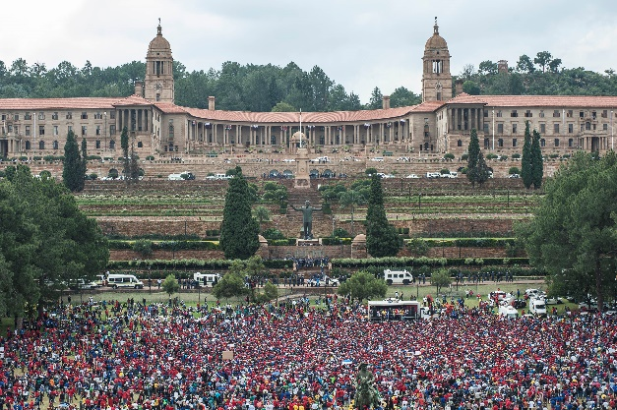

PRETORIA ZOO
The Pretoria Zoo, more formally known as the National Zoological Gardens. This 85-hectare zoo is home to thousands of species including mammals, birds, invertebrates, reptiles and amphibians. The Pretoria Zoo is situated just 5 minutes outside of Central Pretoria and 5.4 km away from Pretoria University (commonly known as Tuks University). Pretoria Zoo also houses South Africa’s largest inland marine aquarium as well as a Reptile Shed. | 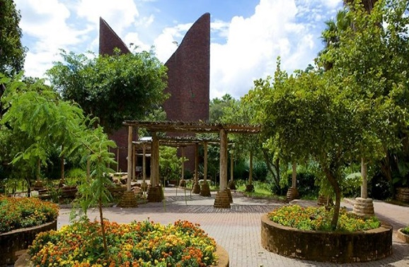

LOC CONTACT
Name: Barbara MANNING
Address: 41 – 17th Street, Parkhurst Johannesburg, 2193. RSA
Email: barbara@sanaa.org.za
Language: English / French
Phone number (WhatsApp) – English (Barbara): +27 82 901 4900
Phone number (WhatsApp) – French (Saber): +216 28 566 301

Looking forward to welcoming you in Pretoria, South Africa

