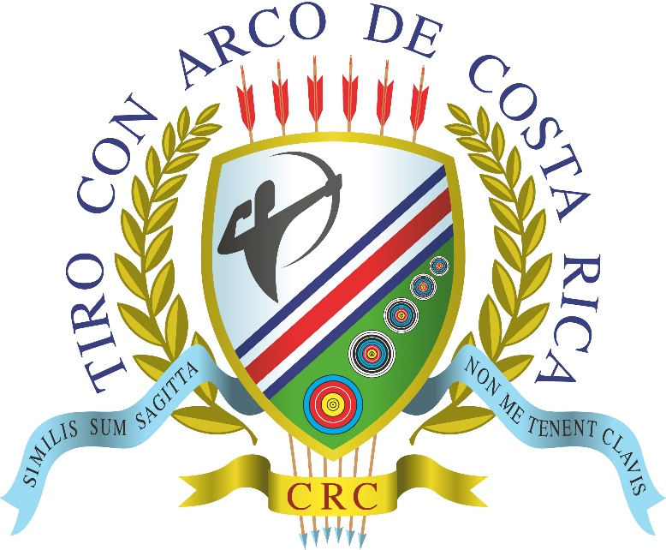
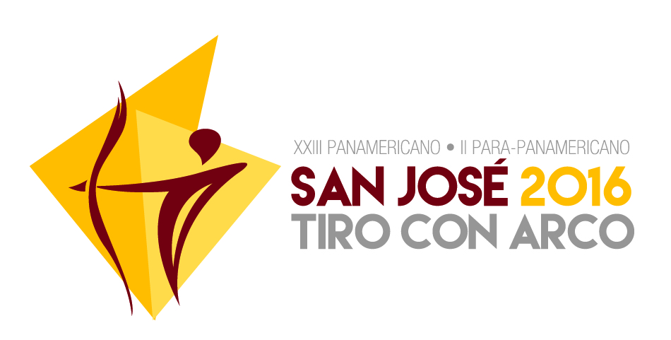

January 2016
To all World Archery Member Associations:
Dear President,
The Organizing Committee of the San José 2016 XIII Pan American and the II Para Pan American Championships, would like to invite all archers from your organization to participate on these events in San José, Costa Rica, from the 23rd to the 29th of May 2016.
This World Ranking Event will be held at the Costa Rican National Stadium and has been defined by World Archery (WA) as a qualifier tournament for the 2017 World Games that will take place at Wroclaw, Poland.
Based on our previous experiences, we want to offer not only a great sporting event, but one that becomes an unforgettable experience for all participants.
In the following pages you will find the necessary information to follow up the inscription process, tournament costs, hotel reservations, transport information, event calendar, and much more.
The official web site for the event is sanjose2016.archerycrc.org, where you can find up to date information on the event, including the information you see in this document. We suggest you review the web site very often as we will publish there all updates and activities as we get closer to the start date in May. We will also use this site to publish information during and after the tournament.
If you have any specific request, please send it to: info@sanjose2016.archerycrc.org.
Looking forward to see you in San José!
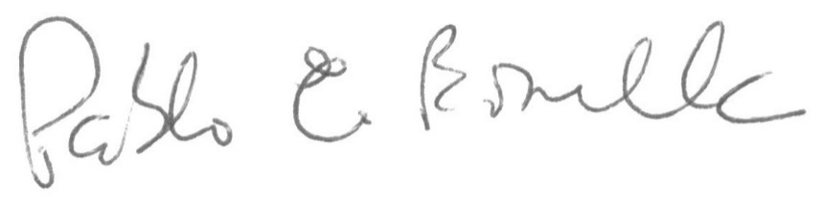
Pablo Bonilla F.
President, Costa Rican Archery Federation / Organizing Committee
Costa Rican Archery Association

Table of Contents
Table of Contents 3
Important Dates 4
General Information 5
Tournament General Information 6
Divisions 6
Classes and Categories 6
Qualification Rounds 6
Elimination and Final Rounds 7
Anti-doping 7
Medals 7
Preliminary Schedule 8
Tournament Registration 9
Preliminary Registration 9
Final Registration 9
Registration Fees 10
Payment Methods 10
Registration Changes 10
Lodging and Food 11
Lodging 11
Food 11
Hotel Address: 12
Hotel Web Site 12
Hotel Irazú Rooms 13
Transportation 14
General Travel Arrangements 15
Visas and Travel Requirements 15
Important Links 16

Important Dates

Preliminary Registration Start Date: February 1st
(register.worldarchery.org)

Preliminary Registration End Date: March 25th
Final Registration End Date: May 2nd
Additional $50 after this date
Hotel Reservation Form – Send and Payment End Date: May 2nd
Lodging at the official hotel cannot be guaranteed if payment is received after this date.
Tournament Registration – Payment End Date: May 9th
Any payment received after this date will have a $50 penalty fee
Tournament Registration – Cancellation End Date: May 16th
Any registration that is cancelled after this date will have to be paid in full.
Flights Information Form – Send End Date: May 16th
Transportation from the Airport to the Official Hotel cannot be guaranteed if this information is received after this date.

General Information

Tournament Fee - Archers $100
If lodging is not in the official hotel $200

Tournament Fee – Team Official / Coach $80
If lodging is not in the official hotel $160

Competition Format - Recurve
Qualification Round………. 2x70 / 2x60
Elimination Round………. Set System at 70m

Competition Format – Compound and W1
Qualification Round 2x50
Elimination Round cumulative score at 50m

Medals per category
First three places – Individual Final Rounds
First three places – Team and Mixed Teams Final Rounds

Tournament General Information

Divisions
Archers will compete in the Recurve and Compound Divisions

Classes and Categories
At the San José 2016 Pan American Championship, archers may compete in the Open, Junior, Cadet and Master classes, for both Men and Women.

At the San José 2016 Para Pan American Championship, archers may compete in the Open Classes for Recurve, Compound and W1, for both Men and Women.

In both the Pan American and the Para Pan American Championships, only 4 archers per category are allowed for each WA Member Association or country.

A specific individual category will be opened only if there are at least 4 archers representing a minimum of 3 countries. There must be at least 4 countries represented in the team categories.

Qualification Rounds
The 50m, 60m, y 70m round will be used for recurve and compound, according to the official regulations for each category:

Round | Division | Category | Target Faces
50m | Compound | All | 80cm
60m | Recurve | Cadets and Masters | 122cm
70m | Recurve | All except Cadets and Masters | 122cm

Elimination and Final Rounds
After the Qualification Rounds, there will be an Elimination Rounds per category:

- Junior Archers may participate in the Open Elimination Rounds, for Compound and Recurve, Men and Women.
- Master and Cadet Archers may participate in the Compound Elimination Rounds for the Open Categories (Men and Women).
- Archers competing in the Para Pan American Championship may participate in the Elimination Rounds of the Open Categories (Men and Women) of the Pan American Championship.
- The total number of archers of the same country in the Elimination Rounds of the Open Categories, shall not be more than 4, even after adding the Junior, Cadet, Master and Para Archers.
- The Recurve Elimination Rounds (Olympic Round), will be at 60m for Cadets and Masters, and at 70m for all other categories. The set system will be used (up to 5 sets of 3 arrows)
- The Compound and W1 Elimination Rounds (Compound Round), will be at 50m for all categories. The cumulative score system will be used (5 ends of 3 arrows).
- In the Team Elimination Rounds, each team will shoot 4 ends of 6 arrows (2 per archer).
- In the Mixed Team Elimination Rounds, each team will shoot 4 ends of 4 arrows (2 per archer).
- In the Final Rounds, the alternate shooting system will be used (1 arrow per archer).

Anti-doping
Because this is a World Ranking Event, international anti-doping regulations will apply as defined by World Archery for this type of events. Please refer to the World Archery (WA) and the World Anti-Doping Agency (WADA) web sites to review the regulations in place at the time of the tournament.

Medals
The following medals will be awarded in the San José 2016 Pan American and Para Pan American Championships:

- First 3 Individual places, for Men and Women in all categories.
- First 3 Team and Mixed Team places for Men and Women in all categories.

Preliminary Schedule
The following Schedule may be modified to allow for changes in the number of participants, the number of open categories, or any other change that is not possible to foresee at this time. Any change will be notified in advance through the official web site of the event.

Sunday, May 22nd | Official arrival day
Monday, May 23rd | Unofficial Practice  Official Arrival day
Tuesday, May 24th | Judges Meeting  Official Practice  Equipment Inspection  Team Captains Meeting  Inauguration Ceremony
Wednesday, May 25th | Qualification Round, All Categories
Thursday, May 26th | Individual Elimination Rounds:  - Open Compound  - Recurve: Juniors, Cadets and Masters  - Recurve PARA
Friday, May 27th | Individual Elimination Rounds:  - Open Recurve  - Compound: Juniors, Cadets and Masters  - Compound: PARA and W1
Saturday, May 28th | Team Elimination and Final Rounds  Mixed Team Elimination Rounds
Sunday, May 29th | Individual Final Rounds  Mixed Teams Final Rounds
Monday, May 30th | Official Departure day

Tournament Registration
Preliminary and Final registrations for archers and officials will be processed through WAREOS, the World Archery Online Registration System.

In order to use the system, the URL http://register.worldarchery.org/ should be used, using the username and password provided by WA to all Member Associations. In case your organization does not have this information, please contact Jae Kyung Lee (jklee@archery.org) to request it. If you have any issue with the use of WAREOS system, you may contact Sergio Font (sergiofont@yahoo.com).

To process the preliminary and final registrations through WAREOS, you first must fine the “XXIII Pan American and II Para Pan American Championships San José 2016” tournament and choose the “Entries” option.
It is important to take into account that the tournament will be visible in the WAREOS system only during the official registrations dates.

Preliminary Registration
The preliminary (or numeric) registration should be done using the Preliminary Entries option in the system, for each one of the available tournament categories. Each Member Association should insert the number of archers per category they wish to register in the tournament.

Final Registration
Once the names of the archers that will participate in the tournament are known, final registration process allows each Member Association to choose them in WAREOS from the list of archers already in the system. This is done through the Final Entries column, and then selecting each archer for every category.
It is important to be aware of the registration deadlines, after which the information in WAREOS cannot be updated.
Any change to the information added (or not added) to the system after the Final Registration End Date will be penalized with a US$50 fee per archer and official, which should be cancelled before the start of the tournament.
If a Member Association (or any of its archers) is registered in the WAREOS system and does not participate in the tournament, it will have to cancel the full registration fee (including penalties), unless the Organizing Committee is informed at least one week before the start of the tournament.
Only Member Associations that are in good standing with their obligations with World Archery may participate in this event.
For security purposes, and as part of the registration process, a digital Passport size photograph is requested for each registered archer and official. This photograph should have a resolution of at least 300 dpi (dots per inch). All participants must comply with this request.

Registration Fees
The registration fee for archers is $100 and for officials and coaches is $80. These are in US dollars.
If a Member Association or any participant does not make their lodging arrangements through the Organizing Committee (through the official web site forms), the registration fee will be $200 per archer and $160 per official or coach.

Payment Methods
Different payment methods will be accepted, the details of which will be found in the Registration section of the Official web site. International Bank Transfers will be among them.

No payment will be processed through checks or Travelers Checks.

Registration Changes
Changes to the registered archers will be accepted only in the same category and division, after the Final Registration Date, and up to one week before the start of the tournament.

Lodging and Food

Lodging
The official hotel for the event is the Best Western Irazú Hotel, located 5 minutes from the National Stadium. Transportation will be provided to and from this official hotel only (airport and tournament venue). Accommodation at any other location will require participants to be in charge of their own transportation to and from the airport and the tournament venue.
Hotel reservation will be processed only through the event official web site. No paper or email information will have to be sent, unless it is directly requested by the hotel or the Organizing Committee.
The lodging registration forms will be available in the Registration section of the web site and will be available during the official registration dates.

Food
For the participants of the San José 2016 Pan American and Para Pan American Championships, food costs for all 3 daily meals (breakfast, lunch and dinner), are included in the lodging fees.
Breakfast and dinner will be served at the official hotel. Lunch will be served at the National Stadium.
The following are the lodging feeds per room type (all amounts are in US$):
Room Type | Price per person  per day
Single | $140
Double | $100
Triple | $80

All taxes are included.

The room prices above include:
- Breakfast, Lunch and Dinner.
- Unlimited Free International Phone Calls on each room.
- High Speed Wireless Internet in every room and hotel locations.
- Juan Santamaría Airport Arrival and Departure Transportation to and from the Hotel, following a pre-defined schedule.
- Free local phone calls and 24-hour internet Access through the Business Center.
- 24-hours gym and coffee station.
- 24-hours free parking

Hotel Address: Hotel Irazú
Km. 3, General Cañas Highway
San José, Costa Rica.

Address from the Airport: 9 kilometers towards San José, take the roundabout towards La Uruca and turn to your right on the first exit. The hotel is 200 meters towards San José.

Hotel Web Site: http://www.bestwesterncostarica.com/

Hotel Irazú Rooms

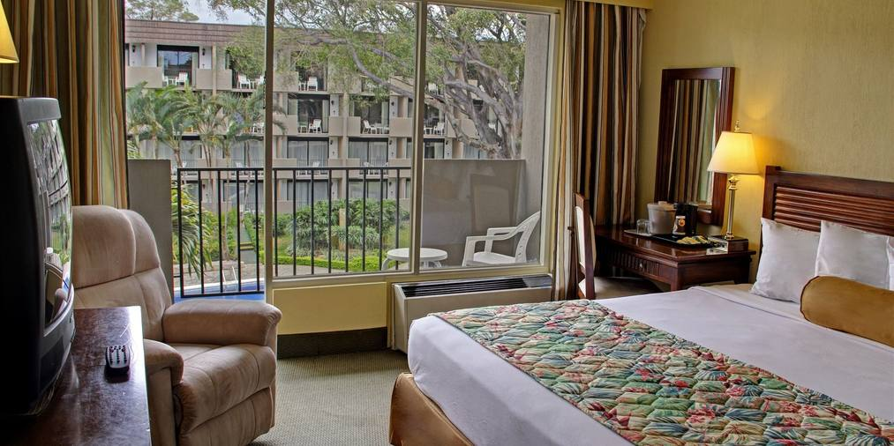

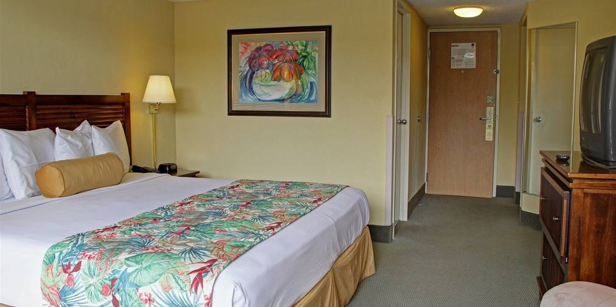

Transportation

The official hotel will be in charge of airport arrival and departure transportation. No transportation will be provided to and from other lodging locations. For this, archers and delegations must fill the form located on the official web site, in the Transportation Section.
Daily transportation to the tournament venue (the National Stadium) will be provided only to and from the official hotel. No transportation will be provided to and from other lodging locations.

General Travel Arrangements
- Tournament participants must be prepared for rain, although the 2016 season is expected to be hotter and dryer than usual.
- No strong winds are expected.
- San José has a moderate climate all year round, with temperatures between 20º and 26º centigrade (68 to 79 degrees Fahrenheit).

Visas and Travel Requirements
- Not all travelers require a visa to travel to Costa Rica. You can review the general requirements here.
- You can verify if you need a visa to travel to Costa Rica, depending on your country of citizenship, in this web page.
- If you require an invitation letter for your visa request process, please send an email to info@sanjose2016.archerycrc.org.
- Costa Rica is requiring the Yellow Fever vaccine for travelers from certain countries, especially from the South American Region. Additional information can be found here. Exceptions of this requirements can be found on this link.

Important Links

Official Web Site http://sanjose2016.archerycrc.org/
General Information request info@sanjose2016.archerycrc.org
Visa / Vaccination Requirements http://www.costarica-embassy.org/index.php?q=node/72
Yellow Fever Exceptions http://www.costarica-embassy.org/index.php?q=node/97
World Archery www.archery.org
World Archery Americas (COPARCO) www.coparco.org
World Archery Costa Rica (WACR) http://www.archerycrc.org/
World Anti-doping Agency http://www.wada-ama.org/
Sports and Travel – Costa Rica http://sportsandtravelcr.com/

