South American, Open Youth Archery Championship "Ciudad de Guayaquil"

From 4 to 9 October 2021

GUAYAQUIL – ECUADOR

Place and Date

The South American Championship "Ciudad de Guayaquil" will be held at the Estadio Modelo Alberto Spencer, located in the city of Guayaquil – Ecuador
Date: October 4-9, 2021.

Participants
Categories Recurve Junior Men, Recurve Junior Women, Compound Junior Men, and Compound Junior Women. Archers who were born in 2001 or later.
Categories Recurve Cadet Men, Recurve Cadet Women, Compound Cadet Men, and Compound Cadet Women. Archers who were born in 2004 or later.
Athletes from National Federations and Archery clubs affiliated and recognized in their countries.
Each archer may participate in one category only.
South American competitions: only teams from South American countries.
Open competition: All World Archery Member Associations can register archers for the open event, and there is no limit in the number of participants a national federation can enter in each category.Important dates
 | deadline
Start of registration | June 14, 2021
Preliminary registration deadline | July 31, 2021
Final registration deadline | September 15, 2021
Accommodation reservations | August 31, 2021
Request for transport Airport-Hotel-Airport | September 15, 2021
Request for visa support letters | August 31, 2021
Final payment of accommodations | September 15, 2021
Deadline for cancellation with refund | September 20, 2021

Preliminary programming
date | Activity
2&3-Oct | Arrivals
3-oct | Unofficial practice
4-oct | Official practice, equipment inspection and team managers' meeting
5-oct | Qualification round: all categories
6-oct | Mixed team and team: South American Championships Elimination to Bronze matches  Team and Mixed Team Eliminations till Gold matches (open event)
7-oct | Individual Elimination to medal matches (open event)
8-oct | Individual Elimiination to Bronze matches – South American Championships
9-oct | Compound Team and Mixed Team Gold Matches – South American Championships.  Recurve Team and Mixed Team Gold Matches – South American Championships.  Individual Compound Gold Matches – South American Championships  Individual Recurve Gold Matches – South American Championships  Award ceremony
10-oct | Departures

This preliminary schedule is subject to change, which will be reported as soon as possible.

Team Competition
Teams will be composed of 2 athletes, in compliance with the team format for the Pan American Junior Games
The mixed teams will be composed of two athletes (a man and a woman) in the same bow category.

Registrations

Registrations, accommodation reservations, transfers, flight arrival/departure information, and visa invitation letter requirements must be made on World Archery’s Online Registration System, WAREOS.
Preliminary registration must be made by July 31, 2021.
The final registration must be made by September 15, 2021.
All participating delegations must have registered by that date: List of their athletes, coaches and officials.
Each registered delegation shall designate a person who shall be the representative of the team. The person with whom the organizing committee will maintain all communication regarding registration, claims and all queries and general information that may be necessary to resolve during the stay and the course of the championship.

Accommodation

Sheraton Guayaquil Hotel
- 5-star hotel
- Single Room: US$ 100.00 per room per day
- Double room: US$ 160.00 per room per day
- Check-in from: October 2 or 3, 2021 at 14:00
- Check-out until: October 10, 2021 at 12:00
- Hotel website https://www.espanol.marriott.com/hotels/travel/gyesi-sheraton-guayaquil-hotel/

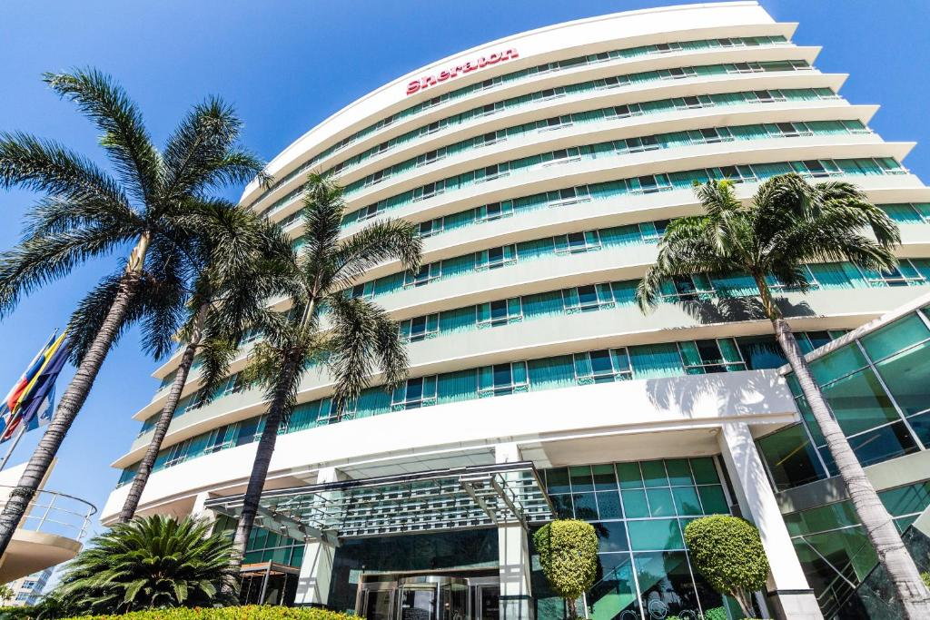

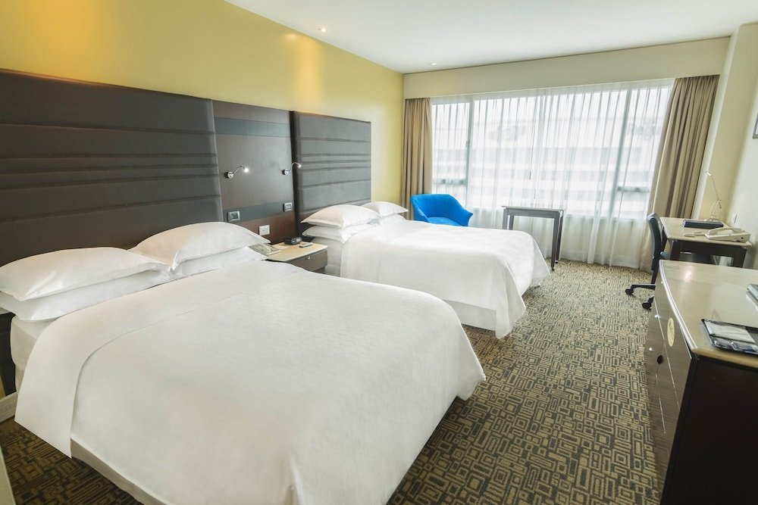
The entire team must be accommodated in the same hotel. The accommodation includes breakfast, lunch, dinner, and transport between airport-hotel-competition venue. Lunch will be served at the stadium where the competition is held. Breakfast and dinner should be taken at the hotel´s restaurant, not at any other restaurant.

Entry Fee
Individual: US$80 per athlete
Officers/coaches: US$70 per person

Payment conditions

The registration fee must be paid in full before the arrival of the delegation.
The hotel reservations require of a minimum deposit of 50% of the total amount and must be transferred before August 31, 2021. The final outstanding balance shall be transferred by 15 September 2021.
The bank details for the transfer are in the name of:
FEDERACION ECUATORIANA DE TIRO CON ARCO
Banco Bolivariano
Checking Account No.: 0855053013
Swift Code: BBOLECEGXXX

Addresses:
Banco Bolivariano  Junín 200 and Panamá  Guayaquil, EC090306  Ecuador | Federación ecuatoriana de tiro con arco  Av. From the Americas s//n  Ecuadorian Olympic Committee Building  Guayaquil, EC090510  Ecuador

All payments will be made in USD by bank transfer. All bank charges will be paid by the participants. Credit cards will not be accepted.

Cancellations and changes
All cancellations and changes will be made through WAREOS.
Cancellations received by September 20, 2021, will be fully refunded after covering for bank charges.
Cancellations received after September 20 are non-refundable.
All refunds will be processed after the event.
Name changes will be accepted for team officials or athletes (same category and division) up to two days before official practice without any charge or penalties.
In the case of late arrivals, the accommodation will be charged from the original date of reservation.

Health regulations (COVID-19)
Participants are defined as athletes, coaches, officials, judges, volunteers, and all personnel who are present during the event.
All participants must follow the health rules laid down by local and national authorities as well as those specific to the sport.
Any participant who feels unwell should not attend.
All participants should check their health status regularly.
As of May 31, 2021, Ecuador's entry and exit protocols are:
By order of the National Emergency Operations Committee (COE) all passengers entering Ecuador through any of the authorized points of entry, without exception, must present a mandatory RT-PCR test or printed negative antigen test (original and duplicate), performed up to three (3) days before arrival in Ecuador or the printed COVID-19 vaccination card or its equivalent (original and duplicate), with the complete schema.
In addition, the National COE has indicated that passengers whose point of origin, stopover or transit is Brazil must undergo mandatory quarantine for 10 days in hotels authorized by the Ministry of Tourism, regardless of the result of a COVID-19 test. This provision is effective as of April 8, 2021 at 11:59 p.m.
For admission you must also fill out the Traveler's Health Declaration Form that you can download from https://www.cancilleria.gob.ec/wp-content/uploads/2020/06/formulario_de_salud_del_viajero_revisado.pdf.pdf_1-1.pdf
Authorities in Ecuador do not request COVID-19 testing to leave the country. You only need your usual travel documentation and mandatory mask-wearing. However, we recommend that you inform your airline about the provisions in place to enter or leave your destination country, including check-in requirements.
For more information or requirements update visit the websites:
- http://www.tagsa.aero
- https://www.gestionderiesgos.gob.ec/coe-nacional/

On October 8 and 9, sampling services for COVID tests will be available for those participants who require this test to return to their country. COVID-19 tests have a cost of:
- RT-PCR: $60
- COVID19 antigens: $40

These prices may vary according to the prices that are established on that date. The coordination for the tests will be carried out upon the arrival of the delegations.

Additional Information

Weather
Due to its location, the climate of Guayaquil is warm almost all year round. For October, the temperature ranges between 21 and 30 degrees Celsius, with a relative humidity of 57%

Internet
The hotel has WiFi internet in rooms and public areas of the hotel. No internet service will be provided at the shooting range.

Ianseo Scorekeeper
In the competition, the Ianseo Scorekeeper will be used for the recording of the score. Athletes must have a cell phone with the application downloaded.
To inquire about the installation or use of the application you can consult the website www.ianseo.net or watch the video https://www.youtube.com/watch?v=FBkXUU6TFKs

Contact Information
For more information:
- Web: www.feta.org.ec
- Facebook, Instagram and Twiteer: fetaecuador
- Mail: fetasudamericano2021@gmail.com
- Guillermo Quiroga: +593 997002916
- Juan Sánchez Rugel: +593 993300270

