TO ALL WORLD ARCHERY MEMBER ASSOCIATIONS,

Dear Presidents,

As President of the Archery Federation of Chile (FECHTA), and in the representation of the Local Organizing Committee (LOC) of the XXVI Panamerican and V Para-Panamerican Archery Championships, to be held in Santiago, Chile on November 21-27, 2022, I would like to invite you all to be part of one of the most important archery events to take place in the Americas in 2022.

This tournament is a World Ranking Event and will be the main Qualifier Tournament for the SANTIAGO 2023 Panamerican and Parapan American Games. The tournament will be held at the Bernardo O´Higgins National Military Academy in Las Condes County in our capital city, Santiago.

With the support of the National Olympic Committee (NOC), National Paralympic Committee, and the Ministry of Sports, we are working hard to give your archers an extraordinary experience inside the competition field as well as a cultural opportunity to know our beautiful country and culture.

Enclosed you will find all the necessary information to register for the XXVI Panamerican and V Para-Panamerican Archery Championships, official fees, hotel reservations, tournament schedule, etc.

This year, the Archery Federation of Chile celebrates Its 40th Birthday, and we are looking forward to seeing you all in November to celebrate together!

You can also contact us at: Santiago2022@fechta.cl for information, or further questions.

Sincerely yours,
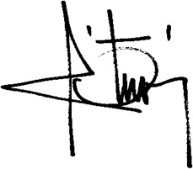

César Otárola Bruce
President
Archery Federation of Chile

Important Dates:
Please find enclosed information regarding the details of this event and how to complete registration. To register participation, please complete all the necessary sections in WAREOS (https://extranet.worldarchery.sport) within the deadlines listed below:
Summary of deadlines:
Start date for online registration WAREOS 20 May 2022
- Preliminary Entries 21 August 2022
- Final Entries 31 October 2022
- Late entry fees 31 October 2022
- Hotel Reservation and 50% payment 21 September 2022
- Transportation 31 October 2022
- Visa Support 21 September 2022
- Final Hotel Reservation & Payment 21 October 2022
- Full refund cancellation deadline 7 November 2022
¨*after this deadline, the LOC is allowed to retain all amounts due by the Member Association.
Looking forward to welcoming you in Santiago de Chile!

PRELIMINARY PROGRAMME
Saturday Nov. 19 Arrivals
Sunday Nov. 20 Arrivals and free practice
Monday Nov. 21 Pan Am Championships Official Practice, Team managers’ meeting and equipment inspection
Para Pan Am Championships – Classification
Tuesday Nov. 22 Pan Am Championships Qualification Round (all categories)
Para Pan Am Championships – Official Practice, Team managers’ meeting and equipment inspection
Wednesday Nov. 23 Pan Am Championships – Team Elimination and Finals
Para Pan Am Championships – Qualification Round (all categories)
Thursday Nov. 24 Pan Am Championships – Individual Eliminations to Semifinals
Para Pan Am Championships – Mixed Teams and Doubles elimination to finals
Friday Nov. 25 Pan Am Championships – Pan Am Games Individual Qualifier
Para Pan Am Championships – Individual Elimination to semifinals, VI Individual Elimination to Finals.
Saturday Nov. 26 Pan Am Championships – Mixed teams Elimination to semifinals
Para Pan Am Championships – Individual medal finals
Sunday Nov. 27 Pan Am Championships – Individual and Mixed Team medal finals

NOTE: This preliminary programme is subject to change according to participation and TV requirements. All changes will be published and distributed in good time.
PRELIMINARY & FINAL REGISTRATION
All entries, accommodation reservations, transport needs, flight arrival/departure information and visa invitation letter requests are to be completed using the World Archery Online Registration System WAREOS https://extranet.worldarchery.sport This system handles the entire registration process for this event. No entry forms, hotel reservations or transportation forms will be accepted; all information must be entered into WAREOS.
Member associations can login to WAREOS at http://extranet.worldarchery.sport with the username and password assigned by World Archery. After entering WAREOS, selecting the event from the list will allow a member association to register their athletes. Select/press the “Entries” button to see the list of categories in the event. Select/press the “category” to enter the athlete and official numbers/details participating for that event. A WAREOS User Manual can be downloaded in PDF format (English) upon login.
Contact (wareos@archery.sport) with any questions regarding technical problems on WAREOS. For any question regarding the organisation of the event (transport, accommodation, meals etc.) please contact directly the LOC.
Athletes from a minimum of 4 different Member Associations shall be registered and participate in the event. Entries should be completed using WAREOS.
Member Associations can only use WAREOS to make any changes or amendments to entries and will be able to do so at any time. An email will automatically notify the Organising Committee and Member Association of any changes made in WAREOS.
EVENTS
The Pan American Championships will include individual, team and mixed team events in the Recurve Men, Recurve Women, Compound Men, Compound Women, Barebow Men and Barebow Women categories.
The Parapan American Championships will include individual, doubles, and mixed team events in the Recurve Men Open, Recurve Women Open, Compound Men Open, Compound Women Open, Men W1, Women W1, VI1, and VI 2/3 categories. A minimum of three participants will be required for a category to be considered valid for awards.
PARTICIPANTS
Each national federation can enter up to four archers in each individual category at both the Pan American and the Parapan American Championships.

PAN AMERICAN AND PARA PAN AMERICAN GAMES QUALIFICATION
The systems to qualify for the 2023 Pan American and Parapan American Games have been approved and distributed. For questions on these systems and their application in the 2022 Championships in Santiago de Chile, please contact worldarcheryamericas@gmail.com
ENTRY FEES
Individual: | 140 USD per athlete
Officials:  ENTRY FEES IN NON-OFFICIAL HOTELS  Individual:  Officials:  Airport Transfer*: | 120 USD per person  280 USD per athlete  240 USD per person  Included
Entry fees INCLUDE daily local transport to and from the practice field to/from official hotels during the qualification, elimination, and finals venues (timetable to be confirmed on site). Teams not arranging their accommodation with the Organizing Committee will not be entitled to airport transfers coordinated by the LOC.
Any changes that are made after the deadlines specified or if entries differ by more than 4 athletes from the preliminary entries, the following penalty fees will automatically be applied:
Penalty fees to be paid to Organizing Committee: | Cost (USD):
Entries made after the preliminary and/or final entry deadline date. | 50 per entry
If final entries differ from the preliminary entries by more than 4 athletes/officials. | 150 per entry
Failure to have made preliminary entries before the deadline date but then have submitted final entries. | 150 per entry
ACCOMMODATION & GENERAL INFORMATION
Pullman Hotel “El Bosque”– 4 Star Hotel
- Single Room full board: USD 180 per room
- Number of single rooms: 35
- Double Room full board: USD 250 per room
- Number of double rooms: 75
- Check-in from November 18th 3pm
- Hotel website: https://all.accor.com/hotel/B461/index.es.shtml?utm_campaign=seo+maps&utm_medium=seo+maps&utm_source=google+Maps

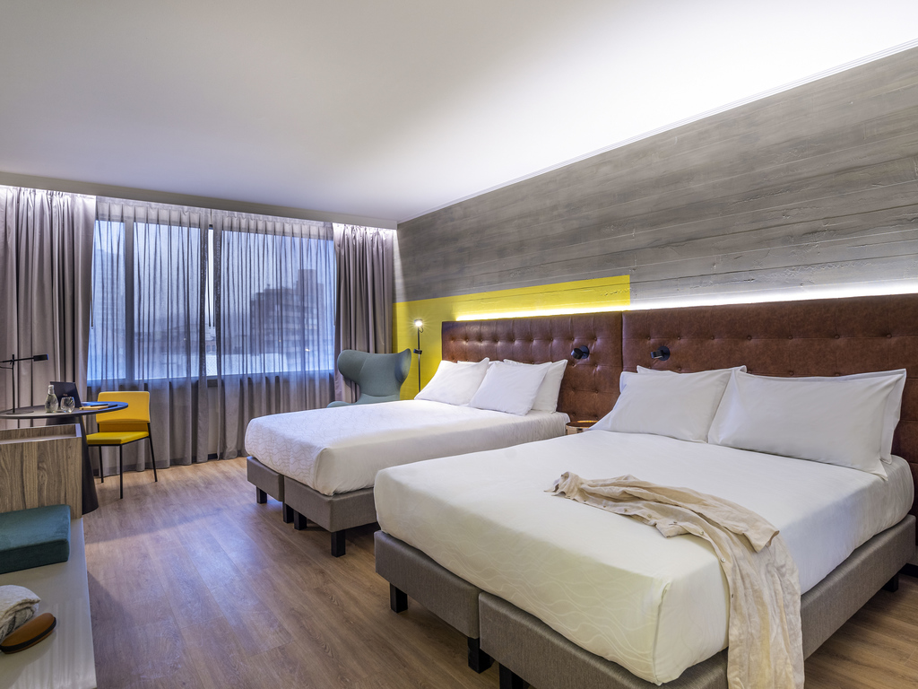
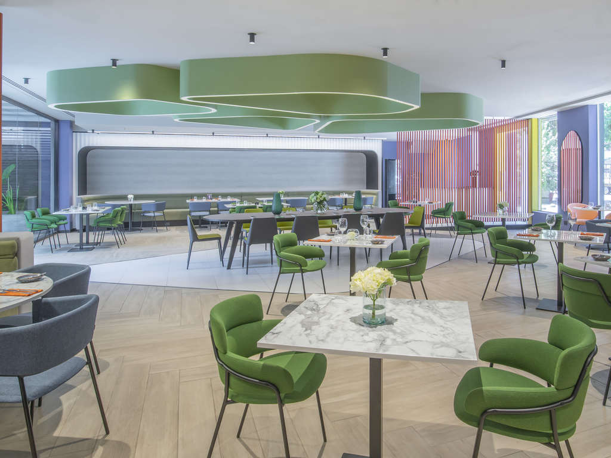

Pullman Hotel “Vitacura” – 4 Star Hotel
- Single Room full board: USD 170 per room
- Number of single rooms: 45
- Double Room full board: USD 240 per room
- Number of double rooms: 105
- Check-in from November 18th 3pm
Hotel website: https://all.accor.com/hotel/B470/index.es.shtml?utm_campaign=seo+maps&utm_medium=seo+maps&utm_source=google+Maps
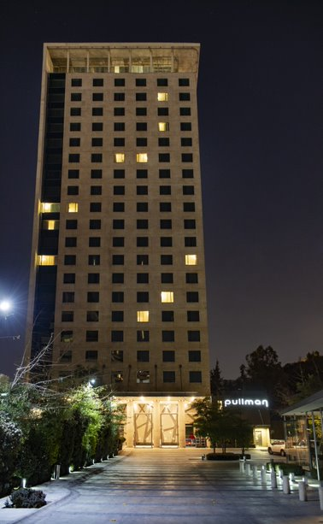
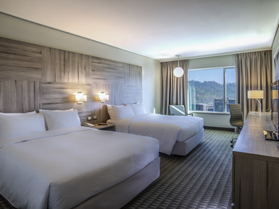

Rooms are allocated on a first come, first serve basis. Breakfast, lunch, and dinner are included in the accommodation fee. Lunch will be served at the archery venue.
Important Note: Please refer to the accommodation pages for detailed hotel information. Complete all necessary sections in WAREOS and make full payment for entries and accommodation by the specified deadlines. Bank transfers only, no credit cards will be accepted. In addition, the LOC will be responsible to provide any event information at this hotel and provide transportation to the venues.
Transportation
Transportation will be provided from the International Airport in Santiago de Chile to the official hotel, if booked through WAREOS, from September 18 and until one day after the closing day.
Event Shuttle transport will be available between the official hotel, practice and competition venue starting November 19. Transport timetables will be confirmed.
Visa
All participants who need an entry visa to Chile will be required to complete the Visa Support sections in WAREOS by no later than September 21, 2022. It is the applicants’ responsibility to supply the necessary information, ensuring all details are up to date, correct and submitted by the deadlines specified. All participants that require a visa are kindly requested to supply a copy of their latest/valid passport. Copies of each application can be uploaded on WAREOS. All passport copies and personal details entered/uploaded to WAREOS will be held securely and in the strictest of confidence and not shared with other parties
PAYMENT CONDITIONS:
Complete all necessary sections in WAREOS and make full payment by the specified deadlines. Bank transfers only. No credit cards will be accepted. All bank charges will be paid by the participants.
The entry fees should be paid in full before arrival.
To confirm hotels reservations, a minimum 50% deposit of the total amount is required to be bank transferred to the OC before 21 September 2022. Reservations after this date will be considered only according to availability. The final outstanding balance shall be made via bank transfer by 21 October 2022. Accommodation cannot be guaranteed after this deadline. A balanced invoice will be provided via WAREOS.
BANK INFORMATION for ACCOMMODATION, TRANSPORTATION and
ENTRY FEES:
A/C name: Federación Chilena de Tiro con Arco
Address: Av. Ramon Cruz 1176, Oficina 305, Ñuñoa, Santiago de Chile.
Telephone: (562) 22724216 - (562) 22721833
Bank: BANCO CREDITO DE INVERSIONES
Account No.: 13337408
SWIFT Code: CREDCLRM
Bank´s Address: AV. NUEVA PROVIDENCIA N°1819, PROVIDENCIA SANTIAGO, CHILE
Bank’s pone #: +56 966673051

NOTE: ALL PAYMENTS SHALL BE MADE IN USD BY BANK TRANSFER.
All bank charges will be paid by the participants. CREDIT CARDS are not accepted.
Cancellations & Changes
All cancellations and changes must be made through WAREOS / Open WAREOS:
- Cancellations received before 7 November 2022 a full refund of the deposit payment will be made.
- Cancellations received after 7 November 2022 no refund will be given.
- Refunds will be processed after the event.
- Name changes to team officials or athletes (same category) will be accepted up to two (2) days before the official practice without any additional charge or penalty, if it is after this, they will have a cost of 50 USD.
- Should flight arrival details change last minute, please contact the Organising Committee using the details indicated in the team managers’ booklet.
- If a participant’s arrival is later than the original scheduled arrival date, the room will be charged from the date of the original booking in WAREOS.
- An email will automatically notify the Organising Committee and Member Association of any changes made in WAREOS.
HEALTH REGULATIONS (COVID-19)
INFORMATION
- Everybody should follow the Government/public health authorities measures (national and sport-specific regulations) and be aware of the travel restrictions.
CLOSEST HOSPITAL
Clinica Red Salud Santiago
Address: Avenida Libertador Bernardo O´Higgins 4850, Santiago
Phone: +56 6007186000

Training
Training facilities will be available starting on 19 November 2022 at the Qualification Elimination Field located approximately 30 minutes from the official hotel. Transport to training will be made available from 19 November 2022 at no additional cost.
Weather
Temperatures in November are expected to range between 11 and 27 degrees Celsius. On average there is little precipitation in the month of November in Santiago.
Media Registration
Media representatives can apply for registration by emailing info@archery.sport
Internet
Will be available in the official hotels for free (in hotel rooms and in the lobby). There will also be Wi-Fi available for access to results on venue.
Water
Each participant with receive clean bottles of water. Bottled water will be available.
PERSONAL HYGIENE AND HEALTH ADVICE
- Anyone due to participate in the event who is feeling ill should not attend.
- Participants (athlete, volunteer, official etc.) should proactively and regularly monitor their health status (including taking their temperature and monitoring for any symptoms).
- Stay home and self-isolate even with minor symptoms for 10 days or more depending on national protocols, when showing any symptoms (fever, tiredness, dry cough, headache, nasal congestion, runny nose, sore throat, difficulty breathing).
- Contact a healthcare provider immediately if any respiratory illness is noted.
  - Masks to be worn at all times (transport, common area in the hotel, venue, training etc.), except on the shooting line. This is the regulation at the time the invitation package is released.
- Regularly and thoroughly clean your hands with an alcohol-based hand rub or wash them with soap and water.
- Avoid touching your eyes, nose and mouth.
- Cover your mouth and nose with your bent elbow or tissue when you cough or sneeze. Then dispose of the used tissue immediately and wash your hands.
- Avoid touching high-contact surfaces such as door handles, walls or windows, etc.
- Avoid crowded places.
- Avoid steam rooms or saunas.
- No spitting, as the main mode of transmission of the virus is in respiratory secretions.
- No handshakes, high fives and any other personal contact.
- Athletes should not share clothing, bar soap, sports equipment, water bottles or other personal items.

TRANSPORT & ACCOMMODATION
- Avoid using public transport to go to the hotel and between the hotel and the venue. Use the LOC Shuttles provided.

VENUE
- Access to the venue might be revoked at any time in the event of a positive test, exposure or close contact.
- Limit contact/interactions with others.
- Handwashing/alcohol- based hand gel will be available at multiple locations in the event facility and accommodations.
- Regular toilet cleaning will be done (at least once per session).
- Trash bins will be available to dispose of used tissues and masks on transport to the venue, at the venue, and accommodations.
- Medical personnel will be on site to assess on an as needed basis.
- An isolation room/space to hold any symptomatic person found at the venue will be available.
- Space on shooting line shall be 0.90 metre minimum per athlete.
PARTICIPANTS
- Maintain the staff/team to a minimum to minimise risk of transmission.
- Maintain social distancing, a 2m distance between yourself and others at all times.
For participants who require PCR tests to return to their countries, the LOC has made arrangements with a lab for the samples to be taken and processed. The cost is PCR 80.00 USD per test. If an Antigen test is required, the cost is 50.00 USD per test. Test requests can be made on WAREOS.
ADDITIONAL INFORMATION
LOC CONTACT
Name: Brisa Briceño
Email: santiago2022@fechta.cl
Language: Spanish
Phone number with international extension: +56 9 91678049

