Date: - September 9, 2015, 2015

TO ALL World Archery MEMBER ASSOCIATIONS

Dear President,

On behalf of the Organizing Committee of the Asian Para Archery Championships Bangkok, (THA)-Rio 2016 Qualification, sport Association for the the Disabled of Thailand under the Royal Patronage of His Majesty the King and the Thailand Archery Association, we would like to invite you to the Asian Para Archery Championships Bangkok, (THA)-Rio 2016 Qualification, which will be held from 10-18th November in Bangkok, Thailand.

To register participation, please find enclosed the necessary documents and return your completed forms within the deadlines listed below:

Summary of deadlines:

- Preliminary Entries 12th August 2015
- Hotel Reservation Form & Deposit 25th September 2015
- Final Entries 20th October 2015
- Transportation Form 30th September 2015
- Visa Support Form 30th September 2015
- Final Hotel Reservation Form 30th September 2015
& Remaining Payment

We look forward to welcoming you and your teams to Bangkok, Thailand.

Sincerely yours,

Mr. Sanguan KOSAVINTA
President
Thailand Archery Association

Mr. Charnvit MUNIKANOND
Event Director Local Organising Committee
PRELIMINARY PROGRAMME
Day |  | Date | Description
*** | Tuesday 10th NOV. |  | Arrival of participants, T/D, Classification
*** | Wednesday 11 NOV. |  | -Arrival of participants  -Practice field and local transport available  -Classification
 | Thursday 12 NOV. |  | -Arrival of participants, Jury of Appeal, Judge and DOS  -Practice field and local transport available  -Classification  -Opening Ceremony
DAY 1 | Friday 13 NOV. |  | -Official Practice (Compound Women and Men), W1, 50 M.  -Official Practice (Recurve Women and Men) 70 M.  -Equipment Inspection  -Team Managers’ Meeting (Time and Place TBC)
DAY 2 | Saturday 14 NOV. |  | Qualification Round (Compound Women and Men) W1, 50 M.  -Qualification Round (Recurve Women and Men) 70 M.
DAY 3 | Sunday 15 NOV. |  | Individual Elimination Round – Semi Final Round  -(Compound Women and Men) W1, 50 M.  Individual Elimination Round – Semi Final Round  -(Recurve Women and Men) 70 M.
DAY 4 | Monday 16 NOV. |  | Team Eliminations  • Recurve Team Open (Men & Women)  • Recurve Mixed Teams)  • Compound Team Open (Men & Women)  • Compound (Mixed Teams)  All matches to and including Bronze Match
DAY 5 | Tuesday 17 NOV. |  | Individual Bronze and Gold Medal Match  -(Compound Women and Men) W1, 50 M.  -(Recurve Women and Men) 70 M.  Team Open & Mixed Team – Gold Medal Match  -Recurve Men Team Open  -Recurve Women Team Open  -Recurve Mixed Team  -Compound Men Team Open  -Compound Women Team Open  -Compound Mixed Team
DAY 6 | Wednesday 18 NOV. |  | Departure of teams

NOTE: This is a preliminary programmed and subject to change according to the number of participants in each division. All changes will be published and distributed to all participants in advance.
PRELIMINARY & FINAL REGISTRATION
All the registration process must be done using the World Archery Online Registration System (WAREOS, formerly FORS): http://register.worldarchery.org. No entry forms will be accepted for registering for this event.

A maximum number of 3 athletes per country (host country included) are allowed to be registered into each category of the event. All entries have to be done using WAREOS.

In order to use WAREOS, please login on http://register.worldarchery.org with your Username and Password assigned by World Archery. After entering the WAREOS, please go to "Online Registration" and register your athletes and officials for this event. A " WAREOS User Manual" can be downloaded in PDF format (English) using the same website link.

For any questions regarding WAREOS, please contact the World Archery office, Jaekyung Lee, World Archery Events Coordinator (jklee@archery.org).

Start date for online registration using WAREOS August 2015
End of Preliminary registration using WAREOS: 12th August 2015
End of Final registration using WAREOS: 20th October 2015

Please pay attention to the stated deadlines. Teams will not be able to enter or update their data in WAREOS, after the deadlines, as the system will be blocked. If teams wish to make any changes to their Final Registration after the deadline they need to contact Jaekyung Lee, World Archery Events Coordinator (jklee@archery.org).

Final Entries processed after the deadline will result in a penalty fee of 50 Euros per athlete to be paid to the LOC upon arrival at the field.

Final registrations that differ by more than 4 athletes from the preliminary registration or have been submitted after the preliminary deadline will result in a penalty fee of 150 Euros to be paid to the LOC upon arrival at the field.

Any entries received fewer than 3 days before the Team Managers’ meeting will be refused if no preliminary entry and/or final entry were made. This decision cannot be appealed by the teams and is fully compliant with the current World Archery rules, article 3.7.1.2. Entries received after the deadlines are subject to penalties as clearly stated in the rulebook and the invitation documents of World Cups and World Championships. A Member Association which has made final entries in WAREOS and does not participate will be invoiced for the number of entries in the system unless they have informed World Archery and the LOC in writing at least one week before the event that they are unable to attend.

Member Associations, which have penalty fees outstanding from 2014 will need to have paid these penalty fees before being eligible to enter and compete in The Asian Para Archery Championships Bangkok, (THA)-Rio 2016 Qualification.

ACCOMMODATION
The official hotels are:
The Grand Four Wings Convention Hotel 5 Stars hotel ★★★★★

http://www.grandfourwings.com/

No rooms are specifically wheelchair accessible but doors are wide enough (approximately 28- 30inches wide) to enter rooms. The bathrooms have shower boxes with a small step (approx. 2cm). The shower extension over the bath has a long lead and thus by using the provided special wheelchairs it should be reasonable for wheelchair users. There are no handrails by the toilet, bath or shower.

It will take approximately 15-20 minutes to get to the stadium or 20-30 minutes in rush hours. Location: 333 Srinakarin Road, Huamark, Bangkapi, and Bangkok 10240, Thailand.

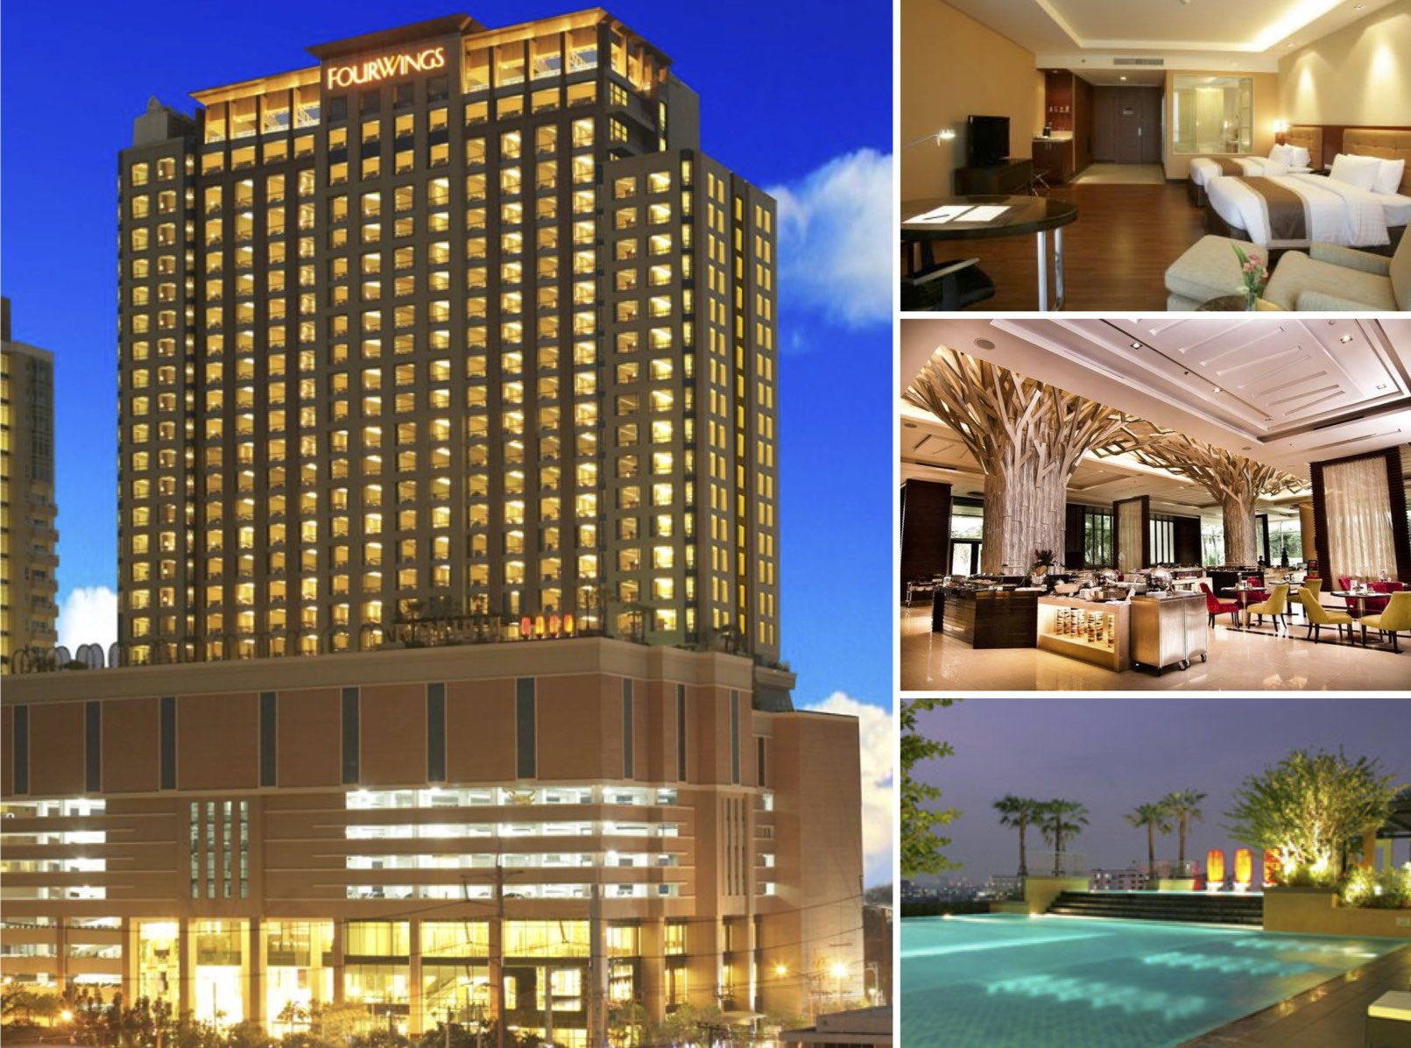

TOWN IN TOWN HOTEL Bangkok 3 Stars Hotel ★★★

This is the headquarters hotel for the tournament

Centrally located in the lively center of the city, it has easy access to the city’s attractions.
No bathrooms are wheelchair accessible but special arrangements have been made such as replacing bathroom doors with curtains, providing special wheelchairs which can be used by people to shower and then move back into their own chairs. If the dining room is too busy special arrangements are made for archers to eat their meals in a separate area.

Address: 300/1 Ladprao 94, Wangthonglang, Bangkok 10310

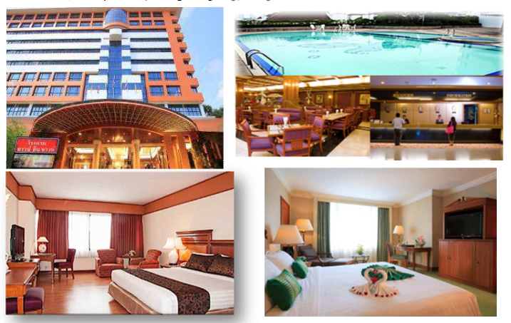

Teams which do not book their accommodation through the LOC will be charged a double entry fee for each athlete and official.

- Reservations should be made before: 25th September 2015
- Final Hotel Reservation & Transportation Forms: 30th September 2015

To confirm your hotel reservations, a 50% deposit, of the total amount, is required to be transferred, to the LOC before 10th October 2015, via a bank transfer, using the details provided on the form Reservations received after this date will be considered according to availability.

The hotel room rates are per person, per day including full board (hot/cold, open buffet breakfast, box lunch at the ground and dinner with non-alcoholic drinks). (First meal is dinner on the arrival day till morning breakfast of the departure day)

Official Tournament Hotels

The Grand Four Wings Convention Hotel (5 Stars hotel ★★★★★) 6 km from the venue

- EUR 1,600 / per person for twin/double occupancy hotel room;
- EUR 1,900 / 1 person for single occupancy hotel room.

TOWN IN TOWN HOTEL Bangkok (3 Stars hotel★★★) 5.7 km from the venue (Main LOC office is located here)

- EUR 1,300 / per person for twin/double occupancy hotel room;
- EUR 1,500 / 1 person for single occupancy hotel room.

All participants must book their accommodation through the LOC. Participants that do not book their accommodation through the LOC, or not staying at the official hotels, will have to pay double entry fees for each athlete and official and will not be entitled to any event information or transportation.
The tournament information office will be located in the main foyer of the Town in Town Hotel.
Any changes to transport schedules or other urgent messages and the results from each day will also be made available at each hotel.

GENERAL INFORMATION
Entry Package includes (Coverage from 10-18th November 2015 for 8 days)
- Local transportation from hotel to official venue
- Reception dinner and Parting dinner.
- Bangkok Sight seeing limit 25 persons per day
- Bottled water on the ground
- Classification where appropriate
- Medical/Ambulance service on ground

Transport: from Suvarnabhumi Intl. airport to the hotel and back to the airport
EUR 30 per person

The LOC will provide each team with a liaison person who speaks English. Please noted that our Airport reception team Liaison will stand by at gate 9-10. They will hold the sign/Logo of World Archery which easy to capture them. Moreover, for your convenience LOC will arrange the rest corner at the airport, which will be located at gate 10 area, where you can wait and relax yourself while waiting the shuttle bus to hotel.

Please refer to the accommodation pages below for detailed hotel information. Please complete all the necessary forms by the deadlines given and arrange full payment for accommodation before arrival. No credit cards will be accepted on site.

Teams will also need to register for their accreditation, at the latest, the day before official practice. If participants do not register the day before, no changes will be made to the entry list. Participants will not be allowed to compete if registration is not completed in time and will not be allocated to a target.

Pre competition arrivals
Archery fields from local clubs and hotels out of the city near those venues are at your disposal. For any information, prices and days, please contact directly
Ms. Narumon SUBRSI, Email: npcthiland@gmail.com

Map:

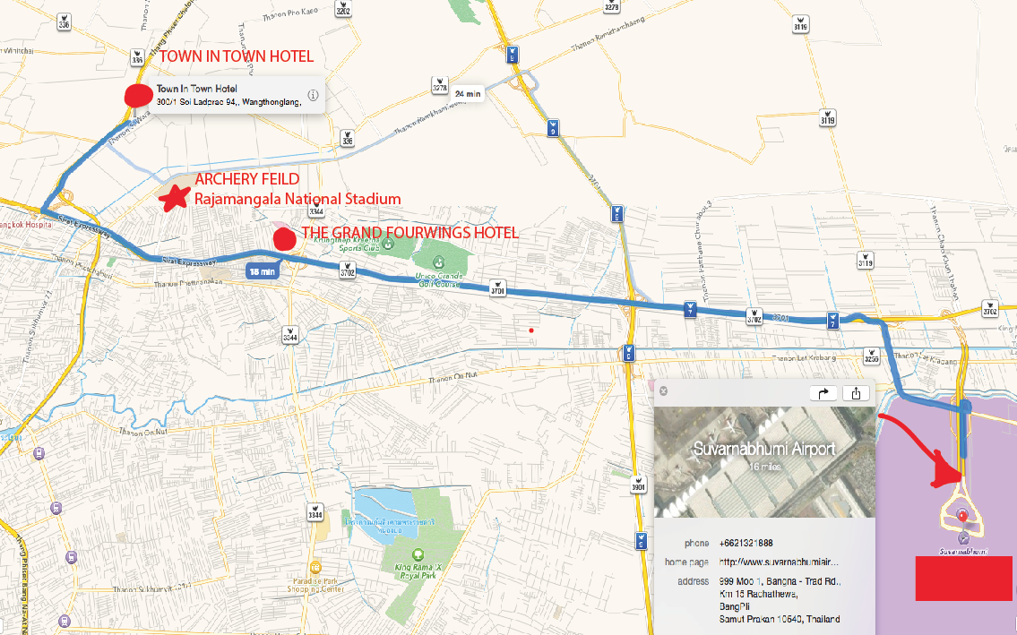

ADDITIONAL INFORMATION

Bangkok, Thailand

Bangkok, Thailand

Entertainment

Bangkok is a city that never sleeps. For night owls, there is always something to do, to see, and even have a late snack. Anytime is a good time!

Dining

Thai food is hot and spicy! Local favorites including somtam (green papaya salad), tom yam kung (hot and sour shrimp soup), pad Thai (Thai style noodles) and many others. However, nearly any style of international cuisine can easily be found in this thriving metropolis. From street side stalls to hi-end restaurants, Bangkok has it all.

Facilities

Currency exchange and financial services are readily available. Bangkok has excellent health and medical services and most large hospitals are equipped with state of the art medical technology, pharmaceuticals and internationally qualified specialists.

Transportation

Skytrain (“BTS”). BTS sky trains ply along Sukhumvit, Silom and Phahonyothin roads. The routes connect Bangkoks leading hotels and major shopping areas such as Siam Square, Silom, Ratchaprasong and Chatuchak Weekend Market. The fare ranges from 10-40 baht according to the distance. For more information, contact the Bangkok Mass Transit System at tel: 0 2617 7300 or visit www.bts.co.th

http://www.bts.co.th/th/Image%20Event/Route_BTS.html

Subway (“MRT”).
In April 2004 the MRTA (Mass Rapid Transit Authority of Thailand) started service, its first route of underground electric mass rapid transit system from Hua Lam Phong (Main Railway Station) to Bang Sue, a total distance of 20 kilometers. It intersects with the Skytrain (BTS) at Silom and Sukhumvit stations, from where it's a short walk to BTS Sala Daeng and BTS Asok stations, respectively. Passengers can enjoy their convenient shopping on certain types of business. Passengers can issue the Single Journey Token from the Ticket Vending Machine and/or Stored Value Card at the Ticket Office
Taxi.
Cheap and abundant, taxis can be hailed from the roadside. They are an excellent way to get around, but in the heart of the city it is best to make use of the skytrain and subway as much as possible, in order to avoid the traffic. A ride within the city centre typically costs less than 100 baht. A ride from the airport to the city centre typically costs around 300 baht. Public taxis depart from a designated stand immediately outside the airport terminal, and have a 50 baht surcharge above the meter fee. Private taxi (limousine) services are available from within the terminal building, but fares are subject to negotiation and are usually significantly more expensive.
Bus.
Public buses are plentiful and cheap, with a minimum fare of 7 baht to most destinations within metropolitan Bangkok. Air-conditioned buses have minimum and maximum fares of 10 and 22 baht, respectively. Air-conditioned microbuses charge a flat fare of 25 baht all routes. A bus route map is available at bookshops and the TAT office. Visit www.bmta.co.th for more information on Bangkok’s public buses.
Boat.
Taxis that are even more unusual, though equally convenient, are the river taxis that ply the Chao Phraya River. Some are just cross river ferries, but others serve the many landing stages on both banks and cover a route that goes up as far as the northern suburb of Nonthaburi. If you wish to visit a riverside attraction, a river taxi is a great way to avoid the traffic and see a bit of the river life at the same time.
Car Rental.
Rental companies include: Avis Tel: 0 2251 1131-2 www.AVISthailand.com and Master Car Rental 222/9 Ladprao Rd., Wangthonglang, Bangkok Tel: 02 931 8787, 02 663 3030 www.mastercarrental.com

Most popular areas of Bangkok

Have a trawl through our Area Guides, where we tell you all about the city's main areas. This will help you decide where to stay, where to visit and where to avoid. At 1,600 square kilometers and counting, Bangkok is big, and the many different areas can be bewildering - even for those who've spent years here.

The most popular areas for visitors are Siam, Silom, Sukhumvit Road, Sathorn, Chidlom- Ploenchit, Pratunam and the Riverside - all charismatic parts of town that combine sights, nightlife, shopping, great hotels and convenient locations with access to public transport. Budget travellers and backpackers, of course, still swear by Khao San Road.
Areas of Interest

Siam Society House and Garden (0.7 km/0.4 miles) - The 19th-century Kamthieng House, on the grounds of the Siam Society Headquarters, is a rice farmer's teak house transplanted from the banks of Chiang Mai's Ping River. Its collection, organized with financial help from the Asia and Rockefeller foundations, is oriented toward ethnographic objects illustrating the culture of everyday life.
Thai National Museum (5.0 km/3.1 miles) - The history of the National Museum Bangkok dates back to 1874 when His Majesty, King Rama V opened the first public "museum" to exhibit the royal collection of King Rama IV, and other objects of general interest, at the Concordia Pavilion inside the Brand Palace. Later, the Museum was transferred to its present site, the "Wang Na", or "Palace to the Front" which had been the palace of the Prince Successor. In 1926, it was named the "Bangkok Museum" and subsequently developed into the National Museum Bangkok when it came under the direction of the Department of Fine Arts in 1934.

Temple of the Dawn (Wat Arun) 10.0 km/6.2 miles - The famous Wat Arun, perhaps better known as the Temple of the Dawn, is one of the best known landmarks and one of the most published images of Bangkok. It consists of a massive elongated prang (Khmer-style tower) and is surrounded by four smaller prangs. The prang is described by the Tourism Authority of Thailand as 104m high while most other sources quote figures around 80-85m. It is decorated by bits of porcelain, which had previously been used as ballast by boats coming to Bangkok from China, a hallmark of the reign of King Rama III.

Airport Suvarnabhumi (New Bangkok) International Airport
Location:

Suvarnabhumi (New Bangkok) International Airport is located in Racha Thewa in the Bang Phli district of Samut Prakan province, 30 kilometers east of Bangkok. The airport is the international airport serving Bangkok, Thailand.

Archery Venues:

National Archery Association of Thailand

Address: 286 Ramkhamhaeng Road Huamark, Bangkapi Bangkok 10240 Thailand

Transportation
- Transportation will be provided from Bangkok Suvarnabhumi Intl Airport (BKK) to the official hotels, on 10 November 2015
- Transportation will be provided from the official hotels to Suvarnabhumi Intl Airport (BKK), on 17-19 November 2015
** Local transportation will be available between official hotels and practice and competition venues. Transport timetables will be confirmed. Buses and/or vans will be provided.

Cancellations & Changes
Written Cancellations must be:
- Received before 30th September 2015 for full refund of the deposit payment.
- Received after 15th October 2015, no refund will be awarded.

All refunds, if any, will be processed after the event.

Name change (the same category and division) will be accepted up to 72 hours before the event, without any additional charge. The LOC should be informed about any changes immediately in the travel programme 72 hours prior arrivals. If your arrival is later than originally scheduled, the room charges will start from the original date indicated by the accommodation forms received from the Member Association.

Training
There is a training field is in the Sport Authority of Thailand.

Weather
November (Average):
Avg. High Temp 88°F /31°C Avg. Low Temp 73°F / 23°C
Avg. Rain full 57 (mm)

Ceremonies
There wil be an opening and closing ceremony. Further details will be given on arrival.

Water on the Venue
Water will be provided on the field during competition for accredited people.

Media Registration
Media representatives can apply for registration by emailing npcthailand@gmail.com

LOC Contact:
Name: Narumon Subsri
Telephone/Line/Whatapp: + 66 87 042 8487
Email: npcthailand@gmail.com
Language: English

Visa
All participants who need an entry visa to Thailand, are kindly requested to fill in the Visa Support Form below and return completed to the Organizing Committee, as soon as possible, but no later than 30th October 2015.
After the Visa Support Form is received, an official invitation, from the Thailand Archery Association, will be provided for visa application. Participants should obtain their visas before departure to Thailand. Teams and officials from countries with no diplomatic relations with Thailand are kindly requested to inform the LOC of where they prefer to apply for the visa in the third country.

Visa Support Form
All participants who need an entry visa to Thailand, are kindly requested to fill in the Visa Support Form and with Copies of passports returned to the Organizing Committee, as soon as possible, but no later than 30th October 2015.
Only e-mail is accepted to npcthailand@gmail.com

Gender  M/F. | Family Name | Given Name | Date of Birth DD/MM/YY | Nationality and place of birth | Title  (Athlete/Coach/Official) | Passport No. | Expiration Date of Passport  DD/MM/YY | Location of Visa collection

CLASSIFICATION ALERT!!

MEDICAL INTAKE FORMS.

The Medical Intake Forms for archers requiring classification is one month prior to the date to the date of classification (10-11 November 2015).

All medical intake forms must be scanned and email to the Chief Classifier at:

rmdish@hanmail.net

Failure to do so will result in no classification for the archer, and will not be allowed to shoot in the competition. Archers scheduled for classification must arrive in Bangkok one day before. Archers who are late for classification will not be classified.

