TO ALL World Archery Asia (WAA) Members Association
Dear President / Secretary General

We are very pleased to inform you that 22nd Asian Archery Championships 2021 will be held in Dhaka, Bangladesh from 13 – 19 November 2021.

On behalf of the Local Organizing Committee (LOC), we are honor to invite you to participate to one of the most important archery event to take place in Asia in 2021. Our priority is for you to be able to compete in a safe environment with all the necessary sanitary measures. These might change between now and the event and we request your cooperation and understanding. As we are fully aware of the risks that you are taking, we will always put priority on providing a safe environment for you to compete without worrying about your health and safety.

Dhaka is the capital and the largest city of Bangladesh. Dhaka is the economic, political, and cultural center of Bangladesh, and is one of the major cities in South Asia, the largest city in Eastern South Asia.

Local Organizing Committee (LOC) sincerely welcomes you and will do our best to host you with warm hospitality for providing beautiful memories and sharing friendship between participants from all over Asia during your stay in Dhaka, Bangladesh.

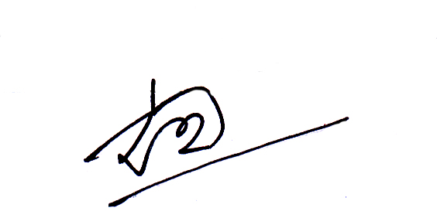
We are looking forward to seeing you in Dhaka, Bangladesh.

Sincerely yours,

Lt. Gen. Md Mainul Islam (Retd.) Kazi Rajib Uddin Ahmed Chapol
Chairman Organizing Committee and Secretary General Organizing
President, Bangladesh Archery Federation Committee and General Secretary,
Contact: +8801713 002 014 Bangladesh Archery Federation,
1st Vise President World Archery Asia
Contact: +8801711 409 252

Contact (24/7): +88 01977 409 252 (WhatsApp)
Email: 22acoc2021dhaka@gmail.com OR barchery@gmail.com

**All archers, officials, delegates traveling to Bangladesh for the 22nd Asian Archery Championships Dhaka, 2021 are required to have a Negative PCR based COVID 19 test certificate obtained within 72 hours of the flight time and show it on arrival at the airport.

Important Dates:
Please find enclosed information regarding the details of this event and how to complete registration. To register participation, please complete all the necessary sections in WAREOS within the deadlines listed below:

Summary of Deadlines:

- Start date for online registration WAREOS 02 August 2021
- Preliminary Entries 14 September 2021
- Final Entries 14 October 2021
- Hotel Reservation 14 September 2021
- Transportation 14 September 2021
- Visa Support 14 September 2021
- Final Hotel Reservation & Payment 14 October 2021
- Full refund cancellation deadline 07 October 2021

Looking forward to welcoming you in Dhaka, Bangladesh.
PRELIMINARY PROGRAMME

11 & 12 November 2021  Thursday & Friday | Arrival of participants  Practice field will be available from 11 November
13 November 2021  Saturday | Opening Ceremony (TBC)  Official Practice  Equipment Inspection  Team Managers Meeting, Venue & Time: TBC
14 November 2021  Sunday | Qualification Round for Recurve and Compound  (Recurve and Compound)  Mixed Team Eliminations
15 November 2021  Monday | Individual Eliminations  (Recurve and Compound)
16 November 2021  Tuesday | Individual Eliminations  (Recurve, Compound and Team Eliminations)
17 November 2021  Wednesday | Mixed Team Eliminations  (Recurve and Compound)
18 November 2021  Thursday | Finals Compound – Individual and Team  - Compound (Women and Men)  - Award Ceremonies
19 November 2021  Friday | Finals Recurve – Individual and Team  - Recurve (Women and Men)  - Award Ceremonies
20 November 2021  Saturday | Departure of teams

NOTE 1: This preliminary programme is subject to change according to participation and TV requirements.
All changes will be published and distributed in good time.
PRELIMINARY & FINAL REGISTRATION
All entries, accommodation reservations, transport needs, flight arrival/departure information and visa invitation letter requests are to be completed using the World Archery Online Registration System WAREOS. These systems now handle the entire registration process for this event. No entry forms, hotel reservations or transportation forms will be accepted.

Member associations can login to WAREOS at http://extranet.worldarchery.sport with the username and password assigned by World Archery. After entering WAREOS, selecting the event from the list will allow a member association to register their athletes. Select/press the “Entries” button to see the list of categories in the event. Select/press the “category” to enter the athlete and official numbers/details participating for that event. A WAREOS User Manual can be downloaded in PDF format (English) upon login.

Contact Ms CECILE TOSETTI (ctosetti@archery.sport) in the World Archery Office with any questions regarding technical problems on WAREOS. For any question regarding the organisation of the event (transport, accommodation, meals etc.) please contact directly the LOC.

Athletes from a minimum of 4 different Member Associations shall be registered and participate in the event. Entries should be completed using WAREOS.

Start date for online registration using WAREOS/Open WAREOS 02 August 2021
End of Final registration using WAREOS/Open WAREOS 14 October 2021

Please respect the stated deadlines.

Member Associations can only use WAREOS to make any changes or amendments to entries and will be able to do so at any time. An email will automatically notify the Organising Committee and Member Association of any changes made in WAREOS.

ACCOMMODATION & GENERAL INFORMATION

 | Hotel Sheraton  (Five Star) | The Westin Dhaka  (Five Star)
Single Room price | USD 150.00 per room | USD 150.00 per room
Number of rooms | 98 | 80
Double/Twin Room price | USD 240.00 per room | USD 240.00 per room
Number of rooms | 75 | 75
Board plan | Full board | Full board
Check-In from* | 11 November  1400 hrs | 11 November  1400 hrs
Check-Out time* | 1200 hrs | 1200 hrs
*Early CHECK-IN: Chargeable (Full day charge)
*CHECK-OUT time: After 1200 hrs half day charge up to 1800 hrs. Beyond 1800 hrs would be full day charge
Rooms are allocated on a first come, first serve basis. Accommodation includes breakfast, lunch and dinner with non-alcoholic drinks. Lunch will be served at the archery tournament venue from 13 November 2021 (Lunch on 11 & 12 November will be served in the hotel).
- Reservations should be made before 14 September 2021
- Final Hotel Reservation before & 14 October 2021
- Transportation before 14 September 2021

Note 2: Complete all necessary sections in WAREOS and make the payment for accommodation by the specified deadlines. Bank transfers only, no credit cards will be accepted.
In addition, the LOC will be responsible to provide any event information at this hotel and provide transportation to the venues. Private vehicles cannot be used.

Important Information

- Minimum of 30% of the total hotel reservation payment should be paid before 14 October 2021 by bank Transfer.
- The rest of 70% of the total amount to be paid in US$ (US dollar) to the Local Organizing Committee (LOC) office at the hotel upon arrival (before CHECK-IN).
- Countries who are willing to pay FULL amount of the hotel reservation before 14 October 2021 can also pay by bank transfer.
- Bank Transfer fees - Both sides are responsible by the sender.
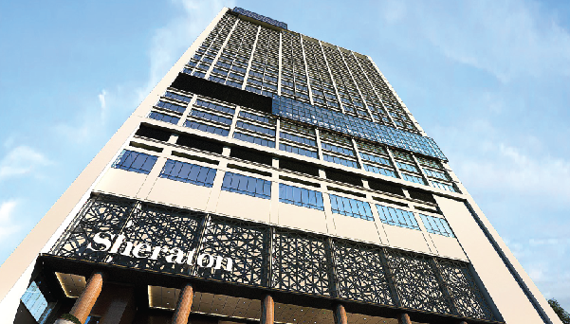
- Full refund of hotel reservation cancellation should be made before 07 October 2021.
Hotel Sheraton
Sheraton Dhaka features tastefully designed guestrooms and suites. Furnished elegantly, the guestrooms come with the signature Sheraton elements and the Sheraton Sleep Experience. The Sheraton Club Lounge is set to provide a feel of exclusivity where one can also find a spot to unwind in comfort while enjoying the elite privileges of lounge check-in, daily breakfast, and round-the-clock canapés. It also offers a world-class fitness center with all modern exercising equipment.

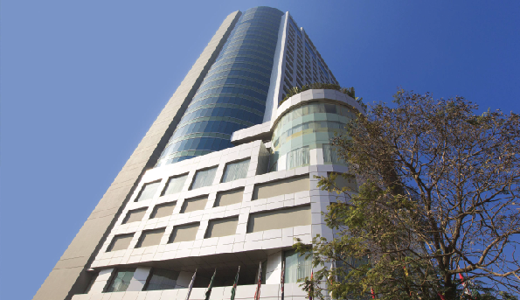
The Westin Dhaka

Discover Dhaka, Bangladesh, from The Westin Dhaka. Located in Gulshan 2, Dhaka's dynamic business and diplomatic district, corporate offices, the U.S. Embassy, shopping, dining, entertainment, and historic landmarks. Recharge in your spacious luxury hotel room or suite where you'll find pampering touches, high-speed Wi-Fi, a mini-refrigerator, room service available 24 hours a day, a supremely comfortable Westin Heavenly Bed, and skyline views.

ENTRY FEE
Entry Fees:
Individual: | 150 USD per athlete
Officials: | 100 USD per person
Entry fees include airport transfer to hotels, daily local transport to and from the practice field to/from official hotels during the qualification, elimination and finals venues (timetable to be confirmed on site).

COVID TESTS FEE
30 USD per athlete/official/guest
This fee includes 03 (three) COVID tests from arrival day of the delegations until the last test necessary before departure.
You can book the COVID Test Fees for your delegation on WAREOS in the Extras section. The payment has to be made to the LOC.

PAYMENT CONDITIONS:
The entry fees and COVID test fees should be paid in full before arrival.
A balanced invoice will be provided via WAREOS.

PAYMENT CONDITIONS:
The entry fees should be paid in FULL before 14 October 2021.

Reservations after this date will be considered only according to availability. The final outstanding balance shall be made via bank transfer before arrival. Accommodation cannot be guaranteed after this deadline. A balanced invoice will be provided via WAREOS.

BANK INFORMATION for ACCOMMODATION, and ENTRY FEES:
BANK DETAILS (PAYMENT IN USD ONLY)
Account Name: Bangladesh Archery Federation
Account Number: 10831020031555
Bank Name: Prime Bank Limited
Branch: Islamic Banking Branch
Bank Fax: +88 02 9567228
Swift Code: PRBLBDDH005

Please send the scanned copy of the Bank Transfer sheet after remittance by E-mail
at 22acoc2021dhaka@gmail.com and barchery@gmail.com

NOTE 3: ALL PAYMENTS SHALL BE MADE IN USD (US dollar).
All bank charges will be paid by the participants. CREDIT CARDS are not accepted.

Cancellations & Changes
All cancellations and changes must be made through WAREOS / Open WAREOS:
- Cancellations received before 07 October 2021 a full refund of the deposit payment will be made.
- Cancellations received after 07 October 2021, no refund will be given.
- Refunds will be processed after the event.
- Name changes to team officials or athletes (same category and division) will be accepted up to 1700 hrs two (2) days before official practice without any additional charge or penalty fees.
- Should flight arrival details change last minute, please contact the Organising Committee.
- If a participant’s arrival is later than the original scheduled arrival date, the room will be charged from the date of the original booking in WAREOS.
- An email will automatically notify the Organising Committee and Member Association of any changes made in WAREOS.

HEALTH REGULATIONS (COVID-19)
INFORMATION
- Everybody should follow the Government/public health authority’s measures (national and sport-specific regulations) and be aware of the travel restrictions.
- For your information, Medical infrastructure/Hospital with proper care will be reachable within 15 minutes from the venue, where COVID-19 test can be done.

PERSONAL HYGIENE AND HEALTH ADVICES
- Anyone due to participate in the event who is feeling ill should not attend
- Participants (athlete, volunteer, official etc.) should proactively and regularly check their health status (including taking their temperature and monitoring for any symptoms)
- Stay home and self-isolate even with minor symptoms for 10 days or more depending on national protocols, when showing any symptoms (fever, tiredness,
dry cough, headache, nasal congestion, runny nose, sore throat, difficulty
breathing).
- Contact a healthcare provider immediately if any respiratory illness is noted
- Masks to be worn at all times everywhere (transport, common area in the hotel, venue, training etc.) except on shooting line
- Regularly and thoroughly clean your hands with an alcohol-based hand rub or
wash them with soap and water
- Avoid touching eyes, nose and mouth
- Cover your mouth and nose with your bent elbow or tissue when you cough or
sneeze. Then dispose of the used tissue immediately and wash your hands
- Avoid touching high-contact surfaces such as door handles, walls or windows, etc.
- Avoid going to crowded places
- Avoid steam rooms or saunas
- No spitting, as the main mode of transmission of the virus is in respiratory secretions
- No handshakes, high fives and any other personal contact
- Athletes should not share clothing, bar soap, sports equipment, water bottles or other personal items
TRANSPORT & ACCOMMODATION
    - Transportation service from the Airport to Hotel to Airport (arrival and departure) is included in the accommodation. Transportation from Hotel to tournament venue and vice-versa during the practice and competition days’ are organized by the Organizing Committee at NO CHARGE.

    - Avoid using public transport to go to the hotel and between the hotel and the venue.
    - For more details of Transportation, please check below

VENUE
- Access to the venue might be denied at any time in case of disease suspicion
- Limit contact/interactions
- Handwashing/alcohol- based hand gel will be available at multiple locations in the event facility and accommodation
- Regular toilet cleaning will be done (at least once per session)
- Tissues and containers will be at disposal to dispose of used tissues on transport to the venue, at the venue and any other facility
- No shows allowed. Winners will receive their medals in a simple ceremony only with the winners and their team, all wearing masks
- Medical post and designated personnel on site able to help assess cases and potential other illness will be present
- An isolation room/space to hold any symptomatic person found at the venue will be available
- Space on shooting line shall be 1.00 meter minimum per athlete
- No spectators are allowed during the event
PARTICIPANTS
- Maintain the staff/team to a minimum to minimise transmission
- Maintain social distancing, at least 1.5 meter distance between yourself and others at all time

ADDITIONAL INFORMATION
Medical emergency contact and location
A full time Medical team will be available at the hotel, tournament and practice venue (from 11 – 19 November 2021)
Contact: Dr. Md. Ehsanul Karim Cell: +88 01712 132 773

Transportation
Local Organizing Committee (LOC) will ensure transportations from to Hazrat Shahjalal International Airport, Dhaka to the designated hotel and vice versa (Arrival and departure). Transportation from Hotel to venue and vice-versa (from 11 November – 20 November) is organized by Local Organizing Committee (LOC).
All international flights are usually from Hazrat Shahjalal International Airport, Dhaka, Bangladesh.
Travel Information | Distance | Time
Airport To Hotel Sheraton | 9.4 Kilometer | 20 minutes on weekend (Friday)  45-60 minutes on weekdays
Hotel Sheraton To  Bangladesh Army Stadium | 3.1 Kilometer | 10 minutes on weekend (Friday)  20 – 30 minutes on weekdays
Airport To The Westin Dhaka | 9.9 Kilometer | 25 minutes on weekend (Friday)  55 – 70 minutes on weekdays
The Westin Dhaka To  Bangladesh Army Stadium | 3.6 Kilometer | 15 - 20 minutes on weekend (Friday)  25 – 30 minutes on weekdays

TOURNAMENT AND PRACTICE VENUE
Bangladesh Army Stadium is the tournament venue and adjacent to the tournament venue practice venue is situated. The practice venue will be available from 11 November 2021 to 12 November 2021. Transport during main event and practice session will be free from hotel to the destination and vice-versa.

Weather
The climate in Dhaka during November can be summarized as hot, humid and reasonably dry. November is in the fall / autumn in Dhaka and is typically the 4th coldest month of the year. Daytime maximum temperatures average around a muggy 30°C (86°F), whilst at night 19°C (66°F) is normal.

Media Registration
Media representatives can apply for registration by emailing info@archery.sport

Team ACCREDITATION
Please also send your team’s passport size photo for your accreditation card along with their name and designation through E-mail, before 14 September 2021. The maximum size of the document must be 1MB.

Water
Each participant with receive clean bottles of water. Unlimited bottled water will be available at the hotel, qualification and practice venues.

NATIONAL FLAG AND ANTHEM
All participating teams are requested to bring two national flags (Height 3 Feet X Width As per ratio) a CD of the National Anthem along with them, for the Awarding Ceremony.

Visa
All participants who need an entry visa to Dhaka, will be required to complete the Visa Support sections in WAREOS by no later than 14 September 2021.

Please note that each passport (participant/sports delegates/anyone traveling for the championships) must be valid AT LEAST 06 (SIX) MONTHS from the time of your entry in Dhaka, Bangladesh. In the countries where there is Bangladesh Embassy/Visa Consulate, the member associations are requested to obtain their visa accordingly. We will provide a visa support letter to avail visas from Bangladesh Embassy / High Commission / Visa Consulate.

VISA ON-ARRIVAL
It is noted that in the countries where there is no Embassy / High Commission / Visa Consulate of Bangladesh, we will provide visas on arrival for them. The member associations are requested to provide the participant's details that are passport, photograph, and other necessary documents before 14 September 2021.

The Visa on arrival fee at the airport has to be borne by any individual/ the participating countries. The fee for a visa on arrival will be applicable and payable in US$ dollars only.

Please fill up all the necessary information of VISA SUPPORT FORM in the WAREOS before deadline for visa support letter. It is the applicants’ responsibility for supplying the necessary information, ensuring all details are up to date, correct and submitted by the deadlines specified.

In addition, all participants that require a visa are kindly requested to supply a copy of their latest/valid passport. Copies of each application can be uploaded on WAREOS. All passport copies and personal details entered/uploaded to WAREOS will be held securely and in the strictest of confidence and not shared with other parties.

LOC CONTACT
Name: Kazi Rajib Uddin Ahmed Chapol
Email: 22acoc2021dhaka@gmail.com OR barchery@gmail.com
Number: +88 01711 409 252, +88 01977 409 252 (WhatsApp - 24/7)
Language: English

