TO ALL World Archery Europe MEMBER ASSOCIATIONS

Dear President,

On behalf of the Organizing Committee (OC) of the Para Archery European Championships 2020, Olbia, we would like to invite your country to the 2020 European Para Championships, which will be held from 18 to 26 April.

To register participation, please complete all the necessary sections in WAREOS within the deadlines listed below:

Summary of deadlines:

- Start date for online registration using WAREOS: 19 October 2019
- End of Preliminary registration using WAREOS: 19 January 2020
- 50% Deposit Hotel and entries Payment 19 January 2020
- End of Final registration using WAREOS: 23 February 2020
- Remaining Hotel Payment 29 March 2020
- Transportation 29 March 2020
- Final Entry 29 March 2020
- Visa Support 19 March 2020

Looking forward to welcoming you in Olbia.

Sincerely yours,

Paolo Poddighe Mario Scarzella
President President
Organizing Committee Italian Archery Federation

PRELIMINARY PROGRAMME:

Friday, 17 April Arrival of participants, W1, Compound and Recurve

Saturday, 18 April Practice field available
Classification, W1, Compound and Recurve

Sunday, 19 April Official practice
Equipment Inspection, W1, Compound and Recurve
Team managers meeting
Opening Ceremony

Monday, 20 April Qualification rounds, W1, Compound and Recurve

Tuesday, 21 April Individuals elimination rounds (to semi-finals)
Arrival Visually Impaired

Wednesday, 22 April Continental Qualification tournament – Ranking matches
Free Practice + Classification Visually Impaired

Thursday, 23 April Teams and individual elimination rounds (to semi-finals)
W1, Compound and Recurve
Official Practice + Qualif + Elimination Visually Impaired

Friday, 24 April Teams Matches Bronze/Gold
Award ceremony

Saturday, 25 April Individual Matches Bronze/Gold
Award ceremony

Sunday, 26 April Departure of participants

NOTE:
This preliminary programme is subject to change according to the number of participants and special requirements. All changes will be published and distributed in good time.
PRELIMINARY & FINAL REGISTRATION

No entry forms will be available to register for this event; the registration process must be completed using WAREOS.

Member Associations can login WAREOS at http://extranet.worldarchery.org. After entering WAREOS, selecting the event from list will allow a member association to register their athletes. Select/press “Entries” button to see list of categories in the event. Select/press the “Category” to enter the athlete and official numbers/details participating for that event.

For any questions regarding the WAREOS, please contact the World Archery office, Mr. JK LEE (jklee@archery.org).

A maximum number of three (3) athletes per country can be registered into each category and divisions of the event.

Starting date of online-registration with WAREOS is: | 14 October 2019
End of Preliminary registration: | 19 January 2020
End of Final registration: | 29 March 2020

Please respect the stated deadlines.

Member Associations should only use WAREOS to make any changes/amendments to their entries and will be able to do so at any time. Any changes made in WAREOS an email will be automatically sent to the Organizing Committee and Member Association with the updated information.

However, any changes that are made after the deadlines specified or if entries differ by more than 4 athletes from the preliminary entries, the following penalty fees will automatically be applied:
Penalty fees to be paid to Organising Committee: | Cost (EURO):
Entries made after the preliminary and/or final entry deadline date. | 45 per entry
If final entries differ from the preliminary entries by more than 6 athletes/officials. | 140 per entry
Failure to have made preliminary entries before the deadline date but then have submitted final entries. | 140 per entry

Any entries received less than 3 days before the team managers meeting will be refused if no preliminary entry and/or final entry are made prior.

As a final note, only Member Associations in good standing will be eligible to compete. This means that World Archery fee must have been paid prior the participation.

ACCOMMODATION & GENERAL INFORMATION

The official hotels is Resort Geovillage. Hotels are allocated on a first come, first serve basis. Accommodation includes breakfast, lunch and dinner with non-alcoholic drinks.

Important Note
Non-official accommodation is not allowed. Any team or individual accommodated in non-official hotel will not be accredited and participation in the event will be refused.

To confirm hotels reservations, a 50% balance of the total amount due is required to be paid by bank transfer to the OC within 19 January 2020. Reservations after this date will be considered only according to availability.

- Hotel Resort Geovillage
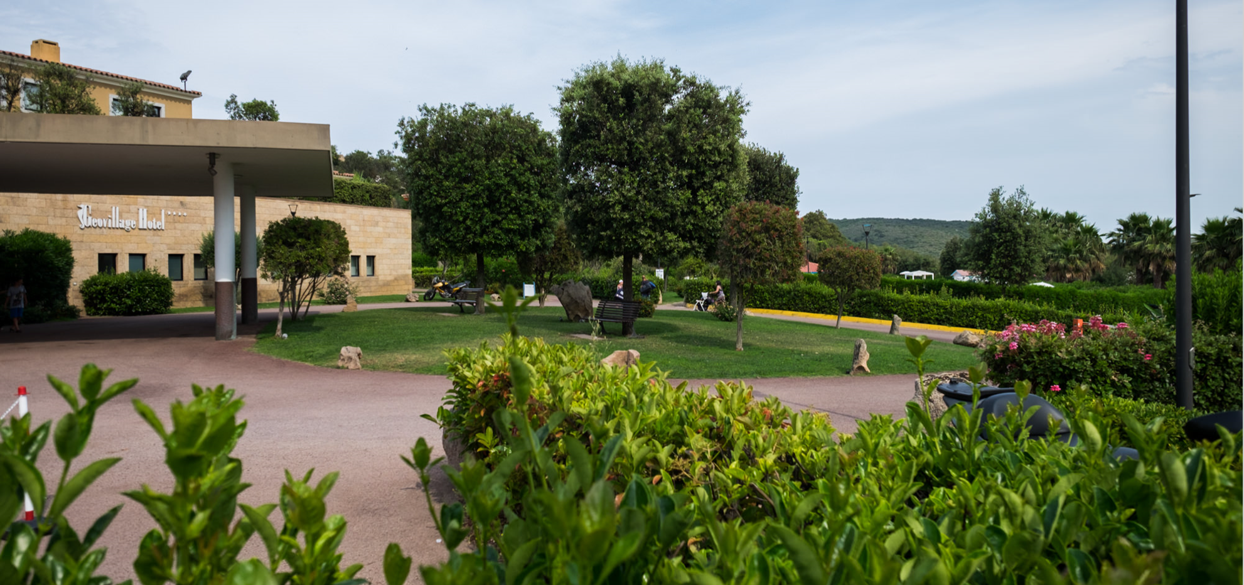
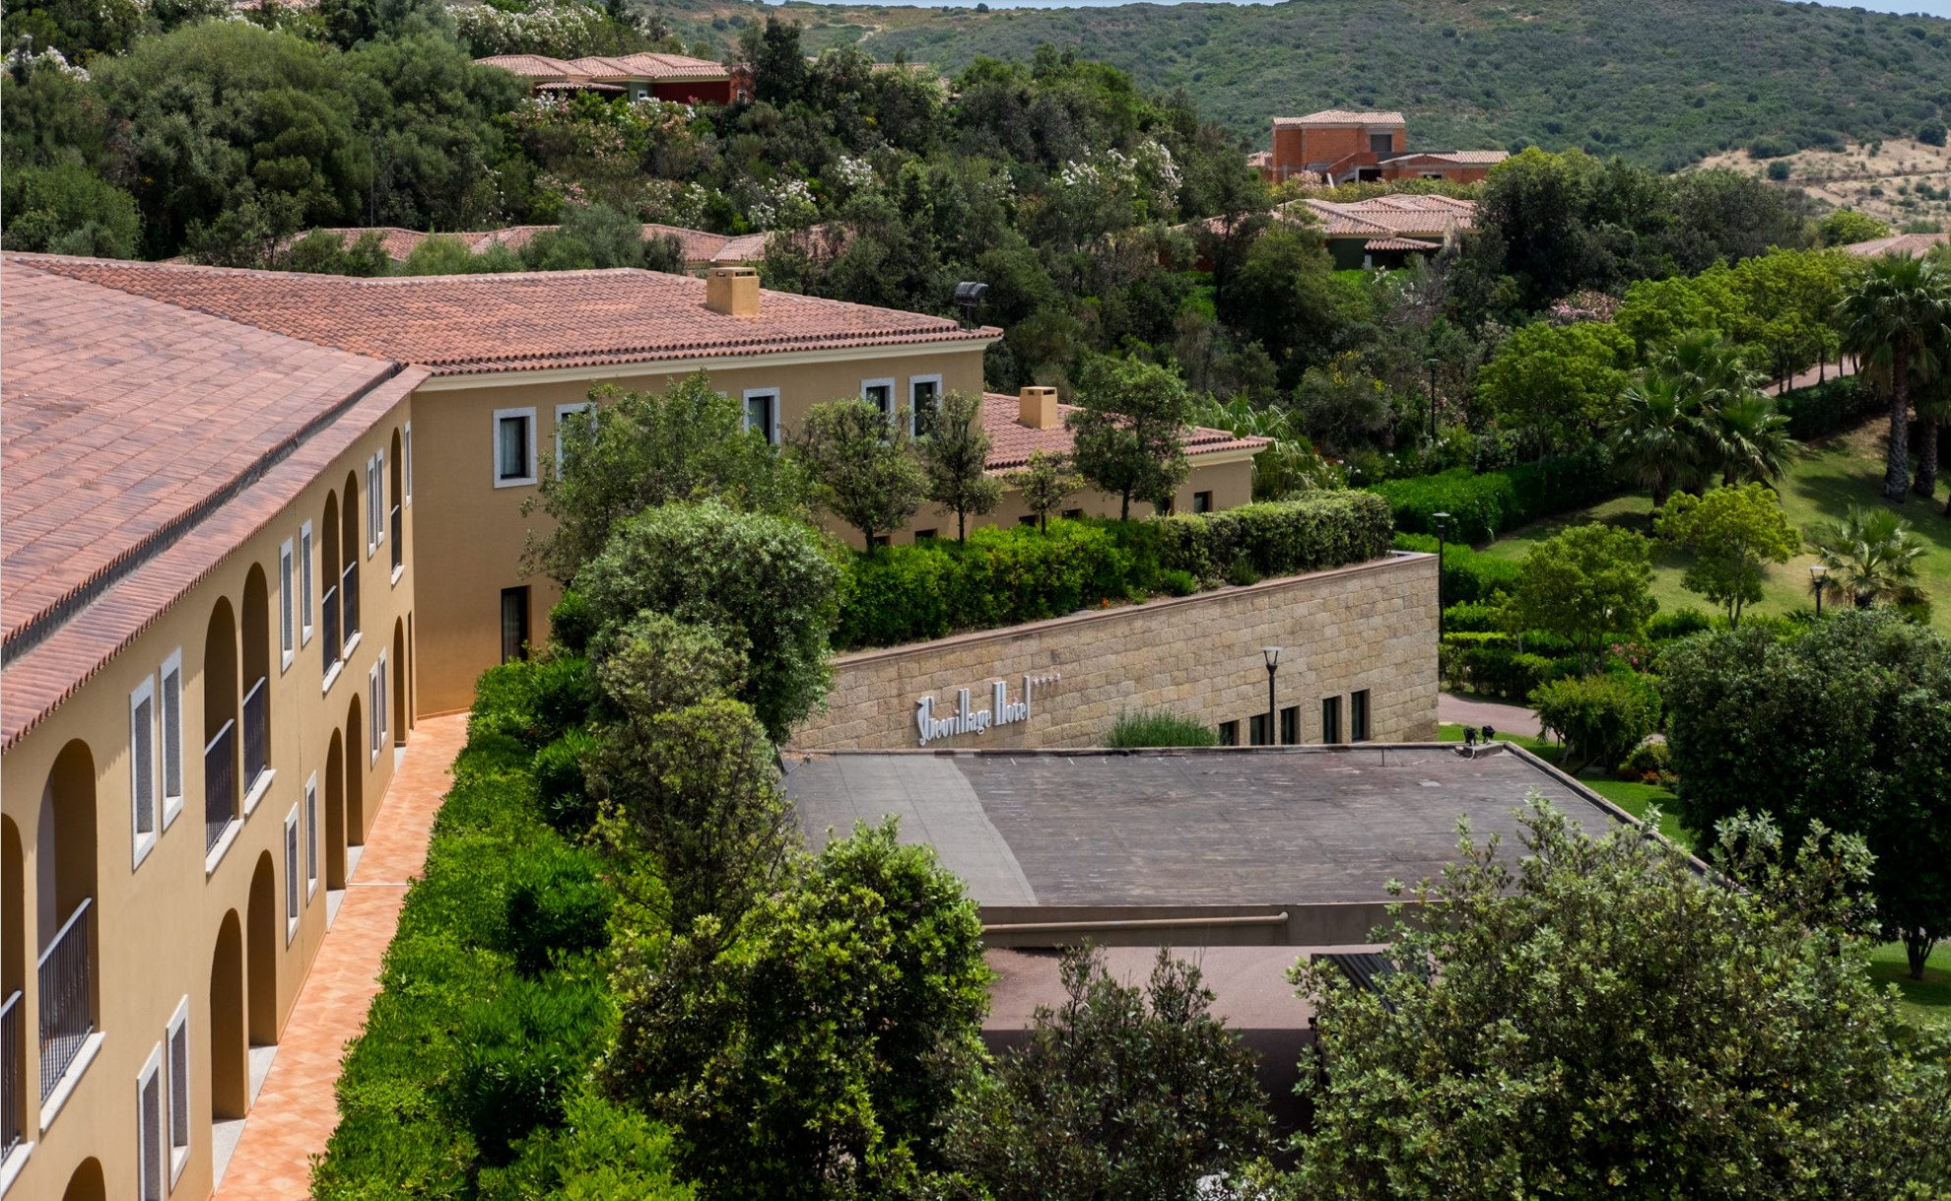

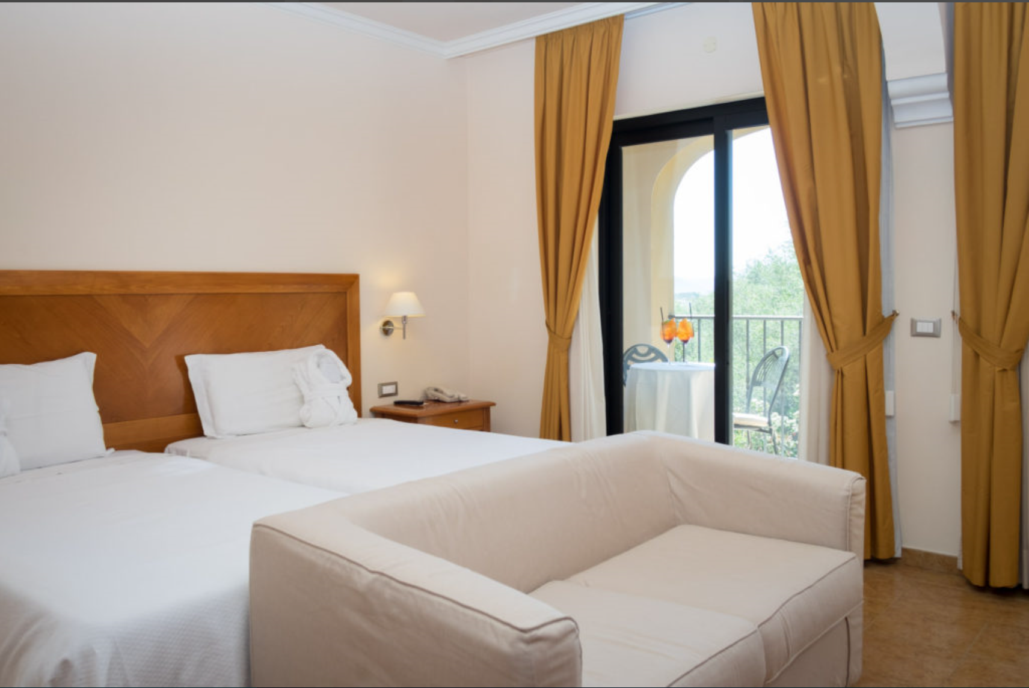

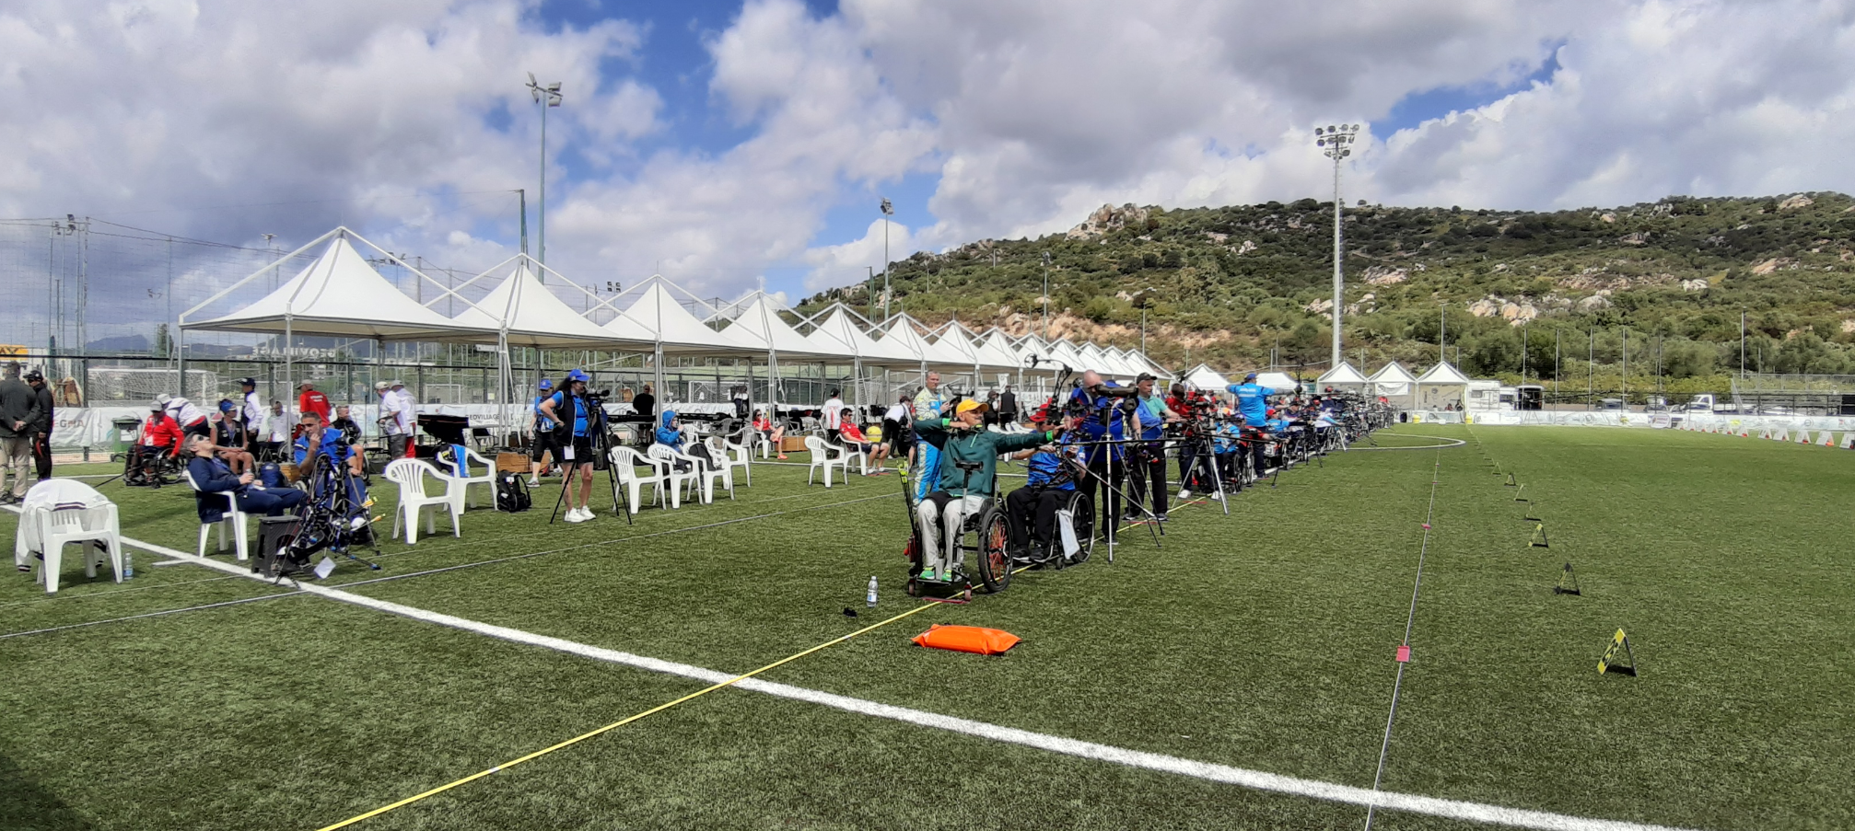
- 2 minute walk from venue
- Hotel has a pool area, Wi-Fi, continental breakfast and full service restaurant and lounge.
- One King bed half fare, Single Rooms 155 Euro
- Two Queen beds half fare, Twin Rooms 135 Euro per person

The hotel must be paid for the whole period of the event, according to the following two packages:

Full package W1, Compound and Recurve:
- accommodation for 9 nights, with full board
- in twin room / person : €. 1215,00
- in single room / person €. 1395,00
- meals (breakfast, lunch, dinner) from the dinner on Friday 17 April until the
breakfast on Sunday 26 April, departure day

Full package Visually Impaired:
- accommodation for 5 nights, with full board
- in twin room / person : €. 675,00
- in single room / person €. 775,00
- meals (breakfast, lunch, dinner) from the dinner on Tuesday 21 April until the
breakfast on Sunday 26 April, departure day

All accommodation requests received after 19 January 2020 are subject to higher hotel rates.
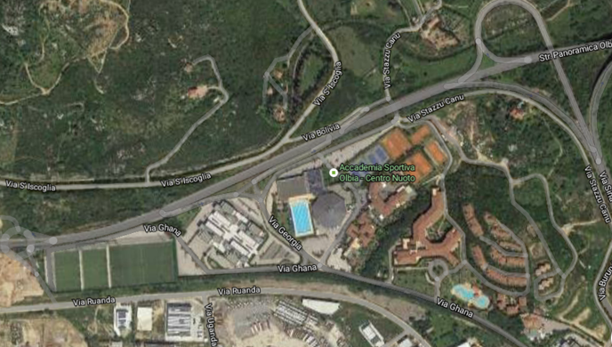
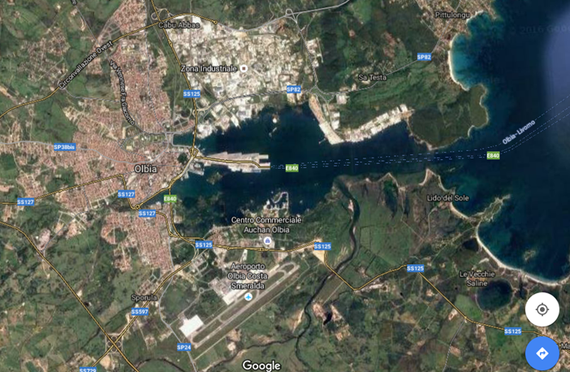
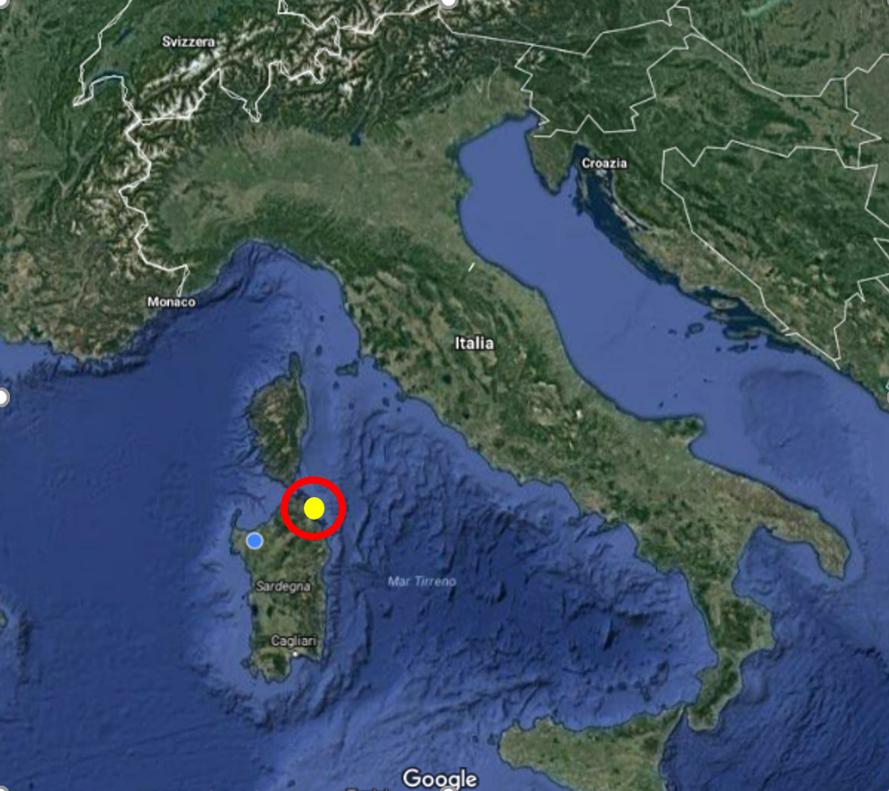
- MAPS LOCATION

Hotel
Field
Port
Geovillage
Airport

Competition & Training Venue Qualification “Resort Geovillage”
Location: GPS: lat = 40.946667° N – lon = 9.524167° E

Final Venue “Old Port, Molo BRIN”
Location: GPS: lat = 40.922885° N – lon = 9.506662° E

https://geovillage.it/en/
ENTRY FEE
Entry fee:
Individual: 180 EUR per athlete
Officials: 130 EUR per person
Teams: no entry fees

Entry fees include daily local transport to and from the practice field to/from official hotel during the qualification, elimination and finals venues (timetable to be confirmed on site).

PAYMENT CONDITIONS:
The entry fees should be paid in full upon arrival.

Payment of accommodation, a minimum deposit of 50% should be paid when booking by 19 January 2020. The final outstanding balance shall be made by bank transfer within 29 March. After this deadline, the LOC cannot guarantee the accommodation.

NOTE:
- Please indicate in the reference/notes of the payment section the team or Federation name corresponding to the payment
- All payment shall be made in EUR by BANK TRANSFER or CASH upon arrival
- All bank wire charges will be paid by the participant
- CREDIT CARDS or TRAVEL CHECKS will not be accepted as payment

BANK INFORMATION for ACCOMMODATION, TRANSPORTATION and
ENTRY FEES:
Bank Account Details
Account name/Beneficiary | A.S.D. Arcieri Torres Sassari
Bank name | Banco di Sardegna
Bank address | Agenzia. n.6, Predda Niedda nord -07100 Sassari - Italy
Bank account number | 70020330
BC-Number | 17211
SWIFT/BIC | BPMOIT22XXX
IBAN | IT17T0101517211000070020330

Please add the following reason:
Registration to Para Archery European Championship 2019

TO GUARANTEE RESERVATIONS
The 50% deposit of the accommodation must be paid in advance by
19 January 2020 made by bank transfer. The balance payment is due before arrival and within 29 March 2020.
ADDITIONAL INFORMATION
Transportation
Transportation will be provided from the official arrival airport, Olbia, Km 6 from the venue, to the official hotels, two days before the official practice day and one day after the closing day. Local transport will be available between official hotels and archery venue.
Transportation is also provided from Alghero airport, (150 Km from the venue), at the cost of €. 50.00 per person per single route.

Cancellations & Changes
- Cancellations received before 23 February 2020 a full refund of the deposit payment will be made.
- Cancellations received after 29 March 2020, no refund will be given.
- Refunds will be processed after the event.
- Name changes to team officials or athletes (same category and division) will be accepted up to 72 hours before the event without any additional charge.
- Should flight arrival details change last minute, please contact the Organizing Committee using the details indicated in the Team Managers’ Booklet.
- If a participant’s arrival is later than the original scheduled arrival date, the room will be charged from the date of the previous booking.

Training
A training course will be available from 18 April 2020. The training venue is next to the competition field. For teams that wish to arrive and practice earlier than this dates, please contact the LOC directly to make the necessary arrangements.

Closing Banquet
The closing Banquet will be held on 25 April 2020 at 20,30 at the cost of 10 Euro per person.

Weather
According to weather information, the average temperature in April is expected to be 53 to 79°F / 12 to 26 °C.

Media Registration:
Media representatives can apply for registration by emailing stampa@fitarco-italia.org

Internet
Wi-Fi will be available in the official hotels for free (both in the rooms and in the lobby). Wi-Fi available will be available at the venue too.

Water
Bottled water will be available venue.

Visualy Impared Classification
Visually impared archers classification will be held in Olbia in a specialized structure.
Transport to this location will be organized by the organizing committee for free.
There will be only 1 panel of VI classifiers. In case of protest or automatic reassessment, there will not be possibility to be reassessed on place.
It would be done on another event with a VI classification session.

LOC Contact:
Name: Mr. Carlo Pisano, Registration Manager
Email: secretary@sardinia-para-archery.it
Language: English, Marco Carpignano
Phone number +39 3389331101
Postal address Piazzale Segni,1 C/o Palasport
07100 Sassari – Sardinia - Italy
Website http://www.sardinia-para-archery.it

Visa:
All participants who need an entry visa to Italy, will be required to complete the Visa Support Form in WAREOS by no later than 22 March 2020.
It is the applicants’ responsibility for supplying the necessary information, ensuring all details are up to date, correct and submitted by the deadlines specified.
In addition, all participants that require a visa are kindly requested to supply a copy of their latest/valid passport. Copies of each applicate can be uploaded on WAREOS. All passport copies and personal details entered/uploaded to WAREOS will be held securely and in the strictest of confidence and not shared with other parties.

Please, note that the Organizing Committee can provide invitation for the period of the Para Archery European Championships in Olbia only.

