EUROPEAN FIELD CHAMPIONSHIPS 2021

INVITATION PACKAGE

To all World Archery Europe Member Associations

Dear President, Secretary General,

On behalf of the Local Organizing Committee, I would like to invite your country to the European Field Championships 2021, which will be held from 5-12 September in Porec, Croatia.

So far in the second pandemic year, we have managed to hold several large and essential tournaments: European Grand Prix, both stages, European Outdoor Championships, several World Cup stages and Olympics qualifiers.

Now, all the participants in Tokyo are known, and we can focus our strengths and skills on Field Archery, an interesting discipline.

On day 3, a qualifying tournament for The World Games will be organized. The World Games 2022 will take place 7-17 July 2022 in Birmingham, Alabama, USA.

In Porec, you will see exciting views, shooting into the sea, the taste of the Mediterranean and the smell of Istrian summer.

We are looking forward to archery, an exciting tournament, achieving the desired quotas, and your stay in beautiful Istria.

Sincerely yours,
Mr. Darko Uidl
OC President
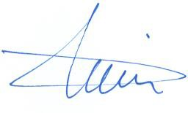

IMPORTANT DATES

Please find enclosed all the necessary information for registration, organization, and participation for this event. To register participation, please complete the necessary details in WAREOS within the deadlines listed below:
Summary of deadlines:
Registration Opening date - WAREOS 1 July 2021
Preliminary Entries Deadline 20 July 2021
Preliminary Hotel Reservation 20 July 2021
Hotel Reservation & 50% Payment 30 July 2021
Final Entries Deadline 20 August 2021
Entry Fee Payment Deadline 20 August 2021
Final Hotel Reservation & Full Payment 20 August 2021
Transportation & Full Payment 20 August 2021
Visa Support Deadline 10 July 2021

PRELIMINARY PROGRAMME

Day |  | Date | Description
Day -2 | Saturday  4 September |  | Arrival of Delegations  Practice field and local transportation available  Team Registration
Day -1 | Sunday  5 September |  | Arrival of Delegations  Practice field and local transportation available  Team Registration
DAY 0 | Monday  6 September |  | Official practice and equipment inspection  Team Managers' Meeting  Opening Ceremony
DAY 1 | Tuesday  7 September |  | 1st Qualification Round – 24 targets unmarked
DAY 2 | Wednesday  8 September |  | 2nd Qualification Round – 24 targets marked
DAY 3 | Thursday  9 September |  | Qualification event for the World Games 2022  Birmingham, Alabama, USA
DAY 4 | Friday  10 September |  | Individual Eliminations
DAY 5 | Saturday  11 September |  | Team Eliminations & Finals  Mixed Team Event (Semi-finals & Finals)
DAY 6 | Sunday  12 September |  | Individual Finals  Award Ceremony  Departure of Delegations

NOTE
This preliminary programme is subject to change according to participation and TV requirements. All changes will be published and distributed in good time.

PRELIMINARY & FINAL REGISTRATION

All entries, accommodation reservations, transport needs, flight arrival/departure information and visa invitation letter requests are to be completed using the World Archery Online Registration System WAREOS. These systems now handle the entire registration process for this event. No entry forms, hotel reservations or transportation forms will be accepted.

Member associations can login to WAREOS at http://extranet.worldarchery.sport with the username and password assigned by World Archery. After entering WAREOS, selecting the event from the list will allow a member association to register their athletes. Select/press the “Entries” button to see the list of categories in the event. Select/press the “category” to enter the athlete and official numbers/details participating for that event. A WAREOS User Manual can be downloaded in PDF format (English) upon login.

Contact Ms CECILE TOSETTI (ctosetti@archery.sport) in the World Archery Office with any questions regarding technical problems on WAREOS. For any question regarding the organisation of the event (transport, accommodation, meals etc.) please contact directly the LOC.

A maximum number of 3 athletes per country (host country included) are allowed to be registered into each category of the event.

Start date for online registration using WAREOS: 1 July 2021
End of Final registration using WAREOS: 20 August 2021

Please respect the stated deadlines.

Member Associations should only use WAREOS to make any changes/amendments to their entries and will be able to do so at any time. Any changes made in WAREOS an email will instantly be automatically sent to the Local Organizing Committee and Member Association with the updated information.

However, any changes that are made after the deadlines specified or if entries differ by more than 4 athletes from the preliminary entries, the following penalty fees will automatically be applied:

Penalty fees to be paid to Organizing Committee: | Cost (EURO):
Entries made after the preliminary and/or final entry deadline date. | 50 per entry
If final entries differ from the preliminary entries by more than 4 athletes/officials. | 140 per entry
Failure to have made preliminary entries before the deadline date but then have submitted final entries athletes/officials/teams | 50/30/20 per entry

NOTE
Member Associations that have penalty fees outstanding from earlier events will need to pay these penalty fees and get good standing before being eligible to enter and compete.
Also, World Archery fee must have been paid prior the participation.

ACCOMMODATION & GENERAL INFORMATION

Important Note
Non-official accommodation is not allowed. Any team or individual accommodated in non-official hotel will not be accredited and participation in the event will be refused.

The official hotels are divided in two categories: Standard and Comfort. Hotels are especially selected by the organization for the event. Hotel allocations will be made on a 'first come-first serve' basis. Accommodation rates will offer full board and half board meal packages.

Reservations should be made before 30 July 2021
Final Hotel Reservation & Transportation Forms 20 August 2021

To confirm your hotel reservations, 50% deposit of the total amount is to be paid by a bank transfer to the Organizing Committee before 30 July 2021. Reservations received after this date will be considered only according to availability.

o Standard Hotel *** (Plavi, Istra, Grand Vista)

Half board (dinner at the hotel)
Single Room price 122 €
Number of rooms 20
Double/Twin 219 € per room
Number of rooms 100
Full board (lunch and dinner at the hotel)
Single Room 135 €
Double/Twin 245 € per room

- Comfort Hotel **** (Molindrio)

Half board (dinner at the hotel)
Single Room 150 €
Number of rooms 10
Double/Twin 249 € per room
Number of rooms 70
Full board (lunch and dinner at the hotel)
Single Room 166 €
Double/Twin 275 € per room

Board plan half board, full board
Check-in from 4 September 2021
Hotel website Hotel Molindrio

The hotel rates are per room, per night, including free internet. Additional purchases in the hotel bar, café and mini bar are at own expense.*
*All prices are including city tax.

During the event there will be a tournament desk available in office on the FoP with all the relevant and latest information about the Championships.

HOTEL UPDATE ON COVID-19 MEASURES

All information will be forwarded to the WhatsApp and Viber groups for everyone signed up for this mode of communication. Information will be shared through Instagram and Facebook.

Important Note
Refer to the accommodation pages for detailed hotel information.
Please complete all the necessary sections in WAREOS and make full payment for entries, transport, and accommodation by the specified deadlines.
Bank transfers only, no credit cards or travel checks will be accepted.

- Standard Hotel

Hotel Plavi ***
Sitting right above a Blue Flag beach, Hotel Plavi was partially renovated in 2016 when the new, light, and airy dining and reception area were created.
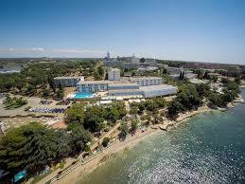
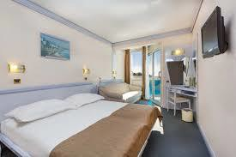

Grand Vista***
Renowed for the breathtaking vista from the dining room over the pool, Hotel Gran Vista is a well-kept location just outside Poreč. Situated on a slope, it offers daily exercise in the form of stairs you must take to the paved beach in front of the hotel and back.
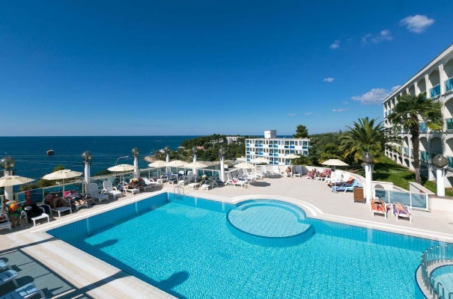
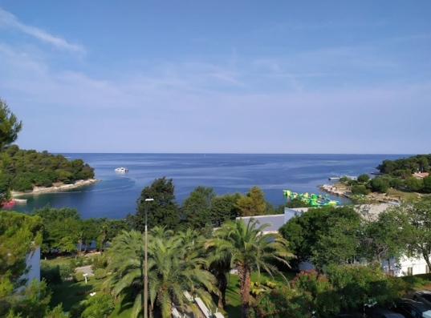

Hotel Istra***
Located just outside of Poreč, Hotel Istra overlooks a lovely cove and has everything you might need for a simple, relaxing holiday. The grounds are well kept, dominated by palm trees, colorful flowers and rose bushes.

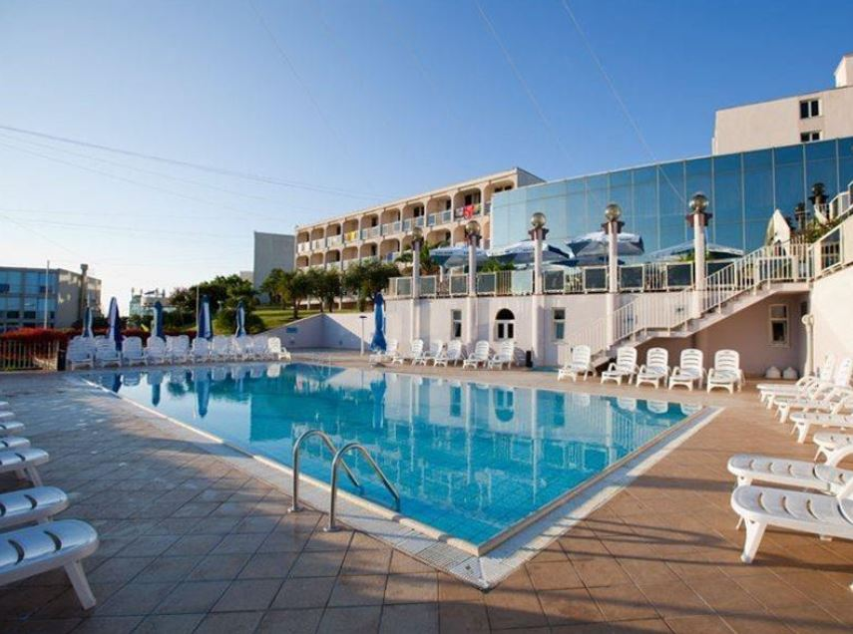
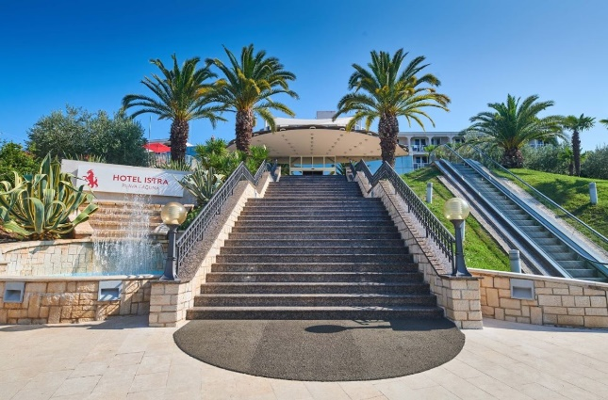

- Comfort Hotel

Hotel Molindrio ****

At Zelena Resort, hotel Molindrio takes the holiday experience to the next level, combining upscale amenities and elegance into one of the chicest Plava Laguna properties in Porec. The hotel grounds are all neatly trimmed grass if you want to take a barefoot walk. All rooms are appointed with sweet smelling linens, a plush
robe, and slippers. There is a private balcony too, so you can catch those dreamy Mediterranean views and sunsets and bask in the views of the Zelena Resort.

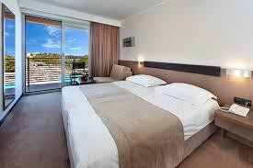
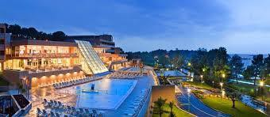

ENTRY FEE
Individual: | 150 € | per athlete
Officials: | 50 € | per person
Teams: | 75 € | per team
There is no entry fee for mix teams.

Temporary Upgrade: 30 € per accreditation (for athletes wishing to be a coach temporarily).

Entry fees include daily local transport to and from the practice field to/from official hotels during the qualification, elimination, and finals venues (timetable to be confirmed on site).

PAYMENT CONDITIONS
All fees should be paid in full before arrival.

Payment of accommodation and local transportation: a minimum deposit of 50% of the total amount owed should be made when booking by 30 July 2021.
The final outstanding balance shall be transferred 15 days before arrival. Accommodation cannot be guaranteed after this deadline. A balance invoice will be provided via WAREOS.
Entry fee should be paid by 20 August 2021 separately than Accommodation & Transportation due to Croatian Tax policy.

Bank information for ACCOMMODATION &TRANSPORTATION

BANK RAIFFEISEN BANK AUSTRIA D.D. BANK ACCOUNT HOLDER NAME UNILINE D.O.O.
ADRESS BOZE GUMPCA 38, 52100 PULA
ACCOUNT No HR3024840081500154861
BIC/SWIFT CODE RZBHHR2X

Bank information for ENTRY FEES
BANK: PRIVREDNA BANKA ZAGREB D.D. BANK ACCOUNT HOLDER NAME: HRVATSKI STRELICARSKI SAVEZ
ADDRESS: HRVATSKOG PROLJECA 34, 10040 ZAGREB
ACCOUNT NO: HR6623400091110039202
BIC/SWIFT CODE: PBZGHR2X

NOTE: All payments shall be made in EUR only by BANK TRANSFER.

Bank transfer fees are responsible on the sender.
Credit cards and Travel checks will not be accepted.

CANCELLATIONS & CHANGES
All cancellations and changes must be made through WAREOS:
- Cancellations received before 5 August 2021 a full refund of the deposit payment will be made.
- Cancellations received after 23 August 2021 - 50% refund will be given.
- Cancellations received after 28 August 2021 - 25% refund will be given.
- Cancellations received after 1 September 2021 no refund will be given.
- Refunds will be processed after the event.
- Name changes to team officials or athletes (same category and division) will be accepted up to 72 hours before the event without any additional charge.
- Should flight arrival details change last minute, please contact the Organizing Committee using the details indicated in the Team Managers’ Booklet.
- If a participant’s arrival is later than the original scheduled arrival date, the room charges will start from the dates of the original booking made by the Member Association.

HEALTH REGULATIONS (COVID-19)

INFORMATION

- Pula General Hospital, Zagrebacka 30, 52100 Pula; +385 52 376 000
- Everybody should follow the Government/public health authorities measures (national and sport-specific regulations) and be aware of the travel restrictions.
- For your information, medical infrastructure/Hospital with proper care will be reachable within 20 minutes from the venue, where COVID-19 test can be done.

PERSONAL HYGIENE AND HEALTH ADVICE

- Anyone due to participate in the event who is feeling ill should not attend.
- Participants (athlete, volunteer, official etc.) should proactively and regularly check their health status (including taking their temperature and monitoring for any symptoms).
- Stay home and self-isolate even with minor symptoms for 10 days or more depending on national protocols, when showing any symptoms (fever, tiredness, dry cough, headache, nasal congestion, runny nose, sore throat, difficulty breathing).
- Contact a healthcare provider immediately if any respiratory illness is noted.
- Masks to be always worn everywhere (transport, common area in the hotel, venue, training etc.) except on shooting line.
- Regularly and thoroughly clean your hands with an alcohol-based hand rub or wash them with soap and water.
- Avoid touching eyes, nose, and mouth.
- Cover your mouth and nose with your bent elbow or tissue when you cough or sneeze. Then dispose of the used tissue immediately and wash your hands
- Avoid touching high-contact surfaces such as door handles, walls or windows, etc.
- Avoid going to crowded places.
- Avoid steam rooms or saunas.
- No spitting, as the main mode of transmission of the virus is in respiratory secretions.
- No handshakes, high fives and any other personal contact.
- Athletes should not share clothing, bar soap, sports equipment, water bottles or other personal items.

TRANSPORT & ACCOMMODATION

- Avoid using public transport to go to the hotel and between the hotel and the venue.
- All meals must be taken in the hotel or at home, not at any other restaurant/bar.

VENUE

- Access to the venue might be denied at any time in case of disease suspicion.
- Limit contact/interactions.
- Handwashing/alcohol-based hand gel will be available at multiple locations in the event facility and accommodation.
- Regular toilet cleaning will be done (at least once per session).
- Tissues and containers will be at disposal to dispose of used tissues on transport to the venue, at the venue and any other facility.
- No shows allowed. Winners will receive their medals in a simple ceremony only with the winners and their team, all wearing masks.
- Medical post and designated personnel on site able to help assess cases and potential other illness will be present.
- An isolation room/space to hold any symptomatic person found at the venue will be available.
- Space on shooting line shall be 1 metre minimum per athlete.
- No spectators are allowed during the event.

PARTICIPANTS

- Maintain the staff/team to a minimum to minimise transmission.
- Maintain social distancing, at least 1,5 metre distance between yourself and others at all times.

ADDITIONAL INFORMATION

Transport:
As the Porec city is not in the close distance of a major international airport (except for the local Pula airport), you can choose one of these for your arrival airport, whichever suits you best.

CROATIA Zagreb Airport, Pula Airport, Rijeka Airport
SLOVENIA Ljubljana Airport
ITALY Trieste Airport, Venice Airport

Local transport to Porec from the above airports is very poor, so we advise you to book the private transfer options below. Price is per person one way.

Private transfers Standard car Van Minibus Bus
To/from Porec-one way min 3 pax min 7 pax min15 pax min 49 pax
Pula Airport 40€ 25€ 23€ 15€
Zagreb Airport 120€ 80€ 70€ 35€
Ljubljana Airport 90€ 60€ 45€ 25€
Trieste Airport 60€ 40€ 30€ 20€
Venezia Airport 130€ 70€ 50€ 30€
Rijeka Airport 60€ 40€ 30€ 20€

Internet
Free WiFi will be available in the official hotels (in hotel rooms and in the lobby).

Meals
The lunch is foreseen to be served at hotels. Team managers can request a lunchbox in hotel where they are located to dine at FoP during the official days.

Water
Water will be available at the venues free of charge.

Media Registration
Media representatives can apply for registration by emailing ecfield2021@archery.hr

Weather
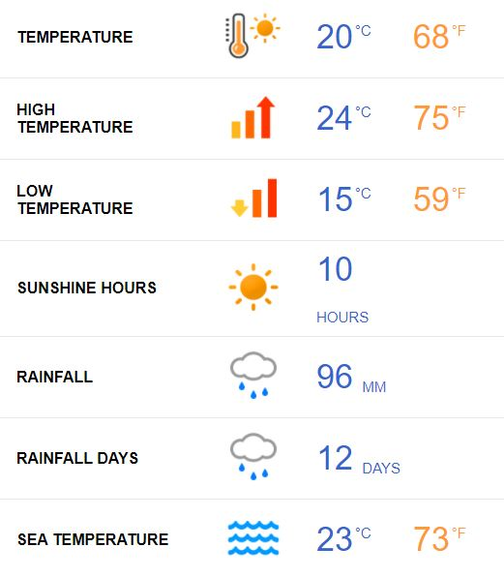

September is the beginning of autumn in Porec.
The temperatures stay high though, with an average high of 24°C and a low temperature of 15°C, so still plenty of time to work on your tan and enjoy the sandy beaches.
With the average sea temperature still relatively high at an average of 23°C, there's plenty of opportunity to enjoy the water still, either with sailing trips or water sports.

Dress regulations
WA & WAE dress regulations do apply.

Closing Party
Banquet or closing party will not be organized due to epidemiologic recommendation unless epidemiological measures and recommendations are repealed by September.

VISA SUPPORT

All participants who need an entry Visa to Croatia, will be required to complete the Visa Support Form in WAREOS no later than 10 July 2021.

It is the applicants’ responsibility for supplying the necessary information, ensuring all details are up to date, correct and submitted by the deadlines specified.

In addition, all participants that require a visa are kindly requested to supply a copy of their latest/valid passport. Copies of each application can be uploaded on

WAREOS. All passport copies and personal details entered/uploaded to WAREOS will be held securely and in the strictest of confidence and will not be shared with other parties.

Please note that the Organizing Committee can provide invitation for the period of the European Field Championships.

LOC CONTACT

Organizing Committee President Darko Uidl

General Secretary - Entry Fee Kresimir Cadez
Email archery@archery.hr
ecfield2021@archery.hr
+385 91 4343 463
English and Croatian
Transport, Accommodation
& Finances Hrvoje Mijic
Email ecfield@uniline.hr
+385 99 4696 283
Language English and Croatian

EFC Email ecfield2021@archery.hr
Official website http://www.ecfield.eu

