to ALL World Archery MEMBER ASSOCIATIONS

INVITATION

Dear Member Associates,

On behalf of the Organizing Committee of the Bulgarian Archery Federation, I’m pleased to invite you and welcome your Federation to participate to the WAE-GRAND PRIX 2022, which is to be held on 03 – 08 May, 2022, in Plovdiv (Bulgaria).

European Grand Prix 2022 is a WA Ranking Event.

The tournament will be organized following the WORLD ARCHERY rules and the WAE GRAND PRIX rules in both divisions: Recurve and Compound.

This competition is a great opportunity to prepare your teams before European Outdoor Championships 2022 (6 – 12, June, München (Ger))

WAE will give a total amount of 12 000 Euro to the winners as follows:
(for each competition: Recurve and Compound, Men and Women)
Prize money for European winners:
1st place: Euro 1 500
2nd place: Euro 1 000
3rd place: Euro 500

We are happy to welcome national teams from all continents and also club archers.
You will certainly be able to sense the Bulgarian hospitality. We also hope that you and your team will enjoy your stay in Plovdiv and will enjoy great tournament and a wonderful week in Plovdiv.

To register participation, please complete all necessary sections in WAREOS within the stated deadlines:

Registration opening deadline  Preliminary Entries | 20 December 2021  3 February 2022
Final Entries | 11 April 2022
Preliminary Hotel Reservation | 7 March 2022
50% Hotel Reservation  Visa Support | 7 March 2022  7 March 2022
Transportation | 11 April 2022
Final Hotel Reservation & Payment | 11 April 2022
Final Payment | 11 April 2022
Full refund cancellation deadline* | 11 April 2022
*After this deadline, the LOC is allowed to retain all amounts due by the Member Association

Looking forward to welcoming you in Plovdiv!

Sincerely yours,
Mr. Atanas Temelkov
President of Bulgarian Archery Federation

PRELIMINARY PROGRAM

DAY -1 | Sunday  01 May 2022 | Arrival of participants.  Practice field and local transport available.
DAY 0 | Monday  02 May 2022 | Arrival of participants.  Accreditation.  Practice field and local transport available.
DAY 1 | Tuesday  03 May 2022 | Official practice, Equipment inspection.  Team Managers’ Meeting.  Opening Ceremony (If any)
DAY 2 | Wednesday  04 May 2022 | Qualifications 70m Round Recurve and 50m Compound  Practice field and local transport available.
DAY 3 | Thursday  05 May 2022 | Elimination Individual Round till semi finals  Mixed Team Eliminations  All divisions
DAY 4 | Friday  06 May 2022 | Teams and Mixed Teams Elimination Round and Finals.  Award Ceremony for Teams and Mixed Teams
DAY 5 | Saturday  07 May 2022 | Individual Finals  Award Ceremony for Individual, Teams and Mixed Teams  Closing Party (If any)
DAY 6 | Sunday  08 May 2022 | Departure of teams

A maximum number of 6 men and 6 women per country can be registered into each division of the event.
The host country may enter the maximum of 8 men and 8 women per division.

NOTE:
This preliminary program is subject to change according to the number of participants and TV requirements. All changes to the program will be published and informed to all participants in good time.

PRELIMINARY & FINAL REGISTRATION

All entries, accommodation reservations, transport needs, flight arrival/departure information and visa invitation letter requests are to be completed using the World Archery Online Registration System WAREOS https://extranet.worldarchery.sport. This system handles the entire registration process for this event. No entry forms, hotel reservations or transportation forms will be accepted; all information must be entered into WAREOS.

Member associations can login to WAREOS at http://extranet.worldarchery.sport with the username and password assigned by World Archery. After entering WAREOS, selecting the event from the list will allow a member association to register their athletes. Select/press the “Entries” button to see the list of categories in the event. Select/press the “category” to enter the athlete and official numbers/details participating for that event. A WAREOS User Manual can be downloaded in PDF format (English) upon login.

Contact wareos@archery.sport with any questions regarding technical problems on WAREOS. For any question regarding the organization of the event (transport, accommodation, meals, invoices, visa etc.) please contact directly the LOC.

Athletes from a minimum of 4 different Member Associations shall be registered and participate in the event.

Member Associations can only use WAREOS to make any changes or amendments to entries and will be able to do so at any time. An email will automatically notify the Organising Committee and Member Association of any changes made in WAREOS.

Starting date of online-registration with WAREOS is: | 20 December 2021
End of Preliminary registration: | 3 February 2022
End of Final registration: | 11 April 2022

Please respect the stated deadlines.

ENTRY FEES

Individuals: 200 € / archer
Officials: 100 € / person
Team: 0 € / team
Mixed Team: 0 € / team

ENTRY FEES IN NON-OFFICIAL HOTELS
Individuals: 400 € / archer
Officials: 200 € / person
Team: 0 € / team
Mixed Team: 0 € / team

*There is no entry fee for teams and mixed teams.

Entry fees include daily local transport to and from the practice field to/from official
hotels during the qualification, elimination and finals venues (timetable to be confirmed
on site).
*The Entry fee includes the Closing Party meal (if any).

Any changes made after the deadlines specified or if entries differ by more than 4 athletes from the preliminary entries, the following penalty fees to will automatically be applied:
PENALTY FEES TO BE PAID TO ORGANISING COMMITTEE (EURO)
Penalty fees for Late Entries (after final deadline): | 50 € per entry
Penalty fees for not filling Preliminary entries | 150 € per entry
Penalty fee for differences between preliminary and final entries:  *If the difference between final and preliminary entries number is more than 4 athletes/officials. | 150 € per entry

ACCOMMODATION & GENERAL INFORMATION

The Official Hotels are GRAND HOTEL PLOVDIV and PARK HOTEL PLOVDIV. Hotels are
especially selected by the organization for the event. Hotel allocations will be made on a
'first come-first serve' basis. Accommodation rates will offer full board meal menu. Reservation should be made before 7 March 2022.

To confirm your hotel reservations, 50% deposit of the total amount is to be paid by a bank transfer to the Organizing Committee before 7 March 2022. Reservations received
after this date will be considered only according to availability and the room rate can change.

The room rates:
- are in Euro (€) per room, per night
- including bed, breakfast, lunch, dinner with non-alcoholic drinks on the spot
- including free internet in hotel lobby
- Additional purchases in the hotel bar, café and mini bar is at own expense.*
*All prices are including city tax.
Lunch during competition days will be served in the hotel.

Booking NON-OFFICIAL hotel:
Participants who may decide to book their accommodation at or with other hotels, i.e. non-official hotels, and not through the Local Organizing Committee (LOC), shall have to pay a double entry fee, and the LOC will not be responsible for providing transportation from those hotels to the venue (transport for these teams will be provided only to and from airport& train station). It is not possible to distribute any information at the non-official hotels, also.

GRAND HOTEL PLOVDIV

HOTEL | CATEGORY | Single room | Double room
GRAND HOTEL PLOVDIV | 4 **** | 119 € | 198 €

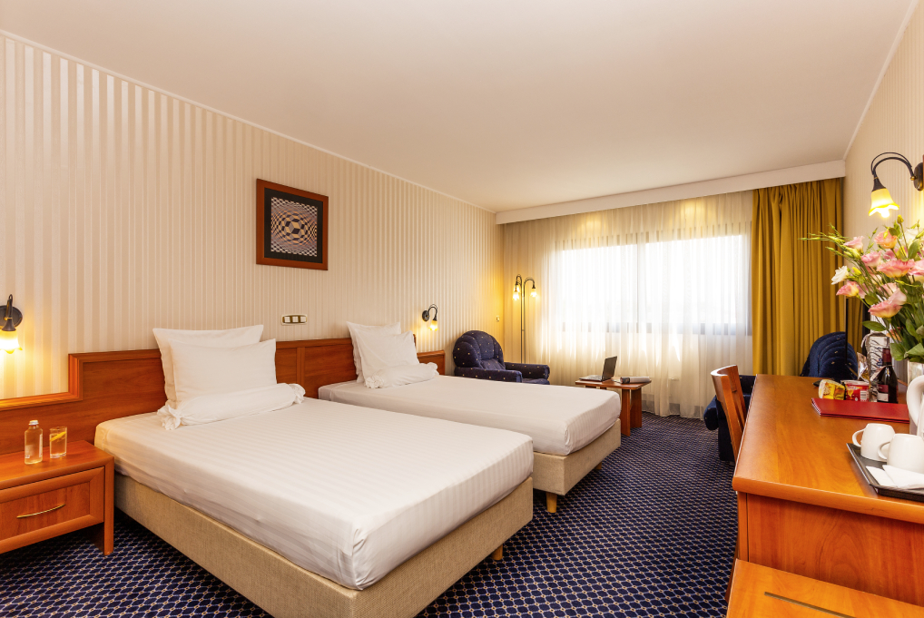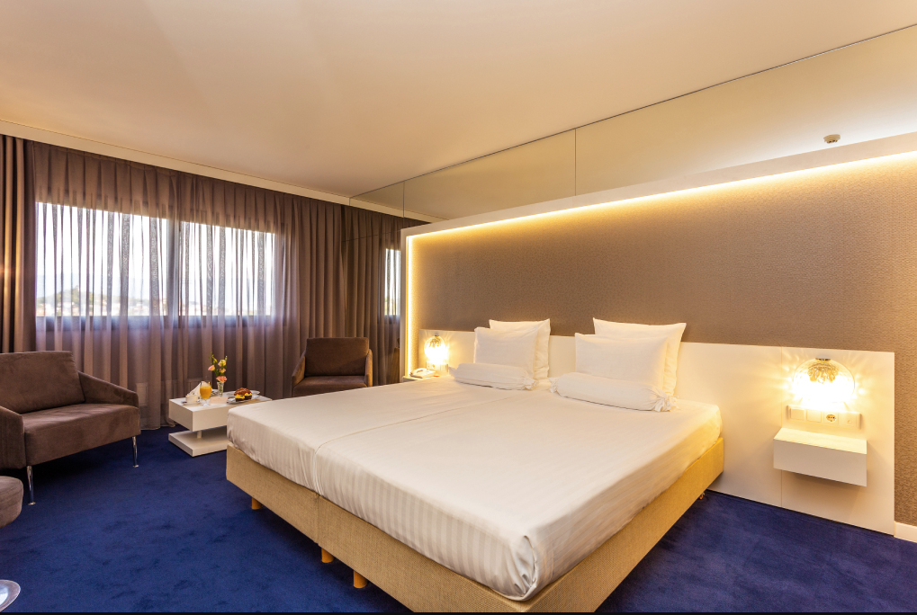
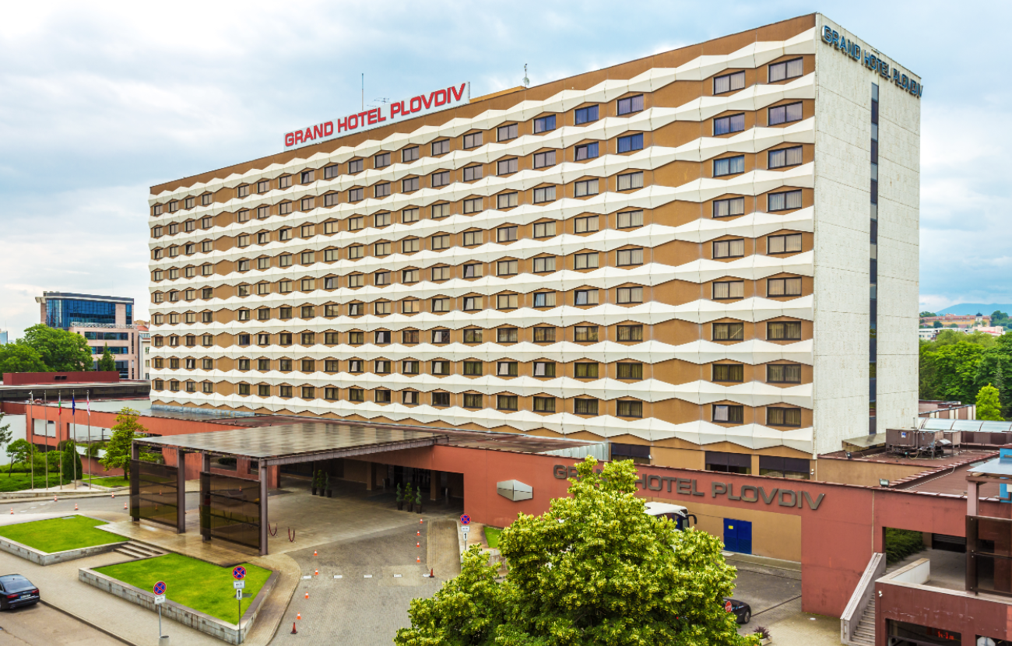

PARK HOTEL PLOVDIV

HOTEL | CATEGORY | Single room | Double room
PARK HOTEL PLOVDIV | 3 *** | 109 € | 178 €

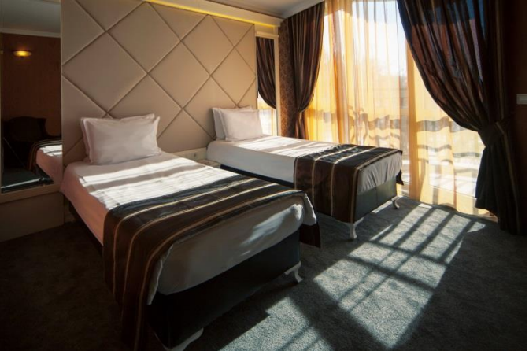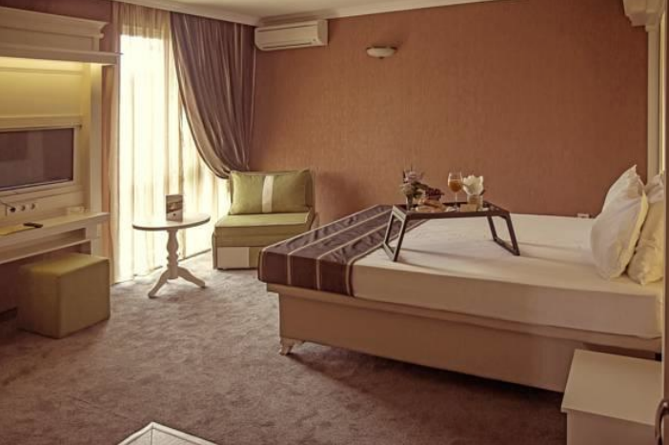

TRANSPORTATION
The OC will collect the teams from the two airports. You have to pay the transportation fee as follows:

From SOFIA airport to Official Hotels – (one way): 40 €/person
From PLOVDIV airport to Official Hotels – (one way): 10 €/person

The last date for the payment of the transportation fee is 11 April 2022.
Between airports and hotel, the organizer will use buses, small buses, vans and cars, what will depend of number of persons scheduled for transportation. Transportation from the airports will start two days before the official practice day and will end the day after the closing day

A daily shuttle service will be available for the tournament days from the Official Hotels to the competition venue and back - free of charge.

VISA
Bulgaria is a member of European Union.
It is your responsibility to establish with your respective foreign office if your team requires a visa for Bulgaria.
For participants who need a formal visa and invitation letter for entry to Bulgaria, will be required to complete the Visa Support sections in WAREOS by no later than 7 March 2022.
It is the applicants’ responsibility for supplying the necessary information, ensuring all details are up to date, correct and submitted by the deadlines specified.
In addition, all participants that require a visa are kindly requested to supply a copy of their latest/valid passport. Copies of each application can be uploaded on WAREOS. All passport copies and personal details entered/uploaded to WAREOS will be held securely and in the strictest of confidence and not shared with other parties.
Please ensure your passport is valid for at least six months from the date you enter Bulgaria, or you may not be admitted.
If our help is needed you may contact us immediately.

PAYMENT CONDITIONS
All fees should be paid in full before arrival!
Payment of accommodation and local transportation: a minimum deposit of 50% of the total amount owed should be made when booking by 7 March 2022.
The final outstanding balance shall be transferred before 11 April 2022.
Accommodation cannot be guaranteed after this deadline. A balance invoice will be provided via WAREOS.

NOTE:
- Please indicate in the reference/notes section the team or reservation name that corresponds to the payment.
- All payment shall be made in EURO only by BANK TRANSFER.
- Bank transfer fees are responsible on the sender.
- Credit cards and Travel checks will not be accepted.

BANK INFORMATION for ACCOMMODATION, TRANSPORTATION and ENTRY FEES:
BANK: FIRST INVESTMENT BANK
SWIFT CODE: FINVBGSF
IBAN: BG13FINV91501203792590
ADDRESS: 37, Dragan Tsankov Blvd., 1797 Sofia, Bulgaria

NOTE: ALL PAYMENTS SHALL BE MADE IN EURO

Cancellations & Changes
All cancellations and changes must be made through WAREOS / Open WAREOS:
- Should flight arrival details change last minute, please contact the Organising Committee using the details indicated in the team managers’ booklet.
- If a participant’s arrival is later than the original scheduled arrival date, the room will be charged from the date of the original booking in WAREOS.
- An email will automatically notify the Organising Committee and Member Association of any changes made in WAREOS.
- Cancellations received after 11 April 2022 no refund will be given. Refunds will be processed after the event.
- Name changes to team officials or athletes (same category and division) will be accepted up to 72 hours before the event without any additional charge.
- Should flight arrival details change last minute, please contact the Organising Committee using the details indicated in the Team Managers’ Booklet.

HEALTH REGULATIONS (COVID-19)
INFORMATION
- Everybody should follow the Government/public health authorities measures
(national and sport-specific regulations) and be aware of the travel restrictions
- For your information, Medical infrastructure/Hospital with proper care will be
reachable within 15 minutes from the venue, where COVID-19 test can be
done

ADDITIONAL INFORMATION
Training
Training venues will be available starting from 29 April 2022.
For those teams wishing to arrive earlier and practice at a practice field we would be happy to organize a training camp for everyone who intends to come earlier. Please announce your arrival at the Training Camp by 7 March 2022.

Weather in Plovdiv
In this period in Plovdiv is sunny. The temperatures in May are expected to range between 23 and 28 degrees Celsius. The average in the last few years has been 25 degrees Celsius.

Media Registration
Media representatives can apply for registration by emailing egp2022@abv.bg

Internet
Will be available at the official hotels for free.
There will also be Wi-Fi available for access to results at the venue.

Water
Water will be available at the venue free of charge.

Meals
The lunch is foreseen to be served at hotels. Team managers can request a lunchbox in
Hotel where they are located to dine at FoP during the official days. Number of lunchboxes is limited.

Dress regulations
WA & WAE dress regulations do apply.

Closing Party
Banquet or closing party will be organized or not depending on epidemiologic recommendation.

CLUB ARCHERS PARTICIPATION
Other athletes (not competing as country but only as club) can register on Open WAREOS at https://extranet.worldarchery.sport/ with their username and password if already registered in the past or register to get the log in details if it’s the first time. After the creation of the profile, follow the instructions to register to the event. Contact Ms CECILE TOSETTI (wareos@archery.sport) in the World Archery Office with any questions regarding technical problems on WAREOS. For any question regarding the organization of the event (transport, accommodation, meals etc.) please contact directly the LOC.

LOC CONTACT
Email: egp2022@abv.bg

Mobile phone: + 359 88 796 3009 – Atanas Temelkov – president (English)
Mobile phone: + 359 88 464 0216 – Donka Shopova – secretary general (English)
Mobile phone: + 359 88 649 1949 – Bulat Germanov (Russian)

Web address: https://egp2022.archery.bg/

Looking forward to welcoming You in Plovdiv, Bulgaria!

