INVITATION

TO ALL WORLD ARCHERY MEMBER ASSOCIATIONS

Dear Mr President,

On behalf of the Organizing Committee and Romanian Archery Federation we are pleased to invite you to the 2022 European Youth Cup that will be held in Bucharest, Romania, on 25 – 31 July 2022.
This event will be organized following the WA rules and WAE YOUTH CUP RULES for Junior Women, Junior Men, Cadet Women and Cadet Men classes, Recurve and Compound divisions in the Outdoor Target Archery discipline.

This European Youth Cup in Bucharest is a very good opportunity for the final preparation to the European Youth Outdoor Championships in Lilleshall, Great Britain, just 15 days prior to European Youth Outdoor Championships 2022.

We are looking forward to welcoming you and we are sure you will enjoy your stay in Bucharest.

THE PARTICIPATION IS OPEN TO ALL WORLD ARCHERY MEMBER ASSOCIATIONS.

Yours sincerely,

Zoltan Miklos  Competition / FOP Manager | President of Romanian Archery Federation  Cornel Milan

Cristian Mocanu Project Manager | LOC E-mail: oc-bucharest@frta.ro  Info: +40 723 375 275

Important Dates:

Please find enclosed detailed information regarding this event. To register participation, please complete all the necessary sections in WAREOS (https://extranet.worldarchery.sport) within the deadlines listed below.

Summary of deadlines:

Registration Opening date on WAREOS 1 February 2022
Preliminary Entries 25 April 2022
Final Entries 04 July 2022
Late Entries Fee 15 July 2022
Hotel reservation down-payment (60%) 25 April 2022
Hotel reservation and payment 04 July 2022
Transportation 04 July 2022
Final Payment 04 July 2022
Visa Application 04 June 2022
Full refund cancellation deadline (before) 04 July 2022

*After this deadline, the LOC is allowed to retain all amounts due by the Member Association.

Please respect the stated deadlines.

PRELIMINARY PROGRAMME

Saturday 23 July 2022 Arrival of Delegations
Unofficial Practice

Sunday 24 July 2022 Arrival of Delegations
Unofficial Practice
Team Registration

Monday 25 July 2022 Official practice and Equipment inspection
Team Managers' Meeting at the Ramada Hotel,
Bucharest Opening Ceremony

Tuesday 26 July 2022 Qualification round CADETS Qualification round JUNIORS

Wednesday 27 July 2022 Mixed Teams

Thursday 28 July 2022 Individual Eliminations – up to Semifinals

Friday 29 July 2019 Team Eliminations and Finals Team & Mixed Team Awarding

Saturday 30 July 2022 Individual Finals
Award Ceremony/Closing Ceremony
Disco party* (subject to restrictions)

Sunday 31 July 2022 Departure of Delegations

Note: This preliminary program is subject to changes according to the number of participants and the special requirements due to Covid-19. Although the future conditions regarding the pandemic are unknown, we hope to run the event without big restrictions. However, all requirements of the Ministry of Health and National institute of Public Health will be followed.
All changes and necessary information will be published and distributed in good time.

Website: https://eyc2022.frta.ro

PRELIMINARY & FINAL REGISTRATION

All entries, accommodation reservations, transport needs, flight arrival/departure information and visa invitation letter requests are to be completed using the World Archery Online Registration System WAREOS https://extranet.worldarchery.sport. This system handles the entire registration process for this event. No entry forms, hotel reservations or transportation forms will be accepted; all information must be entered into WAREOS.

Member associations can login to WAREOS at http://extranet.worldarchery.sport with the username and password assigned by World Archery. After entering WAREOS, selecting the event from the list will allow a member association to register their athletes. Select/press the “Entries” button to see the list of categories in the event. Select/press the “category” to enter the athlete and official numbers/details participating for that event. A WAREOS User Manual can be downloaded in PDF format (English) upon login.

Contact wareos@archery.sport with any questions regarding technical problems on WAREOS. For any question regarding the organization of the event (transport, accommodation, meals, invoices, visa etc.) please directly contact the LOC.

Athletes from a minimum of 4 different Member Associations shall be registered and participate in the event.

A maximum number of six (6) athletes per country can be registered into each category and divisions of the event.

Member Associations can only use WAREOS to make any changes or amendments to entries and will be able to do so at any time. An email will automatically notify the Organizing Committee and Member Association of any changes made in WAREOS.

Starting date of online registration with WAREOS is: | 1 February 2022
End of Preliminary registration: | 25 April 2022
End of Final registration: | 04 July 2022

Please respect the stated deadlines.

ENTRY FEES

Individual 85 EUR per athlete
Official Free of charge
Teams Free of charge

ENTRY FEES IN NON-OFFICIAL HOTELS

Individual 300 EUR per athlete
Official 300 EUR per person

Any changes made after the deadlines specified or if entries differ by more than 4 athletes from the preliminary entries, the following penalty fees to will automatically be applied:
PENALTY FEES TO BE PAID TO ORGANISING COMMITTEE
Penalty fees for Late Entries (after final deadline): | 45 EUR per entry
Penalty fees for not filling Preliminary entries | 140 EUR per entry
Penalty fee for differences between preliminary and final entries:  *If the difference between final and preliminary entries number is more than 4 athletes/officials | 140 EUR per entry

Member Associations that have penalty fees outstanding from 2021 will need to have paid these penalty fees before being eligible to enter and compete.

Any entries received less than 3 days before the Team managers meeting for a European Youth Cup will be refused if no preliminary entry and/or final entry are made prior. This decision cannot be appealed by the teams and is fully compliant with the current World Archery rules, article 3.7.1.2. Entries received after the deadlines, are subject to penalties as clearly stated in the rule book and the invitation documents of European Youth Cup. A Member Association that has made final entries in WAREOS and does not participate will be invoiced for the number of entries entered in the system, unless they have informed World Archery Europe and the Organizing Committee in writing at least one week prior to the event that they are unable to attend.

ACCOMMODATION

Ramada by WYNDHAM Bucharest Parc / Plaza Hotel
- 3* Single Room price: 120.00 EUR per room
- Number of rooms: 70
- 3* Double/Twin Room price: 180.00 EUR per room
- Number of rooms: 60
- Board plan: full board
- Check-in from 23 July
- Late check-out 31 July
- Hotel website: https://www.wyndhamhotels.com/ramada/bucharest-parc/
- GPS Coordinates: Latitude: 44.48023047178949 | Longitude: 26.062463559749265

- 4* Single Room price: 140.00 EUR per room
- Number of rooms: 20
- 4* Double/Twin Room price: 200.00 EUR per room
- Number of rooms: 50
- Board plan: full board
- Check-in from 23 July
- Late check-out 31 July
- Hotel website: https://www.wyndhamhotels.com/ramada/bucharest-plaza/
- GPS Coordinates: Latitude: 44.48023047178949 | Longitude: 26.062463559749265

3 *
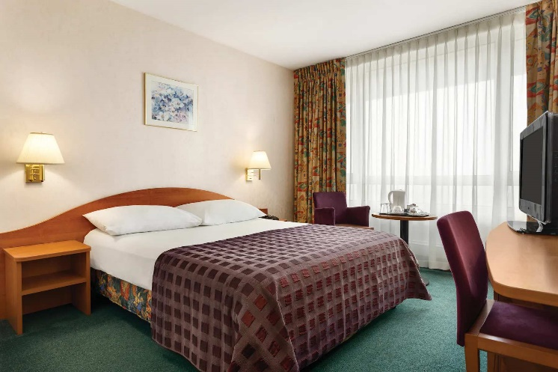 | 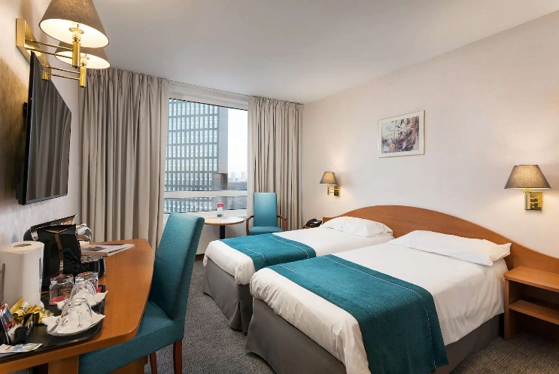
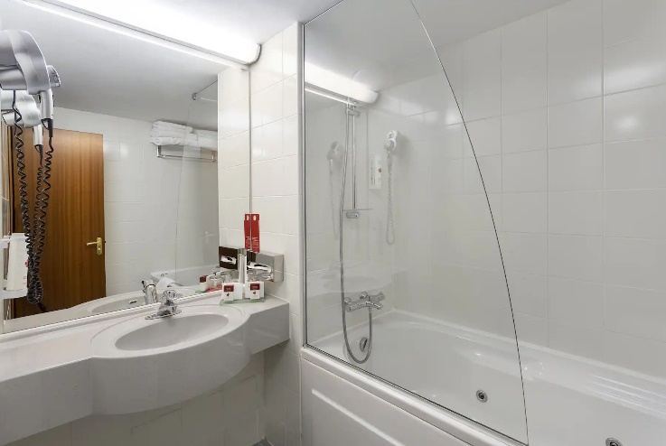 | 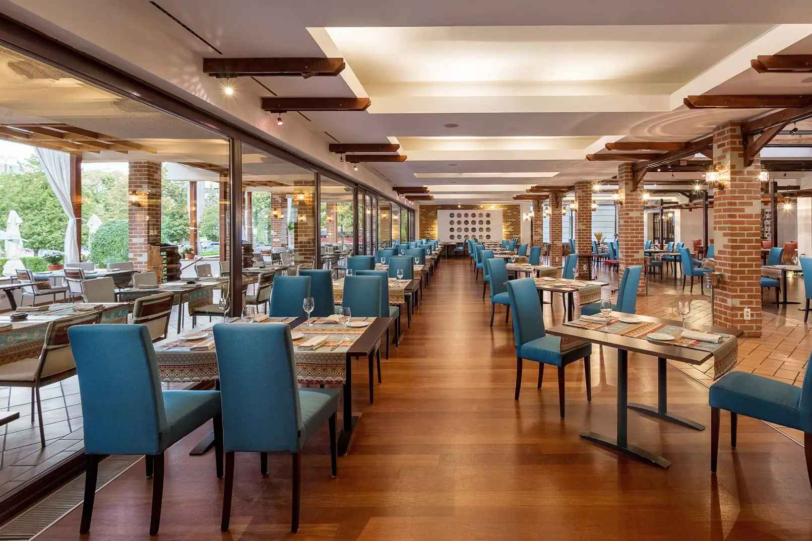

4*
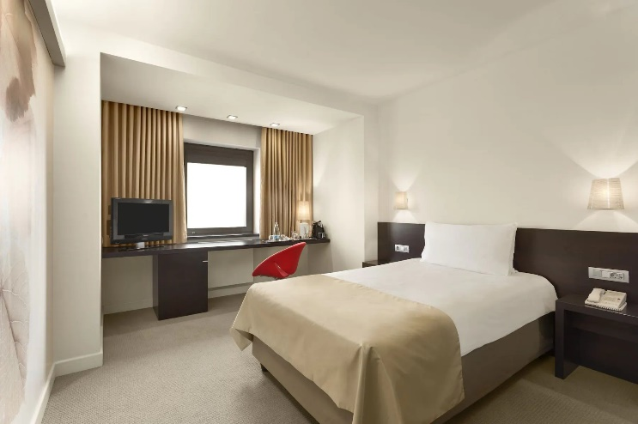 | 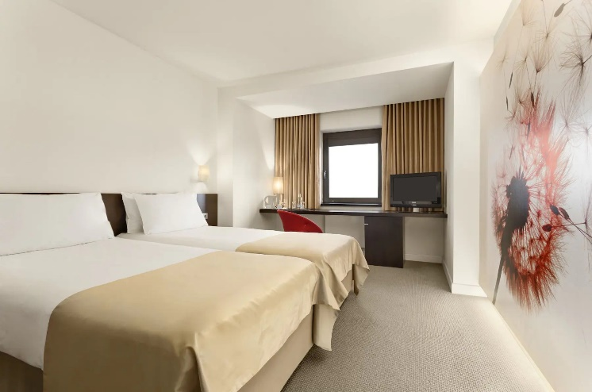
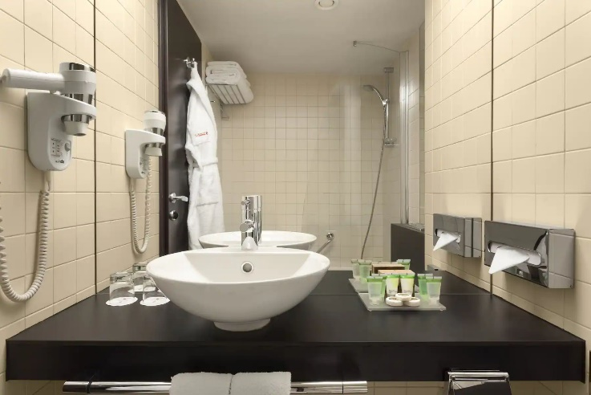 | 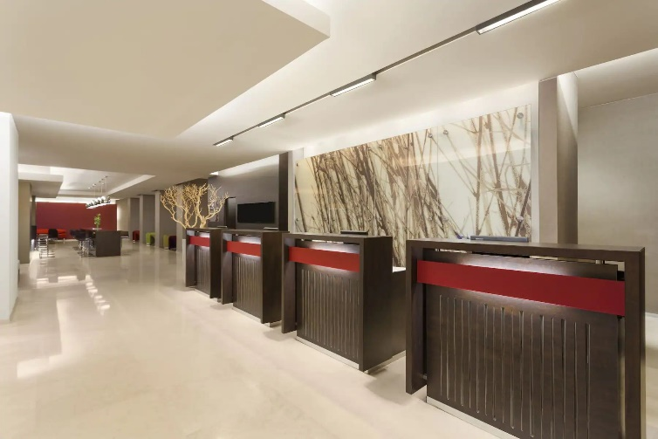
Rooms are allocated on a first come, first serve basis. Accommodation includes breakfast, lunch and dinner. Lunch and dinner will be served at the hotel.
Teams who do not reserve their accommodation through the organizing committee will be charged 300 EUR entry fee per athlete and per official.

In addition, the LOC will not be responsible to provide any event information at non-official hotels and will not provide transportation to the venues.

TRANSPORTATION
Transportation will be provided from Bucharest (OTOPENI) International Airport to the official hotel, from two days before the official practice day and until one day after the closing day at 30 EUR (round trip) price per athlete and per official. Local transport will be available between the official hotels and competition venue for free. Transport timetables will be confirmed.
The LOC will use buses, small buses, vans, and cars, what will depend on number of persons scheduled for transportation.

VISA
All participants who need an entry visa to Romania, will be required to complete the Visa Support sections in WAREOS by no later than 04 June 2022.

It is the applicants’ responsibility for supplying the necessary information, ensuring all details are up to date, correct and submitted by the deadlines specified.

In addition, all participants that require a visa are kindly requested to supply a copy of their latest/valid passport. Copies of each application can be uploaded on WAREOS. All passport copies and personal details entered/uploaded to WAREOS will be held securely and in the strictest of confidence and not shared with other parties.

PAYMENT CONDITIONS
Complete all necessary sections in WAREOS and make full payment by the specified deadlines. Bank transfers only, no credit cards will be accepted. All bank charges will be paid by the participants.

The entry fees should be paid in full before arrival.

To confirm hotels reservations, a minimum 60% deposit of the total amount is required to be bank transferred to the OC before 04 July 2022. Reservations after this date will be considered only according to availability. The final outstanding balance shall be made via bank transfer before arrival. Accommodation cannot be guaranteed after this deadline. A balanced invoice will be provided via WAREOS.

BANK INFORMATION FOR ACCOMMODATION, TRANSPORTATION AND ENTRY FEES
A/C Name: Romanian Archery Federation
Federation’s Address: Str. Vasile Conta, Nr. 16, Sector 2
Telephone number: +40 723 375 275
City and Country: Bucharest, Romania
Zip Code: 020951
Bank: Banca Comerciala Romana
Account Number IBAN: RO46 RNCB 0090 0005 0853 0017
Swift: RNCBROBU
Bank’s address: Str. Lipscani Nr. 18-20, Sector 2
Bank’s Phone: +40 214 074 200
City: Bucharest, Romania

NOTE: ALL PAYMENTS SHALL BE MADE IN EUR.

- NO CREDIT CARDS
- NO TRAVEL CHECKS

IN CASE YOU OF PAYMENT IN CASH ON ARRIVAL, THEN IT WILL BE CHARGED EXTRA 1% OF THE DEPOSIT AS THE BANK PROCESSING COST.

PLEASE SEND THE COPY OF THE BANK TRANSFER TO THE ORGANIZER by email to:
oc-bucharest@frta.ro

CANCELLATIONS & CHANGES
All cancellations and changes must be made through WAREOS:

- Should flight arrival details change last minute, please contact the Organizing Committee using the details indicated in the team managers’ booklet.
- If a participant’s arrival is later than the original scheduled arrival date, the room will be charged from the date of the original booking in WAREOS.
- An email will automatically notify the Organizing Committee and Member Association of any changes made in WAREOS.

HEALTH REGULATIONS (COVID-19)
INFORMATION
- Everybody should follow the Government/public health authorities measures (national and sport-specific regulations) and be aware of the travel restrictions
- For your information, medical infrastructure/Hospital with proper care will be reachable within 700 m from the venue.
- The COVID-19 PCR tests can be done at the official Hotel on departure.
  - The price for PCR test is 60 EUR.

Medical emergency contact and location
Spital Universitar de Urgenta Elias, Bulevardul Mărăști 17, București 011461
Phone: +40 021 316 1600

ADDITIONAL INFORMATION

Training
A training field will be available starting on 24 July 2022 right nearby of the National Rugby Stadium ‘Arcul de Triumf’ located approximately 10 minutes from the official hotels. There will be an additional payment of EUR 15 per person, per day for transport between the practice venue and hotels from July 24 to July 30.
Practice Field GPS coordinates: Latitude: 44.46885585457669 | Longitude: 26.076092072722282

Weather
The Bucharest’s temperatures in July are expected to range between 25 and 32 degrees Celsius. The average in the last few years has been 28 degrees Celsius.

ACCREDITATION AND TEAM MANAGERS MEETING
Accreditation will take place upon arrival of teams in the lobby of the Ramada Hotel on 24 of July 2022.
Accreditation office will be open on Sunday 24 of July from 08:00 - 21:00.
Accreditation cards will be possible to issue from Monday 25 of July on the competition venue only with the additional payment of 50 € per person.

Media Registration
Media representatives can apply for registration by emailing at marketing@frta.ro

Internet
The internet will be available in the official hotels for free (in hotel rooms and in the lobby).
There will also be Wi-Fi available for access to results on venue.

Water
There are water dispensers will be available at the qualification and practice venues.
Each participant with receive clean refillable water container.

DISCO PARTY*
On the final day - Saturday, 30 July 2022, after the dinner the Disco party will be organized with the cost of 15 euro / person, if possible due to the special requirements due to Covid-19.
The drinks and cakes are included in the cost for Disco party.
The Disco party payment has to be paid during accreditation.

LOC CONTACT

Name: Cristian Mocanu
Address: CSN Sala Polivalenta, Calea Piscului 10, I.9, Bucharest, Romania
Email: oc-bucharest@frta.ro
Language: English
Phone number: +40 723 375 275
INFORMATION ABOUT BUCHAREST

Bucharest is the primary entry point into Romania. Bucharest is a booming city with many large infrastructure projects changing the old face of the city. Known in the past as "The Little Paris," Bucharest has changed a lot lately, and today it has become a very interesting mix of old and new that has little to do with its initial reputation.

Finding a 300-year-old church near a steel-and-glass building that both sit next to a communist style building is commonplace in Bucharest. Bucharest offers some excellent attractions, and has, in recent years, cultivated a sophisticated, trendy, and modern sensibility that many have come to expect from a European capital.
Those who knew Bucharest in the past but have not visited it after 2010 will be surprised by the scale of the changes that are taking place. Ambitious projects are quite common in Bucharest.

The largest project finished at this time is the impressive Basarab Bridge, which is Europe's widest cable-stayed bridge.

Looking forward to welcoming you in Bucharest, Romania.

