EUROPEAN INDOOR CHAMPIONSHIPS
INVITATION PACKAGE
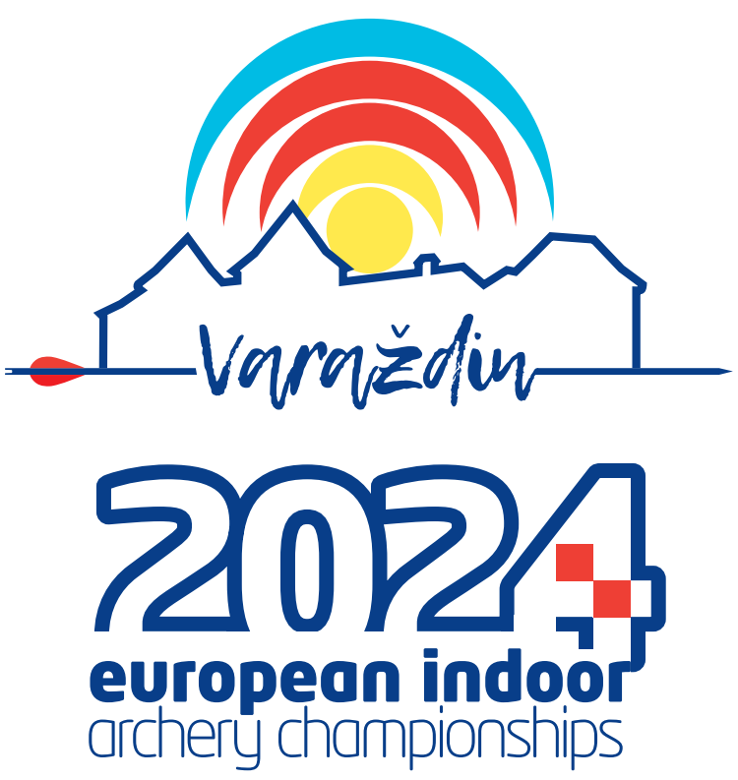

To all World Archery and World Archery Europe Member Associations

Dear President, Secretary General,

On behalf of the Local Organizing Committee I would like to invite your country to the European Indoor Championships 2024, which will be held from 19-24 February 2024, in Varazdin, Croatia.

This event will be organized following the WA and WAE Rules, Recurve, Compound and Bare bow divisions in the Indoor Target Archery discipline.

Please, find enclosed the necessary documents concerning the registration, organization, and participation in this event. To register participation complete all the necessary sections in WAREOS within the deadlines.

We are looking forward to welcoming you and your teams to Varazdin, Croatia.
Sincerely yours,

Darko Uidl
Organizing Committee
President
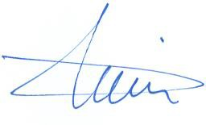

IMPORTANT DATES

To register participation, please complete all the necessary sections in WAREOS (https://extranet.worldarchery.sport) within the deadlines listed below.

Please respect the stated deadlines.

Summary of deadlines:

Registration Opening date on WAREOS 5 October 2023

Preliminary Entries 20 November 2023

Final Entries 30 January 2024

Preliminary Hotel reservation
& Transportation 15 November 2023

Final Hotel reservation 5 January 2024

60% Hotel deposit 5 January 2024

Remaining Hotel payments 15 January 2024

Hotel Cancelation 100% 15 November 2023

Hotel Cancelation 50% 15 December 2023

Final Transportation 15 January 2024

Visa Support 15 November 2023

Full refund cancellation deadline* 15 December 2023

*After this deadline, the LOC is allowed to retain all amounts due by the Member Association.

PRELIMINARY PROGRAMME

Day |  | Date | Description
Sunday | 18 Feb |  | Arrival of Participants  Practice Available
Monday | 19 Feb |  | Official Practice & Equipment Inspection  Team Managers' Meeting
Tuesday | 20 Feb |  | Qualification Round  (Practice Available)
Wednesday | 21 Feb |  | Individual Matches
Thursday | 22 Feb |  | Individual &Team Matches
Friday | 23 Feb |  | AM Team Matches  PM Team Finals & Award Ceremony
Saturday | 24 Feb |  | Individual Finals & Award Ceremony  Closing
Sunday | 25 Feb |  | Departure of Teams

NOTE
This preliminary programme is subject to change according to participation and media requirements. All changes will be published and distributed in good time.
Website: http://www.archeryeurope.org

PRELIMINARY & FINAL REGISTRATION

All entries, accommodation reservations, transport needs, flight arrival/departure information and visa invitation letter requests are to be completed using the World Archery Online Registration System WAREOS. These systems now handle the entire registration process for this event. No entry forms, hotel reservations or transportation forms will be accepted.
Member associations can login to WAREOS at http://extranet.worldarchery.sport with the username and password assigned by World Archery. After entering WAREOS, selecting the event from the list will allow a member association to register their athletes. Select/press the “Entries” button to see the list of categories in the event. Select/press the “category” to enter the athlete and official numbers/details participating for that event. A WAREOS User Manual can be downloaded in PDF format (English) upon login.
Contact wareos@archery.sport with any questions regarding technical problems on WAREOS. For any question regarding the organisation of the event (transport, accommodation, meals etc.) please directly contact the LOC.

A maximum number of three (3) athletes per country can be registered in each event category.

Start date for online registration using WAREOS: 5 October 2023
End of Preliminary Registration using WAREOS 20 November 2023
End of Final registration using WAREOS: 30 January 2024

Please respect the stated deadlines.

Member Associations should only use WAREOS to make any changes/amendments to their entries and will be able to do so at any time. Any changes made in WAREOS an email will instantly be automatically sent to the Local Organizing Committee and Member Association with the updated information.

NOTE
Member Associations that have penalty fees outstanding from earlier events will need to pay these penalty fees and get good standing before being eligible to enter and compete.
Also, World Archery fee must have been paid prior the participation.
Please respect the stated deadlines.
However, any changes that are made after the deadlines specified or if entries differ by more than 4 participants from the preliminary entries, the following penalty fees will automatically be applied:
Penalty fees to be paid to OC | Cost
Penalty fee for late entries (after the final deadline) | 50 € per entry
Penalty fee for not filling Preliminary entries | 150 € per entry
Penalty fee for differences between preliminary and final entries: | 150 € per entry

Any entries received less than three (3) days before the Team managers meeting will be refused if no preliminary entry and/or final entry are made prior.
ACCOMMODATION & GENERAL INFORMATION

Important Note
Non-official accommodation is not allowed. Any team or individual accommodated in non-official hotel will not be accredited and participation in the event will be refused.

Rooms are allocated on a 'first come-first serve' basis. Accommodation includes breakfast and dinner with water - half board meal packages.

Lunch will be served at the archery venue Hall Arena Varazdin. Price for lunch is
16 € per person

The official hotels are divided in two categories: Standard and Comfort.

Reservations should be made before 15 November 2023
Final Hotel Reservation 5 January 2024

To confirm your hotel reservations, 60% deposit of the total amount is to be paid by a bank transfer to the Organizing Committee before 5 January 2024. Reservations received after this date will be considered only according to availability.

Standard Hotels ***

Hotel Varazdin***

Varazdin Hotel opened in August 2007. Thanks to the good location, and primarily high-level services, developed into a distinctive hotel in our region. It is located near the city center, near the railway station. Thirty modern and elegantly furnished rooms provide an atmosphere of pleasant environment which guarantees quality vacation all that is required to be ready for new challenges and everyday obligations. Special privileges such as free high speed internet access, climatized all rooms with the possibility of individual control, parking places for guests, Hotel is the perfect choice for business people, but every passenger who wants to enjoy the sights of our beautiful city. The unique atmosphere, professional and friendly staff will fulfill all expectations to stay in our hotel unforgettable.
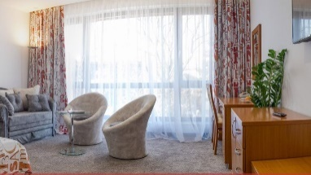
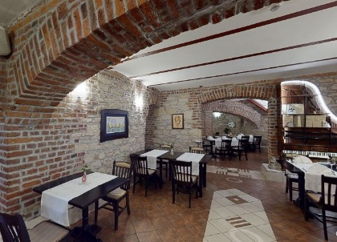
Half board (dinner at the hotel)
Single Room price 187 €
Number of rooms 5
Double/Twin 352 € / room
Number of rooms 14

Distance from FoP Arena Varazdin – 5 km/10 min
Hotel Amalia***

Hotel Amalia is located in Ludbreg, the very center of the world, and offers free WiFi in all rooms. The facility includes a bar and free private parking.
All rooms have a private bathroom with a bath or shower, and some include a seating area. The facility offers room service and a restaurant.

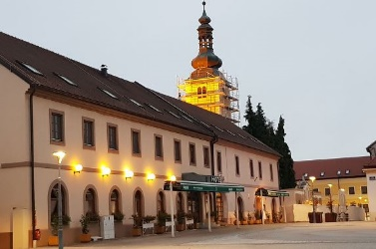
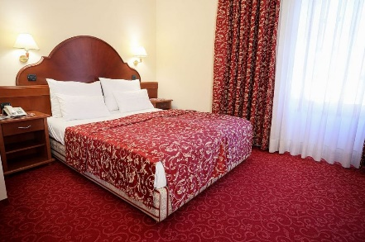
Half board (dinner at the hotel)
Single Room price 187 €
Number of rooms 10
Double/Twin 352 € / room
Number of rooms 40

Distance from FoP Arena Varazdin – 25 km/25 min

Hotel Kralj***

Hotel Kralj is located in the north of Croatia, in Medjimurje, at the entrance to Donji Kraljevec. It is located only 2 km from Prelog, 10 km from Cakovec, 25 km from Varazdin, 100 km from Zagreb.
The close proximity of Hungary, Slovenia, and Austria, as well as good traffic connections, allows guests quick communication and easy access to all the facilities and sights found in this part of the Republic of Croatia, as well as Europe.

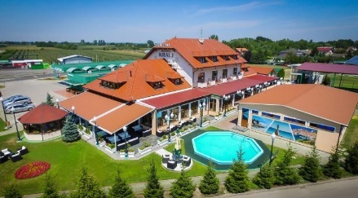
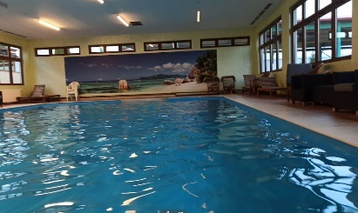
Half board (dinner at the hotel)
Single Room price 187 €
Number of rooms 18
Double/Twin 352 € / room
Number of rooms 7

Distance from FoP Arena Varazdin – 27 km/27 min

Comfort Hotels ****

Hotel Turist****+

Since its opening in 1964, through the expansion in 1978. year, until a thorough renovation and redesign in 2021. Hotel Turist became and remained an unavoidable part of life in Varazdin.
It created the most beautiful memories of generations of locals, but also visitors and members of the hotel team. Although the hotel has changed its color palette and decoration over the years, one thing has remained the same – Hotel Turist is still a popular meeting place for people from Varazdin, a place where locals and visitors negotiate business or relax in the company of loved ones, while enjoying delicious food and drinks.
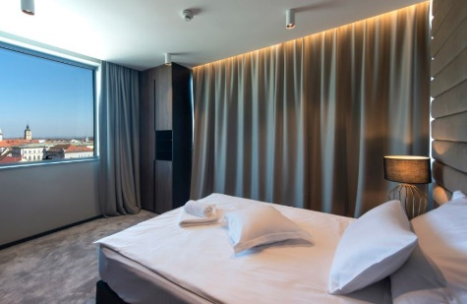
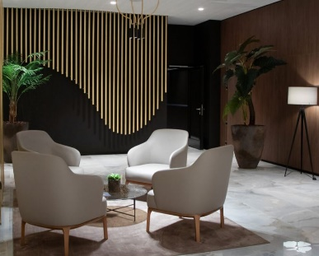
Half board (dinner at the hotel)
Single Room price 199 €
Number of rooms 8
Double/Twin 378 € / room
Number of rooms 30

Distance from FoP Arena Varazdin – 4 km/12 min

Hotel Panorama****

At Panorama hotel you’ll find a relaxing oasis with a Finnish sauna and Turkish bath which are going to provide you with much needed relaxation after a strenuous training. The unique sports – recreational centre offers a myriad of possibilities for athletes and people who feel the same. Interior courts, i.e. the sports hall of an interesting and attractive construction, is sized at two handball courts.
It’s suitable for futsal, basketball, badminton, volleyball, handball, table tennis and martial arts. We offer different options of sports in the fresh air on exterior courts that encompass three tennis courts, an artifical turf soccer court and a sand volleyball court.

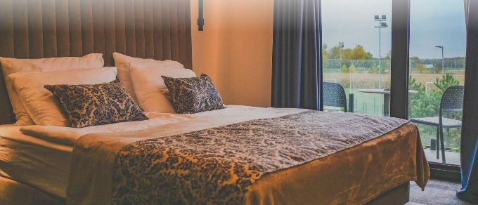
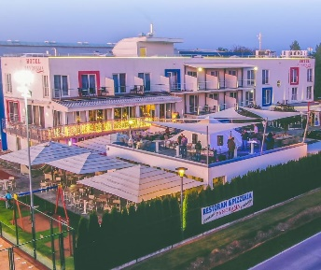
Half board (dinner at the hotel)
Single Room price 199 €
Number of rooms 14
Double/Twin 378 € / room
Number of rooms 33

Distance from FoP Arena Varazdin – 22 km/22 min

Important Note

Refer to the accommodation pages for detailed hotel information.
Please complete all the necessary sections in WAREOS and make full payment for entries, transport, and accommodation by the specified deadlines.

ENTRY FEE
Individuals 200 € per Athlete
Officials 100 € per Person
Teams 125 € per Team
There is no entry fee for Mix teams.

Temporary Upgrade: 30 € per accreditation (for athletes wishing to be a coach temporarily).
Entry fees include daily local transport to and from the FOP to/from official hotels during the qualification, elimination, and finals (timetable to be confirmed on site).
All participants should book their accommodation through the LOC.

PAYMENT CONDITIONS

All fees should be paid in full before arrival.

Payment of accommodation and local transportation: a minimum deposit of 60% of the total amount owed should be made when booking by 5 January 2024.
The final outstanding balance shall be transferred before 15 January 2024. Accommodation cannot be guaranteed after this deadline. A balance invoice will be provided via WAREOS.
Entry fee should be paid by 30 January 2024 separately than Accommodation & Transportation due to Croatian Tax policy.

Bank information for ACCOMMODATION & TRANSPORTATION

BANK RAIFFEISEN BANK AUSTRIA d.d.
ACCOUNT HOLDER NAME UNILINE d.o.o.
ADRESS BOZE GUMPCA 38, 52100 PULA
ACCOUNT NO HR3124840081100646084
BIC/SWIFT CODE RZBHHR2X

Bank information for ENTRY FEES

BANK PRIVREDNA BANKA ZAGREB d.d.
ACCOUNT HOLDER NAME HRVATSKI STRELICARSKI SAVEZ
ADDRESS HRVATSKOG PROLJECA 34, 10040 ZAGREB
ACCOUNT NO HR6623400091110039202
BIC/SWIFT CODE PBZGHR2X
NOTE: All payments shall be made in EUR only by BANK TRANSFER.
Bank transfer fees are responsible on the sender.
Credit cards and Travel checks will not be accepted.

CANCELLATIONS & CHANGES
- All cancellations and changes must be made through WAREOS:
- Cancellations received before 15 December 2023 a full refund of the deposit payment will be made.
- Cancellations received after 15 December 2023 no refund will be given.
- Refunds will be processed after the event.
- Name changes to team officials or athletes (same category and division) will be accepted up to 72 hours before the event without any additional charge.
- Should flight arrival details change last minute, please contact the Organizing Committee using the details indicated in the Team Managers’ Booklet.
- If a participant’s arrival is later than the original scheduled arrival date, the room charges will start from the dates of the original booking made by the Member Association.

ADDITIONAL INFORMATION

Transport:

Local transport to Varazdin from the Zagreb airport is rare, so we advise you to book the private transfer options below. Price is per person one way.

Transfer to / from Varazdin | One passenger | Two and more passengers
Zagreb Airport | 170 € | 140 €

For transfers from airports in Slovenia and Hungary, please contact us at WAE.IC2024@uniline.hr

Group transfer with bus – fixed time departure - one way
If you choose group transfer, you will have to adapt to all other passengers and wait for the departure time.
Minimum of 20 passengers to confirm the transfer departure. Organizer can cancel the transfer if there will not be 20 or more passengers booked per transfer.

Internet
Free WiFi will be available in the official hotels (in the rooms and in the lobby).

Meals
The lunch is foreseen to be served at Hall Arena Varazdin. Price for lunch is 16 €.

Water
Water will be available at the venues free of charge.

Media Registration
Media representatives can apply for registration by emailing archery@archery.hr

Weather
Monthly Averages in February - Varazdin
Min Temperature -3°C Max Temperature 13°C Sunshine Hours 103
Snowy Days 5 Precipitation 46 mm Rainy Days 6

Dress regulations
WA & WAE dress regulations do apply.

Opening & Closing Party
Opening – simple ceremony before Qualification round, 20 February.
Banquet or closing party will not be organized.

VISA SUPPORT

All participants who need an entry visa to Croatia, will be required to complete the Visa Support Form in WAREOS no later than 15 November 2023.

It is the applicants’ responsibility for supplying the necessary information, ensuring all details are up to date, correct and submitted by the deadlines specified.
In addition, all participants that require a visa are kindly requested to supply a copy of their latest/valid passport. Copies of each application can be uploaded on WAREOS. All passport copies and personal details entered/uploaded to WAREOS will be held securely and in the strictest of confidence and will not be shared with other parties.
Please note that the Organizing Committee can provide invitation for the period of the European Indoor Championships.

LOC CONTACT

President of Organizing Committee Darko Uidl
General Secretary - Entry Fee Kresimir Cadez
Email archery@archery.hr
Phone +385 91 4343 463
English and Croatian

Transport, Accommodation Hrvoje Mijic
Email WAE.IC2024@uniline.hr
Phone +385 99 4696 283
Language English and Croatian

Event manager Damir Kolarek

Official website http://waeic2024.org

Looking forward to welcoming you in Varazdin, Croatia.

