TO ALL World Archery Member Associations,
Dear President,

As Chair of the Local Organising Committee (LOC) of the 2023 WAO Para Grand Prix to be held in Melbourne, Australia from the 26th JANUARY 2023, I would like to invite you all to be part in this inaugural archery event to take place in the Oceania in 2023.

Waverley Archery Club – Mulgrave is well located 30 minutes from Melbourne’s CBD with accommodation only 5 minutes from the field of play.

We welcome any other member associations affiliated with World Archery who would like to attend this tournament

The 2023 WAO Para Grand Prix will be hosted in conjunction with the Archery Australia 2023 National Para and VI Target Championships which all visitors are welcome to participate in.

Following is information regarding the events along with accommodation options etc.

If you have any questions regarding this tournament, please don’t hesitate in contacting the LOC via the details below

Sincerely yours,

Hazel Hockley
President Waverley Archery Club

IMPORTANT DATES

Please find enclosed detailed information regarding this event. To register participation, please complete all the necessary sections in WAREOS (https://extranet.worldarchery.sport) within the deadlines listed below.

Summary of deadlines:

Registration Opening date on WAREOS | 24th December 2022
Preliminary Entries | 24th December 2022
Final Entries | 7th January 2023
Late entries fee | $50 AUD
Hotel reservation down-payment (50%) | 7th January 2023
Hotel reservation and payment | 20th January 2023
Transportation | 20th January 2023
Visa support | 10th January 2023
Full refund cancellation deadline  *After this deadline, the LOC is allowed to retain all amounts due by the Member Association. | 10th January 2023

Please respect the stated deadlines.

PRELIMINARY PROGRAMME 18 TARGETS
25th January 2023  Wednesday | Arrival of participants
26th January 2023  Thursday  27th January 2023  Friday  28th January 2023  Saturday | Classifications and unofficial practice  Official Practice (Equipment Inspection)  Qualification Round (W1, Para Open Recurve and Compound)
Individual Eliminations (1/16, 1/8, 1/4)
(W1, Para Open Compound and Recurve)

30th January 2023  Monday | Pairs matches  (Compound, Recurve)  Finals (W1, Para Open, Compound, Recurve and Pairs)  Award ceremonies (Compound, Recurve)
31st January 2023  Tuesday | Departure of teams

NOTE: This preliminary programme is subject to change according to participation and TV requirements. All changes will be published and distributed in good time.

PRELIMINARY & FINAL REGISTRATION
All entries, accommodation reservations, transport needs, flight arrival/departure information and visa invitation letter requests are to be completed using the World Archery Online Registration System WAREOS https://extranet.worldarchery.sport. This system handles the entire registration process for this event. No entry forms, hotel reservations or transportation forms will be accepted; all information must be entered into WAREOS.

Member associations can login to WAREOS at http://extranet.worldarchery.sport with the username and password assigned by World Archery. After entering WAREOS, selecting the event from the list will allow a member association to register their athletes. Select/press the “Entries” button to see the list of categories in the event. Select/press the “category” to enter the athlete and official numbers/details participating for that event. A WAREOS User Manual can be downloaded in PDF format (English) upon login.

Contact wareos@archery.sport with any questions regarding technical problems on WAREOS. For any question regarding the organisation of the event (transport, accommodation, meals, invoices, visa etc.) please contact directly the LOC.

Athletes from a minimum of 4 different Member Associations shall be registered and participate in the event.

There is no limit to the number of athletes per country can be registered into each category and divisions of the event.

Member Associations can only use WAREOS to make any changes or amendments to entries and will be able to do so at any time. An email will automatically notify the Organising Committee and Member Association of any changes made in WAREOS.

ENTRY FEES

Individual $250 AUD per athlete
Official $230 AUD per person
Teams NA
International License 100 CHF per participant per calendar year to be paid to World Archery

ENTRY FEES IN NON-OFFICIAL HOTELS

Individual $250 AUD per athlete
Official $230 AUD per person
Teams NA
International License 100 CHF per participant per calendar year to be paid to World Archery

Entry fees for individual/Official/Teams include airport transfer to hotels, daily local transport to and from the practice field to/from official hotels during the qualification, elimination and finals venues (timetable to be confirmed on site).

Any changes made after the deadlines specified or if entries differ by more than 4 athletes from the preliminary entries, the following penalty fees to will automatically be applied:

PENALTY FEES TO BE PAID TO ORGANISING COMMITTEE

Penalty fees for Late Entries (after final deadline): | 50 per entry
Penalty fees for not filling Preliminary entries | NA
Penalty fee for differences between preliminary and final entries: | NA

ACCOMMODATION

Waverley International Hotel
- Single Room price: AUD 155.00 per room
- Number of rooms: 10
- Double/Twin Room price: AUD 228.00 per room
- Number of rooms: 10
- Board plan: breakfast, half board
- Check-in from 25/01/2023 10am
- Late check-out AUD 110
- Hotel website: www.waverleymelbourne.com/glen-waverley-deals.php
- 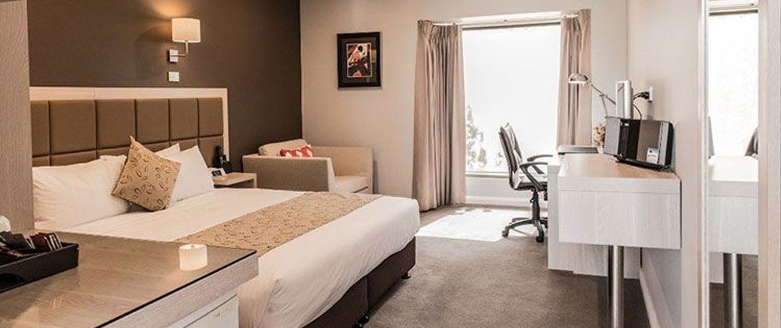
Rooms are allocated on a first come, first serve basis. Accommodation includes breakfast and lunch with non-alcoholic drinks. Lunch will always be served at the archery venue, dinner is available at many local restaurants
In addition, the LOC will be responsible to provide any event information at this hotel and provide transportation to the venues. Private vehicles can be used too.

TRANSPORTATION
Transportation will be provided from Melbourne Tullamarine airport to the official hotel, from two days before the official practice day and until two days after the closing day at $60 each way. Local transport will be available between the official hotel, practice and competition venues is free for the duration of the tournament. Transport timetables will be confirmed.

VISA
All participants who need an entry visa to Country, will be required to complete the Visa Support sections in WAREOS by no later than 10/01/2023.

It is the applicants’ responsibility for supplying the necessary information, ensuring all details are up to date, correct and submitted by the deadlines specified.

In addition, all participants that require a visa are kindly requested to supply a copy of their latest/valid passport. Copies of each application can be uploaded on WAREOS. All passport copies and personal details entered/uploaded to WAREOS will be held securely and in the strictest of confidence and not shared with other parties.

PAYMENT CONDITIONS
Complete all necessary sections in WAREOS and make full payment by the specified deadlines. Bank transfers only, no credit cards will be accepted. All bank charges will be paid by the participants.

The entry fees and accommodation should be paid in full before arrival.

To confirm hotels reservations, a minimum 50% deposit of the total amount is required to be bank transferred to the OC before 10/01/2023. Reservations after this date will be considered only according to availability. The final outstanding balance shall be made via bank transfer before arrival. Accommodation cannot be guaranteed after this deadline. A balanced invoice will be provided via WAREOS.

BANK INFORMATION FOR ACCOMMODATION, TRANSPORTATION AND ENTRY FEES
A/C Name: Archery Australia
Federation’s Address: PO Box 32, Sydney Markets NSW 2129
Telephone number: +61 2 9772 2995
City and Country: Sydney, Australia
Bank: Commonwealth Bank Australia
Account Number: 222210257553
Swift: TBC
Bank’s address: Simmons St Revesby NSW 2212
Bank’s Phone: +61 131198
City: Sydney Australia

NOTE: ALL PAYMENTS SHALL BE MADE IN AUD $.

CANCELLATIONS & CHANGES
All cancellations and changes must be made through WAREOS:

- Should flight arrival details change last minute, please contact the Organising Committee using the details indicated in the team managers’ booklet.
- If a participant’s arrival is later than the original scheduled arrival date, the room will be charged from the date of the original booking in WAREOS.
- An email will automatically notify the Organising Committee and Member Association of any changes made in WAREOS.

HEALTH REGULATIONS (COVID-19)
INFORMATION
- Everybody should follow the Government/public health authorities measures (national and sport-specific regulations) and be aware of the travel restrictions
- For your information, Medical infrastructure/Hospital with proper care will be reachable within 15 minutes from the venue, where COVID-19 test can be done.
Medical emergency contact and location
Peter James Centre (Public Hospital)
Cnr Mahoneys Road and Burwood Highway, Burwood east, VIC 3151
+61 3 9881 1888

ADDITIONAL INFORMATION

Weather
Weather this time of year can be hot with temperatures between 25 – 33 degrees C. Appropriate clothing and sunscreen is advisable.

Internet
Will be available in the official hotels for free (in hotel rooms and in the lobby). There will also be Wi-Fi available for access to results on venue.

Water
Each participant with receive clean bottles of water.
Bottled water will be available at the qualification and practice venues.
A water fountain system will be used.

LOC CONTACT

Name: Hazel Hockley
Email: president@waverleycityarchers.org.au
Language: English
Phone number with international extension: +61 412 224 242

Looking forward to welcoming you in Melbourne, Australia

