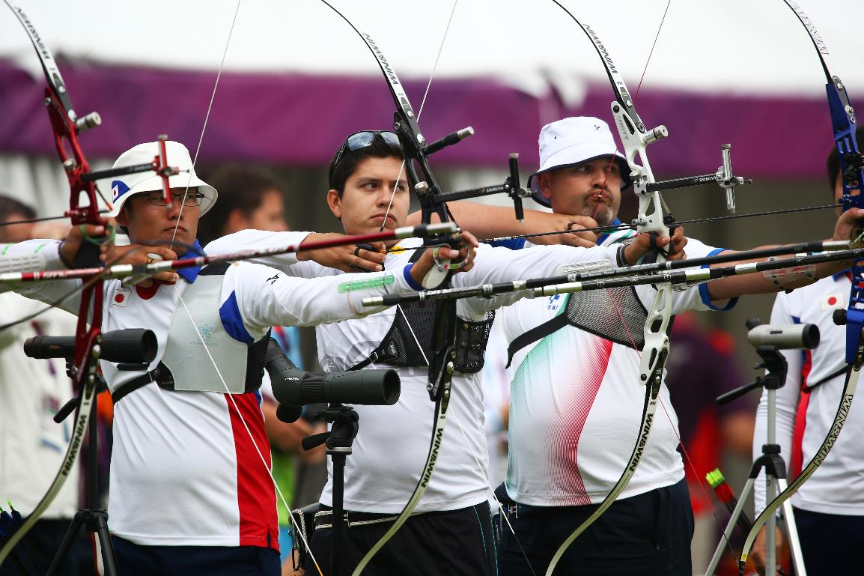

**Test Event Information**

(June/2015)

**TO ALL World Archery MEMBER ASSOCIATIONS**

Dear President,

The Rio 2016 team is pleased to announce that the Archery Test Event – Aquece Rio International Archery Challenge is scheduled for September 15th – 22th 2015. This event, organised by Rio 2016, is part of the Rio 2016 Test Events Programme and is a great opportunity for the Nations to test the Field of Play and get the atmosphere of the Games.

We would like to invite your National Federation to participate in our event. The Aquece Rio International Archery Challenge will be organised in accordance with World Archery rules. This event has been awarded World Ranking and World Record status, taking place at the same venue that will host the Rio 2016 Olympic and Paralympic Games Archery competition: the Sambodromo.

We are looking forward to welcoming you and your teams, to Rio de Janeiro – Brazil.

Sincerely,

Rio 2016 Sport Department

1. COMPETITION INFORMATION
   1. Event information

|  |  |
| --- | --- |
| Name of the Event | Aquece Rio International Archery Challenge |
| Sport Events | Women & Men (3 Paralympic athletes per gender) |
| Venue | Sambodromo |
| Location | Maracanã |
| Competition Dates | 15 - 22 September 2015 |
| Training Dates | 15 September 2015 |
| Entry Fees | No |
| Ticketed Event | No – 500 spectators will receive complimentary tickets for the weekend |

Training:

The training field will be in the same place that will have the Ranking Round, and will be available for training just in the morning from 15 September 2015 and after the Ranking Round, every day from 16 September 2015 until the last day of competition. The training field is walking distance to the competition field, approximately 100 meters.

Weather:

**September (Average):**

Temperature 23o C

Low Temperature 19o C

High Temperature 26o C

Sunshine Hours- 7 Hours

Rainfall days- 13 days

Ceremonies:

There are no opening or closing ceremonies planned.

Medals ceremonies will be on the Competition Venue in the following days:

Sep, 19th – Women’s Team

Sep, 20th – Men’s Team

Sep, 21st – Women’s Individual

Sep, 22nd - Men’s Individual

* 1. Provisional SCHEDULE

This preliminary programme is subject to change, based on the number of participants. All changes will be communicated to the teams accordingly.

|  |  |
| --- | --- |
| Date | Activity |
| 14/09/2015 | Official arrivals day |
| 15/09/2015 | Official practice and equipment inspection  Team captains’ meeting  Ranking Round |
| 16/09/2015 | Men’s and Women’s Individual: 1/32nd and 1/16th Eliminations |
| 17/09/2015 | Men’s and Women’s Individual: 1/32nd and 1/16th Eliminations |
| 18/09/2015 | Men’s and Women’s Individual: 1/32nd and 1/16th Eliminations |
| 19/09/2015 | Women’s Team: Eliminations to Gold Medal Match |
| 20/09/2015 | Men’s Team: Eliminations to Gold Medal Match |
| 21/09/2015 | Women’s Individual: 1/8th Eliminations to Gold Medal Match |
| 22/09/2015 | Men’s Individual: 1/8th Eliminations to Gold Medal Match |
| From 23/09/2015 | Teams Departure |

* 1. registration process

The Aquece Rio International Archery Challenge is an invitational tournament organized to receive the participation of 64 male athletes (61 Olympic and 3 Paralympic) and 64 female athletes (61 Olympic and 3 Paralympic). Paralympic athletes will compete in the same conditions as the Olympic athletes.

PRELIMINARY & FINAL REGISTRATION

All registration process must be completed using the World Archery Online Registration System (WAREOS, formerly FORS): http://register.worldarchery.org. No entry forms will be accepted for registering to this event.

A maximum number of **3 athletes per country** (host country included) are allowed to be registered into each category of the event. Preliminary entries have to be completed using the WAREOS.

In order to use WAREOS, please login on [http://register.worldarchery.org](http://register.worldarchery.org/) with your Username and Password assigned by World Archery. After entering the WAREOS, please go to "Online Registration" and register your athletes for this event. A "WAREOS User Manual" can be downloaded in PDF format (English) using the same website link.

Start date for online registration using WAREOS **10 June 2015**

End of Preliminary registration using WAREOS: **29 June 2015**

End of Final registration using WAREOS: **25 August 2015**

Please pay attention to the stated deadlines. Teams will **not be** able to enter or update their data in WAREOS, after the deadlines, as the system will be blocked. If, teams wish to make any changes to their Final Registration, after the deadline, you need to contact WA office (Mr Jae Kyung Lee, WA Events coordinator, email: [jklee@archery.org](mailto:jklee@archery.org)).

Final Entries processed after the deadline will result in a penalty fee of 50 Euros per athlete to be paid to Rio 2016 upon arrival at the field.

Final registrations that differ by more than 4 athletes from the preliminary registration or have been submitted after the preliminary deadline will result in a penalty fee of 150 Euros to be paid to Rio 2016 upon arrival at the field.

**ACCREDITATION**

Rio 2016 will use the registration list to establish the accreditation, including Team Officials and the demand from WA.

Rio 2016 will proceed with accreditation distribution to teams on site.

1. Logistics
   1. ACCOMMODATION and transport

Accommodation and transport costs are the National Federation’s financial responsibility. The teams will organize and pay for transport (Airport-Hotel-Airport and Hotel-Venue-Hotel), accommodation and meals (lunch and/or dinner at the hotels), if required, directly with the agency. The agency will send to the teams the Hotel Reservation Form and the Transport Form.

To assist the participating national federations with accommodation/meals at the hotels and transport, Rio 2016 has appointed Alatur as the official Rio 2016 Test Events Agency. Please see below the agency contact details:

**ALATUR**

**+55 11 3217 9041 or +55 11 3217 4329.**

[test-events@alatur.com](mailto:test-events@alatur.com)

**ACCOMMODATION**

We are pleased to propose two official hotels options in the center of the city area, close to the Sambodromo:



1. Ibis Santos Dumont (<http://www.ibis.com/pt-br/hotel-5691-ibis-rio-de-janeiro-santos-dumont/index.shtml>) is 3,7 Km from Sambodromo and is able to offer full board if required.

 

1. Novotel Santos Dumont (<http://www.novotel.com/pt-br/hotel-6522-novotel-rio-de-janeiro-santos-dumont/index.shtml>) next to the Ibis, and also able to offer full board. 

* The hotels are adjacent to each other and use the same drop-off and pick-up point for the official transport.
* Accessible rooms will be available in both hotels for Paralympic athletes.
* Each meal requested will include a main course (a la carte or hot buffet) and soft drink.

|  |  |  |  |
| --- | --- | --- | --- |
| Hotels  (Prices in Reais) | Single Room (one person) | Twin Room (two people) | Price per Meal (lunch and dinner) |
| IBIS SANTOS DUMONT | R$ 275,00 | R$ 295,00 | R$ 55,00 |
| NOVOTEL SANTOS DUMONT | R$ 460,00 | R$ 480,00 | R$ 80,00 |

* Below the proposed prices for the official hotels and meals:

**PAYMENT POLICY FOR ACCOMMODATION**

The 25% deposit of the total amount for hotel accommodation should be paid by 30 July 2015. The balance payment is due by 30 August 2015. Accommodation cannot be guaranteed, nor at the above quoted rates beyond this deadline. A balance invoice will be issued after payment.

**TRANSPORT**

The official Rio 2016 Test Events Agency Alatur will propose transport from/to Rio de Janeiro Airport and a Shuttle service between the Official Hotel and the Competition Venue.

Airport Transfer includes a Meet and Greet service with English-speaking coordinators at the International Airport Arrivals to personally welcome Rio 2016 clients with a specific name board and escort them to the transfer to the hotel.

**Hotel-Venue-Hotel Shuttle** includes English-speaking coordinators at the official hotel and venue to assist with boarding, advise on timings and manage the drivers.

|  |  |  |  |
| --- | --- | --- | --- |
| **SERVICE** | **ROUTE** | **VEHICLE** | **TOTAL COST (BRL) PER PERSON** |
| TRANSFER | AIRPORT/OFFICIAL HOTELS/AIRPORT | TBD – Saloon car / Van / Mini-Bus / Bus | R$ 518,00 |
| SHUTTLE | OFFICIAL HOTELS / VENUE / OFFICIAL HOTELS |

* 1. Catering

Teams are responsible for their own catering.

Arrangements (a food concession with hot buffet and a bar with snacks, sandwiches, beverages, etc) will be organised at the venue for the teams to purchase lunch.

Refreshment (water, cereal bars, fruit) for athletes will be offered free of charge by Rio 2016. There is an option to have lunch and/or dinner at the hotel (full board option), if required, when booking accommodation via Alatur.

* 1. VISA PROCESS

Rio 2016 has developed a thorough Visa Programme that will also cover those participating in all Test Events.

For all the participants that are nationals from countries who need a visa to enter Brazil (please check the page 27 of the guide available on <http://www.aquecerio.com/archery2015>), Rio 2016 will provide introduction letters that must be submitted with the visa application at the chosen Brazilian Consulate/Embassy abroad. To request an Invitation Letter, please send an email to [archery@aquecerio.com](mailto:archery@aquecerio.com) with a list of the applicants, including their full names (as per their passports), passport numbers, dates of birth, country and city where the visa will be made.

Prior to making arrangements for your travel, we recommend you check the Rio 2016 Visa and Work Permit Guide attached. In this document you will find information on which type of Visa you will need to have. You will also be able to find instructions on how to apply for your visa.

It is also important to be aware of the time frame for issuing a Visa to Brazil will depend on the country where the participant is applying. Please check the website of the chosen Brazilian Consulate or Embassy for further information on turnaround times.

1. WEBSITE

The official website of the Aquece Rio International Archery Challenge Championship is:

<http://www.aquecerio.com/archery2015>

1. CONTACT

For any questions, please contact Luiz Eduardo Almeida:

Luiz Eduardo Almeida – Rio 2016 Archery Sport Manager

[archery@aquecerio.com](mailto:archery@aquecerio.com)

This contact should be used solely by National Federations in matters relating to the Aquece Rio International Archery Challenge. In this respect, please do not hesitate to use it. Any other subject relating to the Rio 2016 Olympic or Paralympic Games must be directed through the relevant NOC/IPC contact.



**05.2014**