**INVITATION**

Dear President,

On behalf of the Organizing Committee of the HELLENIC ARCHERY FEDERATION, I would like to invite and welcome your Association to participate to the EUROPEAN YOUTH CUP 1st leg 2017, which will be held in Marathon/Greece, on April 17th- 22nd 2017.

This event is the first leg of the European Youth Cup for the year 2017 that is hosted in Greece and will be followed by the European Youth Championships in 2018, which will be the quota tournament for Europe for the Youth Olympics 2018.

The European Youth Cup 1st leg 2017 will be organized following the WORLD ARCHERY rules and WAE YOUTH CUP rules, in both divisions: Recurve and Compound, for Junior Women, Junior Men, Cadet Women and Cadet Men classes, in the discipline of Outdoor Target Archery.

Participating to this very important event, you will meet the Greek hospitality and we hope you and your delegation will also enjoy staying in the beautiful and historical place of Marathon.

Please find enclosed the necessary documents concerning the organization, registration and participation to this event.

We kindly ask you to return within the stated deadlines:

* Preliminary Entries 15 February 2017
* Preliminary Hotel Reservation Form 15 February 2017
* Visa Invitation Letter Form 15 February 2017
* Transportation Form 27 March 2017
* Final Hotel Reservation Form 27 March 2017
* Budget Form  27 March 2017
* Final Entries 27 March 2017

We are looking forward to welcoming you in Marathon!

Sincerely yours,

**Dr. Petros Synadinos**

**President**

**Hellenic Archery Federation**

**PRELIMINARY PROGRAM**

|  |  |  |  |
| --- | --- | --- | --- |
| **Saturday**  **15 April** | Arrival of participants.  *(Practice Field open)* |  | |
|  |  |  | |
| **Sunday**  **16 April** | Arrival of participants.  *(Practice Field open)* |  | |
|  |  | | |
| **Day 1**  **Monday**  **17 April** | Official practice, Equipment Inspection  Team Managers’ Meeting  Opening Ceremony | | |
|  |  |  | |
| **Day 2**  **Tuesday**  **18 April** | Qualification Round CADETS  Qualification Round JUNIORS  *(Practice Field open)* | | |
|  |  |  | |
| **Day 3**  **Wednesday**  **19 April** | Mixed Teams Elimination Rounds *(Practice Field open)*  Mixed Teams Finals & Medal Matches *(Practice Field open)*  Award Ceremony | | |
|  |  | |  |
| **Day 4**  **Thursday**  **20 April** | Individual Elimination Rounds up to Semi Finals *(Practice Field open)* | |  |
|  |  | | |
| **Day 5**  **Friday**  **21 April** | Teams Elimination Rounds *(Practice Field open)*  Teams Finals & Medal Matches *(Practice Field open)*  Award Ceremony | | |
|  |  |  | |
| **Day 6**  **Saturday**  **22 April** | Individual Bronze & Gold Medal Matches (alternate shooting)  Award Ceremony  Closing Party | | |
|  |  |  | |
| **Sunday**  **23 April** | Departures of participants | | |

Maximum four (4) archers are allowed to enter the competition per category and per division.

NOTE:

This preliminary program could change slightly according to the number of participants.

All changes to this program will be published and informed to all participants in good time.

**PRELIMINARY AND FINAL REGISTRATION**

No entry forms will be available for registering in this event.

The registration process has to be done using the WA Online Registration System (WAREOS, V.2)([http://register.worldarchery.org](http://register.worldarchery.org/)/)

A maximum number of 4 athletes per country are allowed to be registered into each category of the event.

All World Archery MA’s are eligible to compete in European Youth Cup competitions, but only the results of the athletes from WORLD ARCHERY EUROPE MA’s will be taken in consideration for Youth Cup Circuit.

Preliminary entries have to be done using the WAREOS, V.2:

In order to be able to use WAREOS, please enter this address in your web browser ([http://register.worldarchery.org](http://register.worldarchery.org/)/) and use the Username and Password that WA has assigned to each Member Association. After entering the WAREOS, please go to “Online Registration” and register your archers for this event. **Pay attention: the date of birth is mandatory**

A “WAREOS User Manual” can be downloaded in PDF (English and Russian) from the same website. For any question or doubts regarding the use of WAREOS, please contact Mr. Matteo Pisani email: [matteo@pisani.eu](mailto:matteo@pisani.eu).

|  |  |
| --- | --- |
| Starting date for online-registration with WAREOS is: | 01 January 2017 |
| End of Preliminary registration with WAREOS is: | 15 February 2017 |
| End of Final registration with WAREOS is: | 27 March 2017 |

Please pay attention to the stated deadlines. After passing the deadlines, MAs would not be able to enter or update their data in WAREOS anymore, as the system will be blocked. In this case, if any MA would like to change or proceed with the Final Registrations process or change their Final entry, it is required to contact Mr. Matteo Pisani at email: [matteo@pisani.eu](mailto:matteo@pisani.eu)with a copy to Organizing Committee email [info@eyc2017-marathon.gr](mailto:info@eyc2017-marathon.gr)

Final registration that will differ for more than **4** archers according to preliminary registration will have a penalty fee of **€100** to be paid to the OC on arrival for the tournament.

Teams that enter after **27 March 2017** will pay a penalty of **€100 per athlete** to be paid to the OC on arrival for the tournament.

A Member Association which made entries in WAREOS and does not participate will be invoiced for the number of entries entered in the system, unless the MA inform in writing the OC ([info@eyc2017-marathon.gr](mailto:info@eyc2017-marathon.gr)) and Mr. Matteo Pisani ([matteo@pisani.eu](mailto:matteo@pisani.eu))at latest one week prior to the event that they are not able to participate.

Since entries are through the WAREOS only, Member Associations declare that their athletes and officials are aware of the participation waiver and anti doping agreement. We recommend Member Associations to advise their athletes on this matter. However, accepting the conditions of the athlete participation waiver and the anti doping are eligible to participate in the event.

Only Member Associations in good standing will be eligible to compete. This also means that any penalty fee for 2016World Archery fee will have to be paid prior to this Youth Cup.

Only Member Associations in good standing will be eligible to compete. This means that World Archery fee 2017 must have been paid prior to participation.

**ACCOMMODATION ANDGENERAL INFORMATION**

The official Hotel is : GOLDEN COAST HOTEL 4*

***Final Reservations should be made before 15 March 2017***

|  |  |  |  |  |
| --- | --- | --- | --- | --- |
|  | | **Prices in Euro (€),per person, per night**  **Full Board** | | |
| **HOTEL** | **Category** | **Single** | **Double** | **Triple** |
| GOLDEN COAST HOTEL | 4* | 120 | 85 | 80 |

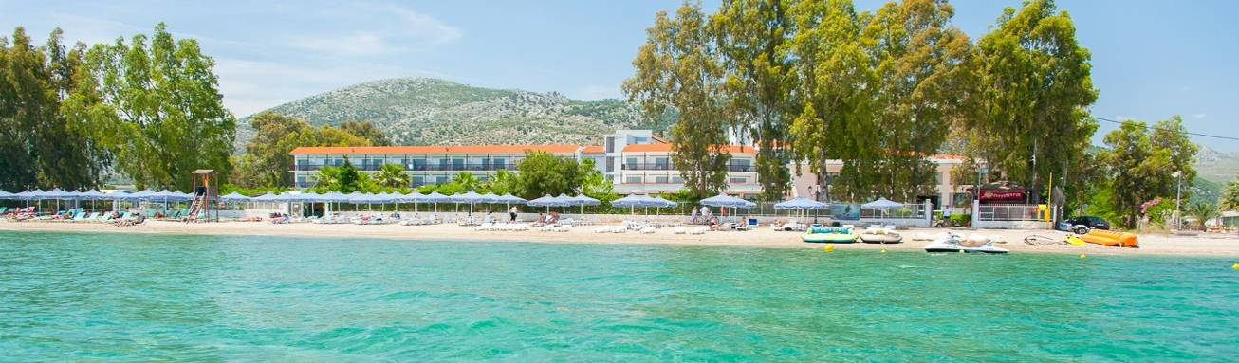

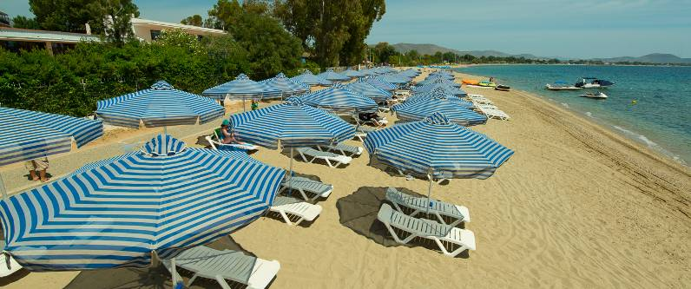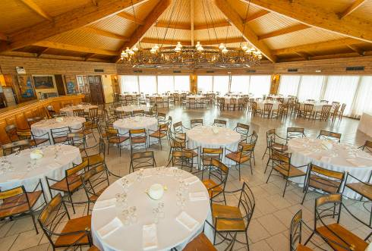

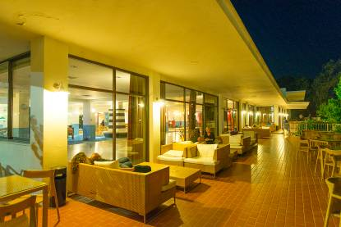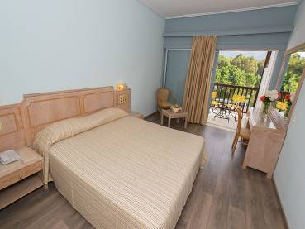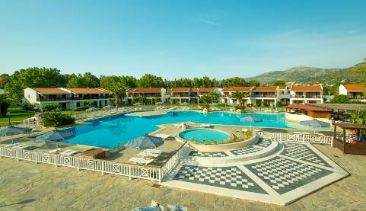

Hotel tel. center: (+30) 2294113000, Fax: (+30) 2294113001

Email: [info@goldencoast.gr](mailto:info@goldencoast.gr) - Website: [www.goldencoast.gr](http://www.goldencoast.gr)

The room prices are in Euro (€) per person and per night.

It is offered on a “Fully Board” basis including bed, breakfast, lunch and dinner.

In the room price is also included service charge and VAT and the local transportation from/to Hotel/Venue, with a daily shuttle service to the competition.

Free Wi-Fi will be available at the hotel reception area and hotel rooms.

Preliminary Hotel Reservations should be made before: **15 February 2017.**

Reservations after this date shall be subject to availability.

Final Hotel Reservations should be made before: **27 March 2017.**

A 50% deposit of the Accommodation payment is required before: **15 February 2017**.

The rest 50% of Accommodation payment is to be made, before**: 27 March 2017.**

Accommodation cannot be guaranteed, nor at the above quoted prices beyond each deadline.

Reservations after each deadline will be considered only according to availability and the room rate may change.

For receiving the best check in service upon your team arrival at the hotel, you are requested to send to the OC a list with the roommates’ names of every room you have reserved.

The rooming list should be sent no later than **30 March 2017**.

**Entry fees**\***:**

Individuals:  **75** Euro per athlete

Team : *Free of charge*

Officials : *Free of charge*

*\*The Entry fee includes the daily local transportation hotel-venue and Closing Party*

**Transportation:**

Athens International Airport (ATH)

From/to Airport – Hotel (arrival and departure): **20** Euro/person

**TRAINING CAMP:**

A Training Camp will be organized for the teams that want to practice before the EYC 2017, 1st leg. The training field will be the same practice field as for the EYC 2017, located in the Hotel land.

**Training Camp starting date**: Monday, 10 April 2016 (arrival).

**Practice time**: 08.30 – 16.30.

For more details and prices, please refer to the attached Training Camp Invitation.

**Closing Party:**

After the dinner of 22nd April 2017 it will follow music and dance in the hotel.

Opening: 20:30 p.m. until the end...

Everyone is awaited at the Party - join the Party!

**Weather for Marathon:**

[Click here for weather information in English](http://www.weatheronline.co.uk/weather/maps?LANG=en&CONT=grgr&REGION=0005&LAND=GR&LEVEL=100&WMO=b4937&SI=kph&CEL=C&UP=0&R=0) (EN)

[Click here for weather information in French](http://www.wofrance.fr/weather/maps?LANG=fr&CONT=euro&REGION=0005&LAND=GR&LEVEL=100&WMO=b4937&SI=kph&CEL=C&UP=0&R=0)(FR)

**Water:**

Water will be available on the fields free of charge.

**Visa:**

For all nations that will need visa permits, please make sure to apply for such as early as possible in your country of origin before leaving. If our help is needed you may contact us immediately: [info@eyc2017-marathon.gr](mailto:info@eyc2017-marathon.gr) , no later than **15 February 2017**, for we could send an official invitation over to the Greek Embassy for further cooperation.

**Dress Regulations**:

WA & WAE dress regulations do apply.

**Awards Ceremony:**

It is required that each team should bring its National Anthem(on a CD or on a pen-drive) and a country’s Flag (90cm x 120cm approx).

**Pre-payments:**

Hotel booking will only be regarded valid as soon as a **50 %** down payment has been received by the Organizing Committee, **before 15 February 2017.**

The balance of full payments is to be made, **before 27 March 2017.**

**Booking non official hotel:**

Participants who may decide to book their accommodation at or with other hotels, i.e. non-official hotels, and not through the Local Organizing Committee (LOC), shall have to pay a **double entry fee**, and the LOC will not be responsible for providing transportation from those hotels to the venue (transport for these teams will be provided only to and from airport). It is not possible to distribute any information at the non-official hotels.

**Meals at the venue:**

All meals will be served at the Hotel, during the official days.

For replacing lunch with lunch-box, please inform the OC **one day before**.

Lunch-box will contain 2 sandwiches, 1 juice and fruit.

**ADDITIONAL INFORMATION**

Accommodation and Practice field will be available a week before and after competition for teams who want to practice. Teams are welcome at this time. Please contact OC for reservations and details, **before 15 February 2017.**

**Please note that Hotel Reservations will be made in priority of receiving the 50% payment of Accommodation payment, no later than: 15 February 2017.**

**Please also refer to the detailed Payment Policy below.**

**PAYMENT POLICY**

* For the payment of Accommodation, a **50%** deposit of the total amount payment is required before **15 February 2017.**
* A balance invoice will be issued after payment.
* The Entry Fees should be paid **in full** before **15 February 2017.**
* The Transportation Fee should be paid **in full** before **27 March 2017.**
* **The balance of full payments is due by 27 March 2017**.
* An Invoice will be issued after full payment.
* All prices for payments after the stated deadlines are subject to additional charges.

**Payments must be sent to the following Bank Account:**

Bank account nominee : HELLENIC ARCHERY FEDERATION

Bank Name          : ATTICA BANK ATE

International Banking Account Number (IBAN): GR96 0160 0690 0000 0008 4951 773

Bank Identification Code (BIC) : ATTIGRAA

Bank address                 : O69 OMIROU 23, ATHENS 10672, GREECE

**NOTE**: ALL PAYMENTS SHOULD BE **IN EURO (€)**

* BY BANK TRANSFER, for a **50%** of the Accommodation payment, before **15 February 2017**
* BY BANK TRANSFER (for the **balance** of full payments), before **27 March 2017**

Bank transfer fees are the responsibility of the sender.

NO CREDIT CARDS, NO TRAVELLERS CHEQUES, NO FOREIGN CURRENCIES

**Cancellations & Changes:**

Cancellations must be in writing to the Hellenic Archery Federation, by email to [info@eyc2017-marathon.gr](mailto:info@eyc2017-marathon.gr)

or by FAX to: +30 210 6400347

and:

* received until **15 February 2017,** for full refund of the deposit payment
* received until **27 March 2017,** for 50% refund of the deposit payment
* received later than **27 March 2017** , no refund
* late arrivals or early departures will be charged according to the Final Hotel Reservation Form.

All refunds, if any, will be processed after the end of the event.

**PRELIMINARY HOTEL RESERVATION FORM**

***Return at the latest: 15 February 2017***

Member Association: __________________________________________

Email address: ___________________________

Telephone: ___________________ and Fax: ___________________

**Hotel Name : GOLDEN COAST HOTEL, 4\***

Arrival Date :

Departure Date :

Number of Nights : ________

Number of Rooms

|  |  |
| --- | --- |
| Single: |  |
| Double: |  |
| Triple: |  |

Please check this box if you need facilities for persons with disabilities.

We require that **50%** of the accommodation payment should be made before **15 February 2017.**

Date: __________ Signature President / Secretary General: _______

**Please return Preliminary Hotel Reservation Form to**: **Hellenic Archery Federation,**

**before 15 February 2017,** by e-mail:[info@eyc2017-marathon.gr](mailto:info@eyc2017-marathon.gr)or Fax: +30 210 6400347

**TRANSPORTATION FORM**

***Return at the latest: 27 March 2017***

Member Association: ________________________________________

Email address: ___________________________

Telephone: ___________________ and Fax: ___________________

|  |  |  |  |
| --- | --- | --- | --- |
| Total number of Persons: | ………. | *X 20 € =* | **TOTAL (B): ………… €** |

**Arrival information**

**By plane**:

**Airport:** Athens International: El. Venizelos (ATH Flight Nr: ______________

Date: _______________ Arrival Time: ___________

**Departure information**

**By plane**:

**Airport:** Athens International: El. Venizelos (ATH Flight Nr: ______________

Date: _______________ Departure Time: ___________

Please check this box if you need facilities for persons with disabilities.

Date: ____________ Signature President / Secretary General: ____________________

**Note:**

OC should be informed in writing about changes in the Teams’ travel program before **27 March 2017**. If your arrival is later than your original schedule, the room charges are starting from the original date indicated in the Member Association’s Final Hotel Reservation Form.

**Please return Transportation Form to**: **Hellenic Archery Federation,**

**before 27 March 2017,** by e-mail:[info@eyc2017-marathon.gr](mailto:info@eyc2017-marathon.gr)or Fax: +30 210 6400347

**FINAL HOTEL RESERVATION FORM**

***Return at the latest: 27 March 2017***

Member Association: ________________________________________

Arrival Date: _________________ Departure date: _________________

* OC should be informed in writing about changes in the Teams’ accommodation booking and travel program until **15 February 2017** (full refund) or until **27 March 2017** (50% refund). If your arrival is later or departure is earlier than your original schedule, the rooms will be charged according to the original dates indicated in the Member Association’s Final Hotel Reservation Form.

**Please refer to the Cancellations & Changes at the PAYMENT POLICY page.**

|  |  |  |  |  |  |
| --- | --- | --- | --- | --- | --- |
| **GOLDEN COST HOTEL4\*** | **Number of**  **rooms** | **Number of**  **rooms** | **Nights** | **Price/person** | **Total in Euro€** |
| Single room |  |  |  | 120 € |  |
| Double room |  |  |  | 85 € |  |
| Triple room |  |  |  | 80 € |  |
|  |  |  |  | **TOTAL (C)** |  |

**The rates are in Euro (€) per person, per night, full board.**

Please check this box if you need facilities for persons with disabilities.

We require that balance of full Accommodation payment should be made before **27 March 2017**

**Payments must be sent to the following Bank Account:**

Bank account nominee : HELLENIC ARCHERY FEDERATION

Bank Name          : ATTICA BANK ATE

International Banking Account Number (IBAN): GR96 0160 0690 0000 0008 4951 773

Bank Identification Code (BIC) : ATTIGRAA

Bank address                 : O69 OMIROU 23, ATHENS 10672, GREECE

**NOTE**: ALL PAYMENTS SHOULD BE **IN EURO (€)**

* BY BANK TRANSFER, for a **50%** of the Accommodation payment, before **15 February 2017**
* BY BANK TRANSFER (for the **balance** of full payments), before **27 March 2017**

Bank transfer fees are the responsibility of the sender.

NO CREDIT CARDS, NO TRAVELLERS CHEQUES, NO FOREIGN CURRENCIES

Date:____________ Signature President / Secretary General: _________________________

**BUDGET FORM**

***Return at the latest: 27 March 2017***

Member Association: ____________________________

Telephone: ________________ Fax: _______________ Mobile: _______________

E-mail: _______________________________________

|  |  |  |  |
| --- | --- | --- | --- |
|  | Number | Price | Total |
| Athletes Entry Fee | …….. | 75 € | € |
| **TOTAL ENTRY FEES ( A )** | | | **€** |
| Transportation Fee | ……… | 20 € | € |
| **TOTAL TRANSPORTATION FEES (B)** | | | **€** |
| **TOTAL ACCOMMODATION (C)** | | | **€** |
| **Grand Total ( A+B+C )** | | | **€** |
| Deposit 50% of Accommodation payment before 15 February 2017 | | | € |
| Balance of full payments due on 27 March 2017 | | | € |

**Payments must be sent to the following Bank Account:**

Bank account nominee : HELLENIC ARCHERY FEDERATION

Bank Name          :ATTICA BANK ATE

International Banking Account Number (IBAN): GR96 0160 0690 0000 0008 4951 773

Bank Identification Code (BIC) : ATTIGRAA

Bank address                 : O69 OMIROU 23, ATHENS 10672, GREECE

**NOTE**: ALL PAYMENTS SHOULD BE **IN EURO (€)**

* BY BANK TRANSFER, for a **50%** of the Accommodation payment, before **15 February 2017**
* BY BANK TRANSFER (for the **balance** of full payments), before **27 March 2017**

Bank transfer fees are the responsibility of the sender.

NO CREDIT CARDS, NO TRAVELLERS CHEQUES, NO FOREIGN CURRENCIES

Date: _______________ President/SecretaryGeneral:___________________________

VISA INVITATION LETTER FORM

***Return at the latest: 15 February 2017***

Country/Team:___________________________________

Duration of stay: Arrival ……………………… / Departure ………………………

Country Contact Person:_______________________________

Email: _____________________________________________

Phone:_____________________________ Fax: ____________________

|  |  |  |  |  |  |  |  |
| --- | --- | --- | --- | --- | --- | --- | --- |
| № | Given Name | Family Name | Date of Birth | Passport Number | Date of issue | Validity | Indicate Athlete or Official |
| 1 |  |  |  |  |  |  |  |
| 2 |  |  |  |  |  |  |  |
| 3 |  |  |  |  |  |  |  |
| 4 |  |  |  |  |  |  |  |
| 5 |  |  |  |  |  |  |  |
| 6 |  |  |  |  |  |  |  |
| 7 |  |  |  |  |  |  |  |
| 8 |  |  |  |  |  |  |  |
| 9 |  |  |  |  |  |  |  |
| 10 |  |  |  |  |  |  |  |
| 11 |  |  |  |  |  |  |  |
| 12 |  |  |  |  |  |  |  |

Date: _______________ President/Secretary General:______________________________

**INFORMATION ABOUT MARATHON**

Please visit the following link for information and history of Marathon area and the Marathon battle (EN):

<http://en.wikipedia.org/wiki/Marathon,_Greece>

Please visit the following link for information and history of Marathon sport (FR):

<http://fr.wikipedia.org/wiki/Marathon_%28sport%29>

**To Contact the Organizing Committee:**

* Mrs Evelyn Papadopoulou(for All matters)

Email: [info@eyc2017-marathon.gr](mailto:info@eyc2017-marathon.gr) &

[evelynpapa310@gmail.com](mailto:evelynpapa310@gmail.com)

Phone +30 210 6400186

+30 2310 280 279

Fax +30 210 6400347

Mobile +30 6944 89 80 81

* Mrs Maria Kyrillopoulou(for Lodging matters)

Phone +30 210 6400109

Mobile +30 6974 47 40 17

* Mr. Kostas Chamilothoris (for Transportation matters)

Phone +30 210 6400109

Mobile +30 6983 24 52 46