FINAL: Version 1.0 (02 March 2017)

TO ALL World Archery MEMBER ASSOCIATIONS

Dear President,

On behalf of the Local Organising Committee of the World Archery 3D Championships 2017, and French Archery Federation (FFTA); I would like to invite you to the World Archery 3D Championships 2017, 19 – 23 September in Robion, France.

Please find enclosed the necessary documents of registration, organisation and participation for this event. Please completed all the necessary details in WAREOS before the following deadlines:

Summary of deadlines:

- Preliminary Entries 21st June 2017
- Preliminary Hotel Reservation 21st June 2017
- Visa Support 21st July 2017
- Final Entries 31st July 2017
- Transportation 31st July 2017
- Final Hotel Reservation payment 31st July 2017

Looking forward to welcoming you in Robion, France.

Sincerely yours,

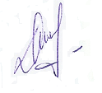
Mr Michel DAUMAS
President
Organising Committee

PRELIMINARY PROGRAMME:

Sunday, September 17th, 2017 | - Arrival of Delegations  - Practice field and local transportation available team registration
Monday, September 18th, 2017 | - Arrival of Delegations  - Practice field and local transportation available team registration  - Official Practice  - Team Managers' Meeting  - 17:00hrs Opening Ceremony
Tuesday, September 19th, 2017 | - 1st Qualification Round – 24 targets.
Wednesday, September 20th, 2017 | - 2nd Qualification Round – 24 targets.
Thursday, September 21st, 2017 | - 1st Individual Elimination Round. 12 targets  - 2nd Individual Elimination Round. 8 targets
Friday, September 22nd, 2017 | - Team Elimination Round. 8 targets  - Team semi-finals – 4 targets.
Saturday, September 23rd, 2017 | - Individual semi-finals – 4 targets  - Individual and Team Finals – 4 targets  - Award Ceremony Closing Ceremony  - Gala Dinner and Party
Sunday, September 24th, 2017 | - Departure of Delegations

Note: The preliminary program could change slightly according to the number of participants and TV requirements. All changes to the program will be published and all participants will be informed in good time.
PRELIMINARY & FINAL REGISTRATION
All entries, accommodation reservations, transport needs, flight arrival/departure information and visa invitation letter requests are to be completed using WAREOS.

The World Archery Online Registration System (WAREOS): http://register.worldarchery.org has been updated to handle the entire registration process for this event. No entry forms, hotel reservations or transport forms will be accepted as all information is to be entered into WAREOS.

In order to use WAREOS, please login on http://register.worldarchery.org with your Username and Password assigned by World Archery. After entering WAREOS, please find the event, from the list, you wish to register your athletes. Select/press the “Entries” button to see the list of categories in the event. Select/press the “category” to enter the athlete and official numbers/details participating for that event. A "WAREOS User Manual" can be downloaded in PDF format (English) using the same website link.

For any questions regarding the WAREOS, please contact the World Archery office, Mr. JK LEE (jklee@archery.org).

A maximum number of 3 athletes, per country is allowed to be registered into each category of the event. Preliminary entries should be completed using WAREOS.

Start date for online registration using WAREOS 28th February 2017
End of Preliminary registration using WAREOS: 21st June 2017
End of Final registration using WAREOS: 31st July 2017

Please respect the stated deadlines.

Member Associations should only use WAREOS to make any changes/amendments to their entries and will be able to do so at any time. Any changes made in WAREOS an email will instantly be automatically sent to the Organising Committee and Member Association with the updated information.

However, any changes that are made after the deadlines specified or if entries differ by more than 4 athletes from the preliminary entries, the following penalty fees will automatically be applied.
Penalty fees to be paid to Organising Committee: | Cost (EUR):
Entries made after the preliminary and/or final entry deadline date. | 45 per entry
If final entries differ from the preliminary entries by more than 4 athletes/officials. | 140 per entry
Failure to have made preliminary entries before the deadline date but then have submitted final entries. | 140 per entry

Penalty Fee to be paid to World Archery: | Cost (CHF):
Lost accreditation. | 30 each
Changes made to the athlete and/or team official names after the final entry deadline date and within 3 days prior to the start of the event. | 50 each change

NOTE: CHF currency exchange rates will be those on the date of the event.

Member Associations that have penalty fees outstanding from 2016 will need to have paid these penalty fees before being eligible to enter and compete.

Any entries received less than 3 days before the team managers meeting for the World Championships will be refused if no preliminary entry and/or final entry are made prior. This decision cannot be appealed by the teams and is fully compliant with the current World Archery rules, article 3.7.1.2. Entries received after the deadlines, are subject to penalties as clearly stated in the rule book and the invitation documents of World Cups and World Championships. A Member Association that has made final entries in WAREOS and does not participate will be invoiced for the number of entries entered in the system, unless they have informed World Archery and the Organising Committee in writing at least one week prior to the event that they are unable to attend.

ACCOMMODATION & GENERAL INFORMATION

The World Archery 3D Championships will be organized in two places.
The opening ceremony will take place in ROBION.

All the qualification and eliminatory rounds will be shot in ROBION on the slopes of the Luberon, from 19th to 22nd September 2017.

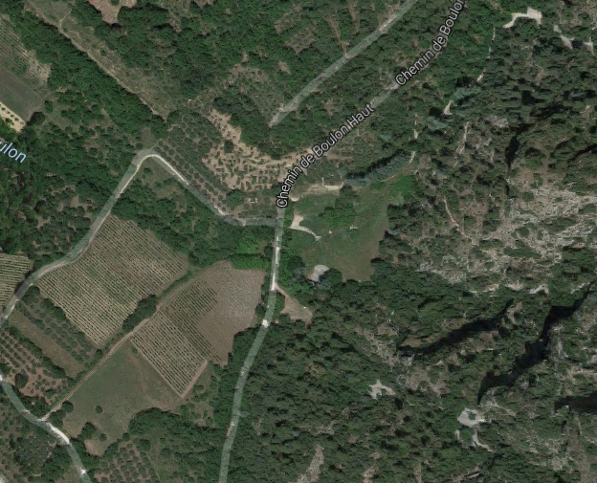

TRAINING FIELD

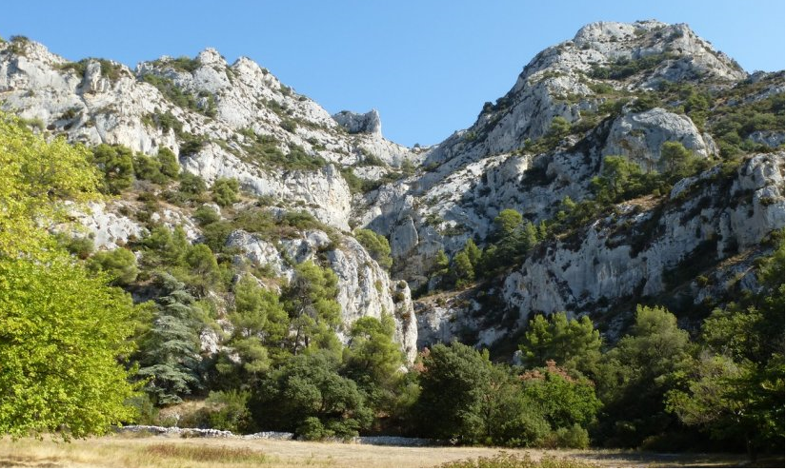

The semi-finals and finals will be shot in front of the Palace of the Popes in the centre of AVIGNON.

The Award Ceremony and the Closing Ceremony will take place inside the Palace of the Popes.

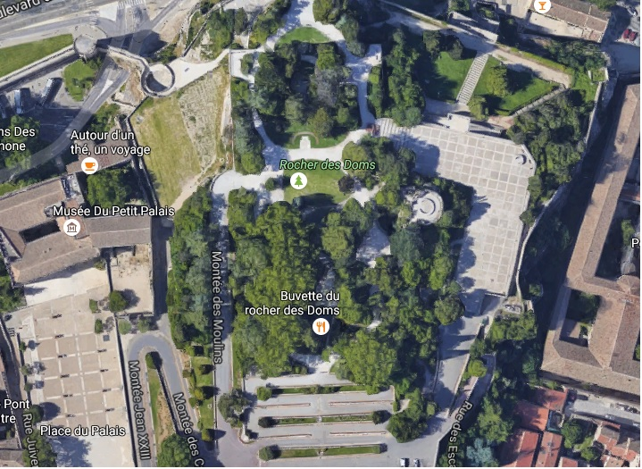

PLACE OF FINALS

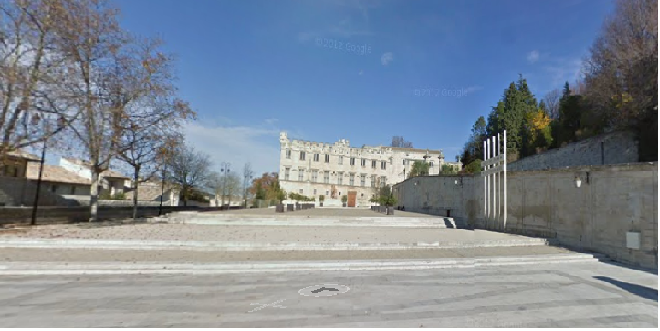

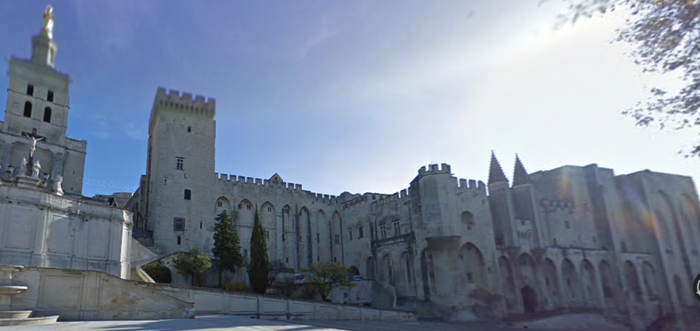

PLACES OF ARRIVAL

Robion and Avignon are easily reached.
By plane:
- Marseille airport there are daily connections with Paris and to most major World airports.
- Avignon Airport there are daily connections with Paris.
- By train: a lot of daily connections with Paris and Roissy airport.
- By car: motorway/highway access is less than 10 km away.

Marseille airport is 100 km away from Robion, and there will be a shuttle bus service for transfers.

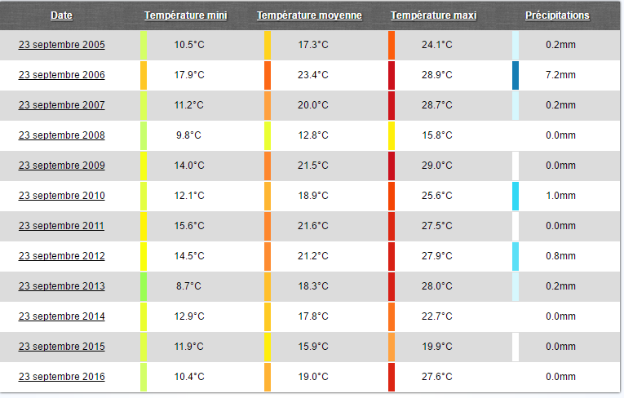
Weather (September Averages)

ACCOMMODATION

Hotel Belambra is the official hotel, offering a special price to participants as agreed with the LOC.

Final Reservations should be made before 31st July 2017. Reservations after this date will be subject to availability.

Hotels reservations will be based on a first come, first served basis.

- Preliminary reservations need to be made before: 21st June 2017.
- Final Hotel Reservations need to be made before: 31st July 2017.

The transfer service, between the hotel and the competition venues, is only available for those teams who have reserved their accommodation through the Local Organising Committee.

IMPORTANT NOTE:

Transportation to and from the venue will be provided only for the delegations staying in the official hotel, and booked through the LOC. Please, take note that no information or transportation will be provided to non-official hotels.

Hotel Prices

Hotel Belambra (OFFICAL HOTEL)

Triple Room € 80.00 per person per night
Twin Room € 90.00 per person per night
Single Room € 100.00 per person per night

- http://www.belambra.fr/club-l-isle-sur-la-sorgue-le-domaine-de-mousquety/ete

* Prices are per person and per day and include half board (Breakfast and Dinner are served in the form of a Hot Buffet).

Important Note:
Please refer to the accommodation pages below for detailed hotel information. Please complete all necessary sections in WAREOS and make full payment for entries and accommodation by the specified deadlines. Bank transfers only, no credit cards or travel checks will be accepted.

Participants who book their accommodation in non-official hotels will need to pay a double entry fee. In addition, the LOC will not be responsible to provide any event information at this hotel or provide transportation to the venues.

Teams that book non-official accommodation will need to register at the accreditation desk no later than the day before official practice day. Failing to do so will result in no changes being made to the entry list and it is likely that participation in the event will be refused if registration is not completed in time.

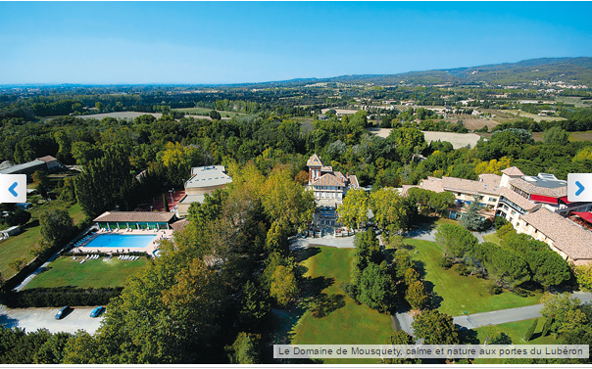

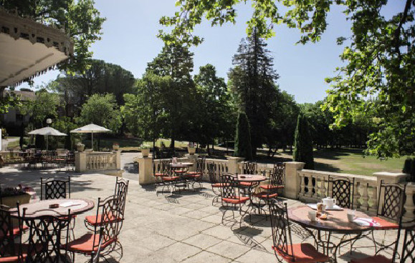

Internet:
Free Internet is available in the official hotel (guest rooms and hotel lobby).

LUNCH PACKS

Teams can book their lunch packs for the competition at an additional cost of €12.00 per person per day. Each pack will consist of 2 sandwiches, fruit, a cake and a drink. To order a lunch pack, teams can send their requirements with their entry form or book when they arrived. Lunch packs will be supplied from Tuesday to Friday
Meal tickets for participating local restaurants will be given on the Monday of the event, and likewise for the Saturday in Avignon. There is a wide choice of participating restaurants in the center of the city near the site of the event finals.

Do any of your team members have dietary requirements or allergies e.g. vegetarian, nut allergies or gluten free etc.
Yes No

If yes, please specify: ______________________________________________

TRANSPORTATION

Entry fees include daily local transfers to and from the venue to the official hotel during the qualification, elimination and final rounds for accredited persons. This transport service will operate from September 18th to 23rd. Transfer timetables will be confirmed and supplied at a later date.

Arrival transportation will be provided from all airports on September 17th and 18th only.
Departure transportation will be provided to all airport on September 24th only.

- Avignon Airport and rail station (arrival and departure): Free of charge
- Marseille Airport (arrival and departure): 80 € / per person round trip
- Transportation from the official hotel, to and from the venue will be free of charge

Arrival
- We will arrive at Marseille Airport with flight N°. ……….………
- We will arrive at Avignon Airport with flight N°. ……….………
- We will arrive at Avignon rail station.
- From: ……..…… Date: ……..…………… (DD/MM/YY) Time: …............…..

Departure
- We will leave from Marseille Airport with flight N°. ……….………
- We will leave from Avignon Airport with flight N°. ……….………
- We will leave from Avignon rail station.
- From: ……..…… Date: ……..…………… (DD/MM/YY) Time: …............…..

ENTRY FEE
Entry Fees:
Individual: | 150 EUR per athlete
Officials: | 100 EUR per person
Temporary Upgrade:  For athletes wishing to be a coach temporarily | 25 EUR per accreditation

Entry fee in NON official hotels:
Individual: 300 EUR per athlete
Officials: 200 EUR per person

There is no entry fee for teams.

Entry fees include daily local transport to and from the practice field to/from official hotels during the qualification, elimination and finals venues (timetable to be confirmed on site).

PAYMENT CONDITIONS:
The entry fees should be paid in full before arrival.

Payment of accommodation, a minimum deposit of 50% should be made when booking by 21 June 2017. The final outstanding balance shall be made via bank transfer before arrival. Accommodation cannot be guaranteed after this deadline. A balanced invoice will be provided via WAREOS.

BANK INFORMATION for ACCOMMODATION, TRANSPORTATION and
ENTRY FEES:
BRANCH: Caisse d’Epargne
Account Named: Les Archers du Baude
Account Number: 08010674066
ABI Code: 11315
CAB Code: 00001
IBAN Number: FR76 11315000010801067406685
SWIFT (BIC) Code: CEPAFRPP131

Note: Please indicate in the reference/notes section, the team or reservation name which corresponds to the payment.
All bank charges/fees are the responsibilities of the sender.
Credit cards or travel checks will not be accepted.
ADDITIONAL INFORMATION

Cancellations & Changes
All cancellations and changes must be made through WAREOS:
- Cancellations received before 21st July 2017 a full refund of the deposit payment will be made.
- Cancellations received after 21st July 2017, no refund will be given.
- Refunds will be processed after the event.
- Name changes to team officials or athletes (same category and division) will be accepted up to 72 hours before the event without any additional charge.
- Should flight arrival details change last minute, please contact the Organising Committee using the details indicated in the Team Managers’ Booklet.
- If a participant’s arrival is later than the original scheduled arrival date, the room charges will start from the dates of the original booking made by the Member Association.
- Any changes made in WAREOS an email will automatically be sent to the Organising Committee and Member Association with the updated information.

Training
A training field will be available starting from 17 September 2017. The training field is near the competition field and is about 10 km from the hotels.

Media Registration:
Media representatives can apply for registration by emailing info@archery.org

Gala dinner and party
On Saturday 23rd September at 8.30pm, the Local Organising Committee will be delighted to welcome all athletes and officials, to a gala dinner and party at Belambra hotel.

Water
Bottled water will be available at the qualification and practice venues

LOC Contact:
Name: Michel DAUMAS
Language: English and French
Email: m.daumas@wanadoo.fr
Official website: http://www.robion2017.com
General Mail: contact.robion2017@gmail.com
Transport and Hotels:
Technical Delegate: Cenneth AHLUND: cenneth.ahlund@gmail.com

Visa
All participants who need an entry visa to France, will be required to complete the Visa Support sections in WAREOS by no later than 21st July 2017.

It is the applicants’ responsibility for supplying the necessary information, ensuring all details are up to date, correct and submitted by the deadlines specified.

In addition, all participants that require a visa are kindly requested to supply a copy of their latest/valid passport. Copies of each applicate can be uploaded on WAREOS. All passport copies and personal details entered/uploaded to WAREOS will be held securely and in the strictest of confidence and not shared with other parties.

