World Archery
3D Championships 2019

Invitation Package

TO ALL World Archery MEMBER ASSOCIATIONS

Dear President,

On behalf of the Local Organizing Committee (LOC), we would like to invite your country to the World Archery 3D Championships 2019, which will be held from 2 to 7 September in Lac La Biche, Alberta – Canada.

Please find enclosed the necessary information for registration, organization and participation for this event. Please complete all the necessary details in WAREOS before the following deadlines:

Summary of deadlines:
- Preliminary Entries 4 June 2019
- Accommodation Reservation 4 June 2019
- Visa Support 1 July 2019
- Transportation 1 August 2019
- Final Hotel Reservation 1 August 2019
& Payment
- Final Entries 12 August 2019

We are looking forward to welcoming you and your teams, to the beautiful city of Lac La Biche and the Province of Alberta Canada.

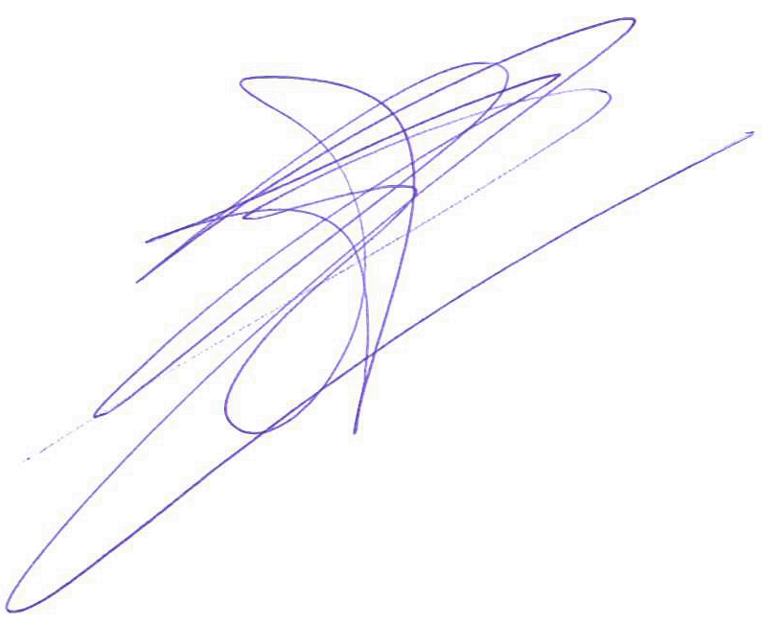
Sincerely yours,

Mr. Rene Schaub
President of the Organizing Committee

PRELIMINARY PROGRAMME
Day |  | Date | Description
DAY -1 | Saturday  31 August |  | Arrival of Participants  Practice field and local transport available
DAY 0 | Sunday  1 September |  | Arrival of participants  Practice field and local transport available
DAY 1 | Monday  2 September |  | - Official Practice for all  - Registration and Equipment Inspection  - Team Managers Meeting  - Opening of the Championships
DAY 2 | Tuesday  3 September |  | 1st Qualification round (24 targets)  - Women and men  - All categories
DAY 3 | Wednesday  4 September |  | 2nd Qualification round (24 targets)  - Women and men  - All categories
DAY 4 | Thursday  5 September |  | Individual Pool Elimination  - Elimination Round (women and men) for all categories
DAY 5 | Friday  6 September |  | Semi-finals matches  - Individual (men and women) in all categories  Team Matches
Day 6 | Saturday  7 September |  | Team and Individual Finals  - Team Finals  - Individual Finals  - Award Ceremonies and Closing Ceremony  - Gala at the Bold Centre
DAY 7 | Sunday  8 September |  | - Departure of Teams

NOTE: This preliminary programme could be changed slightly according to number of participants and TV requirements. All changes will be published and distributed to all participants in good time.

PRELIMINARY & FINAL REGISTRATION
All entries, accommodation reservations, transport needs, flight arrival/departure information and visa invitation letter requests are to be completed using WAREOS.

The World Archery Online Registration System (WAREOS): http://extranet.worldarchery.org has been updated to handle the entire registration process for this event. No entry forms, hotel reservations or transport forms will be accepted as all information is to be entered into to WAREOS.

In order to use WAREOS, please login on http://extranet.worldarchery.org with your Username and Password assigned by World Archery. After entering WAREOS, please go to "Online Registration" and register your athletes and officials for this event. A "WAREOS User Manual" can be downloaded in PDF format (English) using the same website link.

For any questions regarding WAREOS, please contact the World Archery office, Mr. JK LEE (jklee@archery.org).

A maximum number of 3 athletes per country are allowed to be registered into each category of the event. Preliminary entries should be completed using WAREOS.

Start date for online registration using WAREOS 2 February 2019
End of Preliminary registration using WAREOS: 4 June 2019
End of Final registration using WAREOS: 12 August 2019

Please respect the stated deadlines.

Member Associations should only use WAREOS to make any changes/amendments to their entries and will be able to do so at any time. Any changes made in WAREOS an email will instantly be automatically sent to the Local Organizing Committee and Member Association with the updated information.

However, any changes that are made after the deadlines specified or if entries differ by more than 4 athletes from the preliminary entries, the following penalty fees will automatically be applied.

Penalty fees to be paid to Organizing Committee: | Cost (USD):
Entries made after the entry deadline date. | 50 per entry
If final entries differ from the preliminary entries by more than 4 athletes/officials. | 150 per entry
When no preliminary entries were made before the deadline date but then submit final entries. | 150 per entry

Penalty Fee to be paid to World Archery: | Cost (CHF):
Lost accreditation. | 30 each
Changes made to the athlete and/or team official names after the final entry deadline date and within 3 days prior to the start of the event. | 50 each change

NOTE: CHF currency exchange rates will be those on the date of the event.

Member Associations that have penalty fees outstanding from earlier events will need to have paid these penalty fees before being eligible to enter and compete.

Any entries received less than 3 days before the team managers meeting for a Hyundai Archery World Cup or World Championships will be refused if no preliminary entry and/or final entry are made prior. This decision cannot be appealed by the teams and is fully compliant with the current World Archery rules, article 3.7.1.2. Entries received after the deadlines, are subject to penalties as clearly stated in the rule book and the invitation documents of World Cups and World Championships. A Member Association that has made final entries in WAREOS and does not participate will be invoiced for the number of entries entered in the system, unless they have informed World Archery and the OC in writing at least one week prior to the event that they are unable to attend

ACCOMMODATION & GENERAL INFORMATION
The following are the official accommodation options for the championships.

Ramada-4.5 Star 50 Rooms Available
- Single Room $ 182.00 US (Including Breakfast & Dinner)
- Double/Twin Room $220.00 US Double Occupancy (Including Breakfast & Dinner)
- Superior Single Room $198.00 US (Including Breakfast & Dinner)
- Superior Double Room $236.00 US Double Occupancy (Including Breakfast & Dinner)
- https://www.ramada.com

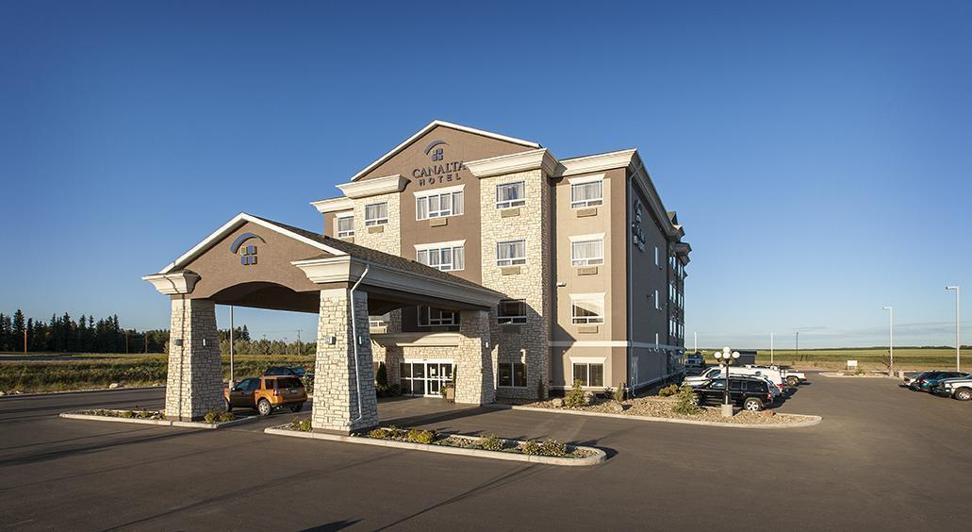
Canalta-4.5 Star 50 Rooms Available
- Single Room $ 182.00 US (Including Breakfast & Dinner)
- Double/Twin Room $220.00 US Double Occupancy (Including Breakfast & Dinner)
- Superior Room with Kitchenette $176.00 US (Including Breakfast)
- Superior Double Room with Kitchenette $196.00 US Double Occupancy (Including Breakfast)
- Double/Twin Room $150.00 US Double Occupancy (Including Breakfast)
- http://www.canaltahotels.com/our-properties/laclabiche
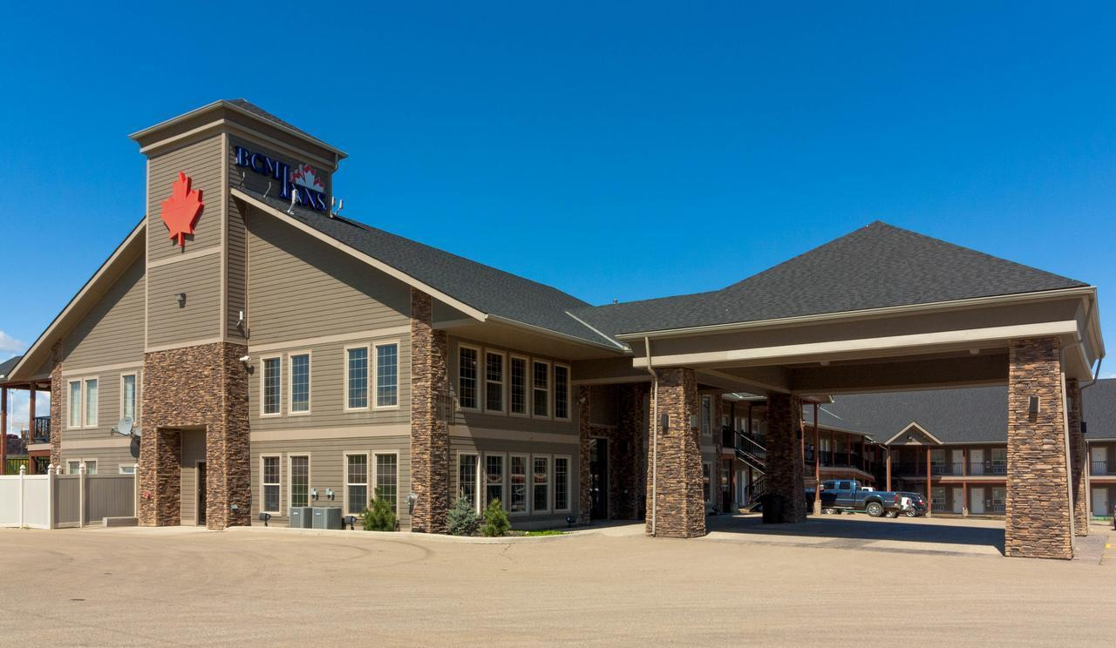
BCMInn-4.0 Star 50 Rooms Available
- Double bed Kitchenette Room $ 150.00 US Double Occupancy (Including Breakfast)
- https://www.bcminns.com

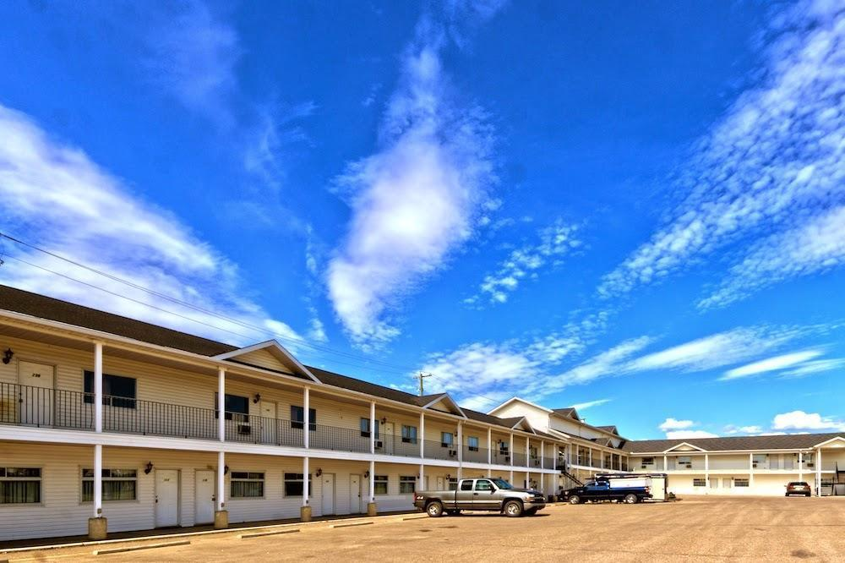
Parkland 1 -3.5 Star 60 Rooms Available
- Single Room $ 115.00 US (Including Breakfast & Dinner)
- Double/Twin Room $170.00 US Double Occupancy (Including Breakfast & Dinner)
- Single Kitchenette $120.00 US (Including Breakfast)
- Double Kitchenette $150.00 US Double Occupancy (Including Breakfast)
- Triple Kitchenette $195.00 US Triple Occupancy (Including Breakfast)
- https://www.parklandmotels.com

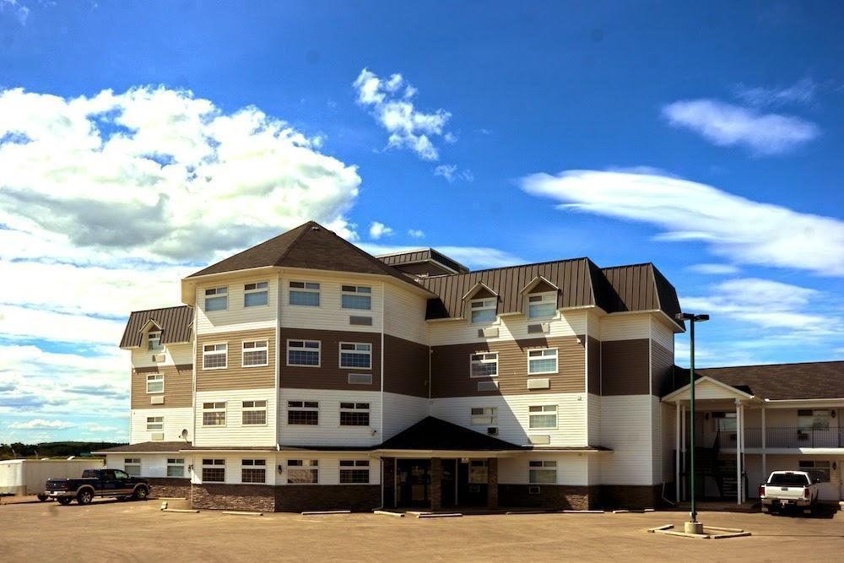
Parkland 2 -3.5 Star 50 Rooms Available
- Single Room $ 120.00 US (Including Breakfast & Dinner)
- Double/Twin Room $180.00 US Double Occupancy (Including Breakfast & Dinner)
- Single Kitchenette $120.00 US (Including Breakfast)
- Double Kitchenette $150.00 US Double Occupancy (Including Breakfast)
- Triple Kitchenette $195.00 US Triple Occupancy (Including Breakfast)
- https://www.parklandmotels.com

The hotel room rates are per room, per night and include free internet. The prices include either Bed and Breakfast or Half Board and Taxes.

Lunch is available for purchase for $15 US per person per day

Dinner is available for purchase for $22 US per person per day

All Hotels are 6-8 KMs (10 minutes) from the Venues

During the event there is a tournament desk available in all official hotels with all the relevant and latest information about the World Championships.

Reservations should be made before: 04 June 2019
Final Hotel Reservation & Transportation before: 01 August 2019.

To confirm hotels reservations, a minimum 50% deposit of the total amount is required to be bank transferred to the OC before 04 June 2019. Reservations after this date will be considered only according to availability.

Important Note:
Please refer to the accommodation pages for detailed hotel information. Please complete all the necessary sections in WAREOS and make full payment for entries, transport and accommodation by the specified deadlines. Bank transfers only, no credit cards or travel checks will be accepted.

Participants who book their accommodation in non-official hotels will:
- Need to pay a double entry fee.
- The LOC will not be responsible to provide any event information at this hotel or provide transportation to the venues.
- Team will need to register at the Championships accreditation office no later than the day before official practice day. Failing to do so will result in changes being made to the entry list and it is likely that participation in the event will be refused if registration is not competed in time.

There will be a map with the accommodations, Venues and Practice Facilities on the web site www.2019worldarchery3dchampionships.ca

MAP:
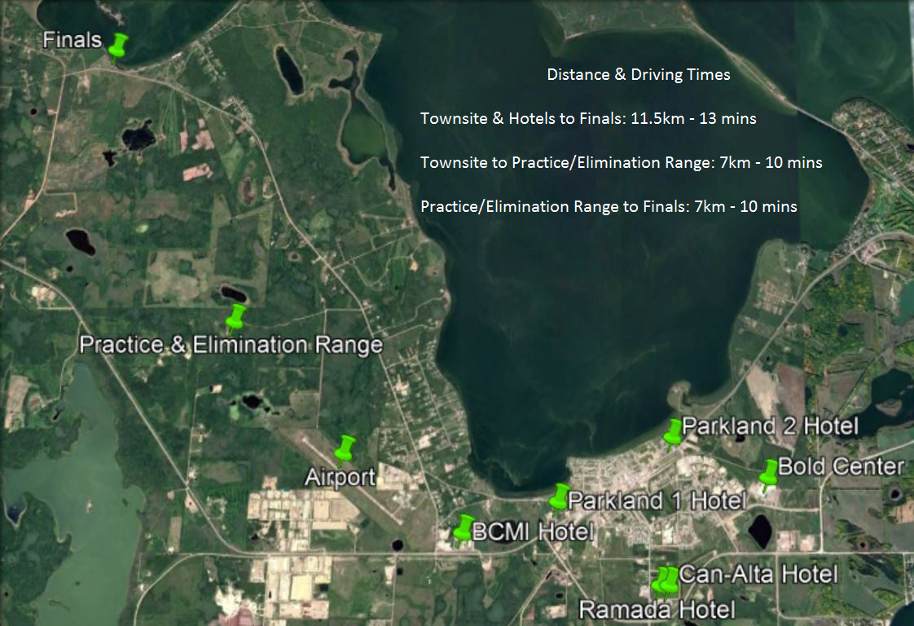

ENTRY FEE
Entry fee:
Individual: 250 USD per athlete
Officials: 125 USD per person
Temporary Upgrade: 30 CHF per accreditation (for athletes wishing to be a coach temporarily).

Entry fee in NON official hotels:
Individual: 500 USD per athlete
Officials: 250 USD per person

There is no entry fee for teams.

PAYMENT CONDITIONS:
All fees should be paid in full before arrival.

Payment of accommodation and local transportation: a minimum deposit of 50% of the total amount owed should be made when booking by 04 June 2019. The final outstanding balance shall be transferred before arrival. Accommodation cannot be guaranteed after this deadline. A balance invoice will be provided via WAREOS.

BANK INFORMATION for ACCOMMODATION, TRANSPORTATION and
ENTRY FEES:
BANK: Scotia Bank
ADDRESS: P.O. Box 690 Lac La Biche Alberta Canada
BANK ACCOUNT HOLDER NAME: Lakeland Archers Club
ACCOUNT NO: 619290022012
BIC/SWIFT CODE: NOSCCATT

NOTE: All payments shall be made in USD by BANK TRANSFER before arrival.

Bank transfer fees are responsible on the SENDER.
CREDIT CARDS and TRAVEL CHECKS will not be accepted.

ADDITIONAL INFORMATION
Transport
Transportation will be provided from Edmonton airport (YEG) 300 Km, to the official hotels, two days before the official practice day and return one day after the closing day. In addition, the bus transport will take participants from their accommodations to the field, to all social events and can even be available to take in some of the sights of Lakeland County. The cost of this service is only $ 100.00 US per person for services for the entire event.
There will be busses assisted to your country for the whole time that will bring you to the practice, competition and sightseeing as necessary.

Lunch at the Venue
At additional cost, teams can pre-order lunch boxes to consume at the competition venue.

To order lunch boxes, teams should do so in advance on WAREOS. Lunch boxes will cost $15.00 US per person. Lunch boxes will include:
- Sandwich, Fruit, Cake, and other snack items and something to drink.
- There will be a hot lunch provided at the venue if you would prefer.
- Dinner will be served at the Bold Centre every night during the Championships. If you are in a Bed and Breakfast only accommodation, you may purchase Dinner tickets for $22 US per person through WAREOS.
Please specify in WAREOS any food allergies and/or dietary requirements.

Public transport
Lac La Biche has a limited public transit system to assist in moving thoughout the community.
Fares (per ride) Individidual-$2.00
For more information about the community access program visit
http://www.laclabichecounty.com/our-services/fcss-and-community-development/community-access-system-sing

Cancellations & Changes

- Cancellations received before 04 June 2019 a full refund of the deposit payment will be made.
- Cancellations received after 12 August 2019, no refund will be given.
- Refunds will be processed after the event.
- All cancellations and changes must be made through WAREOS. Changes made to the athlete and/or team official names after the final entry deadline date and within 3 days prior to the start of the event will be subject to a 50 CHF charge.
- The organising committee should be informed immediately about any changes in travel arrangements 72 hours prior arrivals.
- If your arrival is later than your original schedule, the room charges are starting from the original date indicated by the Member Association in their WAREOS accommodation reservation.
- An email will automatically notify the Organising Committee and Member Association of any changes made in WAREOS.
- All cancellations and changes must be made through WAREOS.

Training
Training venues will be available starting from 31 August 2019. For those teams wishing to arrive earlier and practice at a local club, please check the contact details on the official event website: http://www.2019worldarchery3dchampionships.ca

Internet
Free WIFI will be available in the official hotels (in hotel rooms and in the lobby). There will also be Wi-Fi available for access to results.

Photographs
There will be 2 Professional Photographers Taking pictures or the 3D Championship and a collection of all the pictures will be send to all the Team Managers for all the registered Archers at no extra cost.

Water and Washrooms
Water and washrooms will be available at the qualification and practice venues.

Media Registration
Media representatives can apply for registration by emailing info@2019worldarchery3dchampionships.ca

Weather
Average Temperature 16 º C
Low Temperature 10º C
High Temperature 20º C
Sunshine Hours 6 Hours
Rainfall days 19 days
Sunrise 5.30h
Sunset 22.00h

VISA SUPPORT
All participants who need an entry visa to the Canada, will be required to complete the Visa Support Form in WAREOS no later than 01 July 2019.

It is the applicants’ responsibility for supplying the necessary information, ensuring all details are up to date, correct and submitted by the deadlines specified.

In addition, all participants that require a visa are kindly requested to supply a copy of their latest/valid passport. Copies of each application can be uploaded on WAREOS. All passport copies and personal details entered/uploaded to WAREOS will be held securely and in the strictest of confidence and will not be shared with other parties.

Please note that the Organizing Committee can provide invitation for the period of the 3D World Archery Championships only.

LOC Contact:
Name: Bruce Hennel & Aimée Barnabé
Language: (English)
Email: info@2019worldarchery3dchampionships.ca
Official website: 2019worldarchery3dchampionships.ca
President Organizing Committee: Rene Schaub acal@mcsnet.ca
Cell 1-780-689-8488

Lac la Biche
For information on what to know and what you can do please visit the official website of Alberta tourism board: www.alberta.ca/en
Check out the Lac La Biche County Visitor Guide book on our web site 2019worldarchery3dchampionships.ca

