TO ALL World Archery MEMBER ASSOCIATIONS

Dear President,

On behalf of the Local Organizing Committee (LOC) of the World Archery Field Championships 2018, Cortina – Italy and FITARCO, we would like to invite your country to the 2018 World Archery Field Championships, which will be held from 4th to 9th September in Cortina d’Ampezzo, one of the most beautiful town of Northern Italy, in the heart of Dolomitic Alps.

Please find enclosed the necessary documents of registration, organization and participation for this event. Please complete all the sections in WAREOS before the deadlines:

Summary of deadlines:

- Preliminary Entries 06 June 2018
- Preliminary Hotel Reservation 04 May 2018
- Preliminary Transportation 30 June 2018
- Visa Support 30 June 2018
- Final Hotel Reservation 06 July 2018
& Payment
- Final Transportation 06 July 2018
- Final Entries 14 August 2018

Looking forward to welcoming you in Cortina D’Ampezzo Dolomiti, Italy.

Sincerely yours,

Mr. Luciano TREVISSON
President
Organizing Committee

PRELIMINARY PROGRAMME:

02 Sept 2018  Sunday | Arrival of participants  Accreditation and Registration  Local transport available
03 Sept 2018  Monday | Arrival of participants  Accreditation and Registration  Practice field and local transport available
04 Sept 2018  Tuesday | Official Practice (for all)  Equipment Inspection  Team Managers Meeting  Opening Ceremony
05 Sept 2018  Wednesday | 1st Qualification Round  24 Targets - Unmarked
06 Sept 2018  Thursday | 2nd Qualification Round  24 Targets - Marked
07 Sept 2018  Friday | Individual Eliminations
08 Sept 2018  Saturday | Finals - Team  Award Ceremonies
09 Sept 2018  Sunday | Finals - Individual Finals  Award Ceremonies  Closing Ceremony  Banquet
10 Sept 2018  Monday | Departure of teams

NOTE:
This is a preliminary programme and subject to change according to the number of participants and TV requirements. All changes will be published and distributed in advance.
PRELIMINARY & FINAL REGISTRATION

All entries, accommodation reservations, transport needs, flight arrival/departure information and visa invitation letter requests are to be completed using WAREOS.

The World Archery Online Registration System (WAREOS) at http://register.worldarchery.org now handles the entire registration process for this event. No entry forms, hotel reservations or transportation forms will be accepted; all information must be entered into WAREOS.

Member Associations can login to WAREOS at http://register.worldarchery.org with the username and password assigned by World Archery. After entering WAREOS, selecting the event from the list will allow a member association to register their athletes. Select/press the “Entries” button to see the list of categories in the event. Select/press the “category” to enter the athlete and official numbers/details participating for that event. A WAREOS User Manual can be downloaded in PDF format (English) upon login.

Contact Mr. JK LEE (jklee@archery.org) in the World Archery Office with any questions regarding WAREOS.

A maximum number of three (3) athletes per country (host country included) can be registered into each category of the event. Preliminary entries have to be complete using WAREOS.

Start date for online registration using WAREOS 28 February 2018
End of Preliminary registration using WAREOS: 06 June 2018
End of Final registration using WAREOS: 14 August 2018

Please respect the stated deadlines.

Member Associations can only use WAREOS to make any changes or amendments to entries and will be able to do so at any time. An email will automatically notify the Organising Committee and Member Association of any changes made in WAREOS.

Any changes that are made after the deadlines specified or if entries differ by more than 4 athletes from the preliminary entries, the following penalty fees will automatically be applied.

Penalty fees to be paid to Organising Committee: | Cost (EURO):
Entries made the entry deadline dates. | 45 per entry
If final entries differ from the preliminary entries by more than 4 athletes/officials. | 140 per entry
When no preliminary entries were made before the deadline date but then submit final entries. | 140 per entry

Penalty Fee to be paid to World Archery: | Cost (CHF):
Lost accreditation. | 30 each
Changes made to the athlete and/or team official names after the final entry deadline date and within 3 days prior to the start of the event. | 50 each change

NOTE: CHF currency exchange rates will be those on the date of the event.

Member Associations that have penalty fees outstanding from 2017 will need to have paid these penalty fees before being eligible to enter and compete.

Any entries received less than 3 days before the team managers meeting for the World Championships will be refused if no preliminary entry and/or final entry are made prior. This decision cannot be appealed by the teams and is fully compliant with the current World Archery rules, article 3.7.1.2. Entries received after the deadlines, are subject to penalties as clearly stated in the rule book and the invitation documents of the World Championships. A Member Association that has made final entries in WAREOS and does not participate will be invoiced for the number of entries entered in the system, unless they have informed World Archery and the Organising Committee in writing at least one week prior to the event that they are unable to attend.

ACCOMMODATION & GENERAL INFORMATION
The official hotels are the 4* Hotel (Bellevue-Villa Blu-Cortina-De La Poste), 3* Hotel (Bellaria-Menardi-Panda-Regina-Serena-Trieste-Villa Alpina-VillaNeve-Columbia-Nord) and 2* Hotel (Montana-Oasi-Pontejel-Fiames). Hotels are allocated on a first come, first serve basis. Accommodation includes breakfast and dinner with non-alcoholic drinks.

Teams who book their own accommodation will be charged a double entry fee.
- Reservations should be made before 6 May 2018
- Final Hotel Reservation & Transportation before: 6 July 2018.

To confirm hotels reservations, a 60% deposit of the total amount is required to be bank transferred to the LOC before 16 June 2018. Reservations after this date will be considered only according to availability.

IMPORTANT!
Please, note that there will be a limited number of rooms at each hotel, especially for the number of triple rooms. To ensure that you stay at your preferred hotel, please book your hotel as soon as possible. Reservations are only final after the LOC has received the deposit of 60%. Due to limited capacity a ‘First Come, First Serve’ policy will be followed. According to the availability of the rooms, Mete Travel reserves the right to direct the teams to the hotels of the same level. Some hotels do not have a restaurant, but dinner options are available in local affiliated restaurants.
Also note that it will not be possible to refund the deposit after 21st July 2018.

The hotel room rates are per room, per night, including Wi-Fi, half board
(Breakfast and dinner) at the hotels and local transportation.

- Hotels (4 Star)
- Single Room Euro 150,00 (including Breakfast & Dinner)
- Double/Twin Room Euro 220,00 (including Breakfast & Dinner)
- Triple Room Euro 305,00 (including Breakfast & Dinner)
- http://www.bellevuecortina.com/it
- http://www.hotelvillablucortina.it/hotel-cortina-4-stelle/
- http://www.hotelcortina.com/it/
- http://www.delaposte.it/

- Hotels (3 Star)
- Single Room Euro 100,00 (including Breakfast & Dinner)
- Double/Twin Room Euro 180,00 (including Breakfast & Dinner)
- Triple Room Euro 255,00 (including Breakfast & Dinner)
- http://www.hbellaria.it/
- http://www.hotelmenardi.it/it/
- http://www.cortinahotelpanda.it/it/home/
- http://www.hotelreginacortina.com/
- http://hotelserenacortina.it/
- http://www.hoteltriestecortina.it/
- http://www.villaalpina.it/it/home/
- https://www.hotelvillaneve.it/
- https://www.hcolumbia.it/it/
- http://www.nordhotelcortina.it/

- Hotels (2 Star)
- Single Room Euro 90,00 (including Breakfast & Dinner)
- Double/Twin Room Euro 160,00 (including Breakfast & Dinner)
- Triple Room Euro 225,00 (including Breakfast & Dinner)
- http://www.cortina-hotel.com/
- http://www.hoteloasi.it/
- http://hotelpontejelcortina.it/
- http://www.hotelfiames.com

Important Note:
Please refer to the accommodation pages below for detailed hotel information. Complete all necessary sections in WAREOS and make full payment for entries and accommodation by the specified deadlines. Bank transfers only, no credit cards or travel checks will be accepted.

Participants who book their accommodation in non-official hotels will have to pay double entry fee, and the LOC is not responsible to provide any transportation or meals from NON-Official Hotels. Transportation will be provided to and from official hotels only. In addition, no information will be distributed to the nonofficial hotels. Furthermore they have to register at accreditation no later than the day before the official practice. If they do not register the day before, no changes will be made to the entry list and it is likely that they will not be allowed to compete.

- Hotel Ancora
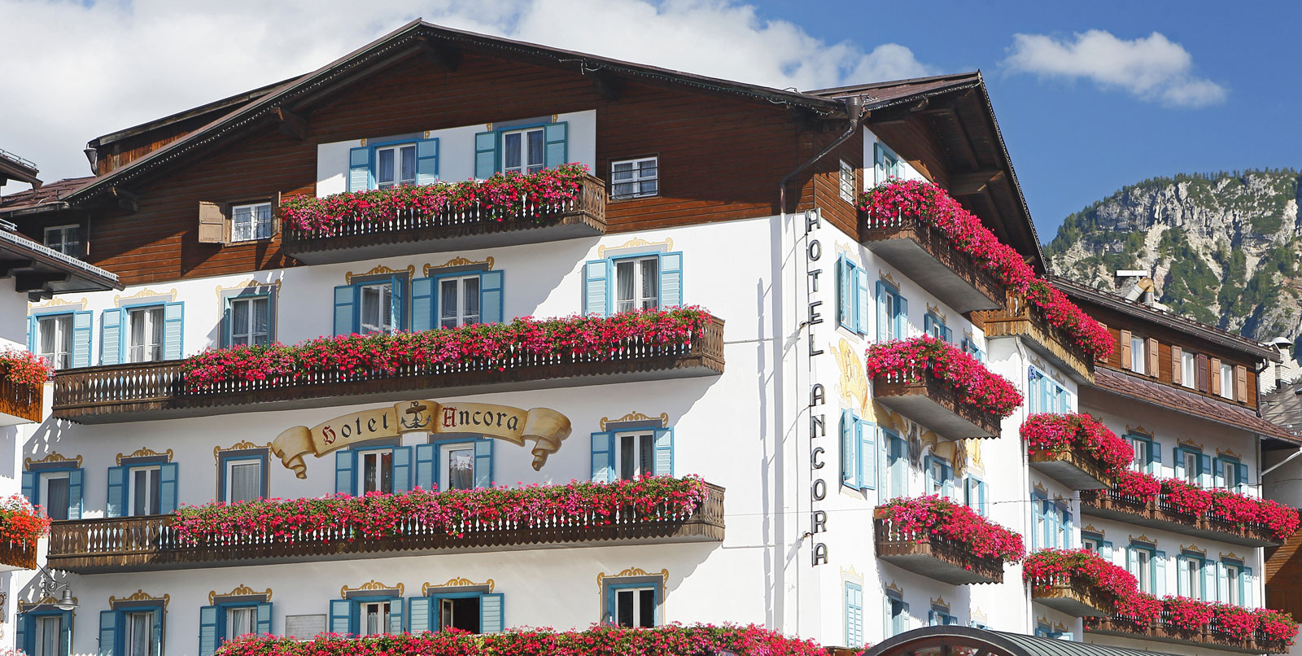
Directly on Finals Venue
10 minute drive from Qualif. Venue

Hotel has, Wi-Fi, continental breakfast and full service restaurant and lounge.

Convention A (Hotels 4 Star)

- Hotel Bellevue
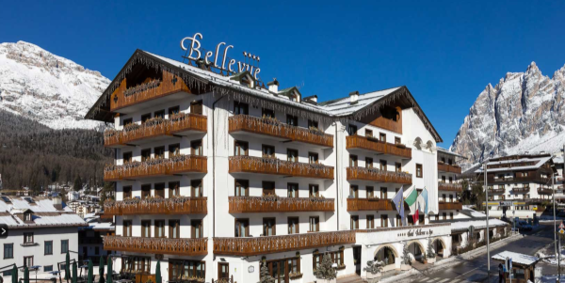
2 minute walk from Finals Venue
10 minute drive from Qualif. Venue

Hotel has, Wi-Fi, continental breakfast and full service restaurant and lounge.

Convention A (Hotels 4 Star)

- Hotel Villa Blu
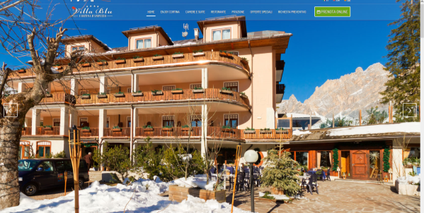
4 minute drive from Finals Venue
10 minute drive from Qualif. Venue

Hotel has, Wi-Fi, continental breakfast and full service restaurant and lounge.

Convention A (Hotels 4 Star)

- Hotel Cortina
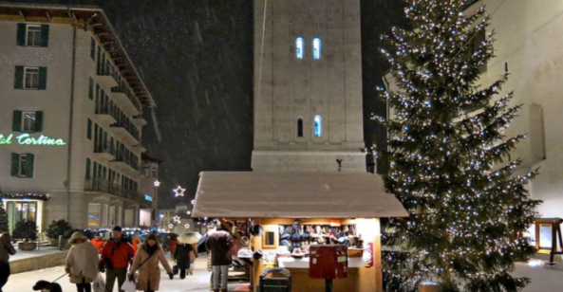
At Finals Venue
10 minute drive from Qualif. Venue

Hotel has, Wi-Fi, continental breakfast and full service restaurant and lounge.

Convention A (Hotels 4 Star)

- Hotel De La Poste
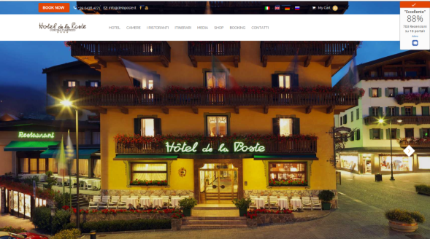
At Finals Venue
10 minute drive from Qualif. Venue

Hotel has, Wi-Fi, continental breakfast and full service restaurant and lounge.

Convention A (Hotels 4 Star)

- Hotel Bellaria
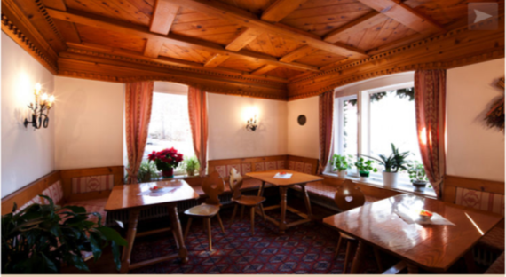
At Finals Venue
10 minute drive from Qualif. Venue

Hotel has, Wi-Fi, continental breakfast and full service restaurant and lounge.

Convention B (Hotels 3 Star)

- Hotel Menardi
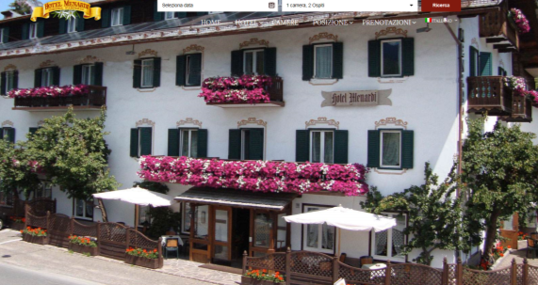
4 minute drive from Finals Venue
10 minute drive from Qualif. Venue

Hotel has, Wi-Fi, continental breakfast
and full service restaurant and lounge.

Convention B (Hotels 3 Star)

- Hotel Panda
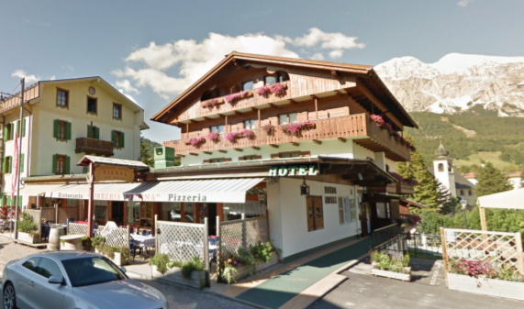
6 minute walk from Finals Venue
12 minute drive from Qualif. Venue

Hotel has, Wi-Fi, continental breakfast

Convention B (Hotels 3 Star)

- Hotel Regina
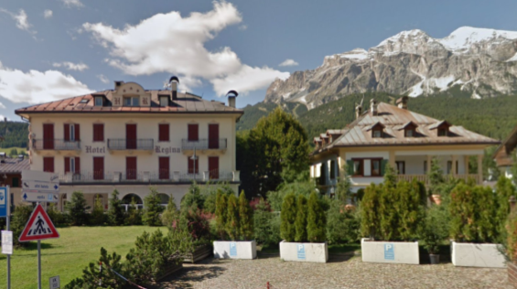
5 minute walk from Finals Venue
10 minute drive from Qualif. Venue

Hotel has, Wi-Fi, continental breakfast

Convention B (Hotels 3 Star)

- Hotel Serena
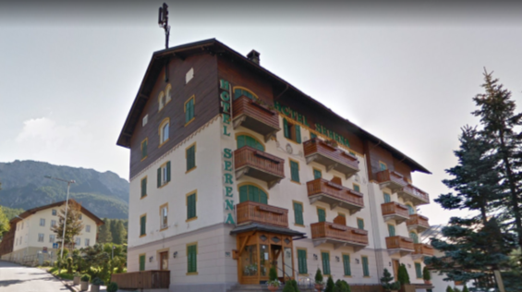
10 minute walk from Finals Venue
12 minute drive from Qualif. Venue

Hotel has, Wi-Fi, continental breakfast
and full service restaurant.

Convention B (Hotels 3 Star)

- Hotel Trieste
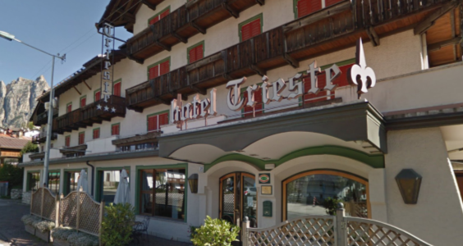
13 minute walk from Finals Venue
12 minute drive from Qualif. Venue

Hotel has, Wi-Fi, continental breakfast
and full service restaurant.

Convention B (Hotels 3 Star)

- Hotel Villa Alpina
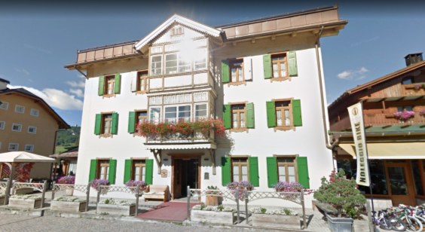
7 minute walk from Finals Venue
12 minute drive from Qualif. Venue

Hotel has, Wi-Fi, continental breakfast
and full service restaurant.

Convention B (Hotels 3 Star)

- Hotel Villa Neve
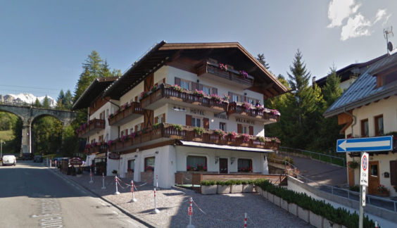
5 minute walk from Finals Venue
12 minute drive from Qualif. Venue

Hotel has, Wi-Fi, continental breakfast

Convention B (Hotels 3 Star)

- Hotel Columbia
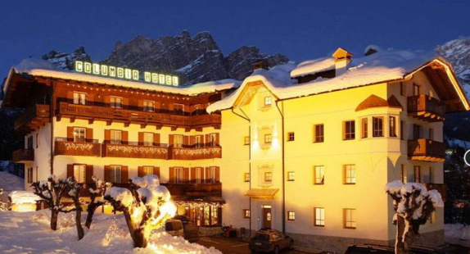
4 minute drive from Finals Venue
8 minute drive from Qualif. Venue

Hotel has, Wi-Fi, continental breakfast

Convention B (Hotels 3 Star)

- Hotel Nord
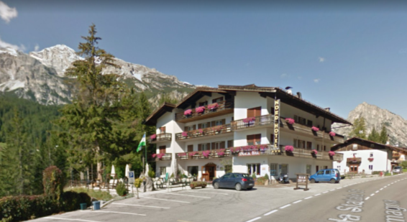
5 minute drive from Finals Venue
12 minute drive from Qualif. Venue

Hotel has, Wi-Fi, continental breakfast

Convention B (Hotels 3 Star)

- Hotel Montana
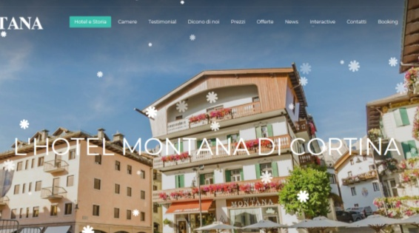
At Finals Venue
10 minute drive from Qualif. Venue

Hotel has, Wi-Fi, continental breakfast

Convention C (Hotels 2 Star)

- Hotel Oasi
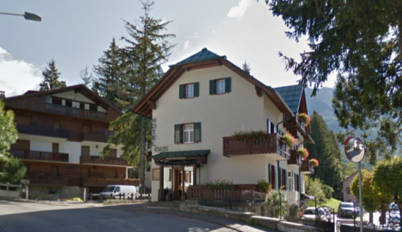
8 minute walk from Finals Venue
10 minute drive from Qualif. Venue

Hotel has, Wi-Fi, continental breakfast

Convention C (Hotels 2 Star)

- Hotel Pontejel
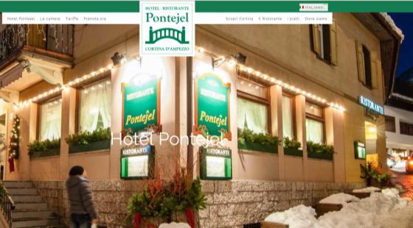
3 minute walk from Finals Venue
10 minute drive from Qualif. Venue

Hotel has, Wi-Fi, continental breakfast
and full service restaurant.

Convention C (Hotels 2 Star)

- Hotel Fiames
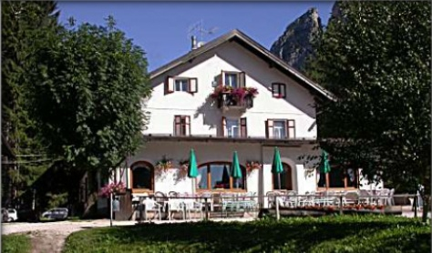
9 min drive from Finals Venue
18 minute drive from Qualif. Venue

Hotel has, Wi-Fi, continental breakfast
and full service restaurant.

Convention C (Hotels 2 Star)

All accommodation requests received outside of the LOC negotiated hotel deadline dates, 01 September 2018 through 10 September 2018 are subject to higher hotel rates.

Hotels are in City Area
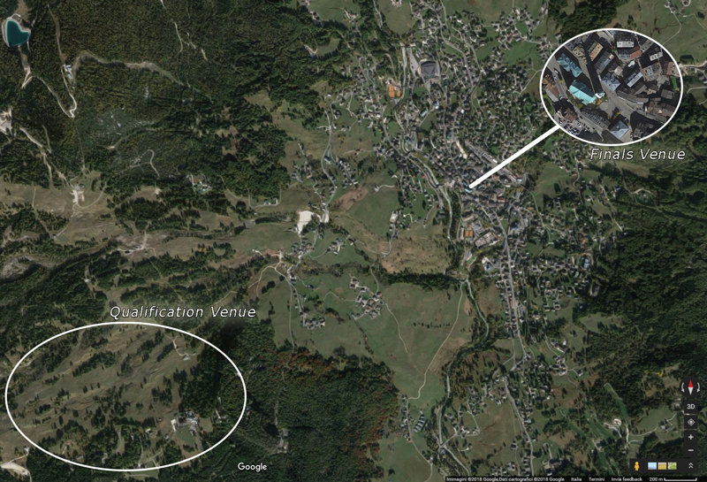
Venue Map >>

https://www.google.it/maps/@46.5351478,12.1180325,3202m/data=!3m1!1e3?hl=it

ENTRY FEE
Entry fee:
Individual: 230 EUR per athlete
Officials: 115 EUR per person

Entry fee in NON-official hotels:
Individual: 460 EUR per athlete
Officials: 230 EUR per person

There is no entry fee for teams.

Entry fees include daily local transport to and from the practice field to/from official hotels during the qualification, elimination and finals venues (timetable to be confirmed on site).

PAYMENT CONDITIONS:
For the payment of accommodation, a 60% deposit of the total amount payable is required and due by 16 June 2018. The final outstanding balance shall be bank transferred before arrival. Accommodation cannot be guaranteed after this deadline. A balanced invoice will be provided via WAREOS.

NOTE:
- Please indicate in the reference/notes section the team or reservation name that corresponds to the payment
- All payment shall be made in EUR by BANK TRANSFER or CASH upon arrival
- All bank wire charges will be paid by the participant
- CREDIT CARDS or TRAVEL CHECKS will not be accepted as payment

BANK INFORMATION for ACCOMMODATION,
TRANSPORTATION and ENTRY FEES:

BANK: CREDITO VALTELLINESE
ADDRESS: PIAZZA SAN FEDELE 4, 20121 MILANO ITALY
BANK ACCOUNT HOLDER NAME: METE TRAVEL & EVENTS SRL
IBAN ACCOUNT NO: IT50O0521601630000000015513
ABI CODE: 05216
CAB CODE: 01630
SWIFT CODE: BPCVIT2S

TO GUARANTEE RESERVATIONS
The 60% of the total amount must be paid in advance by
16 June 2018 made by bank transfer. The balance payment is due before arrival.

ADDITIONAL INFORMATION
Transportation
Transportation will be provided from the official arrival airport, Marco Polo (Venezia) 140 km far from the venue, to the official hotels, two days before the official practice day and one day after the closing day.

The cost of this service is € 30,00 round trip per person

Local transport will be available between official hotels and archery venue. Transport timetables will be confirmed. Buses and/or vans will be provided.

Lunch at the venue
At additional cost, teams can pre-order lunch boxes to consume at the competition venue. To order a lunch box, teams should do so in advance on WAREOS. Lunch boxes will cost € 15,00 per person. Lunch boxes will include:
- Sandwich, Fruit, Cake, Other snack item

There is a possibility that the LOC can provide a hot lunch on venue, however this is subject to the number of requests received.
Please contact booking@metetravelandevents.com if your team is interested in that option. The price per person is €20.

Banquet
The LOC can provide a Gala Dinner on Sunday 9th September, however this is subject to the number of requests received.
Please contact booking@metetravelandevents.com if your team is interested in this option. The price per person is €40.

Ceremonies
All ceremonies will take place in the Cortina Piazza Dibona. Details to be provided.

Water on the Venue
Bottled water will be available on the field free of charge.

Media Registration
Media accreditations can be applied by emailing stampa@fitarco-italia.org

Cancellations & Changes
All cancellations and changes must be made through WAREOS:
- Cancellations received before 21 July 2018 a full refund of the deposit payment will be made.
- Cancellations received after 21 July 2018, no refund will be given.
- Refunds will be processed after the event.
- Name changes to team officials or athletes (same category and division) will be accepted up to 72 hours before the event without any additional charge.
- Should flight arrival details change last minute, please contact the Organising Committee using the details indicated in the Team Managers’ Booklet.
- If a participant’s arrival is later than the original scheduled arrival date, the room will be charged from the date of the original booking in WAREOS.
- An email will automatically notify the Organising Committee and Member Association of any changes made in WAREOS.

Training
At the venue a training field will be available starting from 03 September 2018. The training facility is next to the competition field. For teams who wish to arrive and practice earlier than this date, please contact the LOC directly to make arrangements.

Weather
According to weather information, the average temperature in September is expected to be 42,8 to 60,8°F / 6 to 16 °C.

September 2017 Average Values
T average | T  min | T  max | Humidity | Wind medium | Rain days | Thunderstorms days | Fog days
11.3 °C | 7.1 °C | 14 °C | 78.6 % | 5.7 km/h | 13 | 1 | 1

Internet
Wi-Fi will be available in the official hotels for free (in hotel rooms and in the lobby). There will also be Wi-Fi available at the venue.

LOC Contact for booking queries
Name: Mr. Ernesto Pellegrini, Registration Manager
Email: booking@metetravelandevents.com
Language: Italian, English

Official website www.archeryfieldcortina.it

IMPORTANT INFORMATION REGARDING VISAs
All participants who need an entry visa to Italy, will be required to complete the Visa Support sections in WAREOS by no later than 30 June 2018.

It is the applicants’ responsibility for supplying the necessary information, ensuring all details are up to date, correct and submitted by the deadlines specified.

In addition, all participants that require a visa are kindly requested to supply a copy of their latest/valid passport. Copies of each applicate can be uploaded on WAREOS. All passport copies and personal details entered/uploaded to WAREOS will be held securely and in the strictest of confidence and not shared with other parties.

Please note that the Organising Committee can provide invitation letters for the period of the Field World Championships in Italy only.

