TO ALL World Archery MEMBER ASSOCIATIONS

Dear President,

The World Archery Field Championships will be held in Yankton, South Dakota, United States of America on 3-9 October 2022. This championship series will start at the beautiful Lewis & Clark Lake Archery Field Ranges and end with elimination and finals at the NFAA Easton Yankton Archery Center (NEYAC) Ranges.

On behalf of the Local Organizing Committee (LOC), it is of great pleasure to invite you to participate in this championship.

Please find enclosed the necessary documents of registration, organization and participation for this event. Please complete all the sections in WAREOS before the deadlines:

Summary of deadlines:

* Preliminary Entries 5 July 2022
* Preliminary Hotel Reservation 15 August 2022
* Preliminary Transportation 15 August 2022
* Visa Support 15 August 2022
* Final Hotel Reservation

& Payment 05 September 2022

* Final Transportation 05 September 2022
* Final Entries 12 September 2022

Looking forward to welcoming you in Yankton, United States of America.

Sincerely yours,



Mr. Bruce CULL

President

Organizing Committee

PRELIMINARY PROGRAM:

2 Oct 2022 Arrival of Participants

Sunday Accreditation and Registration

Local transport available

3 Oct 2022 **Official Practice (for all)**

Monday Registration & Equipment Inspection

Team Managers Meeting

Opening Ceremony

4 Oct 2022 **1st Qualification Round**

Tuesday 24 Targets - Unmarked

5 Oct 2022 **2nd Qualification Round**

Wednesday 24 Targets – Marked

6 Oct 2022 **Eliminations**

Thursday

7 Oct 2022 **Individual Semi-Finals**

Friday **Team Quarter & Semi-Finals**

**Team Junior Semi-Finals**

**Mixed Team Semi-Finals**

8 Oct 2022 **Finals -Team**

Saturday Award Ceremonies

9 Oct 2022 **Finals – Individual Finals**

Sunday Award Ceremonies

Closing Ceremony

Banquet

10 Sept 2022 Departure of Teams

Monday

Note: This is a preliminary program and subject to change according to the number of participants and TV requirements. All changes will be published and distributed in advance.

PRELIMINARY & FINAL REGISTRATION

All entries, accommodation reservations, transport needs, flight arrival/departure information and visa invitation letter requests are to be completed using the World Archery Online Registration System WAREOS <https://extranet.worldarchery.sport>. This system handles the entire registration process for this event. No entry forms, hotel reservations or transportation forms will be accepted; all information must be entered into WAREOS.

Member associations can login to WAREOS at <https://extranet.worldarchery.sport> with the username and password assigned by World Archery. After entering WAREOS, selecting the event from the list will allow a member association to register their athletes. Select/press the “Entries” button to see the list of categories in the event. Select/press the “category” to enter the athlete and official numbers/details participating for that event. A WAREOS User Manual can be downloaded in PDF format (English) upon login.

Contact [wareos@archery.sport](mailto:wareos@archery.sport) with any questions regarding **technical problems on WAREOS**. For any question regarding the organisation of the event (transport, accommodation, meals, invoices, visa etc.) please contact **directly the LOC** at ([yankton2022@neyac.org](mailto:yankton2022@neyac.org))

A maximum number of **three (3) athletes per country** (host country included) is allowed to be registered into each category of the event. Preliminary entries have to be completed using WAREOS.

Start date for online registration using WAREOS **2 May 2022**

End of Preliminary registration using WAREOS: **05 July 2022**

End of Final registration using WAREOS: **12 September 2022**

Please respect the stated deadlines.

Member Associations can only use WAREOS to make any changes/amendments to their entries and will be able to do so at any time. An email will be automatically sent to the Organizing Committee and Member Association with the updated information in WAREOS.

Any changes that are made after the deadlines specified or if entries differ by more than 2 athletes from the preliminary entries, the following penalty fees will automatically be applied.

|  |  |
| --- | --- |
| **Penalty fees to be paid to Organizing Committee:** | **Cost (USD):** |
| Entries made after the preliminary and/or final entry deadline date. | **50** per entry |
| If final entries differ from the preliminary entries by more than 2 athletes/officials. | **150** per entry |
| Failure to have made preliminary entries before the deadline date but then have submitted final entries. | **150** per entry |

|  |  |
| --- | --- |
| **Penalty Fee to be paid to World Archery:** | **Cost (CHF):** |
| Lost accreditation. | **30** each |
| Changes made to the athlete and/or team official names after the final entry deadline date and within 3 days prior to the start of the event. | **50** each change |

**NOTE:** CHF currency exchange rates will be those on the date of the event.

Member Associations that have penalty fees outstanding from 2021 will need to have paid these penalty fees before being eligible to enter and compete.

Any entries received less than 3 days before the team managers meeting for the World Championships will be refused if no preliminary entry and/or final entry are made prior. This decision cannot be appealed by the teams and is fully compliant with the current World Archery rules, article 3.7.1.2. Entries received after the deadlines, are subject to penalties as clearly stated in the rule book and the invitation documents of the World Championships. A Member Association that has made final entries in WAREOS and does not participate will be invoiced for the number of entries entered in the system, unless they have informed World Archery and the Organizing Committee in writing at least one week prior to the event that they are unable to attend.

ACCOMMODATION & GENERAL INFORMATION

The official hotels are Best Western/Kelly Inn, Comfort Inn, Holiday Inn Express and Lewis & Clark Resort. Due to limited capacity a “First Come, First Serve” policy will be followed. All hotels are on the shuttle route. The accommodation cost will include breakfast and lunch. Dinner will be provided each night at the NFAA Easton Yankton Archery Center for an additional cost. If teams don’t purchase the dinner option, they will be responsible for own meals and evening transportation to meals.

Teams who do not reserve their accommodation through the organizing committee will be charged a double entry fee.

* Reservations should be made on or before **15 August 2022**
* Final Hotel Reservation & Transportation on or before **05 September 2022**

To confirm the reservation, a 50% deposit of the total amount is required to be bank transferred to the LOC on or before **15 August 2022**. Reservations after this date will be considered only according to availability.

**IMPORTANT!**

Please, note that there will be a limited number of rooms at each hotel. To ensure that you stay at your preferred hotel, please book your hotel as soon as possible. Reservations are only final after the LOC has received the deposit of 60%. Due to limited capacity a ‘First Come, First Serve’ policy will be followed. According to the availability of the rooms, the LOC reserves the right to direct the teams to the hotels of the same level. Most hotels do not have a restaurant, but dinner option is available each evening at the NFAA Easton Yankton Archery Center.

The hotel room rates are per room, per night, including Wi-Fi, breakfast at the hotels, lunch at the venues and local transportation.

In addition, the LOC will not be responsible to provide event information to any hotel not on the official accommodation list.

Teams that book non-official accommodation will need to register at the accreditation desk no later than the day before official practice day. Failing to do so will result in no changes being made to the entry list and it is likely that participation in the event will be refused if registration is not completed in time.

Hotels:

1. Best Western Kelly Inn

Located next to elimination & final NFAA Easton Yankton Archery Center venue

15-minute drive to Lewis & Clark Archery Field venue

Hotel has a pool area (with hot tub), Wi-Fi, and full-service restaurant and lounge

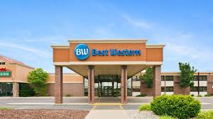 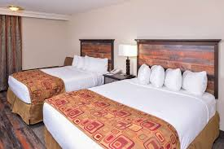 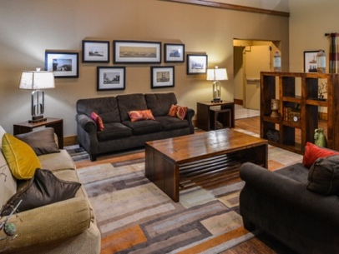

* Single Room (includes breakfast, lunch and local transport for 1 person) $175.00 USD - Number of Rooms: 30
* Double Room (includes breakfast, lunch and local transport for 2 people) $230.00 USD - Number of Rooms: 40

Hotel website <https://www.bestwesternyankton.com/>

1. Comfort Inn

8-minute drive to elimination & finals venue at NFAA Easton Yankton Archery Center

15-minute drive to Lewis & Clark Archery Field venue

No restaurant or lounge on property. A variety of restaurants are within walking distance.

Hotel has Wi-Fi, fitness center, indoor whirlpool/hot tub and sauna.

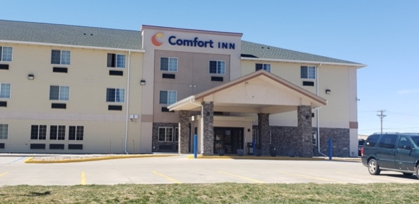 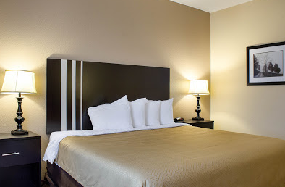 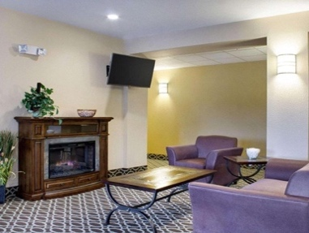

* Single Room (including breakfast, lunch & local transport for 1 person) $165.00 USD - Number of Rooms - 10
* Double Room (including breakfast, lunch & local transport for 2 people) $220.00 USD - Number of Rooms - 20

Hotel website <https://www.choicehotels.com/south-dakota/yankton/econo-lodge-hotels>

1. Holiday Inn Express

8-minute drive to eliminations & finals venue at NFAA Easton Yankton Archery Center

15-minute drive to Lewis & Clark Archery Venue

Hotel has pool area (with whirlpool) and Wi-Fi

No restaurant or lounge available at property. A variety of restaurants are within walking distance.

Wal-Mart is a 5-minute walk from the hotel

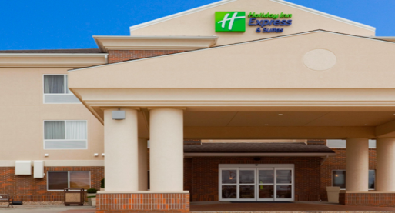 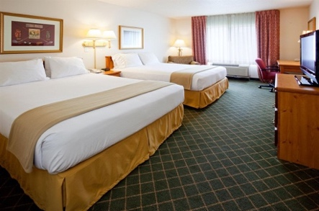 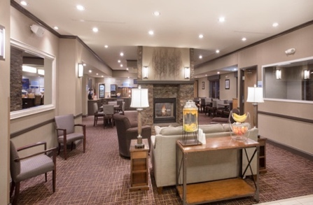

* Single Room (including breakfast, lunch & local transport for 1 person) $195.00 USD - Number of Rooms: 10
* Double Room (includes breakfast, lunch & local transport for 2 people) $250.00 USD - Number of Rooms: 20

Hotel website <https://www.ihg.com/holidayinnexpress/hotels/us/en/yankton/yknsd/hoteldetail>

4a. Lewis & Clark Resort Motel

Enjoy this beautiful lakefront property, located minutes from the Lewis & Clark qualification venue. Sit around the campfire or enjoy miles of scenic walking paths.

15-minute drive to elimination & finals venue at NFAA Easton Yankton Archery Center

Rooms each have Wi-Fi, a microwave and dorm size refrigerator.

No restaurant or lounge available on property

One restaurant within walking distance.

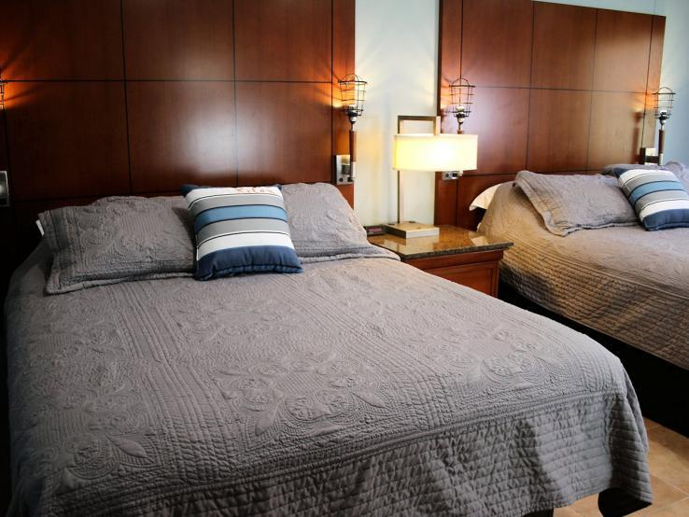 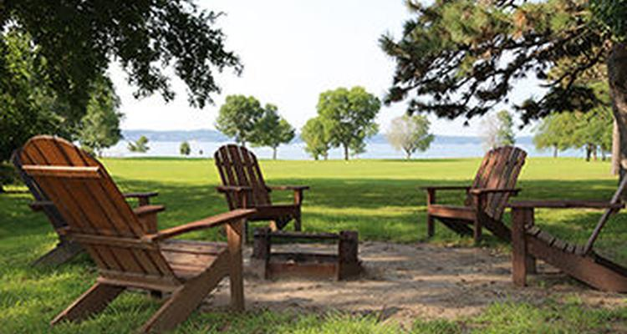 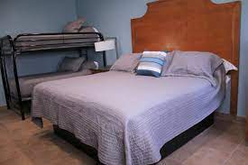

* Double Room (includes breakfast, lunch & local transport for 2 people). $225.00 USD - Number of Rooms: 8
* Triple Room - Queen Bed & Twin Bunk Beds (includes breakfast, lunch & local transport for 3 people) $290.00 USD - Number of Rooms: 16

Hotel website: <https://lewisandclarkpark.sd.gov/cabin-motel-lodge-information.aspx>

4b. Lewis & Clark Resort Cabins

Enjoy this beautiful lakefront property, located minutes from the Lewis & Clark qualification venue. Sit around the campfire or enjoy miles of scenic walking paths.

15-minute drive to elimination & finals venue at NFAA Easton Yankton Archery Center

No restaurant or lounge available on property - kitchen facilities available in cabins.

One restaurant within walking distance.

All cabins contain:

* Toaster, Microwave, Refrigerator, Stove, Skillet, Plates, Sauce Pan, Cups, Glasses, Bowls, Silverware, Utensils, Picnic Table and Campfire Pit with cooking grate.

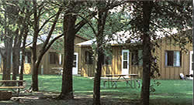 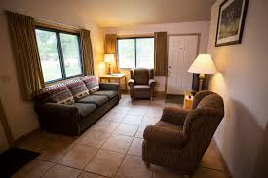 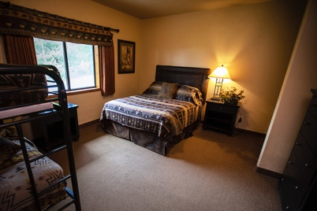

* Four-person, two bedroom cabin (2 Queen beds, 1 Twin Bunks) -includes breakfast, lunch & local transport for 4 people $410.00 USD

Number of cabins - 2

* Five-person, three bedroom cabin (3 Queen beds, 1 Twin Bunks) – includes breakfast, lunch & local transport for 5 people $490.00 USD

Number of cabins – 12

* 10-person, four bedroom cabin (6 Queen beds, 2 Twin Bunks) - includes breakfast, lunch & local transport for 10 people $1,100.00 USD

Number of cabins – 2 - *NEW CONSTRUCTION IN 2021! View details* [*here*](https://www.lewisandclarkresort.com/cottages.php)*.*

Hotel website: https://www.lewisandclarkresort.com/

1. **Yankton Inn**

Located across the parking lot of the NFAA Easton Yankton Archery Center

Economy hotel with microwave and refrigerator in rooms.

Restaurant and lounge within walking distance.

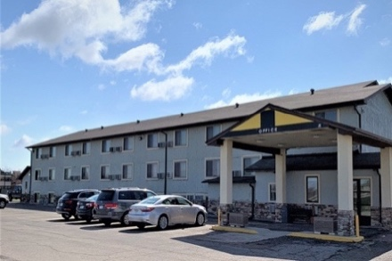 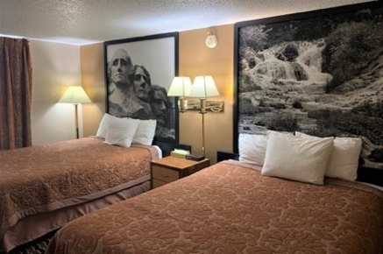 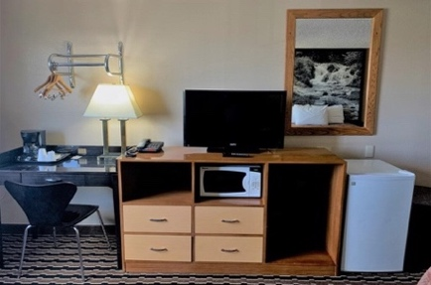

* Single Room (including breakfast, lunch & local transport for 1 person) $140.00 USD - Number of Rooms: 10
* Double Room (includes breakfast, lunch & local transport for 2 people) $195.00 USD - Number of Rooms: 25

Hotel Website: <https://www.yanktoninn.com/>

**ENTRY FEE**

**Entry fee:**  
Individual: 250 USD per athlete

Officials: 125 USD per person

Guest: 150 USD per person

VIP*: 250 USD per person

**Entry fee for NON-official hotel bookings:**

Individual: 500 USD per athlete

Officials: 250 USD per person

There is no entry fee for teams.

Entry fees include daily local transport to and from the practice field to/from official hotels during the qualification, elimination and finals venues (timetable to be confirmed on site).

*VIP ACCESS – Must be approved by LOC before credentials are issued. Examples of VIP’s include Presidents of Federations, Secretary General, World Archery Officers, etc. VIP credentials provide access to VIP area at finals venue and specialized transportation. Please note - transportation is not available from non-official hotels.

VIP and Guest entry fees do not include Field of Play access for qualification or elimination rounds.

**PAYMENT CONDITIONS:**  
The entry fees should be paid in full before arrival.

To confirm hotel reservations, a minimum 50% deposit of the total amount is required to be bank transferred to the LOC on or before **15 August 2022**. Reservations after this date will be considered only according to availability. The final outstanding balance shall be made via bank transfer before arrival. Accommodation cannot be guaranteed after this deadline. A balanced invoice will be provided via WAREOS.

**BANK INFORMATION for ACCOMMODATION, TRANSPORTATION and ENTRY FEES:**

BANK: US Bank  
BANK ADDRESS: Waterfall Plaza, 6145 S. Minnesota Ave

CITY/STATE Sioux Falls, SD

ZIP: 57108  
BANK PHONE NUMBER: 605-335-0680

BANK ACCOUNT HOLDER NAME: National Field Archery Association Foundation

ABA NUMBER/ROUTING NUMBER: 091408501  
ACCOUNT NUMBER: 175091635730  
SWIFT CODE: USBKUS441MT

NOTE: ALL PAYMENTS SHALL BE MADE IN USD BY BANK TRANSFER.

All bank charges will be paid by the participants. CREDIT CARDS are not accepted.

**Cancellations & Changes**

All cancellations and changes must be made through WAREOS:

* Cancellations received before 15 September 2022 a full refund of the deposit payment will be made.
* Cancellations received on or after 15 September 2022; no refund will be given.
* Refunds will be processed after the event.
* Name changes to team officials or athletes (same category and division) will be accepted up to 17:00 hrs., two (2) days before official practice without any additional charge or penalty fees.
* Should flight arrival details change last minute, please contact the Organizing Committee using the details indicated in the team managers’ booklet.
* If a participant’s arrival is later than the original scheduled arrival date, the room will be charged from the date of the original booking in WAREOS.
* An email will automatically notify the Organizing Committee and Member Association of any changes made in WAREOS.

**HEALTH REGULATIONS (COVID-19)**

**INFORMATION:**

* Everybody should follow the Government/public health authorities measures (national and sport-specific regulations) and be aware of the travel restrictions.
* For your information, Medical Infrastructure/Hospital with proper care will be reachable within 10 minutes from venue, where COVID-19 test can be done.

**PERSONAL HYGIENE AND HEALTH ADVICE:**

* Anyone due to participate in the event who is feeling ill should not attend.
* Participants (athlete, volunteer, official, etc.) should proactively and regularly check their health status (including taking their temperature and monitoring for any symptoms).
* Stay home and self-isolate even with minor symptoms for 10 days or more depending on national protocols, when showing any symptoms (fever, tiredness, dry cough, headache, nasal congestion, runny nose, sore throat, difficulty breathing).
* Contact a healthcare provider immediately if any respiratory illness is noted.
* Masks to be worn at all times everywhere (transport, common area in the hotel, venue, training, etc.) except on shooting line.
* Regularly and thoroughly clean your hands with an alcohol-based hand rub or wash them with soap and water.
* Avoid touching eyes, nose and mouth.
* Cover your mouth and nose with your bent elbow or tissue when you cough or sneeze. Then dispose of the used tissue immediately and wash your hands.
* Avoid touching high-contact surfaces such as door handles, walls or windows, etc.
* Avoid going to crowded places.
* Avoid steam rooms and saunas.
* No spitting, as the main mode of transmission of the virus is in respiratory secretions.
* No handshakes, high fives and any other personal contact.
* Athletes should not share clothes, bar soap, sports equipment, water bottles or other personal items.

**VENUE:**

* Access to the venue might be denied at any time in case of disease suspicion
* Limit contact/interactions
* Handwashing/alcohol – based hand gel will be available at multiple locations in the event facility and accommodation.
* Regular toilet cleaning will be done (at least once per session).
* Tissues and containers will be at disposal to dispose of used tissues on transport to venue, at the venue and any other facility.
* No shows allowed. Winners will receive their medals in a simple ceremony only with the winners and their team, all wearing masks.
* Medical post and designated personnel on site able to help assess cases and potential other illness will be present.
* An isolation room/space to hold any symptomatic person found at the venue will be available.
* Space on shooting line shall be 1.00 meter minimum per athlete.

**PARTICIPANTS:**

* Maintain the staff/team to a minimum to minimize transmission.
* Maintain social distancing, at least 6 feet / 2 meters distance between yourself and others at all times.

**COVID-19 TESTING:**

COVID-19 testing, PCR test with travel certificate, will be available for participants prior to departure home. Expense for tests will be added closer to the event. All expenses are the responsibility of the participant and shall be booked through WAREOS in the “Extras” section.

**ADDITIONAL INFORMATION**

**Transportation**

Transportation will be provided from the two official airports:

Joe Foss Regional Airport in Sioux Falls, SD (FSD) 80 mi /130 km from the venue, to the official hotels, two days before the official practice day and one day after the closing day.

Eppley Airfield in Omaha, NE (OMA) 156 mi / 251 km from the venue, to the official hotels, two days before the official practice day and one day after the closing day

The cost of this service is $20 USD per person one way to/from Sioux Falls Airport and $30 USD per person one way to/from Omaha Airport.

Local transport will be available between official hotels and archery venues. Transport timetables will be confirmed. Buses and/or vans will be provided.

**Lunch at the venues**

Lunch is included in hotel charge. Those signed up through official hotel bookings will be provided a box lunch on practice and qualification days. On elimination and finals days – a warm lunch will be provided at the NFAA Easton Yankton Archery Center.

**Dinner**

At an additional cost, teams can sign up for dinner service which will take place each evening at the NFAA Easton Yankton Archery Center. To order this option, teams should do so in advance on WAREOS. The charge each night for dinner at the center will be $20.00 per person. Teams that don’t sign up for dinner service at the complex will be responsible for their own meals and evening transportation to and from meals.

**Banquet**

The LOC will provide a Gala Dinner on Sunday the 9th of October.   
Please sign up in WAREOS if selecting this option. Price is $40 USD per person.

**Ceremonies**

All ceremonies will take place at the NFAA Easton Yankton Archery Center. Details to be provided.

**Water on the Venue**

Bottled water will be available on the field free of charge.

**Media Registration**

Media accreditations can be applied by registering online at yankton2022.org/media-registration.

**Training**

A training field will be available starting 26 September 2022. The training facility is at the NFAA Easton Yankton Archery Center. Teams who wish to arrive and practice earlier than this date, please contact the LOC directly to make arrangements. A fee of $10.00 per day/per person will be charged and individuals will have access to both the indoor and outdoor facilities.

**Weather**

According to weather information, the average temperature in October is expected to be 45 to 70°F / 7 to 21°C. It is recommended to dress in layers as temperatures will vary throughout each day. Qualification ranges may include areas of rough terrain, please bring appropriate footwear. Average sunrise is 7:30AM and average sunset is 7:00PM.

**Internet**

Wi-Fi will be available in the official hotels for free (in hotel rooms and in the lobby). There will also be Wi-Fi available at the NFAA Easton Yankton Archery Center venue.

LOC Contact for booking queries: yankton2022@neyac.org

Official website: [yankton2022.org](http://www.Yankton2020WAFC.com)

**IMPORTANT INFORMATION REGARDING VISAs**

Application for and obtaining travel visas to the United States are completely and solely the responsibility of the participating teams. A visa will be required of all visitors to enter the United States with the exception of Canada and the 38 nations that are part of the “Visa Waiver Program.” The process for obtaining a visa requires each individual to submit an application through a U.S. Embassy or U.S. Consulate. This is a process that MUST be done by the applicant – the organizing committee cannot do it for you!

VISA WAIVER PROGRAM COUNTRIES

Andorra France Liechtenstein Singapore

Australia Germany Lithuania Slovakia

Austria Greece Luxembourg Slovenia

Belgium Hungary Malta Spain

Brunei Iceland Monaco Sweden

Chile Ireland Netherlands Switzerland

Czech Republic Italy New Zealand Taiwan

Denmark Japan Norway United Kingdom

Estonia Korea, Republic of Portugal

Finland Latvia San Marino

**All participants will be required to complete the Visa Support sections in WAREOS by no later than 15 August 2022**.

It is the applicants’ responsibility for supplying the necessary information, ensuring all details are up to date, correct and submitted by the deadlines specified.

In addition, all participants that require a visa are kindly requested to supply a copy of their latest/valid passport. Copies of each applicate can be uploaded on WAREOS. All passport copies and personal details entered/uploaded to WAREOS will be held securely and in the strictest of confidence and not shared with other parties.

Please note that the Organizing Committee can provide invitation letters for the period of the Field World Championships in United States only.

ARCHERY VENUES:

NFAA Easton Yankton Archery Center  
800 Archery Lane, Yankton, SD, 57078

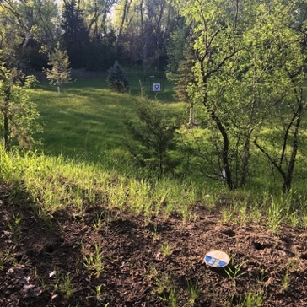 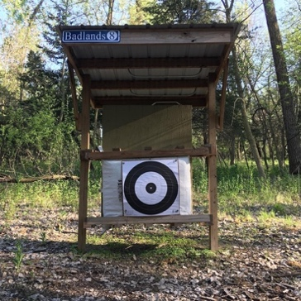 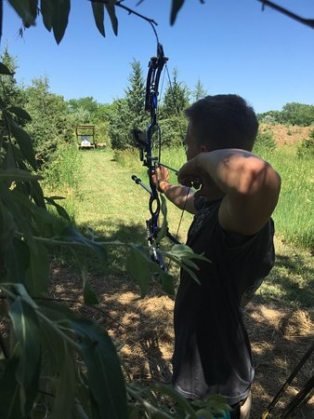

Yankton, South Dakota is the home of National Field Archery Association Foundation, and the first of the [Easton Foundations](http://www.esdf.org/) Archery Centers. Situated on over 130 acres; the [NFAA Easton Yankton Archery Center](http://www.neyac.org/) includes three outdoor field ranges, a 3D range, two FITA ranges, two 90m indoor ranges, two classrooms, a fitness studio, an art studio and the NFAA Foundation Archery Museum.

In 2007, Yankton beat out several Midwest cities to become the new headquarters’ of the [National Field Archery Association (NFAA)](https://www.nfaausa.com/). The original plan called for a 4,000 square foot office building to house the NFAA staff. In partnership with the NFAA Foundation, the Easton Foundations saw the opportunity to add on to the NFAA Headquarters and create a multi-million-dollar, state-of-the-art archery training facility. With incentives from the City of Yankton, the county and the state of South Dakota; the low cost made it impossible for the Easton Foundation to refuse. With that, the project grew to over 20,000 square feet.

In 2011 and again in 2017, the NFAA Foundation broke ground again with two separate expansion that added a combined 50,000 square feet and extended the building to include the World’s first indoor 90-meter range and an archery distribution warehouse. The ranges have a combined 38 targets with 76 full-length shooting lanes, in a climate-controlled environment for year-round shooting. With movable targets, the range can be set up for shooting at any distance, and can accommodate as many as 80 targets for 18-meter (20 yard) tournaments.

Easton Field and First Dakota Field are 90-meter grass fields with room for a combined 130 targets and 260 shooting lanes. Awnings cover the entire width of the ranges, providing shade for the archers between ends, and a lawn behind the shooting line allows for spectators.

Lewis & Clark Archery Field Range

43349 SD Hwy 52, Yankton, SD

 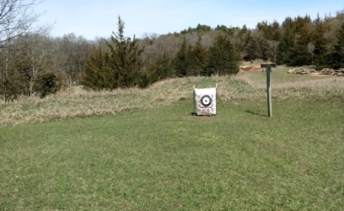 

Archers may take advantage of a 28-target NFAA (National Field Archery Association) certified archery range, as well as a practice range. The archery range is set up into two, 14-target rounds and is laid out in a wooded section of the park, giving archers a natural setting to enjoy their sport with an elevated shooting platform with a 6’ and 12’ level for shooting at 3D targets.

**THE CITY OF YANKTON:**

Yankton may be South Dakota's most historic town located on the northern bank of the Missouri River. Life in Yankton has always revolved around the Missouri River. Native Americans followed the river's flow to their destination’s centuries ago. Citizens today use the river for various recreational activities that include: boating, fishing, kayaking and skiing.

This quaint town of almost 15,000 people has 14 parks with over 263 acres of green space. While in Yankton you will have to opportunity to experience the majestic beauty of the Meridian Bridge; the longest walking bridge in the United States that connects two states, South Dakota and Nebraska.

**Population**

Yankton City: 14,852  
County: 22,979  
State of South Dakota: 895,376

**Elevation**

City: 1,211 feet 369 meters

**Area Attractions:**

Lewis & Clark Lake Area

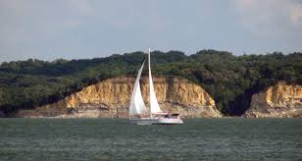 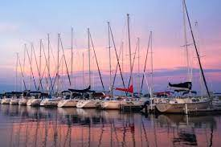 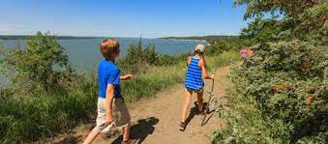

Lewis and Clark Lake is one of the state park system's most popular resort parks. Three separate campgrounds comprise this modern recreation area, attracting visitors from throughout the Midwest. Modern resort facilities - from marinas to camping cabins to sandy beaches - attract water lovers to Lewis and Clark.

Meridian Bridge and Meridian Plaza

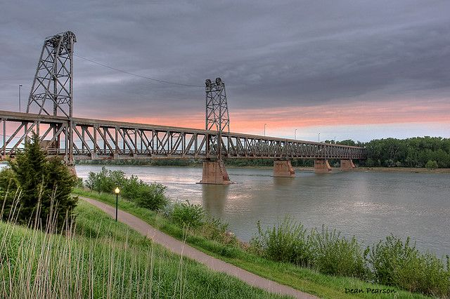 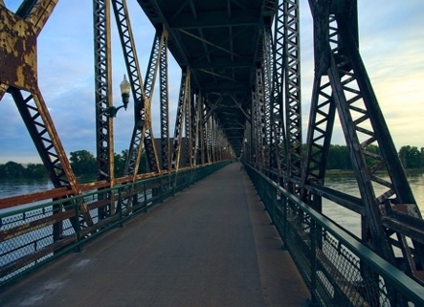 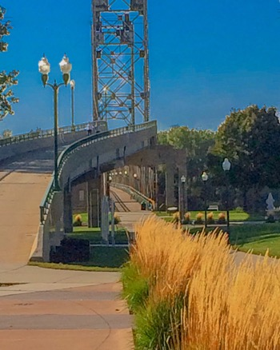

The Meridian Bridge, a landmark in Yankton since 1924, is the result of hard work and determination of local citizens. The bridge closed to vehicle transportation in October 2008, but opened in November 2011 to foot traffic. The bridge welcomes both foot and bike traffic. Spanning over 3,209 feet, the Meridian Bridge is the longest pedestrian bridge connecting two states, Nebraska and South Dakota. It officially opened on October 11, 1924 and was the first permanent bridge crossing the Missouri River. This unique bridge is a “double-decker” with one lane positioned above another. It was constructed as a lift-span bridge to allow riverboat traffic to traverse the river. Up until 1953, it was operated as a toll bridge.

The Meridian District:

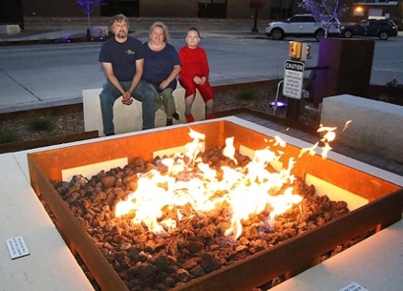 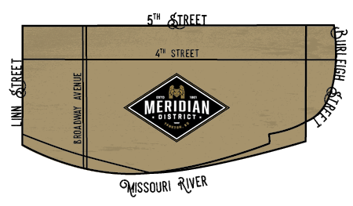 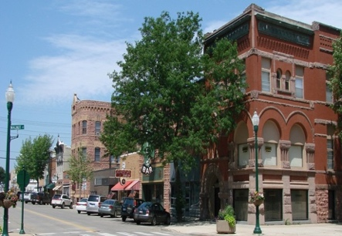

Stroll through the downtown area and browse many individually owned and operated businesses and unique shops. You’ll discover specialty gift, clothing and antique shops, as well as art galleries, home furnishing, decorating and business services, food, drink and entertainment all to suit your needs. Historic downtown Yankton offers small town charm, unique architecture and area attractions and events all year round. Located along the Missouri River, just blocks away from historic neighborhoods, sites, museums and community parks.

Missouri National Recreational River:

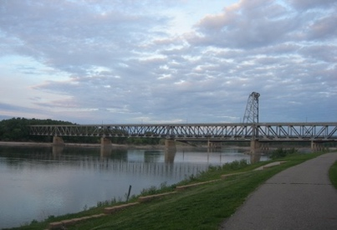 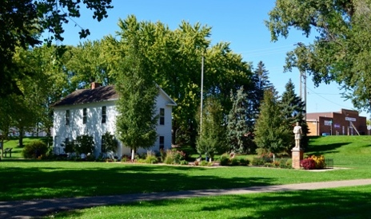 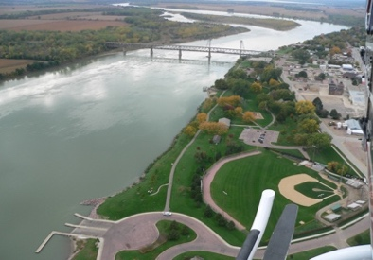

Did you know Yankton has a National Park? That’s right, the Missouri National Recreational River runs right along Yankton’s historic waterfront. Come discoer beautiful stretches of the Missouri River with plenty of outdoor activities, including miles of trails for hiking, biking, running and paddling. Start your visit at Riverside Park where there are exhibits detailing the history of the Lewis & Clark Expedition, the steamboat era and the Dakota Territorial Capital. The Meridian Bridge offers a wonderful vantage point to look up and down the Recreational River’s Wild and Scenic waters.

**Additional community information can be located at http://www.cityofyankton.org and http://www.visityanktonsd.com/.**