TO ALL World Archery MEMBER ASSOCIATIONS

Dear President,

On behalf of the Organising Committee (OC) of the World Indoor Archery Championships 2016, Ankara – Turkey and The Turkish Archery Federation, we would like to invite your country to the World Archery Indoor Championships 2016, which will be held from 1 to 6 March in Ankara, the capital of Turkey.

To register participation, please find enclosed the necessary documents and return your completed forms within the deadlines listed below:

Summary of deadlines:

- Hotel Reservation Form & Deposit 2 December 2015
- Preliminary Entries 2 December 2015
- Visa Support Form 6 January 2015
- Final Hotel Reservation Form 6 January 2016
& Remaining Payment
- Transportation Form 9 February 2016
- Final Entries and entry payment 9 February 2016

We are looking forward to welcoming you and your teams, to Ankara – Turkey.

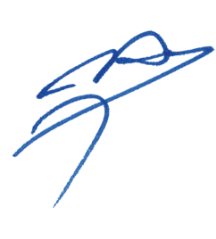
Sincerely yours,

Husnu Kocaoglu
Chairman of the Organising Committee
&
The President of the Antalya Archery Club

PRELIMINARY PROGRAMME
Day |  | Date | Description
 | Sunday  28 February |  | Arrival of Participants  Unofficial practice  Transport available
DAY 0 | Monday  29 February |  | Arrival of Participants  Unofficial practice  Transportation available
DAY 1 | Tuesday  1 March |  | Official Practice (For all)  Equipment Inspection  Team Managers Meeting 16:00 at the “Congresium” venue.  Opening Ceremony
DAY 2 | Wednesday  2 March |  | Qualification Round (All Categories)  Individual Eliminations 1/16th for all
DAY 3 | Thursday  3 March |  | Individual Eliminations (All Categories)  1/8th to semifinals
DAY 4 | Friday  4 March |  | Team Eliminations (all categories)  1/8th to semifinals
DAY 5 | Saturday  5 March |  | Finals Recurve – Individual and Team  - Junior (Girls and Boys categories)  - Recurve (Women and Men)  - Award Ceremonies
DAY 6 | Sunday  6 March |  | Finals Compound – Individual and Team  - Junior (Girls and Boys)  - Compound (Women and Men)  - Award Ceremonies  - Banquet
 | Monday  7 March |  | Departure of Participants

NOTE: This is a preliminary programme and subject to change according to the number of participants in each division and TV requirements. All changes will be published and distributed to all participants in advance.
PRELIMINARY & FINAL REGISTRATION
All registration process must be completed using the World Archery Online Registration System (WAREOS): http://register.worldarchery.org. No entry forms will be accepted for registering to this event.

A maximum number of three athletes per country (host country included) are allowed to be registered into each category of the event. Preliminary entries have to be completed using the WAREOS.

Team Managers that wish to use their junior athletes in the senior team competition, should enter their junior athletes in the senior individual competition only, to compete as a senior athlete and not participate in the junior competition.

In order to use WAREOS, please login on http://register.worldarchery.org with your Username and Password assigned by World Archery. After entering the WAREOS, please go to "Online Registration" and register your athletes for this event. A "WAREOS User Manual" can be downloaded in PDF format (English) using the same website link.

For any questions regarding the WAREOS, please contact the World Archery office, Mr JK Lee (jklee@archery.org).

Start date for online registration using WAREOS 1 September 2015
End of Preliminary registration using WAREOS: 2 December 2015
End of Final registration using WAREOS: 9 February 2016

Please pay attention to the stated deadlines. Teams will not be able to enter or update their data in WAREOS, after the deadlines, as the system will be blocked. If, teams wish to make any changes to their Final Registration, after the deadline, you need to contact Mr JK Lee, World Archery Member Services Coordinator (jklee@archery.org).

Final Entries processed after the deadline will result in a penalty fee of 50 Euros per athlete to be paid to the LOC upon arrival at the field.

Final registrations that differ by more than four athletes from the preliminary registration or have been submitted after the preliminary deadline will result in a penalty fee of 150 Euros to be paid to the LOC upon arrival at the field.

Any entries received less than three days before the team managers meeting for a World Championships will be refused if no preliminary entry and/or final entry were made prior. This decision cannot be appealed by the teams and is fully compliant with the current World Archery rules, article 3.7.1.2. Entries received after the deadlines, are subject to penalties as clearly stated in the rule book and the invitation documents of World Cups and World Championships. A Member Association that has made final entries in WAREOS and does not participate will be invoiced for the number of entries entered in the system.

Member Associations that have penalty fees outstanding from 2015 will need to have paid these penalty fees before being eligible to enter and compete.

ACCOMMODATION & GENERAL INFORMATION
Teams who do not reserve their accommodation through the LOC will be charged a double entry fee. 300 euro (athletes) / 200 euro (officials).

- Hotel Reservations should be made before: 2 December 2016
- Final Hotel Reservation 6 January 2016
- Transportation Forms: 9 February 2016

To confirm your hotel reservations, a 60% deposit, of the total amount, is required to be transferred, to the LOC before 2 December 2015, via a bank transfer, using the details provided on page 18. Reservations received after these dates will be considered according to availability.

IMPORTANT! Please note that there will be a limited number of rooms at each hotel. To ensure that you stay at your preferred hotel, please send the Hotel Reservation form ASAP. Note, that the reservation is final only after the OC have received 60% deposit. We will use the principle of first come first served. Also note that it will not be possible to refund the deposit after 1 November.

There are two official hotels:
1. The Green Park Hotel (5 Star)
Single room 195 Euro
Double room 270 Euro
2. Bilkent Hotel (5 Star)
Single room 190 Euro
Double room 260 Euro

The hotel room rates are per room, per night, including free internet, full board, breakfast and dinner at the hotels, lunch will be served at the venue. Meals include water, tea and coffee. Additional purchases in the hotel bar, café and minibar is at own expense. Please refer to accommodation pages below for detailed hotel information.

The Green Park Hotel *****

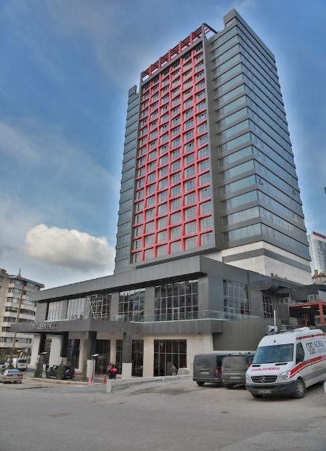
Featuring a free indoor pool and wellness centre, the 5-star.
Green Park Hotel Ankara is located in Ankara. This property offers a restaurant, a free fitness centre and free Wi-Fi throughout.
Our guests may try different Mediterranean or World Cuisine during their stay. Green Park Hotel Ankara offers one Breakfast Restaurant, Café & Bistro and one A la Carte Restaurant.

Spacious and air conditioned, rooms here will provide you with satellite flat-screen TV, a safe and a minibar. Each room has a private bathroom with a hairdryer, slippers and free toiletries. The hotel offers 227 Standard, 48 Deluxe, 2 Suit, 1 King and 1 disabled room.
Located in one of the most popular centres of the city Green Park Hotel Ankara is frequently preferred for both national and international business meetings and congresses. Within the compass of congress or business meeting the hotel is capable of hosting 1500 participants.
Ankara Esenboga Airport is 35-minute drive away.
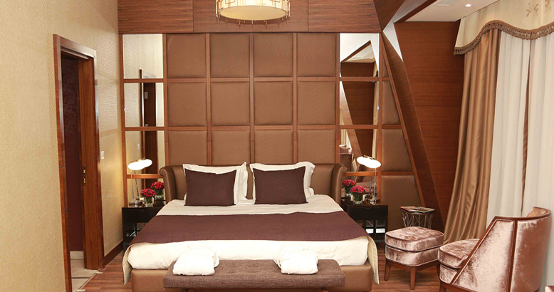
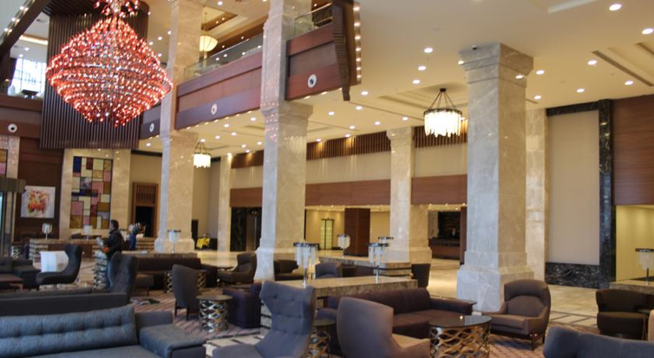

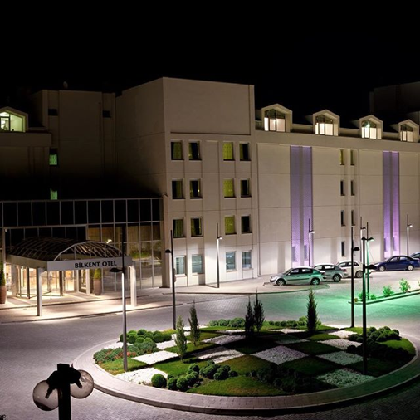
Bilkent Hotel *****

This deluxe 5-star hotel features a full-service spa and a multifunctional business centre. The in-house restaurant serves a contemporary interpretation of Turkish and Mediterranean cuisine. The hotel has 21 multipurpose rooms reserved for congresses and meetings. The hotel is located in the Bilkent district, in the west of Ankara. The railway station is 13 km away. Bilkent University is located 1 km from Bilkent Hotel. The hotel provides a total of 235 rooms 164 of which are non-smoking. Flat-screen TVs and free Wi-Fi are standard in all guest rooms at Bilkent Hotel and Conference Center. Some rooms include a private spa bath and access to the Executive Lounge.
The North Shields Pub offers pints of imported British beer with international sports broadcasts or live music. Hand-made cakes and desserts for special occasions are available at Bilkent’s patisserie. The spa area includes a sauna and a Turkish bath. Guests can relax by the indoor pool, or swim laps in the outdoor semi-Olympic pool.
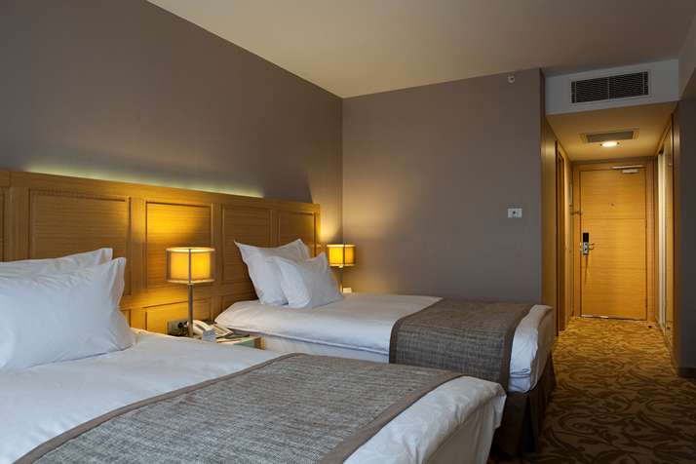
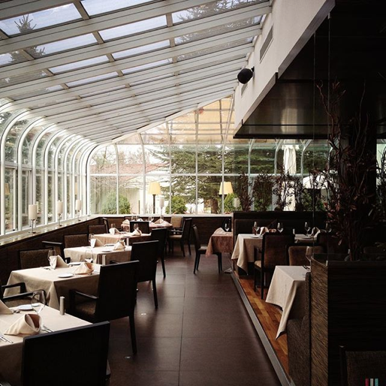

Important Note:
Please complete all the necessary forms by the deadlines given and arrange full payment for accommodation before 6 January 2016. No credit cards or travel checks will be accepted on site.
All participants should book their accommodation through the LOC. Participants that do not book their accommodation through the LOC, will have to pay double entry fees and will not be entitled to any event information or transportation.
Teams will also need to register for their accreditation, at the latest, the day before official practice. If participants do not register the day before, no changes will be made to the entry list. Participants will not be allowed to compete if registration is not completed in time and will not be allocated to a target.

Overview over the most important places in Ankara.
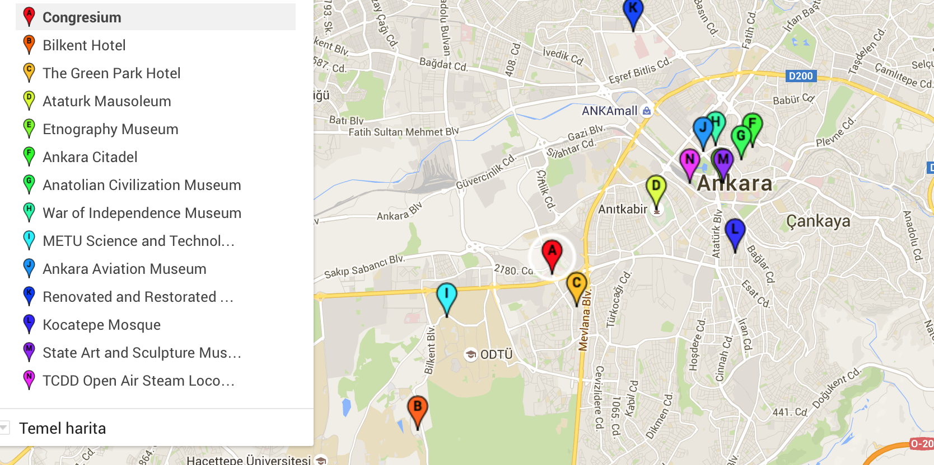

Fans and Spectators in Ankara
The capital of Ankara will set a spectacular scene of yet another big sporting event this winter when the world’s best archers come to Ankara.
Saturday 5 and Sunday 6 March will be the finals of the 2016 World Archery Indoor Championships, hosted in the modern exhibition and conference hall “The Congresium” situated in the centre of modern Ankara with plenty of shopping malls and restaurants.
Finals are divided into a two sessions per day, morning and afternoon both days. Exact times and programme are to be confirmed.
Recurve Finals take place Saturday 5 March and Compound Finals take place the following day, Sunday 6 March at the same venue.
Tickets cost 10 euro per session. A weekend pass costs 30 euro.
There will be free entrance at the finals for team managers and athletes.
The preliminary rounds will be staged at the Qualification Hall at the same venue with exhibition stands and a try archery stand. This will be the first major archery tournament to kick start the season containing the Rio 2016 Olympic Games.
PRELIMINARY HOTEL RESERVATION FORM

Team Manager Details:

Gender: Women Men

Name of Member Association: _________________________________________

Country / Region: _____________________

Contact Name: ________________________________

Telephone: __________________ E-mail: _____________________

Country/Team from: ___________________________________________

Hotel: ____________________________________

From the __________ to the __________

Number of Rooms:
The Green Park Hotel:

Single : 195 Euro
Double : 270 Euro

Bilkent Hotel:
Single : 190 Euro
Double : 260 Euro

Do you require a room for a disabled team member? Yes No

If yes, please specify: ______________________________________________

Do any of your team members have dietary requirements or allergies such as, vegetarian, nut allergies or gluten free etc. Yes No

If yes, please specify: ______________________________________________

Accommodation Payment:

ROOM TYPE AMOUNT OF ROOMS NIGHT RATE P/N TOTAL RATE

___________ _____________________ _________________ _____________

Single __________________ x ___________ x = _______________

Twin __________________ x ___________ x = _______________

TOTAL ACCOMMODATION AMOUNT _____________________________

DEPOSIT 60% OF TOTAL AMOUNT ______________________________

Please pay the deposit before 2 December 2015

Date: ______________________

Signature of President / Secretary General: ______________________________

PLEASE RETURN THIS HOTEL RESERVATION FORM TO LOC BEFORE
2 December 2015 by email to ankara@indoor2016.org

ENTRY FEE

Entry fee:
Individual: 150 Euro per athlete
Officials: 100 Euro per person

Entry fee in NON official hotels:

Individual: 300 Euro per athlete
Officials: 200 Euro per person

For participants using official hotels, entry fees include daily local transport to and from the practice field to official hotels during the qualification, elimination and finals venues (timetable to be confirmed). All participants should book their accommodation through the LOC.

Participants that do not book their accommodation through the LOC, will have to pay double entry fees and will not be entitled to any event information or transportation.

TRANSPORTATION FORM

AIRPORT (Arrival) – HOTEL – AIRPORT (Departure)

Country/Team from: ___________________________________________

Number of passengers: ___________ person/s

Arrival information

We will arrive by plane in Ankara Esenboga Airport:

From: ___________________________ Flight Nr: ______________________

Date: _____________________ (DD/MM/YY) Arrival Time: ________________

Departure information

We will depart by plane from Ankara Esenboga Airport:

To airport: _________________________ Flight Nr: _______________

Date: ____________________ (DD/MM/YY) Departure Time: _______________

If you are not arriving or departing in one group, please specify in the tables below.

Arrivals:

No. of persons | Arriving from | Flight no. | Date | Time

Departures:

No. of persons | Departure | Flight no. | Date | Time

Date: ____________________ (DD/MM/YY)

Signature: ______________________________

President / Secretary General MA: _______________________________

Note:
The entry fee INCLUDES transportation between hotels and archery venues.

PLEASE RETURN THIS TRANSPORTATION FORM TO THE LOC ASAP, BUT BEFORE 10 February by email to: ankara@indoor2016.org

Airport Transportation payment: (Round trip)

NUMBER OF PERSONS FEE (EUR) TOTAL (EUR)

______________________ x Euro 20 = __________________________

Please pay the transportation fee before 9 February 2016

FINAL HOTEL RESERVATION

Personal information team manager:

Gender: Women Men

Name of Member Association: _________________________________________

Country / Region: _____________________

Contact Name: ________________________________

Telephone: __________________ E-mail: _____________________

Country/Team from: ___________________________________________

Hotel: ____________________________________

From the __________ to the __________

Number of Rooms:
The Green Park Hotel;
Single : 195 Euro
Double : 270 Euro

Bilkent Hotel;
Single : 190 Euro
Double : 260 Euro

Do you require a room for a disabled team member? Yes No

If yes, please specify: ______________________________________________

Do any of your team members have dietary requirements or allergies such as, vegetarian, nut allergies or gluten free etc. Yes No

If yes, please specify: ______________________________________________

Date: ______________________

Signature of President / Secretary General: ______________________________

Accommodation Payment:

ROOM TYPE AMOUNT OF ROOMS NIGHT RATE P/N TOTAL RATE

___________ _____________________ _________________ _____________

Single __________________ x ___________ x = _______________

Twin __________________ x ___________ x = _______________

TOTAL ACCOMMODATION AMOUNT _____________________________

REMAINING
PAYMENT 40% OF TOTAL AMOUNT ______________________________

To Guarantee Reservations:
For the payment of accommodation, a 60% deposit of the total amount payable is required to be paid by 2 December 2015. The remaining payment for accommodation should be paid with the final hotel reservation by 6 January 2016. Accommodation cannot be guaranteed after this deadline.

A balance invoice will be provided via email or on arrival, as required, after payment.

It will not be possible after 1 January to have the deposit refunded.

PLEASE RETURN THIS FINAL HOTEL RESERVATION FORM TO LOC BEFORE
6 January 2016 by email to ankara@indoor2016.org

FINAL ENTRY FEE FORM
Entry Fee Payment:
The entry fees should be paid in full BEFORE 9 February 2016.

NUMBER OF PERSONS ENTRY FEE (EUR) TOTAL (EUR)

Athletes ___________________ x Euro 150 = ________________________

Officials ___________________ x Euro 100 = ________________________

TOTAL ENTRY FEE ________________________

Please send this form to the LOC BEFORE 9 February 2016 by email to ankara@indoor2016.com

PAYMENT CONDITIONS:
For the payment of accommodation, a 60% deposit of the total amount payable is required to be paid with preliminary Hotel registration by 2 December 2015. The remaining payment for accommodation should be paid with the final hotel registration by 6 January 2016. Accommodation cannot be guaranteed after this deadline.

A balanced invoice will be provided via email after final payment. There is only one account number where payments are to be made. Please be aware that accommodation, transportation and entry fee must be paid in to this bank account number written below:

BANK INFORMATION for ACCOMMODATION, TRANSPORTATION AND ENTRY FEE:

Bank information: ***

Account name : SERENAS ULUSLAR ARASI TURIZM KONGRE
ORGANIZASYON A.S.
Bank : HSBC BANK A.S.
Account No : 106 1026689 773 99
Swift Code : HSBCTRIX
IBAN : TR 050012300106102668977399

NOTE:
Bank transfer fees are under the sender’s responsibility.
Please indicate in the reference/notes section the team or reservation name that corresponds to the payment.

ALL PAYMENTS SHALL BE MADE IN EURO
By BANK TRANSFER

All bank charges/fees are the responsibilities of the sender.
CREDIT CARDS or TRAVEL CHECKS will not be accepted.

ADDITIONAL INFORMATION ABOUT ANKARA

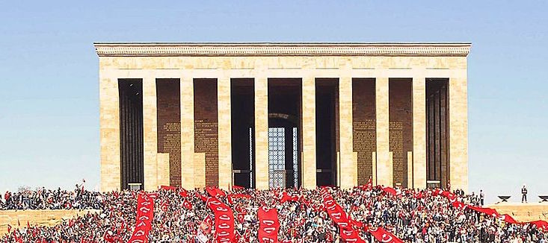
1. ATATURK MAUSOLEUM;
Anıtkabir (literally, "memorial tomb") is the mausoleum of Mustafa Kemal Atatürk, the leader of the Turkish War of Independence and the founder and first President of the Republic of Turkey. It is located in Ankara and was designed by architects Professor Emin Onat and Assistant Professor Ahmet Orhan Arda, whose proposal beat 48 other entries from several countries in a competition held by the Turkish Government in 1941 for a "monumental tomb" for Atatürk.
The site is also the final resting place of İsmet İnönü, the second President of Turkey, who was interred there after he died in 1973. His tomb faces the Atatürk Mausoleum, on the opposite side of the Ceremonial Ground.
The mausoleum was depicted on various Turkish banknotes during 1966–1987 and 1997–2009

2. Etnography Museum;
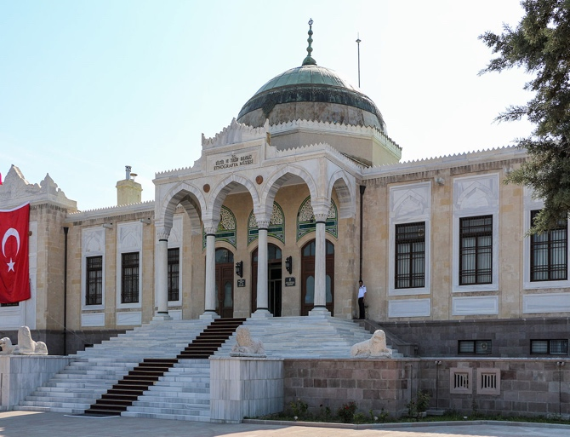
The Ethnography Museum of Ankara is a museum of ethnography dedicated to the cultures Turkish civilizations. The building was designed by architect Arif Hikmet Koyunoğlu and was built between 1925 and 1928. The museum temporarily hosted the sarcophagus of Mustafa Kemal Atatürk from November 21, 1938 until November 10, 1953, during the period of the construction of Anıtkabir, its final resting place.

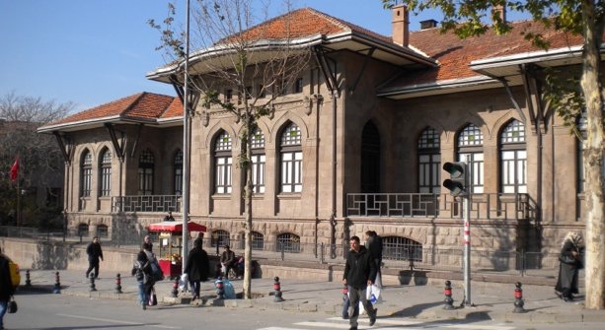
3. War of Independence Museum;
War of Independence Museum (Kurtuluş Savaşı Müzesi), housed in the first Turkish Grand National Assembly building in the Ulus district of Ankara, Turkey, displays important photographs, documents and furniture from the Turkish War of Independence.

4. Anatolian Civilizations Museum;

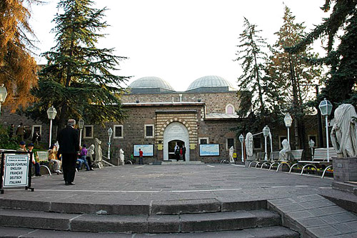
The Museum of Anatolian Civilizations (Turkish: Anadolu Medeniyetleri Müzesi) is located on the south side of Ankara Castle in the Atpazarı area in Ankara, Turkey. It consists of the old Ottoman Mahmut Paşa bazaar storage building, and the Kurşunlu Han. Because of Atatürk's desire to establish a Hittite museum, the buildings were bought upon the suggestion of Hamit Zübeyir Koşay, who was then Culture Minister, to the National Education Minister, Saffet Arıkan. After the remodelling and repairs were completed (1938–1968), the building was opened to the public as the Ankara Archaeological Museum.
Today, Kurşunlu Han, used as an administrative building, houses the work rooms, library, conference hall, laboratory and workshop. The old bazaar building houses the exhibits. Within this Ottoman building, the museum has a number of exhibits of Anatolian archeology. They start with the Paleolithic era, and continue chronologically through the Neolithic, Early Bronze, Assyrian trading colonies, Hittite, Phrygian, Urartian, Greek, Hellenistic, Roman, Byzantine, Seljuq and Ottoman periods. There is also an extensive collection of artefacts from the excavations at Karain, Çatalhöyük, Hacılar, Canhasan, Beyce Sultan, Alacahöyük, Kültepe, Acemhöyük, Boğazköy (Gordion), Pazarlı, Altıntepe, Adilcevaz and Patnos as well as examples of several periods.

5. State Art and Sculpture Museum;
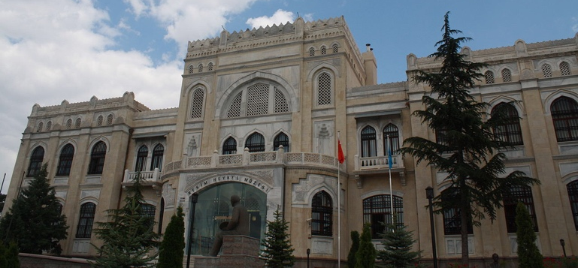
The State Art and Sculpture Museum (Turkish: Resim ve Heykel Müzesi) is a museum dedicated to fine arts and sculpture in Ankara, Turkey. It was designed in 1927 by architect Arif Hikmet Koyunoğlu and built between 1927 and 1930 as the Türkocağı Building, upon the direction of Mustafa Kemal Atatürk, the founder and first President of Turkey. It is located close to the Ethnography Museum and houses a rich collection of Turkish art from the late 19th century to the present day. There are also galleries for guest exhibitions.
The museum was reopened after the restoration of the building in 1980. Today, the museum is a centre of art where the most outstanding works of the artists who played important roles in the development of Turkish painting and sculpture are exhibited. In addition to the collections of art works reflecting the formation and development periods of Turkish plastic arts, and its classification, and to the Library of Plastic Arts which fills the gap in this field (enriched every year by the donations of domestic or foreign resources, or by new purchases), the archives of Turkish artists satisfactorily respond to the needs of researchers working in these fields.

6. Ankara Citadel;
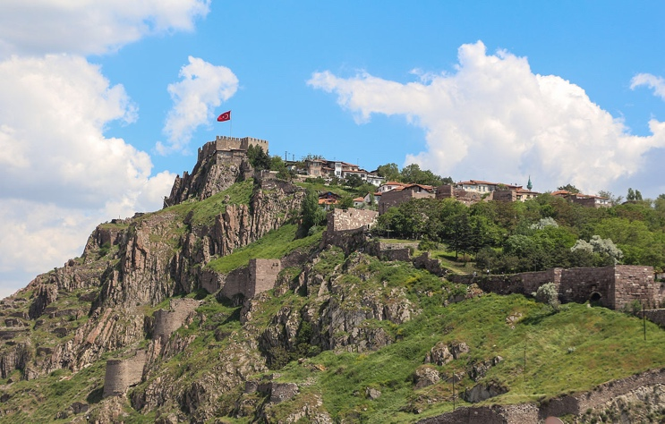
Ankara Castle (Turkish: Ankara Kalesi) is a fortification from ancient or medieval era in Ankara, Turkey. The exact date of its construction is unknown. Having been controlled by Romans and Byzantines earlier; it was captured by Seljuq Turks in 1073, by Crusaders in 1101 and again by Seljuqs in 1227. The castle saw extensive repair by the order of İbrahim Paşa in 1832 during the Ottoman era.
The outer citadel surrounds the old Ankara. There are 42 pentagonal towers along the walls, which range between 14–16 m (46–52 ft) in height. The inner castle covers around 43 km² (17 sq mi). Its southern and western walls intersect in a right angle, the eastern walls follow the ledges of the hill and the northern side was protected with a different type of defensive walls.

7. TCDD Open Air Steam Locomotives Museum;
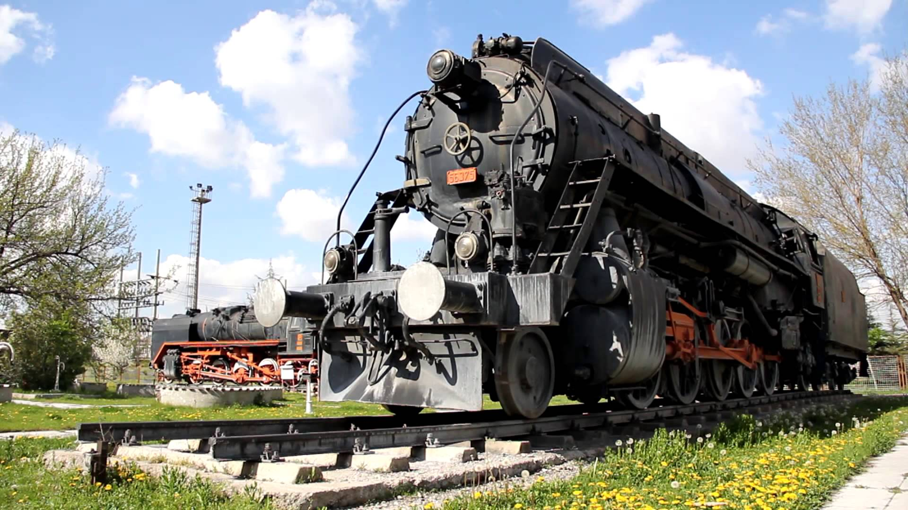
The TCDD Open Air Steam Locomotive Museum (Turkish: TCDD Açık Hava Buharlı Lokomotif Müzesi) is a railroad museum in Ankara, Turkey, which traces the history of steam locomotives. Due to the construction of the new Railway Station, the Museum was closed in March 2014 and the locomotives were transferred. The museum is owned and operated by the Turkish State Railways (TCDD). It is part of the Ankara Railway Museum, which consists of also Ankara Railway History Museum, Atatürk's Car and Railway Art Museum.

8. METU Science and Technology Museum;
METU Science and Technology Museum (Turkish: ODTÜ Bilim ve Teknoloji Müzesi) is a museum established within the campus of the Middle East Technical University, Ankara, Turkey. The museum is aimed to present the modern technological tools as well as technological past of Turkey.
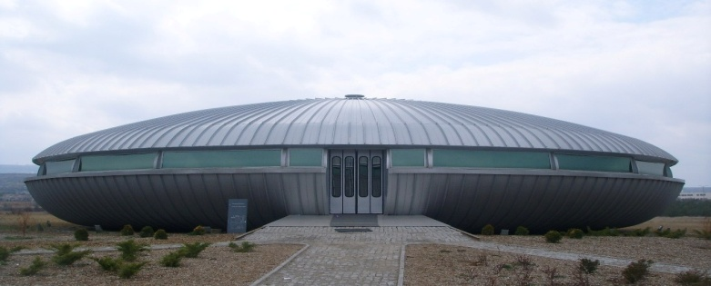

9. Ankara Aviation Museum;
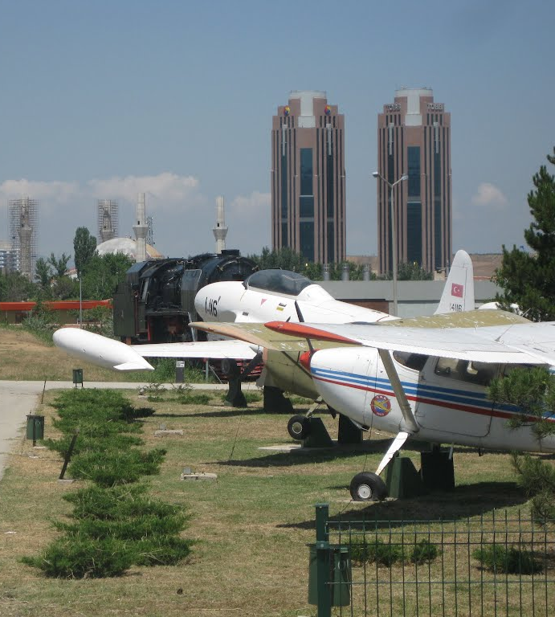
Etimesgut Air Base (IATA: ANK, ICAO: LTAD) (Turkish: Etimesgut Hava Üssü) is an airbase of the Turkish Air Force located 15 km (9.3 mi) west of Ankara, Turkey. It is owned by Turkish Air Force and jointly operated by the air force and the Turkish Aeronautical Association (Turkish: Türk Hava Kurumu) (THK). International Defence Industry, Aerospace and Maritime Fair (IDEF) and civil aviation air shows are being held at this airport.
The airport has two runway in east-west direction. The northern part of the airport, limited by the Ankara-Istanbul motorway O-20 at north, is assigned to the military with the longer runway 11L/29R. The southern area and the shorter runway 11R/29L are being used by the THK. The Ankara Aviation Museum, open to public, is located at the north-eastern corner of the airport.

10. Renovated and Restorated Old Ankara Houses;
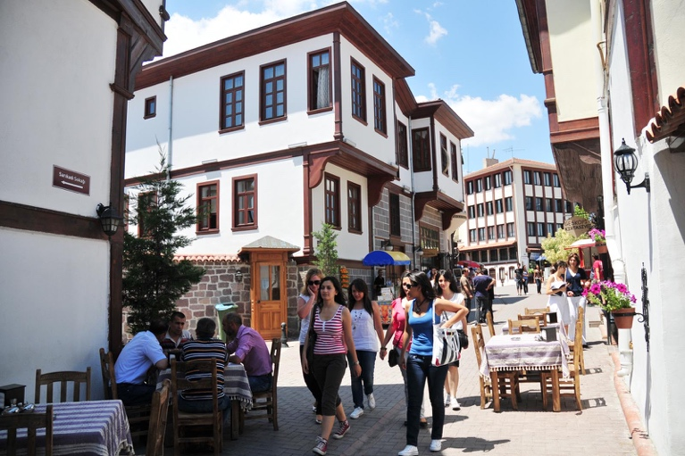
Hamamönü, is a recently restored neighbourhood with Ottoman style timber Ankara houses, and one of the most interesting parts of Ankara to visit. Located down the hill from Ankara Castle near Ulus, Hamamonu is an entire neighbourhood of narrow streets, old houses and historic buildings. Most old houses are now restaurants, cafes or souvenir shops. In addition to the neighbourhood itself, there are 4 historic mosques to visit: Haci Mussa Mosque, Tacettin Sultan Mosque, Karacabey Mosque, Sarikadi Mosque. Mehmet Akif Ersoy, the famous Turkish poet also writing the lyrics of Turkish National Anthem, had his house here, which is now a museum named after him. His statue is also placed in the central square. The Art Street is full of shops selling local art crafts and souvenirs, and the Hand Crafts Market is where local women sell their crafts and works. Hamamönü can be visited day or night, but especially in good weather, it is more alive after dark. During the month of Ramadan, the local municipality organises lots of events in Hamamönü, and the area gets entertaining after dark, but also very crowded. Hamamönü is one of the best places to get a feeling of what an Ottoman town was like centuries ago, and get a sip of Turkish coffee, a breath of nargile - smoke pipes, or just gather around. Don't expect alcohol in the restaurants in this neighbourhood for conservative Turkish taste.

11. Kocatepe Mosque;
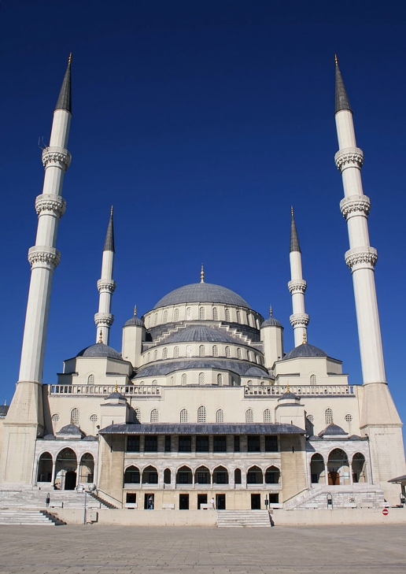
The Kocatepe Mosque is the largest mosque in Ankara, the capital of Turkey. It was built between 1967 and 1987 in the Kocatepe quarter in Kızılay, and its size and prominent situation have made it a landmark that can be seen from almost anywhere in central Ankara.

Archery Venue:
The archery qualification, elimination round and medal finals will be held at the Congresium Exhibition Centre.

The Congresium is located between 3 and 6 kilometres from the officials’ and athletes’ hotels, and just 1-2 kilometres from the city centre of Ankara. There is public metro system and taxis for trips to Ankara downtown, around 10 minutes.

Transportation:
- Transportation will be provided from Ankara Esenboga International Airport to the official hotels, on 28 & 29 February 2016.
- Transportation will be provided from the official hotels to Ankara Esenboga International Airport on 7 March 2016.
Local transportation will be available between official hotels and the competition venue. Transport timetables will be confirmed and provided. Buses and/or vans will be provided.

Cancellations & Changes:

Name change (the same category and division) will be accepted up to 72 hours before the event, without any additional charge. The LOC should be informed about any changes immediately in the travel programme 72 hours prior to arrivals. If your arrival is later than originally scheduled, the room charges will start from the original date indicated by the accommodation forms received from the Member Association.

Training:
Training will be available at the venue from 28 February 2016. Transportation between the hotels and the venue will be provided.

Weather:
February (Average): March (Average):
Temperature 2º C Temperature 6º C (68 F)
Low Temperature -2º C Low Temperature 0º C (57 F)
High Temperature 7º C High Temperature 12º C (79 F)
Sunshine Hours- 4 Hours Sunshine Hours- 5 Hours
Rainfall days- 11 days Rainfall days- 11 days

Ceremonies:
Details to be provided.

Water on the Venue:
Bottled water will be provided in the venue during competition for accredited people.

Media Registration:
Media representatives can apply for registration by emailing info@archery.org.

Internet Connection:
Free WiFi will be available in official hotels and in the archery venue.

LOC Contact:
Name: Ms. Başak YILDIRIM – Registration and Accommodation Manager
Email: ankara@indoor2016.org
Language: English
Official website: www.indoor2016.org
Facebook: www.facebook.indoor2016.com

