TO ALL World Archery Master Athletes

Dear Master Athlete,

The World Archery Excellence Centre will have the honour of hosting the first ever Masters World Archery Championships in Lausanne, Switzerland on 14 – 18 August 2018.

On behalf of the Organising Committee, it is our great pleasure to invite you to participate in this championship. You will not only have state of the art Archery facilities but will also be able to make the most of our beautiful city and its cultural and tourism activities.

As this is the first event of its kind, we would highly appreciate if you could express your interest in participating in this event as soon as possible so that we can adapt the scope required to deliver an excellent experience for participants.

Please find enclosed the necessary documents of registration, organization and participation for this event. Please complete all the sections in Open WAREOS before the deadlines:

Summary of deadlines:

- Visa Support 04 June 2018
- Athlete Registration 24 July 2018

Looking forward to welcoming you in Lausanne, Switzerland.

Sincerely yours,

Mr. Juan-Carlos HOLGADO
World Archery Excellence Centre Director
FIDTA - Fondation Internationale de Développement du Tir à l’Arc
and Local Organising Committee

PRELIMINARY PROGRAMME:

12 August 2018 | Arrival of participants  Practice field and local transport available
13 August 2018  Monday | Arrival of participants  Practice field and local transport available
14 August 2018  Tuesday | Official Practice and Registration (for all)  Equipment Inspection  Participant Meeting  Opening Ceremony
15 August 2018  Wednesday | Group 1 – TARGET Indoor  Group 2 – TARGET Outdoor  Group 3 – Free Day/Sightseeing  Award Ceremonies of the day / per group
16 August 2018  Thursday | Group 1 - FIELD  Group 2 – Free Day/Sightseeing  Group 3 – TARGET Outdoor  Award Ceremonies of the day / per group
17 August 2018  Friday | Group 1 - Free Day/Sightseeing  Group 2 – FIELD  Group 3 – TARGET Indoor  Award Ceremonies of the day / per group
18 August 2018  Saturday | Group 1 – TARGET Outdoor  Group 2 – TARGET Indoor  Group 3 – FIELD  Award Ceremonies of the day / per group  Closing Ceremony and/or banquet
19 August 2018  Sunday | Departure of Participants

NOTE:
This preliminary program might change according to number of participants.
All changes will be published and distributed to all participants in good time.
PRELIMINARY & FINAL REGISTRATION
Age Groups:
- 40-49
- 50-59*
- 60-69
- 70+

Disciplines:
- Recurve
- Compound
- Barebow (in field only unless there are a minimum of 8 participants for Indoor and Outdoor)
- Instinctive (a minimum of 8 participants, otherwise age groups will be combined)
- Longbow (a minimum of 8 participants, otherwise age groups will be combined)

Events:
Outdoor:
- 72 arrow qualification round
- Recurve 60m and 70m with the 122cm target face
- Compound 50m with the 80cm (10-6 scoring zone) target face
- Head to head elimination
Indoor:
- A combined format of 60 arrows at 18m and then 60 arrows at 25m
- 18m indoor with the single or triple vertical 40cm target face
- 25m indoor with the single or triple vertical 60cm target face

Field:
- 72 arrows over 24 targets (12 marked and 12 unmarked)

*NOTE:
World Championships medals and titles will only be awarded for the 50-59 aged category for indoor and outdoor recurve and compound only, for field for recurve, barebow and compound. All other events will get medals but there is no official world championship title.

All entries and visa invitation letter requests are to be completed using OPEN WAREOS.

The World Archery Online Registration System (WAREOS):
http://register.worldarchery.org has been updated to handle the entire registration process for this event. No entry forms will be accepted as information is to be entered in WAREOS.

To use WAREOS, please login on http://register.worldarchery.org with your Username and Password assigned by World Archery through the online system. After entering WAREOS, please find the event-category from the list you wish to register. Select/press the “Entries” button to see the list of categories in the event. Select/press the “category” to enter the athlete and/or accompanied official numbers/details participating. A "WAREOS User Manual" can be downloaded in PDF format (English) using the same website link.

For any questions regarding the OPEN WAREOS, please contact the World Archery office, Mr. JK LEE (jklee@archery.org).

Start date for online registration using WAREOS 08 January 2018
End of Registration using WAREOS: 24 July 2018

Participants should only use OPEN WAREOS to make any changes/amendments to their entries and will be able to do so at any time. Any changes made in WAREOS an email will instantly be sent to the Organising Committee and to the participant with the updated information.

NOTE: CHF currency exchange rates will be communicated by World Archery at the start of the event.

ACCOMMODATION & GENERAL INFORMATION
While Lausanne and Switzerland in general are considered to have a high cost of living, accommodation can be found to satisfy the aspirations and budgets for all.

We have proposed various kinds of accommodation on the lakeside (South Cluster) close to the Outdoor venue and the hill side (North Cluster) close to the WAEC where the Indoor competition will take place. Competitors can also choose to find accommodation in the centre of the town and then use public transportation to the North and South terminals of the metro M2.

Competitors will be invited to manage their accommodation directly with the proposed hotels at the rates that have been negotiated. Food and Beverage outlets will be available at all venues except the Field venue where Lunch packs will be available.

Information on hotels (Cost per room/hotel/night and how to book accommodation) will be provided shortly in the event page “Accommodation” of the website https://worldarcherycentre.org/
ENTRY FEE
ENTRY FEE:
Individual: 200 CHF for one event + training
+ 75 CHF for two events
+ 50 CHF for three events

Accompanied Officials: 100 CHF per person for all events

There is no team event.

Entry fee includes daily local transport to and from practice field to the official hotels during the qualification, elimination and finals venues (timetable to be confirmed).

PAYMENT CONDITIONS:
The entry fees should be paid in advance before deadline of registration
(24 July 2018).

For the payment of accommodation, it will follow each hotel policies.
Participants need to book their accommodation by themselves.

BANKING INFORMATION for ENTRY FEES:

International Wiring Instructions

BENEFICIARY: Fondation Internationale de Développement de Tir à l’Arc SWIFT/BIC CODE: CRESCHZZ10A
IBAN: CH49 0483 5040 3388 5100 2
Current account: 403388-51-2

By credit card

 |  |  |  | - |  |  |  |  | - |  |  |  |  | -
CREDIT CARD N°:

/
EXP. DATE:

Name of the card owner:
SECURITY code (3 digit):

ADDITIONAL INFORMATION

Transportation
- Airport transfers and transport between the hotels and the venues – participants will arrange and pay by themselves (*)
- Transportation between competition and practice venues the organising committee will provide.

Cancellations & Changes
Written Cancellations must be:
- Received before 31 July 2018 for full refund of the entry fee payment
- Received later than 31 July 2018, 50% refund.

All refunds, if any, will be processed after the event.

Training
Training ranges will be available starting from 12 August 2018. Training ranges are located at the World Archery Excellence Centre. Participants that wish to arrive and practice earlier than this date, please contact the organising committee directly to make arrangements. lausanne2018@worldarcherycentre.org

Weather
The climate in Lausanne is at its hottest between July and August, when temperatures average 25°C / 77°F by day and drop to around 14°C / 57°F at night.

Media Registration:
Media representatives can apply for registration by emailing info@archery.org.

Internet
There will also be Wi-Fi available at the venue.

Water
Bottled water will be available venue.
IMPORTANT INFORMATION REGARDING SWISS VISAs
Applications for and obtaining travel visas to Switzerland are completely and solely the responsibility of the participant. Depending on the purpose of your travel to Switzerland, there are different types of Swiss visas that will apply to the occasion.

Whether you are planning to go on a visit, study or work and reside there permanently, you will have to apply for a different Swiss Visa, accordingly.
You can apply for the Swiss Schengen Visa since 2008 when Switzerland as an EFTA Member State also became a member state of the Schengen Area.

Stat: As per 2014, Switzerland has issued a total of 412,438 uniform Schengen visas.

General required documents for a Swiss Schengen Visa Application:
- Download the application form, fill it completely and with sincerity. You can also fill the Schengen Visa application form electronically and then print a hard-copy.
- 2 photos must be attached; the photo should be of passport format – a recent whole-face capture with a light background. Learn more about photo requirements and specifications for a Swiss Visa.
- Your passport and copies of your previous visas – valid for at least 3 months beyond return date – are required. Your passport must have at least two blank pages.
- A copy of your return-ticket reservation. It is not recommended to purchase the ticket before obtaining the visa – if not otherwise required
- Travel medical insurance confirmation of minimum 30,000 € coverage within Switzerland and the entire Schengen area
- A cover letter stating the purpose of visit to Switzerland and itinerary
- Flight itinerary reservation with dates and flight numbers specifying entry and exit from Switzerland
- Proof of accommodation for the whole duration of the intended stay in Switzerland
- Proof of civil status (marriage certificate, birth certificate of children, death certificate of spouse, ration card if applicable)
- Proof of sufficient financial means for the period of stay in Switzerland. A foreign national who wants to enter and reside in the territory of Switzerland must be able to attest owning at least 100 CHF or 92.34€/day on his disposition during its stay in Switzerland, while, in case the foreigner is a student this amount reduces to 30 CHF or 27.70€/day. A foreigner is obliged to provide such proof of sufficient financial means, the moment applying for a Swiss Visa to the Swiss Embassy or Consulate.

Most categories of visas may be issued to an applicant up to 60 days before its effective date. HOWEVER, it cannot be emphasized enough that the letter of invitation and application process should start as early as possible. Participants from countries subject to additional clearances should be especially conscientious about applying early, since Swiss Immigration will not guarantee that ANY cases will be expedited.

Visa
All participants who need an entry visa to Switzerland, will be required to complete the Visa Support Form in Open WAREOS by no later than 04 June 2018.

It is the applicants’ responsibility for supplying the necessary information, ensuring all details are up to date, correct and submitted by the deadlines specified.

In addition, all participants that require a visa are kindly requested to supply a copy of their latest/valid passport. Copies of each applicate can be uploaded on Open WAREOS. All passport copies and personal details entered/uploaded to Open WAREOS will be held securely and in the strictest of confidence and not shared with other parties.

Any questions please email: lausanne2018@worldarcherycentre.org

OC Contact:
Name: World Archery Masters Championships
Official website: https://worldarcherycentre.org/
Venue Name: World Archery Excellence Centre
General email: lausanne2018@worldarcherycentre.org

About Switzerland
Switzerland, in its full name the Swiss Confederation (Latin: Confoederatio Helvetica, hence its abbreviation CH), is a federal republic consisting of 26 cantons, with Bern as the seat of the federal authorities. The country is situated in Western Europe, where it is bordered by Germany to the north, France to the west, Italy to the south, and Austria and Liechtenstein to the east.

Switzerland is a landlocked country geographically divided between the Alps, the Swiss Plateau and the Jura, spanning an area of 41,285 km2 (15,940 sq. mi). While the Alps occupy the greater part of the territory, the Swiss population of approximately 8 million people is concentrated mostly on the Plateau, where the largest cities are to be found.
Among them are the two global cities and economic centres of Zurich and Geneva.

The Swiss Confederation has a long history of armed neutrality—it has not been in a state of war internationally since 1815—and did not join the United Nations until 2002. It pursues, however, an active foreign policy and is frequently involved in peace-building processes around the world. Switzerland is also the birthplace of the Red Cross and home to a large number of international organizations, including the second largest UN office. On the European level, it is a founding member of the European Free Trade Association and is part of the Schengen Area – although it is notably not a member of the European Union, nor the European Economic Area.

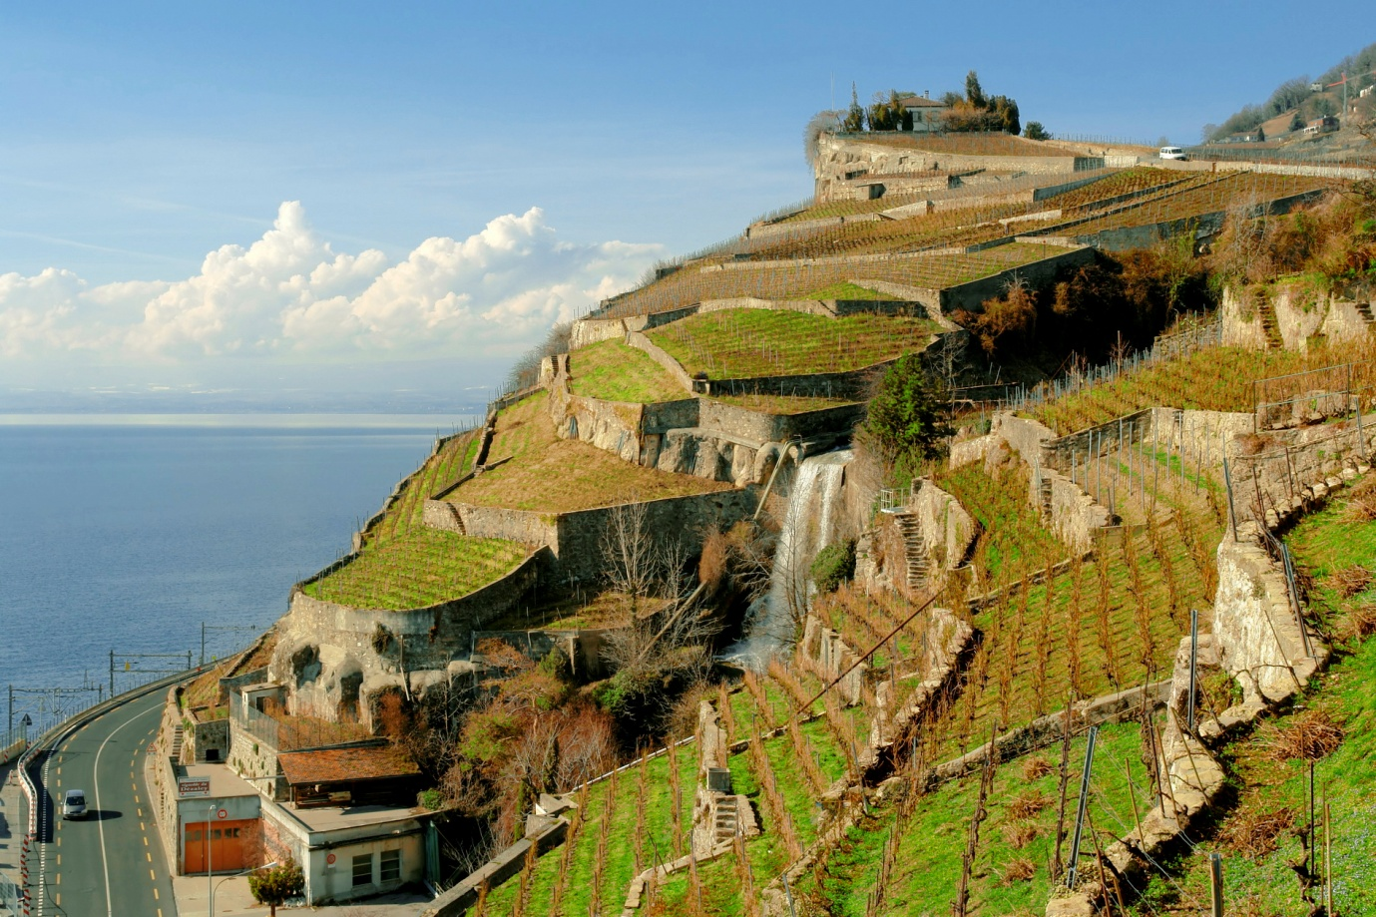
About Lausanne
Lausanne is a city in Romandy, the French-speaking part of Switzerland, and is the capital of the canton of Vaud. The seat of the district of Lausanne, the city is situated on the shores of Lake Geneva (French: Lac Léman). It faces the French town of Évian-les- Bains, with the Jura Mountains to its north-west. Lausanne is located 62 km (39 mi) northeast of Geneva.

Lausanne has a population (as of December 2011) of 129,383, making it the fifth largest city of the country, with the entire agglomeration area having 336,400 inhabitants. The Metropolitan Area of Lausanne-Geneva is over 1.2 million inhabitants. The headquarters of the International Olympic Committee are located in Lausanne – the IOC officially recognises the city as the Capitale Olympique – as are the headquarters of the Court of Arbitration for Sport. There are 55 International Federations, including World Archery and sport related organisations in Lausanne de Vaud. It lies in the middle of a wine region. The city has a 28-station metro system, making it the smallest city in the world to have a rapid transit system.

The Olympic Museum
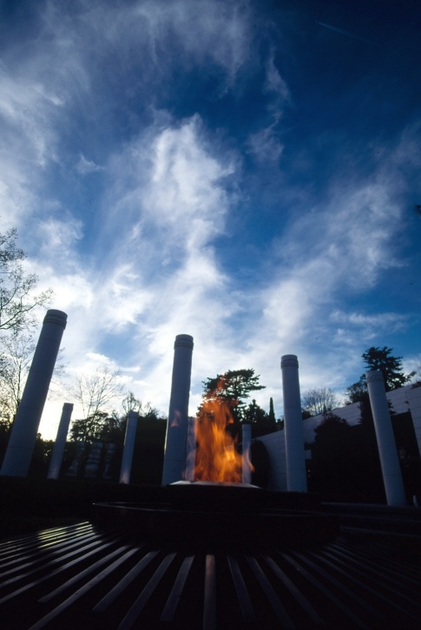
To experience the Olympics at close quarters and feel the Olympic spirit the way the athletes felt it, to study the history of the Games from antiquity to today - thanks to the latest computer technology and audiovisual media, all of this can be accomplished in the Olympic Museum in Lausanne.

The idea of a museum dedicated to appreciating the Olympic idea goes back to Pierre de Coubertin, who revived the Olympic Games and founded the International Olympic Committee (IOC). The Olympic Museum, which was opened in 1993 in Ouchy, a district of Lausanne, reflects the spirit of the sports games which bring nations together.

An unusual new building in the most beautiful of locations on Lake Geneva is home to interactive exhibitions, documents, films and collections of precious objects dating from Greek antiquity up until modern times. The museum is the largest information center on the subject of the Olympic Games in the world.

Money
The currency in Switzerland is Swiss franc, usually indicated as CHF. However, you will be able to use Euro in most of the places.

As of 21 August 2014, http://www.oanda.com/currency/converter/
1 CHF - 0.82 EUR
1 CHF - 1.09 USD

Time
From the end of March to the end of October, Summer Time applies (CET + 1 hour).
During the winter, Central European Time (CET) applies in Switzerland.

Electricity
The voltage in Switzerland, as in most of Europe, is 230V/50 Hz. Switzerland uses type C (2-pin) and Type J (3-pin) plugs. (Type C 2-pin plugs also fit J sockets.)
Most power sockets are designed for three pin round plugs. The standard continental type plug with two round pins, applied for many electrical travel products, may be used without problem. Adaptors are available in most hotels.

Weather
Lausanne has an average of 123 days of rain or snow per year and on average receives
1,150 mm (45 in) of precipitation. The wettest month is June during which time Lausanne receives an average of 117 mm (4.6 in) of rain. During this month there is precipitation for an average of 10.8 days. The month with the most days of precipitation is May, with an average of 12.4, but with only 107 mm (4.2 in) of rain or snow. The driest month of the year is February with an average of 78 mm (3.1 in) of precipitation over 10.2 days.

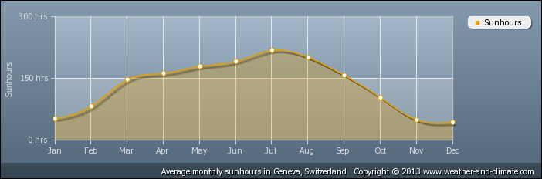
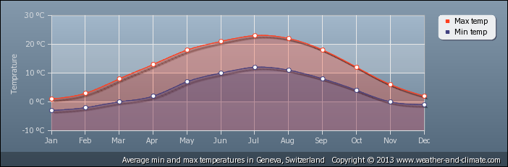
The City of Lausanne:
Additional community information can be located at http://www.cityofyankton.org and http://www.visityanktonsd.com/.

Population Lausanne City: 125,552
Switzerland: 8 million

Elevation City: 1,211 feet 369 meters

Archery Venues:
- North Cluster
- Competition Venues
  - World Archery Excellence Centre (WAEC) - Indoor Competition / Outdoor 70-60 m Competition (Recurve Bow).
  - Montheron, a 10 minute drive from WAEC – Field Competition

- SOUTH CLUSTER
- Competition Venue
  - Lausanne Archery Club (CAL) – Outdoor 50 m Competition (Compound bow)

The competition will take place across three competition venues, depending on the discipline:

Venue Name | World Archery Excellence Centre - FIDTA
Competition hosted | Indoor Archery + outdoor 60 +70 m
Venue Information | Ch de Chalet Pra Roman 10, 1000 Lausanne 25
Specifications | Dimensions: 9000m2 in Total / surface: indoor-synthetic floor / outdoor, grass + asphalt for walking paths / toilets: 6
Transport Information | public transport to Croisette + shuttle busses
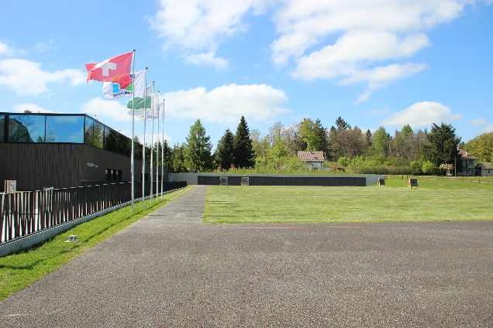
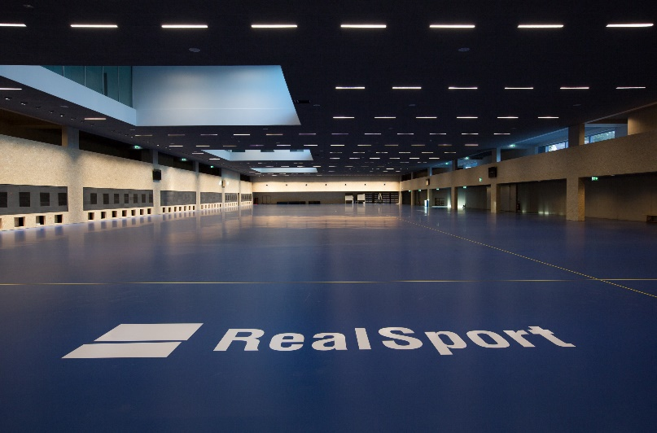

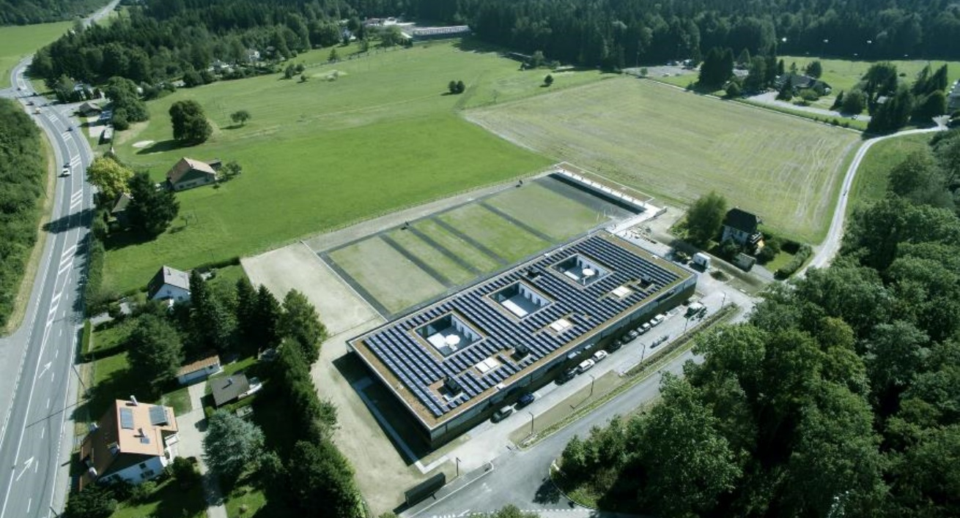

Venue Name | Field Archery Range Montheron,  Compagnie des Archers de Lausanne (CAL)
Competition hosted | Field Archery
Venue Information | Montheron
Specifications | Field range of 20 fix targets which will be modified for the event  http://www.archers.ch/plan_field/parcours.html
Transport Information | Shuttle busses from WAEC / dedicated transport when needed
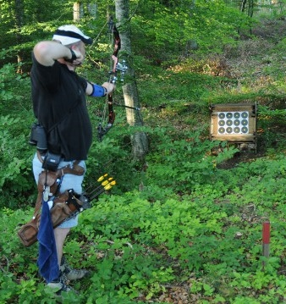
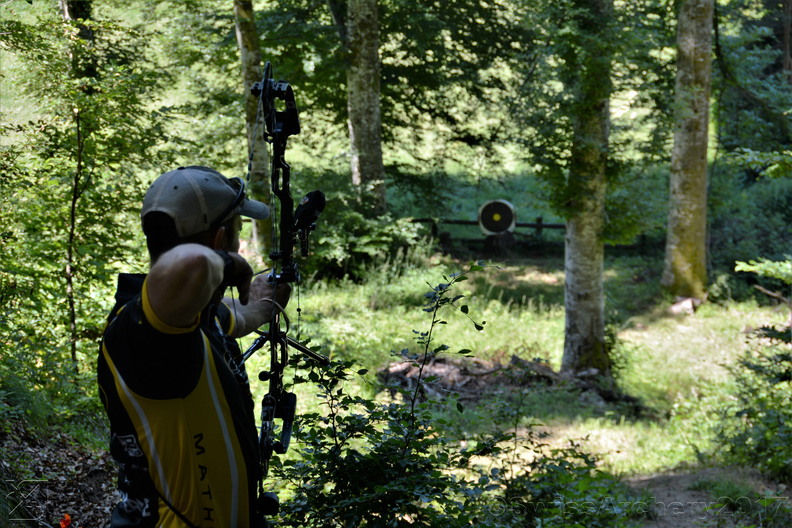

Venue Name | Archery outdoor field Vidy,  Compagnie des Archers de Lausanne (CAL)
Competition hosted | Outdoor Archery 50 m
Venue Information | Park de Vidy
Specifications | Dimensions : 50m x 110m large / surface: grass / toilets: 1
Transport Information | Public transport + Shuttle busses
