TO ALL World Archery MEMBER ASSOCIATIONS

Dear President,

On behalf of the Organising Committee (OC) of the World Archery Para Championships 2017, Beijing, and the China Administration of Sports for Persons with Disabilities (CASPD), we would like to invite you to the World Archery Para Championships 2017, which will be held from 12 – 17 September in Beijing, China.

Please find enclosed the necessary documents of registration, organisation and participation for this event. Completed all the necessary details in WAREOS before the following deadlines:

Summary of deadlines:

- Preliminary Entries 30 June 2017
- Final Entries 22 August 2017
- Hotel Reservation 30 June 2017
- Transportation 30 June 2017
- Visa Support Form 20 July 2017
- Medical intake and classification forms for
- VI and Physical Impairments
completed in English send to
email: classification@archery.org 10 August 2017
- Final Hotel Reservation Form 22 August 2017
&Payment Form

We look forward to welcoming you and your teams to Beijing, China.

Sincerely yours,

Ms WANG Meimei
Chairperson of CDPF Executive Board
Vice President of NPC China

PRELIMINARY PROGRAMME:
Day |  | Date | Description
 | Wednesday- Thursday  7-8 September |  | Arrival of national and international technical officials
 | Friday-Saturday  8-9 September |  | Arrival of participants  Local transport available
 | Sunday-Monday  10-11 September |  | Arrival of Participants  Practice field and local transport available  PI Classification
DAY 1 | Tuesday  12 September |  | Official Practice (For all)  Equipment Inspection  Team Managers Meeting  Opening Ceremony
DAY 2 | Wednesday  13 September |  | Qualification Round (All Categories)  Mixed Team Elimination 1/8 to semi-finals (All categories)
DAY 3 | Thursday  14 September |  | Individual Eliminations (All Categories)  1/16 to semi-finals  VI Classification
DAY 4 | Friday  15 September |  | VI 1 and VI 2/3 individual qualification and elimination rounds to semi finals  Team Eliminations (all categories)  1/8 to semi-finals
DAY 5 | Saturday  16 September |  | Finals VI 1 and VI 2/3 Individual Finals  Finals Recurve – Individual, Team and Mixed Team  - Recurve (Women and Men)  - Award Ceremonies
DAY 6 | Sunday  17 September |  | Finals Compound – Individual, Team and Mixed Team  - Compound (Women and Men)  - Award Ceremonies  - Closing Banquet
 | Monday  18-19 September |  | Departure of Participants
NOTE:
This preliminary programme could be changed slightly according to number of participants and TV requirements. All changes will be published and distributed to all participants in good time.
PRELIMINARY & FINAL REGISTRATION
All entries, accommodation reservations, transport needs, flight arrival/departure information and visa invitation letter requests are to be completed using WAREOS.

The World Archery Online Registration System (WAREOS): http://register.worldarchery.org has been updated to handle the entire registration process for this event. No entry forms, hotel reservations or transport forms will be accepted as all information is to be entered into WAREOS.

In order to use WAREOS, please login on http://register.worldarchery.orgwith your Username and Password assigned by World Archery. After entering WAREOS, please find the event from the list you wish to register your athletes. Select/press the “Entries” button to see the list of categories in the event. Select/press the “category” to enter the athlete and official numbers/details participating for that event. A "WAREOS User Manual" can be downloaded in PDF format (English) using the same website link.

For any questions regarding the WAREOS, please contact the World Archery office, Mr. JK LEE (jklee@archery.org).

A maximum number of 3 athletes per country are allowed to be registered into each category of the event. Preliminary entries should be completed using WAREOS.

Start date for online registration using WAREOS 31 May 2017
End of Preliminary registration using WAREOS: 30 Jun 2017
End of Final registration using WAREOS: 22 Aug 2017

Please respect the stated deadlines.

Member Associations should only use WAREOS to make any changes/amendments to their entries and will be able to do so at any time. Any changes made in WAREOS an email will instantly be automatically sent to the Organising Committee and Member Association with the updated information.

However, any changes that are made after the deadlines specified or if entries differ by more than 4 athletes from the preliminary entries, the following penalty fees will automatically be applied.

Penalty fees to be paid to Organising Committee: | Cost (EUR):
Entries made after the preliminary and/or final entry deadline date. | 45 per entry
If final entries differ from the preliminary entries by more than 4 athletes/officials. | 140 per entry
Failure to have made preliminary entries before the deadline date but then have submitted final entries. | 140 per entry

Penalty Fee to be paid to World Archery: | Cost (CHF):
Lost accreditation. | 30 each
Changes made to the athlete and/or team official names after the final entry deadline date and within 3 days prior to the start of the event. | 50 each change

NOTE: CHF currency exchange rates will be those on the date of the event.

Member Associations that have penalty fees outstanding from 2016 will need to have paid these penalty fees before being eligible to enter and compete.

Any entries received less than 3 days before the team managers meeting for the World Championships will be refused if no preliminary entry and/or final entry are made prior. This decision cannot be appealed by the teams and is fully compliant with the current World Archery rules, article 3.7.1.2. Entries received after the deadlines, are subject to penalties as clearly stated in the rule book and the invitation documents of World Cups and World Championships. A Member Association that has made final entries in WAREOS and does not participate will be invoiced for the number of entries entered in the system, unless they have informed World Archery and the Organising Committee in writing at least one week prior to the event that they are unable to attend.

ACCOMMODATION

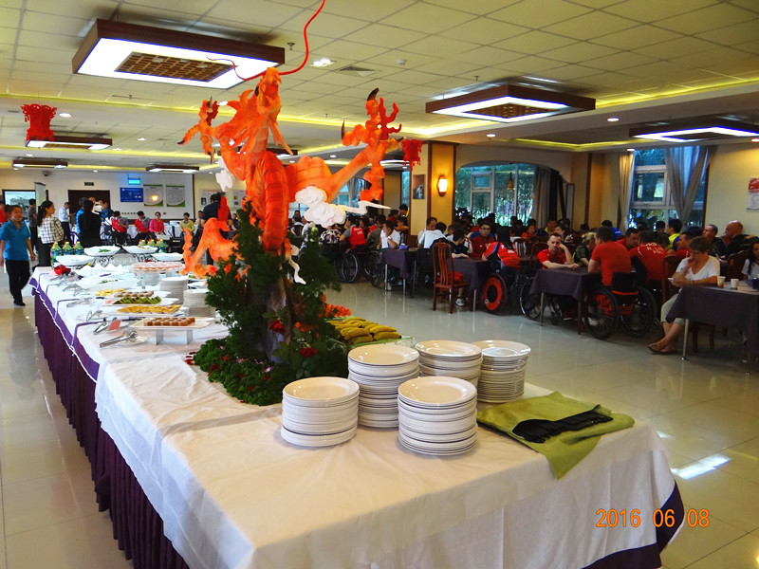
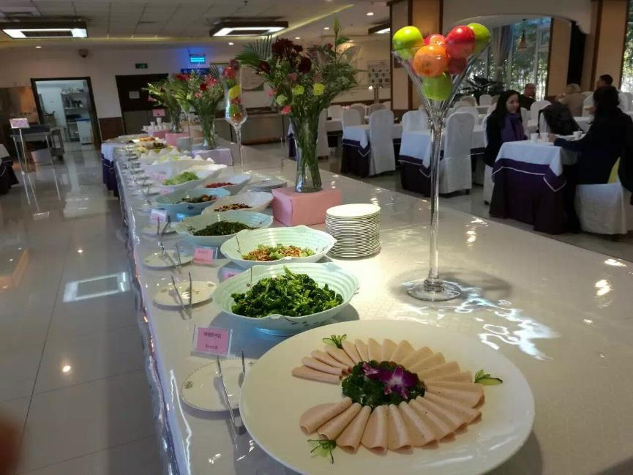
There is only one hotel for this tournament, China Administration for Persons with Disabilities (CASPD). It is a purpose-built accommodation facility, with 500 rooms specifically designed for people with disabilities and is part of a large site with a range of sporting facilities. This venue was designed and built as a training campus for the 2008 Beijing Olympic and Paralympic Games.
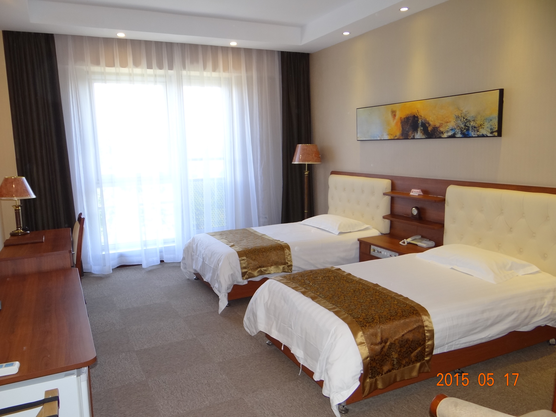
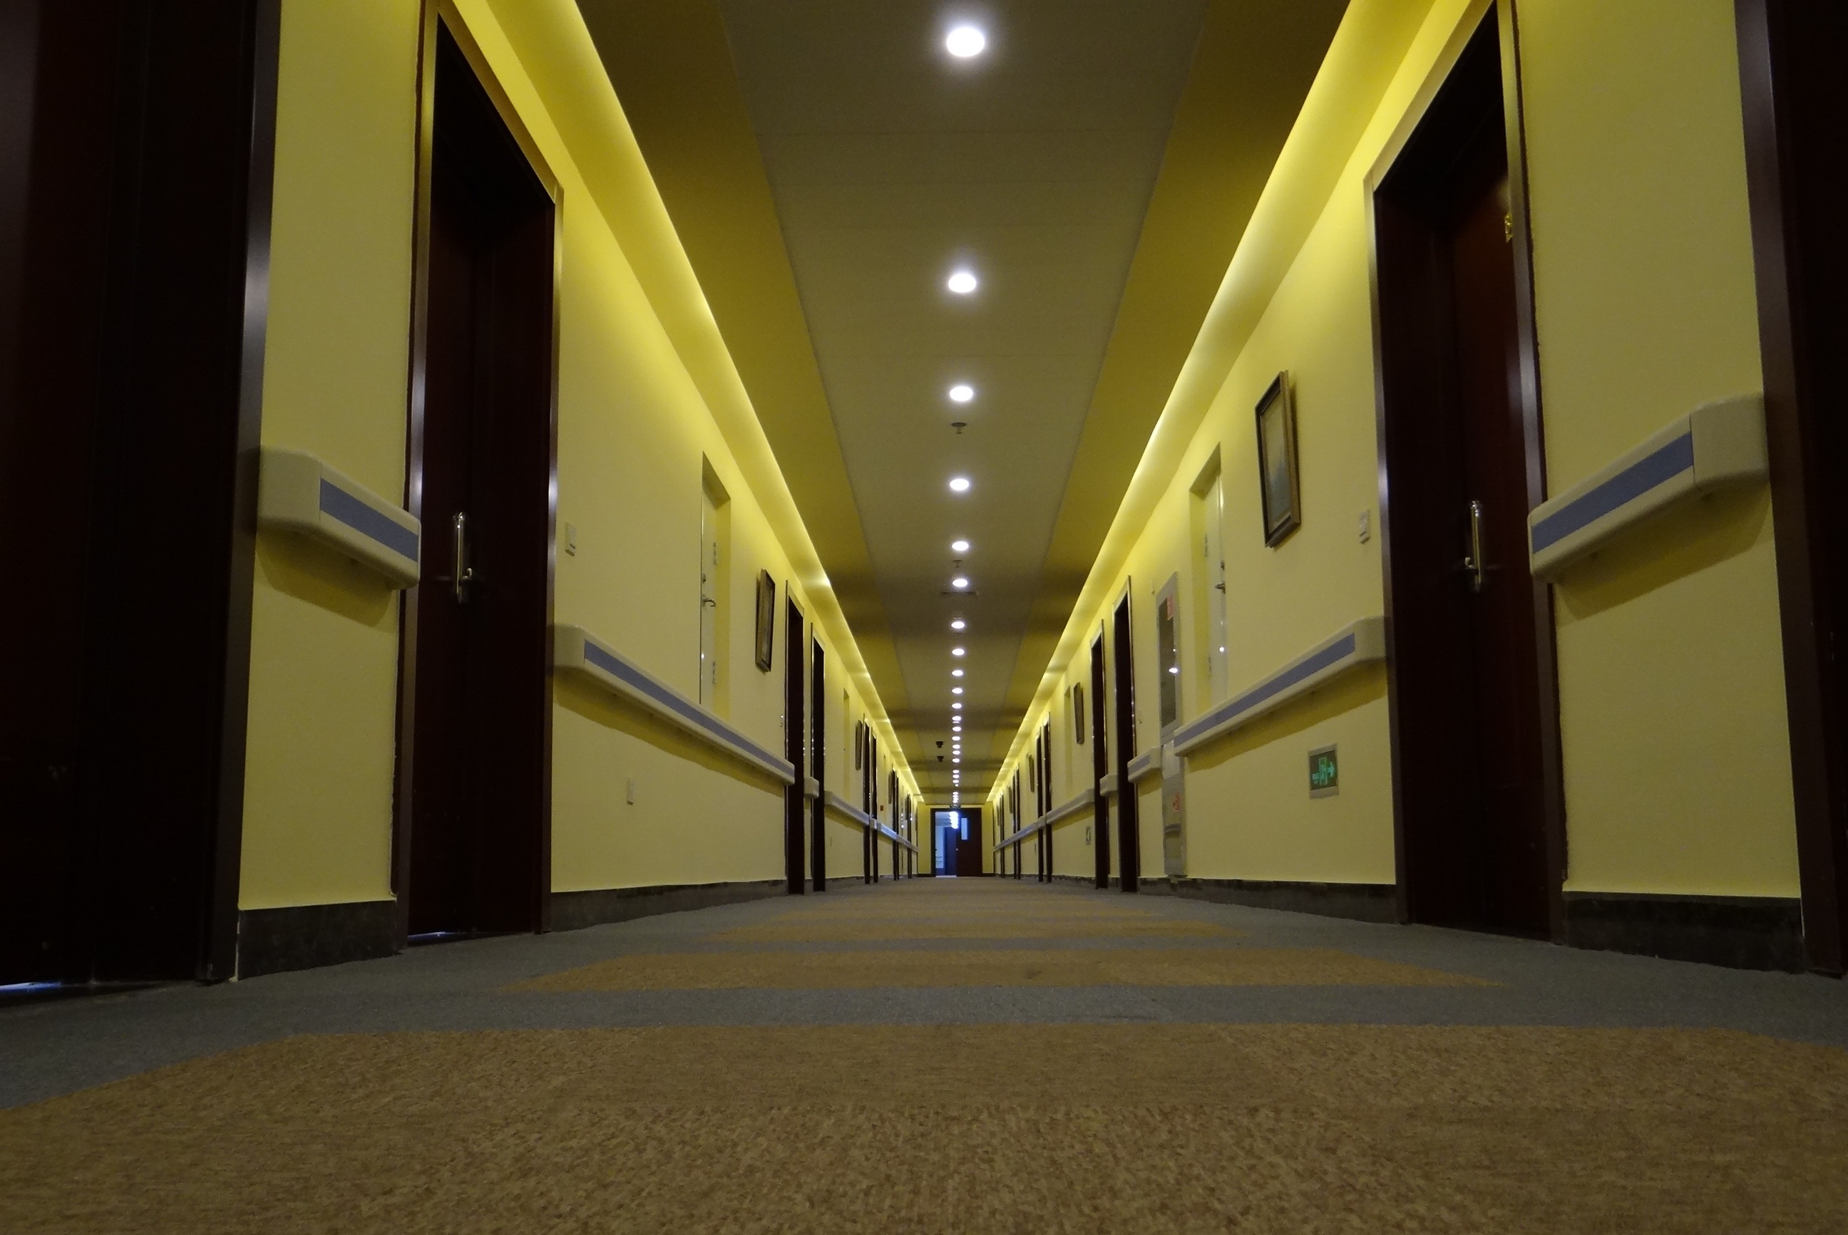

No. | Item | Content
1 | Name of Hotel | (CASPD) - China Administration of Sports for Persons with Disabilities
2 | Hotel Address | NO.321, Tianbei Road, Houshayu Town, Shunyi District, Beijing, China
3 | Website Address | http://www.caspd.org.cn/
4 | Star rating | 4 stars
5 | Distance from airport | 40-45mins
6 | Distance from the archery venue | 200m
7 | Airport transfer (round trip) | 20 EUR/person
8 | Single rooms | 150 EUR/room/day
9 | 220 Double Rooms | 240 EUR/room/day
10 | 19 suites | For World Archery officials
11 | Meals (Breakfast, Lunch and Dinner) and non-alcoholic drink | Included in the hotel rate
12 | Parking | Free
13 | Internet/WiFi | Free
14 | Laundry | Free (only in hotel)
15 | Use of other sporting facilities | Indoor gym open, basketball courts (indoor) open, outdoor tennis open, time to be confirmed.

. The rooms will be allocated on a first come first served basis.

Teams who book their own accommodation will be charged a double entry fee and will not receive tournament information/results or local transportation.

- Reservations should be made before: 30 June 2017
- Final Hotel Reservation & Transportation before: 22August 2017

To confirm hotel reservations, a 50% deposit of the total amount is required to be bank transferred to the OC before 30 June 2017. Reservations after this date will be considered only according to availability.

Important Note:
Please refer to the accommodation pages above for detailed hotel information. Please complete all necessary sections in WAREOS and make full payment for entries and accommodation by the specified deadlines. Bank transfers only, no credit cards or travel checks will be accepted.

Participants who book their accommodation in non-official hotels will need to pay a double entry fee. In addition, the OC will not be responsible to provide any event information at this hotel or provide transportation to the venues.

Teams that book non-official accommodation will need to register at the accreditation desk no later than the day before official practice day. Failing to do so will result in no changes being made to the entry list and it is likely that participation in the event will be refused if registration is not completed in time.
ENTRY FEE
Entry Fees:
Individual: | 150€ per athlete
Officials: | 100€ per person
Temporary Upgrade:  For athletes wishing to be a coach temporarily | 30 CHF per accreditation

Entry fee in NON official hotels:
Individual: 300€ per athlete
Officials: 200€ per person
There is no entry fee for teams.

PAYMENT CONDITIONS:
The entry fees should be paid in full before arrival.

Payment of accommodation, a minimum deposit of 50% should be made when booking by 30 June 2017. The final outstanding balance shall be made via bank transfer before team arrival. Accommodation cannot be guaranteed after this deadline. A balanced invoice will be provided via WAREOS.

BANK INFORMATION for ACCOMMODATION, TRANSPORTATION and
ENTRY FEES:
BANK: AGRICULTURAL BANK OF CHINA BEIJING BRANCH
ADDRESS: NO.13 CHAOYANGMEN BEI AVENUE, DONGCHENG DIST, Beijing 100010, P.R.China
BANK ACCOUNT HOLDER NAME: CHINA ADMINISTRATION OF SPORTS FOR PERSONS WITH DISABILITIES
ACCOUNT NO: 11120101040049661
SWIFT CODE: ABOCCNBJ010

NOTE: ALL PAYMENTS SHALL BE MADE IN EUR By BANK TRANSFER.

All bank charges will be paid by the participants.
CREDIT CARDS or TRAVEL CHECKS will not be accepted.

ADDITIONAL INFORMATION
Transportation
Transportation will be provided to each team from Beijing International airport to the official hotel only on arrival and departure day. Transport timetables will be confirmed. Buses and/or vans will be provided.

Cancellations & Changes
All cancellations and changes must be made through WAREOS:
- Cancellations received before 1 July 2017 a full refund of the deposit payment will be made.
- Cancellations received after 1 August 2017, no refund will be given.
- Refunds will be processed after the event.
- Name changes to team officials or athletes (same category and division) will be accepted up to 72 hours before the event without any additional charge.
- Should flight arrival details change last minute, please contact the Organising Committee using the details indicated in the Team Managers’ Booklet.
- If a participant’s arrival is later than the original scheduled arrival date, the room charges will start from the dates of the original booking made by the Member Association.
- Any changes made in WAREOS an email will automatically be sent to the Organising Committee and Member Association with the updated information.

Training
A training field will be available starting from 10 September 2017. The training field is near the competition field and is about 200 meters from the hotel.

Weather
According to weather information, the average temperature in September is expected to be between 15°C/59°F to 26°C/79°F.

Media Registration:
Media representatives can apply for registration by emailing info@archery.org

Water
Bottled water will be available at the qualification and practice venue.

Ceremonies
An opening ceremony will be held at the competition field with performances by local artists.

Closing Banquet
A closing farewell dinner will be staged at the banquet hall (Free).

Internet
Will be available in the official hotel for free (hotel rooms and in the lobby). There will also be Wi-Fi available on venue for access to results.

Note: Access to Facebook and GMAIL sites are not available in China.

OC Contact:
Name: Mr McFarlane
Language: English
Email: huyang@caspd.org.cn
Official website: http://www.caspd.org.cn/
General Mail: Ms Ellen zhangshuai@caspd.org.cn
Technical Delegate: Ms Carole HICKS: carole.hicks@paradise.net.nz

Visa
All participants who need an entry visa to China, will be required to complete the Visa Support sections in WAREOS no later than 01 July 2017.

It is the applicants’ responsibility for supplying the necessary information, ensuring all details are up to date, correct and submitted by the deadlines specified.

In addition, all participants that require a visa are kindly requested to supply a copy of their latest/valid passport. Copies of each applicant can be uploaded on WAREOS. All passport copies and personal details entered/uploaded to WAREOS will be held securely and in the strictest of confidence and not shared with other parties.

Top Attractions

FORBIDDEN CITY
The palace museum, also known as the Purple Forbidden City, is the largest and most well reserved imperial residence in China today. Under Ming Emperor Yongle, construction began in 1406. It took 14 years to build the Forbidden City. The first ruler who actually lived here was Ming Emperor Zhudi. For five centuries thereafter, it continued to be the residence of 23 successive emperors until 1911 when Qing Emperor Puyi was forced to abdicate the throne. In 1987, the United Nations Educational, Scientific and Cultural Organization recognized the Forbidden City as a world cultural legacy.

The Great Wall
In the north of China, there lies a 6,700-kilometer-long (4,161-mile-long) ancient wall. Now well-known as the Great Wall of China, it starts at the Jiayuguan Pass of Gansu Province in the west and ends at the Shanhaiguan Pass of Hebei Province in the east. As one of the Eight Wonders in the world, the Great Wall of China has become the symbol of the Chinese nation and its culture.

Summer Palace
Situated in the western outskirts of Haidian District, the Summer Palace is 15 kilometers (9.3 miles) from central Beijing. Having the largest royal park and being well preserved, it was designated, in 1960 by the State Council, as a Key Cultural Relics Protection Site of China. Containing examples of the ancient arts, it also has graceful landscapes and magnificent constructions. The Summer Palace is the archetypical Chinese garden, and is ranked amongst the most noted and classical gardens of the world. In 1998, it was listed as one of the World Heritage Sites by UNESCO.

