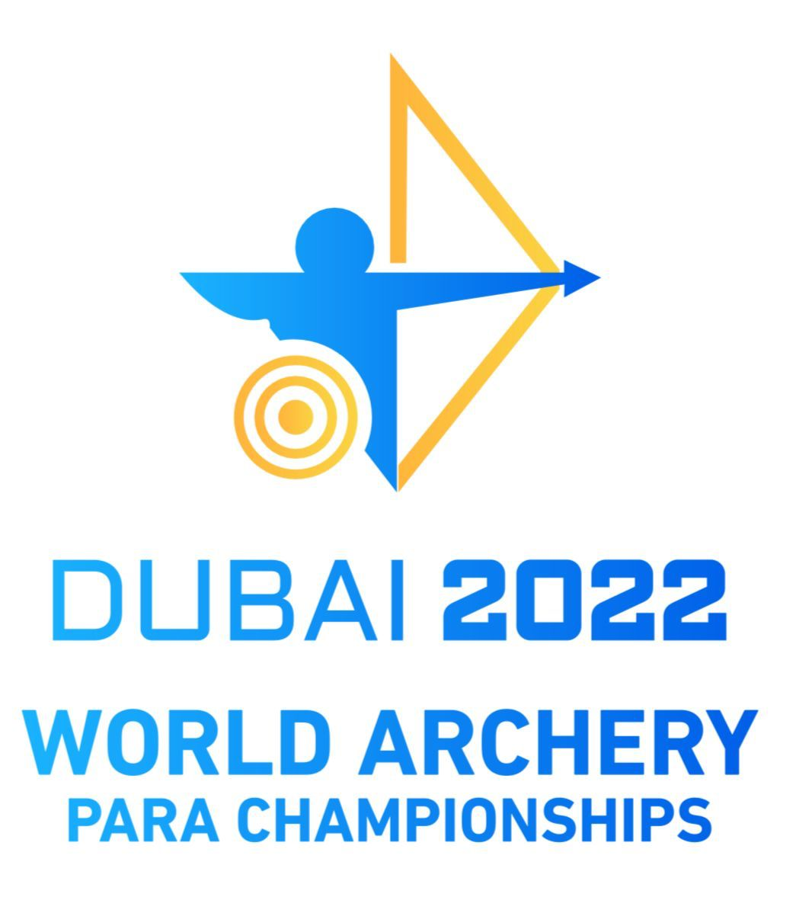

19-27 February 2022

INVITATION PACKAGE
V.1.2 20 January 2022

An Invitation to Participate in the:
Dubai 2022 World Archery Para Championships

Dubai 19 - 27 February 2022

Dear World Archery members /NPCs/ dear friends: Please forward this invitation to the relevant personnel regarding Para Archery within your country:
The World Archery Federation and the Dubai Club for people of Determination would like to invite you to the 2022 edition of the World Archery Para Championships - Dubai 2022 in the period from 19 – 28 February 2022 at the Dubai Club for People of Determination, United Arab Emirates.

We are very proud to host such a prestigious event that will help develop the legacy within the sport and further develop our athletes with international competition experiences.

Through the continued support of the government entities, national sports governing bodies, private and public sector partners, we are very pleased that this competition is hosted in the United Arab Emirates; where we are sure your Para- Archers will experience our fantastic Emirati hospitality and face elite competition.

Dear National Paralympic Committees,
Dear National Federations,
The World Archery Para Championships unleash the return of world class sporting activity for the year 2022 to be a renewed from Dubai, United Arab Emirates, for world athletes to achieve their goals.

The challenge is one of the characteristics of the people of the Emirates, and people of determination are an important and complementary part of this framework, and by this they prove to the world that the impossible does not exist here, so no pandemic, problem or barrier can stand in front of our determination to achieve the desired future.

To all world champions, we say welcome to the homeland of challenge and in the source of happiness and in the space of the impossible. Welcome again and again to Dubai arenas and halls of the Dubai Club for People of Determination with new hope and renewed energy.

The UAE salutes you, and Dubai welcomes you, and the Dubai Club for People of Determination opens its stadiums for your concerns, which have no limits. Welcome to creativity ... to convergence ... to love.

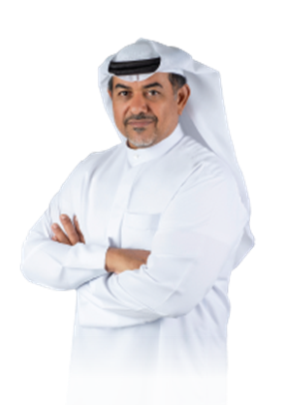

Thani Juma Berregad
LOC - President
Dubai Club for the People of Determination

The World Archery Para Championships, for People of Determination coming 2022 carries a lot of innovation and renewal, and we know very well that there is a challenge in organizing these Championships in this exceptional year, in which the world is witnessing the pandemic of the Coronavirus disease (Covid-19).

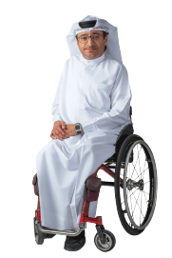
Our country only accepts to move forward, and because our wise leadership instilled innovation and challenge in us, we quote from them their inspiring words that motivate us to develop and innovate. The directives of the sponsor of these championships, His Highness Sheikh / Hamdan bin Mohammed bin Rashid Al Maktoum, Crown Prince of Dubai and Chairman of the Dubai Executive Council, were clear to all of us since the first version of the need for development and innovation, as it was to support His Highness Sheikh Mansour bin Mohammed bin Rashid Al Maktoum, Chairman of the Dubai Sports Council The positive impact on continuing to organize 2022 World Archery Para Championships, despite the challenges. The World Archery Para Championships for People of Determination will be an icon of global Paralympic sports and to reach the world through the Dubai Gate. In Dubai, different civilizations meet to blend into one harmonious fabric that reflects the extent of harmony and rapprochement between peoples. Welcome all to your second country and among your brothers...

Majid Al- Usaimi
LOC – Manager
Dubai Club for the People of Determination

Important Dates

Registration opening date | 21/10/2021
Preliminary entries deadline | 19/11/2021
Final entries deadline | 29/01/2022
Submission and request of classification and medical intake forms | 10/01/2022

Preliminary and final registration

All entries, accommodation reservations, transport needs, flight arrival/departure information and visa invitation letter requests are to be completed using the World Archery Online Registration System WAREOS . These systems now handle the entire registration process for this event. No entry forms, hotel reservations or transportation forms will be accepted.

Member associations can login to WAREOS at http://extranet.worldarchery.sport with the username and password assigned by World Archery. After entering WAREOS, selecting the event from the list will allow a member association to register their athletes. Select/press the “Entries” button to see the list of categories in the event. Select/press the “category” to enter the athlete and official numbers/details participating for that event. A WAREOS User Manual can be downloaded in PDF format (English) upon login.

Contact wareos@archery.sport with any questions regarding technical problems on WAREOS. For any question regarding the organization of the event (transport, accommodation, meals etc.) please directly contact the LOC.

Please respect the stated deadlines.

Member Associations must use WAREOS only to make any changes or amendments to entries and will be able to do so at any time. An email will automatically notify the Organizing Committee and Member Association of any changes made in WAREOS.

Provisional schedule
 | Compound Open | W1 | Visually Impaired | Recurve Open
SAT  19/02 | ARRIVAL | ARRIVAL  Free practice  (priority to CO) | ARRIVAL  Free practice (priority to  CO & W1) | ARRIVAL  Free practice (priority to  CO & W1)
SUN  20/02 | Classification  Free practice
MON  21/02 | Classification  Official Practice | Classification  Free practice
TUE  22/02 | Qualification  Elimination to 1/24 | Official Practice | Classification  Free practice | Classification  Free practice
WED  23/02 | Eliminations  - Mixed teams  - Doubles  - Individuals |  | Official Practice | Official Practice
THU  24/02 |  | Qualification | Qualification | Qualification
FRI  25/02 | Medals matches  - Mixed teams  - Doubles  - Individuals  - Awards Cerem. | Eliminations  - Mixed teams  - Doubles | Eliminations Individuals | Elimination  - Mixed teams
SAT  26/02 | DEPARTURE | Medals matches  - Mixed teams  - Doubles  - Individuals  - Awards Cerem. | Medals matches  - Individuals  - Awards Cerem. | Elimination  - Doubles
SUN  27/02 |  | DEPARTURE | DEPARTURE | Eliminations  - Individuals  Medals matches  - Mixed teams  - Doubles  - Individuals  - Awards Cerem.
MON  28/02 |  |  |  | DEPARTURE

Classification

For countries which have athletes needing to be classified for the first time or who have “Review” status which requires a further classification, please complete the classification application form and medical intake form for each person and send it to classification@archery.sport , no later than 10 January 2022.

New classification for VI archers will apply. A classification session will be organized.

VI archers with review status or with only national classification shall be classified on place.

Links for documents:
Classification submission form: https://documents.worldarchery.sport/?doc=4210
Para-Athlete medical form: https://documents.worldarchery.sport/?doc=4209
VI athlete medical form: https://documents.worldarchery.sport/?doc=93

The classification schedule will be published after the final entries.

Rules to apply

World Archery rules will apply.

Please make sure to review Book 3, Article 21 who will change as of 1 January 2022.

Main changes are about teams which are replaced by doubles:

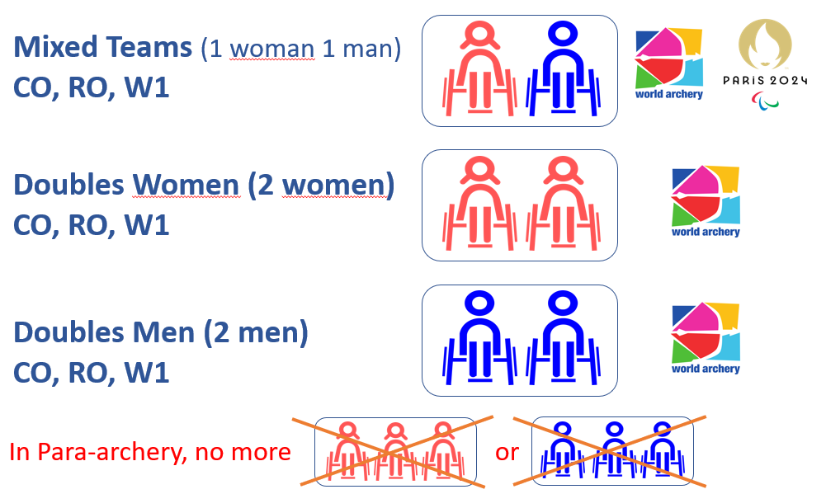

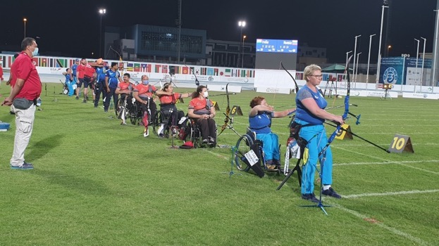

The new rules do not permit the combination of gender or division anymore in CO and W1 categories.

Venue

Dubai Club for People of Determination: https://goo.gl/maps/qz2G3qJSromhmQcx7
Accommodation

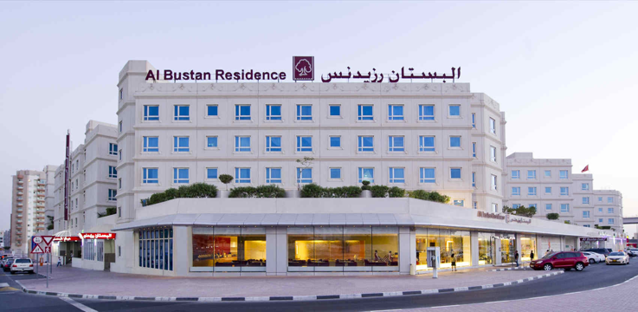
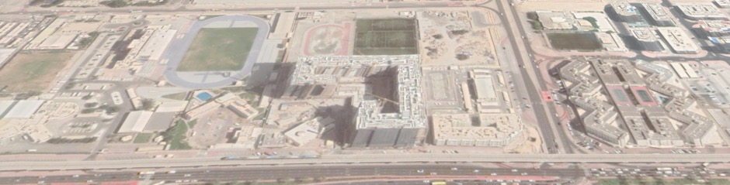
600 m
Venue Al Bustan Residence
Al Bustan Hotel is the official hotel for all athletes and officials. The hotel offers accommodation in single, double, triple and quadruple rooms.

Address: Al Nahda Road-Al Towar, P.O. Box 2017 Dubai, UAE
Website: www.al-bustan.com

Accommodation
Full board including three meals with non-alcoholic drinks (breakfast, Lunch and Dinner)
- Single room
- Double room
- Triple room: apartment including 1 single room and 1 double room, two bathrooms, kitchen, lounge and dining area
- Quadruple room: apartment including 2 double room, two bathrooms, kitchen, and lounge and dining area with sofa bed

Fees per night (including VAT)

- Single room 210 USD
- Double room 400 USD
- Triple room 590 USD
- Quadruple room 790 USD

Check-in first date: 19 February 2022 at 12:00
Check -out last date: 28 February 2022 at 16:00
Teams who arrive on 19 February 2022 before 12:00 and want to have access to their rooms before the check in will be charged an extra night. After 12:00 the hotel will available the room (without extra cost).
On 28 February 2022 teams who wants to stay in their rooms after the check-out (16:00) will be charged for an extra night. Teams can stay in the lobby without extra cost.

All rooms will be allocated once payment has been received in full.

If the competition schedule will not allow teams to get lunch at the hotel, the LOC will provide lunch packets at the venue, this will be decided after the Competition schedule has been published officially.

Accommodation in non-official hotels will be charged a double entry fee, 250 USD for officials and 500 USD for athletes.

Registration & Booking

Entry fees

Athletes: 250 USD
Officials: 125 USD
Teams: no fee

Entry fees include airport transfer to hotels, daily local transport to and from the practice field to/from official hotels during the qualification, elimination, and finals venues (timetable to be confirmed on site).

Payment procedure

Full accommodation fees must be transferred to the following bank account, no later than 10 January 2022. Please note that rooms will only be booked and allocated to teams when the accommodation payment has been received in full. An extra charge of 10% will be apply to any payment received after deadline.
Account name | Dubai Club for People of Determination
Bank name | Dubai Islamic Bank
Branch name | Dubai Main Branch – Al Maktoum Street
Account number | 001520726988901
Swift-Code | DUIBAEAD
IBAN | AE95 0240 0015 2072 6988 901

Cancellations & Changes

All cancellations and changes must be made through WAREOS:

- 50% of payment will be refunded if cancellations are made by 10 January 2022
- No payments will be refunded to cancellations from 11 January 2022
- Refunds will be processed after the event.
- Should flight arrival details change last minute, please contact the Organising Committee using the details indicated in the team managers’ booklet.
- If a participant’s arrival is later than the original scheduled arrival date, the room will be charged from the date of the original booking in WAREOS.
- An email will automatically notify the Organising Committee and Member Association of any changes made in WAREOS.

The value of the invoices will be issued in dirhams and dollars, all bank charges will be paid by the participants

Penalty fees

Penalty fees to be paid to Organizing Committee | Cost (USD)
Entries made after the entry deadline date. | 50.- per entry
If final entries differ from the preliminary entries by more than 2 athletes/officials. | 150.- per entry
When no preliminary entries were made before the deadline date but then submit final entries. | 150.- per entry
Penalty Fee to be paid to World Archery | Cost (CHF)
Lost accreditation. | 30.- each
Lost classification card | 30.- each
Any change to the final country entry list, such as (but not limited to):  - Athlete or official name change  - Date of birth change  - Official position change  - Absence or incomplete on-site contact person | 50.- each change

NOTE: CHF currency exchange rates will be those on the date of the event.

Transportation

Transportation will be provided for free to all athletes and team officials from/to Dubai. International Airport to the official hotel takes only 5 minutes by car or bus.

The distance between the competition venue and the official competition hotel is about 600 meter and takes 6 minutes by car or bus.

Please refer to the following welcome desk at the Airport upon arrival:

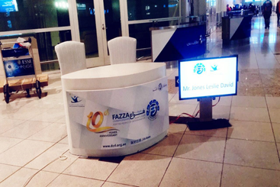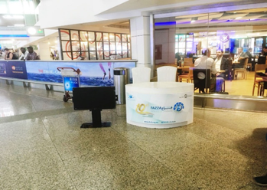
Visa

Request for visa invitation letter is to claim through WAREOS system.

Per Visa: 110 USD

Medical services

Organizing committee will cover only emergency medical cases during the championship.
Designated medical institutions
Rashid hospital, which is located 15 minutes from competition venue Dubai club for people of determination:
Address: Umm Hurair 2 – Dubai
Phone: +971 4 2192000

Venue medical centre
Will be in Dubai club for people of determination competition stadium
- Period: 19 till 28 February 2022
- Timing: 8:30 to 22:00 (emergency 24 H)
- Specialty: sports medicine – Emergency medical care (further medical investigations will be available in hospital upon doctor request)
- Facility: examination rooms ,3 beds treatment rooms
- Physiotherapy room and massage which is chargeable
- Object: Athletes, Team Officials, Staff, Spectators
- Ambulances: 3 paramedics

Official hotels
24H emergency on call doctor (contact help desk)
Local Emergency Numbers: Police: 999
Ambulance: 998
Fire: 997

Medical Insurance
The LOC will provide “on-site” emergency medical care for all accredited persons. Any costs incurred for any other medical care must be paid by the patient or their National Paralympic Committee/Sport Federation/ Clubs. All participating teams are responsible for arranging the personal travel and accident insurance coverage in relation to the Dubai 2022 World Archery Para Championships for all members of their respective delegations.

Other medical matters

- Team doctors are allowed to practice on their national team and all prescriptions and investigations must be arranged through the LOC medical team.
- Importation of Medicines: The head doctor accompanying a team must provide a list of the medicines the team is bringing into UAE, including dosages and quantities. The list will constitute a statement on behalf of the Member Federation which will be retained by the Dubai Club For People Determination - Dubai 2022 Medical Services and will be shared with the UAE Dubai Health Authority or another government body if requested. A template form will be sent soon to the participating teams.
- Distribution of ice
Ice will be provided at the competition and training venues.
- Athletes under treatment by prohibited medicine in UAE such as (marijuana) should provide medical report with medical prescription at the airport (Dubai customs might request it )
- Importation of medical equipment: A template form will be sent to participating teams.
- For a medical emergency outside the opening hours of the Venue Medical clinic please contact the doctor on call (telephone number to be confirmed) or the Emergency Ambulance service on 998.

Covid19 rules and regulations according to Dubai sports council-UAE

These rules applied only on Dubai which mean all teams must come through Dubai airport to avoid any complication of quarantine in another state.

- All delegations must provide PCR negative test 48 hours before arriving to Dubai airport at the departure airport.
- All teams will be tested at the arrival terminal in Dubai airport by Dubai health authority and transportation will be available from airport to hotel, they must stay at their hotel room until we receive negative results (results delivered in less than 24 hours).
- Positive cases will be moved to quarantine complex, and it will be medically managed by Dubai health authority.
- All athletes in contact with positive covid19 case will be retested and if their results are negative, they can compete.
- Body Temperature check at the accommodation and competition venue.
- Covid-19 precaution procedures will be applied in hotel and competition venue.
- Covid-19 physician will be designated for ensure safety and prevention.
- All team members will be submitted to another PCR test five days after their entry in Dubai.
- Isolation room will be available at the hotel and competition venue.

- All club facilities and transportations will be sanitized regularly.
- Face masks are mandatory all the times except for the athletes while on shooting line or eating.
- All travellers from Dubai airport should present negative PCR covid19 test not older than 48 hours before flight time. Test that will be conducted at the competition venue hall.
- Local organizing committee are not responsible for any cost resulting from positive cases such as changing flight or hotel accommodation, or quarantine.
- All participants should adhere to UAE Health Authority law in covid19 prevention rules and regulations to avoid legal consequences.
http:www.emirates.com/English/help/covid-19/
PERSONAL HYGIENE AND HEALTH ADVICES
- Anyone due to participate in the event who is feeling ill should not attend
- Participants (athlete, volunteer, official etc.) should proactively and regularly check their health status (including taking their temperature and monitoring for any symptoms)
- Stay home and self-isolate even with minor symptoms for 10 days or more depending on national protocols, when showing any symptoms (fever, tiredness, dry cough, headache, nasal congestion, runny nose, sore throat, difficulty breathing).
- Contact a healthcare provider immediately if any respiratory illness is noted
- Masks to be worn at all times everywhere (transport, common area in the hotel, venue, training etc.) except on shooting line or when eating.
- Regularly and thoroughly clean your hands with an alcohol-based hand rub or wash them with soap and water
- Avoid touching eyes, nose and mouth
- Cover your mouth and nose with your bent elbow or tissue when you cough or sneeze. Then dispose of the used tissue immediately and wash your hands
- Avoid touching high-contact surfaces such as door handles, walls or windows, etc.
- Avoid going to crowded places
- Avoid steam rooms or saunas
- No spitting, as the main mode of transmission of the virus is in respiratory secretions
- No handshakes, high fives and any other personal contact
- Athletes should not share clothing, bar soap, sports equipment, water bottles or other personal items
TRANSPORT & ACCOMMODATION
- Avoid using public transport to go to the hotel and between the hotel and the venue
- All meals have to be taken in the hotel or at home, not at any other restaurant/bar
VENUE
- Access to the venue might be denied at any time in case of disease suspicion
- Limit contact/interactions
- Hand washing/alcohol- based hand gel will be available at multiple locations in the event facility and accommodation
- Regular toilet cleaning will be done (at least once per session)
- Medical post and designated personnel on site able to help assess cases and potential other illness will be present
- An isolation room/space to hold any symptomatic person found at the venue will be available
- Space on shooting line shall be 1.25 metre minimum per athlete
PARTICIPANTS
- Maintain the staff/team to a minimum to minimise transmission
- Maintain social distancing, at least 1,5 metre distance between yourself and others at all time

Contacts

phone numbers:
Airport coordinator | Ola Adnan | +971 507988484
Hotel & Logistics Coordinator | Ashraf Ghobash | +971 507746604
Transportation | Essam Mohamed | +971 509262644

LOC Contact Address

Kresh Jagarnath
Sports Facilities and Events Manager
Tel: 00971 4 2988127
Mobile: +971 50 5031868
P.O. Box: 20990, DUBAI - UNITED ARAB EMIRATES
Email: kjagarnath@dcd.org.ae

Media Registration

Media representatives can apply for registration by emailing info@archery.sport

Welcome to DUBAI

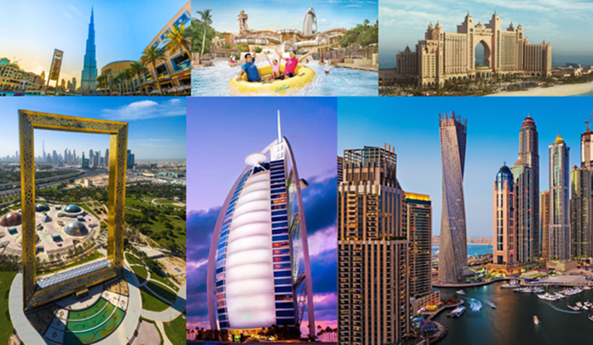

The United Arab Emirates
UAE is consisting of seven emirates: Abu Dhabi, Dubai, Sharjah, Ras Al Khaimah, Ajman, Umm Al Quwain and Fujairah. Four-fifths of the UAE is desert but has contrasting landscapes—from the towering red dunes of the Liwa to the rich palm-filled Oasis of Al Ain, from the precipitous Hajjar Mountains to the more fertile stretches of its coastal plains.
Though small (like the size of Scotland), the UAE has become an important player in regional and international affairs. In 1971, the late President Sheikh Zayed bin Sultan Al Nahyan unified the small, underdeveloped states into a federation—the only one in the Arab world. With his visionary leadership, oil wealth was used to develop the UAE into one of the world’s most open and successful economies.
In 2004, His Highness Sheikh Khalifa bin Zayed Al Nahyan became the President and has since continued to strive towards an ambitious vision for the UAE.
DUBAI
Dubai is located on the Eastern coast of the Arabian Peninsula, in the southwest corner of the Arabian Gulf. It is extremely well known for its warm hospitality and rich cultural heritage, and the Emirati people are welcoming and generous in their approach to visitors. With year-round sunshine, intriguing deserts, beautiful beaches, luxurious hotels and shopping malls, fascinating heritage attractions and a thriving business community, Dubai receives millions of leisure and business visitors each year from around the world.

Dubai Rulers
Since 1833 the reigning Al Maktoum family have ruled Dubai. Under their wise and progressive leadership Dubai has prospered and it is now the business and tourism hub for a region.

Dubai History
Saruq Al-Hadid site is considered one of the most important archaeological discoveries in Dubai and the region, as it offers much of the UAE old past, especially during the Iron and Bronze Ages، which confirms that the UAE civilization extends to 5 thousand years.
Dubai Economy
The past few decades have witnessed incredible growth throughout all sectors of the Dubai economy. The emirate’s government is constantly working to improve its commercial transparency and introduce dynamic regulations that aid the formation of small and medium enterprises. Dubai’s economy is no longer reliant on oil, but is more diversified, relying heavily on trade, services and finance sectors. With its central geographic location between Asian and European markets, Dubai has worked hard to establish itself as an integral part of the global trade mechanism. Its central location has also allowed Dubai to become a popular and accessible tourist destination.

GENERAL INFORMATION

Weather
Dubai has a tropical desert climate because of its location within the Northern desert belt. Summers are extremely hot and humid, with an average high around 41 °C (106 °F) and overnight lows around 30 °C (86 °F). Most days are sunny throughout the year. Winters are warm and short with an average high of 23 °C (73 °F) and overnight lows of 14 °C (57 °F). Precipitation, however, has been increasing in the last few decades with accumulated rain reaching 150 mm (5.91 in) per year. The weather in Dubai can bring short and irregular rainfall as is typical for the Middle East. Most of the rainfall occurs in the December to March period. The weather between December and March remains warm and is the most comfortable climatic conditions of the year.
Currency
The local currency is the dirham, which is pegged at AED 3.59 to 1 US dollar. Dubai is tolerant and cosmopolitan, and all visitors are welcome. However, Islam is a way of life in the city, and therefore tourists should adopt a certain level of cultural and religious sensitivity for the duration of their stay.
Electricity and power sockets in the UAE
In the United Arab Emirates, the standard voltage is 240-220 V. The standard frequency is 50 Hz. The power sockets that are used are of type G. Find pictures of these power sockets and corresponding plugs.

Dubai 2022 World Archery Para Championships - LOC Sponsors

