TO ALL World Archery Member Associations
Dear President,

As Chair of the Local Organising Committee (LOC) of the World Archery Para Championships to be held in Pilsen – Czech Republic on 17 – 23 July 2023, I would like to invite you all to be part of one of the most important sport events to take place in the Czech Republic in 2023.

Pilsen is a modern city with many sport facilities and great sport support. Many well-known athletes in various sports were born or have spent part of their career in Pilsen eg. Peter Cech (soccer goalkeeper), Martin Straka (Ice hockey player and Olympic Champion), Filip Jícha (the best handball player of the 2010 year), Andrea Hlavackova-Sestini (tennis player and Olympic medallist), Katerina Emmons (shooting Olympic medallist) and many others.

It was our pleasure to host European Para Archery Championships 2018 in Pilsen and specially the final venue in the city centre was a great place to win medals.
I hope that you will enjoy the hospitality of Pilsen and have a great summertime in Czech Republic.

Sincerely yours,

Roman Suda
Pilsen 2023 World Archery Para Championships OC Chairman

Important Dates:

Please find enclosed detailed information regarding this event. To register participation, please complete all the necessary sections in WAREOS (https://extranet.worldarchery.sport) within the deadlines listed below.

Summary of deadlines:

Registration Opening date on WAREOS | 17 January 2023
Preliminary Entries | 17 April 2023
Classification Medical form submission | 16 June 2023
Final Entries | 26 June 2023
Hotel reservation down-payment (50%) | 17 April 2023
Hotel reservation and payment | 11 June 2023
Transportation | 11 June 2023
Visa support | 31 May 2023
Full refund cancellation deadline  *After this deadline, the LOC is allowed to retain all amounts due by the Member Association. | 30 April 2023

Please respect the stated deadlines.

PRELIMINARY PROGRAMME

15 July 2023  Saturday | Arrival of participants  Unofficial practice
16 July 2023  Sunday | Classification  Unofficial practice  (CMO, CWO, W1M, W1W, RMO, RWO)
17 July 2023  Monday | Official practice  Equipment inspection  (CMO, CWO, W1M, W1W, RMO, RWO)
18 July 2023  Tuesday | Qualification Round  (CMO, CWO, W1M, W1W, RWO)
19 July 2023  Wednesday | Qualification Round  (RMO)  Elimination Rounds Mixed Teams (RO, CO, W1)  (Recurve and Compound)  Classification (only VI)
20 July 2023  Thursday | Official practice VI  Equipment inspection (VI)  Elimination Round Individuals  (CMO, CWO, RMO, RWO, W1M, W1W)
21 July 2023  Friday | Secondary Tournament Individuals qualification Paris 2024  Qualification round VI  Elimination rounds Doubles (CMO, CWO, RMO, RWO, W1M, W1W)  Elimination rounds individuals (VI)
22 July 2023  Saturday | Finals  Individuals VI  Mixed teams, Doubles, Individuals CO
23 July 2023  Sunday | Finals  Mixed teams, Doubles, Individuals W1Mixed teams, Doubles, Individuals RO
24 July 2023  Monday | Departure of teams

NOTE: This preliminary programme is subject to change according to participation and TV requirements. All changes will be published and distributed in good time.

RULES TO APPLY

World Archery Rules apply for the World Archery Para Championships. Some changes have been done with effect since the 01 March 2023. Please take time to read the updated version of rules on World Archery website:
https://www.worldarchery.sport/rulebook

During the event we will have the first qualifying tournament for Paris 2024. Details on qualification process is available on IPC website:
https://www.paralympic.org/paris-2024/qualification-regulations

PRELIMINARY & FINAL REGISTRATION
All entries, accommodation reservations, transport needs, flight arrival/departure information and visa invitation letter requests are to be completed using the World Archery Online Registration System WAREOS https://extranet.worldarchery.sport. This system handles the entire registration process for this event. No entry forms, hotel reservations or transportation forms will be accepted; all information must be entered into WAREOS.

Member associations can login to WAREOS at https://extranet.worldarchery.sport with the username and password assigned by World Archery. After entering WAREOS, selecting the event from the list will allow a member association to register their athletes. Select/press the “Entries” button to see the list of categories in the event. Select/press the “category” to enter the athlete and official numbers/details participating for that event. A WAREOS User Manual can be downloaded in PDF format (English) upon login.

Contact wareos@archery.sport with any questions regarding technical problems on WAREOS. For any question regarding the organisation of the event (transport, accommodation, meals, invoices, visa etc.) please contact directly the LOC.

A maximum number of 3 can be registered into each category of the event. Preliminary entries should be completed using WAREOS.

Member Associations can only use WAREOS to make any changes or amendments to entries and will be able to do so at any time. An email will automatically notify the Organising Committee and Member Association of any changes made in WAREOS.

ENTRY FEES

Individual 230 EUR per athlete
Official 115 EUR per person
Guest 750 EUR per person
International License 100 CHF per participant per calendar year to be paid
to World Archery

ENTRY FEES IN NON-OFFICIAL HOTELS

Individual 460 EUR per athlete
Official 230 EUR per person
International License 100 CHF per participant per calendar year to be paid
to World Archery

Entry fees for Individual/Official include daily local transport between official hotels and the qualification, elimination, and finals venues (timetable to be confirmed on site).

Entry fees for Guest include daily local transport between official hotels and the qualification, elimination, and finals venues (timetable to be confirmed on site). They have no field of play access.

Any changes that are made after the deadlines specified or if entries differ by more than 4 athletes from the preliminary entries, the following penalty fees will automatically be applied.

PENALTY FEES TO BE PAID TO ORGANISING COMMITTEE

Penalty fees for Late Entries (after final deadline): | 50 per entry
Penalty fees for not filling Preliminary entries | 150 per entry
Penalty fee for differences between preliminary and final entries:  *If the difference between final and preliminary entries number is more than 4 athletes/officials | 150 per entry

PENALTY FEES TO BE PAID TO WORLD ARCHERY (CHF)
Lost / Damaged accreditation | 30.- each
Lost classification card | 30.-each
Any change to the final country entry list, such as (but not limited to):  - Athlete or official name change  - Date of birth change  - Official position change  - Absence or incomplete on-site contact person | 50.- each change

NOTE: CHF currency exchange rates will be those on the date of the event.

Member Associations that have penalty fees outstanding from 2022 will need to have paid these penalty fees before being eligible to enter and compete.

Any entries received less than 3 days before the team managers meeting for a Hyundai Archery World Cup or World Championships will be refused if no preliminary entry and/or final entry are made prior. This decision cannot be appealed by the teams and is fully compliant with the current World Archery rules, article 3.7.1.2. Entries received after the deadlines, are subject to penalties as clearly stated in the rule book and the invitation documents of World Cups and World Championships. A Member Association that has made final entries in WAREOS and does not participate will be invoiced for the number of entries entered in the system, unless they have informed World Archery and the Organizing Committee in writing at least one week prior to the event that they are unable to attend.

ACCOMMODATION
Four stars hotels are in close distance from qualification and final venue. Room rates for all hotels are per room per night and include Breakfast, Lunch and Dinner. Lunch will be served at the archery venue. Dinner will be always served at the hotel.
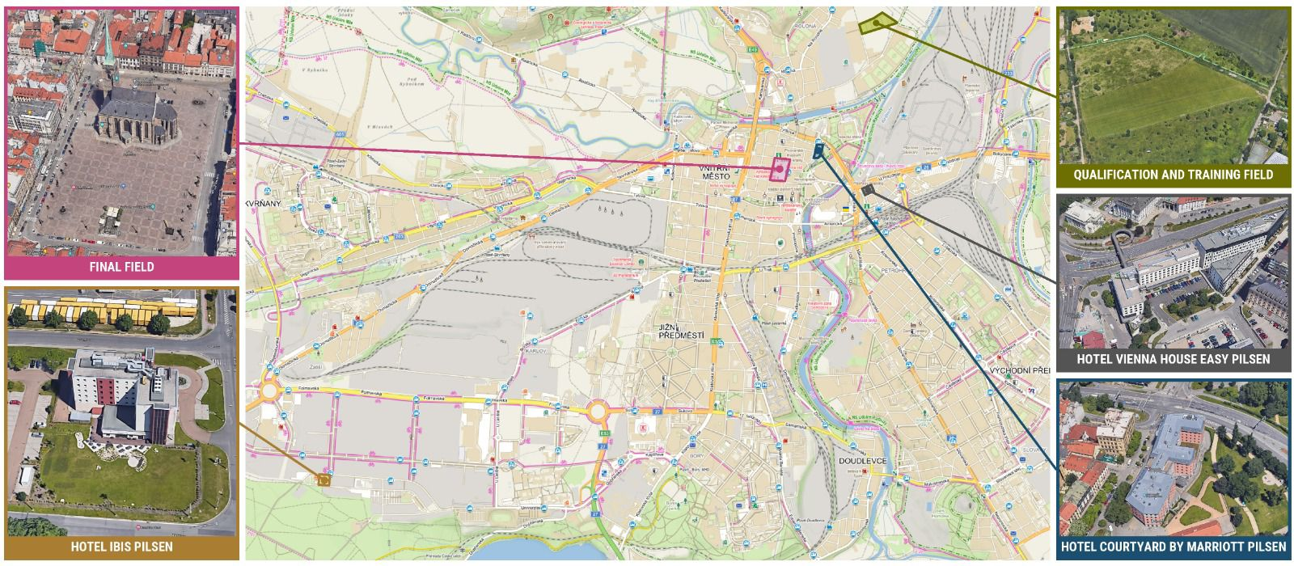

Courtyard Marriot – Four Stars Hotel
- Single Room price: EUR 150.00 per room
- Number of rooms: 50
- Double/Twin Room price: EUR 210.00 per room
- Number of rooms: 70
- Board plan: full board
- Check-in from 15.7.2023 from 2pm
- Check out 24.7. 2023 till 11 am
- Hotel website: https://www.courtyardpilsen.cz/
- Photo
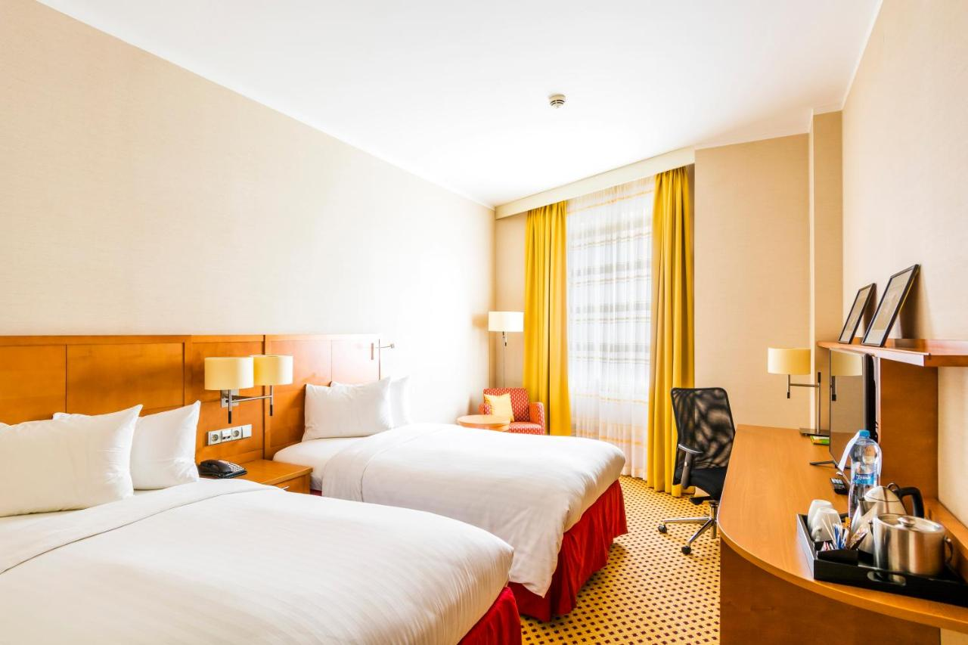

Vienna House Angelo Pilsen – Four stars Hotel
- Single Room price: EUR 150.00 per room
- Number of rooms: 30
- Double/Twin Room price: EUR 210.00 per room
- Number of rooms: 80
- Board plan: full board
- Check-in from 15.7.2023 from 2pm
- Check out 24.7. 2023 till 11 am
- Hotel website: https://www.viennahouse.com/en/easy-pilsen
- Photo

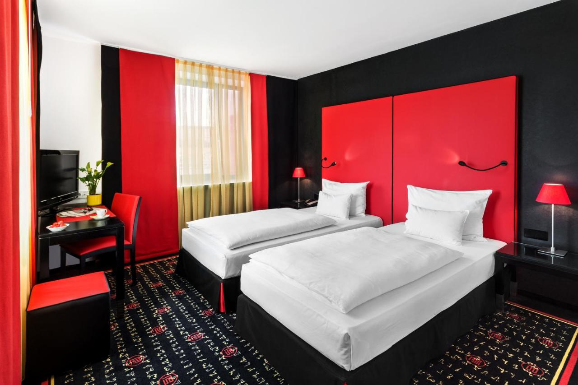
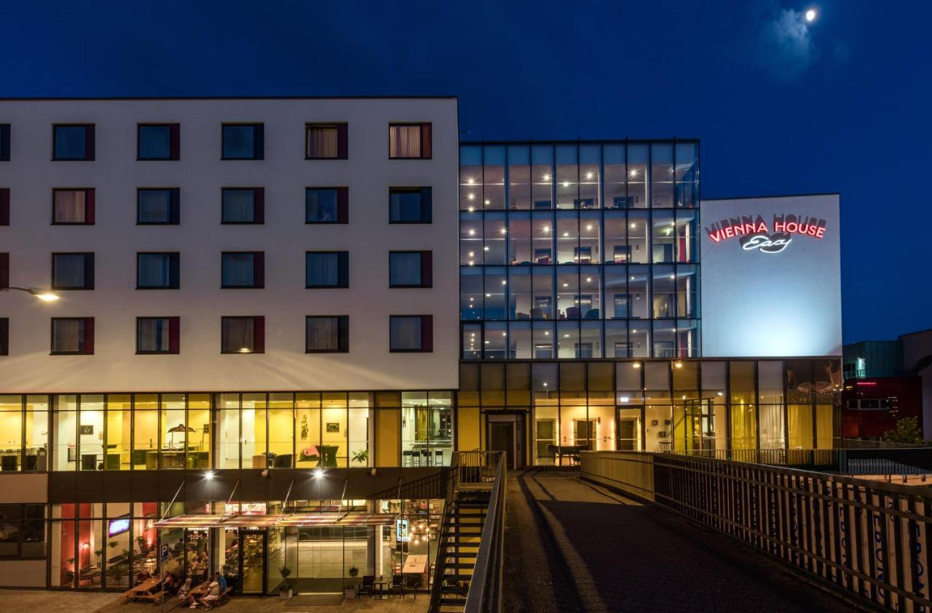

Ibis Pilsen – Three stars Hotel
- Single Room price: EUR 100.00 per room
- Number of rooms: 20
- Double/Twin Room price: EUR 160.00 per room
- Number of rooms: 60
- Board plan: full board
- Check-in from 15.7.2023 from 2pm
- Check out 24.7. 2023 till 11 am
- Hotel website: https://www.hotelibisplzen.cz/en/
- Photo

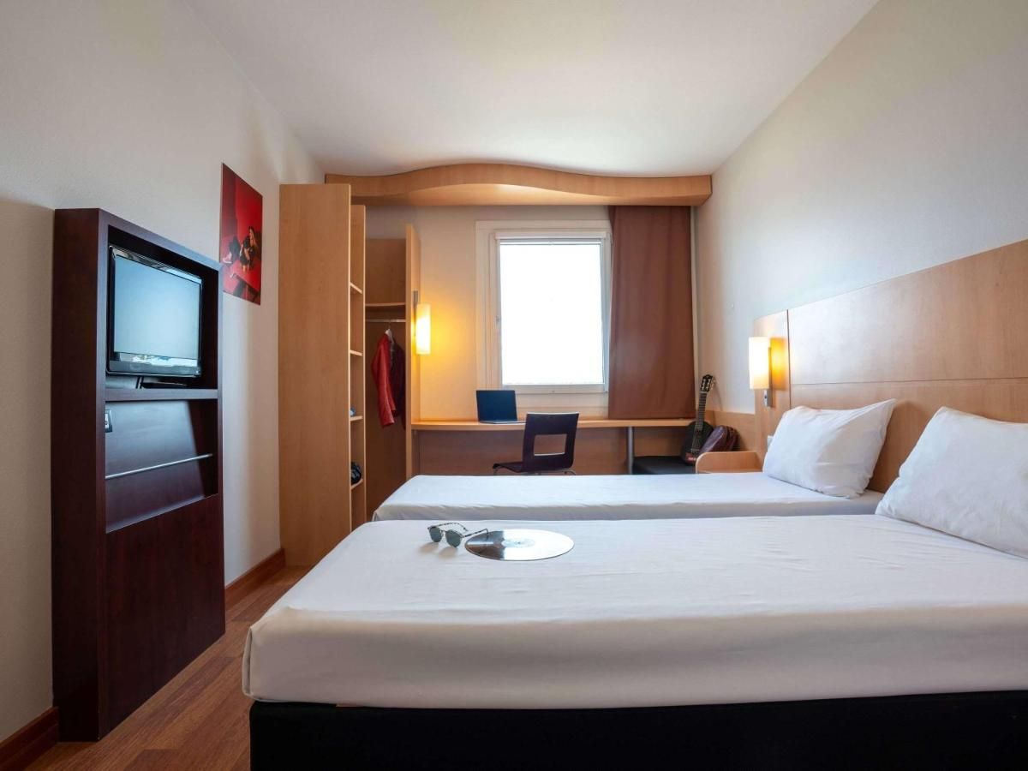
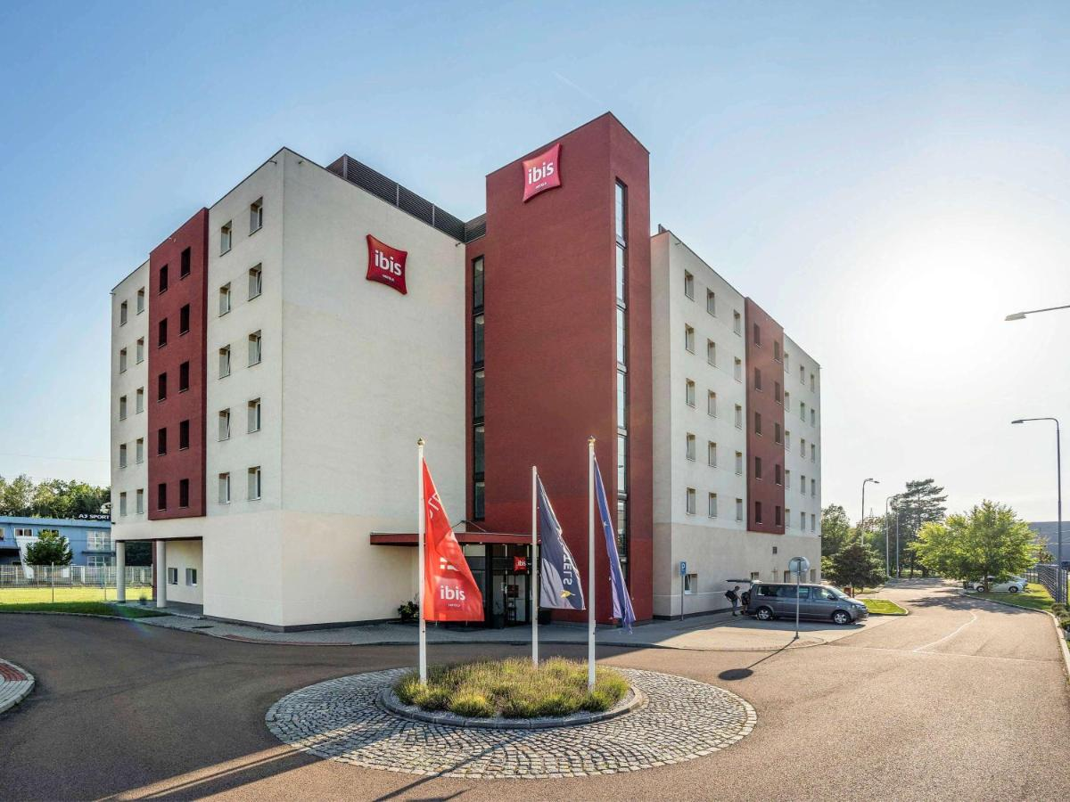

Rooms are allocated on a first come, first serve basis.
Teams who do not reserve their accommodation through the organizing committee will be charged a double entry fee.
In addition, the LOC will not be responsible to provide any event information at this hotel or provide transportation to the venues.

TRANSPORTATION
Transportation will be provided from Vaclav Havel International Airport in Prague to the official hotels from 15 June and until 25 July at 40 EUR/person one way. Local transport will be available between the official hotels and practice, competition, and final venues for free (fee is included in entry fee). Transport timetables will be confirmed on site

CLASSIFICATION

The classification will take place:
- The 16 July for the W1, CO, RO categories
- The 19 July for VI categories

Requests and documents (medical form and information) must be sent to classification@archery.sport no later than 16 June.
All information and forms can be found on World Archery Website:
https://www.worldarchery.sport/sport/disciplines/para-archery/classification

It is the full responsibility of teams to arrive in time. It will not be possible to postpone classification session or official practice nor equipment inspection.
It is recommended to the archers registered for classification to arrive one day before their scheduled classification.

VISA
All participants who need an entry visa to Country, will be required to complete the Visa Support sections in WAREOS by no later than 31 May 2023.

It is the applicants’ responsibility for supplying the necessary information, ensuring all details are up to date, correct and submitted by the deadlines specified.

In addition, all participants that require a visa are kindly requested to supply a copy of their latest/valid passport. Copies of each application can be uploaded on WAREOS. All passport copies and personal details entered/uploaded to WAREOS will be held securely and in the strictest of confidence and not shared with other parties.

PAYMENT CONDITIONS
Complete all necessary sections in WAREOS and make full payment by the specified deadlines. Bank transfers only, no credit cards will be accepted. All bank charges will be paid by the participants.

The entry fees should be paid in full before arrival.

To confirm hotels reservations, a minimum 50% deposit of the total amount is required to be bank transferred to the OC before 17 April 2023. Reservations after this date will be considered only according to availability. The final outstanding balance shall be made via bank transfer before 11 June 2023. Accommodation cannot be guaranteed after this deadline. A cost summary will be available through WAREOS.

BANK INFORMATION FOR ACCOMMODATION, TRANSPORTATION AND ENTRY FEES
A/C Name: Český lukostřelecký svaz / Czech archery Association
Federation’s Address: Zátopkova 100/2, Praha 6, 160 17
Telephone number: +420 774 433 884
City and Country: Prague, Czech Republic
Bank: MONETA Money bank
Account Number: CZ47 0600 0000 0002 1468 1606
Swift: AGBACZPP
Bank’s address: Vyskočilova 1442/1b, Praha 4, 140 28
Bank’s phone: +420 224 443 636
City: Prague, Czech Republic

NOTE: ALL PAYMENTS SHALL BE MADE IN EUR.

CANCELLATIONS & CHANGES
All cancellations and changes must be made through WAREOS:

- Cancellations received before 30 April 2023 a full refund of the deposit payment will be made.
- Cancellations received after 30 April 2023; no refund will be given.
- Refunds will be processed after the event.
- Should flight arrival details change last minute, please contact the Organizing Committee using the details indicated in the team managers’ booklet.
- If a participant’s arrival is later than the original scheduled arrival date, the room will be charged from the date of the original booking in WAREOS.
- An email will automatically notify the Organizing Committee and Member Association of any changes made in WAREOS.

HEALTH REGULATIONS (COVID-19)

INFORMATION
- Everybody should follow the Government/public health authorities measures (national and sport-specific regulations) and be aware of the travel restrictions
- For your information, medical infrastructure/Hospital with proper care will be reachable within 15 minutes from the venue, where COVID-19 test can be done.

Medical emergency contact and location
Fakultní nemocnice Plzeň / Pilsen General hospital
Address: Alej Svobody 80, 304 60 Plzeň
Tel: +420 377 103 111
https://www.fnplzen.cz/en

ADDITIONAL INFORMATION
Archery venue
Qualification venue will be located at FC Viktoria Plzeň training field, address Luční 645/54 Pilsen. Final venue will be located at the Náměstí republiky square , next to St. Bartholomew’s Cathedral.

Training
A training field will be available on 15 and 16 July 2023 and will be located at qualification venue.
For any need of training facilities earlier than these dates, please contact the Chairman of the LOC.

Weather
Average day temperature in Pilsen in July is 18 degrees Celsius/morning, 27 degrees Celsius/midday, 21 degrees Celsius evening.

Media Registration
Media representatives can apply for registration by emailing loc2023@czecharchery.cz or at info@archery.sport.

Internet
Will be available in the official hotels for free (in hotel rooms and in the lobby). There will also be Wi-Fi available for access to results on venue.

Water
Each participant will receive bottle with logo of the championships. A water fountain system will be used.

LOC CONTACT
LOC email: loc2023@czecharchery.cz

Chairman of LOC
Name: Roman Suda
Address: Zátopkova 100/2, Praha 6 160 17
Email: roman.suda@czecharchery.cz
Language: English
Phone number with international extension: +420 724 073 469
Accommodation, transportation, visa etc.
Name: Hana Majarová
Email: hana.majarova@czecharchery.cz
Language: English
Phone number with international extension: +420 733 565 769

Looking forward to welcoming you in Pilsen, Czech Republic.

