TO ALL World Archery MEMBER ASSOCIATIONS

Dear President,

The Hyundai World Archery Championships will be held in Yankton, South Dakota, United States of America on 19 - 26 September 2021. This event will be held at the NFAA Easton Yankton Archery Center (NEYAC).

On behalf of the Local Organizing Committee (LOC), it is of great pleasure to invite you to participate in this championship.

Please find enclosed the necessary documents of registration, organization and participation for this event. Please complete all the sections in WAREOS before the deadlines:

Summary of deadlines:

* Preliminary Entries 01 August 2021
* Preliminary Hotel Reservation 01 August 2021
* Preliminary Transportation 01 August 2021
* Visa Support 01 August 2021
* Final Hotel Reservation 31 August 2021

& Payment

* Final Transportation 31 August 2021
* Final Entries 31 August 2021
* Extra penalty starting date 16 September 2021

Looking forward to welcoming you in Yankton, United States of America.

Sincerely yours,



Mr. Bruce CULL

President

Organizing Committee

PRELIMINARY PROGRAM:

19 Sept 2021 Arrival of Participants

Sunday Accreditation and Registration

Practice Field and local transport available

20 Sept 2021 **Official Practice (for all)**

Monday Registration and equipment inspection

Team Managers Meeting

Opening Ceremony

21 Sept 2021 **Qualification Round**

Tuesday

22 Sept 2021 **Team, Mixed Team Eliminations**

Wednesday

23 Sept 2021 **Team, Mixed Team Eliminations**

Thursday

24 Sept 2021 **Individual and Team Finals**

Friday Team Medal Matches

Awards Ceremony

25 Sept 2021 **Finals Compound**

Saturday Mixed Team Medal Matches

Individual Medal Matches

Awards Ceremony

26 Sept 2021 **Finals Recurve**

Sunday Team Medal Matches

Mixed Team Medal Matches

Individual Medal Matches

Awards and Closing Ceremony

27 Sept 2021 Departure of Teams

Monday

Note: This is a preliminary program and subject to change according to the number of participants and TV requirements. All changes will be published and distributed in advance.

PRELIMINARY & FINAL REGISTRATION

All entries, accommodation reservations, transport needs, flight arrival/departure information and visa invitation letter requests are to be completed using WAREOS.

The World Archery Online Registration System (WAREOS): <http://register.worldarchery.sport> now handles the entire registration process for this event. No entry forms, hotel reservations or transport forms will be accepted; all information is to be entered into WAREOS.

Member Associations can log in to WAREOS at <http://register.worldarchery.sport> with your Username and Password assigned by World Archery. After entering WAREOS, please find the event from the list, you wish to register your athletes. Select/press the “Entries” button to see the list of categories in the event. Select/press the “category” to enter the athlete and official numbers/details participating for that event. A *WAREOS User Manual* can be downloaded in PDF format (English) upon login.

Contact Ms. Cécile Tosetti ([ctosetti@archery.sport](mailto:ctosetti@archery.sport)) in the World Archery Office with any questions regarding **technical problems on WAREOS**. For any questions regarding the organization of the event (transport, accommodation, meals, etc.) please contact **directly the LOC** at [yankton2021@neyac.org](mailto:yankton2021@neyac.org)

A maximum number of **three (3) athletes per country** (host country included) is allowed to be registered into each category of the event. Preliminary entries have to be completed using WAREOS.

Start date for online registration using WAREOS **08 June 2021**

End of Preliminary registration using WAREOS: **01 August 2021**

End of Final registration using WAREOS: **31 August 2021**

Please respect the stated deadlines.

Member Associations can only use WAREOS to make any changes/amendments to their entries and will be able to do so at any time. An email will be automatically sent to the Organizing Committee and Member Association with the updated information in WAREOS.

Any changes that are made after the deadlines specified or if entries differ by more than 2 athletes from the preliminary entries, the following penalty fees will automatically be applied.

|  |  |
| --- | --- |
| **Penalty fees to be paid to Organizing Committee:** | **Cost (USD):** |
| Entries made after the preliminary and/or final entry deadline date. | **50** per entry |
| If final entries differ from the preliminary entries by more than 2 athletes/officials. | **150** per entry |
| Failure to have made preliminary entries before the deadline date but then have submitted final entries. | **150** per entry |

|  |  |
| --- | --- |
| **Penalty Fee to be paid to World Archery:** | **Cost (CHF):** |
| Lost accreditation. | **30** each |
| Changes made to the athlete and/or team official names after the final entry deadline date and within 3 days prior to the start of the event. | **50** each change |

**NOTE:** CHF currency exchange rates will be those on the date of the event.

Member Associations that have penalty fees outstanding from 2020 will need to have paid these penalty fees before being eligible to enter and compete.

Any entries received less than 3 days before the team managers meeting for the World Championships will be refused if no preliminary entry and/or final entry are made prior. This decision cannot be appealed by the teams and is fully compliant with the current World Archery rules, article 3.7.1.2. Entries received after the deadlines, are subject to penalties as clearly stated in the rule book and the invitation documents of the World Championships. A Member Association that has made final entries in WAREOS and does not participate will be invoiced for the number of entries entered in the system, unless they have informed World Archery and the Organizing Committee in writing at least one week prior to the event that they are unable to attend.

ACCOMMODATION & GENERAL INFORMATION

**Due to logistics of hotels and COVID-19, you will register for the room rate and number of nights you will be stay. You will *NOT* choose the exact hotel. Exact hotels will be assigned after the preliminary entry deadline.**

The official hotels in Yankton are Best Western/Kelly Inn, Econolodge, Holiday Inn Express, Lewis & Clark Resort. In Vermillion – Red Roof Inn & Best Western Vermillion Inn. Due to limited capacity a “First Come, First Serve” policy will be followed. All hotels are on the shuttle route. The accommodation cost will include breakfast and lunch. Dinner will be provided each night at the NFAA Easton Yankton Archery Center for an additional cost. If teams don’t purchase the dinner option, they will be responsible for own meals and evening transportation to meals.

Teams who do not reserve their accommodation through the organizing committee will be charged a double entry fee.

* Reservations should be made on or before **01 August 2021**
* Final Hotel Reservation & Transportation on or before **31 August 2021**

To confirm the reservation, a 60% deposit of the total amount is required to be bank transferred to the LOC on or before **01 August 2021**. Reservations after this date will be considered only according to availability.

**IMPORTANT!**

DUE TO LOGISTICS OF HOTELS & COIVID-19 - Please, note that there will be a limited number of rooms at each hotel. Please book your hotel as soon as possible. Reservations are only final after the LOC has received the deposit of 60%. Due to limited capacity a ‘First Come, First Serve’ policy will be followed. According to the availability of the rooms, the LOC reserves the right to direct the teams to the hotels of the same level. Most hotels do not have a restaurant, but dinner option is available each evening at the NFAA Easton Yankton Archery Center.

The hotel room rates are per room, per night, including Wi-Fi, breakfast at the hotels, lunch at the venues and local transportation.

In addition, the LOC will not be responsible to provide event information to any hotel not on the official accommodation list.

Teams that book non-official accommodation will need to register at the accreditation desk no later than the day before official practice day. Failing to do so will result in no changes being made to the entry list and it is likely that participation in the event will be refused if registration is not completed in time.

Hotels:

Tier 1

* Single Room / 1 person- (includes breakfast, lunch and local transport) $205.00 USD
* Double Room / 2 people- (includes breakfast, lunch and local transport) $290.00 USD

Best Western Kelly Inn

Located next to NFAA Easton Yankton Archery Center venue

Hotel has a pool area (with hot tub), Wi-Fi, and full-service restaurant and lounge

 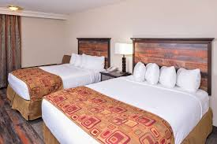 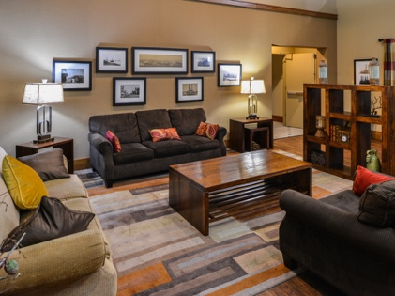

Hotel website <https://www.bestwesternyankton.com/>

Holiday Inn Express

10-minute drive to NFAA Easton Yankton Archery Center

Hotel has pool area (with whirlpool) and Wi-Fi

No restaurant or lounge available at property

* A variety of restaurants are within walking distance.
* Wal-Mart is a 5-minute walk from the hotel

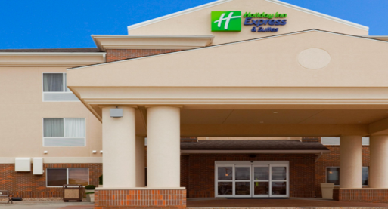 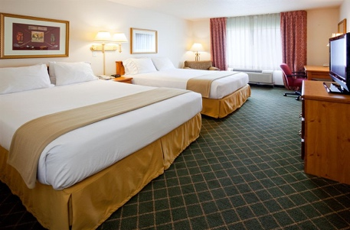 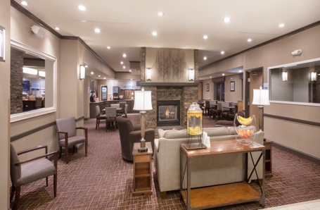

Hotel website <https://www.ihg.com/holidayinnexpress/hotels/us/en/yankton/yknsd/hoteldetail>

Econolodge

10-minute drive to NFAA Easton Yankton Archery Center

No restaurant or lounge on property

* A variety of restaurants are within walking distance.

Hotel has Wi-Fi, fitness center, indoor whirlpool/hot tub and sauna.

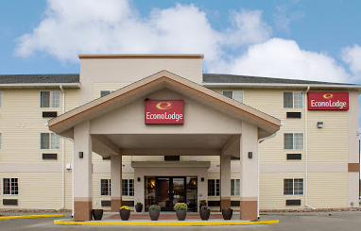 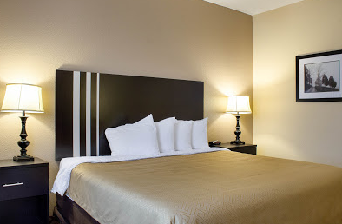 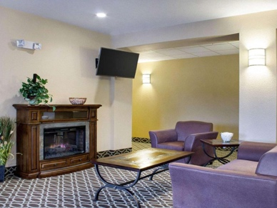

Hotel website <https://www.choicehotels.com/south-dakota/yankton/econo-lodge-hotels/sd105?brand=EL>

**Riverfront Hotel Properties**

* Located in downtown Yankton and minutes away from NFAA Easton Yankton Archery venue
* Centrally located in retail, dining and entertainment district and walking distance to finals venue.

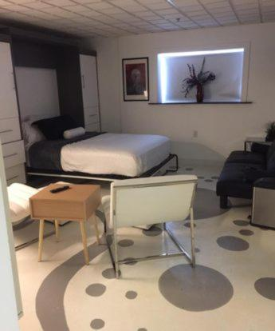 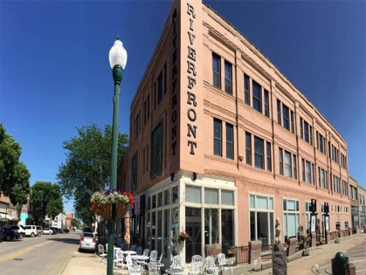 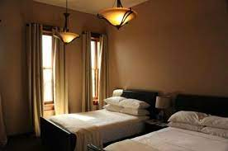

Hotel Website <https://theriverfronteventcenter.com/>

Red Roof Inn

Located in Vermillion, SD

20-minute drive to NFAA Easton Yankton Archery Center

No restaurant or lounge available on property

Hotel has pool area, Rooms have Wi-Fi

Multiple restaurants within walking distance.

Hotel Website: <https://www.redroof.com/property/sd/vermillion/RRI492>

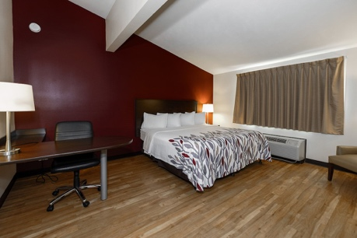 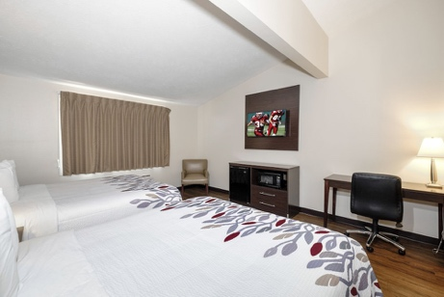 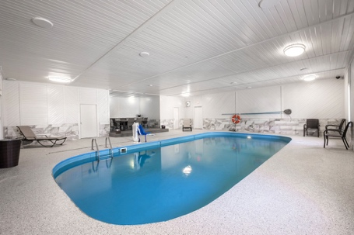

Best Western Vermillion

Located in Vermillion, SD

20-minute drive to NFAA Easton Yankton Archery Center

No restaurant or lounge available on property

Hotel has pool area, hot tub & steam room

Rooms have Wi-Fi

Multiple restaurants within walking distance.

Hotel Website: <https://www.bestwestern.com/en_US/book/hotels-in-vermillion/best-western-vermillion-inn/propertyCode.42051.html>

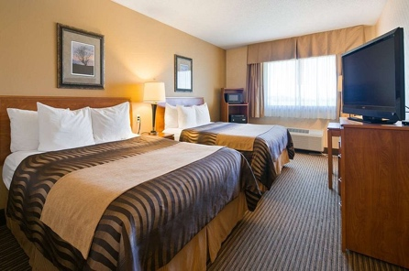 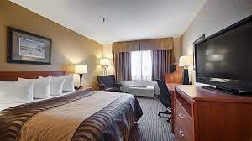 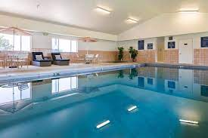

Tier 2

* Double Room (2 people)- (includes cold breakfast, lunch & local transport). $240.00 USD
* Triple Room (3 people) - King Bed & Twin Bunk Beds (includes cold breakfast, lunch & local transport). $330.00 USD
* Four person, two bedroom cabin (2 Queen beds, 1 Twin Bunks) -includes cold breakfast, lunch & local transport $400.00 USD
* Five person, three bedroom cabin (3 Queen beds, 1 Twin Bunks) - includes cold breakfast, lunch & local transport $475.00 USD

Lewis & Clark Resort Motel (Double & Triple Rooms)

Located on Lewis & Clark Lake

15-minute drive to NFAA Easton Yankton Archery Center

Rooms each have Wi-Fi, a microwave and dorm size refrigerator.

Two restaurants within walking distance.

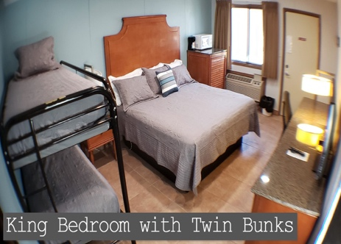 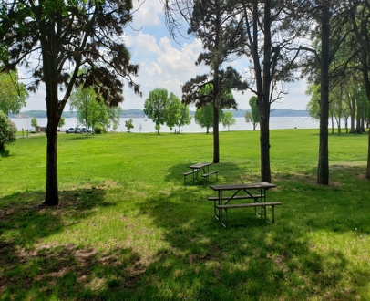 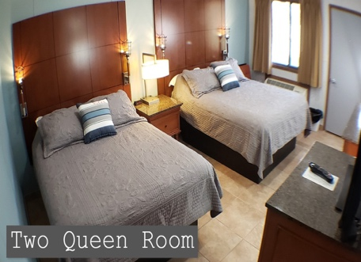

Hotel website: <https://lewisandclarkpark.sd.gov/cabin-motel-lodge-information.aspx>

Lewis & Clark Resort Cabins (4 and 5 person room options)

Located on Lewis & Clark Lake

15-minute drive to NFAA Easton Yankton Archery Center

Kitchen facilities available in cabins.

All cabins contain:

* Toaster, Microwave, Refrigerator, Stove, Skillet, Plates, Sauce Pan, Cups, Glasses, Bowls, Silverware, Utensils, Picnic Table and Campfire Pit with cooking grate.

Two restaurants within walking distance.

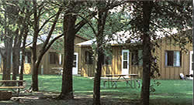 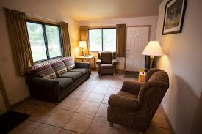 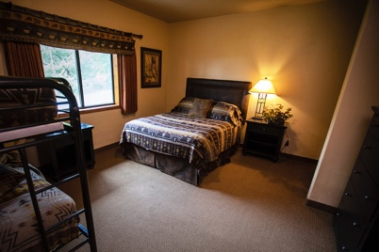

Hotel website: <https://lewisandclarkpark.sd.gov/cabin-motel-lodge-information.aspx>

**E Circle E (only double rooms available)**

* 15-minute drive to NFAA Easton Yankton Archery Center
* No restaurant or lounge available on property
* A rustic, rural retreat with modern amenities

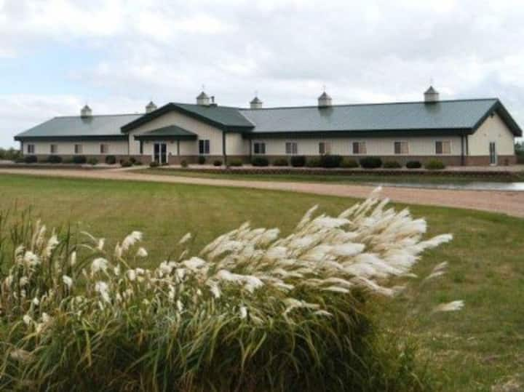 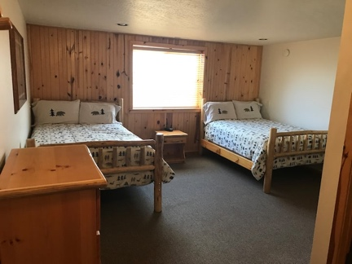 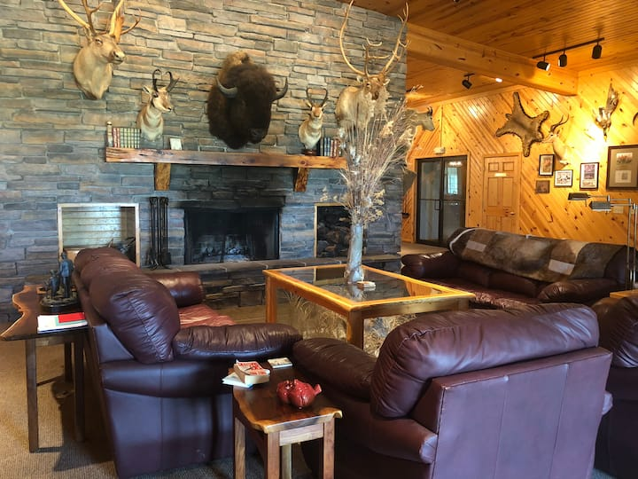

Tier 3

* Single Room / 1 person – (includes breakfast, lunch and local transport) 150.00 USD
* Double Room / 2 people – (includes breakfast, lunch and local transport )200.00 USD

**Yankton Inn**

* Located across the parking lot of the NFAA Easton Yankton Archery Center
* Economy hotel with microwave and refrigerator in rooms.
* Restaurant and lounge within walking distance.

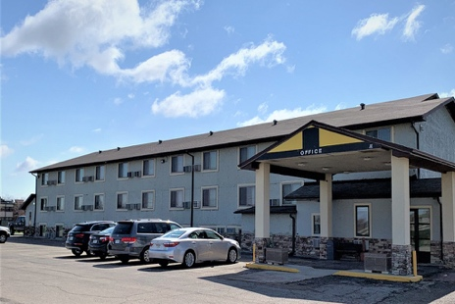 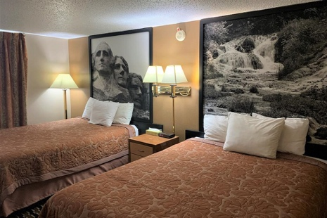 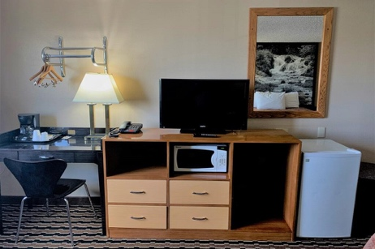

Hotel Website: <https://www.yanktoninn.com/>

**ENTRY FEE**

**Entry fee:**  
Individual: 250 USD per athlete

Officials: 125 USD per person

Guest: 150 USD per person

VIP*: 300 USD per person

**Entry fee in NON-official hotels:**

Individual: 500 USD per athlete

Officials: 250 USD per person

Guest: 250 USD per person

VIP*: 400 USD per person

There is no entry fee for teams.

Entry fees include daily local transport to and from the practice field to/from official hotels during the qualification, elimination and finals venues (timetable to be confirmed on site).

*VIP ACCESS – Must be approved by LOC before credentials are issued. Examples of VIP’s include Presidents of Federations, Secretary General, World Archery Officers, etc. VIP credentials provide access to VIP area at finals venue and specialized transportation. Please note - transportation is not available from non-official hotels.

**PAYMENT CONDITIONS:**  
The entry fees should be paid in full before arrival.

To confirm hotel reservations, a minimum 60% deposit of the total amount is required to be bank transferred to the LOC on or before 1 August 2021. Reservations after this date will be considered only according to availability. The final outstanding balance shall be made via bank transfer before arrival. Accommodation cannot be guaranteed after this deadline. A balanced invoice will be provided via WAREOS.

**BANK INFORMATION for ACCOMMODATION, TRANSPORTATION and ENTRY FEES:**

BANK: US Bank  
BANK ADDRESS: Waterfall Plaza, 6145 S. Minnesota Ave

CITY/STATE Sioux Falls, SD

ZIP: 57108  
BANK PHONE NUMBER: 605-335-0680

BANK ACCOUNT HOLDER NAME: National Field Archery Association Foundation

ABA NUMBER/ROUTING NUMBER: 091408501  
ACCOUNT NUMBER: 175091635730  
SWIFT CODE: USBKUS44IMT

NOTE: ALL PAYMENTS SHALL BE MADE IN USD BY BANK TRANSFER.

All bank charges will be paid by the participants. CREDIT CARDS are not accepted.

**Cancellations & Changes**

All cancellations and changes must be made through WAREOS:

* Cancellations received before 14 August 2021 a full refund of the deposit payment will be made.
* Cancellations received after 14 August 2021; no refund will be given.
* Refunds will be processed after the event.
* Should flight arrival details change last minute, please contact the Organizing Committee using the details indicated in the team managers’ booklet.
* If a participant’s arrival is later than the original scheduled arrival date, the room will be charged from the date of the original booking in WAREOS.
* An email will automatically notify the Organizing Committee and Member Association of any changes made in WAREOS.

**HEALTH REGULATIONS (COVID-19)**

**INFORMATION:**

* Everybody should follow the Government/public health authorities measures (national and sport-specific regulations) and be aware of the travel restrictions.
* For your information, Medical Infrastructure/Hospital with proper care will be reachable within 10 minutes from venue, where COVID-19 test can be done.

**PERSONAL HYGIENE AND HEALTH ADVICE:**

* Anyone due to participate in the event who is feeling ill should not attend.
* Participants (athlete, volunteer, official, etc.) should proactively and regularly check their health status (including taking their temperature and monitoring for any symptoms).
* Stay home and self-isolate even with minor symptoms for 10 days or more depending on national protocols, when showing any symptoms (fever, tiredness, dry cough, headache, nasal congestion, runny nose, sore throat, difficulty breathing).
* Contact a healthcare provider immediately if any respiratory illness is noted.
* Masks to be worn at all times everywhere (transport, common area in the hotel, venue, training, etc.) except on shooting line.
* Regularly and thoroughly clean your hands with an alcohol-based hand rub or wash them with soap and water.
* Avoid touching eyes, nose and mouth.
* Cover your mouth and nose with your bent elbow or tissue when you cough or sneeze. Then dispose of the used tissue immediately and wash your hands.
* Avoid touching high-contact surfaces such as door handles, walls or windows, etc.
* Avoid going to crowded places.
* Avoid steam rooms and saunas.
* No spitting, as the main mode of transmission of the virus is in respiratory secretions.
* No handshakes, high fives and any other personal contact.
* Athletes should not share clothes, bar soap, sports equipment, water bottles or other personal items.

**TRANSPORT & VENUE:**

* Avoid using public transport to go to the hotel and between the hotel and the venue.

**VENUE:**

* Access to the venue might be denied at any time in case of disease suspicion
* Limit contact/interactions
* Handwashing/alcohol – based hand gel will be available at multiple locations in the event facility and accommodation.
* Regular toilet cleaning will be done (at least once per session).
* Tissues and containers will be at disposal to dispose of used tissues on transport to venue, at the venue and any other facility.
* No shows allowed. Winners will receive their medals in a simple ceremony only with the winners and their team, all wearing masks.
* Medical post and designated personnel on site able to help assess cases and potential other illness will be present.
* An isolation room/space to hold any symptomatic person found at the venue will be available.
* Space on shooting line shall be 1.00 meter minimum per athlete.
* No spectators are allowed during the event.

**PARTICIPANTS:**

* Maintain the staff/team to a minimum to minimize transmission.
* Maintain social distancing, at least 6 feet / 2 meters distance between yourself and others at all times.

**COVID-19 TESTING:**

COVID-19 testing, PCR test with travel certificate, will be available for participants prior to departure home. Expense for tests will be added closer to the event. All expenses are the responsibility of the participant and shall be booked through WAREOS in the “Extras” section.

**ADDITIONAL INFORMATION**

**Transportation**

Transportation will be provided from the two official airports:

Joe Foss Regional Airport in Sioux Falls, SD (FSD) 80 mi /130 km from the venue, to the official hotels, two days before the official practice day and one day after the closing day.

Eppley Airfield in Omaha, NE (OMA) 156 mi / 251 km from the venue, to the official hotels, two days before the official practice day and one day after the closing day

The cost of this service is $25 USD per person one way to/from Sioux Falls Airport and $35 USD per person one way to/from Omaha Airport.

Local transport will be available between official hotels and archery venues. Transport timetables will be confirmed at a closer date from the event. Buses and/or vans will be provided.

**Lunch at the venues**

Lunch is included in hotel charge. Those signed up through official hotels will be provided a warm lunch at the NFAA Easton Yankton Archery Center.

**Dinner**

At an additional cost, teams can sign up for dinner service which will take place each evening at the NFAA Easton Yankton Archery Center. To order this option, teams should do so in advance on extra section in WAREOS . Charge each night for dinner at the center will be $20.00 per person. Teams that don’t sign up for dinner service at the complex will be responsible for their own meals and evening transportation to and from meals.

**Banquet**

The LOC will provide a Gala Dinner on Sunday 26th September.   
Please sign up in extra section in WAREOS if selecting this option. Price is $40 USD per person.

**Ceremonies**

All ceremonies will take place at the finals venue. Details to be provided.

**Water on the Venue**

Bottled water will be available on the field free of charge.

**Media Registration**

Media accreditations can be requested at www.yankton2021.org/media.

**Training**  
A training field will be available starting 16 September 2021. The training facility is at the NFAA Easton Yankton Archery Center. Teams who wish to arrive and practice earlier than this date may add this in the extra section in WAREOS. Prior to 16 September 2021, a fee of $10.00 per day/per person will be charged and individuals will have access to both the indoor and outdoor facilities.

**Weather**

According to weather information, the average temperature in September is expected to be 60 to 80°F / 15 to 27°C. Average sunrise is 7:10 AM. Average sunset is 7:20 PM.

**Medical Services/Hospital**Avera Sacred Heart Hospital  
501 Summit St  
Yankton, SD 57078  
1-605-668-8000

**Internet**

Wi-Fi will be available in the official hotels for free (in hotel rooms and in the lobby). There will also be Wi-Fi available at the NFAA Easton Yankton Archery Center venue.

LOC Contact for booking queries: yankton2021@neyac.org

Official website: www.yankton2021.org

**IMPORTANT INFORMATION REGARDING VISAs**

Applying for a travel visa to the United States is the sole responsibility of the participating teams. A visa is required for all visitors to enter the United States except for citizens of Canada and the 38 nations who are eligible for the “Visa Waiver Program.” To obtain a visa each individual must apply through a U.S. Embassy or Consulate. This process MUST be done by the applicant – the organizing committee cannot do it for you!

**Due to COVID-19, restrictions may vary per county. Please contact us as soon as possible to begin your VISA process. For an updated list please visit** [**www.yankton2021.org/visas**](http://www.yankton2021.org/visas)**.**

**All participants are required to complete the Visa Support sections in WAREOS by no later than 01 August 2021**.

**As part of COVID-19 mitigation efforts, the United States has restricted the entry of foreign nationals to the US where a person has had a physical presence in a restricted country in the 14 days before arriving in the US. A foreign national in this category will require a National Interest Exemption (NIE). For a current list of countries please go to** [**www.yankton2021.org/visas**](http://www.yankton2021.org/visas)**. Please note, the NIE is required for ANYONE who has traveled through one of the restricted countries. Restrictions are not based on citizenship, but physical presence.**

It is the applicants’ responsibility to supply the necessary information, and to ensure all details are up to date, correct, and submitted by the deadlines specified.

In addition, all participants that require a visa are requested to supply a copy of a valid passport. Copies of each application can be uploaded on WAREOS. All passport copies and personal details entered/uploaded to WAREOS will be held securely and in the strictest of confidence.

Please note, the Organizing Committee can only provide invitation letters for the period of the Hyundai World Archery Championships in the United States.

**CONTACT DETAILS:**

Stephanie Moser Address: NFAA Easton Yankton Archery Center  
yankton2021@neyac.org 800 Archery Lane  
1-605-260-9282 Yankton, SD 57078

ARCHERY VENUES:

NFAA Easton Yankton Archery Center  
800 Archery Lane, Yankton, SD, 57078

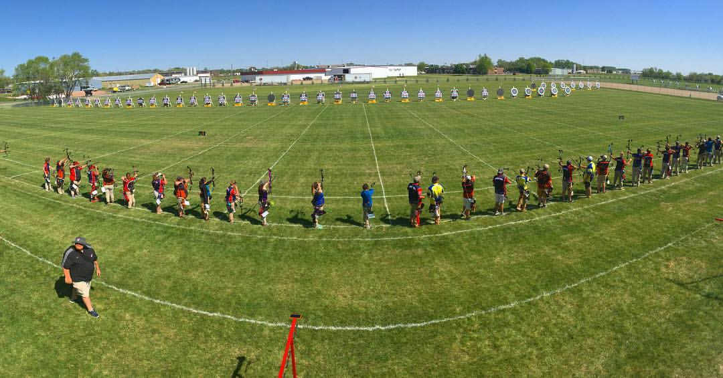 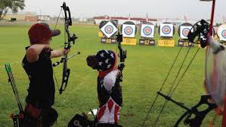

Yankton, South Dakota is the home of National Field Archery Association Foundation, and the first of the [Easton Foundations](http://www.esdf.org/) Archery Centers. Situated on over 130 acres; the [NFAA Easton Yankton Archery Center](http://www.neyac.org/) includes three outdoor field ranges, a 3D range, two FITA ranges, two 90m indoor ranges, two classrooms, a fitness studio, and the NFAA Foundation Archery Museum.

Easton Field and First Dakota Field are 90-meter grass fields with room for a combined 130 targets and 260 shooting lanes. Awnings cover the entire width of the ranges, providing shade for the archers between ends, and a lawn behind the shooting line allows for spectators.

FINALS VENUE:

Riverside Park  
Douglas Avenue & Levee Street, Yankton, SD, 57078

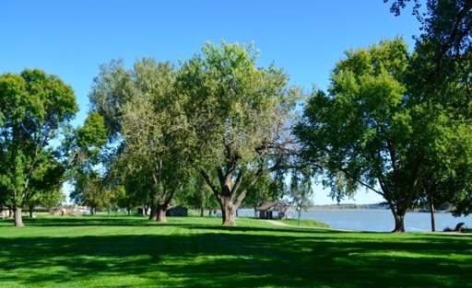  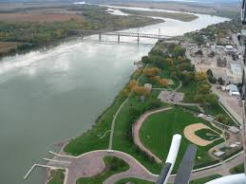

Located along the Missouri River, Riverside Park offers an amphitheater, picnic shelters, walking & bike trails and lots of green space.

**THE CITY OF YANKTON:**

Yankton may be South Dakota's most historic town located on the northern bank of the Missouri River. Life in Yankton has always revolved around the Missouri River. Native Americans followed the river's flow to their destination’s centuries ago. Citizens today use the river for various recreational activities that include: boating, fishing, kayaking and skiing.

This quaint town of almost 15,000 people has 14 parks with over 263 acres of green space. While in Yankton you will have to opportunity to experience the majestic beauty of the Meridian Bridge; the longest walking bridge in the United States that connects two states, South Dakota and Nebraska.

**Population**

Yankton City: 14,573  
County: 22,814  
State of South Dakota: 886,667

**Elevation**

City: 1,211 feet 369 meters

Community information can be located at http://www.cityofyankton.org and http://www.visityanktonsd.com/.