TO ALL World Archery Member Associations

Dear President,

As Chair of the Local Organising Committee (LOC) of the 2021 World Archery Youth Championships, Wrocław – Poland, we would like to invite your country to the 2021 World Archery Youth Championships, which will be held from 9 to 15 August in Wrocław – Poland.

Athletes of the world do know that Wrocław is a city where magnificent archery events had been staged: Hyundai Archery World Cup 2013 - 2015 and The World Games 2017. Participants from more than 60 countries have enjoyed the experience of shooting in our city.

Welcome to this amazing city that reinvents itself every day. Our targets look forward to embracing your arrows, just as our hearts are ready to make your visit unforgettably enjoyable.

Please note that birth years for junior and cadets athletes:

An athlete born on the 1/1/2001 or later can compete in the junior class.
An athlete born on the 1/1/2004 or later can compete in the cadet class.

Please find enclosed the necessary information for registration, organization and participation for this event.

We are looking forward to welcoming you and your teams, to the vibrant city of Wrocław - Poland.

Sincerely yours,

JÓZEF BAŚCIUK

Wrocław 2021 World Archery Youth Championships OC Chairman

Important Dates:

Please find enclosed information regarding the details of this event and how to complete registration. To register participation, please complete all the necessary sections in WAREOS within the deadlines listed below:

Summary of deadlines:

- Start date for online registration WAREOS 13 April 2021
- Preliminary Entries 09 May 2021
- Final Entries 19 July 2021
- Extra penalty starting date 06 August 2021
- Hotel Reservation 19 July 2021
- Transportation 19 July 2021
- Visa Support 19 July 2021
- Final Hotel Reservation & Payment 19 July 2021
- Full refund cancellation deadline 06 August 2021

Looking forward to welcoming you in Wrocław City, Poland.

PRELIMINARY PROGRAMME

07 August 2021  Saturday | Arrival of participants  Practice field and local transport available  Registration and accreditation
08 August 2021  Sunday | Arrival of participants  Practice field and local transport available  Registration and accreditation
09 August 2021  Monday | Official Practice  · Official Practice Recurve  · Official Practice Compound  · Registration and Equipment Inspection  · Team Managers Meeting  · Opening of the Championships
10 August 2021  Tuesday | Qualification Round  (Recurve 70m Round and Compound 50m Round)  Mixed Team Eliminations
11 August 2021  Wednesday | Individual Eliminations  (Recurve and Compound)
12 August 2021  Thursday | Individual Eliminations  Team Eliminations  (Recurve and Compound)
13 August 2021  Friday | Mixed Team Eliminations  (Recurve and Compound)
14 August 2021  Saturday | Finals – Compound
15 August 2021  Sunday | Finals – Recurve
16 August 2021  Monday | Departure of teams
17 August 2021  Tuesday | Departure of teams

NOTE: This preliminary programme is subject to change according to participation and TV requirements. All changes will be published and distributed in good time.

PRELIMINARY & FINAL REGISTRATION
All entries, accommodation reservations, transport needs, flight arrival/departure information and visa invitation letter requests are to be completed using WAREOS.

The World Archery Online Registration System (WAREOS) at https://extranet.worldarchery.sport handles the entire registration process for this event. No entry forms, hotel reservations or transportation forms will be accepted; all information must be entered into WAREOS.

Member associations can login to WAREOS at https://extranet.worldarchery.sport with the username and password assigned by World Archery. After entering WAREOS, selecting the event from the list will allow a member association to register their athletes. Select/press the “Entries” button to see the list of categories in the event. Select/press the “category” to enter the athlete and official numbers/details participating for that event. A WAREOS User Manual can be downloaded in PDF format (English) upon login.

Contact Ms CECILE TOSETTI (ctosetti@archery.sport) in the World Archery Office with any questions regarding technical problems on WAREOS. For any question regarding the organisation of the event (transport, accommodation, meals etc.) please contact directly the LOC.

A maximum number of 3 athletes per country can be registered into each category of the event. Preliminary entries should be completed using WAREOS.

Start date for online registration using WAREOS: 13 April 2021
End of Preliminary registration using WAREOS: 09 May 2021
End of Final registration using WAREOS: 19 July 2021

Please respect the stated deadlines.

Member Associations can only use WAREOS to make any changes or amendments to entries and will be able to do so at any time. An email will automatically notify the Organising Committee and Member Association of any changes made in WAREOS.

Any changes that are made after the deadlines specified or if entries differ by more than 4 athletes from the preliminary entries, the following penalty fees will automatically be applied.

Penalty fees to be paid to Organising Committee: | Cost (EUR):
Entries made after the entry deadline dates (late entries) | 50 per entry
If final entries differ from the preliminary entries by more than 4 athletes/officials. | 150 per entry
When no preliminary entries were made before the deadline date but then submit final entries. | 150 per entry

Penalty Fee to be paid to World Archery: | Cost (CHF):
Lost accreditation. | 30 each
Changes made to the athlete and/or team official names after the final entry deadline date and within 3 days prior to the start of the event (very late entries) | 50 each change

NOTE: CHF currency exchange rates will be those on the date of the event.

Member Associations that have penalty fees outstanding from 2020 will need to have paid these penalty fees before being eligible to enter and compete.

Any entries received less than 3 days before the team managers meeting for a Hyundai Archery World Cup or World Championships will be refused if no preliminary entry and/or final entry are made prior. This decision cannot be appealed by the teams and is fully compliant with the current World Archery rules, article 3.7.1.2. Entries received after the deadlines, are subject to penalties as clearly stated in the rule book and the invitation documents of World Cups and World Championships. A Member Association that has made final entries in WAREOS and does not participate will be invoiced for the number of entries entered in the system, unless they have informed World Archery and the Organising Committee in writing at least one week prior to the event that they are unable to attend.

ACCOMMODATION & GENERAL INFORMATION

MAP OF WROCŁAW INCLUDING ARCHERY VENUE, HOTELS AND AIRPORT

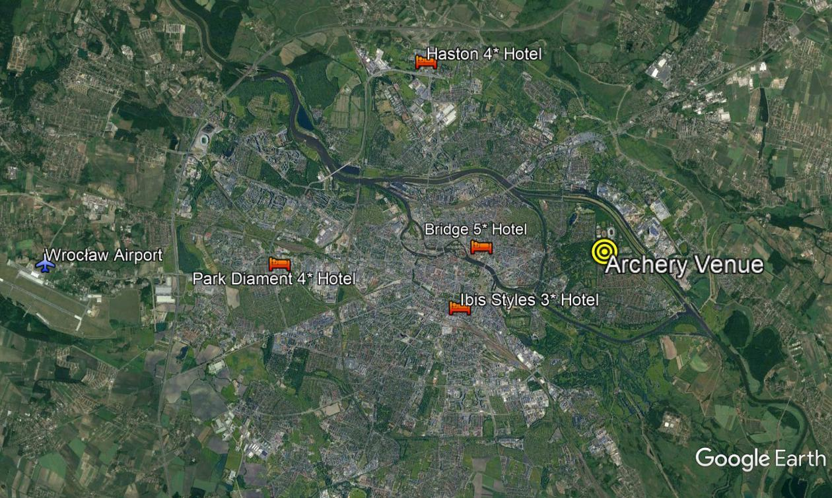

Bridge Hotel – Five Star Hotel
- Single Room price: EUR 150.00 per room
- Number of rooms: 40
- Double/Twin Room price: EUR 240.00 per room
- Number of rooms: 52
- Board plan: breakfast and dinner
- Check-in from 07 August 2021
- Hotel website: https://thebridgewroclaw.pl/

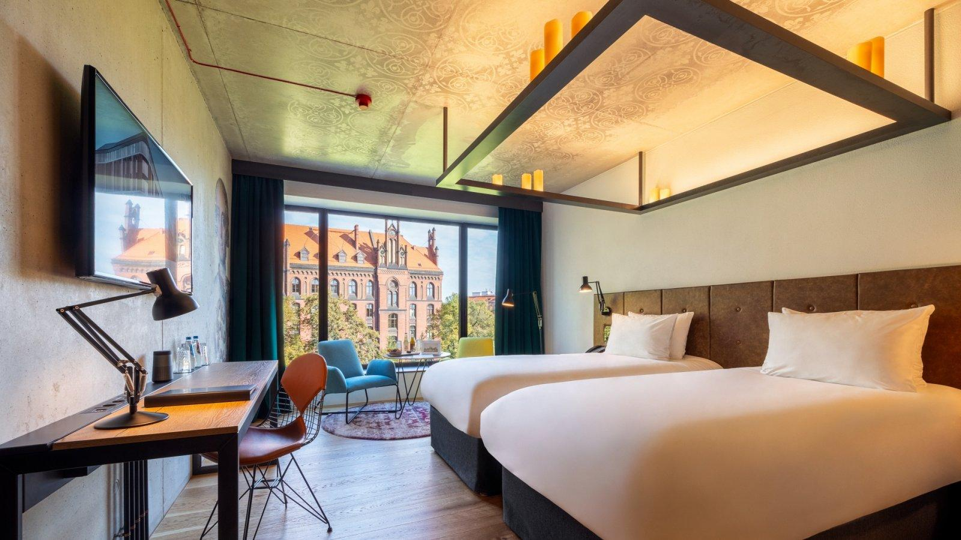

Haston City Hotel – Four Star Hotel
- Single Room price: EUR 130.00 per room
- Number of rooms: 30
- Double/Twin Room price: EUR 220.00 per room
- Number of rooms: 80
- Board plan: breakfast and dinner
- Check-in from 07 August 2021
- Hotel website: http://www.haston.pl/

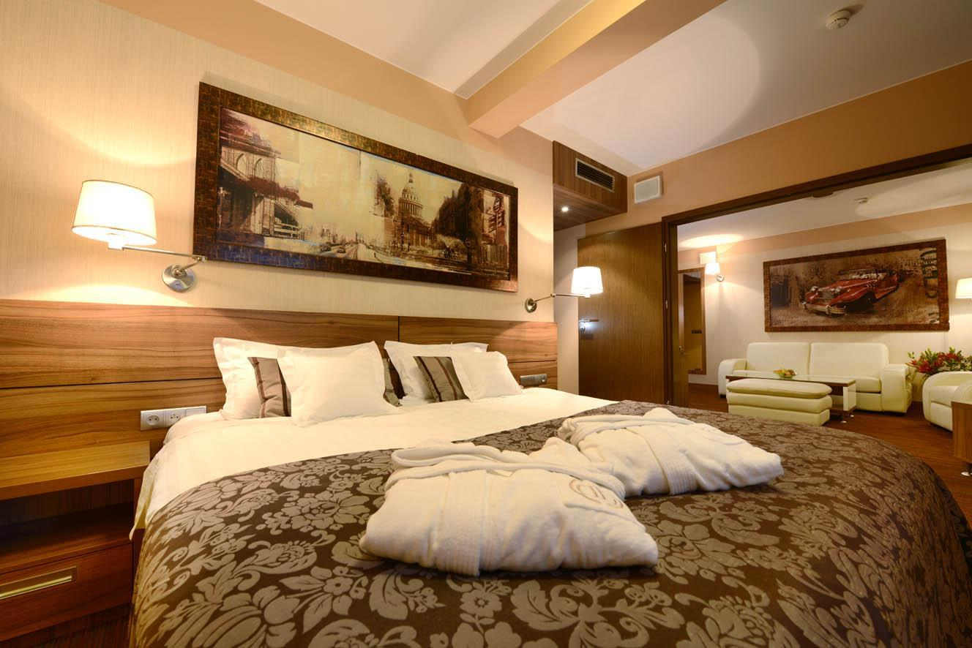

Park Diament Hotel – Four Star Hotel
- Single Room price: EUR 130.00 per room
- Number of rooms: 16
- Double/Twin Room price: EUR 220.00 per room
- Number of rooms: 116
- Board plan: breakfast and dinner
- Check-in from 07 August 2021
- Hotel website: https://www.hotelediament.pl/

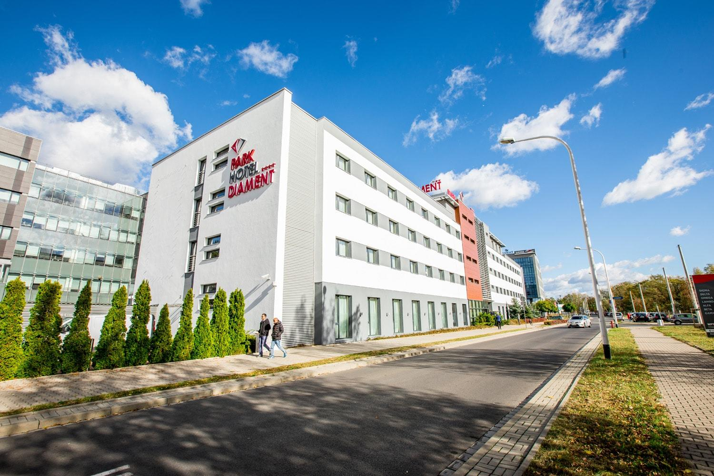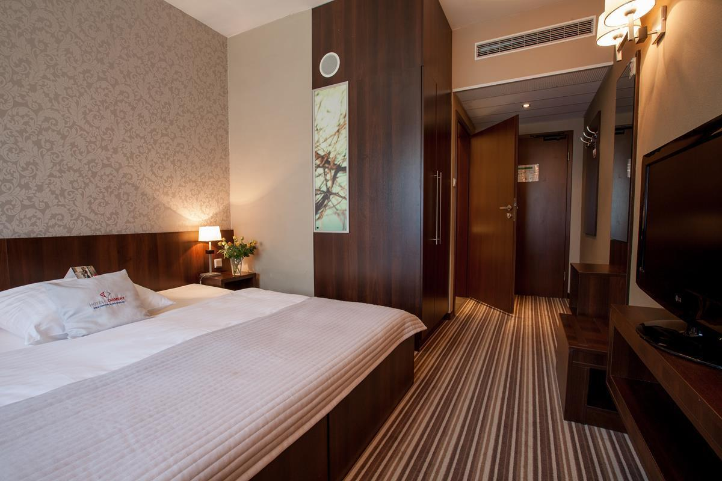

Ibis Styles Wrocław Centrum Hotel – Three Star Hotel
- Single Room price: EUR 100.00 per room
- Number of rooms: 75
- Double/Twin Room price: EUR 160.00 per room
- Number of rooms: 35
- Board plan: breakfast and dinner
- Check-in from 07 August 2021
- Hotel website: https://all.accor.com/hotel/9347/index.pl.shtml

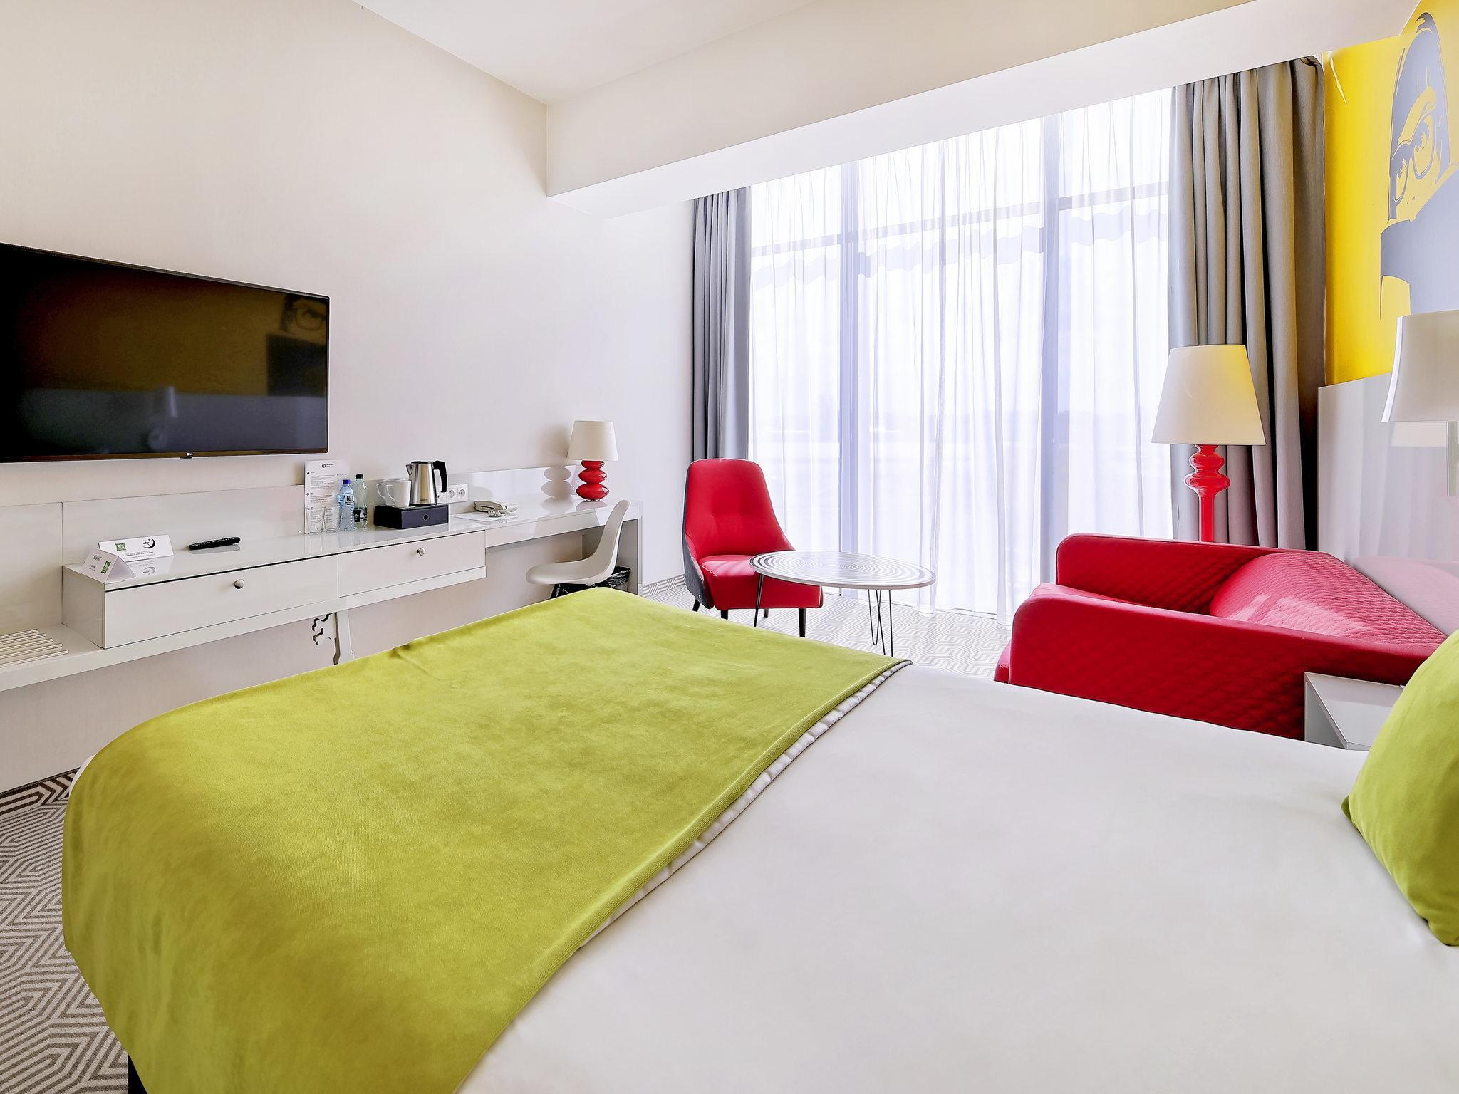

Hotels are allocated on a first come, first serve basis. Accommodation includes breakfast and dinner with non-alcoholic drinks. Lunch will always be served at the archery venue.

- Reservations should be made before 09 May 2021
- Final Hotel Reservation & Transportation before 19 July 2021

Important Note: Please refer to the accommodation pages below for detailed hotel information. Complete all necessary sections in WAREOS and make full payment for entries and accommodation by the specified deadlines. Bank transfers only, no credit cards will be accepted.

ENTRY FEE

Entry Fees:
Individual: | 230 EUR per athlete
Officials: | 115 EUR per person
Temporary Upgrade:  For athletes wishing to be a coach temporarily | 30 CHF per accreditation

Entry fees include daily local transport to and from the practice field to/from official hotels during the qualification, elimination and finals venues (timetable to be confirmed on site).

NOTE: Entry fees do not include airport transfer fee to hotels:
o Wrocław International Airport (IATA: WRO, ICAO: EPWR) €10 Per Person one way
o other airports - please request price to the LOC

PAYMENT CONDITIONS:
The entry fees should be paid in full before arrival.

To confirm hotels reservations, a minimum 50% deposit of the total amount is required to be bank transferred to the OC before 09 May 2021. Reservations after this date will be considered only according to availability. The final outstanding balance shall be made via bank transfer before arrival. Accommodation cannot be guaranteed after this deadline. A balanced invoice will be provided via WAREOS.

BANK INFORMATION for ACCOMMODATION, TRANSPORTATION and
ENTRY FEES:
A/C Name: OSL Strzelec
LOC Address: ul. Górnicza 9, 59-220 Legnica, Poland
Telephone number: +48 693 456 883
City and Country: Legnica, Poland
Bank: BNP Paribas Polska SA
Account Number: PL 28 2340 0009 0901 2460 0000 0010
Swift: PPABPLPK
Bank’s address: Najświętszej Marii Panny 4 Street
Bank’s Phone: +48 22 134 00 00
City: Legnica

NOTE: ALL PAYMENTS SHALL BE MADE IN EUR BY BANK TRANSFER.

All bank charges will be paid by the participants. CREDIT CARDS are not accepted.

Cancellations & Changes
All cancellations and changes must be made through WAREOS:
- Cancellations received before 06 August 2021 a full refund of the deposit payment will be made.
- Cancellations received after 06 August 2021, no refund will be given.
- Refunds will be processed after the event.
- Should flight arrival details change last minute, please contact the Organising Committee using the details indicated in the team managers’ booklet.
- If a participant’s arrival is later than the original scheduled arrival date, the
room will be charged from the date of the original booking in WAREOS.
- An email will automatically notify the Organising Committee and Member Association of any changes made in WAREOS.

PERSONAL HYGIENE AND HEALTH ADVICES (COVID-19)

INFORMATION
- Everybody should follow the Government/public health authorities measures (national and sport-specific regulations) and be aware of the travel restrictions
- For your information, Medical infrastructure/Hospital with proper care will be reachable within 15 minutes from the venue, where COVID-19 test can be done

PERSONAL HYGIENE AND HEALTH ADVICES
- Anyone due to participate in the event who is feeling ill should not attend
- Participants (athlete, volunteer, official etc.) should proactively and regularly check their health status (including taking their temperature and monitoring for any symptoms)
- Stay home and self-isolate even with minor symptoms for 10 days or more depending on national protocols, when showing any symptoms (fever, tiredness, dry cough, headache, nasal congestion, runny nose, sore throat, difficulty breathing).
- Contact a healthcare provider immediately if any respiratory illness is noted
- Masks to be worn at all times everywhere (transport, common area in the hotel, venue, training etc.) except on shooting line
- Regularly and thoroughly clean your hands with an alcohol-based hand rub or wash them with soap and water
- Avoid touching eyes, nose and mouth
- Cover your mouth and nose with your bent elbow or tissue when you cough or sneeze. Then dispose of the used tissue immediately and wash your hands
- Avoid touching high-contact surfaces such as door handles, walls or windows, etc.
- Avoid going to crowded places
- Avoid steam rooms or saunas
- No spitting, as the main mode of transmission of the virus is in respiratory secretions
- No handshakes, high fives and any other personal contact
- Athletes should not share clothing, bar soap, sports equipment, water bottles or other personal items

TRANSPORT & ACCOMMODATION
- Avoid using public transport to go to the hotel and between the hotel and the venue
- All meals have to be taken in the hotel or at home, not at any other restaurant/bar

VENUE
- Access to the venue might be denied at any time in case of disease suspicion
- Limit contact/interactions
- Handwashing/alcohol- based hand gel will be available at multiple locations in the event facility and accommodation
- Regular toilet cleaning will be done (at least once per session)
- Tissues and containers will be at disposal to dispose of used tissues on transport to the venue, at the venue and any other facility
- No shows allowed. Winners will receive their medals in a simple ceremony only with the winners and their team, all wearing masks
- Medical post and designated personnel on site able to help assess cases and potential other illness will be present
- An isolation room/space to hold any symptomatic person found at the venue will be available
- Space on shooting line shall be 1.00 metre minimum per athlete
- No spectators are allowed during the event

PARTICIPANTS
- Maintain the staff/team to a minimum to minimise transmission
- Maintain social distancing, at least 1,5 metre distance between yourself and others at all time

ADDITIONAL INFORMATION

Medical emergency contact and location
Hospital Name: University Hospital, Oddział Intensywnej Terapii Dziecięcej i Anestezjologii
address: Curie-Skłodowskiej 50/52 Street, Wrocław
phone number: +48 71 770 30 65

Entering Poland - crossing border:
PARTICIPANTS OF INTERNATIONAL SPORTS COMPETITIONS ARE EXEMPTED FROM OBLIGATORY QUARANTINE
The exemption of people from outside of the EU from obligatory quarantine concerns:
- competitors,
- coaching staff members,
- doctors, physiotherapists,
- umpires,
accredited journalists.
The exemption applies to persons who are participating in competitions organised by an international sports federation of an Olympic or Paralympic sport, or another organisation recognised by the International Olympics Committee,
an international continental sports organisation belonging to a sports federation,
Polish sports association.

NOTE: Persons crossing the Polish border must present the Border Guard with a letter issued by the organiser of the sports competition. It may also be a document – certified by a Polish sports association competent in a given sport – containing data concerning the fact of organisation of the sports competitions, its date as well as the nature of that person’s participation.

Transportation
Transportation will be provided from Wrocław airport to the official hotels, from two days before the official practice day and until two days after the closing day. Local transport will be available between official hotels, practice and competition venues. Transport timetables will be confirmed.

Training
A training field will be available starting on 07 August 2021 at the Academy of Physical Education in Wrocław located approximately 20 - 30 minutes from the official hotels. Transport to training will be made available at no additional cost on 07 and 08 August 2021.

Weather
August Averages:
Avg. High Temp 24°C/ 76°F
Avg. Low Temp 13°C/ 55°F
Avg. Precipitation 3.92 cm/ 1.54 inches

Media Registration
Media representatives can apply for registration by emailing info@archery.sport

Internet
Will be available in the official hotels for free (in hotel rooms and in the lobby). There will also be Wi-Fi available for access to results on venue.

Water
Bottled water will be available at the qualification and practice venues.

Visa
All participants who need an entry visa to Poland, will be required to complete the Visa Support sections in WAREOS by no later than 09 May 2021.

It is the applicants’ responsibility for supplying the necessary information, ensuring all details are up to date, correct and submitted by the deadlines specified.

In addition, all participants that require a visa are kindly requested to supply a copy of their latest/valid passport. Copies of each application can be uploaded on WAREOS. All passport copies and personal details entered/uploaded to WAREOS will be held securely and in the strictest of confidence and not shared with other parties.

LOC CONTACT

Official website: http://wayc2021-wroclaw.pl/
E-mail: office@wayc2021-wroclaw.pl

Name: Mrs. Małgorzata Szałańska
Address: Górnicza 9 Street, 59-220 Legnica, Poland
Language: Russian
Phone number: +48 693 456 883

Name: Mr. Maciej Łaba
Address: Górnicza 9 Street, 59-220 Legnica, Poland
Language: English
Phone number: +48 669 931 469

