



WORLD ARCHERY

**YOUTH CHAMPIONSHIP 2023**

01 - 09 JULY - LIMERICK IRELAND

Version 1.2 (27th March 2023)

To All World Archery Member Associations:

Dear President,

Céad Míle Fáilte. As Chair of the Local Organising Committee (LOC) of the World Archery Youth Championship 2023 to be held in Limerick, Ireland between 01-09 July 2023. I would like to invite you all to be part of one of the most important archery events to take place in Ireland in 2023. We hope this is the fresh beginning of a long legacy of Archery in Ireland.

Limerick city has a deeply ingrained culture of sport and welcoming of people from around the world. It is the country’s third-largest city and the beating heart of sport in Ireland. Its local government and institutions are fully committed to the city’s development. Its modern infrastructure offers absolute comfort when hosting world-class events. Limerick is also steeped in history going back to medieval times and is surrounded by majestic castles.

We wish for athletes of the world to know that Limerick is a city where magnificent archery events can be staged. In the next few years, we hope to host many archery events and participants from all over will enjoy the experience of competing in our city.

We welcome you to this amazing city. We truly believe you will have an unforgettable experience .

**“We are ready, are you?”**

Sincerely yours,

Adam Taylor

**Adam Taylor**

**WAYC2023 LOC Chairman**





WORLD ARCHERY

**YOUTH CHAMPIONSHIP 2023**

01 - 09 JULY - LIMERICK IRELAND

Version 1.2 (27th March 2023)

**IMPORTANT DATES**

Please find enclosed detailed information regarding this event. To register participation, please complete all the necessary sections in WAREOS within the deadlines listed below.

**Please respect the stated deadlines.**

Registration Opening date on WAREOS **01 September 2022**

Preliminary Entries **01 April 2023**

Final Entries **10 June 2023**

Hotel reservation down-payment (50%) **01 May 2023**

Hotel reservation and payment **01 June 2023\***

Transportation **01 June 2023**

Visa support **01 April 2023**

Full refund cancellation deadline **01 June 2023**

*\*After this deadline, the LOC is allowed to retain all amounts due by the Member Association.*



**Individual Eliminations and Finals –Compound**

U18 Compound men

U18 Compound women U21 Compound men

U21 Compound women **Finals Gold and Bronze**

**Recurve Team Eliminations**

U18 Recurve men’s team

U18 Recurve women’s team

U21 Recurve men’s team

U21 Recurve women’s team

**Finals Gold and Bronze**

**Mixed Team Eliminations** *(Recurve and Compound)*

U18 Recurve mixed team

U21 Recurve mixed team

U18 Compound mixed team U21Compound mixed team **Finals Gold and Bronze**

**Compound team Eliminations**

U18 Compound men’s team

U18 Compound women’s team

U21 Compound men’s team

U21 Compound women’s team **Finals Gold and Bronze**

**Individual Eliminations and Finals –– Recurve**

U21Recurve men U21Recurve women U18 Recurve men

U18 Recurve women

**Finals Gold and Bronze**

**PRELIMINARY PROGRAMME**



WORLD ARCHERY

**YOUTH CHAMPIONSHIP 2023**

01 - 09 JULY - LIMERICK IRELAND

**1st July 2023 Saturday**

**Arrival of participants**

Local transport available

**2nd July Sunday**

**Arrival of participants**

Practice field and local transport available

**Official Practice** Equipment Inspection Team Managers Meeting

**3rd July Monday**

**4th July Tuesday**

**Qualification Round**

(Recurve 70m/60m Round & Compound 50m Round)

**5th July Wednesday**

**6th July Thursday**

**7th July Friday**

**8th July Saturday**

**9th July Sunday**

**10th July Monday**

**Departure of teams**

**NOTE:** This preliminary programme is subject to change according to participation and TV requirements. All changes will be published and distributed in good time.





WORLD ARCHERY

**YOUTH CHAMPIONSHIP 2023**

01 - 09 JULY - LIMERICK IRELAND

Version 1.2 (27th March 2023)

**PRELIMINARY & FINAL REGISTRATION**

All entries, accommodation reservations, transport needs, flight arrival/departure information and visa invitation letter requests are to be completed using the World Archery Online Registration System WAREOS This system handles the entire registration process for this event. No entry forms, hotel reservations or transportation forms will be accepted; all information must be entered into WAREOS.

Member associations can login to WAREOS at https://extranet.worldarchery.sport with the username and password assigned by World Archery. After entering WAREOS, selecting the event from the list will allow a member association to register their athletes. Select/press the “Entries” button to see the list of categories in the event. Select/press the “category” to enter the athlete and official numbers/details participating for that event. A WAREOS User Manual can be downloaded in PDF format (English) upon login.

Contact [wareos@archery.sport](mailto:wareos@archery.sport) with any questions regarding **technical problems on WAREOS**. For any question regarding the organisation of the event (transport, accommodation, meals, invoices, visa etc.) please **contact directly the LOC**.

A maximum number of 3 World Championships athletes per country can be registered into each category of the event. Preliminary entries should be completed using WAREOS.

Member Associations can only use WAREOS to make any changes or amendments to entries and will be able to do so at any time. An email will automatically notify the Organising Committee and Member Association of any changes made in WAREOS.





WORLD ARCHERY

**YOUTH CHAMPIONSHIP 2023**

01 - 09 JULY - LIMERICK IRELAND

Version 1.2 (27th March 2023)

**ENTRY FEES**

**ENTRY FEES IN NON-OFFICIAL HOTELS**

Entry fee for guests includes access to qualification, elimination and finals venues. They have no field of play access.

Any changes that are made after the deadlines specified or if entries differ by more than 4 Youth Championships athletes from the preliminary entries, the following penalty fees will automatically be applied.

**PENALTY FEES TO BE PAID TO THE ORGANISING COMMITTEE**

Penalty fees for Late Entries (after the final deadline) Penalty fees for not filling Preliminary entries

The penalty fee for differences between preliminary and final entries:

**€50 per entry**

**€150 per entry**

**€150 per entry**

*If the difference between final and preliminary entries number is more than 4 athletes/officials

**Individual** €460 per athlete

**Official** €230 per person

**Individual** €230 per athlete

**Official** €115 per person

**Guest** €750 per person includes access to the VIP areas





WORLD ARCHERY

**YOUTH CHAMPIONSHIP 2023**

01 - 09 JULY - LIMERICK IRELAND

Version 1.2 (27th March 2023)

**PENALTY FEES TO BE PAID TO WORLD ARCHERY (CHF)**

**NOTE:** CHF currency exchange rates will be those on the date of the event.

Member Associations that have penalty fees outstanding from 2022 will need to have paid these penalty fees before being eligible to enter and compete.

Any entries received less than 3 days before the team managers meeting for a Hyundai Archery World Cup or World Championships will be refused if no preliminary entry and/or final entry are made prior. This decision cannot be appealed by the teams and is fully compliant with the current World Archery rules, article 3.7.1.2. Entries received after the deadlines, are subject to penalties as clearly stated in the rule book and the invitation documents of World Cups and World Championships. A Member Association that has made final entries in WAREOS and does not participate will be invoiced for the number of entries entered in the system, unless they have informed World Archery and the Organising Committee in writing at least one week prior to the event that they are unable to attend.

Lost / Damaged accreditation **CHF 30 each**

Lost classification card **CHF 30 each**

Any change to the final country entry list, such as (but not limited to):

* Athlete or official name change
* Date of birth change
* Official position change
* Absence or incomplete on-site contact person **CHF 50 each change**



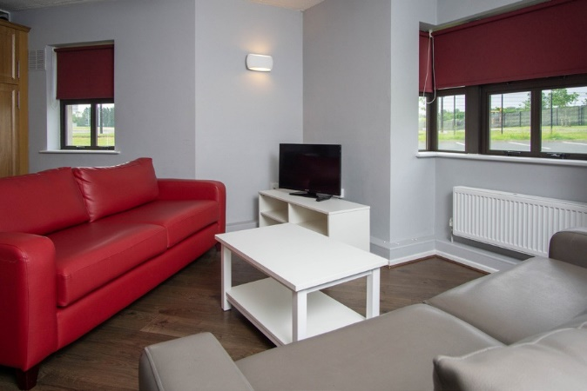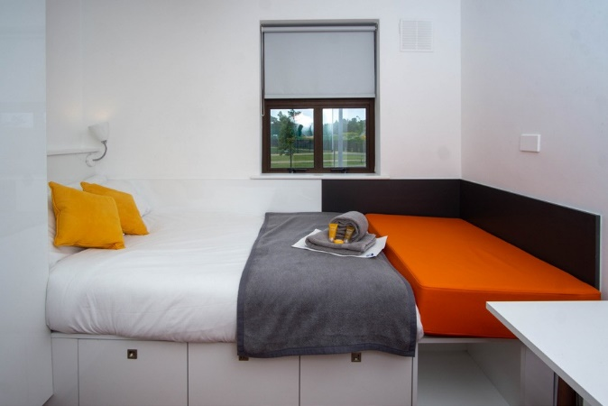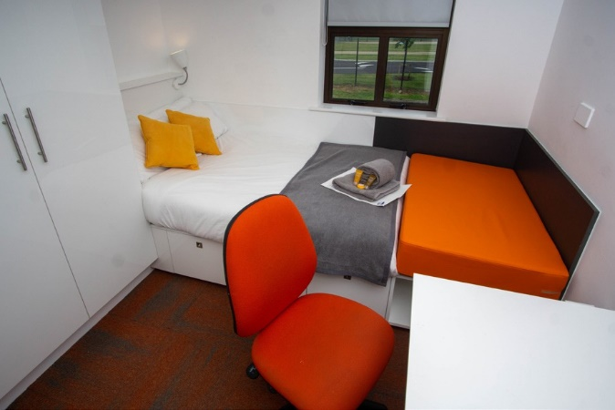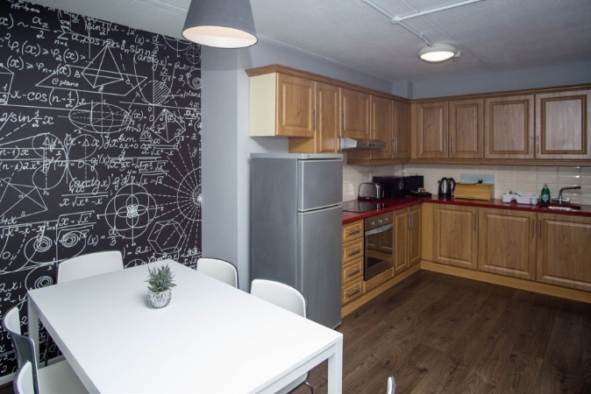

WORLD ARCHERY

**YOUTH CHAMPIONSHIP 2023**

01 - 09 JULY - LIMERICK IRELAND

Version 1.2 (27th March 2023)

**ACCOMMODATION**

**KILMURRY VILLAGE**

Single Room Price: **€180.00 per room per person**

Number of rooms: 450

Made up of 6 bedroom homes

or 8 bedroom homes Ideal for teams

Each room has its own Sink and lockable door. Shared kitchen and shower and Bathroom room.

2 bathrooms per house.

Board plan: Shared Kitchen and living area, Food not included in prices, catering in the designated student courtyard

Check-in from Late check-out

25th June 10am on the day of departure

(latest check out date 11th July)



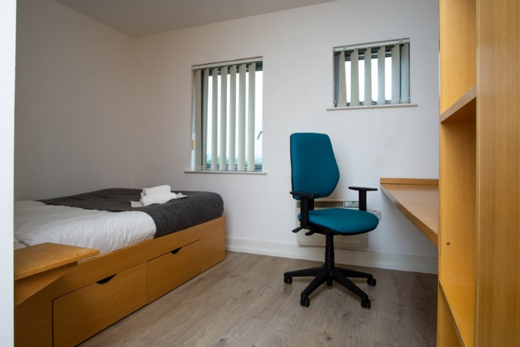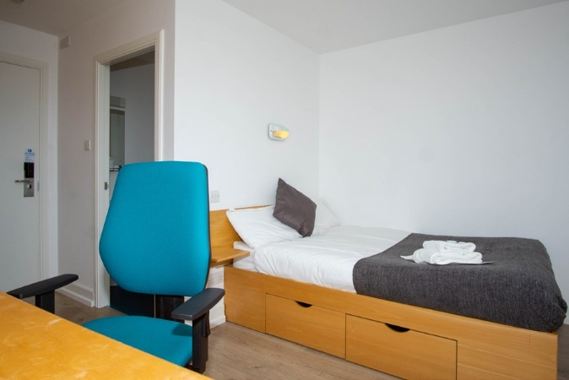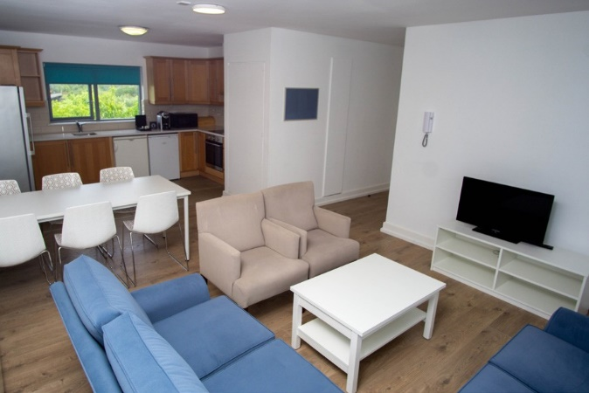

WORLD ARCHERY

**YOUTH CHAMPIONSHIP 2023**

01 - 09 JULY - LIMERICK IRELAND

Version 1.2 (27th March 2023)

**DROMROE VILLAGE**

Single Room Price: **€220.00 per room per person**

Number of rooms: 456

Each room has its own en-suite, and its own lock to each door.

Each room shares a kitchen and living area, with up to 5 other rooms

Board plan: Shared Kitchen and living area, Food not included in prices, catering in the designated student courtyard

Check-in from Late check-out

25th June 10am on the day of departure

(latest check out date 11th July)



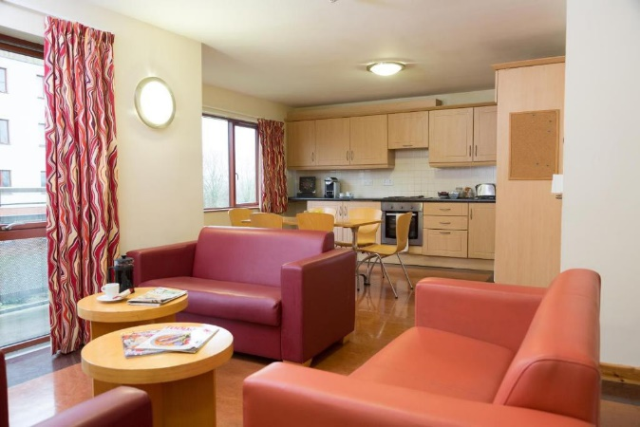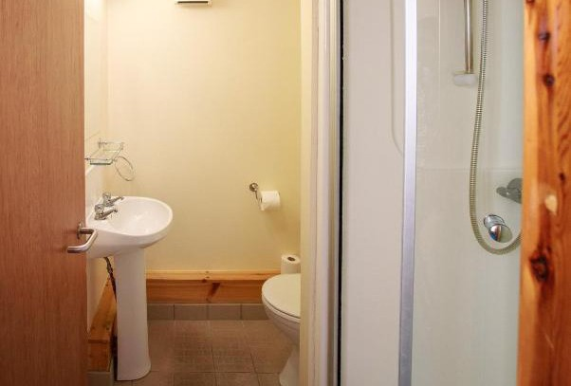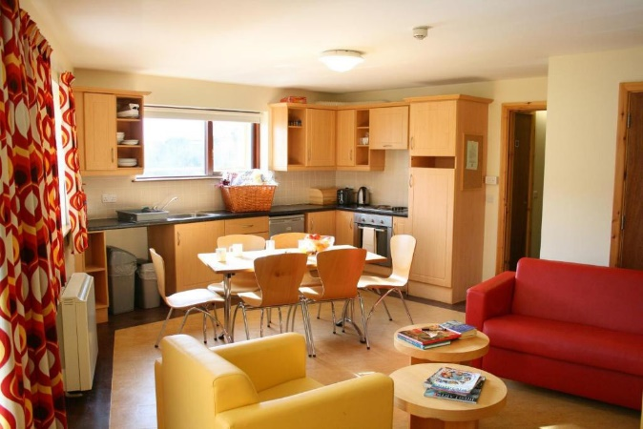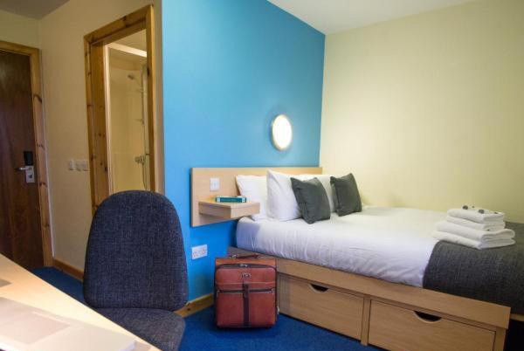

WORLD ARCHERY

**YOUTH CHAMPIONSHIP 2023**

01 - 09 JULY - LIMERICK IRELAND

Version 1.2 (27th March 2023)

**CAPPA VILLAGE**

Single Room Price: **€210.00 per room per person**

Number of rooms: 500

Each room has its own en-suite, and its own lock to each door.

Each room shares a kitchen and living area, with up to 5 other rooms

Board plan: Shared Kitchen and living area, Food not included in prices, catering in the designated student courtyard

Check-in from Late check-out

25th June 10am on the day of departure

(latest check out date 11th July)

**Rooms are allocated on a first come, first serve basis.**

**Teams who do not reserve their accommodation through the organising committee will be charged a double entry fee.**





WORLD ARCHERY

**YOUTH CHAMPIONSHIP 2023**

01 - 09 JULY - LIMERICK IRELAND

Version 1.2 (27th March 2023)

**UNIVISITY OF LIMIERICK AMENDITIES**

DROMROE VILLAGE

* Apache Pizza Pizzeria is located in Dromroe village beside the village reception. Opening Hours are 3pm -11.45pm each day.
* Bike shed to store bikes.
* Launderette-consisting of 3 washing machines and 3 dryers. €3 for wash and €3 for dry. Takes coin only and exact change only. It is self-service so users need to bring their own washing powder etc . All launderettes are open 7am – 11pm every day.
* Dromroe has a large village centre consisting of a village hall and 2 seminar rooms. This would need to be booked to use.

KILMURRY VILLAGE

* Launderette with 4 washers and 4 dryers at €3 each (own products must be brought) open from 7:00 until 23:00
* sports facilities nearby, i.e., gym.

CAPPAVILLA VILLAGE

* Launderette which has 5 washing machines and 5 dryers. It’s €3.00 for the wash and €2.50 for the dryer. Launderettes are open from 8am too 11pm.
* secure bike storage with a number of bikes.
* Quigley we 2 washers and 2 dryers in each block they are the same price for tokens.

COURTYARD/STUDENT CENTRE

* A large food shop
* Bank/ATM,
* 3 bars/restaurants
* Barbers
* Printing
* Stationary



If a voucher is not used. It cannot be redeemed, replaced or refunded. Each voucher is only valid for the date stated on the voucher.

If Lost replacement vouchers must be purchased from the date it was reported lost.



WORLD ARCHERY

**YOUTH CHAMPIONSHIP 2023**

01 - 09 JULY - LIMERICK IRELAND

Version 1.2 (27th March 2023)

**FOOD**

Food vouchers are available to purchase on WAREOS for €45 per day.

One voucher includes breakfast, lunch and dinner for 1 day.

* Lunch is available in the main student courtyard, 5 minutes from the qualifying field.
* Guests in Dromore, Cappavilla and Kilmurry Village can avail of catering for breakfast and dinner in the main student courtyard.

If you have specific dietary requirements, please let us know and we will be happy to make arrangements.



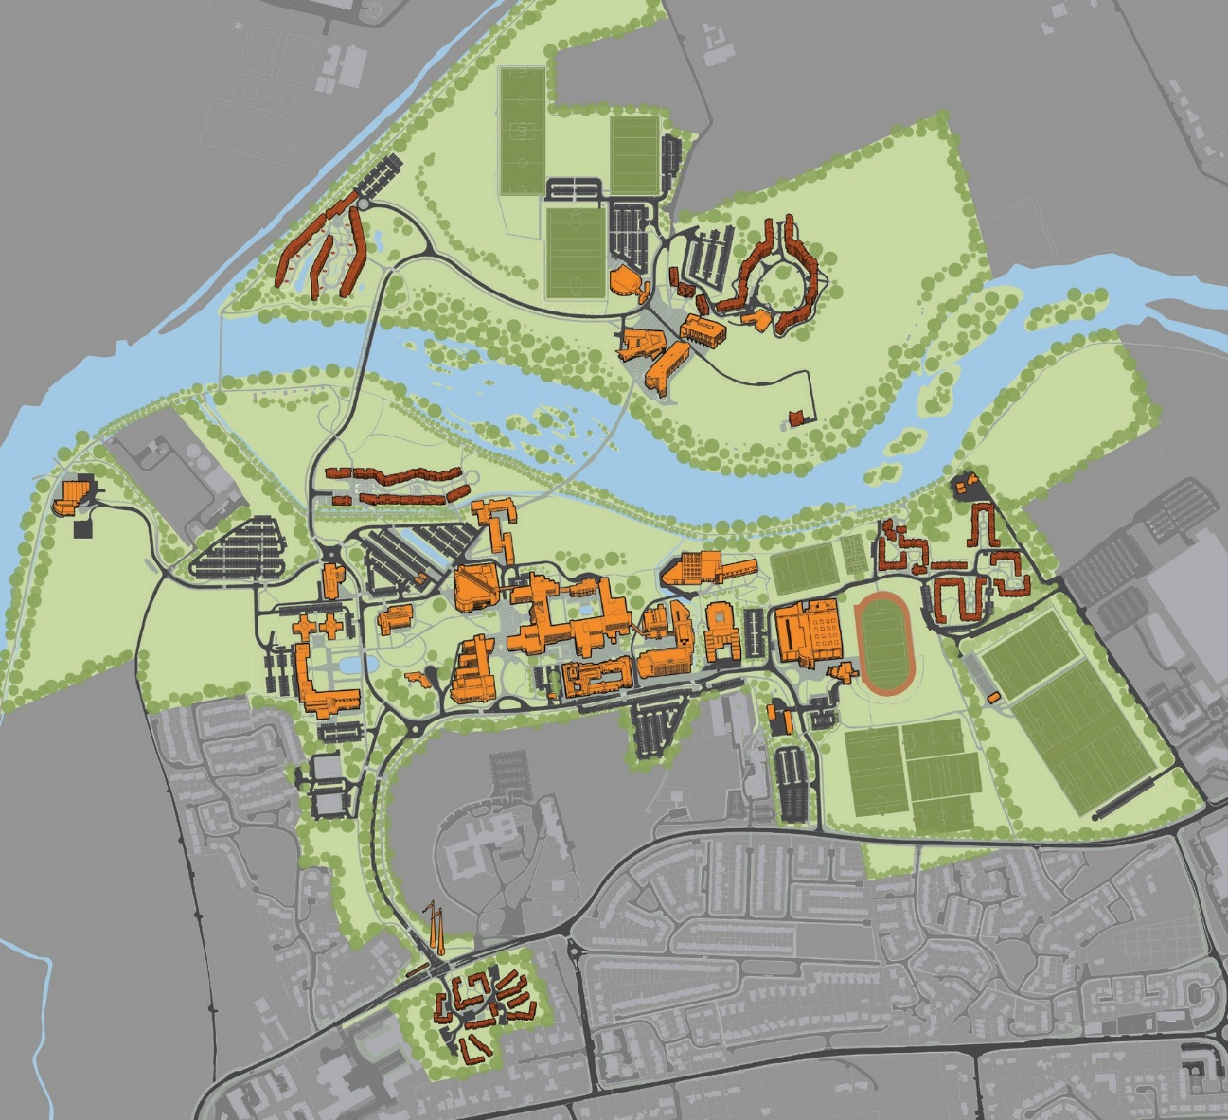

WORLD ARCHERY

**YOUTH CHAMPIONSHIP 2023**

01 - 09 JULY - LIMERICK IRELAND

Version 1.2 (27th March 2023)

Cappa Village

Dromroe Village

Kilmurry Village

Food – Student centre

Food - Pavilion

Finals Field

Qualifying field

Practice Field

Accreditation LOC office





WORLD ARCHERY

**YOUTH CHAMPIONSHIP 2023**

01 - 09 JULY - LIMERICK IRELAND

Version 1.2 (27th March 2023)

**TRANSPORTATION**

Transportation will be provided from Shannon airport to the official hotel, from two days before the official practice day and until two days after the closing day on 10th July return. There is no need for local transport between the official hotel, practice and competition venues as it’s all within walking distance.

€20 per person one way from Shannon Airport to the University of Limerick If travelling to a different airport please email the LOC for a quote for transport or advice on public transport services.

If you wish to fly to Dublin Airport we can offer a private bus. Please contact us directly for a quote. However, you can use Dublincoach.ie (Dublin Airport to the University of Limerick) for a bus that drops your team directly inside the venue. Approx price is €20 each way

For more information please watch https://youtu.be/344R7TYXJIY

**VISA**

All participants who need an entry visa to the Country, will be required to complete the **Visa Support sections in WAREOS** by no later than 01 April 2023.

It is the applicants’ responsibility for supplying the necessary information, ensuring all details are up to date, correct and submitted by the deadlines specified.

In addition, all participants that require a visa are kindly requested to supply a copy of their latest/ valid passport. Copies of each application can be uploaded on WAREOS. All passport copies and personal details entered/uploaded to WAREOS will be held securely and in the strictest of confidence and not shared with other parties.

**PAYMENT CONDITIONS**

Complete all necessary sections in WAREOS and make full payment by the specified deadlines. Bank transfers only, no credit cards will be accepted. All bank charges will be paid by the participants.

The entry fees should be paid in full before arrival.

To confirm hotels reservations, a minimum 50% deposit of the total amount is required to be bank transferred to the LOC **before 01 May 2023**. Reservations after this date will be considered only according to availability. The final outstanding balance shall be made via bank transfer before arrival. Accommodation cannot be guaranteed after this deadline. A cost summary will be available through WAREOS.



Aimwell Events

+353 876459583

Rathfarnham Dublin 16, D16NA07 Ireland

AIB

48771093

93-34-06

IE 67 AIBK 9334 0648 7710 93

AIBKIE2D  
Aib Carrickmines, The Park Dublin 18, D18R1H5 Ireland

+353 1 290 3700



WORLD ARCHERY

**YOUTH CHAMPIONSHIP 2023**

01 - 09 JULY - LIMERICK IRELAND

Version 1.2 (27th March 2023)

**BANK INFORMATION FOR ACCOMMODATION, TRANSPORTATION AND ENTRY FEES**

A/C Name: Telephone number: Address:

Bank:

Account Number: Sort code:

Iban:

Bic:

Bank’s address: Bank’s Phone:

**NOTE:** ALL PAYMENTS SHALL BE MADE IN EUR.

**CANCELLATIONS & CHANGES**

All cancellations and changes must be made through WAREOS:

* Should flight arrival details change last minute, please contact the Organising Committee using the details indicated in the team managers’ booklet.
* If a participant’s arrival is later than the original scheduled arrival date, the room will be charged from the date of the original booking in WAREOS.
* An email will automatically notify the Organising Committee and Member Association of any changes made in WAREOS.

**HEALTH REGULATIONS (COVID-19)**

* Everybody should follow the Government/public health authorities’ measures (national and sport-specific regulations) and be aware of the travel restrictions
* For your information, Medical infrastructure/Hospital with proper care will be reachable within 19 minutes from the venue, where COVID-19 test can be done.

**Medical emergency contact and location**

University Hospital Limerick, St Nessan’s Road, Dooradoyle, Limerick V94 F858 Phone Number +353 6130111

During the competition St Johns Ambulance will be providing on-site emergency services





WORLD ARCHERY

**YOUTH CHAMPIONSHIP 2023**

01 - 09 JULY - LIMERICK IRELAND

Version 1.2 (27th March 2023)

**ADDITIONAL INFORMATION**

**Athlete Protection**

In line with best practices, we will ensure that any volunteer that has access to Athletes will be vetted by the Garda (Irish Police).

If anybody at this event has any issues from bullying to harassment please email in confidence [apo@archery.ie](mailto:apo@archery.ie)

In each goodie bag there will be an information sheet with a phone number and other information should an athlete require it.

**Training**

A training field will be available starting on 2nd July. The training field will operate from 9 am to 5 pm each day until the 9th of July

**Weather**

Limerick City temperatures in July are expected to range between 12 and 20 degrees Celsius. There are chances of rain (as it is Ireland). It is rare to find Air conditioning in Ireland as it rarely gets too hot.

**Media Registration**

Media representatives can apply for registration on the LOC website: [www.wayc2023.com](http://www.wayc2023.com/) or by emailing [adam@aimwellevents.com](mailto:adam@aimwellevents.com) or at [info@archery.sport.](mailto:info@archery.sport)

**Internet**

It will be available in the official hotels for free (in hotel rooms and in the lobby). There will also be Wi-Fi available for access to results only on the qualification field.

**Water**

Each participant will be provided water

**LOC CONTACT**

Name: Email:

Adam Taylor [adam@aimwellevents.com](mailto:adam@aimwellevents.com)

Language:

English

Phone number with international extension: +353876459583

Looking forward to welcoming you to Limerick Ireland