ARCHERY WORLD CUP, STAGE 2
10 - 16 May - Medellin (Colombia)
Version 1.0 (4 January 2016)

TO ALL WORLD ARCHERY MEMBER ASSOCIATIONS

Dear President,

As Chair of the Local Organising Committee (LOC) of the 2nd Stage of the ARCHERY WORLD CUP, and the Americas’ Continental Qualifier Tournament (CQT) for the Rio 2016 Olympic Games to be held in Medellin - Colombia on 10-16 May 2016, I would like to invite you all to be part of one of the most important Archery events to take place in the Americas in 2016.

Medellin is surrounded by majestic mountains. It is the country’s second largest city, industrial capital, business centre, and Colombia’s beating heart of commerce. Through conviction and political will, we have taken on the challenge of transforming Medellin into a city where justice, solidarity and acceptance are paramount.

The city has a deeply ingrained culture of service based on the friendliness, respect and warmth of its people. Its local government and institutions are fully committed to the city’s development. Its modern infrastructure offers absolute comfort when hosting world class events.

Athletes of the world do know that Medellin is also a city where magnificent archery events can be staged. The past 3 years of World Cup stages were successfully hosted here. Participants from more than 35 countries have enjoyed the experience of shooting in our city. Those who joined us previously will certainly want to come back and be our best ambassadors to advertise our 2016 Cup among the rest of the athletes of the world.

Welcome to this amazing city that reinvents itself every day. Our targets look forward to embracing your arrows, just as our hearts are ready to make your visit unforgettably enjoyable.

“Come and discover hundreds of reasons to visit and endless excuses to come back”.

Sincerely yours,
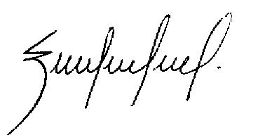

MARIA EMMA GAVIRIA
World Cup Medellin OC Chairman

IMPORTANT DATES

Start date for On-line registration
(WAREOS - http://register.worldarchery.org/) 4 January 2016

Preliminary Entries deadline 10 February 2016
Final Entries deadline 19 April 2016

Preliminary Accommodation Reservation deadline 10 February 2016
Final Accommodation Reservation deadline 9 April 2016
Final Accommodation payment deadline 9 April 2016

Entry Fee Payment deadline 9 April 2016

Submission of Passport copies to Organising Committee deadline 1 April 2016

Submission of Transportation Form deadline 9 April 2016

PRELIMINARY PROGRAMME

Saturday  7 May  or before | PRACTICE IN LOCAL CLUB FACILITIES FROM 9:00 TO 17:00
 | There is an additional fee of USD$50 (per person) for early arrival airport transportation.
 | - There is an additional fee of USD$15 (per person, per day) for transportation to and from the hotel to the local club practice range.
 | - Hot buffet breakfast & dinner are included with hotel reservation. Lunch will be served at the practice field.
Sunday  8 May | OFFICIAL ARRIVAL DAY
 | - Airport transportation to official hotels is provided without additional cost.
 | - Local transportation to and from the practice field is provided without additional cost.
 | - Practice field is open between 09:00 and 17:00 hrs.
 | - Hot buffet breakfast & dinner are included with hotel reservation. Lunch will be served at the practice field.
Monday  9 May | OFFICIAL ARRIVAL DAY / CONTINENTAL QUALIFICATION TOURNAMENT
 | - Transportation between the airport and official hotels is provided without additional cost.
 | - Local Transportation to and from the main competition and practice fields is provided, without additional cost.
 | - Practice field is open between 09:00 and 17:00 hrs. Competition Field will be used for the Continental Qualification Tournament and Practice for recurve athletes. Compound athletes will practice at the practice field adjacent to the main field.
 | - Hot buffet breakfast & dinner are included with hotel reservation. Lunch will be served at the practice field.

COMPETITION PROGRAMME

DAY 1  Tuesday  10 May | Official Practice & Equipment Inspection for Recurve and Compound athletes
 | Team Managers Meeting: 14:00hrs at the qualification venue.
DAY 2 Wednesday  11 May | QUALIFICATION RW - RM (70 m)
 | QUALIFICATION ROUND CW – CM (50 m)
 | Recurve Mixed Team and Compound Mixed Team Rounds 1/8 – Semifinals
DAY 3  Thursday  12 May | INDIVIDUAL ELIMINATION RW & RM
 | 1/48 – 1/24 in the morning, and 1/16 to 1/2 in the afternoon
 | INDIVIDUAL ELIMINATION CW & CM
 | 1/48 – 1/24 in the morning, and 1/16 to 1/2 in the afternoon
DAY 4  Friday  13 May | TEAM ELIMINATION Recurve
 | 1/8 – Quarterfinals & Semifinals in the morning
 | TEAM ELIMINATION Compound
 | 1/8 – Quarterfinals & Semifinals in the morning
DAY 5  Saturday  14 May | MEDAL MATCHES COMPOUND BOW
 | Morning: TEAMS - Bronze and Gold, CW & CM
 | Afternoon: MIXED TEAMS - Bronze & Gold
 | INDIVIDUAL - Bronze & Gold, CW & CM
DAY 6  Sunday  15 May | MEDAL MATCHES RECURVE BOW
 | Morning: TEAMS - Bronze and Gold, RW & RM
 | Afternoon: MIXED TEAMS - Bronze & Gold
 | INDIVIDUAL - Bronze & Gold, RW & RM
Monday  16 May | Official Departure Date
 | Airport transportation from official hotels is provided without additional cost

NOTE

This preliminary programme is subject to change according to the number of participants in each division and TV requirements. All changes will be published and distributed to all participants in advance.
PRELIMINARY & FINAL REGISTRATION

All registration must be done using the World Archery Online Registration System (WAREOS, formerly FORS): http://register.worldarchery.org . No entry forms will be accepted for registering to this event if they are not made with WAREOS.

A maximum number of 4 athletes per country are allowed to be registered into each category of the event. Preliminary entries have to be done using the WAREOS (formerly FORS) system.

In order to use WAREOS, please login on http://register.worldarchery.org with your Username and Password assigned by World Archery. After entering WAREOS, please go to "Online Registration" and register your athletes for this event. A "WAREOS User Manual" can be downloaded in PDF format (English) using the same website link.

For any questions regarding WAREOS, please contact the World Archery office, Mr Jae Kyung LEE (jklee@archery.org).

- Start date for online registration with WAREOS is: 4 January 2016
- End of Preliminary registration with WAREOS is: 10 February 2016
- End of Final registration with WAREOS is: 19 April 2016

Please pay attention to the deadlines. National Associations will not be able to enter or update data of their teams in WAREOS after the deadlines as the system will be blocked. If, teams wish to make or change the Final Registration after the deadline, please contact Mr Jae Kyung LEE, World Archery Member Services Coordinator (jklee@archery.org).

Final Entries processed after the deadline will result in a penalty fee of $50USD per athlete to be paid to the OC upon arrival at the field.

Final registrations that differ by more than 4 athletes from the preliminary registration or have been submitted after the preliminary deadline will result in a penalty fee of $150USD to be paid to the OC upon arrival at the field.

Any entries received less than 3 days before the team captains meeting for a World Archery World Cup or World Championships will be refused if no preliminary entry and/or final entries are made prior. This decision cannot be appealed by the teams and is fully compliant with the current World Archery rules, article 3.7.1.2. Entries received after the deadlines, are subject to penalties as clearly stated in the rule book and the invitation documents of World Cups and World Championships. A Member Association that has made final entries in WAREOS and does not participate will be invoiced for the number of entries entered in the system, unless they have informed World Archery and the OC in writing, at least one week prior to the event that they are unable to attend.

In addition, any Member Associations that have penalty fees outstanding from 2015 will need to have paid these penalty fees in full, before being eligible to enter and compete.
OFFICIAL ENTRY FEES

Entry fees:
Individual: USD 150 per athlete
Official: USD 100 per person

Entry Fees for teams not using official hotels or book accommodation through the OC

Individual: USD 300 per athlete
Official: USD 200 per person

Reminder: Non-official accommodation means accommodation that has been not booked through the LOC).

The entry fee includes airport transportation (both ways) on official event dates.

Teams using non official hotels or accommodation, not booked through the LOC, will not have local transportation provided. Arrival and departure airport transportation is included in the entry fees only on official arrival/departure dates.

- Official Arrival Days: Sunday 8 and Monday 9 May 2016
- Official Departure Day: Monday 16 2016

Payment conditions: The Grand Total (Total Entry Fees plus Total Accommodation Fees) must be paid in full, on or before 9 April 2016.

VISAS

If your country requires a visa to travel to Colombia, it is important that this process be started as soon as possible. Your Federation should submit your visa applications to the Colombian consulate in your country as early as required to have your visas issued in due time to travel to Medellin.

GENERAL INFORMATION

LOC Contact: Sergio FONT
Email: awcmedellin2015@gmail.com
Language: Spanish, English

ACCOMMODATION

To offer you top quality service and comfort, the official accommodation will be provided at the Dann Carlton / San Fernando Plaza Hotel Complex. This complex with two hotels is located in the heart of Medellin, very close to business, shopping and dining areas.
The accommodation fee includes continental breakfast, hot buffet lunch and dinner (lunch will always be served at the archery venues), service charges and taxes.

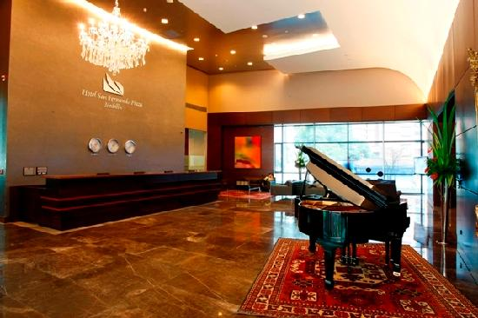
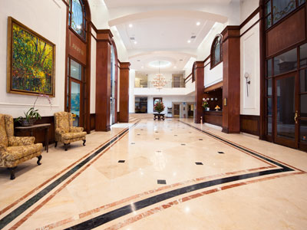
Teams choosing to book their accommodation at non-official hotels (not through the Organizing Committee) will have to pay “Non-Official Entry Fees” (double entry fee).
The lobby of the San Fernando Hotel

The lobby of the Dann Carlton Hotel

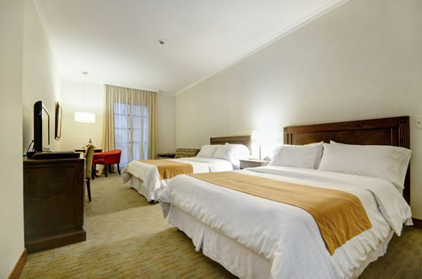
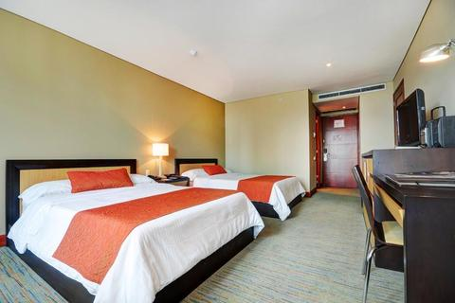
The twin room at the Dann Carlton

The twin room at the San Fernando

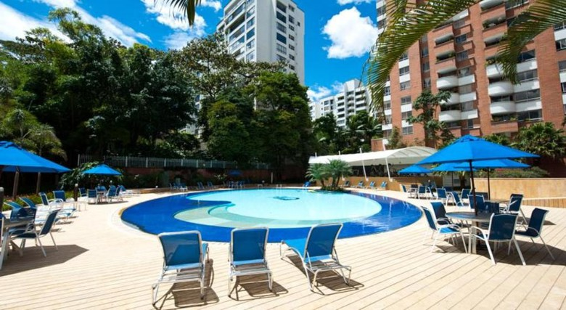
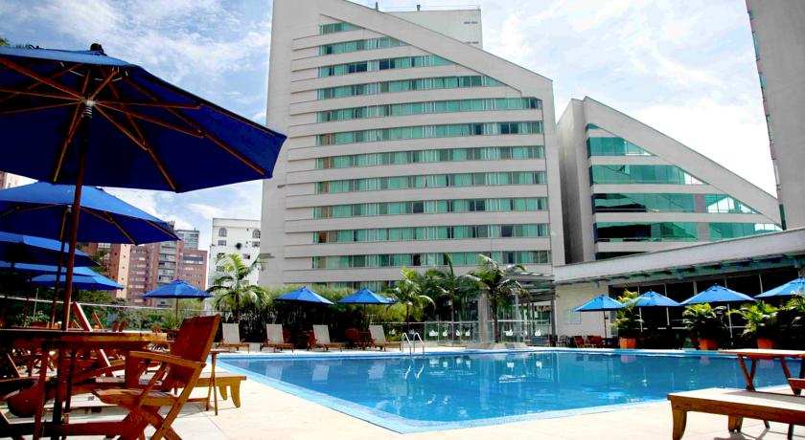
The swimming pool at the San Fernando

The swimming pool at the Dann Carlton

Cancellations & Changes
Cancellations must be in writing and received by the LOC on or before 14 April 2016 to qualify for a full refund of payment. All refunds will be processed by the LOC after 18 May 2016. For any cancellations made after 14 April 2016, NO REFUND will be awarded. The same applies to changes made after April 14 to the final number of participants whose full or partial payment was transferred to the Local Organising Committee.

Name change (same Category and Division) will be accepted up to 72 hours before the event without any additional charge. Teams should email the LOC immediately of any changes by emailing awcmedellin2015@gmail.com at the latest 72 hours prior to arrival. For teams that arrive later than their original schedule, the room charges will start from the original date as indicated in their accommodation request sent by the Member Association.

Airport Transportation
Transportation from the airport will start Sunday 8 May and Monday 9 May (two (2) days before official practice day) and will end Monday 16 May (the day after finals). Team entry fees include airport transportation both ways on official days.

Practice Fields
Before the official event dates
- There will be a practice field available at the “Unidad Deportiva de Belen” beginning Wednesday 4 May 2016. It is located approximately 20 minutes from the official hotels.

During the official dates for the event
- From Monday 9 May 2016 to Friday 13 May the practice field will be located at the competition venue (walking distance from the competition field). Practice on Saturday 14 May for athletes competing on Sunday 15 May will be at the Unidad Deportiva de Belen. Transportation for practice on Saturday 14 May will be provided by the Organizing Committee at no additional cost but this service needs to be requested through the OC on Friday 13 the latest.

Meals
- Breakfast: Continental Breakfast will be provided to teams staying at official accommodation hotels: served from 06:00-09:00 hrs.
- Lunch will always be provided at the competition venue: Hot Buffet will be served 11:30-14:00 hrs, only to participants staying at the official hotels.
- Dinner: dinner will be served from 18:00-21:00 hrs at the official hotels.

Climate
Medellin is a city where it is never cold and very seldom hot. Temperatures in May are expected to range between 20 and 28 degrees Celsius. The average in the last few years has been 25 degrees Celsius.
There are chances of rain, mainly in the afternoons.
ACCOMMODATION RESERVATION FORM

Preliminary accommodation reservations will be accepted from 9 February 2016. Reservations are processed in the order they are received. Hotel priority is on a first come, first serve basis.

LOC Contact: Sergio FONT Email: - awcmedellin2015@gmail.com

Country/Team: _____________________ Email: _______________________________

Contact Given Name: __________________ Family Name: ________________________
HOTEL | Room type/  Occupancy | Number of Rooms by TYPE | Numbers of Persons |  | Total People |  | Fee per Person |  | Nights |  | Total
 |  |  | Female | Male
Dann Carlton / San Fernando Plaza | Single |  |  |  |  | x | $170 | X |  | =
 | Double |  |  |  |  | x | $140 | X |  | =
 | Triple |  |  |  |  |  | $115 | X
Total Accommodation

FULL BOARD OPTION (Breakfast, Lunch and Dinner, including Taxes)

Federation contact person / Phone: _______________________Fax: _________________________

Arrival Date: _________________________ Departure Date: _______________________

- All accommodation is subject to availability at the time of booking.
- Please check here if you require facilities for the disabled.
- Please inform us if any of your team members have any dietary requirements or food allergies.

- ENTRY FEES AND PAYMENT FORM

LOC Contact: Sergio FONT Email: awcmedellin2015@gmail.com

Country/Team: __________________________ Email: ____________________________

Contact Given Name: _____________________ Family Name: ______________________

Phone: ________________________________ Fax: ______________________________

Entry Fees | Number of Persons |  | Total People |  | Cost PP (USD) |  | TOTAL USD
 | Female | Male
Individual Entry Fee Official Hotel |  |  |  | X | USD 150 | =
Official Entry Fee Official Hotel |  |  |  | X | USD 100 | =
Early Arrival Airport Transportation Fee |  |  |  | X | USD 50 | =
Early Arrival practice Fee |  |  |  | X | USD 15 | =
Accommodation Total: |  |  |  |  |  | =
GRAND TOTAL DUE: |  |  |  |  |  | =

* Participants who elect to book their accommodation at other hotels (Non-Official Accommodation), or if participants have booked their accommodation without the LOC will have to pay double entry fee. Individual Entry Fee Non-Official Hotel USD $300 and Official Entry Fee Non-Official Hotel USD $200

INFORMATION FOR THE PAYMENT

LOC Contact: Sergio FONT Email: awcmedellin2015@gmail.com

Country/Team: _____________________________ Email: ________________________

Contact Given Name: ________________________ Family Name: __________________

Telephone: _________________________________ Fax: __________________________

Bank Transfer

A/C Name: Federación de Arqueros de Colombia
Federation’s Address: Carrera 66B N 31 A 15
Telephone number: (57 4) 2659510
City and Country: Medellin - Colombia
Bank: Bancolombia
Account Number: 362 7044-2473 (cuenta corriente)
Swift Bancolombia: COLOCOBM
Bank’s address: Transversal 39B N 73-47 local 104
Bank’s Phone: 57- 4 2505040
City: Medellin, Colombia

TRANSPORTATION REQUEST FORM

Please send this form to the LOC with the Final Accommodation Reservation form prior to 9 April 2016 Email: awcmedellin2015@gmail.com

Country/Team: ____________________________ Email: __________________________

Contact Given Name: _______________________ Family Name: ____________________

Phone: _________________________________ Fax: ____________________________

Number of people in your Group: ______________

ARRIVAL INFORMATION: We will arrive at Jose Maria Cordoba International Airport by plane:

Date: (DD/MM/YYYY) __________________ Carrier (i.e. Delta, United): ___________________

Flight Number: ________________________

Flight Arrival Time _____________________

Check here if you are renting a vehicle and DO NOT NEED transportation from the airport.

DEPARTURE INFORMATION: We will depart from Jose Maria Cordoba International Airport by plane

Date: (DD/MM/YYYY) __________________ Carrier (i.e. Delta, United): ___________________

Flight Number: ________________________

Flight Departure Time _____________________

Check here if you are renting a vehicle and DO NOT NEED transportation from the airport.

Official airport drop-off date is Monday 17 May 2016. Departures after this date, teams will need to pay an additional cost for return airport transportation. Please contact the LOC for a quotation.

IMPORTANT INFORMATION REGARDING COLOMBIA VISAS

Applications for and obtaining travel visas to Colombia is completely and solely the responsibility of the participating teams. The process for obtaining a visa requires each individual to submit an application through a Colombian Embassy or Colombian Consulate. This is a process that MUST be done by the individual applicants – the organising committee cannot do this on their behalf! The information contained in this document is current at the time of distribution. For updated information regarding visa requirements when traveling to Colombia, please refer to their Colombian Embassy.
Countries and territories whose citizens require a Colombian visa:
 | CODE | COUNTRY | CODE | COUNTRY | CODE | COUNTRY
 | ALG | Algeria | HAI | Haiti | NCA | Nicaragua
 | ARM | Armenia | HON | Honduras | NEP | Nepal
 | AZE | Azerbaijan | HUN | Hungary | NFI | Norfolk Islands
 | BAN | Bangladesh | IND | India | NGR | Nigeria
 | BEN | Benin | IRI | Islamic Republic of Iran | NIG | Niger
 | BER | Bermuda | IRQ | Iraq | PAK | Pakistan
 | BIH | Bosnia and Herzegovina | ISV | Virgin Islands | PRK | Democratic People's Republic of Korea
 | BLR | Belarus | KEN | Kenya | QAT | Qatar
 | CAF | Central African Republic | KGZ | Kyrgyzstan | RWA | Rwanda
 | CAM | Cambodia | KIR | Kiribati | SEN | Senegal
 | CHA | Chad | KOS | Kosovo | SLE | Sierra Leone
 | CHI | Chile | KSA | Saudi Arabia | SOM | Somalia
 | CHN | People's Republic of China | KUW | Kuwait | SRB | Serbia
 | CIV | Ivory Coast | LAO | Lao People's Democratic Republic | SRI | Sri Lanka
 | CMR | Cameroon | LBA | Libyan Arab Jamahiriya | SUD | Sudan

 | COD | COUNTRY | COD | COUNTRY | COD | COUNTRY
 | COD | Democratic Republic of the Congo | LIB | Lebanon | TGA | Tonga
 | COM | Comoros | MAC | Macau | THA | Thailand
 | CUB | Cuba | MAR | Morocco | TJK | Tajikistan
 | EGY | Egypt | MAW | Malawi | TOG | Togo
 | FLK | Falkland Islands | MDA | Republic of Moldova | TPE | Chinese Taipei
 | FPO | Tahiti | MGL | Mongolia | TUN | Tunisia
 | FRO | Faroe Islands | MKD | F.Y.R.O. Macedonia | UGA | Uganda
 | GAB | Gabon | MNE | Republic of Montenegro | UKR | Ukraine
 | GEO | Georgia | MRI | Mauritius | UZB | Uzbekistan
 | GHA | Ghana | MYA | Myanmar | VAN | Vanuatu
 | GUI | Guinea | NAM | Namibia | VIE | Vietnam

VISA INVITATION LETTER FORM

Please return this form, no later than 4 April 2016. Only when we have received the below details can we provide your teams with the necessary visa invitation letters to apply for a Columbian visa.

Country/Team: __________________________ Email: _____________________________

Contact Given Name: _____________________ Family Name: _______________________

Phone: ________________________________ Fax: _______________________________
Male or Female | First Name | Family Name | Indicate Athlete or Official | Date of Birth  DD/MM/YY | Place of Birth | Passport Number | Expiration Date of Passport  DD/MM/YY

