TO ALL World Archery MEMBER ASSOCIATIONS

Dear President,

The 3rd stage of the HYUNDAI ARCHERY WORLD CUP will be held in Salt Lake City, Utah, United States of America on 18 to 24 June 2018. On behalf of the Organizing Committee, it is a great pleasure to invite you to participate in this competition. This event will be organized following the Hyundai World Archery World Cup rules for 2018, in both divisions, recurve and compound.

Please find enclosed the necessary documents of registration, organization and participation for this event. Please completed all the sections in WAREOS before the deadlines:

Summary of deadlines:

- Preliminary Entries 22 March 2018
- Preliminary Hotel Reservation 22 March 2018
- 50% Deposit of Total Cost 22 March 2018
- Visa Support 22 March 2018
- Final Hotel Reservation 15 May 2018
& Payment
- Transportation 15 May 2018
- Final Entries 29 May 2018

Looking forward to welcoming you in Salt Lake City, United States of America.

Sincerely yours,

Mr. Greg Easton
President
Organizing Committee

PRELIMINARY PROGRAMME:

16 Jun 2017  Saturday | Arrival of participants  Practice field and local transport available
17 Jun 2017  Sunday | Arrival of participants  Practice field and local transport available
18 Jun 2018  Monday | Official Practice  Equipment Inspection  Team Managers Meeting
19 Jun 2018  Tuesday | Qualification Round,  (Recurve 70m Round and Compound 50m Round)
20 Jun 2018  Wednesday | Individual Eliminations  (Recurve and Compound)
21 Jun 2018  Thursday | Individual Eliminations Team Matches and  Mixed Team Eliminations  (All categories)
22 Jun 2018  Friday | Team Eliminations  (Recurve and Compound)
23 Jun 2018  Saturday | Finals – Compound  (Individual and Team)  Award Ceremonies
24 Jun 2018  Sunday | Finals – Recurve  (Individual and Team)  Award Ceremonies
25 Jun 2018  Monday | Departure of teams

NOTE:
This preliminary program is subject to change according to participation and TV requirements. All changes will be published and distributed in good time

PRELIMINARY & FINAL REGISTRATION

All entries, accommodation reservations, transport needs, flight arrival/departure information and visa invitation letter requests are to be completed using WAREOS.

The World Archery Online Registration System (WAREOS): http://register.worldarchery.org now handles the entire registration process for this event. No entry forms, hotel reservations or transportation forms will be accepted; all information must be entered into WAREOS.

Member associations can login to WAREOS at http://register.worldarchery.org with the username and password assigned by World Archery. After entering WAREOS, selecting the event from the list will allow a member association to register their athletes. Select/press the “Entries” button to see the list of categories in the event. Select/press the “category” to enter the athlete and official numbers/details participating for that event. A WAREOS User Manual can be downloaded in PDF format (English) upon login.

Contact Mr JK LEE (jklee@archery.org) in World Archery Office with any questions regarding WAREOS.

A maximum number of 4 athletes per country can be registered into each category of the event. Preliminary entries should be completed using WAREOS.

Start date for online registration using WAREOS 08 January 2018
End of Preliminary registration using WAREOS: 22 March 2018
End of Final registration using WAREOS: 29 May 2018

Please respect the stated deadlines.

Member Associations can only use WAREOS to make any changes or amendments to entries and will be able to do so at any time. An email will automatically notify the Organising Committee and Member Association of any changes made in WAREOS.

Any changes that are made after the deadlines specified or if entries differ by more than 4 athletes from the preliminary entries, the following penalty fees will automatically be applied.

Penalty fees to be paid to Organising Committee: | Cost (USD):
Entries made after the entry deadline dates. | 50 per entry
If final entries differ from the preliminary entries by more than 4 athletes/officials. | 150 per entry
When no preliminary entries were made before the deadline date but then submit final entries. | 150 per entry

Penalty Fee to be paid to World Archery: | Cost (CHF):
Lost accreditation. | 30 each
Changes made to the athlete and/or team official names after the final entry deadline date and within 3 days prior to the start of the event. | 50 each change

NOTE: CHF currency exchange rates will be those on the date of the event.

Member Associations that have penalty fees outstanding from 2017 will need to have paid these penalty fees before being eligible to enter and compete.

Any entries received less than 3 days before the team managers meeting for a Hyundai Archery World Cup or World Championships will be refused if no preliminary entry and/or final entry are made prior. This decision cannot be appealed by the teams and is fully compliant with the current World Archery rules, article 3.7.1.2. Entries received after the deadlines, are subject to penalties as clearly stated in the rule book and the invitation documents of World Cups and World Championships. A Member Association that has made final entries in WAREOS and does not participate will be invoiced for the number of entries entered in the system, unless they have informed World Archery and the Organising Committee in writing at least one week prior to the event that they are unable to attend.

ACCOMMODATION & GENERAL INFORMATION

The official hotel is the Doubletree by Hilton Salt Lake City Airport. Hotels are allocated on a first come, first serve basis. A backup hotel will be provided subject to the number of the rooms reserved by the teams. All hotels are on or adjacent to the shuttle route and are less than 7 minutes from the venue. The accommodation cost includes breakfast. Catered Lunch and Dinner is not included in registration fee and can be purchased separately per person per day.

Teams who book their own accommodation will be charged a double entry fee.
- Reservations should be made on or before 22 March 2018
- Final Hotel Reservation & Transportation: 15 May2018.

To confirm the reservation, a 50% deposit of the total amount is required to be bank transferred to the OC before 22 March 2018. Reservations after this date will be considered only according to availability.

- Doubletree by Hilton Salt Lake City Airport HOST HOTEL (3.5 Star)
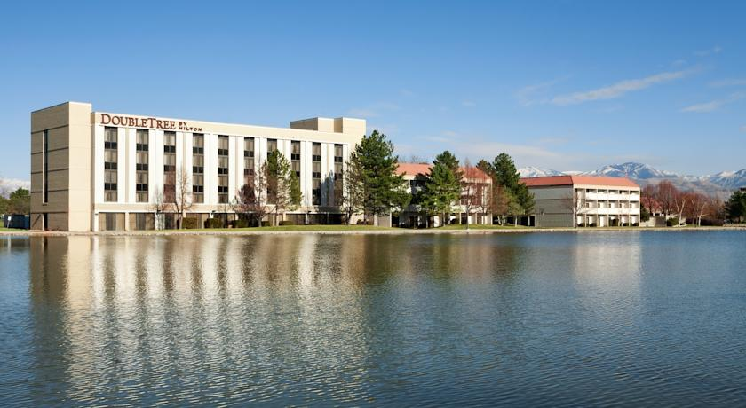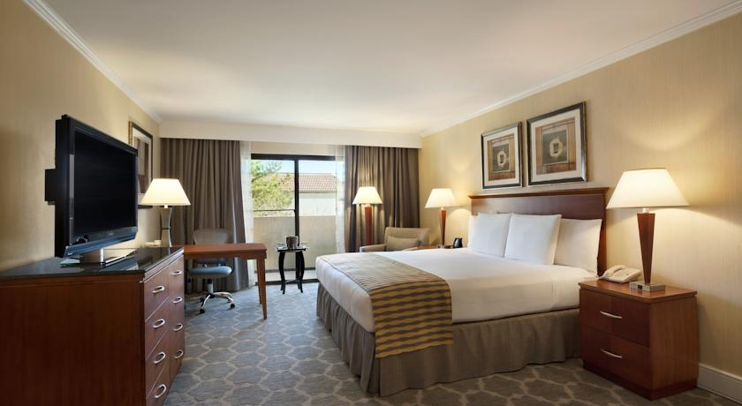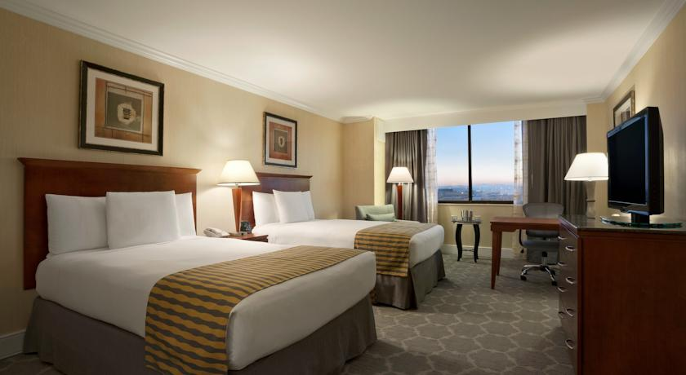
- Single Room with Breakfast $170.00 USD
- Double/Twin Room with Breakfast $110.00 USD Per Person
- Hotel website
http://www.saltlakecityairport.doubletree.com

- Hilton Garden Inn Salt Lake City Airport (3.5 Star)
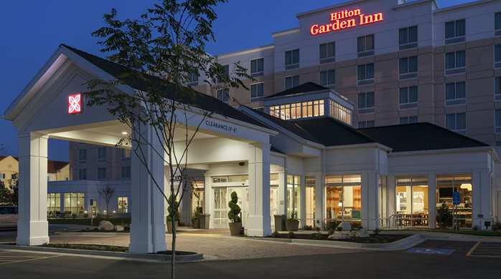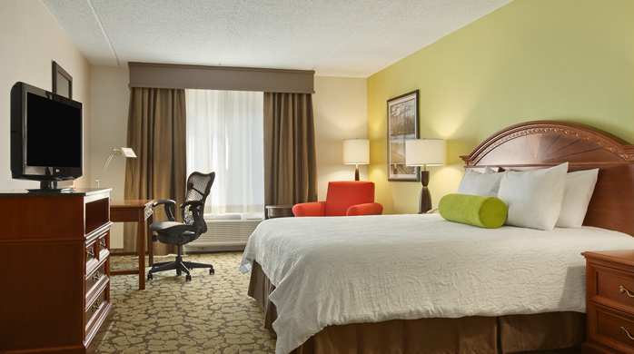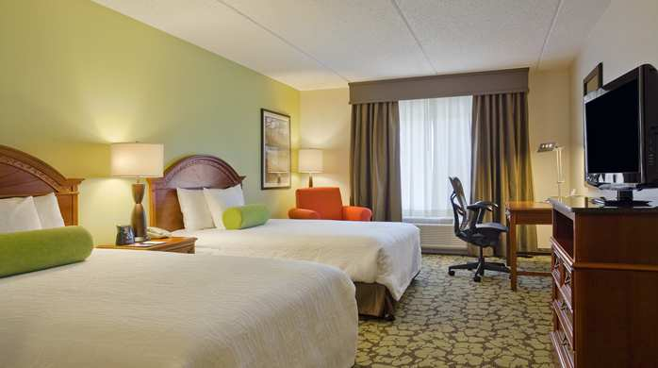
- Single Room with Breakfast $150.00 USD
- Double/Twin Room with Breakfast $100.00 USD Per Person
- Hotel website
http://hiltongardeninn3.hilton.com/en/hotels/utah/hilton-garden-inn-salt-lake-city-airport

3. Courtyard by Marriott Salt Lake Airport (3 Star)
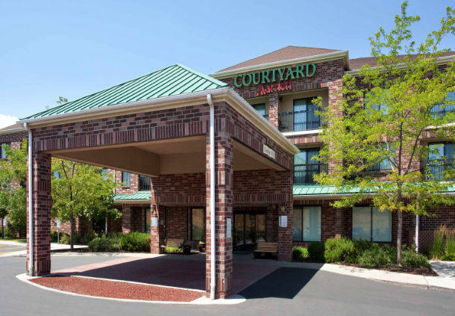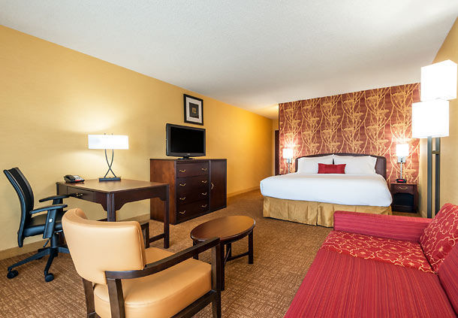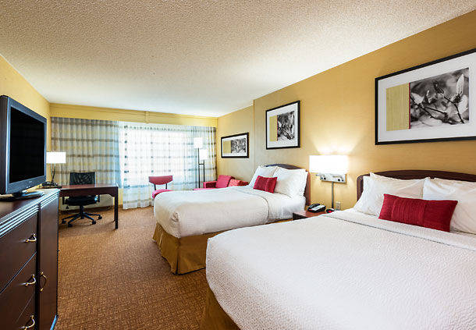
- Single Room with Breakfast $150.00 USD
- Double/Twin Room with Breakfast $100.00 USD Per Person
- Hotel website
http://www.marriott.com/hotels/travel/slcap-courtyard-salt-lake-city-airport/

4. Springhill Suites by Marriott Salt Lake City Airport (3 Star)
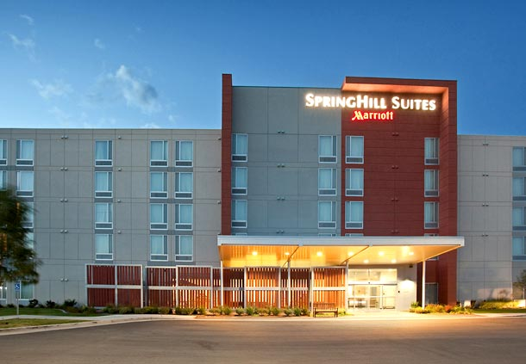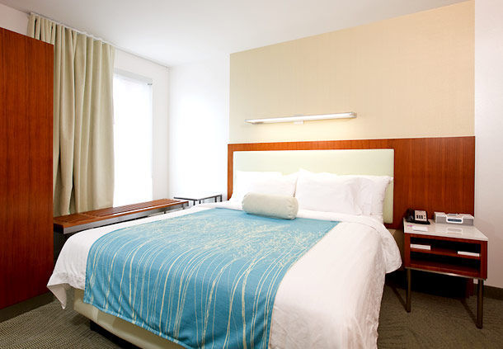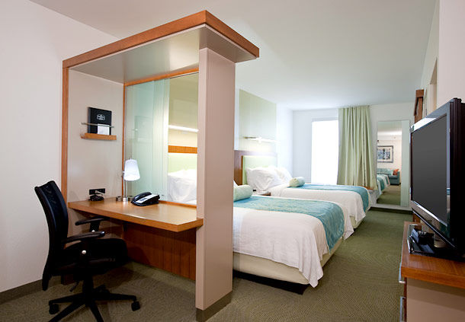
- Single Room with Breakfast $150.00 USD
- Double/Twin Room with Breakfast $100.00 USD Per Person
- Hotel website
http://www.marriott.com/hotels/travel/slcsa-springhill-suites-salt-lake-city-airport/

5. Residence Inn by Marriott Salt Lake City Airport (3 Star)
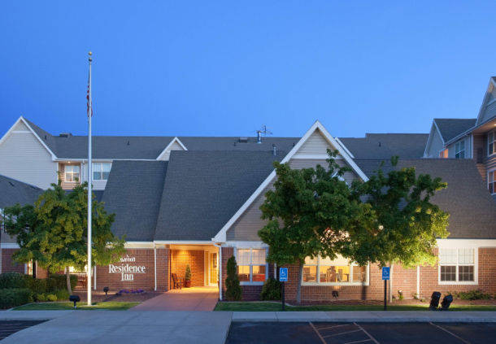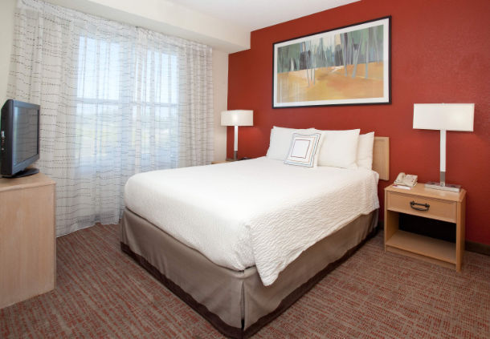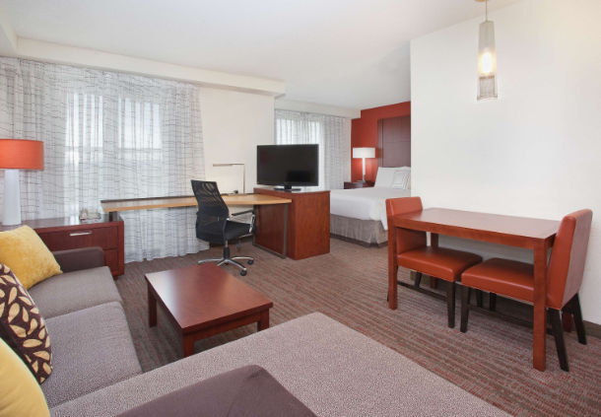
- Single Room with Breakfast $150.00 USD
- Double/Twin Room with Breakfast $100.00 USD Per Person
- Hotel website
http://www.marriott.com/hotels/travel/slcra-residence-inn-salt-lake-city-airport/

7. Fairfield Inn & Suites by Marriott Salt lake City Airport (3 Star)
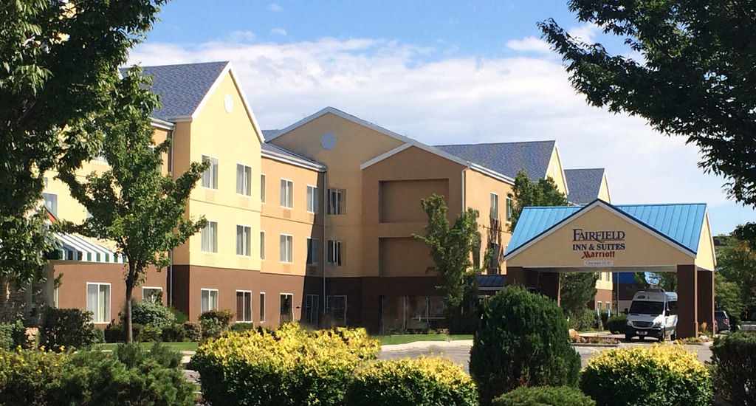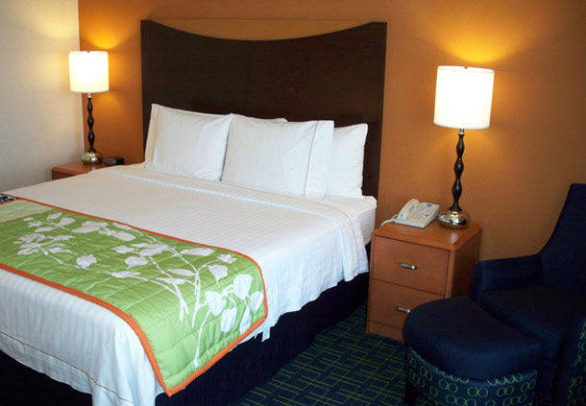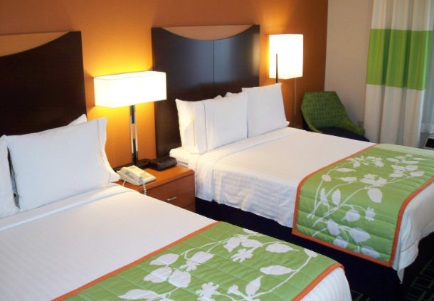
- Single Room with Breakfast $120.00 USD
- Double/Twin Room with Breakfast $ 75.00 USD Per Person
- Hotel website
http://www.marriott.com/hotels/travel/slcfa-fairfield-inn-and-suites-salt-lake-city-airport/

Important Note:
Please refer to the accommodation pages above for detailed hotel information. Complete all the necessary sections in WAREOS and make full payment for entries and accommodation by the specified deadlines. Bank transfers only, no credit cards or travel checks will be accepted.

All accommodation requests received outside of the OC negotiated hotel deadline dates, 16 June 2018 through 25 June 2018 are subject to current advertised hotel rates. All early arrivals (before 16 June 2018) must be approved by OC before any reservations can be made.

Participants who book their accommodation in non-official hotels will need to pay a double entry fee. In addition, the LOC will not be responsible to provide any event information at this hotel or provide transportation to the venues.

Teams that book non-official accommodation will need to register at the accreditation desk no later than the day before the official practice day. Failing to do so will result in no changes being made to the entry list and it is likely that participation in the event will be refused if registration is not completed in time.

Transportation, Lunch and Dinner Pricing

Airport arrival / departure, catered lunch, catered dinner or local transportation is not included in and can be purchased separately per person per day.

When using the Word version - click on table below to calculate total costs.

ENTRY FEE

Entry fee:

Individual: 250 USD per athlete
Officials: 125 USD per person
Temporary Upgrade: 30 CHF per accreditation

For athletes wishing to
be a coach temporarily

Entry fee in NON-official hotels:

Individual: 500 USD per athlete
Officials: 250 USD per person

There is no entry fee for teams.

PAYMENT CONDITIONS:

The entry fees should be paid in full upon arrival.

Payment of accommodation, a minimum deposit of 50% should be made when booking by 22 MARCH 2018. The final outstanding balance shall be made via bank transfer before arrival. Accommodation cannot be guaranteed after 15 MAY 2018 and at current advertised hotel rate may be applied. A balance invoice will be provided via WAREOS.

BANK INFORMATION for ACCOMMODATION, TRANSPORTATION and

ENTRY FEES:

BANK: BANK OF AMERICA
ADDRESS: 333 South Hope Street, Suite 1300
Los Angeles, CA 90071
BANK ACCOUNT HOLDER NAME: Easton Sports Development Foundation
ABA ROUNTING NUMBER: 026009593
ACCOUNT NO: 325017345417
SWIFT CODE: BOFAUS3N

NOTE:
_ ALL PAYMENTS SHALL BE MADE IN USD
_ By BANK TRANSFER or by CASH upon arrival
_ All bank charges will be paid by the participants
_ CREDIT CARDS or TRAVEL CHECKS will not be accepted

To avoid delays in wire transfers please submit a PRO FORMA invoice to your bank with wire transfer request.

TO GUARANTEE RESERVATIONS
The 50% deposit of the accommodation must be paid in advance by
22 MARCH 2018 made by bank transfer. The balance payment is due before arrival.

ADDITIONAL INFORMATION

Transportation
Transportation can be purchased to and from the Salt Lake City International airport to the official hotels, two days before the official practice day and one day after the closing day. Daily local transport can be purchased between official hotels and practice and competition venues. Transport timetables will be confirmed. Buses and/or vans will be provided.

A number of teams found renting their own cars both cost effective and convenient. To assist with this the OC has arranged special rental car pricing and pick up and drop off services. Please e-mail the OC for discounted rental cars information. Rental car rental requires international driver’s license and proof of insurance

Cancellations & Changes

All cancellations and changes must be made through WAREOS:
- Cancellations received before 15 May 2018 a full refund of the deposit payment will be made.
- Cancellations received after 15 May 2018, no refund will be given.
- Refunds will be processed after the event.
- Name changes to team officials or athletes (same category and division) will be accepted up to 72 hours before the event without any additional charge.
- Should flight arrival details change last minute, please contact the Organising Committee using the details indicated in the Team Managers’ Booklet.
- If a participant’s arrival is later than the original scheduled arrival date, the room will be charged from the date of the original booking in WAREOS.
- An email will automatically notify the Organising Committee and Member Association of any changes made in WAREOS.

Training
A training field will be available starting from 16 June 2017. The training field is next to the competition field and is about 2.4 km from the hotels.

Weather
According to weather information, the average temperature in June is expected to be 55.8 to 82.2°F / 13.2 to 27.8 °C.

Internet

Will be available in the official hotels for free (in hotel rooms and in the lobby).

Water

Bottled water will be available at the qualification and practice venues.

IMPORTANT INFORMATION REGARDING U.S. VISAs
Application for and obtaining travel visas to the United States are completely and solely the responsibility of the participating teams. A visa will be required of all visitors to enter the United States with the exception of citizens from 38 countries who are eligible for visa-free entry into the United Sates under the “Visa Waiver Programme”. The process for obtaining a visa requires each individual to submit and pay application fees through a U.S. Embassy or U.S. Consulate. This is a process that MUST be done by the applicant – the organizing committee cannot do it for you!

The information contained in this document was current at the time of distribution. For updated information regarding visa requirements when traveling to the United States of America, please refer to following websites:

ESTA – The Official U.S. Government Website: https://esta.cbp.dhs.gov/

U.S. Dept. of State: http://travel.state.gov/visa/temp/temp_1305.html

VISA WAIVER PROGRAMME COUNTRIES

Andorra | France | Liechtenstein | San Marino
Australia | Germany | Lithuania | Singapore
Austria | Greece | Luxembourg | Slovakia
Belgium | Hungary | Malta | Slovenia
Brunei | Iceland | Monaco | South Korea
Chile | Ireland | The Netherlands | Spain
Czech Republic | Italy | New Zealand | Sweden
Denmark | Japan | Norway | Switzerland
Estonia  Finland | Latvia | Portugal | Taiwan  United Kingdom

NOTE: IF YOUR COUNTRY IS LISTED AS A “VISA WAIVER PROGRAMME” COUNTRY, YOU ARE REQUIRED TO COMPLETE THE ON-LINE ESTA APPLICATION AT https://esta.cbp.dhs.gov/. IT IS IMPORTANT TO REVIEW THE ELIGIBILITY AND PASSPORT REQUIREMENTS TO ENSURE YOU MEET ALL THE CRITERIA BEFORE MAKING YOUR TRAVEL ARRANGEMENTS.

Most categories of visas may be issued to an applicant up to 60 days before its effective date. HOWEVER, it cannot be emphasized enough that the letter of invitation and application process should start as early as possible. Participants from countries subject to additional clearances should be especially conscientious about applying early, since the State Department will not guarantee that ANY cases will be expedited.

Letter of Invitation – For those countries not listed above on the VISA waiver programme, the OC will issue you a Letter of Invitation to use in your application process. AS SOON AS POSSIBLE please complete all the necessary sections fully in WAREOS for the Organising Committee to create the visa letter.

How long should you expect the process to take? There is no standard timeframe for how long it takes to get an appointment for a visa interview and it can vary dramatically from as much as 6 months to just a few days depending on the country. It cannot be emphasized enough to start the application process early.

PLEASE KEEP IN MIND – We cannot guarantee you will receive a VISA and we cannot provide special clearances if you are denied or apply too late. Also note that the application and interview process in your country may very well be in advance of the team selection date required by FITA, so in many cases, you will need to start the application process prior to confirming your final team.

Visa
All participants who need an entry visa to the United States of America, will be required to complete the Visa Support Form in WAREOS by no later than 15 May 2018.

It is the applicants’ responsibility for supplying the necessary information, ensuring all details are up to date, correct and submitted by the deadlines specified.

In addition, all participants that require a visa are kindly requested to supply a copy of their latest/valid passport. Copies of each applicate can be uploaded on WAREOS. All passport copies and personal details entered/uploaded to WAREOS will be held securely and in the strictest of confidence and not shared with other parties.

Any questions please email: Jenni Bailey Edmunds at loc.wcslc@gmail.com.

Visit our local website - http://archeryworldcupsaltlake.org.

Salt Lake City, the city

Population (Source: US Census Bureau, 2015 Population Estimates)
Salt Lake City: 191,180
Salt Lake County: 1,091,742
Wasatch Front: 2,192,225
State of Utah: 2,995,919

Elevation

City: 4,330 feet 1,320 meters
Nearby mountains:
Snowbird base: 8,100 feet 2,469 meters
Hidden Peak: 11,000 feet 3,353 meters

Geography
Salt Lake lies in a mountain valley with the Wasatch Mountains to the east and north. The Oquirrh (pronounced "oaker") Mountains border the western edge of the valley. Salt Lake's official elevation is 4,330 feet/1,320 meters above sea level. The city is situated on land once covered by the prehistoric Lake Bonneville. This ancient lake existed within portions of Utah, Nevada, and Idaho, with an elevation rising from 4,200 feet to 5,200 feet (1,280 meters to 1,585 meters) at some points. The eastern and northern portions of the city are located on a series of terraces, or former beaches, which are known locally as "the benches."

Public Transportation
Utah Transit Authority (UTA) provides over 100 bus routes throughout an 1,800 square-mile area. UTA also provides light-rail service, airport transportation, service to ski resorts in winter, and door-to-door transportation for disabled passengers. A free fare zone is available downtown.

Local Salt Lake City Tours will be available to purchase:

US BUS Utah:

US Bus Utah provides a hop on, hop off bus touring system. The sightseeing tour of SLC will take you to many famous landmarks such as:. Temple Square, the State Capitol, a state-of-the art library and University of Utah.

City Creek Center:
City Creek Center is a world-class fashion and dining destination offering 110 retailers and restaurants, including Nordstrom, Macy's, Salomon, APEX by Sunglass Hut, Brooks Brothers, Athleta, Michael Kors, Coach, Brio Tuscan Grille and more. This unique shopping environment also features a retractable glass roof, a creek that runs through the property, a pedestrian sky bridge, three fountains and more. Located just 10 minutes from Salt Lake International Airport, City Creek Center is a must-see during your Utah vacation.

Utah Olympic Legacy Park
The Utah Olympic Park is a winter sports park built for the 2002 Winter Olympics, and is located 28 miles (45 km) east of Salt Lake City near Park City, Utah, United States. During the 2002 games the park hosted the bobsleigh, skeleton, luge, ski jumping, and Nordic combined events.^{[1]} It still serves a training center for Olympic and development level athletes. Other facilities in addition to the ski jumps and bobsled track located on site include a 2002 Winter Olympics and Ski Museum, day lodge, summer aerial training splash pool, ziplines, and a mountain coaster.
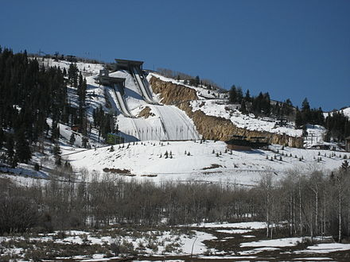
.

Tanger Outlets Park City:
Tanger Outlet Center has over 65 brand name outlet stores including Nike, Polo, Tommy Hilfiger, Fossil, Michael Kors, Under Armour, Brooks Brothers, and JCrew





