6 - 12 May 2019
TEAM MANAGERS
BOOKLET

The Team Managers Meeting will take place in the
Media Center on 1F of Yuanshen Stadium
on 6 May at 16:00hrs

All Team Managers are requested to attend this meeting

Teams without a Team Manager are advised to send one of
their athletes to the meeting

Please read this document upon receipt
and BRING it with you to the Team Managers Meeting

Version 1.0 April 27, 2019 11:30
On the occasion of the opening of the Hyundai Archery World Cup-Lujiazui, Shanghai 2019, Chinese Archery Association and the Organizing Committee, sincerely welcome all the participating archers, officials and all the distinguished guests to Hyundai Archery World Cup-Lujiazui, Shanghai 2019.

Deep gratitude goes to World Archery for authorizing Chinese Archery Association the honour to host this World Cup. I also express my sincere gratitude to Shanghai Sports Bureau, Pudong New Area People’s Government, the Organizing Committee, the sponsors, the volunteers and our media friends for their joint efforts and valuable contribution.

The world cup will provide a platform for all athletes to communicate, to enhance friendship and to learn from each other. We will unite and coordinate with members of world archery to promote the development of archery worldwide. May all the athletes perform well, display fine sportsmanship and get a satisfactory result.

Finally, I wish the Hyundai Archery World Cup-Lujiazui, Shanghai 2019 a complete success.

Liang Chun
President
Chinese Archery Association

Contents
Important dates for the outdoor season 5
Important Telephone Numbers 6
3. Technical aspects of the competition (ED + Chair of Judges) 7
3.1. Number of participants per category (Number of Member Associations: 40) 7
3.2. Competition programme 7
3.3 Practice 7
3.4. Equipment inspection: 8
3.5. Qualification round 9
3.6. Individual elimination round 9
3.7. Team and mixed team elimination round 10
3.8. Individual and team medal matches 10
3.9. Appeal procedure (Form attached) 11
4. Technical matters (ED + Chairman of Judges) 11
4.1. Timing control system 11
4.2. Results system 11
4.3 Rules that apply in this event 12
5. Logistical aspects (OC) 15
5.1. Transportation 15
5.2. Meals during the event 15
5.3. Top things to do in Shanghai 16
6. Protocol and ceremonies (OC) 17
6.1. Medal ceremonies 17
7. Medical related issues (Medical representative) 17
8. Clean Sport 17
8.1 Anti-Doping control 17
8.2. Alcohol test 17
9. Other matters of importance (WA ED) 17
Information about the Archery Venues 19
Appeal Form 23
Accreditation upgrade Form 24

Agenda of the Team Managers meeting
Roll call of all attending nations (ED)

Opening
• Brought to order by the World Archery Event Director (ED), Mr. C MARSH
• Introduction of the panel, by World Archery ED, Mr C. MARSH
• Welcome speech, by Organising Committee

2) Introduction of Officials (ED)
• Organising Committee members, by Mr Zheng Lixun
• Tournament Judges Commission, by the Chairman of Judges
• Director of Shooting, by the Chairman of Judges
• Jury of Appeal, by World Archery ED

3) Technical aspects of competition (ED + Chairman of Judges)
3.1. Number of participants per class
3.2. Competition programme
3.3. Practice-training
3.4. Equipment inspection
3.5. Qualification round & scoring information
3.6. Individual elimination round
3.6.1. Recurve
3.6.2. Compound
3.7. Team elimination round
3.7.1. Recurve team
3.7.2. Compound team
3.8. Individual finals round & team finals round
3.9. Appeal procedure (Form attached)

4) Technical matters (ED + Chairman of Judges)
4.1. Timing control system
4.2. Results system
4.3. Rules that apply in this event.
4.3.1. The ranking (Hyundai Archery World Cup & World Archery Ranking)
4.3.2. Dress regulations
4.3.3. Longines Prize for Precision
4.3.4. Athletes must have at least 6 arrows during Finals (Rule Book 3 – 13.2.1. – bullet point 3)
4.3.5. Individual alternate shooting (Rule Book 3 – 13.6.2.)
4.3.6. Individual shoot-off (Rule Book 3 – 14.5.2.2.)
4.3.7. Team shoot-off (Rule Book 3 – 14.5.2.3.)
4.4. Accreditation cards for 2019

5) Logistical Aspects (OC)
5.1. Transportation: venue, airport, etc.
5.2. Meals, during practice, qualification rounds, finals…

6) Protocol and ceremonies (OC)
6.1. Medal ceremonies and mixed zones

7) Medical related issues (Medical representative)

8) Clean Sport (Medical representative)
8.1. Doping control
8.2. Alcohol test

9) Other matters of Importance (World Archery ED)

10) Questions from Team Managers

11) Closure (ED)
11.1. Closure

Important dates for the outdoor season
Date: | Event: | Entry Deadline Type
22 January | 2019 Hyundai Archery World Cup – Medellin (COL) | Preliminary Entry
5 February | 2019 Hyundai Archery World Cup – Shanghai (CHN) | Preliminary Entry
20 February | 2019 Hyundai Archery World Cup – Antalya (TUR) | Preliminary Entry
4 March | 2019 World Archery Para Championships – ‘s-Hertogenbosch (NED) | Preliminary Entry
11 March | 2019 Hyundai World Championships – ‘s-Hertogenbosch (NED) | Preliminary Entry
1 April | 2019 Hyundai Archery World Cup – Medellin (COL) | FINAL Entry
2 April | 2019 Hyundai Archery World Cup – Berlin (GER) | Preliminary Entry
12 April | 2019 Olympic Test Event – Tokyo 2020 | Preliminary Entry
15 April | 2019 Hyundai Archery World Cup – Shanghai (CHN) | FINAL Entry
29 April | 2019 Hyundai Archery World Cup – Antalya (TUR) | FINAL Entry
10 May | 2019 World Archery Para Championships – ‘s-Hertogenbosch (NED) | FINAL Entry
19 May | 2019 Hyundai World Championships – ‘s-Hertogenbosch (NED) | FINAL Entry
4 June | 2019 World Archery 3D Championships – Lac La Biche (CAN) | Preliminary Entry
10 June | 2019 Hyundai Archery World Cup – Berlin (GER) | FINAL Entry
20 June | 2019 Olympic Test Event – Tokyo 2020 | FINAL Entry
12 August | 2019 World Archery 3D Championships – Lac La Biche (CAN) | FINAL Entry

Important Telephone Numbers
Competition Management
QU Yinan |  |  | +86 138 1093 6561
Hotel and Accommodation
Purple Mountain Hotel：Liza HUANG  Tong Mao Hotel: Lilian LU  Benjoy Hotel: Elaine PAN |  |  | +86 158 0057 5953  +86 158 2117 1310  +86 139 1718 7570
Transport Manager
WANG Qiping |  |  | +86 139 1677 3566
Medical Care
WANG Peng |  |  | +86 139 1673 0828
Technical Requirements & Field Manager
HOU Yun  CHEN Fei |  |  | +86 136 5191 9842  +86 135 2470 5685
Press Officer
SUN Yingjie |  |  | +86 150 2662 1985
World Archery Federation (WA)
Mr Chris MARSH (WA ED) |  |  | +41 79 739 8995
Tournament Judge Commission Chairman
Mr. Graham POTTS
Director of Shooting
WANG Jieyong
World Archery Judges |  |  | World Archery Asia Judges
Flemming SKJOLDBORG (Deputy Chair) |  |  | CHU Yik Fai Sunny Rachel
Shahrzad ALLAHYARI  Angelina CHAN  Rupesh KAR  Sunethra Senevirathne HENARATH PATHIRANNEHELAGE |  |  | Yu-Chiao Hsu
National Judges
CAI Ping | CHEN Na | CHEN Qingyan
FEI Lijun | HANG Kai | HOONG Mau Sui
HUO Ruiping | LI Xinping | LIN Zhijian
SHEN Yan | SHI Lei | SHI Shoubao
TANG Feng | YANG Xiaoyan | YE Hua
ZHAN Fengling | ZHANG Jianping | ZHENG Ye
ZHOU Ping
Jury of Appeal:
To be announced on the day of the Team Managers Meeting

WA Results & Technology Team:
Mr. Matteo PISANI

World Archery Communication:
Mr. Chris WELLS

World Archery Clean Sport Supervisor:
Ms. Anne SMITH

Points to clarify

3. Technical aspects of the competition (ED + Chair of Judges)

3.1. Number of participants per category (Number of Member Associations: 40)

Recurve Men |  | Individual: | 104 (1/48) | Teams: | 23 (1/12)
Recurve Women |  | Individual: | 79 (1/48) | Teams: | 18 (1/12)
Compound Men |  | Individual: | 68 (1/48) | Teams: | 15 (1/8)
Compound Women |  | Individual: | 58 (1/48) | Teams: | 13 (1/8)
 |  | MIXED Teams RECURVE: |  |  | 26 (1/12)
 |  | MIXED Teams COMPOUND: |  |  | 19 (1/12)
Updated April 27 2019

3.2. Competition programme
The latest competition programme will be provided 1 week prior to official practice on the World Archery website. Any official competition schedule will have the version number, date and time printed on it. Latest version of the Competition Schedule at the moment of writing the Team Managers Booklet is V1.0 (27 April 2019, 21:45 UTC).

3.3 Practice
- Training range is available from 4 May.
Saturday 4 – Saturday 11 | 09:00-12:00hrs and 13:30-16:30hrs
- Walking distance to the competition range and 3-5 km from official hotels.

Official Practice
- 09:00hrs – 12:00hrs for recurve women and recurve men.
- 13:30hrs – 16:30hrs for compound women and compound men.
- Shooting will be organized in AB-CD format.

Qualification round practice
- 3 ends of 4 minutes practice on the Field of Play for qualification to immediately follow once the field is reset.
- Non-competing athletes can use the practice field, walking distance of the qualification competition venue.
- Transportation is available for athletes between the qualification field, training range and official event hotels. Schedule will be displayed in the official event hotel lobbies.

3.4. Equipment inspection:
- Monday 6 May, during official practice.
- Located to the right of target 51, by the warm up range
- Teams will be announced in (English) alphabetical order by the DOS.
- All teams are to wear their team uniform and have their valid accreditation.
- Spare equipment must also be brought for inspection.
- Team managers are to check the details of their athletes such as, name, date of birth are correct beforehand.
- Inform the Judge if details are not correct and the Judge will inform World Archery Results Team.
- Instructions to use the tablet scoring system will be carried out if requested.

Athlete (back) Numbers:
- Athlete numbers will be issued on the day of the qualification round (with the score cards) during practice.
- Athlete numbers must be worn on the quiver or thigh, facing the waiting line while shooting.

The Environment:
- Team managers, please instruct your team members to use the litter bins located on the competition, practice ranges and common areas at all times.

Water:
- In an effort to aid the environment, water will be distributed using the familiar World Archery bottle deposit system.
- 2 tokens will be given to all accredited persons at registration. Two bottles of water will be given in exchange for 2 tokens.
- A new bottle of water will only be issued by the return of the empty bottle or with a token. If the empty bottle has been lost, please contact the Organising Committee in the LOC Office.
- Please make sure to give empty bottles back to the water station. Do not throw them in the trash bin. There is a refund and recycling system for all bottles and bins.
- Please use the trash bins provided and clear the area you have used on the FOP before leaving.

Non-Smoking
- This is a non-smoking event.
- Smoking is forbidden inside public buildings and all competition and training areas. This also includes electronic cigarettes, refer to book 3, Art.12.8.
- Smoking areas are indicated for those that do smoke.

3.5. Qualification round

RECURVE WOMEN and RECURVE MEN - 7 May morning
4 athletes per target in AB-CD format
70m Round (72 arrows)
COMPOUND WOMEN and COMPOUND MEN – 7 May afternoon
4 athletes per target in AB-CD format
50m Round (72 arrows)

3.6. Individual elimination round
- Compound women and compound men, it will be in the morning of the 8 May. Recurve women and recurve men, it will be in the afternoon of the 8 May.
- Target faces will NOT be changed after practice arrows. Please instruct your athletes to mark all arrow holes during practice.
- Matches will start as soon as the field is ready.
- Matches at the start of each session will begin on time. Proceeding matches will follow up on the immediate completion of the prior match. Athletes should be alert and prepared for their matches to start slightly earlier than scheduled.
- In case of a bye, athletes may be allowed to shoot on their own target, provided the competition schedule allows. If the competition schedule allows, no score will be recorded or displayed and athletes shooting their bye must respect the DOS timing and signals of the competition. Recurve athletes are permitted to shoot 3 sets of practice and compound athletes are permitted to shoot 5 ends of practice for their bye.
- Individual elimination rounds will start at the 1/48 elimination stage (104 athletes, or less, depending on entries) for Recurve Men. While Recurve Women, Compound Men and Compound Women will start at the 1/24 elimination stage (56 athletes in each category or less, depending on entries)
- The top 8 individual ranked athletes from the qualification round will progress directly to the 1/16 finals.
- Athletes ranked 9th to 104 position will shoot the 1/48 and 1/24 eliminations.
- There will be no alternate shooting during the preliminary elimination rounds.

3.6.1 Recurve elimination
- The sets system will be used for all individual, team and mixed team matches. Individual matches will consist of the best of 5 sets, (3 arrows per set) and the winner is the athlete to reach a minimum of 6 set points first. Team and mixed matches will consist of the best of 4 sets (6 arrows per team and 4 arrows per mixed team). The team that reaches minimum of 5 set points first will win the match. All matches, up to and including the semi-finals, will be shot simultaneously on the qualification range for the individual, team and mixed team events.
Book 1, 4.5.1.4 (Recurve)
- The Elimination Round, in which the top 104 athletes (mandatory for World Archery Championships) are seeded according to their positions in the Qualification Round (see match play chart Appendix 10 and Book 2, Appendix 1). Athletes shoot a series of matches in groups, each match consisting of the best of 5 sets of 3 arrows;

3.6.2 Compound Elimination
- Matches for all compound events will use the cumulative scoring, consisting of 5 ends of 3 arrows. All matches, up to and including the semi-finals, will be shot simultaneously on the qualification range for the individual, team and mixed team events.
Book 1, 4.5.1.5 (Compound)
- The Elimination Round in which the top 104 athletes (mandatory for World Archery Championships) are seeded according to their positions in the 50m Qualification Round (see match play chart Appendix 10 and Book 2, Appendix 1). Athletes shoot a series of matches in groups, each match consisting of 5 ends of 3 arrows;

3.7. Team and mixed team elimination round
- No alternating shooting
- Byes permitted from the 1/12, teams will be allowed to shoot on their allocated target, but no score will be recorded or displayed.

3.7.1. Recurve team
- Wednesday 8 May - 1/12 elimination phase
- Thursday 9 May - Starting at the 1/8 phase until the semi-finals
- Up to 4 sets of 6 arrows, 2 arrows per athlete (70 m, sets system)

3.7.2. Compound team
- Thursday 9 May - Starting at the 1/8 phase until the semi-finals
- 4 ends of 6 arrows, 2 arrows per athlete (50 m, cumulative scoring)

3.7.3. Recurve mixed team
- Wednesday 8 May - 1/12 elimination phase
- Friday 10 May – Starting at the 1/8 until the semi-finals
- Up to 4 ends of 4 arrows, 2 arrows per athlete (70 m, sets system)

3.7.4. Compound mixed team
- Wednesday 8 May - 1/12 elimination phase
- Friday 10 May – Starting at the 1/8 until the semi-finals
- 4 ends of 4 arrows, 2 arrows per athlete (50 m, cumulative scoring)

3.8. Individual and team medal matches
- Saturday 11 May - COMPOUND
- Sunday 12 May – RECURVE
- Finals to be staged at the Lujiazui Central Green Park.
- Venue for finals will have one “Practice field” and one “Warm Up” field.
- Warm-Up field:
  - 6 targets in the same direction to the FoP for the finals.
  - The area will have water, tents, chairs and tables.
  - Will be open 1 hour before the start of competition.
- Athletes are not permitted to use scopes on the finals FOP. Coaches will be provided a Vanguard scope by the coaches’ box on the main FOP.
- Vanguard are the official World Archery scope provided for the main finals field of play for coaches to use. Each scope will be fitted with a wired microphone and possibly a camera. These comments from coaches and athletes are for TV purposes. No sound will go out to the venue. Microphones will only be activated immediately when entering the FoP for the match and deactivated when the match is completed, while exiting the finals FoP. Coaches’ comments will be recorded for use in the TV highlights and on matches placed on www.archery.tv platform.

3.9. Appeal procedure (Form attached)
- An Appeal form is attached to this document (see attached after this chapter, Appendix 1).
- In case of an intent to appeal or an actual appeal, the times indicated on the Appeal form must be considered.
- Appeal forms should be given to the Chairman of the Tournament Judge Commission or to their deputy.
- A fee of US$50- (Euro 50.-) must be paid to the Chairman of the Tournament Judge Commission, for the appeal to be valid.
- If the appeal is upheld by the Jury of Appeal, the fee will be returned. In the case of the appeal being rejected, the fee will not be returned.

4. Technical matters (ED + Chairman of Judges)

4.1. Timing control system
- LONGINES Timing equipment will be used for timing and scoreboards.

4.2. Results system
- Qualification Round - scoring will be completed by athletes. One athlete records, on the official paper based score sheet, the scores of all other athletes on that target. At the same time, another athlete, on that same target, will enter all the scores of the athletes on that target into the scoring tablet. The other athletes should verify that all scores are written and entered correctly.
- Scorecards MUST be signed by both the athlete and the scorer, have all the totals mathematically correct with the 10s+Xs and X count fully completed. Any scorecards where the 10s+Xs and X count are not completed a “0” will be given for the total of 10s+Xs and X count for that athlete. Any score cards not signed or the score total is missing will result in disqualification.
- Elimination Round – scoring will be completed by athletes. One athlete/team records the arrow values of both athletes/teams on the paper score sheet. While at the same time, the other athlete/team inputs the arrow values into the scoring tablet. Both athletes/teams should verify that all scores are written and entered correctly before returning back to the shooting line.
- At the end of the match, the scorecard must be fully completed and signed by the athletes (or agent/judge in the case of finals) involved in the match.
- Scoring tablets will be used during the Qualification and Elimination Rounds, but not in the Finals. Mr. Matteo PISANI (World Archery Results & Technology Manager) is responsible for the results of the event.
- IMPORTANT NOTE: There will be internet access in the official hotels. Because of this we will not distribute any printed results and information. There will be no pigeon boxes on the field.

4.3 Rules that apply in this event
4.3.1. The rankings
- At the end of the event, the Hyundai Archery World Cup Rankings (https://worldarchery.org/world-cup-ranking) will be updated. The World Rankings (https://worldarchery.org/world-ranking) are updated every two weeks.

4.3.2. Dress regulations
- Athletes, officials and staff should wear the appropriate clothing having the correct appearance when on the field during competition. Open-toed shoes or camouflage clothing, accessories or archery equipment are not permitted.
- Athletes, team officials and technicians should wear their national team uniforms and sports shoes having the same appearance as per the division, following World Archery rules.
- During finals with TV coverage, undershirts, compression shirts or sleeves may be used on condition that they match the team uniform colours or are white. Under shirts and sleeve may include design, names or markings but the predominant colour should be white or the colour of the uniform.
- We would like to remind all teams that athlete names and country names or codes are mandatory on the back of their national team uniform shirts for athletes participating in World Archery major events.

4.3.3. Longines Prize for Precision
- The Longines Prize for Precision was launched in 2010. The two most precise athletes in a Hyundai Archery World Cup season will win the trophy, a Longines watch and a 5.000 Swiss Francs prize.
- In odd years, compound athletes shoot for the Longines Prize for Precision. In even years, recurve athletes compete for the prize. In 2019, compound male and female athletes are eligible to win the prize.
- Athletes shooting the most 10s during the Hyundai Archery World Cup individual qualifications and elimination matches as of the 1/16 eliminations of the Hyundai Archery World Cup stage are ranked. The highest-ranked athletes at the end of the season are awarded the prize.
- The race for the Longines Prize for Precision continues until the very last match at the Hyundai Archery World Cup Final!
- During an AWCS, one Longines watch will be awarded to the athlete who shoots the highest percentage of 10s during the competition (all arrows from qualifications and individual rounds will count) in a chosen category, per event, as follows:
  - Ties will be resolved on the basis of:
    - Highest number of Xs
    - If the ties persist, the highest ranked athlete after the matches wil be awarded with the watch
All athletes in the run are asked to be present at the last ceremony of the day the watch is awarded

- Medellin: | Recurve Men (KIM Woojin)
- Shanghai: | Recurve Women
- Antalya: | Compound Men
- Berlin: | Compound Women

4.3.4. Athletes must have at least 6 arrows during Finals (Rule Book 3 – 13.2.1.– bullet point 3)
- In the Finals Rounds (individual matches, alternating shooting,) each athlete shall shoot on a separate target butt and shall not go to the target to score and collect the arrows. Each athlete shall appoint an athlete’s agent who shall observe the scores recorded and withdraw the arrows. The arrows shall be returned to the athlete at the completion of every end/set after the second end/set;

4.3.5. Individual alternate shooting (Rule Book 3 – 13.6.2.)
- When there is individual alternating shooting, athletes competing shall go to the shooting line upon the 10 seconds alerting signal. At the end of the 10 seconds, one sound signal shall start the 20 second shooting period for the first athlete in the match. As soon as the first arrow is shot and the score is posted or the time runs out, the countdown clock for the opponent athlete is started to indicate the appropriate 20 or 30 second shooting period to shoot one arrow. The athletes of the match shall continue to alternate their shots following the countdown clock visual signal until each athlete has shot his three arrows or the athlete is sure he can no longer win the match. The losing athlete may then vacate the shooting line and congratulate the winner.
- If the time runs out a sound signal shall indicate to the other athlete/team the start of his/their time period or the end of the end/set.

4.3.6. Individual shoot-off (Rule Book 3 – 14.5.2.2.)
- A single arrow shoot-off for score;
- If both archers score a 10 (recurve) or X (compound) on their first shoot-off arrow, then the match would be considered a tie and a second shoot-off arrow will be needed to resolve the match;
- If the score is the same the arrow closest to the centre of the target face shall resolve the tie and if the distance is the same, successive single arrow shoot-offs, until the tie is resolved.
- If both athletes miss the scoring area of the target, both athletes will shoot an additional arrow.

4.3.7. Team shoot-off (Rule Book 3 – 14.5.2.3.)
- A three-arrow (two-arrow for Mixed Team) shoot-off for score, a single arrow by each team member;
- If the score is tied, the team with the arrow closest to the centre shall win;
- If still tied the second arrow (or third) closest to the centre shall determine the winner.
4.4 Accreditation cards rules for 2019 and the future
Rule Book 2 – 3.8 Accreditation
- 3.8.1.1. Proof of accreditation shall be carried at all times on the competition area and shall be shown on request of appropriate officials.
- 3.8.1.2. Only holders of appropriate accreditation shall be allowed onto the relevant parts of the competition area.

Accreditation Card  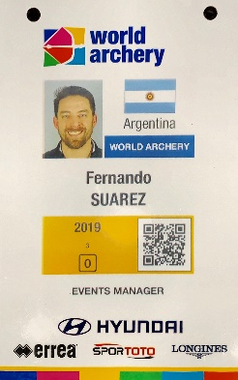 | Lanyard  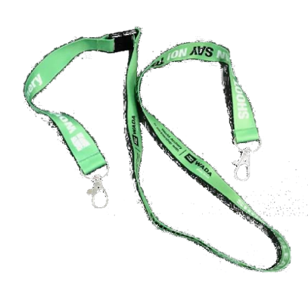
Accreditation card:
- Athletes and team officials, registered in WAREOS, will be issued a World Archery accreditation and lanyard. Please ensure all details are correctly entered in WAREOS.
- Only one accreditation will be issued, with a lanyard, for all the 2019 season. Athletes and team officials should bring their accreditation to all World Archery events such as, World Championships, Hyundai Archery World Cup stages and the Hyundai Archery World Cup Final.
- Accreditation will consist of, a photograph, full name, role, category/bow discipline, country of representation, individual World Archery ID code and access privileges.
- All accreditations will need to be validated and activated on site at each of the separate World Archery events.
- There is a QR code on all accreditations that will be scanned to enter and exit the competition areas.

Photographs:
- Will be taken on venue two days before official practice.
- For a valid photograph, persons are to smile and wear their official Member Association team uniform. No hats or sunglasses can be worn.
- Photos are used for both event accreditation and website biographies.
- Athletes and team official profile photographs expire after 24 months.
- Any athlete or official that desires to update their photograph in the system can go to the accreditation area to do so.

Lost/Damage/Replacement costs:
- For those persons that unfortunately forget to bring, damage or lose their accreditation, can purchase another accreditation from World Archery accreditation area at the event for the cost of 30 CHF (EUR/USD or local currency will be accepted, at a rate to be displayed on site).
Upgrade card:
- Upgrade cards are available for those teams that do not have a coach or team manager available on their team and wish to have a coach for their athlete/team’s match.
- An upgrade card can be allocated to another athlete or accredited person to perform the role of coach for a specific athlete at that particular event.
- Upgrade cards (serial numbered) are individually allocated/valid to an individual person for a particular event athlete/team. As soon as the athlete/team is out of the competition, the upgrade card is no longer active.
- For an upgrade card to be issued, an Accreditation Upgrade Form (AUF) needs to be completed and signed by the Team Manager, President or Secretary General of the Member Association of the athlete/team to be coached. This form can be completed in advance in WAREOS or on venue.
- Each upgrade cards costs 30 CHF (EUR/USD or local currency will be accepted, at a rate to be displayed on site).
- Remember, as stated in the World Archery rules, only 1 accredited team official per athlete is allowed with a maximum of 4 officials if a team has more than 4 athletes competing on the field of play.

5. Logistical aspects (OC)

5.1. Transportation
- Daily transportation information and schedules will be placed at the competition field and notice boards at all the official event hotels.

5.2. Meals during the event

- Meals will be served at the hotel restaurants according to the schedule below:
- Purple Mountain Hotel
Breakfast/Lunch/Dinner: The Collection, 2nd Floor
- Tong Mao Hotel
Breakfast/Lunch/Dinner: Seasons Cafe, 1st Floor
- Benjoy Hotel
Breakfast/Lunch/Dinner: VIP Hall, 1st Floor

- *Catering Times: Breakfast 07:00 - 10:00hrs
Lunch 12:00 - 14:00hrs
Dinner 18:00 - 20:00hrs

*Times will adjust to the competition schedule as and when required.
**Due to peak season in the hotels, please allow enough time for your meals.

- Coaches and Team managers who don’t have time to return to hotel for lunches can order lunch boxes at the hotel information desks a minimum of 24 hours before.

5.3. Top things to do in Shanghai
The following is a short list of the sights and attractions that Shanghai has to offer:
- #8. Peace Hotel - This magnificent hotel was built in 1929 and remained as one of the finest hotels in the world through the 1930's. Take a walk through the lobby, eighth-floor ballroom and up to the rooftop for a great view of the Bund and Nanjing Lu.
- #7. Jin Mao Tower - For a good overview of the city, there is no better spot than the top of Jin Mao Tower in Pudong. Home to the Shanghai Hyatt, it is a wonderful place to stay a few nights or just to visit for the spectacular view. The appropriately named Cloud 9 restaurant and bar sits on the top floor and lays claim to the title of highest bar in the world.
- #6. Xin Tian Di - Shanghai's most popular restaurant and bar district is a great example of the success of the urban renewal effort. Tourists and locals alike pack the streets day and night. Xin Tian Di is divided into the North and South Blocks. The South Block is the more modern of the two and is home to one of China's first major shopping centers as well as boutiques, restaurants and nightclubs. Shikumen architecture lines the streets in the North Block providing a contrast to the modernity of the South Block.
- #5. Yu Yuan Garden - In the center of Old Town, just southwest of the Bund, the Garden of Peace and Comfort offers an escape from the fast pace of the surrounding city. With 30 pavilions and over 5 acres, this 16th century garden can be explored for days. Of the many temples and halls, the Grand Rockery is the most popular. Two thousand tons of rare yellow stones are combined with rice glue to form a massive sculpture that stands 46 feet high.
- #4. Nanjing Lu - Nanjing Road is by far the most popular shopping street in Shanghai. Crowds jam the pedestrian walkway for shopping and sightseeing every day of the week. At night the neon lights shine like the Las Vegas strip. With hundreds of shops and restaurants there is something for everyone. It runs west to east from People's Park all the way to the Bund.
- #3. Jade Buddha Temple - Shanghai's most famous temple is known for its white jade Buddhas carved from a single slab of Burmese jade. Brought to Shanghai in 1881, the statues are housed in separate houses amongst beautiful jewels and stones. In addition there are also ancient carvings, paintings and precious Buddhist cultural relics.
- #2. Huangpu River Cruise - With so many different cruise options, there is no excuse not to enjoy at least a short river cruise. Cruises range from a quick 30 minutes to 4 hours. Along the way you will see the glory of Shanghai from a completely new perspective. The Bund, Jin Mao Tower, the Oriental Pearl TV Tower and Huangpu Park are just a few of the many sights to be seen. Some evening cruises also include dinner under the glittering lights of Shanghai's skyscrapers.
- #1. The Bund - This famous waterfront has been Shanghai's center since the mid-1800's. It offers a taste of the past with the colonial structures along the promenade and a view of the future across the river in Pudong. The city's historical landmarks as well as new 21st century structures can all be seen along the 1 mile walk. It can get extremely crowded during the day, so try to see it in the early mornings along with the locals doing tai-chi or at night under the glow of all the buildings.

6. Protocol and ceremonies (OC)

6.1. Medal ceremonies
- All athletes involved in the ceremonies are requested to go to the gathering point by the athletes’ entrance to the main FoP, equipment can be stored in the staging area until the end of the corresponding victory ceremony.
- Bronze medal winners are requested to be present at the finals venue gathering point of the Award Ceremony, 10 minutes before the ceremonies are due to start.
- Medal ceremonies will be conducted immediately after the conclusion of each gold medal match of each category during the days of the finals (please check the competition schedule).
Mixed zone and press conferences:
- Interviews will take place at the Mixed Zone and athletes will be requested to pass through the mixed zone to speak with the media.

7. Medical related issues (Medical representative)
- First Aid services will be available during training days from 4– 5 May. Ambulance and First Aid Services will be available from 6-10 May in the west area of Yuanshen Sports Center and then from 11-12 May at the Lujiazui Central Green (Finals Venue).
- A doctor and a nurse are available on site for any emergency.
- In case of emergencies in official hotels, please inform the contact person in each hotel or Mr. WANG Peng who is managing medical care operations.
- East Hospital is the official hospital and a green channel will be opened for this event.

8. Clean Sport

8.1 Anti-Doping control
- Anti-Doping control will follow World Archery rules (Hyundai Archery World Cup and World Ranking events).
- Athletes should bring their passports and/or accreditation cards to the anti-doping control station if selected for a test.

8.2. Alcohol test
- Athletes and officials should also be available for random alcohol testing during the competition, following World Archery rules.

9. Other matters of importance (WA ED)
- Accreditation cards must be in your person at all times in the practice and competition areas.
- Only athletes scheduled to compete at certain stages of the event are permitted on the Field of Play, together with one coach/official.
- In order to improve the standard of our events, athletes and team members are kindly requested to complete the online event evaluation questionnaires when they receive the email from World Archery.
- Please remember not to eat food outside of the hotel since quality cannot be guaranteed.

Internet access and additional hotel charges:
- Internet access will be free of charge in the rooms and lobby of official hotels.
- All other hotel expenses including laundry and minibar, etc will be covered by the participants themselves.

10. Questions from Team Managers

11. Closure (ED)
- Closure

Information about the Archery Venues
- Yuanshen Sports Center- QUALIFICATION AND ELIMINATIONS:
655 Yuanshen Rd, YuanShen TiYu ZhongXin, Pudong Xinqu, Shanghai, China
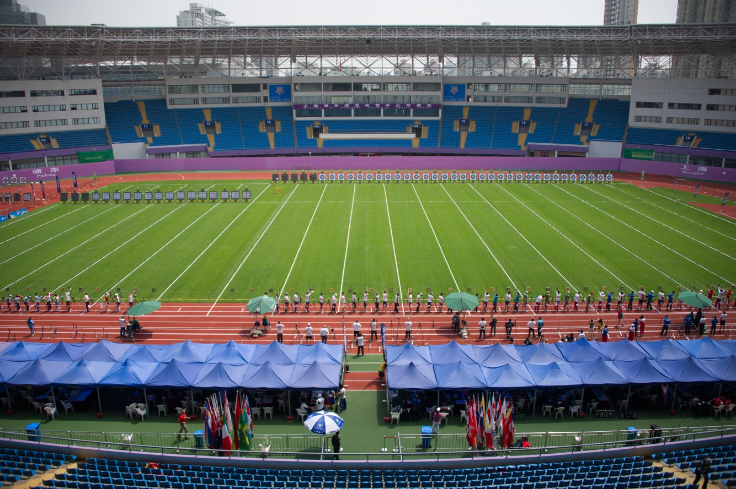

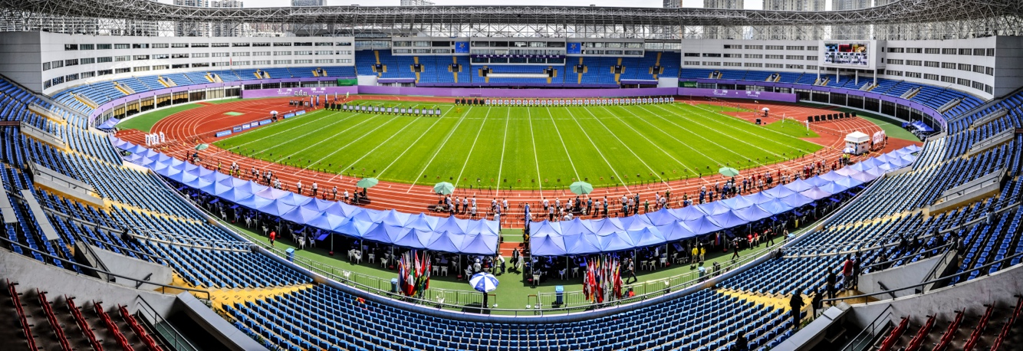

ARCHERY VENUE FOR FINALS:
- Lujiazui Central Green
Lujiazui, Pudong, China
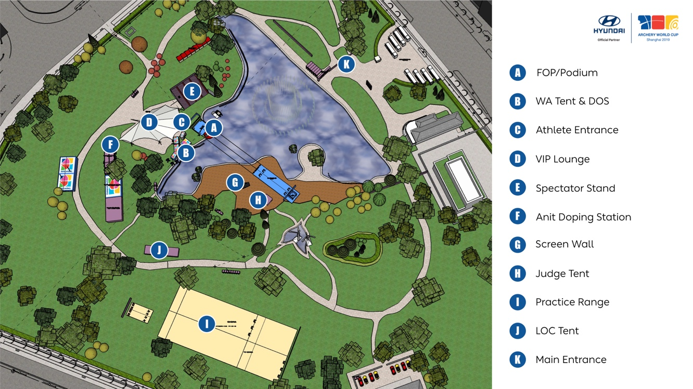

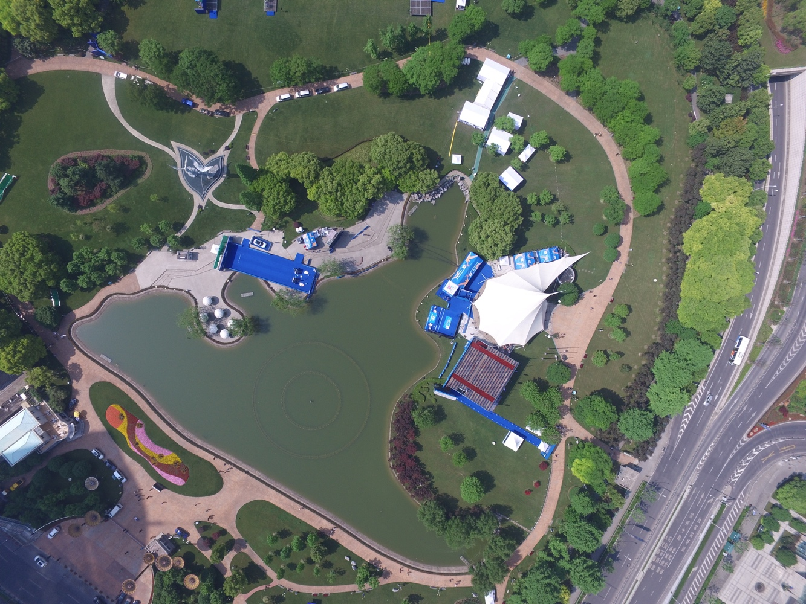

TEAM MEMBER NOMINATION FORM

National Team: …....................................................
Recurve Women:
1. …................................................................................
2. …................................................................................
3. …................................................................................
athlete NOT in the team: …...........................................
Recurve Men:
1. …................................................................................
2. …................................................................................
3. …................................................................................
athlete NOT in the team: …...........................................
Compound Women:
1. …................................................................................
2. …................................................................................
3. …................................................................................
athlete NOT in the team: …...........................................
Compound Men:
1. …................................................................................
2. …................................................................................
3. …................................................................................
athlete NOT in the team: …...........................................
Name and signature of Team Official:

…....................................................................................................
The results of the 3 highest scoring members of the team, per discipline and gender will automatically be used for the team events. If Team Managers wish to use other athletes of the team, pleased use this form to name the athletes that will be competing in the team event.

Forms to be given to the World Archery Results Manager or Chairman of the Judges Commission at least 1 hour before the start of the team competition (1/12 elimination round - RECURVE) on 8 May; (1/8 elimination round - COMPOUND) on 9 May.
MIXED TEAM FORM
MEMBER NOMINATION FORM

National Team: …....................................................

RECURVE Mixed Team:
1. …...................................................................
2. …...................................................................

COMPOUND Mixed Team:
1. …..................................................................
2. …..................................................................

Name and signature of Team Official:

………………………………………………………………………………………………………..

The results of the highest scoring male and female members of the team, will automatically be used for the mixed team event. If Team Managers wish to use other athletes of the team, pleased use this form to name the athletes that will be competing in the mixed team event.

Forms to be given to the World Archery Results Manager or Chairman of the Judges Commission at least 1 hour before the start of the mixed team competition (1/12 elimination round or equivalent first round) on 8 May.

Appeal Form
Appeal Fee
- USD50
- CHF50
- EUR50
This is an intention of Appeal 
This is an appeal from 
(please tick appropriate box)
❒ Team Manager of the following country: ___________________________________
❒ Name of the Team Manager: ___________________________________________
❒ Team (please name country) : __________________________________________
❒ Individual person (name) : _____________________________________________
❒ Other (please specify) : _______________________________________________
This appeal is against: __________________________________________________
Description of Appeal or Protest:
------------------------------------------------------------------------------------------------
------------------------------------------------------------------------------------------------
------------------------------------------------------------------------------------------------
------------------------------------------------------------------------------------------------
I believe this action is against the following rules (state article if known): ____________

Signature: ________________________ Print Name: ______________________

Article 3.13.3.1:
An intention to appeal when it might affect the progression of an athlete from one stage of the competition to the next, shall be expressed in writing and lodged with the chairperson of the Tournament Judge Commission within five minutes of the end of the relevant round or match, whichever applies. During the Finals of match play rounds, the notice of intent to file an appeal shall be given within five minutes of the end of the match, or prior to the start of the next match, whichever is first.

Article 3.13.8:
Jury decisions shall be minuted and reported to the appellant, the chairperson of the Tournament Judge Commission and the organisers before the beginning of the next stage of the competition or before the awarding of prizes.

3.13.4
Amount paid is reviewed and determined by the World Archery Executive Board on an annual basis.

Received on: ______/_______/_______ Time: ________________________
by Chair Person of the Tournament Judge Commission

Signature: _____________________ Name in printing: _______________________

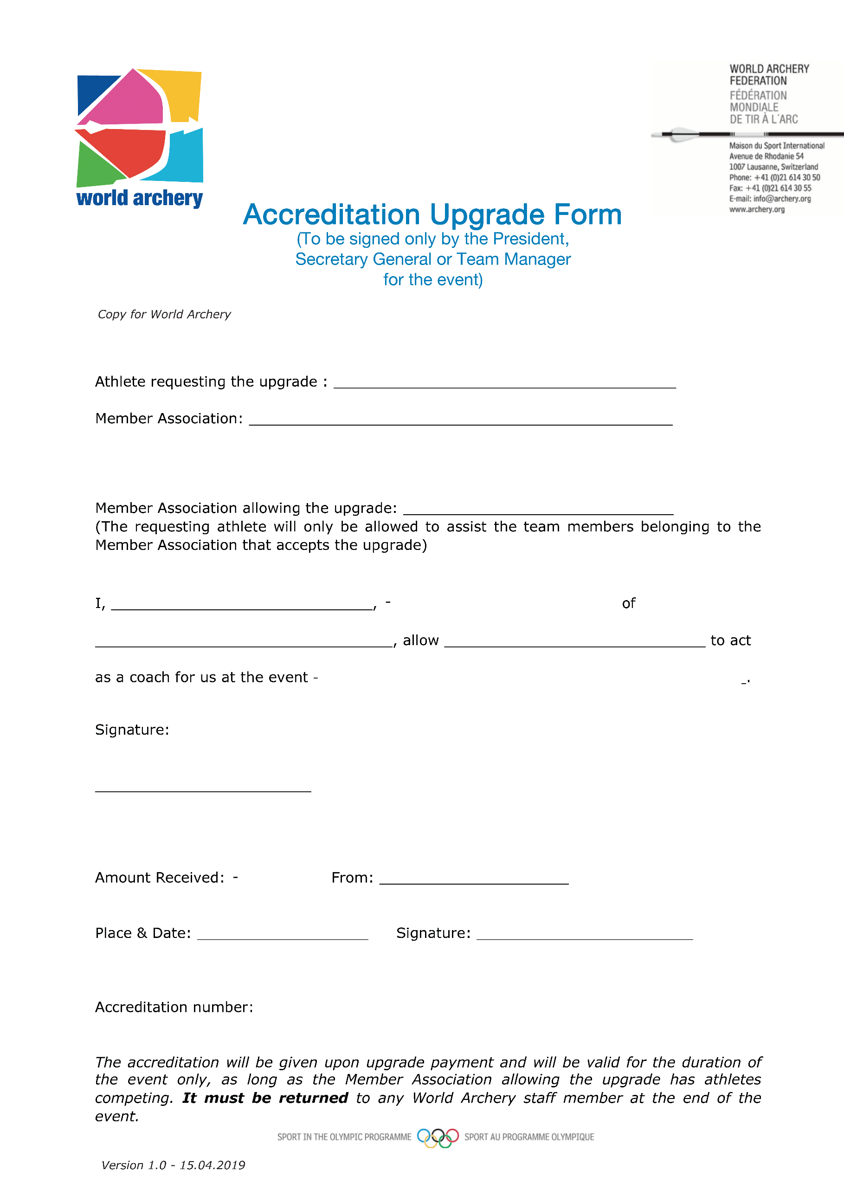
Accreditation upgrade Form

