TO ALL World Archery Member Associations

Dear President,

As Chairman of the Local Organizing Committee (LOC) for the 2nd stage of the HYUNDAI ARCHERY WORLD CUP which will be held in Antalya-TURKEY on 11 – 17 May 2020, I would like to invite and welcome your Association to participate in our event. This competition will be organized following the Hyundai World Cup rules for 2020, in both divisions: Recurve and Compound.

Important Dates:

Please find enclosed the necessary details concerning the registration, organization and participation to this event. We kindly ask you to return within the stated deadlines:

- Start date for online registration WAREOS 27 February 2020
- Preliminary Entries 27 March 2020
- Final Entries 21 April 2020
- Extra Penalty Starting Date 08 May 2020
- Hotel Reservation 05 April 2020
- Transportation 05 April 2020
- Visa Support 05 April 2020
- Final Hotel Reservation & Payment 21 April 2020
- Full refund cancellation deadline 08 May 2020

We hope you and your team will enjoy your stay in Antalya, where you will experience Turkish hospitality at its best.

We hope to see you in Antalya.
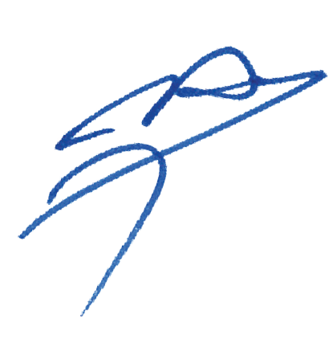
Sincerely yours,

Husnu KOCAOGLU
Chairman of the Organizing Committee
PRELIMINARY PROGRAMME

10 May 2020  Sunday | Arrival of participants  Practice field and local transportation available
11 May 2020  Monday | Official Practice  Equipment Inspection  Team Managers Meeting
12 May 2020  Tuesday | Qualification Round for Recurve and Compound  (Recurve 70m Round and Compound 50m Round)
13 May 2020  Wednesday | Individual Eliminations  (Recurve and Compound)
14 May 2020  Thursday | Individual Eliminations  Team Eliminations  (All Categories)
15 May 2020  Friday | Mixed Team Eliminations  (All Categories)
16 May 2020  Saturday | Finals – COMPOUND
17 May 2020  Sunday | Finals – RECURVE
18 May 2020  Monday | Departure of Teams

NOTE:
This preliminary programme could be changed according to number of participants and TV requirements. All changes will be published and distributed to all participants in good time
PRELIMINARY & FINAL REGISTRATION
All entries, accommodation reservations, transport needs, flight arrival/departure information and visa invitation letter requests are to be completed using WAREOS.

The World Archery Online Registration System (WAREOS): http://extranet.worldarchery.org has been updated to handle the entire registration process for this event. No entry forms, hotel reservations or transportation forms will be accepted as all information is to be entered into WAREOS.

In order to use WAREOS, please login on http://extranet.worldarchery.org with your Username and Password assigned by World Archery. After entering WAREOS, please select the event from the list, to register your athletes. Select/press the “Entries” button to see the list of categories in the event. Select/press the “category” to enter the athlete and official numbers/details participating for that event. A "WAREOS User Manual" can be downloaded in PDF format (English), upon login.

Contact Ms CECILE TOSETTI (ctosetti@archery.sport) in the World Archery Office with any questions regarding technical problems on WAREOS. For any question regarding the organisation of the event (transport, accommodation, meals etc.) please contact directly to the LOC.

A maximum number of 4 athletes per country is allowed to be registered into each category of the event. Preliminary entries should be completed using WAREOS.

Start date for online registration using WAREOS 27 February 2020
End of Preliminary registration using WAREOS: 27 March 2020
End of Final registration using WAREOS: 21 April 2020

Please respect the stated deadlines.

Member Associations should only use WAREOS to make any changes/amendments to their entries and will be able to do so at any time. Any changes made in WAREOS an email will instantly be automatically sent to the Organising Committee and Member Association with the updated information.

However, any changes that are made after the deadlines specified or if entries differ by more than 4 athletes from the preliminary entries, the following penalty fees will automatically be applied.

Penalty fees to be paid to Organising Committee: | Cost (EUR):
Entries made after the entry deadline dates. | 45 per entry
If final entries differ from the preliminary entries by more than 4 athletes/officials. | 140 per entry
When no preliminary entries were made before the deadline date but then submit final entries. | 140 per entry

Penalty Fee to be paid to World Archery: | Cost (CHF):
Lost accreditation. | 30 each
Changes made to the athlete and/or team official names after the final entry deadline date and within 3 days prior to the start of the event. | 50 each change

NOTE: CHF currency exchange rates will be those on the date of the event.

Member Associations that have penalty fees outstanding from 2019 will need to have paid these penalty fees before being eligible to enter and compete.

Any entries received less than 3 days before the team managers meeting for a Hyundai Archery World Cup or World Championships will be refused if no preliminary entry and/or final entry are made prior. This decision cannot be appealed by the teams and is fully compliant with the current World Archery rules, article 3.7.1.2. Entries received after the deadlines, are subject to penalties as clearly stated in the rule book and the invitation documents of World Cups and World Championships. A Member Association that has made final entries in WAREOS and does not participate will be invoiced for the number of entries entered in the system, unless they have informed World Archery and the OC in writing at least one week prior to the event that they are unable to attend.

ACCOMMODATION & GENERAL INFORMATION
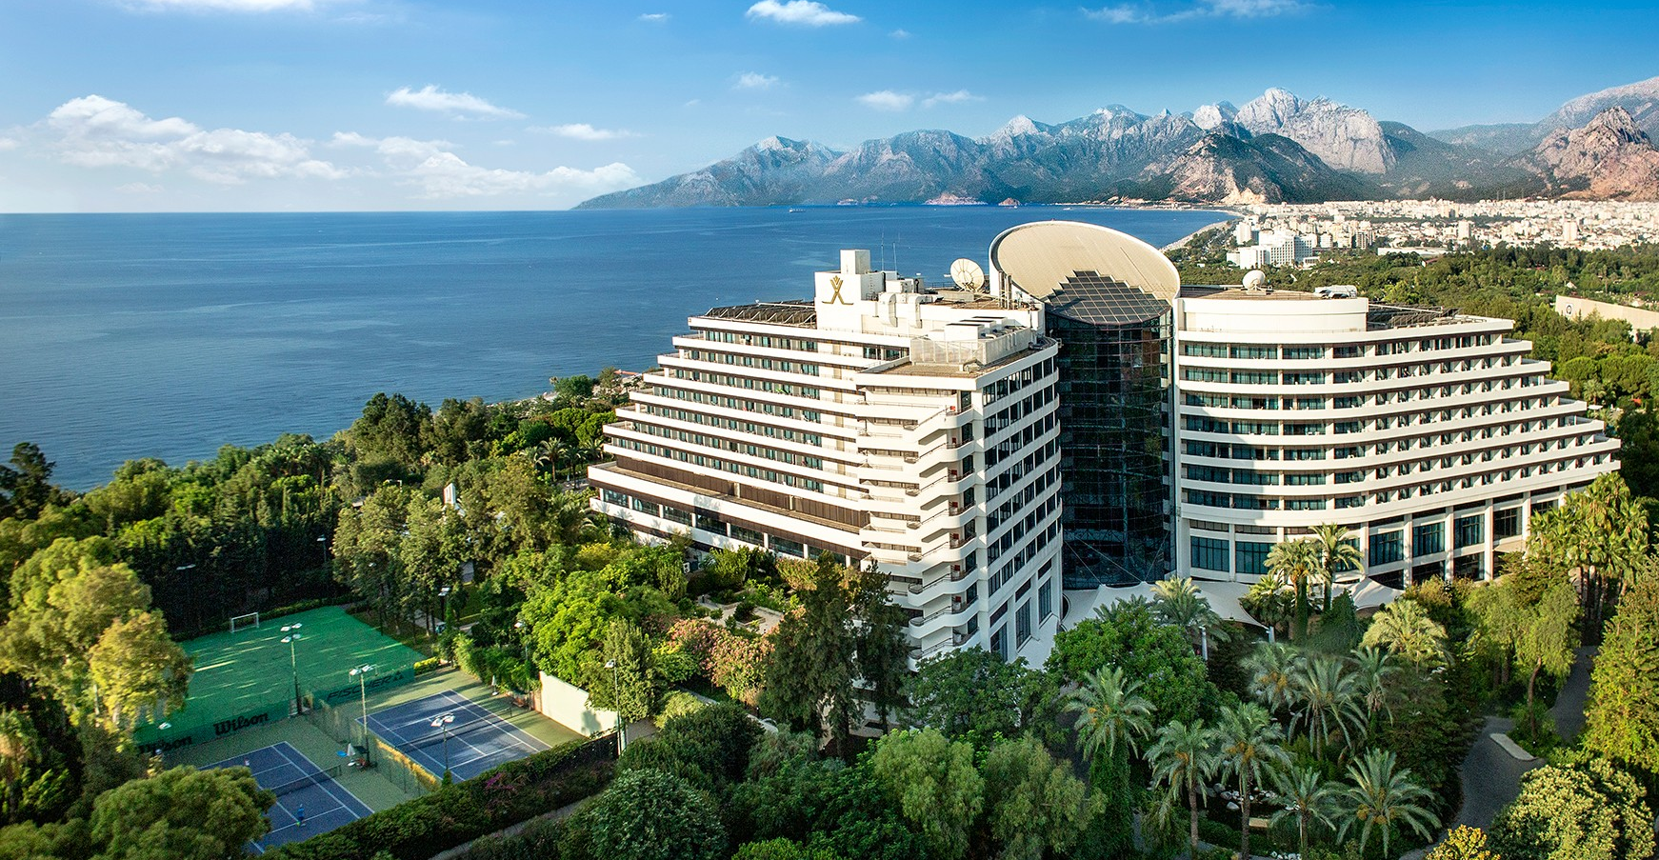
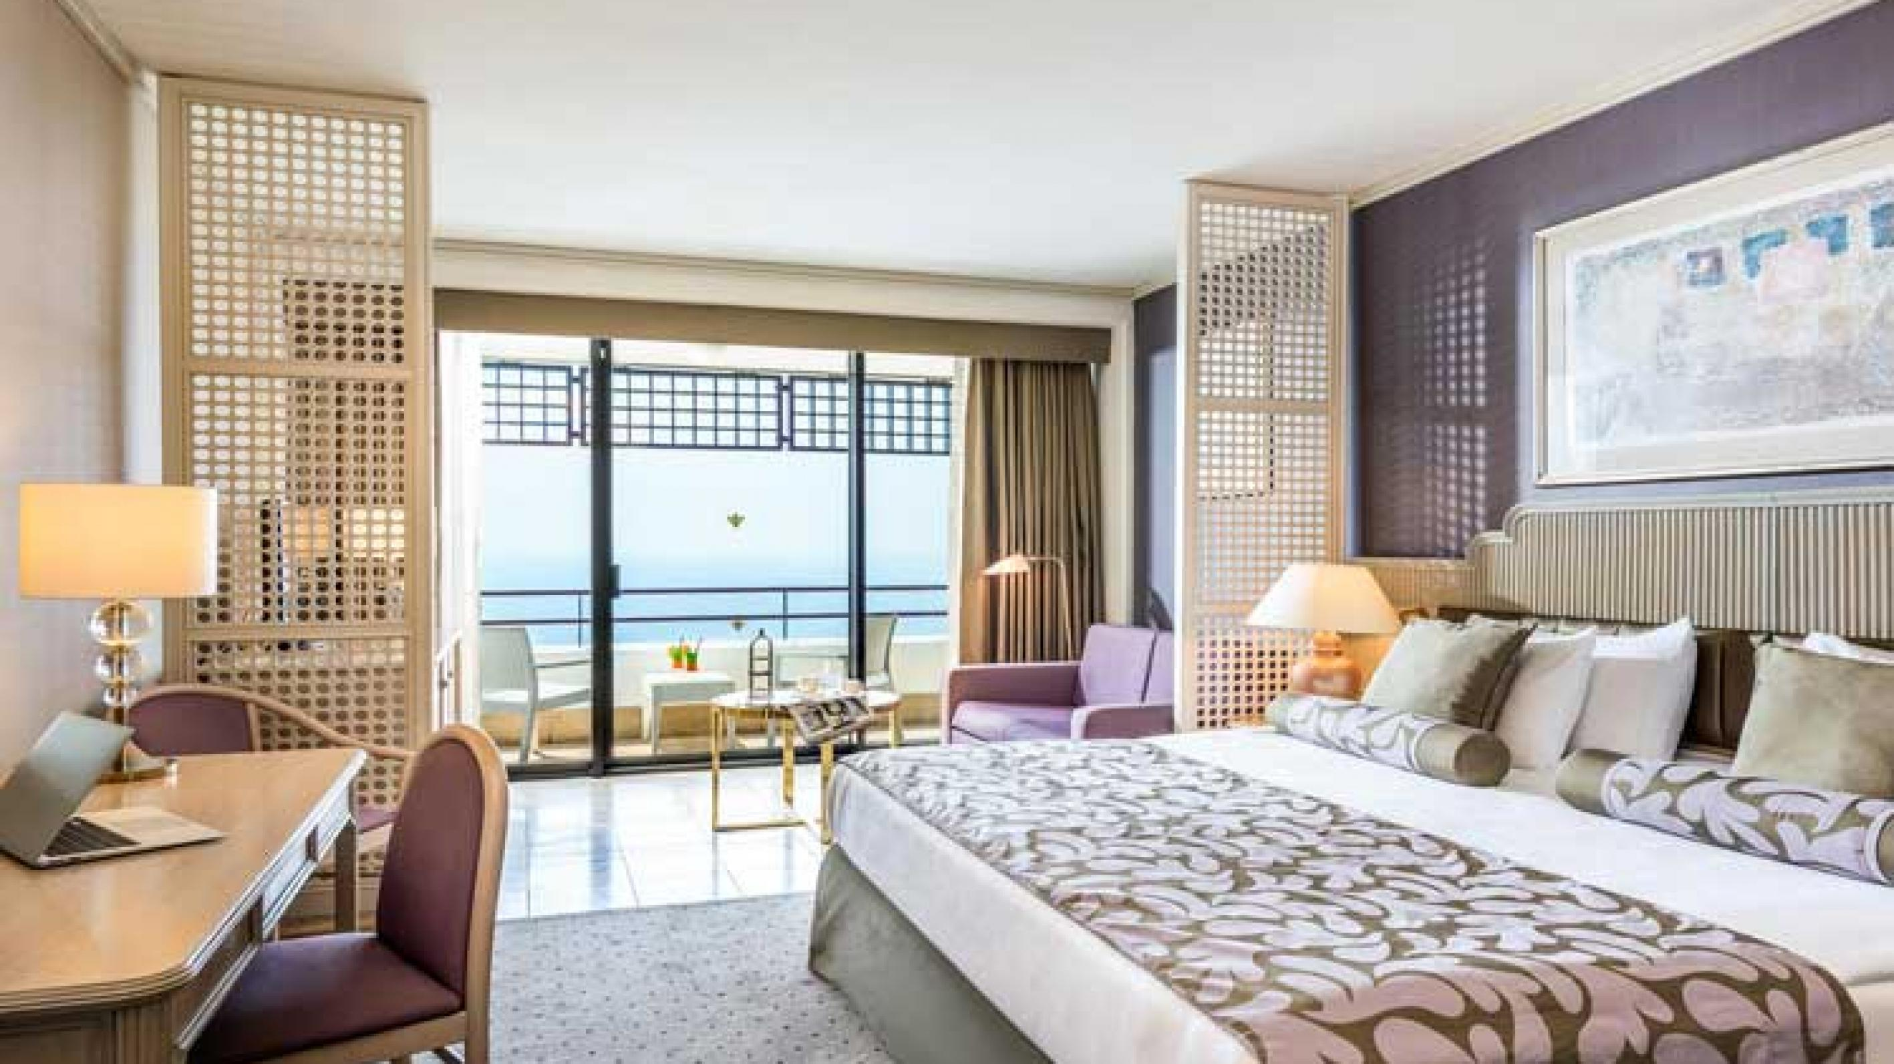
- Rixos Downtown Hotel (5 Star)

- Single Room Price : 190,00 €
- Number of Rooms : 50 Single Room
- Double / Twin Room Price : 285,00 €
- Number of Rooms : 150 Double / Twin Rooms
- Board Plan : Full Board
- Check – in from : 09 May 2020
- Hotel website : https://downtownantalya.rixos.com

- Porto Bello Hotel Resort & Spa (5 Star)
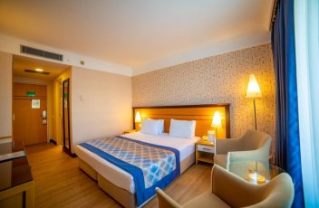
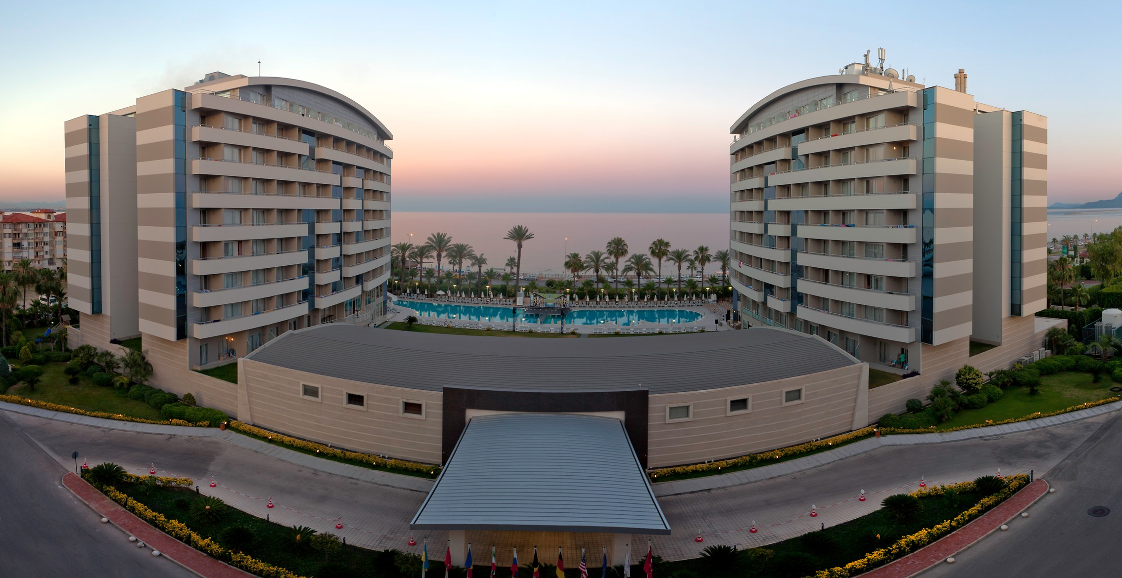
- Single Room Price : 160,00 €
- Number of Rooms : 40 Single Room
- Double / Twin Rooms : 220,00 €
- Number of Rooms : 110 Double / Twin Room
- Board Plan : Full Board
- Check – in from : 09 May 2020
- Hotel website : http://www.portobello.com.tr

The official hotels are Rixos Hotel Downtown and Porto Bello Hotel Resort & Spa. Hotels will be given on a “first come, first serve basis”. Accommodation costs will include “full board” (breakfast, lunch and dinner including with non–alcohol drinks). In addition, tea, coffee and 0.5liter water is available, from 10:00 to 22:00hrs.
Room rates specified are per room, per night, which includes service charge and VAT.

Transport from/to Antalya Airport is 30 Euros per person. A daily shuttle service is free of charge only for those persons accommodated in the Rixos Hotel Downtown and Porto Bello Hotel Resort & Spa.

Teams who book their own accommodation will be charged a double entry fee.

- Reservations should be made before 05 April 2020
- Final Hotel Reservation & Transportation before: 21 April 2020.

Important Note:
Please refer to the accommodation pages below for detailed hotel information. Please complete all necessary sections in WAREOS and make full payment for entries and accommodation by the specified deadlines.

Participants who book their accommodation in non-official hotels will need to pay a double entry fee. In addition, the LOC will not be responsible to provide any event information at this hotel or provide transportation to the venues.

Teams that book non-official accommodation will need to register at the accreditation desk no later than the day before official practice day. Failing to do so will result in no changes being made to the entry list and it is likely that participation in the event will be refused if registration is not completed in time.

ENTRY AND TRANSPORTATION FEES
ENTRY FEES:
Individual: | 230 EUR per athlete
Officials: | 115 EUR per person
Temporary Upgrade:  For athletes wishing to be a coach temporarily | 30 CHF per accreditation

There are no entry fees for teams.

TRANSPORTATION FEES
Transportation fee is 30 Euros (Round Trip) for all participants.

NON-OFFICIAL ENTRY FEES:
(If Member Associations prefer to have their team stay in a non-official hotel)
Individual: 460 EUR per athlete
Officials: 230 EUR per person

PAYMENT CONDITIONS:
Total entry and transportation fees will be paid to the Organizing Committee via a bank transfer using the account details below:

BANK ACCOUNT :ANTALYA OKÇULUK İHTİSAS SPOR KULÜBÜ DERN.
BANK :AKBANK T.A.S
ACCOUNT NO :0139992
SWIFT CODE :AKBKTRIX
IBAN :TR 44 0004 6003 0403 6000 1399 92

NOTE: Bank transfer fees are under the sender’s responsibility. Credit card and travel check will not be accepted.

Cancellations & Changes
All cancellations and changes must be made through WAREOS:
- Cancellations received, in writing before 08 MAY 2020 a full refund of the deposit payment will be made.
- Cancellations received after 08 MAY 2020 no refund will be given.
- Refunds will be processed after the event.
- Name changes to team officials or athletes (same category and division) will be accepted up to 17:00hrs, two (2) days before official practice without any additional charge or penalty fees.
- Should flight arrival details change last minute, please contact the Organizing Committee using the details indicated in the Team Managers’ Booklet.
- If a participant’s arrival is later than the original scheduled arrival date, the room charges will start from the dates of the original booking made by the Member Association.
- An email will automatically notify the Organising Committee and Member Association of any changes made in WAREOS.

ADDITIONAL INFORMATION
Transportation
Transportation will be provided from/to ANTALYA airport to the official hotels, from two days before the official practice day and until two days after the closing day. Local transport will be available between official hotels, practice and competition venues. Transport timetables will be confirmed.

Training
A training field will be available starting on 09 MAY 2020 at the Konyaaltı Atatürk Stadium located approximately 20 minutes from the official hotels.

Weather
Temperatures in May are expected to range between 20 and 28 degrees Celsius. The average in the last few years has been 25 degrees Celsius. There are chances of rain, mainly in the evenings.

Media Registration
Media representatives can apply for registration by emailing info@archery.org

Internet
Will be available in the official hotels for free of charge (in hotel rooms and in the lobby). There will also be Wi-Fi available for access to results and internet on the competition venue.

Water
Bottled water will be available at the qualification and practice venues.

Visa
All participants who need an entry visa to TURKEY, will be required to complete the Visa Support sections in WAREOS by no later than 05 April 2020.

It is the applicants’ responsibility for supplying the necessary information, ensuring all details are up to date, correct and submitted by the deadlines specified.

In addition, all participants that require a visa are kindly requested to supply a copy of their latest/valid passport. Copies of each application can be uploaded on WAREOS. All passport copies and personal details entered/uploaded to WAREOS will be held securely and in the strictest of confidence and not shared with other parties.

LOC CONTACT
Name: Sirer AYDIN
Email: sireraydin@gmail.com
Language: English
Phone number with international extension: +90 530 212 10 79

