TO ALL World Archery Member Associations
Dear President,

As Chair of the Local Organising Committee (LOC) of the first stage of the Hyundai Archery World Cup to be held in Guatemala City - Guatemala on 19-25 April 2021, I would like to invite you all to be part of one of the most important archery events to take place in the Americas in 2021.

Guatemala is a country with extraordinary cultural and natural richness and with a privileged geographical location. It is known as the heart of the Mayan World. Guatemala is the country of the “Eternal Spring” which makes its climate pleasant and enjoyable.

The richness of colors in Guatemalan crafts and its regional costumes, the hospitality of its people, the beauty of the landscapes that frame lots of volcanoes, mountains, rivers and lakes, make Guatemala a magical country.

Guatemala is a city capable of managing world class events and receiving participants from all parts of the world. We are sure that Guatemala City will stay in the heart of all the athletes who visit us.

Welcome to this magical, mystical and ancestral country. We hope you are ready to have an unbelievable experience.

Sincerely yours,

Federico Guillermo Paiz Madrid
President Organizing Committee

Important Dates:

Please find enclosed information regarding the details of this event and how to complete registration. To register participation, please complete all the necessary sections in WAREOS within the deadlines listed below:

Summary of deadlines:

- Start date for online registration WAREOS 18 November 2020
- Preliminary Entries 19 January 2021
- Final Entries 28 March 2021
- Extra penalty starting date 16 April 2021
- Hotel Reservation 19 January 2021
- Transportation 19 February 2021
- Visa Support 19 February 2021
- Final Hotel Reservation & Payment 19 February 2021
- Full refund cancellation deadline 28 March 2021

Looking forward to welcoming you in Guatemala City, Guatemala.

PRELIMINARY PROGRAMME

18 April 2021  Sunday | Arrival of participants  Practice field and local transport available
19 April 2021  Monday | Official Practice  Equipment Inspection  Team Managers Meeting
20 April 2021  Tuesday | Qualification Round  (Recurve 70m Round and Compound 50m Round)  Mixed Team Eliminations
21 April 2021  Wednesday | Individual Eliminations  (Recurve and Compound)
22 April 2021  Thursday | Individual Eliminations  Team Eliminations  (Recurve and Compound)
23 April 2021  Friday | Mixed Team Eliminations  (Recurve and Compound)
24 April 2021  Saturday | Finals – Compound
25 April 2021  Sunday | Finals – Recurve
26 April 2021  Monday | Departure of teams

NOTE: This preliminary programme is subject to change according to participation and TV requirements. All changes will be published and distributed in good time.
PRELIMINARY & FINAL REGISTRATION
All entries, accommodation reservations, transport needs, flight arrival/departure information and visa invitation letter requests are to be completed using WAREOS.

The World Archery Online Registration System (WAREOS) at http://extranet.worldarchery.org now handles the entire registration process for this event. No entry forms, hotel reservations or transportation forms will be accepted; all information must be entered into WAREOS.

Member associations can login to WAREOS at http://extranet.worldarchery.org with the username and password assigned by World Archery. After entering WAREOS, selecting the event from the list will allow a member association to register their athletes. Select/press the “Entries” button to see the list of categories in the event. Select/press the “category” to enter the athlete and official numbers/details participating for that event. A WAREOS User Manual can be downloaded in PDF format (English) upon login.

Contact Ms CECILE TOSETTI (ctosetti@archery.sport) in the World Archery Office with any questions regarding WAREOS.

A maximum number of 4 athletes per country can be registered into each category of the event. Preliminary entries should be completed using WAREOS.

Start date for online registration using WAREOS 18 November 2020
End of Preliminary registration using WAREOS: 19 January 2021
End of Final registration using WAREOS: 28 March 2021

Please respect the stated deadlines.

Member Associations can only use WAREOS to make any changes or amendments to entries and will be able to do so at any time. An email will automatically notify the Organising Committee and Member Association of any changes made in WAREOS.

Any changes that are made after the deadlines specified or if entries differ by more than 4 athletes from the preliminary entries, the following penalty fees will automatically be applied.

Penalty fees to be paid to Organising Committee: | Cost (USD):
Entries made after the entry deadline dates. | 50 per entry
If final entries differ from the preliminary entries by more than 4 athletes/officials. | 150 per entry
When no preliminary entries were made before the deadline date but then submit final entries. | 150 per entry

Penalty Fee to be paid to World Archery: | Cost (USD):
Lost accreditation. | 30 each
Changes made to the athlete and/or team official names after the final entry deadline date and within 3 days prior to the start of the event. | 50 each change

NOTE: CHF currency exchange rates will be those on the date of the event.

Member Associations that have penalty fees outstanding from 2020 will need to have paid these penalty fees before being eligible to enter and compete.

Any entries received less than 3 days before the team managers meeting for a Hyundai Archery World Cup or World Championships will be refused if no preliminary entry and/or final entry are made prior. This decision cannot be appealed by the teams and is fully compliant with the current World Archery rules, article 3.7.1.2. Entries received after the deadlines, are subject to penalties as clearly stated in the rule book and the invitation documents of World Cups and World Championships. A Member Association that has made final entries in WAREOS and does not participate will be invoiced for the number of entries entered in the system, unless they have informed World Archery and the Organising Committee in writing at least one week prior to the event that they are unable to attend.
ACCOMMODATION & GENERAL INFORMATION

Clarion Suites– Four Star Hotel

The Clarion Suites Hotel has the largest and most comfortable rooms in Guatemala

- Single Room price: USD 160.00 per room
- Number of rooms: 20
- Double/Twin Room price: USD 270.00 per room
- Number of rooms: 50
- Board plan: breakfast- lunch (will be served at the shooting range)
- Check-in from 14:00 hrs.
- Late check-out 12:00 hrs.
- Website: www.clarionguatemala.com
- Photo

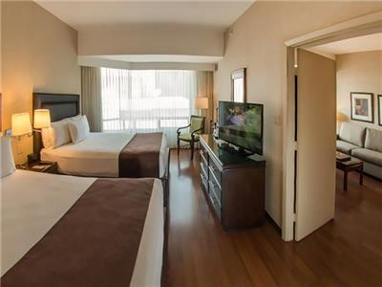
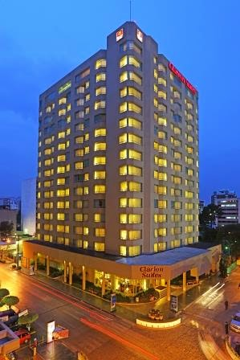

Barceló – Four Star Hotel

Barceló is located near business centers, banks and 2 km. away from the Airport.

- Single Room price: USD 150.00 per room
- Number of rooms: 50
- Double/Twin Room price: USD 260.00 per room
- Number of rooms: 125
- Board plan: breakfast- lunch (will be served at the shooting range)
- Check-in from 15:00 hrs
- Late check-out 12:00 hrs.
- Hotel website: www.barcelo.com
- Photo (hotel & rooms)
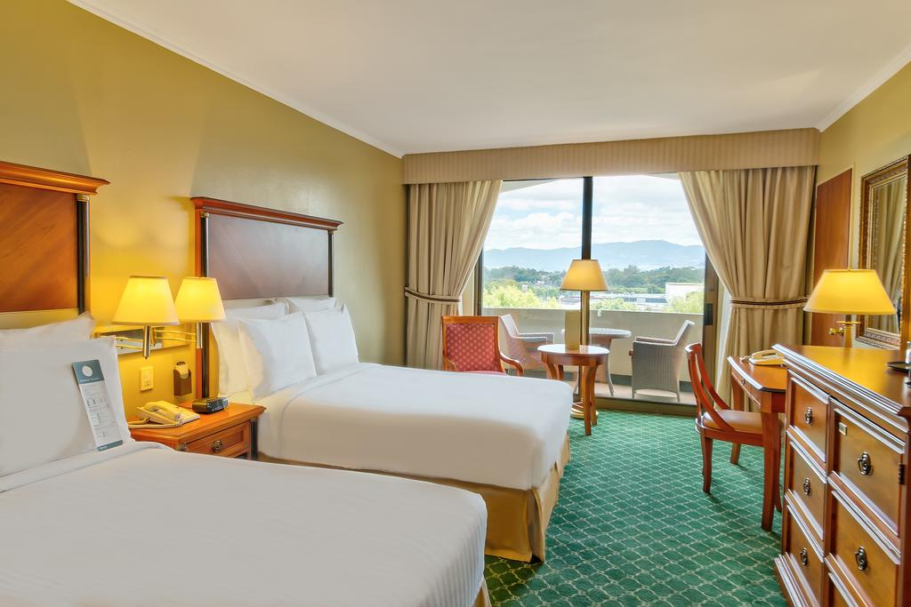
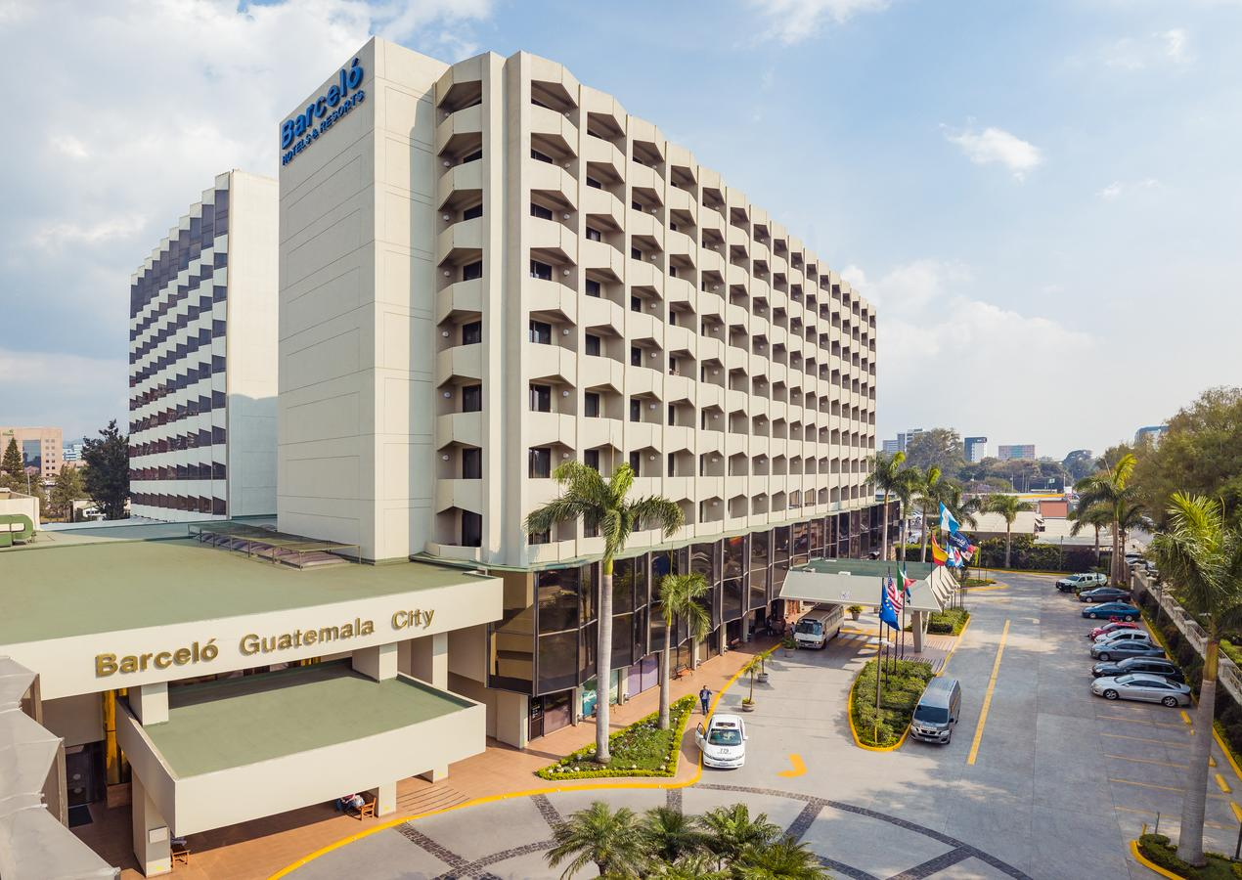

Las Américas – Four Star Hotel

Holiday Inn is located near business centers, banks and 2 km. away from the Airport.

- Single Room price: USD 120.00 per room
- Number of rooms: 20
- Double/Twin Room price: USD 220.00 per room
- Number of rooms: 80
- Board plan: breakfast- lunch (will be served at the shooting range)
- Check-in from 15:00 hrs
- Late check-out 12:00 hrs.
- Hotel website:
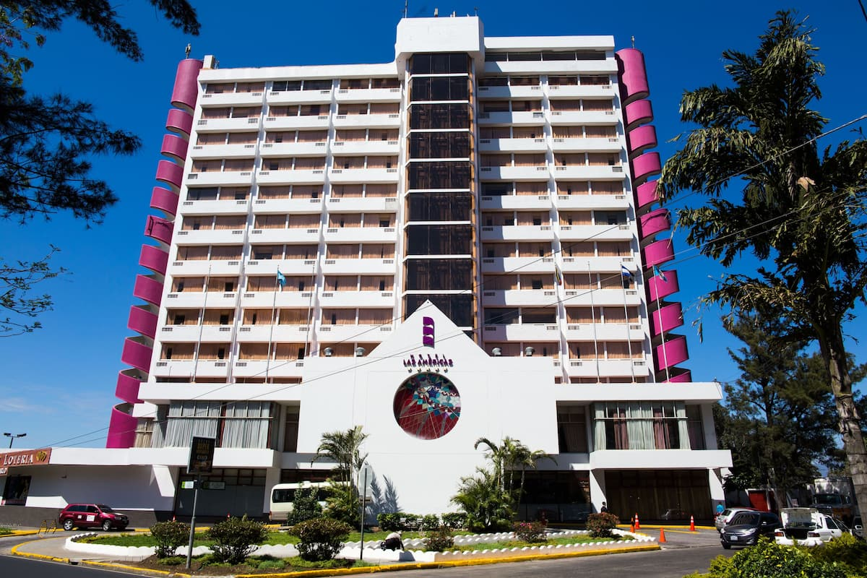
- Photo (hotel & rooms)
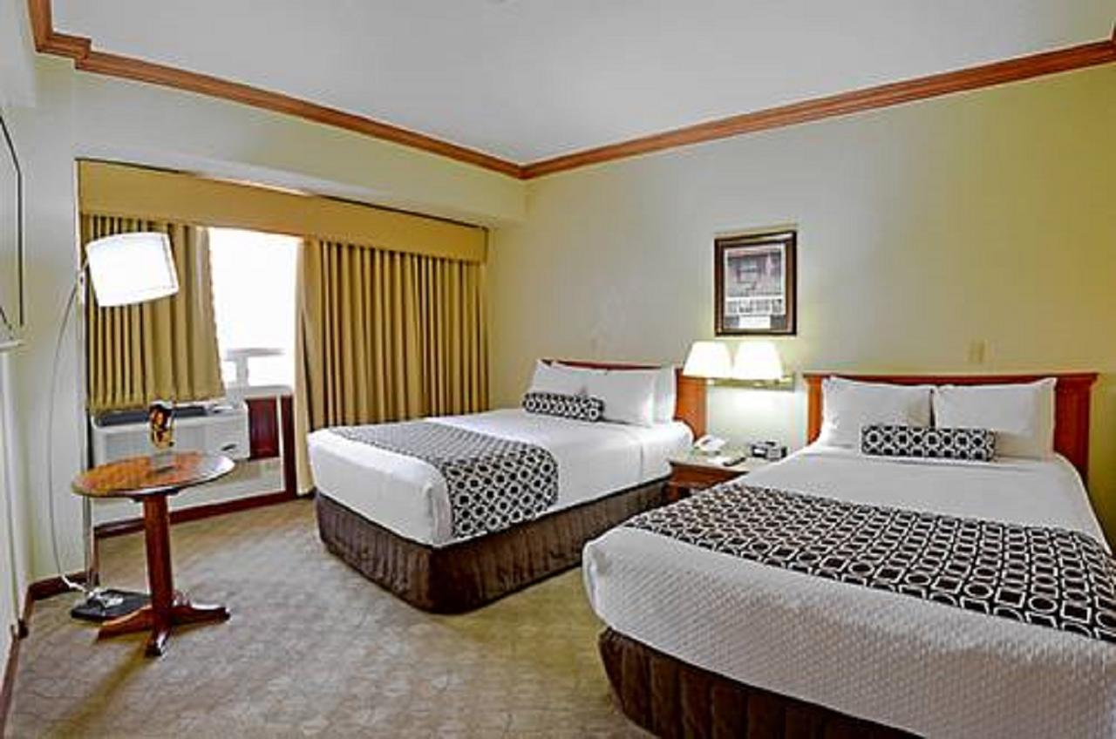

Hotels are allocated on a first come, first serve basis. Accommodation includes breakfast and lunch with non-alcoholic drinks. Lunch will always be served at the archery venue. Dinner is not included, but the hotels are located in an area where there is easy access to a number of inexpensive fast-food places and restaurants.

Teams who do not reserve their accommodation through the organizing committee will be charged a double entre fee.

NOTE: During the days before the official practice, transport is going to be available to take athletes to the stadium and have lunch in there. If they want to be taken to the hotel to have some rest, it is possible too. This transport is already included, there is no extra payment.

NOTE: For those teams that stay in the official hotels but did not make their reservation and payment through the Organising Committee will not have their lunch and transportation covered by the Organisers.

Reservations should be made before 01 February 2021

- Final Hotel Reservation & Transportation before: February 19 2021.

To confirm hotels reservations, a minimum 50% deposit of the total amount is required to be bank transferred to the OC before 01 February 2021. Reservations after this date will be considered only according to availability.

Important Note: Please refer to the accommodation pages below for detailed hotel information. Complete all necessary sections in WAREOS and make full payment for entries and accommodation by the specified deadlines. Bank transfers only, no credit cards will be accepted.

In addition, the LOC will not be responsible to provide any event information at this hotel or provide transportation to the venues.

Teams that book non-official accommodation will need to register at the accreditation desk no later than the day before official practice day. Failing to do so will result in no changes being made to the entry list and it is likely that participation in the event will be refused if registration is not completed in time.
ENTRY FEE
Entry Fees:
Individual: | 250 USD or 230 EUR per athlete
Officials: | 125 USD or 115 EUR per person
Temporary Upgrade:  For athletes wishing to be a coach temporarily | 30 USD per accreditation

Entry fee in NON official hotels:
Individual: 500 USD per athlete
Officials: 250 USD per person

There is no entry fee for teams.

Entry fees include daily local transport to and from the practice field to/from official hotels during the qualification, elimination and finals venues (timetable to be confirmed on site), and it also includes the airport transfers.

PAYMENT CONDITIONS:
The entry fees should be paid in full before arrival.

Payment of accommodation, a minimum deposit of 50% should be made when booking by 19 February 2021. The final outstanding balance shall be made via bank transfer before arrival. Accommodation cannot be guaranteed after this deadline. A balanced invoice will be provided via WAREOS.

BANK INFORMATION for ACCOMMODATION, TRANSPORTATION and
ENTRY FEES:

INTERMEDIARY BANK

NAME: CITIBANK N.A., NEW YORK, NY USA.
ADDRESS: 111 WALL STREET, NEW YORK, NY USA
ABA: 021000089

BENEFICIARY´S BANK

NAME: BANCO DE GUATEMALA
ACCOUNT NR.: 10928742
SWIFT: BAGUGTGC
ADDRESS: 7ª. AV. 22-01 ZONA 1, GUATEMALA, GUATEMALA C.A.
PHONE NR: (502) 2429-6000
WEB: WWW.BANGUAT.GOB.GT

FINAL BENEFICIARY, CUSTOMER ACCOUNT NUMBER

BENEFICIARY: ASOCIACIÓN DEPORTIVA NACIONAL DE TIRO CON ARCO DE GUATEMALA
ACCOUNT NAME: ASOCIACIÓN NACIONAL DE TIRO CON ARCO DE GUATEMALA
ACCOUNT NR: GT21BAGU01010000000001511252
ADDRESS: 4ª AVENIDA 10-96 BALCONES DE SAN CRISTOBAL III, ZONA 8 DE MIXCO, GUATEMALA.
PHONE NR: (502) 2478-3277
WEB: asociacion.archery@gmail.com

Indicate in the field 70 (remittance information) or 72 (sender to Receiver information) of the SWIFT message 103 any information to identify the funds transfer.

PERSONAL HYGIENE AND HEALTH ADVICES (COVID-19)

- Anyone due to participate in the event who is feeling ill should not attend
- Participants (athlete, volunteer, official etc.) should proactively and regularly check their health status (including taking their temperature and monitoring for any symptoms)
- Stay home and self-isolate even with minor symptoms for 10 days or more depending on national protocols, when showing any symptoms (fever, tiredness, dry cough, headache, nasal congestion, runny nose, sore throat, difficulty breathing).
- Contact a healthcare provider immediately if any respiratory illness is noted
- Masks to be worn at all times everywhere (transport, common area in the hotel, venue, training etc.) except on shooting line
- Regularly and thoroughly clean your hands with an alcohol-based hand rub or wash them with soap and water
- Avoid touching eyes, nose and mouth
- Cover your mouth and nose with your bent elbow or tissue when you cough or sneeze. Then dispose of the used tissue immediately and wash your hands
- Avoid touching high-contact surfaces such as door handles, walls or windows, etc.
- Avoid going to crowded places
- Avoid steam rooms or saunas

ADDITIONAL INFORMATION

Medical emergency contact and location
- Hospital Herrera Llerandi – 6A Avenida 8-71, zona 10 Cdad. de Guatemala - tel. (502) 22152727 (502) 23846065
- Hospital La Esperanza - 10A Calle 2-31 zona 14 Ciudad de Ciudad de Guatemala – tel. (502) 2217 0300
- Hospital Centro Medico - 6A Avenida 3-47 zona 10 Cdad. de Guatemala – tel. (502) 2319 4600

Doctor:
- Dr. Gabriel Ramilla. Tel. (502) 55267489

All athletes and officials must travel to Guatemala with their medical insurance.

Transportation
Transportation will be provided from Guatemala airport to the official hotels, starting on April 17 until two days after the closing day. Local transport will be available between official hotels, practice and competition venues. Transport timetables will be confirmed.

For all the athletes that make their payment through the LOC transport is already included.

Airport transfer
As it is described before, the organisers will provide airport transfer to official hotels, starting on April 17. It is particularly important that you send your flight information before the arrival.

A group of the LOC volunteers will be meeting the athletes at the airport and guiding them to their buses.

Cancellations & Changes
All cancellations and changes must be made through WAREOS:
- For cancellations received before 28 March 2021 a full refund of the deposit payment will be made.
- For cancellations received after 28 March 2021, no refund will be made.
- Refunds will be processed after the event.
- Name changes to team officials or athletes (same category and division) will be accepted up to 17:00hrs, two (2) days before official practice without any additional charge or penalty fees.
- Should flight arrival details change at the last minute, please contact the Organising Committee using the details indicated in the team managers’ booklet.
- If a participant’s arrival is later than the original scheduled arrival date, the room will be charged from the date of the original booking in WAREOS.
- An email will automatically notify the Organising Committee and Member Association of any changes made in WAREOS.

Training
A training field will be available starting on 17 April 2021 at Club Los Arcos located approximately 10 minutes from the official hotels. Transport to the practice field will be provided at no additional cost starting on April 17.

Weather
Guatemala is a city that has an average temperature. Temperatures in April are expected to range between 17 and 28 degrees Celsius. The average in the last few years has been 23 degrees Celsius. There are chances of rain, mainly in the afternoons.

Media Registration
Media representatives can apply for registration by emailing info@archery.org

Internet
Will be available in the official hotels for free (in hotel rooms and in the lobby). There will also be Wi-Fi available for access to results on venue.

Water
Bottled water will be available at the qualification and practice venues

Visa
All participants who need an entry visa to Guatemala, will be required to complete the Visa Support sections in WAREOS by no later than 19 February 2021.

It is the applicants’ responsibility for supplying the necessary information, ensuring all details are up to date, correct and submitted by the deadlines specified.
In addition, all participants that require a visa are kindly requested to supply a copy of their latest/valid passport. Copies of each application can be uploaded on WAREOS. All passport copies and personal details entered/uploaded to WAREOS will be held securely and in the strictest of confidence and not shared with other parties.

LOC Contact
Name: Ms. Celeste Collado
Email: copa2021.arco@gmail.com
Language: Spanish and English
Number: (502) 2478-3277/ (502) 2478-3203

