To All World Archery Member Associations,

World Archery and the World Archery Excellence Centre will have the honour of hosting the second stage of the Hyundai Archery World Cup in Lausanne, Switzerland on 17-23 May 2021. Our thoughts are with our friends in Shanghai, and we hope to be in this beautiful city next year once more.

On behalf of the Organising Committee, it is our great pleasure to invite you to participate to one of the most important archery events to take place in Europe in 2021 in the lead up to the Olympic Games and our World Championships. You will not only have access to a unique Archery facility. Our priority is for you to be able to compete in a safe environment with all the necessary sanitary measures. These might change between now and the event and we request your cooperation and understanding.

We are also fully aware that not all member associations will be able to assist due to restrictions in place. We will try to assist where possible, but we know that this is part of the current pandemic situation and this is beyond our control.

Lausanne is the capital city and the biggest town of the canton of Vaud. Situated on the shores of the beautiful Lake Leman, Lausanne, the Olympic Capital hosts the International Olympic Committee and many international sport federations including World Archery since 1996.

We are looking forward to welcoming you in the city we call home in the last 25 years and hope you will have a great and safe experience.

Sincerely yours,

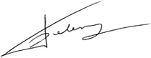

Tom Dielen
Secretary General

Important Dates:

Please find enclosed information regarding the details of this event and how to complete registration. To register participation, please complete all the necessary sections in WAREOS within the deadlines listed below:

Summary of deadlines:

- Start date for online registration WAREOS 19 March 2021
- Preliminary Entries 31 March 2021
- Final Entries 27 April 2021
- Hotel Reservation 31 March 2021
- Transportation 31 March 2021
- Visa Support 31 March 2021
- Final Hotel Reservation & Payment 15 April 2021
- Full refund cancellation deadline 27 April 2021

Looking forward to welcoming you in Lausanne.

PRELIMINARY PROGRAMME

16 May 2021  Sunday | Arrival of participants  Practice field and local transport available
17 May 2021  Monday | Official Practice  Equipment Inspection  Team Managers Meeting
18 May 2021  Tuesday | Qualification Round  (Recurve 70m Round and Compound 50m Round)  Mixed Team Eliminations
19 May 2021  Wednesday | Individual Eliminations  (Recurve and Compound)
20 May 2021  Thursday | Individual Eliminations  Team Eliminations  (Recurve and Compound)
21 May 2021  Friday | Mixed Team Eliminations  (Recurve and Compound)
22 May 2021  Saturday | Finals – Compound
23 May 2021  Sunday | Finals – Recurve
24 May 2021  Monday | Departure of teams

NOTE: This preliminary programme is subject to change according to participation and TV requirements. All changes will be published and distributed in good time.
The number of event days may be shortened depending on the preliminary entries.
PRELIMINARY & FINAL REGISTRATION
All entries, accommodation reservations, transport needs, flight arrival/departure information and visa invitation letter requests are to be completed using WAREOS.

The World Archery Online Registration System (WAREOS) at http://extranet.worldarchery.sport now handles the entire registration process for this event. No entry forms, hotel reservations or transportation forms will be accepted; all information must be entered into WAREOS.

Member associations can login to WAREOS at http://extranet.worldarchery.sport with the username and password assigned by World Archery. After entering WAREOS, selecting the event from the list will allow a member association to register their athletes. Select/press the “Entries” button to see the list of categories in the event. Select/press the “category” to enter the athlete and official numbers/details participating for that event. A WAREOS User Manual can be downloaded in PDF format (English) upon login.

Contact Ms Cécile Tosetti (ctosetti@archery.sport) in the World Archery Office with any questions regarding WAREOS.

A maximum number of 4 athletes per country can be registered into each category of the event. Preliminary entries should be completed using WAREOS.

Start date for online registration using WAREOS 19 March 2021
End of Preliminary registration using WAREOS: 31 March 2021
End of Final registration using WAREOS: 27 April 2021

Please respect the stated deadlines.

Member Associations can only use WAREOS to make any changes or amendments to entries and will be able to do so at any time. An email will automatically notify the Organising Committee and Member Association of any changes made in WAREOS.

Any changes that are made after the deadlines specified or if entries differ by more than 4 athletes from the preliminary entries, the following penalty fees will automatically be applied.

Penalty fees to be paid to Organising Committee: | Cost (CHF):
Entries made after the entry deadline dates. | 50 per entry
If final entries differ from the preliminary entries by more than 4 athletes/officials. | 150 per entry
When no preliminary entries were made before the deadline date but then submit final entries. | 150 per entry

Penalty Fee to be paid to World Archery: | Cost (CHF):
Lost accreditation. | 30 each
Changes made to the athlete and/or team official names after the final entry deadline date and within 3 days prior to the start of the event. | 50 each change

Member Associations that have penalty fees outstanding from 2020 will need to have paid these penalty fees before being eligible to enter and compete.

Any entries received less than 3 days before the team managers meeting for a Hyundai Archery World Cup or World Championships will be refused if no preliminary entry and/or final entry are made prior. This decision cannot be appealed by the teams and is fully compliant with the current World Archery rules, article 3.7.1.2. Entries received after the deadlines, are subject to penalties as clearly stated in the rule book and the invitation documents of World Cups and World Championships. A Member Association that has made final entries in WAREOS and does not participate will be invoiced for the number of entries entered in the system, unless they have informed World Archery and the Organising Committee in writing at least one week prior to the event that they are unable to attend.
ACCOMMODATION & GENERAL INFORMATION

Aquatis Hotel ***

Aquatis Hotel offers 143 comfortable rooms, a restaurant, a relaxation area. The hotel is committed to provide the best services for all.

- Single Room price: CHF 260.00 per room
- Number of rooms: 30
- Double/Twin Room price: CHF 390.00 per room
- Number of rooms: 100
- Board plan: Full board. Breakfast and dinner will be served at the hotel. Lunch will be served at World Archery Excellence Centre.
- Check-in from 14:00 hrs.
- Latest check-out 12:00 hrs.
- Website: https://www.aquatis-hotel.ch/en/

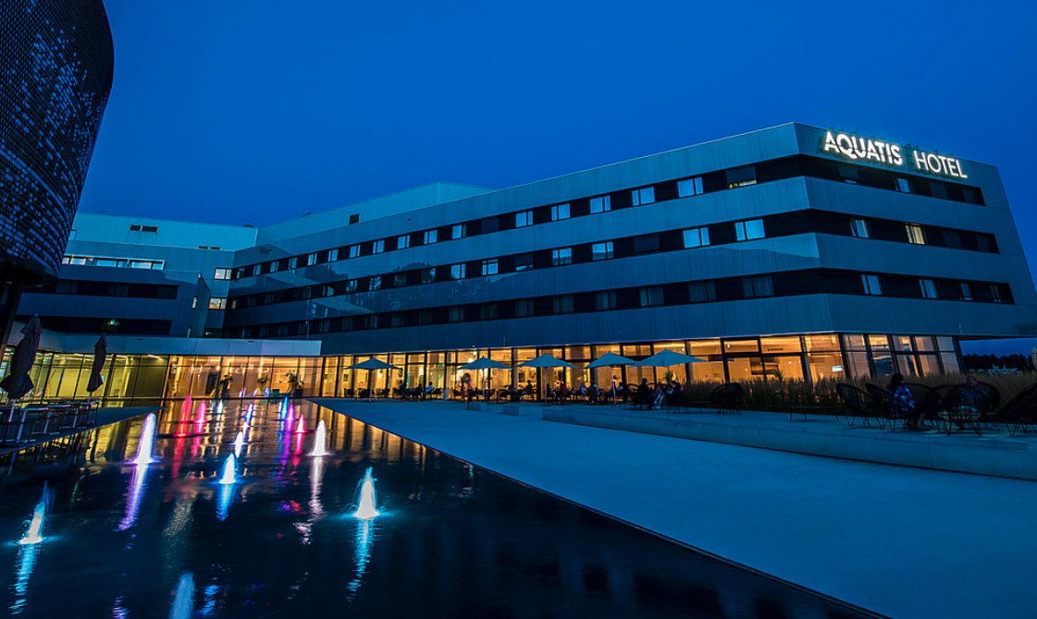

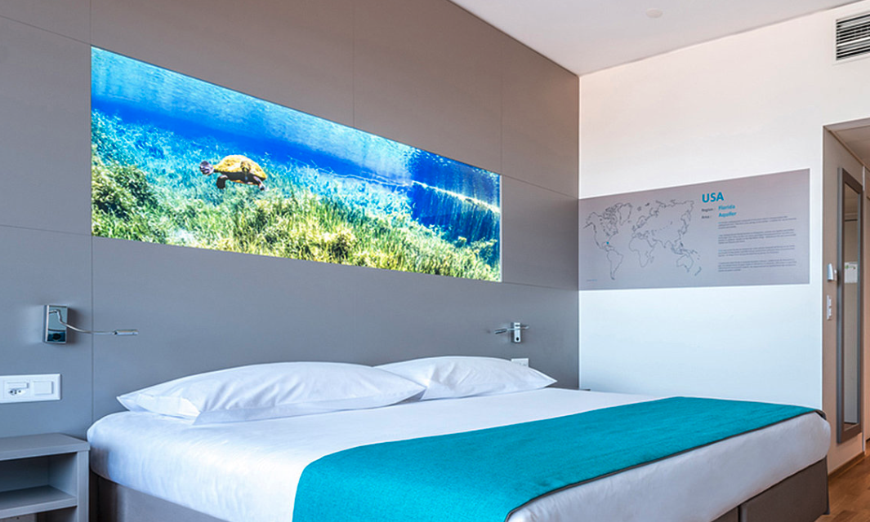

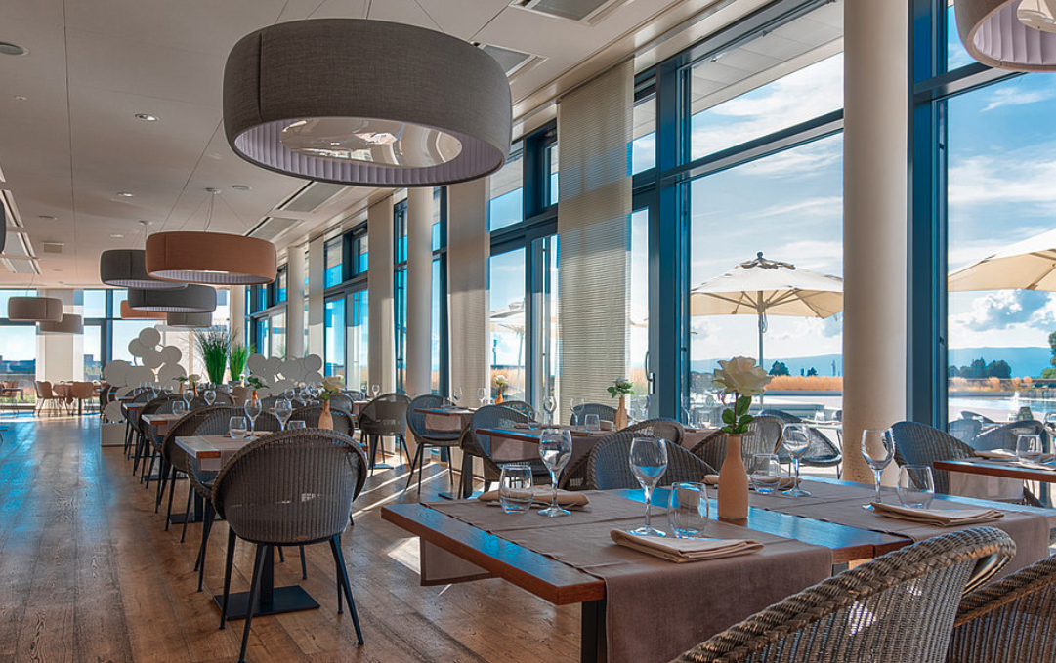

Discovery Hotel ***

Designed in a contemporary modern style, the Discovery Hotel is entirely based on themes to do with discovery and exploration. It has 98 comfortable and well-lit rooms.

- Single Room price: CHF 260.00 per room
- Number of rooms: 15
- Double/Twin Room price: CHF 390.00 per room
- Number of rooms: 15
- Board plan: Full board. Breakfast and dinner will be served at the hotel. Lunch will be served at World Archery Excellence Centre.
- Check-in from 14:00 hrs.
- Latest check-out 12:00 hrs.
- Website: https://www.discovery-hotel.ch/en/hotel

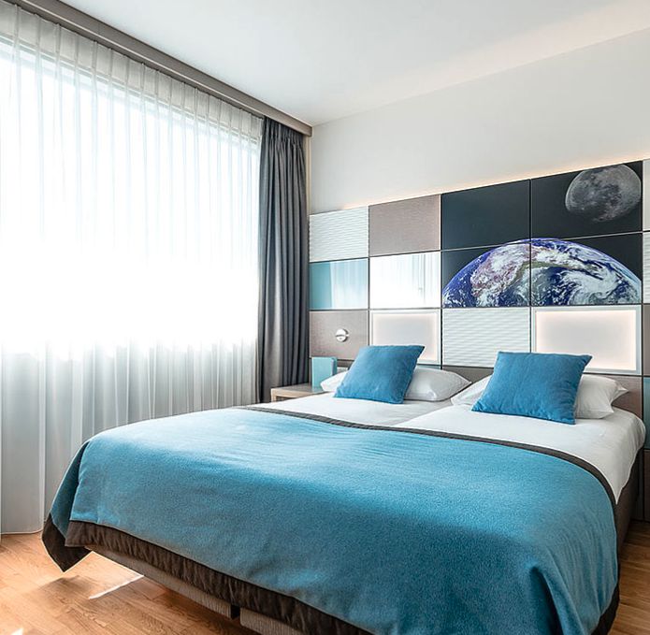

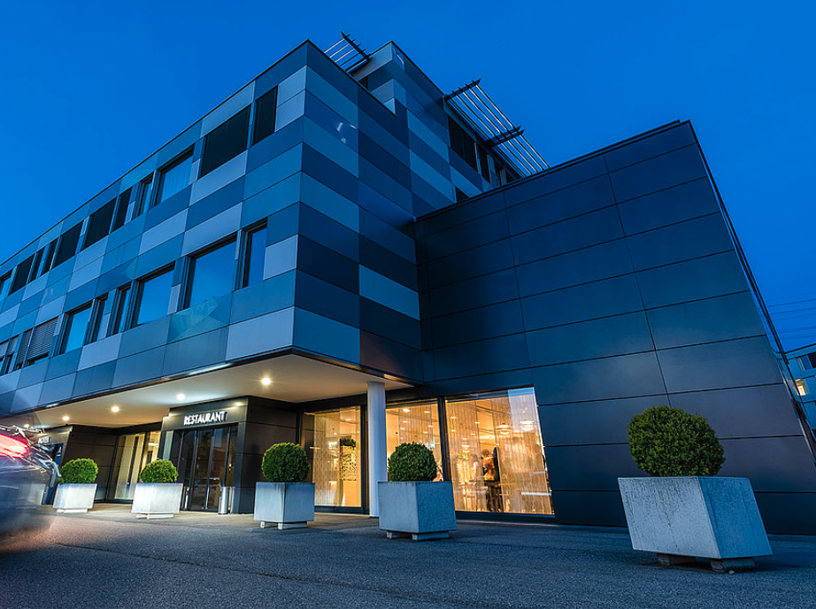
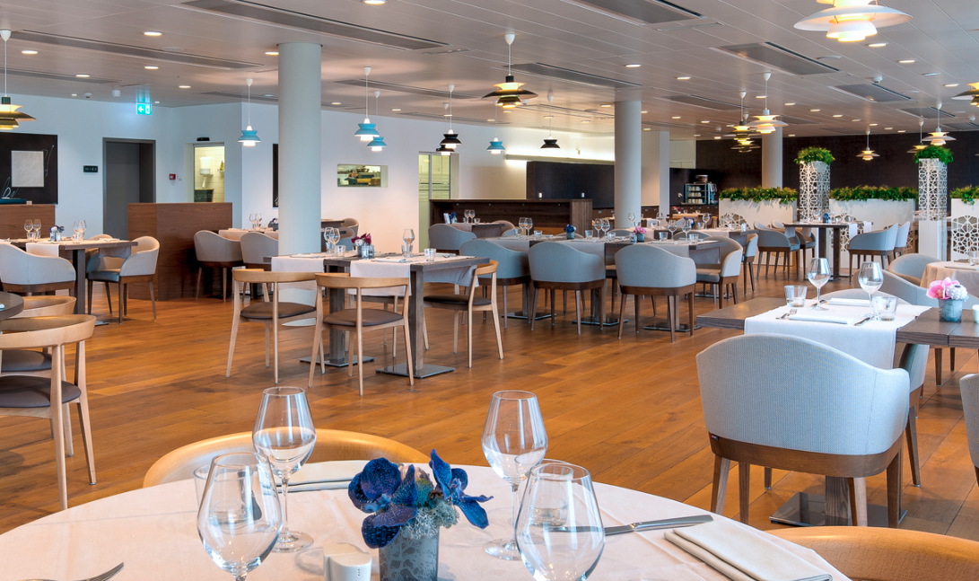

Novotel Hotel ****

Focused on sustainable development, the Novotel Lausanne Bussigny promises a harmonious stay with nature.

- Single Room price: CHF 260.00 per room
- Number of rooms: 5
- Double/Twin Room price: CHF 390.00 per room
- Number of rooms: 35
- Board plan: Full board. Breakfast and dinner will be served at the hotel. Lunch will be served at World Archery Excellence Centre.
- Check-in from 14:00 hrs.
- Latest check-out 12:00 hrs.
- Website: https://all.accor.com/hotel/0530/index.en.shtml
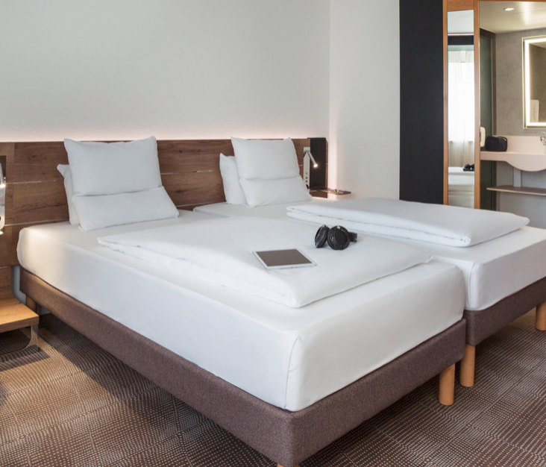
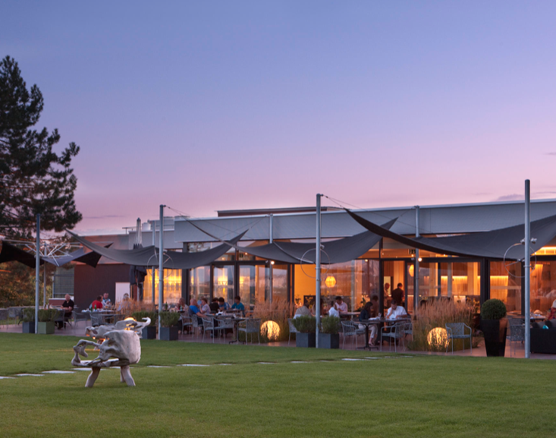

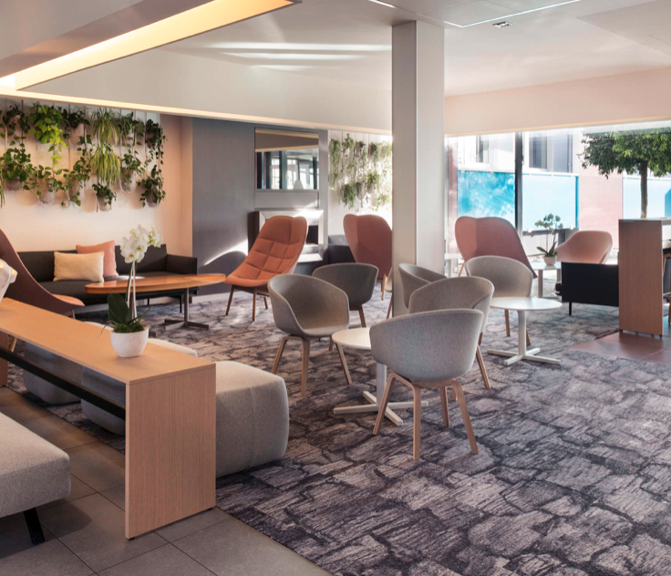

Hotels are allocated on a first come, first serve basis. Accommodation includes breakfast, lunch and dinner with tap water. Lunch will always be served at the archery venue. In case the hotels are fully booked another hotel is foreseen but this will only be offered in that case.

Due to sanitary restrictions, all teams MUST book their accommodation through the organizing committee.

NOTE: World Archery Excellence Centre is offering training options before and after the competition. To organize practice before Monday 17 May, please contact Mr. Junoh Lee (jlee@worldarcherycentre.org).

Reservations should be made before 15 April 2021

- Final Hotel Reservation & Transportation before: 15 April 2021.

To confirm hotels reservations, a minimum 50% deposit of the total amount is required to be bank transferred to the OC before 15 April 2021. Reservations after this date will be considered only according to availability.

Important Note: Please refer to the accommodation pages above for detailed hotel information. Complete all necessary sections in WAREOS and make full payment for entries and accommodation by the specified deadlines. Bank transfers only, no credit cards will be accepted.

ENTRY FEE
Individual: | 250 CHF
Officials: | 125 CHF
Temporary Upgrade:  For athletes wishing to be a coach temporarily | 30 CHF per accreditation

There is no entry fee for teams.

Entry fees include daily local transport to and from the practice field to/from official hotels during the qualification, elimination and finals venues (timetable to be confirmed on site).

PAYMENT CONDITIONS:
The entry fees should be paid in full before arrival.

Payment of accommodation, a minimum deposit of 50% should be made when booking by 15 April 2021. The final outstanding balance shall be made via bank transfer before arrival. Accommodation cannot be guaranteed after this deadline. A balanced invoice will be provided via WAREOS.

BANK INFORMATION for ACCOMMODATION, TRANSPORTATION and
ENTRY FEES:

Bank details (PAYMENT IN CHF only)

Account name: World Archery Federation
Maison du Sport International
Avenue de Rhodanie 54
CH - 1007 Lausanne (Switzerland)
Bank: Banque Cantonale Vaudoise
Address: Rue de la Poste 8
CH -1009 Pully (Switzerland)
Swift/BIC: BCVLCH2LXXX
Account nr. C5299.65.92
IBAN: CH67 0076 7000 C529 9659 2

PERSONAL HYGIENE AND HEALTH ADVICES (COVID-19)
These are the rules in place at the time of the publication of the information package. Additional rules might be enforced later.

- Anyone due to participate in the event who is feeling ill should not attend
- Participants (athlete, volunteer, official etc.) should proactively and regularly check their health status (including taking their temperature and monitoring for any symptoms)
- Stay home and self-isolate even with minor symptoms for 10 days or more depending on national protocols, when showing any symptoms (fever, tiredness, dry cough, headache, nasal congestion, runny nose, sore throat, difficulty breathing).
- Contact a healthcare provider immediately if any respiratory illness is noted
- Masks to be worn at all times everywhere (transport, common area in the hotel, venue, training etc.) except on shooting line
- Regularly and thoroughly clean your hands with an alcohol-based hand rub or wash them with soap and water
- Avoid touching eyes, nose and mouth
- Cover your mouth and nose with your bent elbow or tissue when you cough or sneeze. Then dispose of the used tissue immediately and wash your hands
- Avoid touching high-contact surfaces such as door handles, walls or windows, etc.
- Avoid going to crowded places
- Avoid steam rooms or saunas

ADDITIONAL INFORMATION

Medical emergency contact and location
Centre Hospitalier universitaire Vaudois (CHUV) - Rue du Bugnon 46 -
1011 Lausanne - tel. 021 314 11 11
Ambulance, call the 144

Doctor:
Contact details will be provided in the team manager booklet.

All athletes and officials must travel to Lausanne with a copy of their medical insurance.

Transportation
Transportation will be provided between official hotels, practice and competition venues. Transport timetables will be confirmed.

For all the athletes that make their payment through the LOC transport is already included.

Airport transfer
Organisers will propose airport transfer to official hotels from Geneva airport, starting on 14 May 2021. It is particularly important that you send your flight information before the arrival.

Transfer rate (one-way per person): 50 CHF

A group of the LOC volunteers will be meeting the athletes at the airport and guiding them to their buses.

NO TRANSFER WILL BE ARRANGED TO/FROM TRAIN STATIONS NOR FROM ZURICH NOR BASEL AIRPORT

Cancellations & Changes
All cancellations and changes must be made through WAREOS:
- For cancellations received before 27 April 2021 a full refund of the deposit payment will be made.
- For cancellations received after 27 April 2021, no refund will be made.
- Refunds will be processed after the event.
- Name changes to team officials or athletes (same category and division) will be accepted up to 17:00hrs, two (2) days before official practice without any additional charge or penalty fees.
- Should flight arrival details change at the last minute, please contact the Organising Committee using the details indicated in the team managers’ booklet.
- If a participant’s arrival is later than the original scheduled arrival date, the room will be charged from the date of the original booking in WAREOS.
- An email will automatically notify the Organising Committee and Member Association of any changes made in WAREOS.

Weather
Lausanne city center is 490m above sea level, but the venue is 873m above sea level. The average temperature in May is 8°(min) to 17° (max), with 11 days of rain during the month.

Media Registration
Media representatives can apply for registration by emailing info@archery.sport

Internet
Will be available in the official hotels for free (in hotel rooms and in the lobby). There will also be Wi-Fi available for access to results at the World Archery Excellence Centre. Information on Internet at the Qualification venue will be provided in the team manager booklet

Water
Bottled water will be available at the qualification and practice venues

Visa
All participants who need an entry visa to Switzerland, will be required to complete the Visa Support sections in WAREOS by no later than 15 April 2021. However, we urge everyone to proceed with this as soon as possible.

It is the applicants’ responsibility for supplying the necessary information, ensuring all details are up to date, correct and submitted by the deadlines specified.
In addition, all participants that require a visa are kindly requested to supply a copy of their latest/valid passport. Copies of each application can be uploaded on WAREOS. All passport copies and personal details entered/uploaded to WAREOS will be held securely and in the strictest of confidence and not shared with other parties.

LOC Contact
Name: Ms Cécile Tosetti
Email: ctosetti@archery.sport
Language: English, French, Spanish and Italian
Number: +41 21 614 30 50

Transportation Contact
Name: Karim Sidaoui
Email: ksidaoui@archery.sport
Language: English, French
Number: +41 79 204 51 81

