TO ALL World Archery Member Associations

Dear President,

As Chairman of the Local Organizing Committee (LOC) for the 1st stage of the HYUNDAI ARCHERY WORLD CUP which will be held on 18 – 24 April 2022 in Antalya-TURKEY, I would like to invite and welcome your Association to participate in our event. This competition will be organized following the Hyundai World Cup rules for 2022, in both divisions: Recurve and Compound.

Sincerely yours,
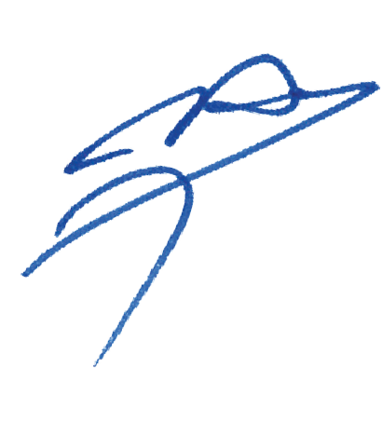

Husnu KOCAOGLU
Chairman of LOC

Important Dates:

Please find enclosed detailed information regarding this event. To register participation, please complete all the necessary sections in WAREOS (https://extranet.worldarchery.sport) within the deadlines listed below.

Summary of deadlines:

Registration Opening date on WAREOS | 1 December 2021
Preliminary Entries | 18 January 2022
Final Entries | 28 March 2022
Hotel reservation down-payment (50%) | 18 January 2022
Hotel reservation and payment | 28 March 2022
Transportation | 28 March 2022
Visa support | 01 March 2022
Full refund cancellation deadline  *After this deadline, the LOC is allowed to retain all amounts due by the Member Association. | 15 April 2022
Please respect the stated deadlines.

PRELIMINARY PROGRAMME

17 April 2022  Sunday | Arrival of participants  Practice field and local transport available
18 April 2022  Monday | Arrival of participants  Practice field and local transport available
19 April 2022  Tuesday | Official Practice & Qualification Round  Official Practice  Compound 50m Round
20 April 2022  Wednesday | Team Eliminations & Qualification  Compound Team Matches & Recurve Qualifications
21 April 2022  Thursday | Individual Eliminations  Team Eliminations  (Recurve Team Matches and Compound Individual Matches)
22 April 2022  Friday | Mixed Team Eliminations & Individual Eliminations  (Mix Team Matches and Recurve Individual Matches)
23 April 2022  Saturday | Finals – Compound
24 April 2022  Sunday | Finals – Recurve
25 April 2022  Monday | Departure of teams

NOTE: This preliminary programme is subject to change according to participation and TV requirements. All changes will be published and distributed in good time.
PRELIMINARY & FINAL REGISTRATION
All entries, accommodation reservations, transport needs, flight arrival/departure information and visa invitation letter requests are to be completed using the World Archery Online Registration System WAREOS https://extranet.worldarchery.sport. This system handles the entire registration process for this event. No entry forms, hotel reservations or transportation forms will be accepted; all information must be entered into WAREOS.

Member associations can login to WAREOS at https://extranet.worldarchery.sport with the username and password assigned by World Archery. After entering WAREOS, selecting the event from the list will allow a member association to register their athletes. Select/press the “Entries” button to see the list of categories in the event. Select/press the “category” to enter the athlete and official numbers/details participating for that event. A WAREOS User Manual can be downloaded in PDF format (English) upon login.

Contact wareos@archery.sport with any questions regarding technical problems on WAREOS. For any question regarding the organisation of the event (transport, accommodation, meals, invoices, visa etc.) please contact directly the LOC.

A maximum number of 4 athletes per country can be registered into each category of the event. Preliminary entries should be completed using WAREOS.

Member Associations can only use WAREOS to make any changes or amendments to entries and will be able to do so at any time. An email will automatically notify the Organising Committee and Member Association of any changes made in WAREOS.

Any changes that are made after the deadlines specified or if entries differ by more than 4 athletes from the preliminary entries, the following penalty fees will automatically be applied.

ENTRY FEES

Individual 230 EUR per athlete
Official 115 EUR per person
Guest 230 EUR per person
VIP guest 300 EUR per person

ENTRY FEES IN NON-OFFICIAL HOTELS

Individual 460 EUR per athlete
Official 230 EUR per person

Entry fees for individual/Official include daily local transport to and from the practice field to/from official hotels during the qualification, elimination and finals venues (timetable to be confirmed on site).

Entry fee for guest includes daily local transport to and from the practice field to/from official hotels during the qualification, elimination and finals venues. They have no field of play access.

Entry fee for VIP guest includes daily local transport to and from the practice field to/from official hotels during the qualification, elimination and finals venues. They have no field of play access.

Any changes made after the deadlines specified or if entries differ by more than 4 athletes from the preliminary entries, the following penalty fees to will automatically be applied:

PENALTY FEES TO BE PAID TO ORGANISING COMMITTEE

Penalty fees for Late Entries (after final deadline): | 50 per entry
Penalty fees for not filling Preliminary entries | 150 per entry
Penalty fee for differences between preliminary and final entries:  *If the difference between final and preliminary entries number is more than 4 athletes/officials | 150 per entry

PENALTY FEES TO BE PAID TO WORLD ARCHERY (CHF)
Lost / Damaged accreditation | 30.- each
Lost classification card | 30.-each
Any change to the final country entry list, such as (but not limited to):  - Athlete or official name change  - Date of birth change  - Official position change  - Absence or incomplete on-site contact person | 50.- each change

NOTE: CHF currency exchange rates will be those on the date of the event.

Member Associations that have penalty fees outstanding from 2021 will need to have paid these penalty fees before being eligible to enter and compete.

Any entries received less than 3 days before the team managers meeting for a Hyundai Archery World Cup or World Championships will be refused if no preliminary entry and/or final entry are made prior. This decision cannot be appealed by the teams and is fully compliant with the current World Archery rules, article 3.7.1.2. Entries received after the deadlines, are subject to penalties as clearly stated in the rule book and the invitation documents of World Cups and World Championships. A Member Association that has made final entries in WAREOS and does not participate will be invoiced for the number of entries entered in the system, unless they have informed World Archery and the Organising Committee in writing at least one week prior to the event that they are unable to attend.

ACCOMMODATION

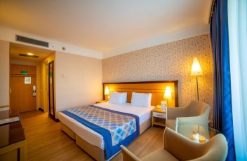
Porto Bello Hotel & Spa – Five Star Hotel
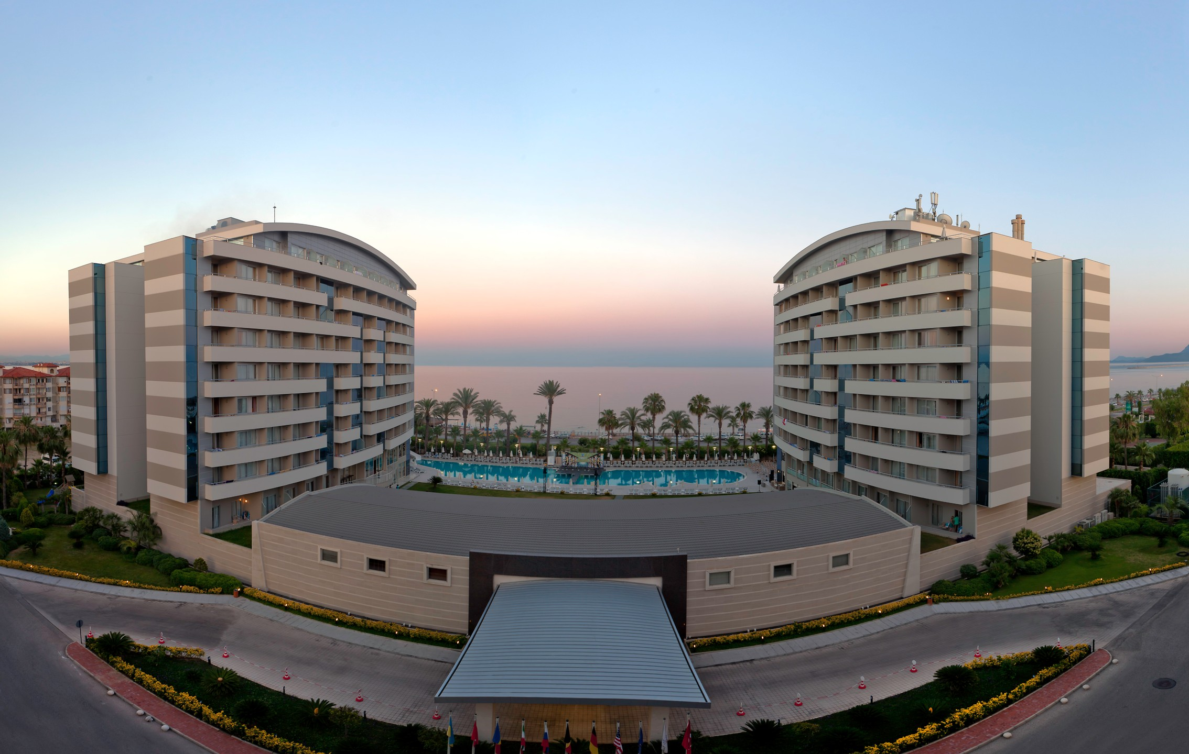
- Single Room price: EUR 180 per room
- Number of rooms: 50
- Double/Twin Room price: EUR 260 per room
- Number of rooms: 100
- Board plan: full board
- Check-in from 17.04.2022
- Hotel website: http://www.portobello.com.tr

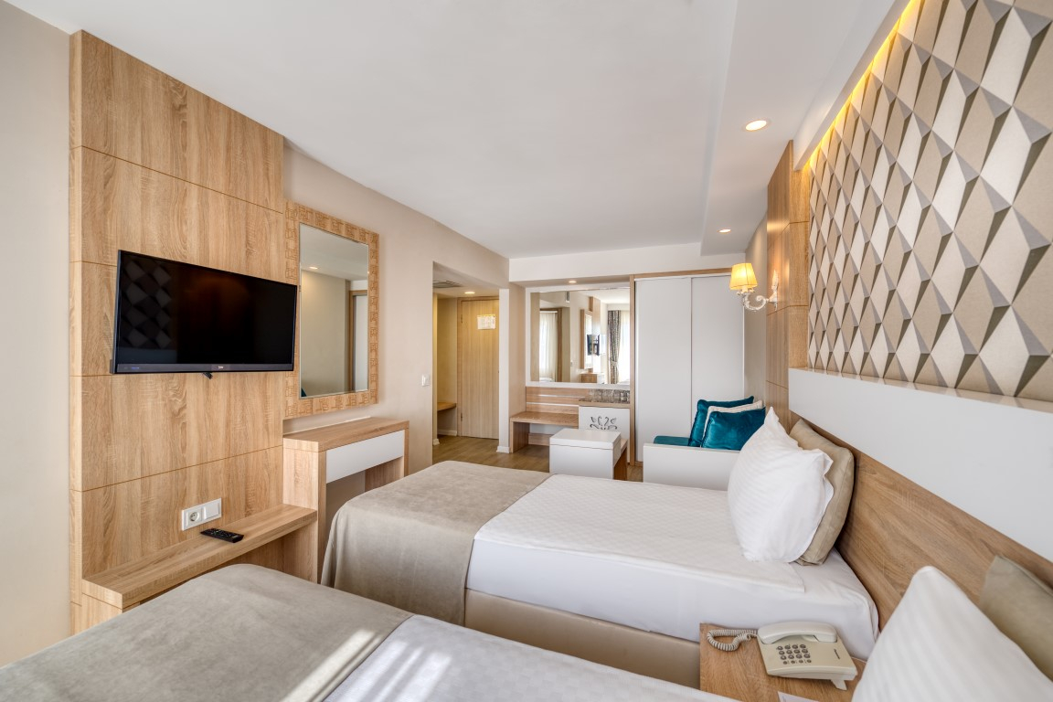
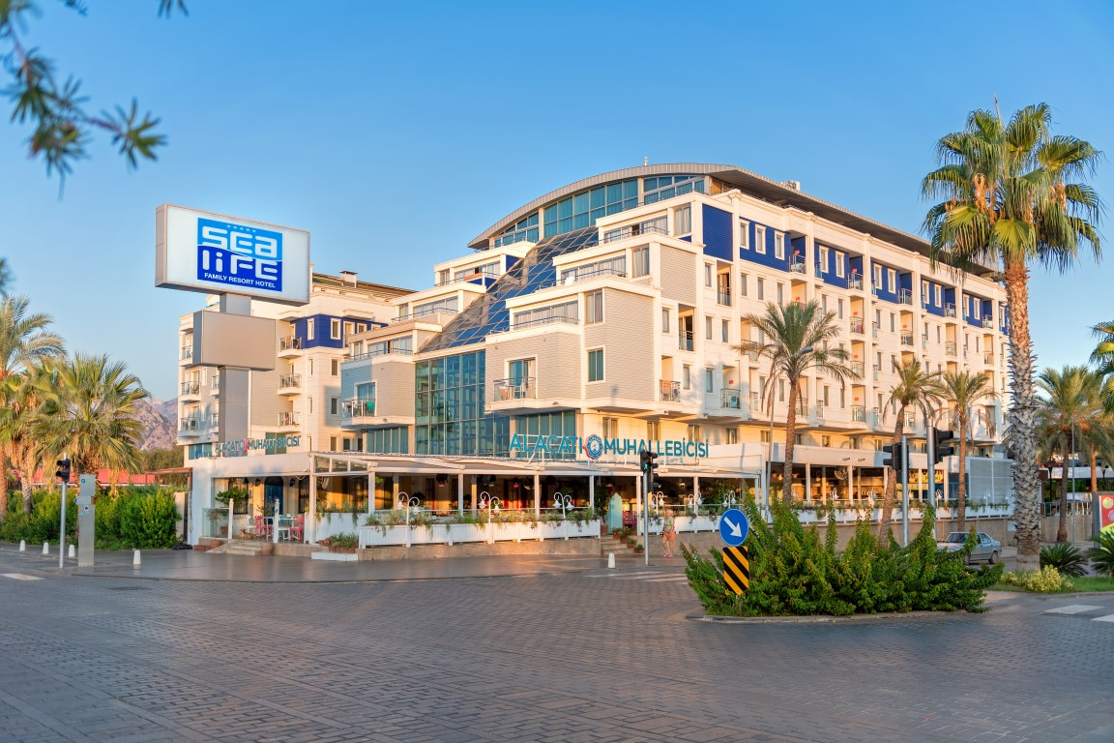
Sealife Family Resort Hotel – Five Star Hotel

- Single Room price: EUR 170 per room
- Number of rooms: 25
- Double/Twin Room price: EUR 250 per room
- Number of rooms: 75
- Board plan: full board
- Check-in from 17.04.2022
- Hotel website: http://www.sealifehotel.com

Rooms are allocated on a first come, first serve basis. Accommodation includes breakfast, lunch and dinner with non-alcoholic drinks.
Teams who do not reserve their accommodation through the organising committee will be charged a double entry fee.

In addition, the LOC will not be responsible to provide any event information at this hotel or provide transportation to the venues.

TRANSPORTATION
Transportation will be provided from Antalya airport to the official hotel, from two days before the official practice day and until two days after the closing day at 50 EUR price for roundtrip. Local transport will be available between the official hotel, practice and competition venues for free. Transport timetables will be confirmed.

VISA
All participants who need an entry visa to Turkey, will be required to complete the Visa Support sections in WAREOS by no later than 01 March 2022.

It is the applicants’ responsibility for supplying the necessary information, ensuring all details are up to date, correct and submitted by the deadlines specified.

In addition, all participants that require a visa are kindly requested to supply a copy of their latest/valid passport. Copies of each application can be uploaded on WAREOS. All passport copies and personal details entered/uploaded to WAREOS will be held securely and in the strictest of confidence and not shared with other parties.

PAYMENT CONDITIONS
Complete all necessary sections in WAREOS and make full payment by the specified deadlines. Bank transfers only, no credit cards will be accepted. All bank charges will be paid by the participants.

The entry fees should be paid in full before arrival.

To confirm hotels reservations, a minimum 50% deposit of the total amount is required to be bank transferred to the OC before 18 January 2022. Reservations after this date will be considered only according to availability. The final outstanding balance shall be made via bank transfer before arrival. Accommodation cannot be guaranteed after this deadline. A cost summary will be available through WAREOS.

BANK INFORMATION FOR ACCOMMODATION, TRANSPORTATION AND ENTRY FEES
BANK ACCOUNT: | ANTALYA OKCULUK IHTISAS SPOR KULÜBÜ
BANK: | YAPI KREDI BANKASI
ACCOUNT NO: | 25086669
SWIFT CODE: | YAPITRIS
IBAN: | TR 03 0006 7010 0000 0025 0866 69

NOTE: ALL PAYMENTS SHALL BE MADE IN EUR.

CANCELLATIONS & CHANGES
All cancellations and changes must be made through WAREOS

- Should flight arrival details change last minute, please contact the Organising Committee using the details indicated in the team managers’ booklet.
- If a participant’s arrival is later than the original scheduled arrival date, the room will be charged from the date of the original booking in WAREOS.
- An email will automatically notify the Organising Committee and Member Association of any changes made in WAREOS.

HEALTH REGULATIONS (COVID-19)

INFORMATION
- Everybody should follow the Government/public health authorities measures (national and sport-specific regulations) and be aware of the travel restrictions
- For your information, Medical infrastructure/Hospital with proper care will be reachable within 15 minutes from the venue, where COVID-19 test can be done.

Medical emergency contact and location
AKDENIZ SIFA HOSPITAL
Kuskavagi Mah. Ataturk Bulvari No 81 Konyaalti / ANTALYA – TURKEY
+ 90 444 7 606

ADDITIONAL INFORMATION

Training
A training field will be available starting on 17 April 2022 at the Konyaalti Ataturk Stadium approximately 10 minutes from the official hotels.

Weather
Temperatures in April are expected to range between 20 and 25 degrees Celsius. The average in the last few years has been 23 degrees Celsius.

Media Registration
Media representatives can apply for registration on the LOC website: www.tof.gov.tr or by emailing media@tof.gov.tr (LOC media contact) or at info@archery.sport

Internet
Will be available in the official hotels for free (in hotel rooms and in the lobby). There will also be Wi-Fi available for access to results and internet on venue.

Water
Each participant with receive clean bottles of water.
Bottled water will be available at the qualification and practice venues.
A water fountain system will be used.

LOC CONTACT

Name: Sirer AYDIN
Email: sireraydin@gmail.com
Language: English
Phone number with international extension: + 90 533 515 25 33

Looking forward to welcoming you in Antalya, TURKEY.

