TO ALL World Archery Member Associations
Dear President,
It is a great pleasure to welcome you in Paris for the second year to this World Cup stage.
The sanitary conditions should be more flexible than the previous edition, but remain attentive!
We hope that you will have the opportunity to walk around this beautiful city of Paris.
This will also be the opportunity to go to the competition site of Paris 2024, the Esplanade des Invalides.
This year, the final stages will take place in an iconic place, the Château de Vincennes.
This will be the opportunity to demonstrate that our discipline is a bridge between the history and the contemporary world.
I wish you an excellent stay and a good competition.

Sincerely yours,

Jean-Michel CLEROY
Hyundai Archery World Cup Paris 2022 OC Chairman

Important Dates:

Please find enclosed detailed information regarding this event. To register participation, please complete all the necessary sections in WAREOS (https://extranet.worldarchery.sport) within the deadlines listed below.

Summary of deadlines:

Registration Opening date on WAREOS | 24 February 2022
Preliminary Entries | 19 March 2022
Final Entries | 30 May 2022
Hotel reservation down-payment (50%) | 21 March 2022
Hotel reservation and payment | 19 May 2022
Transportation | 19 May 2022
Visa support | 19 May 2022
Full refund cancellation deadline  *After this deadline, the LOC is allowed to retain all amounts due by the Member Association. | 21 March 2022

Please respect the stated deadlines.

PRELIMINARY PROGRAMME

19 June 2022  Sunday | Arrival of participants
20 June 2022  Monday | Arrival of participants  Practice field and local transport available
21 June 2022  Tuesday | Official Practice & Qualification Round  Equipment Inspection  Team Managers Meeting  Compound 50m Round
22 June 2022  Wednesday | Team Eliminations & Qualifications  Compound team matches & recurve qualifications
23 June 2022  Thursday | Individual Eliminations  Team Eliminations  (Recurve team matches & Compound individual matches)
24 June 2022  Friday | Mixed Team Eliminations & individual eliminations  (Mix team matches & recurve individual matches)
25 June 2022  Saturday | Finals – Compound
26 June 2022  Sunday | Finals – Recurve
27 June 2022  Monday | Departure of teams

NOTE: This preliminary programme is subject to change according to participation and TV requirements. All changes will be published and distributed in good time.

PRELIMINARY & FINAL REGISTRATION
All entries, accommodation reservations, transport needs, flight arrival/departure information and visa invitation letter requests are to be completed using the World Archery Online Registration System WAREOS https://extranet.worldarchery.sport. This system handles the entire registration process for this event. No entry forms, hotel reservations or transportation forms will be accepted; all information must be entered into WAREOS.

Member associations can login to WAREOS at https://extranet.worldarchery.sport with the username and password assigned by World Archery. After entering WAREOS, selecting the event from the list will allow a member association to register their athletes. Select/press the “Entries” button to see the list of categories in the event. Select/press the “category” to enter the athlete and official numbers/details participating for that event. A WAREOS User Manual can be downloaded in PDF format (English) upon login.

Contact wareos@archery.sport with any questions regarding technical problems on WAREOS. For any question regarding the organisation of the event (transport, accommodation, meals, invoices, visa etc.) please contact directly the LOC.

A maximum number of 4 athletes per country can be registered into each category of the event. Preliminary entries should be completed using WAREOS.

Member Associations can only use WAREOS to make any changes or amendments to entries and will be able to do so at any time. An email will automatically notify the Organising Committee and Member Association of any changes made in WAREOS.

ENTRY FEES

Individual 230 EUR per athlete
Official 115 EUR per person
Guest 230 EUR per person
VIP guest 300 EUR per person

Entry fees for individual/Official include daily local transport to and from the practice field to/from official hotels during the qualification, elimination and finals venues (timetable to be confirmed on site).

Entry fee for guests includes daily local transport to and from the practice field to/from official hotels during the qualification, elimination and finals venues. They have no field of play access.

Entry fee for VIP guest includes daily local transport to and from the practice field to/from official hotels during the qualification, elimination and finals, access to VIP area. They have no field of play access.

Any changes that are made after the deadlines specified or if entries differ by more than 4 athletes from the preliminary entries, the following penalty fees will automatically be applied.

PENALTY FEES TO BE PAID TO ORGANISING COMMITTEE

Penalty fees for Late Entries (after final deadline): | 50 EUR per entry
Penalty fees for not filling Preliminary entries | 150 EUR per entry
Penalty fee for differences between preliminary and final entries:  *If the difference between final and preliminary entries number is more than 4 athletes/officials | 150 EUR per entry
PENALTY FEES TO BE PAID TO WORLD ARCHERY (CHF)
Lost / Damaged accreditation | 30.- each
Lost classification card | 30 .-each
Any change to the final country entry list, such as (but not limited to):  - Athlete or official name change  - Date of birth change  - Official position change  - Absence or incomplete on-site contact person | 50.- each change

NOTE: CHF currency exchange rates will be those on the date of the event.

Member Associations that have penalty fees outstanding from 2021 will need to have paid these penalty fees before being eligible to enter and compete.

Any entries received less than 3 days before the team managers meeting for a Hyundai Archery World Cup or World Championships will be refused if no preliminary entry and/or final entry are made prior. This decision cannot be appealed by the teams and is fully compliant with the current World Archery rules, article 3.7.1.2. Entries received after the deadlines are subject to penalties as clearly stated in the rule book and the invitation documents of World Cups and World Championships. A Member Association that has made final entries in WAREOS and does not participate will be invoiced for the number of entries entered in the system, unless they have informed World Archery and the Organising Committee in writing at least one week prior to the event that they are unable to attend.

ACCOMMODATION

Option 1 : Campanile Porte d’Italie – 3*
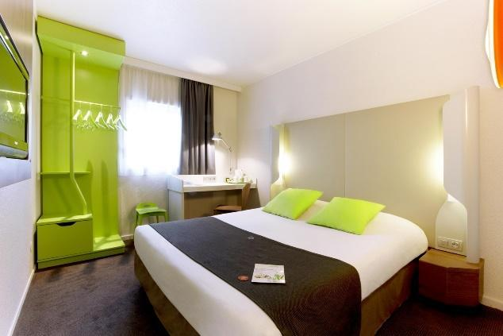
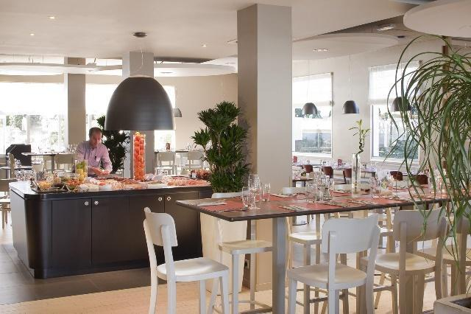

- Single Room price: 176.00 EUR per room
- Number of rooms: 40
- Double/Twin Room price: 277.00 EUR per room
- Number of rooms: 40
- Board plan: Full Board: Breakfast & Dinner at the hotel – Lunch at
the venue (included in the price)
- Check-in from: 14:00
- Check-out: 12:00
- Hotel website: https://paris-sud-porte-ditalie.campanile.com/fr-fr/
- Parking: Paid private parking available (max height 1.90m)

Option 2 : Ibis Styles Météor – 3*
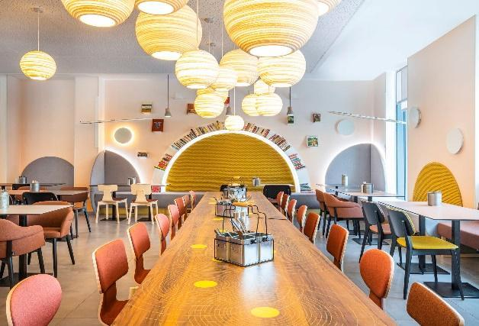
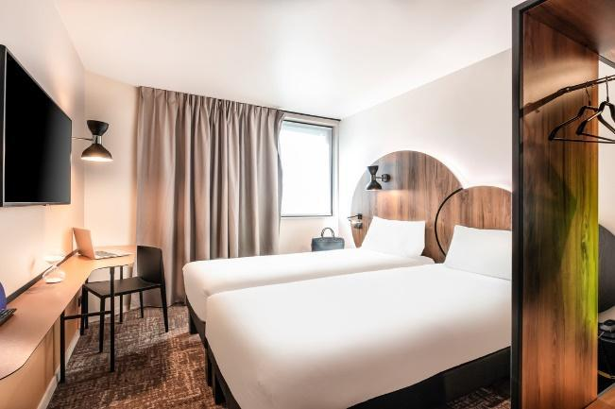

- Single Room price: 228.00 EUR per room
- Number of rooms: 20
- Double/Twin Room price: 339.00 EUR per room
- Number of rooms: 30
- Board plan: Full Board: Breakfast & Dinner at the hotel – Lunch at
the venue (included in the price)
- Check-in from: 14:00
- Check-out: 12:00
- Parking: Paid public parking nearby (max height 1.90m)
- Hotel website: https://all.accor.com/hotel/B2U6/index.fr.shtml

Option 3 : Ibis Styles Paris Bercy – 3*
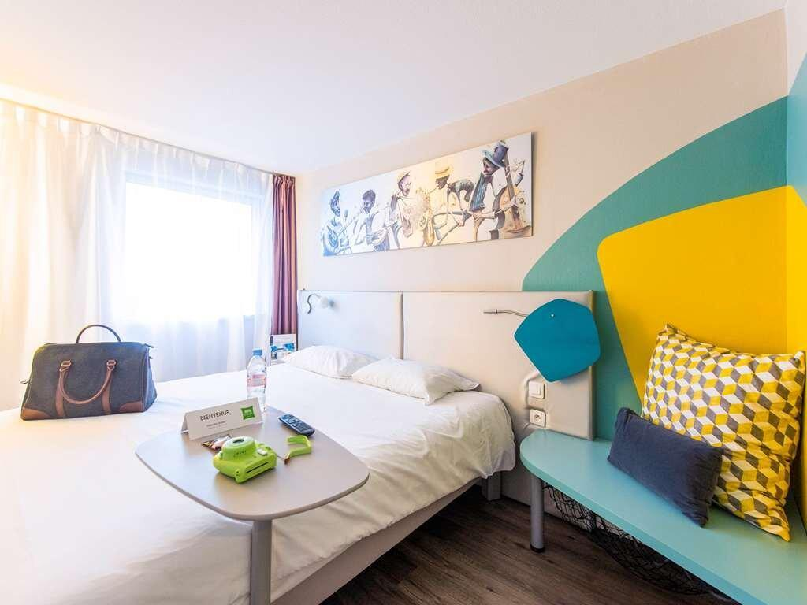
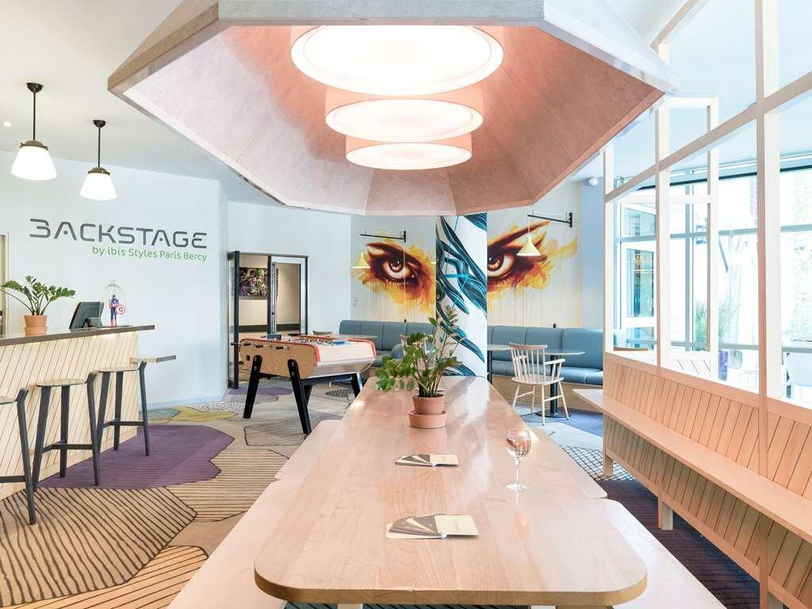

- Single Room price: 225.00 EUR per room
- Number of rooms: 40
- Double/Twin Room price: 327.00 EUR per room
- Number of rooms: 40
- Board plan: Full Board: Breakfast & Dinner at the hotel – Lunch at
the venue (included in the price)
- Check-in from 14:00
- Check-out 12:00
- Hotel website: Follow this link
- Parking: Paid public parking nearby (max height 1.90m)

Option 4 : Novotel Paris Centre Bercy – 4*
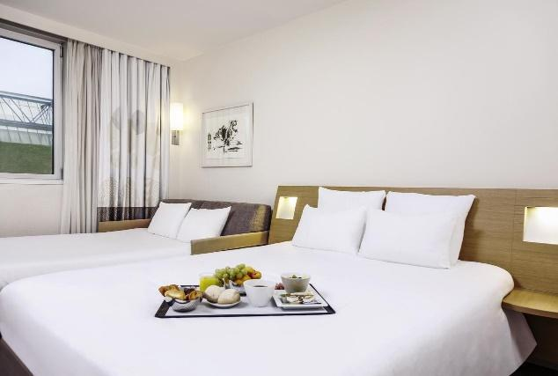
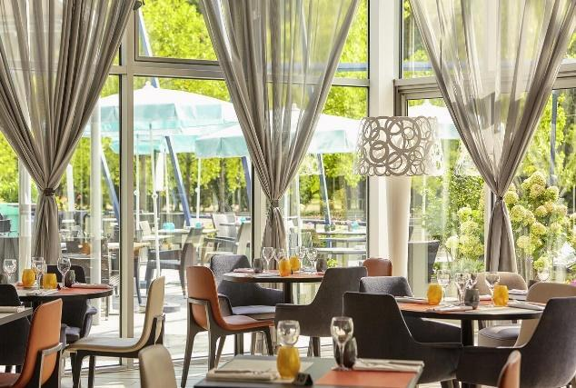

- Single Room price: 272.00 EUR per room
- Number of rooms: 20
- Double/Twin Room price: 393.00 EUR per room
- Number of rooms: 20
- Bedding in Twin Room: 1 double bed + 1 sofa bed
- Board plan: Full Board: Breakfast & Dinner at the hotel – Lunch at
the venue (included in the price)
- Check-in from: 14:00
- Check-out: 12:00
- Hotel website: https://all.accor.com/hotel/0935/index.fr.shtml
- Parking: Paid public parking nearby (max height 1.90m)

Option 5 : Ibis Paris Porte d’Italie – 3*
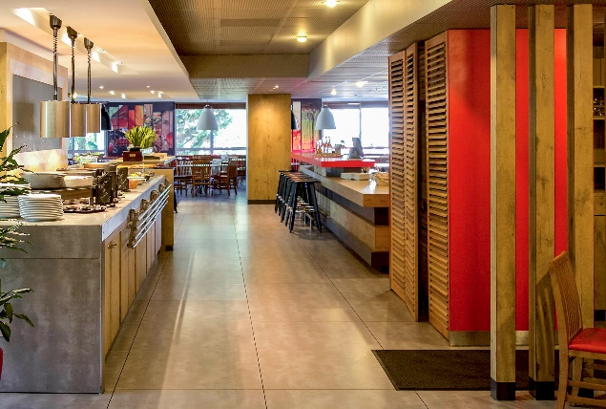
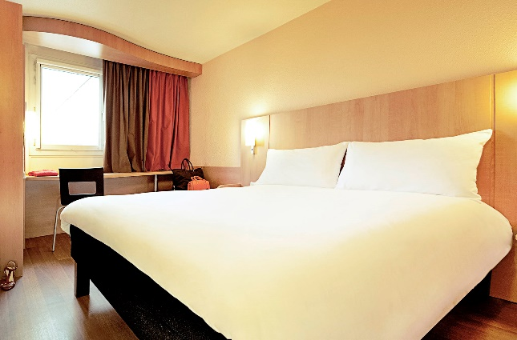

- Single Room price: 200.00 EUR per room
- Number of rooms: 15
- Double/Twin Room price: 302.00 EUR per room
- Number of rooms: 40
- Board plan: Full Board: Breakfast & Dinner at the hotel – Lunch at
the venue (included in the price)
- Check-in from: 14:00
- Check-out: 12:00
- Hotel website: https://all.accor.com/hotel/0634/index.fr.shtml
- Parking: Paid private parking available (max height 1.90m)
- Location: Walking distance to Charlety venue (700m)

HOTELS LOCATION
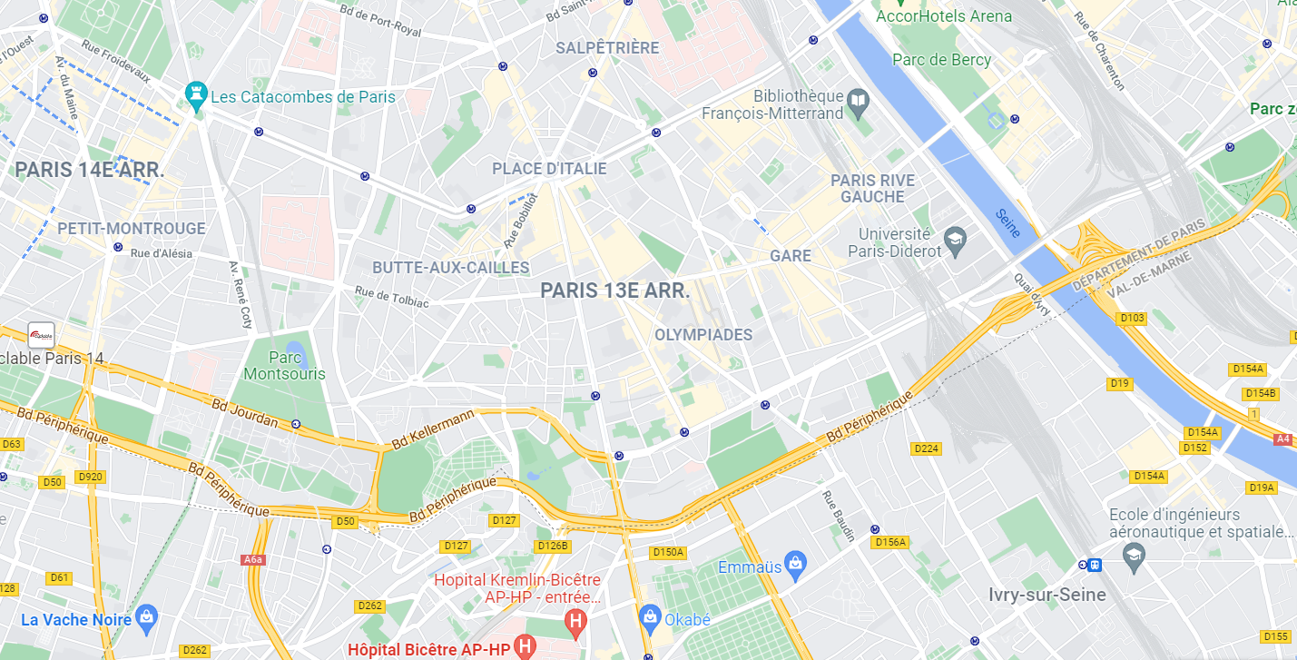
PARIS CENTER

Novotel Bercy
Novotel Bercy 4*

Ibis Styles Bercy
Paris Center
Ibis Styles Bercy 3*

Chateau de Vincennes
Venue 2
To Château de Vincennes
Venue 2

Charlety - Venue 1
Charléty - Venue 1
Ibis Styles Météor

Ibis Styles Météor 3*

Ibis Porte d’Italie

Campanile Porte d’Italie

Campanile Porte d’Italie 3*

Rooms are allocated on a first come, first serve basis. Accommodation includes breakfast, lunch and dinner with non-alcoholic drinks. Lunch will always be served at the archery venue, dinner will be served at the hotel.

It is mandatory to choose official hotels listed by the Local Organizing Committee. A delegation choosing a non-official hotel will not be allowed to participate in the Championships.

TRANSPORTATION

Local Transportation
Local transportation will be provided by the LOC between official hotels and the competition venues. Transport timetables will be displayed in the official hotels.

Airport transfers
Transportation will be provided from/to Paris Orly (ORY) and Paris Charles de Gaulle (CDG) airports to/from official hotels.

Airport Transport fee are detailed below :
 | PRICE per PERSON per TRANSFER
NUMBER OF PASSENGER | 1 | 2 and more
Orly Airport <> Hotel (one way) | 45 EUR | 35 EUR
CDG Airport <> Hotel (one way) | 55 EUR | 39 EUR
Train Station <> Hotel (one way) | 40 EUR | 25 EUR

VISA
All participants who need an entry visa to Country, will be required to complete the Visa Support sections in WAREOS by no later than 19 May 2022.

It is the applicants’ responsibility for supplying the necessary information, ensuring all details are up to date, correct and submitted by the deadlines specified.

In addition, all participants that require a visa are kindly requested to supply a copy of their latest/valid passport. Copies of each application can be uploaded on WAREOS. All passport copies and personal details entered/uploaded to WAREOS will be held securely and in the strictest of confidence and not shared with other parties.

PAYMENT CONDITIONS FOR ENTRY FEES
Complete all necessary sections in WAREOS and the entry fees payment by the specified deadlines. Bank transfers only, no credit cards will be accepted. All bank charges will be paid by the participants.

The entry fees should be paid in full before arrival.

Bank information for Entry fees
A/C Name: Comité d’Organisation France Tir à l’Arc
Federation’s Address: 12 Place Georges Pompidou
City and Country: 93160 Noisy Le Grand, France
Telephone number: +33 (0)1 58 03 58 58
Bank: BNP Paribas
Account Number (IBAN): FR76 3000 4028 3700 0111 4064 094
Swift: BNPAFRPPXXX
Bank’s address: BNP PARIBAS A
Ile de France Institutions
ACI : Z02837A
8-12, rue Sainte Cécile
75450 Paris Cedex 09 - FRANCE
Email address: finance@france-tiralarc.org
City: Paris

NOTE: ALL PAYMENTS SHALL BE MADE IN EUR BY BANK TRANSFER

PAYMENT CONDITIONS FOR ACCOMMODATION AND TRANSPORTATION

Accommodation and transport are provided by Spartner Agency. To confirm hotel and transport reservation here are the steps to follow:

- Complete the dedicated section in Wareos
- Email archery-teamservices@spartner-agency.com to make sure Spartner has your contact information
- Spartner will send you the corresponding proforma invoice, based on the needs indicated on Wareos
- A 50% deposit is required before March 19th to confirm your booking
- Total amount of the reservation will have to be paid by May 19th

Important:
- Accommodation and transport payment is to be made to Spartner Agency, not to the Organizing Committee, after receiving the corresponding proforma invoice.
- Please email archery-teamservices@spartner-agency.com to make sure to receive the proforma invoice on the correct mailbox
- After March 19th reservations will be considered only according to availability.

Bank details: all the bank information will be included in the proforma invoice you’ll receive by email

Your contact at Spartner Agency
Mr. Clément VERDIÉ Mobile : +33 (0)7 64 59 23 30
Phone : +33(0)1 79 35 09 31
E-mail : archery-teamservices@spartner-agency.com
Adress : 34-36 rue de la Folie Regnault 75011 Paris

CANCELLATIONS & CHANGES
All cancellations and changes must be made through WAREOS:
- Should flight arrival details change last minute, please contact Spartner Agency using the details indicated in the team managers’ booklet.
- If a participant’s arrival is later than the original scheduled arrival date, the room will be charged from the date of the original booking in WAREOS.
- An email will automatically notify the Organising Committee and Member Association of any changes made in WAREOS.

HEALTH REGULATIONS (COVID-19)

INFORMATION
- Everybody should follow the Government/public health authorities measures (national and sport-specific regulations) and be aware of the travel restrictions
- For your information, Medical infrastructure/Hospital with proper care will be reachable within 15 minutes from the venue, where COVID-19 test can be done.

Medical emergency contact and location
Hospital name: Kremlin Bicêtre Hospital,
Address: 78 rue du Général Leclerc, 94270 Le Kremlin-Bicêtre,
Phone number: +33 (0)1 45 21 21 21

Hospital name: Hôpital Universitaire Pitié Salpêtrière,
Address: 47-83 Boulevard de l’Hôpital, 75651 Paris,
Phone number: +33 (0)1 42 16 00 00

Hospital name : Hôpital d'Instruction des Armées Bégin
Address : 69 Av. de Paris, 94160 Saint-Mandé
Phone number : +33 (0)1 43 98 50 00

ADDITIONAL INFORMATION

Training
The training field will be available starting on 20 June 2022 from 14:00 at the Stade Charléty in Paris for the Hyundai Archery World Cup participants.
The delegations will have to reserve sessions to access to the training field, to limit the number of archers shooting on the field.

The LOC will have the capacity to propose other training facilities in archery clubs located maximum 15km around the venue on request of delegations arriving before the date of the official training on the base of first askes, first served. Please contact Spartner Agency for any request. archery-teamservices@spartner-agency.com

Weather
June (Average):
Average Temperature: 18° C
Low Temperature: 13° C
High Temperature: 23° C
Sunrise: 05.50h
Sunset: 21.58h

Media Registration
Media representatives can apply for registration on the LOC website: www.archeryworldcup.paris or olivia@15love.net copy to communication@france-tiralarc.org (LOC media contact) or at info@archery.sport.

Internet
Will be available in the official hotels for free (in hotel rooms and in the lobby). There will also be Wi-Fi available for access to results on venue.

Water
Each participant with receive clean bottles of water.
Bottled water will be available at the qualification and practice venues.
A water fountain system will be used.

LOC CONTACT

Name: Patricia RENAUD - Camille PERROT
Email: info@france-tiralarc.org
Language: French, English, Spanish
Phone number : +33 (0)1 58 03 58 61 (French / Spanish)
Phone number : +33 (0)1 58 03 58 66 (French / English)

Looking forward to welcoming you in Paris.

