TO ALL World Archery Member Associations
Dear President,

As President of the Chinese Archery Association, I have great pleasure to invite you to participate in the second stage of the Hyundai Archery World Cup which will be held in Shanghai, China on 16-21 May 2023.

The city of Shanghai is the largest city in China. In its bid to become an international capital of sports events, Shanghai is committed to upgrading the city’s capacity and expanding its international influence by hosting high-profile sports competitions. Ever since its inception in 2009, the Archery World Cup has actively promoted archery not only as a sport but also as a culture. After more than ten years of cultivation and development, the event has gained popularity with fascinating games to watch, and has won widespread acclaims, gradually becoming a hallmark event of the city.

This year marks the return of the stage in Shanghai after 3-year pandemic. With the guidance and support of the World Archery Federation and the Chinese Archery Association and the elaborate preparations made by the Organizing Committee, I believe there will be many new highlights that will surely bring all participants a refreshing experience.

Looking forward to welcoming you in Shanghai, China

Sincerely yours,
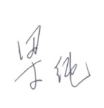
Mr. LIANG Chun
President
Chinese Archery Association

Important Dates:

Please find enclosed detailed information regarding this event. To register participation, please complete all the necessary sections in WAREOS (https://extranet.worldarchery.sport) within the deadlines listed below.

Summary of deadlines:

Registration Opening date on WAREOS | 06 February 2023
Preliminary Entries | 15 February 2023
Final Entries | 25 April 2023
Hotel reservation down-payment (50%) | 17 March 2023
Hotel reservation and payment | 21 April 2023
Transportation | 21 April 2023
Visa support | 14 April 2023
Full refund cancellation deadline  *After this deadline, the LOC is allowed to retain all amounts due by the Member Association. | 28 April 2023

Please respect the stated deadlines.

PRELIMINARY PROGRAMME

14 May 2023  Sunday | Arrival of participants  Practice field and local transport available
15 May 2023  Monday | Arrival of participants  Practice field and local transport available
16 May 2023  Tuesday | Official Practice & Qualification Round  Official Practice  Compound 50m Round
17 May 2023  Wednesday | Team Eliminations & Qualification  Compound Team Matches & Recurve Qualifications
18 May 2023  Thursday | Individual Eliminations  Team Eliminations  (Recurve Team Matches and Compound Individual Matches)
19 May 2023  Friday | Mixed Team Eliminations & Individual Eliminations  (Mixed Team Matches and Recurve Individual Matches)
20 May 2023  Saturday | Finals – Compound
21 May 2023  Sunday | Finals – Recurve
22 May 2023  Monday | Departure of teams

NOTE: This preliminary programme is subject to change according to participation and TV requirements. All changes will be published and distributed in good time.
PRELIMINARY & FINAL REGISTRATION
All entries, accommodation reservations, transport needs, flight arrival/departure information and visa invitation letter requests are to be completed using the World Archery Online Registration System WAREOS https://extranet.worldarchery.sport. This system handles the entire registration process for this event. No entry forms, hotel reservations or transportation forms will be accepted; all information must be entered into WAREOS.

Member associations can login to WAREOS at https://extranet.worldarchery.sport with the username and password assigned by World Archery. After entering WAREOS, selecting the event from the list will allow a member association to register their athletes. Select/press the “Entries” button to see the list of categories in the event. Select/press the “category” to enter the athlete and official numbers/details participating for that event. A WAREOS User Manual can be downloaded in PDF format (English) upon login.

Contact wareos@archery.sport with any questions regarding technical problems on WAREOS. For any question regarding the organisation of the event (transport, accommodation, meals, invoices, visa etc.) please contact directly the LOC.

A maximum number of 4 athletes per country can be registered into each category of the event. Preliminary entries should be completed using WAREOS.

Member Associations can only use WAREOS to make any changes or amendments to entries and will be able to do so at any time. An email will automatically notify the Organising Committee and Member Association of any changes made in WAREOS.

ENTRY FEES

Individual 250 USD per athlete
Official 125 USD per person
Guest 750 USD per person
International License 100 CHF per participant per calendar year to be paid
to World Archery

ENTRY FEES IN NON-OFFICIAL HOTELS

Individual 500 USD per athlete
Official 250 USD per person
International License 100 CHF per participant per calendar year to be paid
to World Archery

Entry fees for individual/Official include airport transfer to hotels, daily local transport to and from the practice field to/from official hotels during the qualification, elimination and finals venues (timetable to be confirmed on site).

Entry fee for guest includes daily local transport to and from the practice field to/from official hotels during the qualification, elimination and finals venues. They have no field of play access.

Any changes that are made after the deadlines specified or if entries differ by more than 4 athletes from the preliminary entries, the following penalty fees will automatically be applied.

PENALTY FEES TO BE PAID TO ORGANISING COMMITTEE (USD)

Penalty fees for Late Entries (after final deadline): | 50 per entry
Penalty fees for not filling Preliminary entries | 150 per entry
Penalty fee for differences between preliminary and final entries:  *If the difference between final and preliminary entries number is more than 4 athletes/officials | 150 per entry
PENALTY FEES TO BE PAID TO WORLD ARCHERY (CHF)
Lost / Damaged accreditation | 30.- each
Lost classification card | 30 .-each
Any change to the final country entry list, such as (but not limited to):  - Athlete or official name change  - Date of birth change  - Official position change  - Absence or incomplete on-site contact person | 50.- each change

NOTE: CHF currency exchange rates will be those on the date of the event.

Member Associations that have penalty fees outstanding from 2022 will need to have paid these penalty fees before being eligible to enter and compete.

Any entries received less than 3 days before the team managers meeting for a Hyundai Archery World Cup or World Championships will be refused if no preliminary entry and/or final entry are made prior. This decision cannot be appealed by the teams and is fully compliant with the current World Archery rules, article 3.7.1.2. Entries received after the deadlines, are subject to penalties as clearly stated in the rule book and the invitation documents of World Cups and World Championships. A Member Association that has made final entries in WAREOS and does not participate will be invoiced for the number of entries entered in the system, unless they have informed World Archery and the Organising Committee in writing at least one week prior to the event that they are unable to attend.

ACCOMMODATION

Jinling Purple Mountain Hotel Shanghai – Five Star Hotel
- Single Room price: USD 185.00 per room
- Number of rooms: 25
- Double/Twin Room price: USD 260.00 per room
- Number of rooms: 55
- Board plan: full board
- Check-in from 13 May 2023
- Late check-out Additional half day’s charge will apply at the regular room rate for late check-outs between 14:00-18:00. Any check-outs after 18:00 will be charged at a full day’s regular room rate.
- Hotel website: www.jinlinghotels.com
- Photo
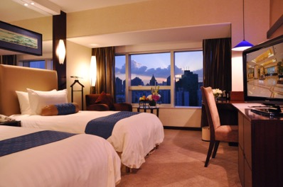
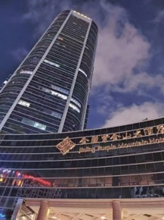
Shun Hotel Century Park Shanghai– Four Star Hotel
- Single Room price: USD 135.00 per room
- Number of rooms: 50
- Double/Twin Room price: USD 180.00 per room
- Number of rooms: 50
- Board plan: full board
- Check-in from 13 May 2023
- Late check-out Additional half day’s charge will apply at the regular room rate for late check-outs between 14:00-18:00. Any check-outs after 18:00 will be charged at a full day’s regular room rate.
- Photo
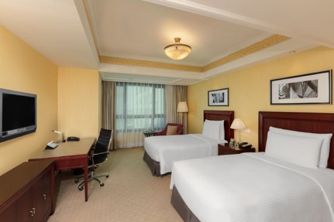
Luxemon Hotel Shanghai– Four Star Hotel
- Single Room price: USD 130.00 per room
- Number of rooms: 20
- Double/Twin Room price: USD 170.00 per room
- Number of rooms: 70
- Board plan: full board
- Check-in from 13 May 2023
- Late check-out Additional half day’s charge will apply at the regular room rate for late check-outs between 14:00-18:00. Any check-outs after 18:00 will be charged at a full day’s regular room rate.
- Photo
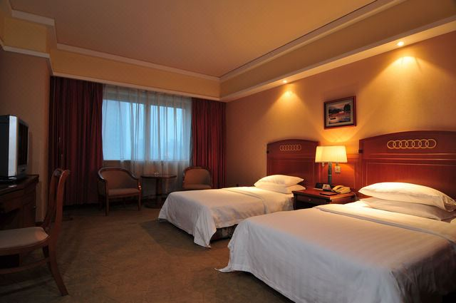
Rooms are allocated on a first come, first serve basis. Accommodation includes breakfast and lunch and dinner with non-alcoholic drinks. Lunch will be served at the hotel (Lunch boxes at the venue are only for the coaches/team managers who don’t have enough time to go back to the hotel for lunch. Please order the lunch boxes at the hotel info desk at least 1 day in advance), dinner will be served at the hotel.
Teams who do not reserve their accommodation through the organising committee will be charged a double entry fee.

In addition, the LOC will not be responsible to provide any event information at this hotel or provide transportation to the venues.

TRANSPORTATION
Transportation will be provided from Shanghai Pudong International Airport or Shanghai Hongqiao International Airport to the official hotels, from two days before the official practice day and until two days after the closing day for free. Local transport will be available between the official hotel, practice and competition venues for free. Transport timetables will be confirmed.

VISA
All participants who need an entry visa to China, will be required to complete the Visa Support sections in WAREOS by no later than 14 April 2023.

It is the applicants’ responsibility for supplying the necessary information, ensuring all details are up to date, correct and submitted by the deadlines specified.

In addition, all participants that require a visa are kindly requested to supply a copy of their latest/valid passport. Copies of each application can be uploaded on WAREOS. All passport copies and personal details entered/uploaded to WAREOS will be held securely and in the strictest of confidence and not shared with other parties.

PAYMENT CONDITIONS
Complete all necessary sections in WAREOS and make full payment by the specified deadlines. Bank transfers only, no credit cards will be accepted. All bank charges will be paid by the participants.

The entry fees should be paid in full before arrival.

To confirm hotels reservations, a minimum 50% deposit of the total amount is required to be bank transferred to the OC before 17 March 2023. Reservations after this date will be considered only according to availability. The final outstanding balance shall be made via bank transfer before arrival. Accommodation cannot be guaranteed after this deadline. A cost summary will be available through WAREOS.

BANK INFORMATION FOR ACCOMMODATION, TRANSPORTATION AND ENTRY FEES
BANK: BANK OF CHINA SHANGHAI YANGJING SUB-BRANCH
ADDRESS: NO.276 GU SHAN ROAD, PUDONG DISTRICT, SHANGHAI, CHINA
BANK ACCOUNT HOLDER NAME: SHANGHAI PUDONG NEW AREA SPORTS FEDERATION
ACCOUNT NO: 454684162932
SWIFT CODE: BKCHCNBJ300

NOTE: ALL PAYMENTS SHALL BE MADE IN USD BY BANK TRANSFER.

CANCELLATIONS & CHANGES
All cancellations and changes must be made through WAREOS:

- Should flight arrival details change last minute, please contact the Organising Committee using the details indicated in the team managers’ booklet.
- If a participant’s arrival is later than the original scheduled arrival date, the room will be charged from the date of the original booking in WAREOS.
- An email will automatically notify the Organising Committee and Member Association of any changes made in WAREOS.

HEALTH REGULATIONS (COVID-19)

INFORMATION
- Everybody should follow the Government/public health authorities measures (national and sport-specific regulations) and be aware of the travel restrictions.
- Please kindly check the latest entry requirements for your travel to China.
- For your information, medical infrastructure/Hospital with proper care will be reachable within 15 minutes from the venue, where COVID-19 test can be done.

Medical emergency contact and location
Shanghai Oriental Hospital
Address: No. 551 South Pudong Road, Pudong New Area, Shanghai, China
Phone No.: +86 21 38804518

ADDITIONAL INFORMATION

Training
A training field will be available starting from 14 May 2023. The training field is near the competition field and is about 3-5 km from the hotels.

Weather
Temperatures in May are expected to range between 15 and 25 degrees Celsius.

Media Registration
Media representatives can apply for registration by emailing info@archery.sport.

Internet
Will be available in the official hotels for free (in hotel rooms and in the lobby). There will also be Wi-Fi available for access to results on venue.

Water
Each participant with receive clean bottles of water.
Bottled water will be available at the qualification and practice venues.
CAA CONTACT

Name: Yuran ZHU
Email: archery2010@126.com
Language: Mandarin and English
Official Website: www.archery.sport.org.cn

LOC CONTACT

Name: Fionna WU
Email: awcshanghai@outlook.com
Language: Mandarin and English

Looking forward to welcoming you in Shanghai, China.

