To all World Archery Member Associations
Dear President,

As Chair of the Local Organising Committee (LOC) of the third stage of the Hyundai Archery World Cup to be held in Medellín, Colombia, on June 13-18, 2023, I would like to invite you all to be part of one of the most important archery events to take place in the Americas and the world in 2023.

Medellin is the country’s second largest city, industrial capital, business centre, and beating heart of commerce. Through conviction and political will, we have taken on the challenge of transforming Medellin into a city where justice, solidarity and acceptance are paramount.

The city has a deeply ingrained culture of service based on the friendliness, respect and warmth of its people.

Athletes of the world do know that Medellin is also a city where magnificent archery events can be staged. In the past 10 years, Medellin has successfully hosted 6 stages of the Hyundai World Cup. Participants from more than 40 countries have enjoyed the experience of shooting in our city. In 2023 we will host our last World Cup, at least for the next 4 years. Those who have come before will certainly encourage those who haven’t to fly to our city and enjoy the competition.

Welcome to this amazing city that reinvents itself every day. Our targets look forward to embracing your arrows, just as our hearts are ready to make your visit unforgettably enjoyable.

Sincerely yours,

Maria Emma Gaviria
World Cup Medellin OC Chairman

Important Dates:

Please find enclosed detailed information regarding this event. To register participation, please complete all the necessary sections in WAREOS (https://extranet.worldarchery.sport) within the deadlines listed below.

Summary of deadlines:

Registration Opening date on WAREOS | 17 February 2023
Preliminary Entries | 13 March 2023
Final Entries | 23 May 2023
Hotel reservation down-payment (50%) | 13 April 2023
Hotel reservation and payment | 23 May 2023
Transportation | 28 May 2023
Visa support | 13 April 2023
Full refund cancellation deadline  *After this deadline, the LOC is allowed to retain all amounts due by the Member Association. | 30 May 2023

Please respect the stated deadlines.

PRELIMINARY PROGRAMME

11 June 2023  Sunday | Arrival of participants  Practice field and local transport available
12 June 2023  Monday | Arrival of participants  Team Managers’ Meeting  Open Practice  Practice Field and local transport available
13 June 2023  Tuesday | Official Practice & Qualification Round  Official Practice  Compound 50m Round
14 June 2023  Wednesday | Team Eliminations & Qualification  Compound Team Matches & Recurve Qualifications
15 June 2023  Thursday | Individual Eliminations  Team Eliminations  (Recurve Team Matches and Compound Individual Matches)
16 June 2023  Friday | Mixed Team Eliminations & Individual Eliminations  (Mix Team Matches and Recurve Individual Matches)
17 June 2023  Saturday | Finals – Compound
18 June 2023  Sunday | Finals – Recurve
19 June 2023  Monday | Departure of teams

NOTE: This preliminary programme is subject to change according to participation and TV requirements. All changes will be published and distributed in good time.
PRELIMINARY & FINAL REGISTRATION
All entries, accommodation reservations, transport needs, flight arrival/departure information and visa invitation letter requests are to be completed using the World Archery Online Registration System WAREOS https://extranet.worldarchery.sport. This system handles the entire registration process for this event. No entry forms, hotel reservations or transportation forms will be accepted; all information must be entered into WAREOS.

Member associations can login to WAREOS at https://extranet.worldarchery.sport with the username and password assigned by World Archery. After entering WAREOS, selecting the event from the list will allow a member association to register their athletes. Select/press the “Entries” button to see the list of categories in the event. Select/press the “category” to enter the athlete and official numbers/details participating for that event. A WAREOS User Manual can be downloaded in PDF format (English) upon login.

Contact wareos@archery.sport with any questions regarding technical problems on WAREOS. For any question regarding the organisation of the event (transport, accommodation, meals, invoices, visa etc.) please contact directly the LOC.

A maximum number of 4 athletes per country can be registered into each category of the event. Preliminary entries should be completed using WAREOS.

Member Associations can only use WAREOS to make any changes or amendments to entries and will be able to do so at any time. An email will automatically notify the Organising Committee and Member Association of any changes made in WAREOS.

ENTRY FEES

Individual 250 USD per athlete
Official 115 USD per person
Guest 750 USD per person
International License 100 CHF per participant per calendar year to be paid to World Archery

ENTRY FEES IN NON-OFFICIAL HOTELS

Individual 500 USD per athlete
Official 230 USD per person
International License 100 CHF per participant per calendar year to be paid to World Archery

Entry fees for individual/Official include airport transfer to hotels, daily local transport to and from the practice field to/from official hotels during the qualification, elimination and finals venues (timetable to be confirmed on site).

Entry fee for guest includes daily local transport to and from the practice field to/from official hotels during the qualification, elimination and finals venues. They have no field of play access.

Any changes that are made after the deadlines specified or if entries differ by more than 4 athletes from the preliminary entries, the following penalty fees will automatically be applied.

PENALTY FEES TO BE PAID TO ORGANISING COMMITTEE

Penalty fees for Late Entries (after final deadline): | 50 USD per entry
Penalty fees for not filling Preliminary entries | 150 USD per entry
Penalty fee for differences between preliminary and final entries:  *If the difference between final and preliminary entries number is more than 4 athletes/officials | 150 USD per entry
PENALTY FEES TO BE PAID TO WORLD ARCHERY (CHF)
Lost / Damaged accreditation | 30.- each
Lost classification card | 30 .-each
Any change to the final country entry list, such as (but not limited to):  - Athlete or official name change  - Date of birth change  - Official position change  - Absence or incomplete on-site contact person | 50.- each change

NOTE: CHF currency exchange rates will be those on the date of the event.

Member Associations that have penalty fees outstanding from 2022 will need to have paid these penalty fees before being eligible to enter and compete.

Any entries received less than 3 days before the team managers meeting for a Hyundai Archery World Cup will be refused if no preliminary entry and/or final entry are made prior. This decision cannot be appealed by the teams and is fully compliant with the current World Archery rules, article 3.7.1.2. Entries received after the deadlines, are subject to penalties as clearly stated in the rule book and the invitation documents of World Cups and World Championships. A Member Association that has made final entries in WAREOS and does not participate will be invoiced for the number of entries entered in the system, unless they have informed World Archery and the Organising Committee in writing at least one week prior to the event that they are unable to attend.

ACCOMMODATION

City Express Hotel – Four Star Hotel
- Single Room price: USD 158.00 per room
- Number of rooms: 87
- Double/Twin Room price: USD 260.00 per room
- Number of rooms: 57
- Board plan: breakfast and lunch (lunch will be served at the venue)
- Check-in from June 10, 2023 (15:00)
- Check-out June 19, 2023 (12:00)
- Hotel website: https://www.cityexpress.com/hoteles-colombia/antioquia/medellin
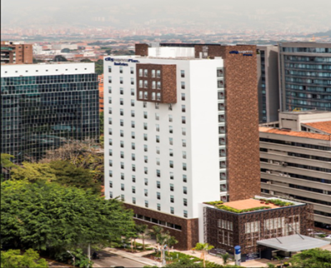
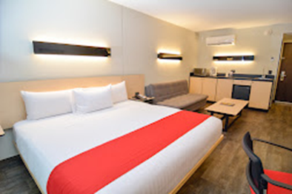

San Fernando Plaza – Five Star Hotel
- Single Room price: USD 180.00 per room
- Number of rooms: 40
- Double/Twin Room price: USD 280.00 per room
- Number of rooms: 70
- Board plan: breakfast and lunch (lunch will be served at the venue)
- Check-in from June 10, 2023 (15:00)
- Late check-out June 19, 2023 (12:00)
- Hotel website: https://www.hotelsanfernandoplaza.com/

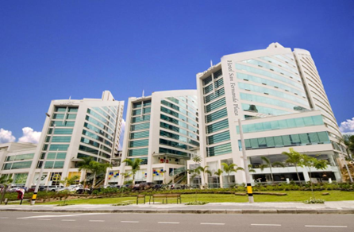

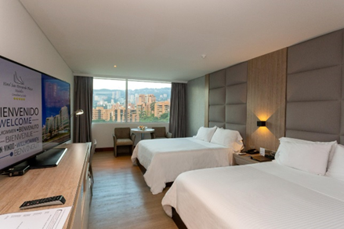

Dann Carlton – Five Star Hotel
- Single Room price: USD 180.00 per room
- Number of rooms: 15
- Double/Twin Room price: USD 280.00 per room
- Number of rooms: 35
- Board plan: breakfast and lunch (lunch will be served at the venue)
- Check-in from June 10, 2023 (15:00)
- Late check-out June 19, 2023 (12:00)
- Hotel website: https://www.danncarlton.com/
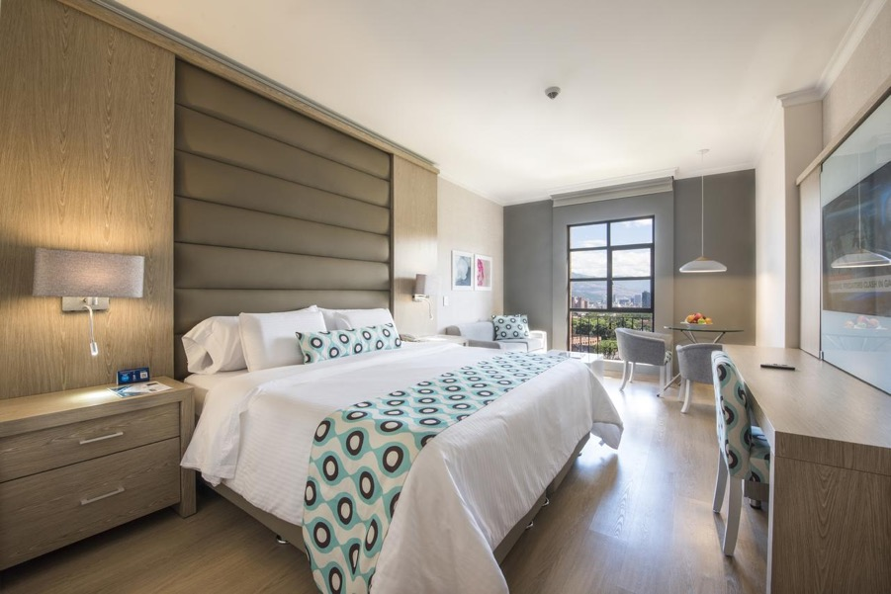
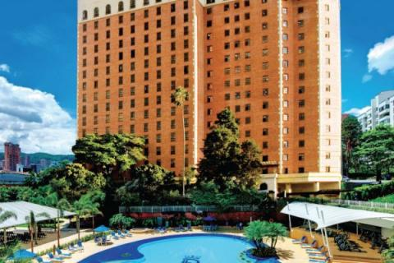
Rooms are allocated on a first come, first serve basis. Accommodation includes breakfast and lunch with non-alcoholic drinks. Lunch will always be served at the archery venue.
Teams who do not reserve their accommodation through the organising committee will be charged a double entry fee.

In addition, the LOC will not be responsible to provide any event information to participants not staying at hotels not reserved by the organisers nor to provide transportation to the venues.

TRANSPORTATION
Transportation will be provided from/to the Jose Maria Cordoba Airport in Medellin to the official hotel, from June 10 and until two days after the closing day for free. Local transport will be available between the official hotel, practice and competition venues at no additional cost starting on June 11. Transport timetables will be confirmed.

VISA
All participants who need an entry visa to Colombia, will be required to complete the Visa Support sections in WAREOS by no later than 13 April 2023.

It is the applicants’ responsibility to supply the necessary information, ensuring all details are up to date, correct and submitted by the deadlines specified.

In addition, all participants that require a visa are kindly requested to supply a copy of their latest/valid passport. Copies of each application can be uploaded on WAREOS. All passport copies and personal details entered/uploaded to WAREOS will be held securely and in the strictest of confidence and not shared with other parties.

PAYMENT CONDITIONS
Complete all necessary sections in WAREOS and make full payment by the specified deadlines. Bank transfers only, no credit cards will be accepted. All bank charges will be paid by the participants.

The entry fees should be paid in full before arrival.

To confirm hotels reservations, a minimum 50% deposit of the total amount is required to be bank transferred to the OC before 13 April 2023. Reservations after this date will be considered only according to availability. The final outstanding balance shall be made via bank transfer by 23 May 2023. Accommodation cannot be guaranteed after this deadline. A cost summary will be available through WAREOS.

BANK INFORMATION FOR ACCOMMODATION, TRANSPORTATION AND ENTRY FEES
A/C Name: Federación de Arqueros de Colombia
Federation’s Address: Carrera 66B N 31 A 15
Telephone number: (57) 3168775003
City and Country: Medellin - Colombia
Bank: Bancolombia
Account Number: 362-1850 4196 (cuenta corriente)
Swift Bancolombia: COLOCOBM
(if you require 11 digits for your transfer COLOCOBMXXX)
Bank’s address: Transversal 39B N 73-47 local 104
Bank’s Phone: 57- 4 4449325
City: Medellin, Colombia

NOTE: ALL PAYMENTS SHALL BE MADE IN USD.

CANCELLATIONS & CHANGES
All cancellations and changes must be made through WAREOS

- Should flight arrival details change last minute, please contact the Organising Committee using the details indicated in the team managers’ booklet.
- If a participant’s arrival is later than the original scheduled arrival date, the room will be charged from the date of the original booking in WAREOS.
- An email will automatically notify the Organising Committee and Member Association of any changes made in WAREOS.

HEALTH REGULATIONS (COVID-19)

INFORMATION
- Everybody should follow the Government/public health authorities measures (national and sport-specific regulations) and be aware of the travel restrictions
- For your information, Medical infrastructure/Hospital with proper care will be reachable within 15 minutes from the venue, where COVID-19 test can be done.

Medical emergency contact and location

Dr. Lina Orrego
ctfedearco@gmail.com
+57 3128953839

Clínica Las Vegas (Hospital)
Calle 2 Sur No. 46-55, Medellin
+57 604 315 9000

ADDITIONAL INFORMATION

Training
A training field will be available starting on 11 June 2023 at the Unidad Deportiva de Belen located approximately 20 minutes from the official hotels. Teams arriving earlier and wishing to practice before 11 June should contact the LOC in advance to make training and transportation arrangements. An additional transport fee will be charged.

Weather
Medellin is a city where it is never cold and very seldom hot. Temperatures in July are expected to range between 20 and 28 degrees Celsius. The average in the last few years has been 25 degrees Celsius. There are chances of rain, mainly in the afternoons.

Media Registration
Media representatives can apply for registration by emailing comunicacionesfedearco@gmail.com (LOC media contact) or at info@archery.sport.

Internet
Will be available in the official hotels for free (in hotel rooms and in the lobby). There will also be Wi-Fi available for access to results on venue.

Water
Each participant with receive clean bottles of water.
Bottled water will be available at the qualification and practice venues.

LOC CONTACT

Name: Gloria Saldarriaga
Address: Cra 66B No 31A-15, Medellin
Email: awcmedellin2023@gmail.com
Language: Spanish and English
Phone number with international extension: +57 3168775003

Looking forward to welcoming you in Medellín, Colombia.

