TO ALL World Archery Member Associations
Dear President,

As Chair of the Local Organising Committee (LOC) of the fourth stage of the Hyundai Archery World Cup to be held in Paris – France on 15-20 August 2023, I would like to invite you all to be part of one of the most important archery events one year before the Paris 2024 Olympic Games.
The Paris World Cup stage is going to be the Test-event support of Olympic and Paralympic 2024 Games, with the finals venue set up on one of the most iconic places of the French capital, the Esplanade des Invalides.

This will be the third of the three editions in which the French Federation with the France Archery Organising Committee is involved.
Our wish is to give to all participants and officials the best image of France and to be the opportunity to offer the best promotion to Archery all around the world.

We hope this stage of the Hyundai Archery World Cup will be the opportunity for your delegation to test the Olympic venue and for the ones, who plan to come earlier to spend the week between the World Championships in Berlin and the beginning of the competition in Paris to discover some of our Pre-Games Training Camps.

Looking forward to welcoming you in Paris.
Sincerely yours,

Jean-Michel CLEROY
Paris OC Chairman

Important Dates:

Please find enclosed detailed information regarding this event. To register participation, please complete all the necessary sections in WAREOS (https://extranet.worldarchery.sport) within the deadlines listed below.

Summary of deadlines:

Registration Opening date on WAREOS | 01 April 2023
Preliminary Entries | 17 May 2023
Final Entries | 26 July 2023
Hotel reservation down-payment (50%) | 17 May 2023
Hotel reservation and payment | 12 July 2023
Transportation | 12 July 2023
Visa support | 12 July 2023
Full refund cancellation deadline  *After this deadline, the LOC is allowed to retain all amounts due by the Member Association. | 12 July 2023

Please respect the stated deadlines.

PRELIMINARY PROGRAMME

13 August 2023  Sunday | Arrival of participants
14 August 2023  Monday | Arrival of participants  Practice field and local transport available  Official Practice & Qualification round
15 August 2023  Tuesday | Equipment Inspection  Team Managers Meeting  Compound 50m round
16 August 2023  Wednesday | Team elimination & Qualifications  Compound team matches & recurve qualifications
17 August 2023  Thursday | Individual Eliminations  Team eliminations  (Recurve team matches & compound individual matches)
18 August 2023  Friday | Mixed Team Eliminations & Individual Eliminations  (Mixed team matches & recurve individual matches)
19 August 2023  Saturday | Finals - Compound
20 August 2023  Sunday | Finals - Recurve
21 August 2023  Monday | Departure of teams

NOTE: This preliminary programme is subject to change according to participation and TV requirements. All changes will be published and distributed in good time.
PRELIMINARY & FINAL REGISTRATION
All entries, accommodation reservations, transport needs, flight arrival/departure information and visa invitation letter requests are to be completed using the World Archery Online Registration System WAREOS https://extranet.worldarchery.sport. This system handles the entire registration process for this event. No entry forms, hotel reservations or transportation forms will be accepted; all information must be entered into WAREOS.

Member associations can login to WAREOS at https://extranet.worldarchery.sport with the username and password assigned by World Archery. After entering WAREOS, selecting the event from the list will allow a member association to register their athletes. Select/press the “Entries” button to see the list of categories in the event. Select/press the “category” to enter the athlete and official numbers/details participating for that event. A WAREOS User Manual can be downloaded in PDF format (English) upon login.

Contact wareos@archery.sport with any questions regarding technical problems on WAREOS. For any question regarding the organisation of the event (transport, accommodation, meals, invoices, visa etc.) please directly contact the LOC.

A maximum number of 4 athletes per country can be registered into each category of the event. Preliminary entries should be completed using WAREOS.

Member Associations can only use WAREOS to make any changes or amendments to entries and will be able to do so at any time. An email will automatically notify the Organising Committee and Member Association of any changes made in WAREOS.

ENTRY FEES

Individual 230 EUR per athlete
Official 115 EUR per person
Guest 750 EUR per person
International License 100 CHF per participant per calendar year to be paid.
to World Archery

Entry fees for Individual/Official include daily local transport to and from the practice field to/from official hotels during the qualification, elimination, and finals venues (timetable to be confirmed on site).

Entry fee for guest includes daily local transport to and from the practice field to/from official hotels during the qualification, elimination, and finals venues. They have no field of play access.

Any changes that are made after the deadlines specified or if entries differ by more than 4 individuals from the preliminary entries, the following penalty fees will automatically be applied.

PENALTY FEES TO BE PAID TO ORGANISING COMMITTEE

Penalty fees for Late Entries (after final deadline): | 50 per entry
Penalty fees for not filling Preliminary entries | 150 per entry
Penalty fee for differences between preliminary and final entries:  *If the difference between final and preliminary entries number is more than 4 athletes/officials | 150 per entry
PENALTY FEES TO BE PAID TO WORLD ARCHERY (CHF)
Lost / Damaged accreditation | 30.- each
Lost classification card | 30.- each
Any change to the final country entry list, such as (but not limited to):  - Athlete or official name change  - Date of birth change  - Official position change  - Absence or incomplete on-site contact person | 50.- each change

NOTE: CHF currency exchange rates will be those on the date of the event.

Member Associations that have penalty fees outstanding from 2022 will need to have paid these penalty fees before being eligible to enter and compete.

Any entries received less than 3 days before the team managers meeting for a Hyundai Archery World Cup or World Championships will be refused if no preliminary entry and/or final entry are made prior. This decision cannot be appealed by the teams and is fully compliant with the current World Archery rules, article 3.7.1.2. Entries received after the deadlines, are subject to penalties as clearly stated in the rule book and the invitation documents of World Cups and World Championships. A Member Association that has made final entries in WAREOS and does not participate will be invoiced for the number of entries entered in the system, unless they have informed World Archery and the Organising Committee in writing at least one week prior to the event that they are unable to attend.

ACCOMMODATION
Mercure Porte d’Orléans – 4*
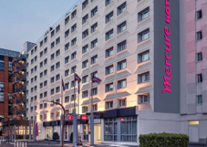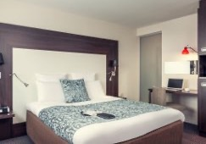
- Single Room price: 248.00 EUR per room
- Number of rooms: 14
- Double/Twin Room price: 356.00 EUR per room
- Number of rooms: 30
- Board plan: full board
- Check-in from: 14:00
- Check-out: 12:00
- Room size: 23m²
- Bed size: 160*200 cm (single) or 90*200 cm (twin)
- Hotel > Venues (distance / time min.): Charléty: 1,5km / 4min – Invalides: 5,2km / 12min
- Hotel website: https://all.accor.com/hotel/0374/index.fr.shtml

Ibis Porte d’Orléans – 3*
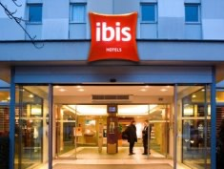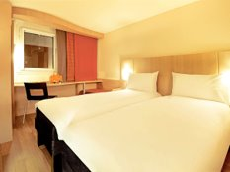
- Single Room price: 203.00 EUR per room
- Number of rooms: 50
- Double/Twin Room price: 314.00 EUR per room
- Number of rooms: 100
- Board plan: full board
- Check-in from: 14:00
- Check-out: 12:00
- Room size: 16m²
- Bed size: 160*190 cm (single) or 80*190 cm (twin)
- Hotel>Venues (distance / time min.): Charléty: 1,6km / 4min – Invalides: 5,3km / 12min
- Hotel website: https://all.accor.com/hotel/0635/index.fr.shtml

Ibis Styles Météor – 3*
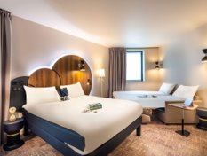
- Single Room price: 223.00 EUR per room
- Number of rooms: 20
- Double/Twin Room price: 336.00 EUR per room
- Number of rooms: 30
- Board plan: full board
- Check-in from: 15:00
- Check-out: 12:00
- Room size: 17m²
- Bed size: 160*190 cm (single) or 90*190 cm (twin)
- Hotel >Venues (distance / time min.): Charléty: 1,5 km / 4min – Invalides: 7km / 16min
- Hotel website: https://all.accor.com/hotel/B2U6/index.fr.shtml

Ibis Porte d’Italie – 3*
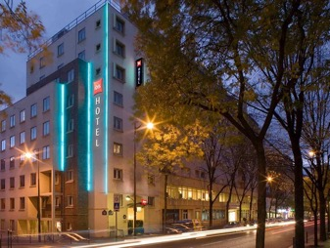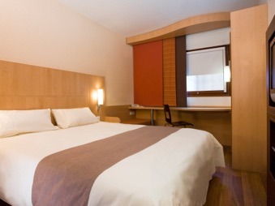
- Single Room price: 198.00 EUR per room
- Number of single rooms: 15
- Double/Twin Room price: 304.00 EUR per room
- Number of rooms: 60
- Board plan: full board
- Check-in from: 12:00
- Check-out: 12:00
- Room size: 12m²
- Bed size: 140*190 cm (single) or 80*190 cm (twin)
- Hotel > Venues (distance / time min.): Charléty: 700m / 3min – Invalides: 6,8km / 14min
- Hotel website: https://all.accor.com/hotel/0634/index.fr.shtml

Pullman Paris Montparnasse – 4*
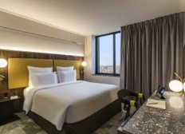
- Single Room price: 298.00 EUR per room
- Number of rooms: 48
- Double/Twin Room price: 376.00 EUR per room
- Number of rooms: 80
- Board plan: full board
- Check-in from: 15:00
- Check-out: 12:00
- Room size: 22m² / 25m²
- Bed size: 180*200 (single) or 100*200 (twin)
- Hotel > Venues (distance / time min.): Charléty: 3,4km / 8min – Invalides: 3,3km / 7min
- Hotel website: https://all.accor.com/hotel/8189/index.fr.shtml

Mercure Montparnasse TGV – 4*
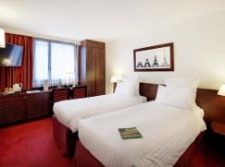
- Single Room price: 288.00 EUR per room
- Number of rooms: 60
- Double/Twin Room price: 406.00 EUR per room
- Number of rooms: 40
- Board plan: full board
- Check-in from: 16:00
- Check-out: 12:00
- Room size: 18m²
- Bed size: 160*200 cm (single) or 90*190 cm (twin)
- Hotel > Venues (distance / time min.): Charléty: 3,5 km/ 8min – Invalides: 3,2km / 7min
- Hotel website: https://all.accor.com/hotel/B8H6/index.fr.shtml

Ibis Montparnasse Catalogne – 3*
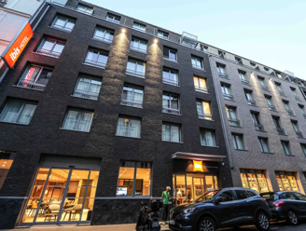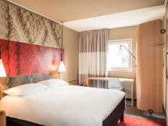
- Single Room price: 258.00 EUR per room
- Number of rooms: 30
- Double/Twin Room price: 372.00 EUR per room
- Number of rooms: 50
- Board plan: full board (dinners will be served at the Mercure Montparnasse TGV)
- Check-in from: 15:00
- Check-out: 12:00
- Room size: 15m²
- Bed size: 140*190 (single) or 90*190 cm (twin)
- Hotel > Venues (distance / time min.): Charléty: 3,4km / 8min – Invalides: 3,2km / 7min
- Hotel website: https://all.accor.com/hotel/B2Q8/index.fr.shtml

FIAP Jean Monnet – 2*
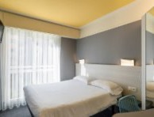
- Single Room price: 173.00 EUR per room (standard) / 183.00 EUR per room (VIP)
- Number of rooms: 30 (standard) / 15 (VIP)
- Double/Twin Room price: 266.00 EUR per room (standard) / 274.00 EUR per room (VIP)
- Number of rooms: 50 (standard) / 3 (VIP)
- Board plan: full board
- Check-in from: 14:30
- Check-out: 09:30
- Room size: 16m² / 20m²
- Bed size: 140*200 cm (single) or 90*190 cm (twin)
- Hotel > Venues (distance / time min.): Charléty: 2,1km / 5min – Invalides: 4,7km / 12min
- Hotel website: https://www.fiap.paris/
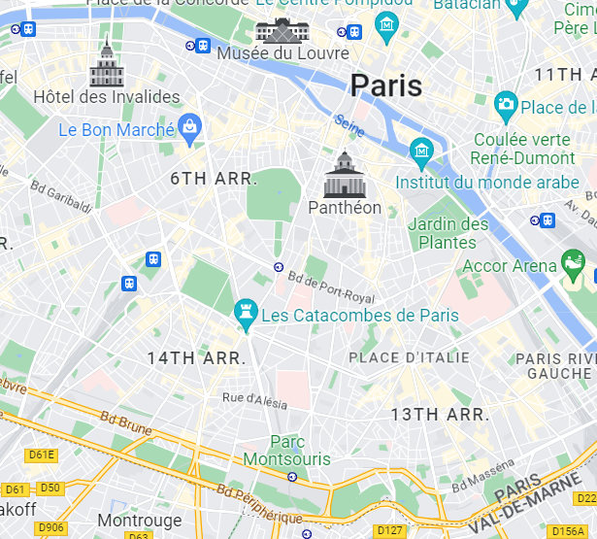
Ibis Styles Météor
Ibis Porte d’Italie
Ibis Porte d’Orléans
Mercure Porte d’Orléans
FIAP Jean Monnet
Mercure Montparnasse TGV
Pullman Montparnasse
Ibis Montparnasse Catalogne
Charléty Stadium (Qualifications)
Invalides (Finales)
Competition sites 4* Hotels 3* Hotels 2* Hotels

Rooms are allocated on a first come, first serve basis. Accommodation includes breakfast, lunch, and dinner, with non-alcoholic drinks. Lunch will always be served at the archery venue; dinner will be served at the hotel.
Teams who do not reserve their accommodation through the organising committee will be charged a double entry fee.

In addition, the LOC will not be responsible to provide any event information at this hotel or provide transportation to the venues.

TRANSPORTATION
Transportation will be provided from Roissy CDG and Orly airports, and all Paris train stations to the official hotels, from two days before the official practice day and until two days after the closing day at the following prices:

 | 1 passenger​ | 2 passengers or more​
Orly Airport​ | 50€ | 40€ / person​
CDG Airport​ | 60€ | 45€ / person​
Train station (Paris)​ | 45€​ | 30€ / person​

Local transport will be available between the official hotel, practice, and competition venues for free.
Transport timetables will be confirmed.

VISA
All participants who need an entry visa to Country, will be required to complete the Visa Support sections in WAREOS by no later than 15 July 2023.

It is the applicants’ responsibility for supplying the necessary information, ensuring all details are up to date, correct and submitted by the deadlines specified.

In addition, all participants that require a visa are kindly requested to supply a copy of their latest/valid passport. Copies of each application can be uploaded on WAREOS. All passport copies and personal details entered/uploaded to WAREOS will be held securely and in the strictest of confidence and not shared with other parties.

PAYMENT CONDITIONS FOR ENTRY FEES
Complete all necessary sections in WAREOS and make full payment by the specified deadlines. Bank transfers only, no credit cards will be accepted. All bank charges will be paid by the participants.

The entry fees should be paid in full before arrival.

Bank information for Entry fees
A/C Name: Comité d’Organisation France Tir à l’Arc
Federation’s Address: 12 Place Georges Pompidou
City and Country: 93160 Noisy Le Grand, France
Telephone number: +33 (0)1 58 03 58 58
Bank information for Entry fees
Bank: BNP Paribas
Account Number: FR76 3000 4028 3700 0111 4064 094
Swift: BNPAFRPPXXX
Bank’s address: BNP PARIBAS A
Ile de France Institutions
ACI: Z02837A
8-12, rue Sainte Cécile
75450 Paris Cedex 09 - FRANCE
Email address: finance@france-tiralarc.org
City: Paris, France
NOTE: ALL PAYMENTS SHALL BE MADE IN EUR BY BANK TRANSFER

LOC CONTACT
Name: Lucy SINCERE - Camille PERROT
Email: info@france-tiralarc.org
Language: French, English
Phone number: +33 (0)1 58 03 58 68 (French / English)
Phone number: +33 (0)1 58 03 58 66 (French / English)

PAYMENT CONDITIONS FOR ACCOMMODATION, TRANSPORTATION AND ENTRY FEES

- Accommodation and transport are provided by Spartner Agency. To confirm hotel and transport reservation here are the steps to follow:

- Complete the dedicated section in Wareos.
- Email archery-teamservices@spartner-agency.com to make sure Spartner has your contact information.
- Spartner will send you the corresponding proforma invoice, based on the needs indicated on Wareos.
- A 50% deposit is required before 17 May 2023 to confirm your booking.
- Total amount of the reservation will have to be paid by 12 July 2023.
- NOTE: ALL PAYMENTS SHALL BE MADE IN EUR BY BANK TRANSFER

Important:
- Accommodation and transport payment is to be made to Spartner Agency, not to the Organizing Committee, after receiving the corresponding proforma invoice.
- Please email archery-teamservices@spartner-agency.com to make sure to receive the proforma invoice on the correct mailbox.
- After May 15th reservations will be considered only according to availability
Bank details: all the bank information will be included in the proforma invoice you will receive by email.

Your contact at Spartner Agency
Ms. Gratianne DEVERLY
Mobile: +33 (0)6 03 24 83 06
Phone: +33 (0)1 79 35 09 28
E-mail: archery-teamservices@spartner-agency.com
Address: 34-36 rue de la Folie Regnault
City: 75011 Paris, France
CANCELLATIONS & CHANGES

All cancellations and changes must be made through WAREOS / Open WAREOS:

- Should flight arrival details change last minute, please contact the Spartner Agency using the details indicated in the team managers’ booklet.
- If a participant’s arrival is later than the original scheduled arrival date, the room will be charged from the date of the original booking in WAREOS.
- An email will automatically notify the Organising Committee and Member Association of any changes made in WAREOS.

Please note that there will be no reimbursement for any modification or cancellation received after July 12th.

HEALTH REGULATIONS (COVID-19)
INFORMATION
- Everybody should follow the Government/public health authorities measures (national and sport-specific regulations) and be aware of the travel restrictions.
- For your information, medical infrastructure/Hospital with proper care will be reachable within 15 minutes from the venue, where COVID-19 test can be done.

Medical emergency contact and location
Hospital name: Kremlin Bicêtre Hospital
Address: 78 rue du Général Leclerc, 94270 Le Kremlin-Bicêtre
Phone number: +33 (0)1 45 21 21 21
Hospital name: Hôpital Universitaire Pitié Salpêtrière
Address: 47-83 Boulevard de l’Hôpital, 75651 Paris
Phone number: +33 (0)1 42 16 00 00
Hospital name: Hôpital Européen Georges Pompidou
20 rue Leblanc 75015 Paris
Phone number: +33 (0)1 56 09 20 00

ADDITIONAL INFORMATION
Training
A training field will be available starting on 14 August 2023 from 10:00 at the Stade Charlety in Paris for the Hyundai Archery World Cup participants.

TRAINING CAMPS INFORMATION
Training camps
The LOC will also offer other training facilities in archery clubs or centres located maximum 80km around the venue on request of delegations arriving in France the week before the competition, on a first come, first served basis.
 | Archery Centre, Les Archers de Compiègne | Compagnie d’arc de Fontainebleau-Avon (Club) | Compagnie d’arc de Villiers sur Marne (Club) | CREPS Ile-de-France, Châtenay-Malabry | CTS Arc, Archery Centre, Chennevières sur Marne
Pictures | 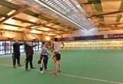 |  | 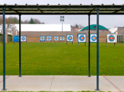 |  | 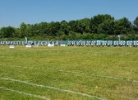
Distance from Roissy CDG | 52 km | 86 km | 37 km | 61 km | 40 km
Distance from Paris | 75 km | 70 km | 20 km | 20 km | 21 km
Facilities | Indoor & outdoor | Outdoor | Outdoor & covered outdoor | Indoor & outdoor | Indoor & outdoor
Target numbers | 25 | 10 | 13 | 6 | 20/20
Distance from shooting range | N/A | N/A | N/A | N/A | 70/50
Rest area | Yes | Yes | Yes | Yes | Yes
Storage room | Yes | Yes | Yes | Yes | Yes
Catering on site | No | No | No | Yes | No
Accommodation | Hotels nearby | Hotels nearby | Hotels nearby | At the centre | Hotels nearby
Opening hours | 9am - 9pm | On request | 9am - 6pm | 7am - 11pm | 9am - 6pm
Price per person per day in ½ twin in full board* | From 180€  3* hotel | - | From 140€  3* hotel | From 125€ | From 130€  3* hotel
 | From 210€  4* hotel | From 255€  4* hotel | From 195€  4* hotel | - | From 180€  4* hotel
*Transport not included

You can download the full Training Centres presentation here:
https://www.spartner-agency.com/wp-content/uploads/2023/03/Training-centers-presentation-2.pdf

Please contact Spartner Agency for any request: archery-teamservices@spartner-agency.com

Weather
August (Average):
Average Temperature: 20° C
Low Temperature: 16° C
High Temperature: 26° C
Sunrise: 06h34
Sunset: 21h02

Media Registration
Media representatives can apply for registration on the LOC website: www.archeryworldcup.paris or olivia@15love.net copy to communication@france-tiralarc.org (LOC media contact) or at info@archery.sport.

Internet
Will be available in the official hotels for free (in hotel rooms and in the lobby). There will also be Wi-Fi available for access to results on venue.

Water
Each participant with receive a gourd.
A water fountain system will be used.

LOC CONTACT
Name: Lucy SINCERE - Camille PERROT
Email: info@france-tiralarc.org
Language: French, English
Phone number: +33 (0)1 58 03 58 68 (French / English)
Phone number: +33 (0)1 58 03 58 66 (French / English)

We look forward to welcoming you in Paris.

