ASSOCIATIONS AND FEDERATIONS MEMBERS OF WORLD ARCHERY
Dear Presidents,
As president of the Argentinian Archery Federation (FATARCO - World Archery Argentina) I have the pleasure and invite you, and your archers to the World Ranking Tournament Iguazú 2016 and " III South-American Championships “ which will be held at Iguazú, Misiones, Argentina, from 25 to 29 July 2016.-
Located in the northeast of Argentina, Iguazú is a city positioned near the confluence of the Parana and Iguazu rivers, on the border with Brazil and Paraguay republics. A cosmopolitan city that offers, among its many attractions the chance to meet one of the natural wonders of the world, Iguazú Falls.-
Argentina is a nation where archery great events have been made. The Pan American Games 1995 successfully took place in the city of Mar del Plata as well as the World Ranking Tournament and First South American Championship held in 2012, corresponding add to them the Youth Argentinan Cup organized in Luján, Buenos Aires in December 2013, and it was a continental level qualifier for Nanjing JJOOJJ 2014 and the XXII Pan American Championships and First Pan American Championships Para-Archery, which took place in the city of Rosario in the year 2016.-
World Ranking Tournament Iguazu 2016, and “III South American Championships” is no exception, and we want you to be part of it, also offering the possibility to enjoy Iguazú Falls, one of the wonders of the world as well as the various tourist attractions of the region, that our country have to offer to you all.-
Sincerely yours,
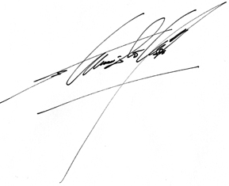

Estanislao Soler Osores
President

IMPORTANT DATES
Initial date for online registration (WAREOS) March 20, 2016
Deadline for preliminary entries May 6, 2016
Deadline for final registration June 20, 2016
End preliminary accommodation reservations May 20, 2016
End of booking accommodation June 20, 2016
End of accommodation payment (transfer) June 20, 2016
Registration payment deadline June 20, 2016
Shipping transport request form July 10, 2016

COMPETITION PROGRAM
Day 1  july 24 | Arrival of delegations  Non official practice
Day 2  july 25 | Official Practice  Team Captains Meeting  Equipment Review
Day 3  july 26 | Classification Round for all categories
Day 4  july 27 | Open Singles Qualifying Tournament (WRT)  * Recurve  * Compound Bow  Playoffs Mixed Team (WRT)
Day 5  july 28 | South American Championship Playoffs III  * Recurve  * Compound Bow  Qualifying and Finals Team (WRT)
Day 6  july 29 | July 29 Final for gold and Recurve Compound Bow  Final Gold Mixed Team (WRT)
Day 7  july 30 | Departure of delegations
Note: This competition program may undergo changes, given the number of participants in each division and the needs of televising. All changes will be published and distributed to all participants with due previous time.-

TOURNAMENT REGISTRATION
All registration must be made using the online registration system WA (WAREOS): http://register.worldarchery.org.
No registration will be accepted if it has not been done with WAREOS.
It will be allowed to register in each category a maximum of 4 athletes per country.
The categories that will participate are:
− Female Recurve
− Male Recurve
− Female Compound
− Male Compound
To use this system, you must go to http://registrer.worldarchery.org/, and use the username and password that has been delivered by WA to each member Association and Federation. If your organization do not have the respective user name and password, please contact Mr. Jae Kyung Lee(jklee@archery.org). If you have any problems in using your access to WAREOS, can contact Mr. Sergio Font (sergiofont@yahoo.com).
To make preliminary and final entries in the system, seek the tournament "Tournament Ranking Iguazu 2016" and the "Entries" option is chosen.

It is important to note that the tournament will be visible only in the official registration dates.
Preliminary registration
The preliminary or numerical entry is made through the Preliminary Entries option within the registration system, for each of the available categories in the tournament in which each delegation wishes to participate. Inside the box, the number of archers to participate scores for that category.
Final registration
Once the names of the archers who will participate in the tournament are known, the final registration process allows choosing them from among the archers who are registered in the system for each Association or Federation. This is done by the Final Entries column, choosing each specific and within each category, the archers who will participate in the tournament.
• Start date for online registration: 20 March 2016
• Deadline for preliminary entries: May 20, 2016
• Deadline for final registration: June 20, 2016
It is important to respect these registration dates, after which Associations or Federations WA members can not update the information in the WAREOS system.
If teams want to make changes to the final registration after the deadlines, please contact Sergio Font:sergiofont@yahoo.com

Any modification to the information entered (or not entered) the system after the due dates, will incur a penalty of an additional $ 50 per archer, which must be canceled at the time of the arrival of the delegations to the event.
Registration fees
The registration fee for this event will be:
• Athlete u $ s 100
• Officers and Trainers u $ s 80

In case that a delegation or a member of her conduct proceedings accommodation in a different hotel of those provided by the Organizing Committee, or those that do not perform this process of accommodation by the Organizing Committee (through the respective forms), the cost registration will be:
• Athlete u $ s 200
• Officers and Trainers u $ s 160

Payment methods
Payment of registration may be made by bank transfer (deadline June 20, 2016), or in cash on July 25, 2016.
No payments will be accepted through credit cards, checks or travelers checks.
Changes to registration
Changes in athletes participating only in the same category and division will be allowed until a week before the event.
ACCOMMODATION AND FEEDING
Preliminary hotel reservations will be accepted until June 20 2016.
Reservations are processed in the order they are received. The hotel will give priority to reserves by the order of arrival of them.
Reservations will not be confirmed until payment is made effective.
Please inform us if any of the members of your team requires a specific food diet or are allergic to certain foods.
Transportation will be provided to and from these hotels (airport and shooting range).

Delegations staying at any other hotel should coordinate and pay for their own transportation.

The room rates are per night and per person and include breakfast, lunch (in shooting location) and dinner.
Hotel reservation will be made only through the form attached below.

No need to send any written information, unless it is requested by the hotel or by the Organizing Committee directly.

• Sheraton Hotel Iguazu *****
www.sheratoniguazu.com

Located in the Iguazu National Park, at meters of the falls.

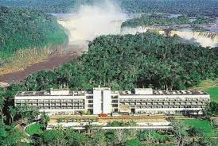

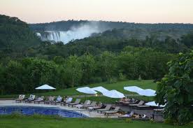

- Hotel Esturion ****

www.raicesesturion.com

Located in the city of Iguazú

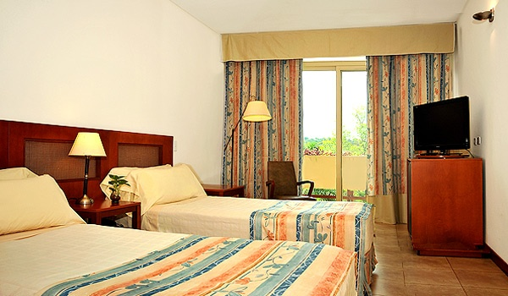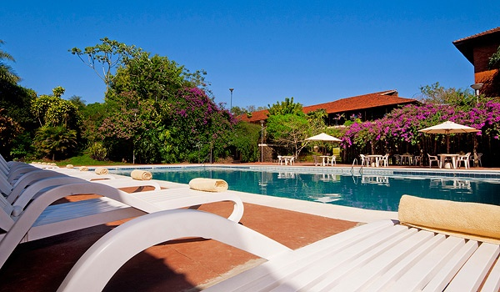

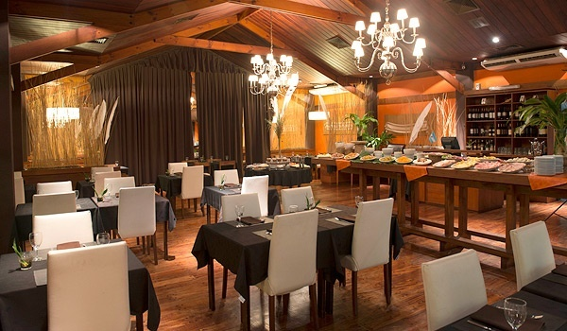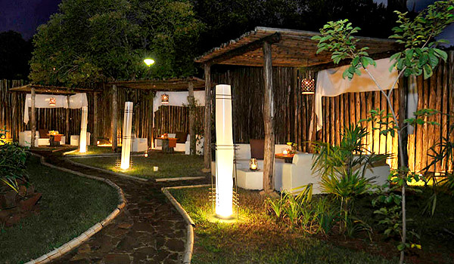

- Hotel Sol Cataratas ***

www.solcataratas.com.ar

Located in the city of Iguazú

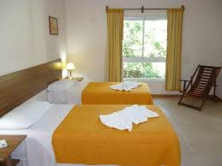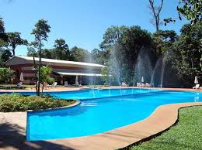

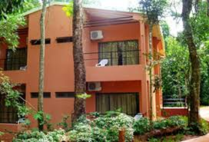

ACCOMMODATION BOOKING FORM
Contact: Estanislao Osores Soler / Jorge Herreros
Email: secretariafatarco@hotmail.com
Country / Equipment: _________________ Email: _______________________
Contact name and last name: ________________________

SHERATON HOTEL IGUAZU ***** (Breakfast, Dinner, Taxes Included ) It does not included intrance to national park Iguazu, one time payment USD 20.- per person.
HOTEL | ROOMS | Number of rooms by type | Numbers of persons |  | Total of Persons |  | Cost per Person |  | Nigths |  | Total
 |  |  | women | men
 | Single |  |  |  |  | x | USD262 | x |  | =
SHERATON IGUAZU***** | Double |  |  |  |  | x | USD 160 | x |  | =
 | Triple |  |  |  |  | x | USD 150 | x |  | =
Total | Rooming

HOTEL ESTURION **** (Breakfast, Dinner, Taxes Included )
HOTEL | ROOMS | Number of rooms by type | Numbers of persons |  | Total of Persons |  | Cost per Person |  | Nigths |  | Total
 |  |  | women | Men
 | Single |  |  |  |  | x | USD 181 | x |  | =
ESTURION***** | Double |  |  |  |  | x | USD 120 | x
 | Triple |  |  |  |  | x | USD 110 | x |  | =
Total | rooming

HOTEL SOL CATARATAS*** (Breakfast, Dinner, Taxes Included )
HOTEL | ROOMS | Number of rooms by type | Numbers of persons |  | Total of Persons |  | Cost per Person |  | Nigths |  | Total
 |  |  | women | Men
 | Single |  |  |  |  | x | USD 113 | x |  | =
SOL CATARATAS*** | Double |  |  |  |  | x | USD 90 | x |  | =
 | Triple |  |  |  |  | x | USD 77 | x
Total | rooming

THE PRICE IS PER PERSON PER DAY

TRANSPORTATION ORDER FORM
The registration fee includes transportation to and from the airport Iguazu (Argentina) and Foz do Iguazú (Brazil) during the official days of competition.
If another airport (Paraguay) used transportation costs will be u$s 70 per segment.
Please send the form to the COL (secretariafatarco@hotmail.com) with final booking at the hotel prior to July 10, 2016.
Country / Team: _________________, Email: ______________________
Contact Name: ___________________ Name: _____________________
Telephone fax:_______________________
Number of people in your group: _________________________
Arrival Information:
Airport:_______________________________________
Date: (DD / MM / YYYY) _______________________ Airline (i.e. Delta, United): _____________
Flight number:___________________
Flight Arrival Time ___________________
Number of passengers:_________________
□ tick here if you are renting a car and will not need transportation from the airport.

The official arrival date is 24 July 2016. Arrivals prior to this date will require teams to pay an additional cost for transportation from the airport to the hotel (u$S 50 per person).
DEPARTURE INFORMATION:
Airport:_______________________________
Date: (DD / MM / YYYY) ______________________ Airline (Delta, United): _______________
Flight number:_________________________
Flight Departure Time:_________________________
Number of passengers:________________________
□ tick here if you are renting a car and will not need transportation to the airport.
The official date of departure from the airport is on Sunday July 30, 2016. The departures after this date will require teams to pay an additional cost for transportation to the airport (u$s 50 per person).
INFORMATION FOR PAYMENT
The deadline for the transfer payment is June 20, 2016.
Only registrations fees may be paid in cash upon arrival in Iguazu, on July 25, 2016.
COL Contact Jorge Herreros Email: secretariafatarco@hotmail.com
Country / Equipment: __________________ Email: ________________________
Name of Contact: _____________ Family Name of Contact: ____________________
Phone: _________________________________ Email: __________________________
Data for bank transfers:
Bank : STANDARD CHARTERED BANK-New York-Usa
SWIFT Nº: SCBL US 33
ABA: 0260-0256-1
AccountNº and Name: BANCO GALICIA 3544032000001
SWIFT BANCO GALICIA Nº: GABAARBA

Beneficiary: CIA. LATINA S.R.L , Banco Galicia account Nro. Nº 1696-2168-1

VISA to enter the country
Citizens of the following countries do not require a visa to enter Argentina for sightseeing or family.
Visits not exceeding 90 days: United States (payable reciprocity fee), Andorra, Armenia, Australia (payable reciprocity fee), Austria, Barbados, Belgium, Bolivia, Brazil, Bulgaria, Canada (payable reciprocity fee) , Colombia, Republic of Korea, Costa Rica, Croatia, Chile, Cyprus, Czech Republic, Denmark, Ecuador, El Salvador, Slovakia, Slovenia, Spain, Estonia, Finland, France, Greece, Guatemala, Guyana, Haiti, Honduras, Hong Kong (passport HKSAR), Hungary, Iceland, Ireland, Israel, Italy, Kazakhstan, Japan, Latvia, Liechtenstein, Lithuania, Luxembourg, Macedonia, Malta, Mexico, Monaco, Montenegro, Nicaragua, Norway, New Zealand, Netherlands, Panama , Paraguay, Peru, Poland, Portugal, Puerto Rico, United Kingdom of Great Britain and Northern Ireland, Romania, Russian Federation, Saint Kitts and Nevis, San Marino, Saint Lucia, Holy See, Saint Vincent and the Grenadines, Serbia, Singapore South Africa, Sweden, Switzerland, Suriname, Thailand, the Republic of Trinidad and Tobago, Turkey, Ukraine and Uruguay.

United States, canada and Australia: payable reciprocity fee (http://cnyor.mrecic.gov.ar/content/turistas-estadounidenses-canadienses-australianos)
Visits not exceeding 60 days: Venezuela
Visits not exceeding 30 days: Grenada, Hong Kong (with British passport B.N.O), Jamaica and Malaysia.
If your country has not been mentioned, see the requirements for obtaining a tourist visahttp://cnyor.mrecic.gov.ar/content/visa-de-turista).
If you require a visa to enter the country we ask you to send the following form prior to June 10, 2016
COL Contact Jorge Herreros Email: asecretariafatarco @ hotmail.
Country / Equipment: _____________________________ Email: ________________________
Name of Contact: ______________________ Contact Name: ________________________
Phone: _________________________________ Email: __________________________
Male/  Female | Name | Last name | Athlet/  Oficial | Date of birth  DD/MM/AA | Place of birth | Passaport | Due date of Passaport

- GENERAL INFORMATION
Contact the Local Organizing Committee (LOC): Estanislao Osores Soler / Jorge Herreros
Email: secretariafatarco@hotmail.com;
- Languages: Spanish, English, Portuguese
- Climate: Subtropical, with a temperatura in July at a average 24ºC
- Payment Currency pesos, dollar

- About Iguazú

Iguazú Falls are located on the river Iguazú, in the limit between the Argentine province of Misiones and the Brazilian estate of Paraná. Are stationed in protected areas and were chosen one of the seven natural wonders of de world.
Iguazú Falls are the main center tourist northeastern Argentna and one of the main around the country, and were declared World Heritage by UNESCO.
Within the Iguazu Park is de Sheraton Hotel Iguazú, this hotel has a panoramic view of the “Garganta del Diablo” (Devil’s Throat) and Brazilian. jumps
Near the falls is the city of Port Iguazú, in the confluence or rivers Iguazú and Paraná. There is located the triple border with Paraguay and Brazil.
- More data
Also, would like to give you the proposal to visit not only the wonderful Iguazu Falls; also many others sights of our country as Salta, Bariloche and Villa La Angostura, Ushuaia and El Calafate with your glacier Perito Moreno, or the city of Buenos Aires.
For this reason in the attachments you do get some proposals so that they can continue enjoying our country.

